Supplementary Information
Supplemental Table S1 Spectral spread for the wavelengths of test flashes
Wavelength (nm) | Light source | Bandpass filter | Full width at half maximum (nm)
405 | M405L4ª | (Not used) | 12.5
425 |  | #87-787^{b}
450 |  | #88-300^{b}
475 |  | #87-788^{b}
500 |  | #88-300^{b}
525 |  | #87-789^{b}
550 | MNWHL4ª | #88-300^{b} | 25
575 |  | #87-790^{b}
600 |  | #88-300^{b}
625 |  | #87-791^{b}
650 |  | #88-300^{b}
675 |  | #87-792^{b}
ªThorlabs, ^{b}Edmund Optics.

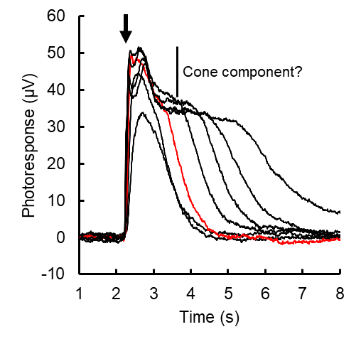
Supplemental Figure S1 Waveform of rod-cone mixed responses after subtracting isolated cone component (Fig. 7c). Flash intensity: 32 to 32000 photons µm⁻², Red: 320 photons µm⁻². Timing of the test flash is shown by an arrow. Cone response-like bumps are still observed on the rod response plateau indicating incomplete rod-cone response separation.

