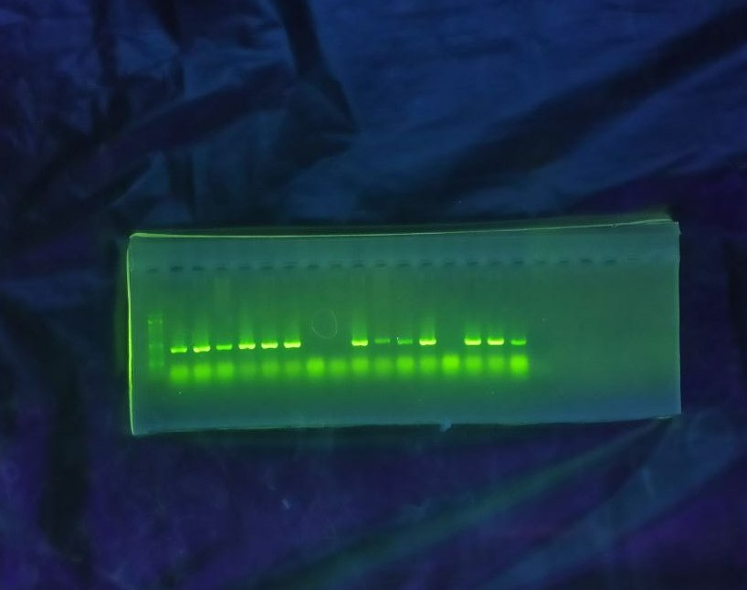

Figure 1 b) Electrophoresis of PCR product for Agroinuclated plants at 21 dpi by C4F/C4R Primers, Left to right (Lane 1 Marker, Lane1-3: Inoculated by BCTIV and treated by 10⁸ Trichoderma spore ml⁻¹ (T₃V), Lane 4-6: Inoculated by BCTIV and treated by 10⁶ Trichoderma spore ml⁻¹ (T₂V), Lane 9-11: Inoculated by BCTIV and treated by 10³ Trichoderma spore ml⁻¹ (T₁V), Lane 12-14-15: Inoculated by BCTIV and not treated by Trichoderma (CV), Lane 16: Positive Control,

