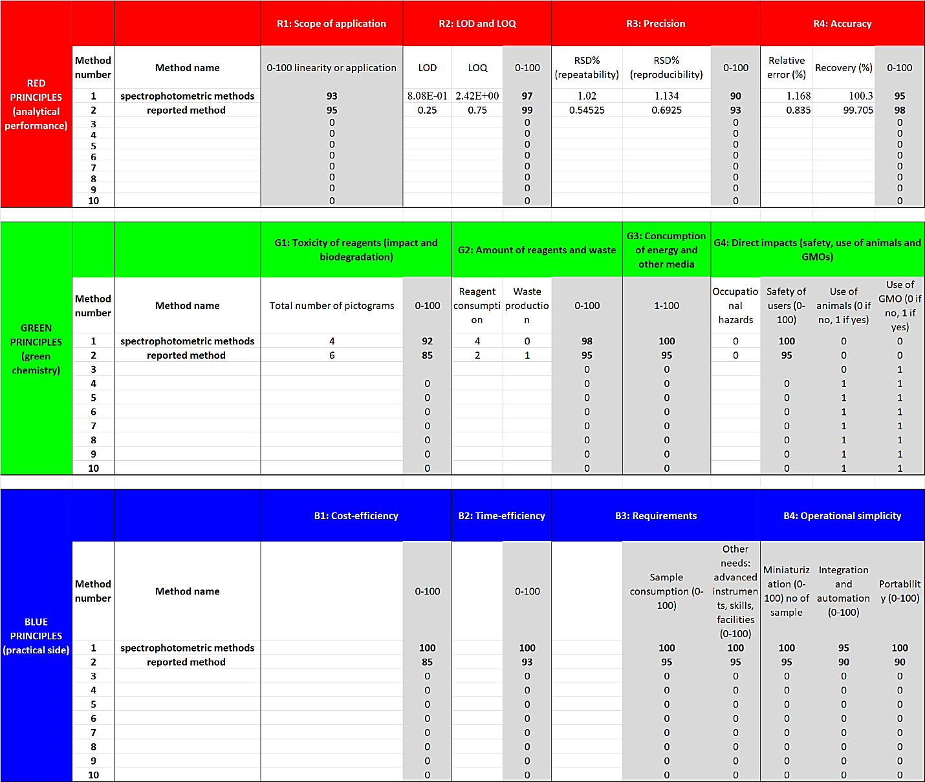

Table S1: Tabular data of each criterion used in RGB model assessment.

