Supplementary Table 1. Associations Between CpG Methylation and Cancer Survival Outcomes Analyzed by MethSurv
Name | Cancer | HR | CI | P value | UCSC Group | CpG Island
cg12690127 | ACC | 2.163 | (1.003;4.663) | 0.049132 | TSS200 | S_Shore
cg13549444 | ACC | 2.719 | (1.256;5.887) | 0.011133 | 1stExon;5'UTR;Body | Open_Sea
cg14311559 | ACC | 3.195 | (1.461;6.988) | 0.003618 | TSS200;Body | Open_Sea
cg19693177 | ACC | 3.174 | (1.432;7.037) | 0.00446 | 1stExon;5'UTR;Body | Open_Sea
cg12690127 | BLCA | 1.738 | (1.288;2.345) | 0.000296 | TSS200 | S_Shore
cg15975802 | BLCA | 1.396 | (1.038;1.878) | 0.027551 | TSS1500 | S_Shore
cg26363363 | COAD | 2.02 | (1.206;3.384) | 0.007584 | TSS200;Body | Open_Sea
cg04234016 | GBM | 0.649 | (0.425;0.991) | 0.045174 | Body | Open_Sea
cg19693177 | HNSC | 1.33 | (1.017;1.739) | 0.037185 | 1stExon;5'UTR;Body | Open_Sea
cg12690127 | KIRC | 0.59 | (0.398;0.875) | 0.00866 | TSS200 | S_Shore
cg14311559 | KIRC | 0.62 | (0.421;0.913) | 0.015478 | TSS200;Body | Open_Sea
cg23193870 | KIRC | 0.553 | (0.372;0.822) | 0.003368 | TSS200 | S_Shore
cg15975802 | KIRP | 3.459 | (1.643;7.282) | 0.001083 | TSS1500 | S_Shore
cg25719851 | KIRP | 2.993 | (1.461;6.129) | 0.002729 | TSS1500 | S_Shore
cg13549444 | LAML | 1.569 | (1.082;2.276) | 0.017589 | 1stExon;5'UTR;Body | Open_Sea
cg24437859 | LGG | 0.413 | (0.284;0.601) | 3.87E-06 | Body | Open_Sea
cg26004710 | LGG | 0.582 | (0.406;0.834) | 0.003194 | Body | Open_Sea
cg25719851 | MESO | 2.245 | (1.382;3.647) | 0.001081 | TSS1500 | S_Shore
cg15264991 | SARC | 0.63 | (0.423;0.94) | 0.023581 | Body | Open_Sea
cg24437859 | STAD | 0.615 | (0.444;0.853) | 0.003587 | Body | Open_Sea
cg19693177 | UCEC | 2.152 | (1.335;3.469) | 0.00166 | 1stExon;5'UTR;Body | Open_Sea
cg26842815 | UCEC | 2.062 | (1.275;3.334) | 0.003177 | TSS200;Body | Open_Sea
cg04234016 | UVM | 0.204 | (0.078;0.536) | 0.001252 | Body | Open_Sea
cg12690127 | UVM | 0.162 | (0.058;0.453) | 0.000524 | TSS200 | S_Shore
cg25719851 | UVM | 0.358 | (0.146;0.877) | 0.024541 | TSS1500 | S_Shore
cg26842815 | UVM | 0.132 | (0.042;0.412) | 0.000486 | TSS200;Body | Open_Sea
HR, hazard radio; CI, confidence interval; USCS, University of California, Santa Cruz.

Supplementary Table 2. The correlations between methylation and mRNA expression of PTPN6.
Cancer Type | Symbol | R | FDR
ACC | PTPN6 | -0.72213 | 0
BLCA | PTPN6 | -0.31634 | 7.9E-11
BRCA | PTPN6 | -0.43446 | 1.7E-32
CESC | PTPN6 | -0.30822 | 4.84E-08
CHOL | PTPN6 | -0.49112
COAD | PTPN6 | -0.2439 | 5.38E-05
DLBC | PTPN6 | -0.19073 | 0.193518
ESCA | PTPN6 | -0.32337 | 8.47E-06
GBM | PTPN6 | -0.63837 | 9.39E-07
HNSC | PTPN6 | -0.36236 | 6.13E-18
KICH | PTPN6 | -0.43392 | 0.000311
KIRC | PTPN6 | -0.65721 | 0
KIRP | PTPN6 | -0.46542 | 0
LAML | PTPN6 | -0.45289 | 8.39E-10
LGG | PTPN6 | -0.64039 | 0
LIHC | PTPN6 | -0.44797 | 0
LUAD | PTPN6 | -0.4291 | 0
LUSC | PTPN6 | -0.3793 | 4.77E-14
MESO | PTPN6 | -0.53122 | 1.93E-07
OV | PTPN6 | -0.86667 | 0.004508
PAAD | PTPN6 | -0.32926 | 8.12E-06
PCPG | PTPN6 | -0.31584 | 1.83E-05
PRAD | PTPN6 | -0.34069 | 7.53E-15
READ | PTPN6 | -0.27767 | 0.007538
SARC | PTPN6 | -0.8531 | 0
SKCM | PTPN6 | -0.83375 | 0
STAD | PTPN6 | -0.40184 | 0
TGCT | PTPN6 | -0.36213 | 6.13E-06
THCA | PTPN6 | -0.54006 | 0
THYM | PTPN6 | -0.79358 | 0
UCEC | PTPN6 | -0.33884 | 6.21E-06
UCS | PTPN6 | -0.83789 | 0
UVM | PTPN6 | -0.86782 | 0

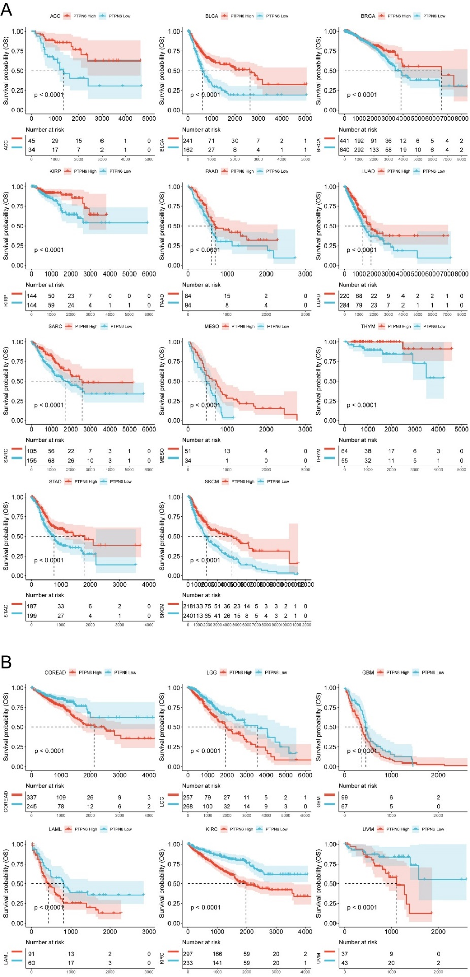
Supplementary Figure 1. Kaplan-Meier survival curves stratified by high versus low PTPN6 expression. (A) Cancers types exhibiting improved prognosis with high PTPN6 expression; (B) Cancers types showing worse prognosis with high PTPN6 expression.
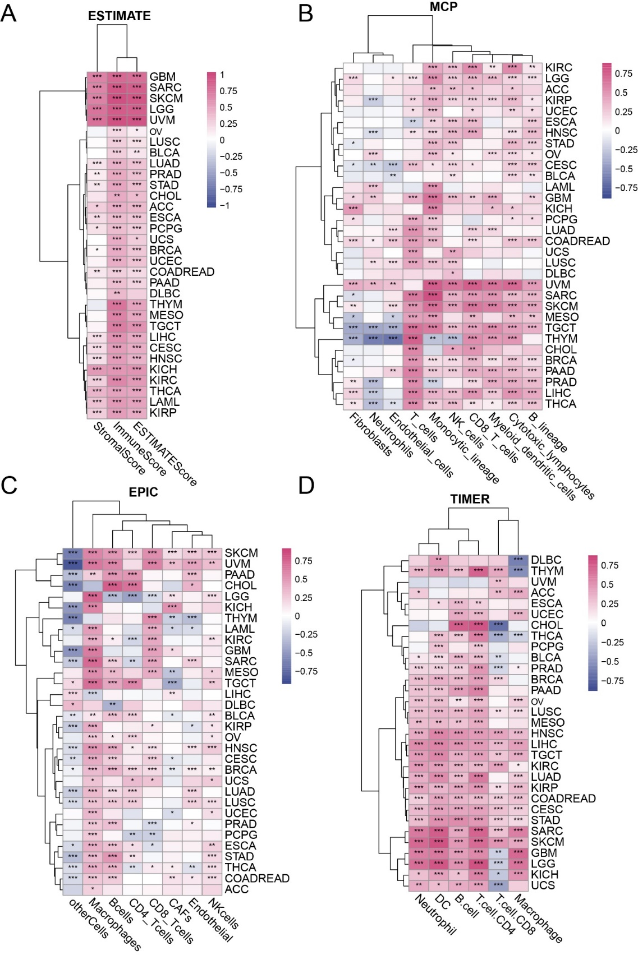
Supplementary Figure 2. Associations between PTPN6 expression and immune cell infiltration. (A) Heatmap depicting the correlation between of PTPN6 expression and immune scores from the correlations with ESTIMATE algorithm across cancer typesimmune scores; Heatmaps showing the correlation between PTPN6 expression and the abundance of different immune cell types estimated by (B) MCP-counter, (C) EPIC, and (D) TIMER algorithms across cancers. Bars represent Pearson's correlation coefficients (R values). *p<0.05, **p<0.01, ***p<0.001.of PTPN6 correlations with distinct immune cell types based on (B) MCP, (C) EPIC, and (D) TIMER algorithms. Bars denote correlation coefficient R values. * represents p<0.05, ** denotes p<0.01, *** represents p<0.001.
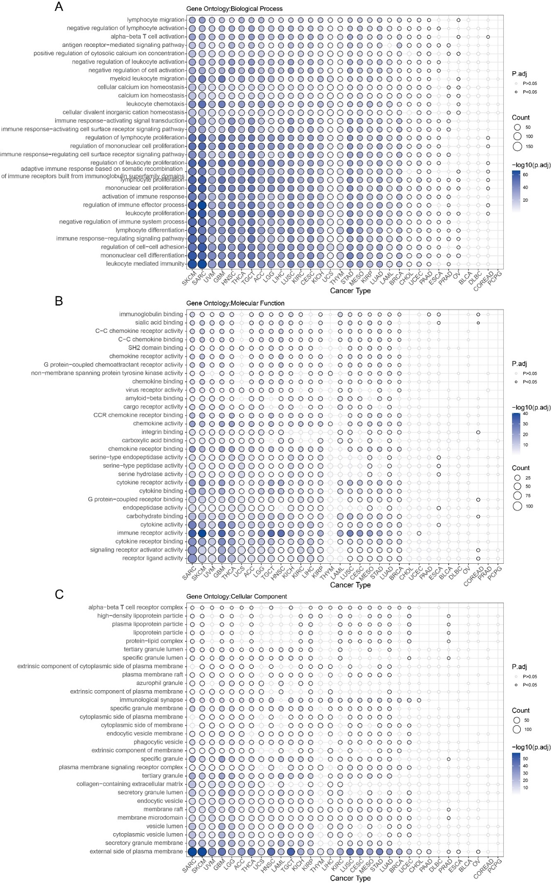
Supplementary Figure 3. Gene Ontology (GO) enrichment analysis of differential genes between high and low PTPN6 expression groups.by PTPN6 expression. Bubble plots showing the enriched GO results for (A) Biological Process (GOBP), (B) Molecular Function (GOMF), and (C) Cellular Component (GOCC) terms for genes differentially expressed between high and low PTPN6 expression cohorts. Color denotes p-value and size indicates number of enriched genes.

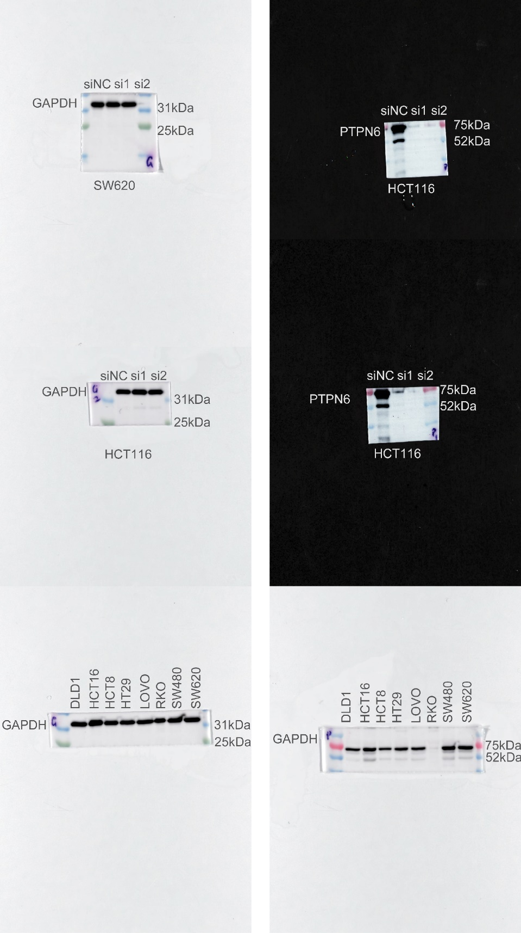
Supplementary Figure 4. Blots original images.

