Supplementary Information

Supplementary Table S1. List of excluded articles

Supplementary Table S2. Search strategy

Supplementary Table S3. Quality assessment

Supplementary Table S4. GRADE (Grading of Recommendations Assessment, Development and Evaluation) assessment

Supplementary Figure S1. Funnel and Doi plots

Supplementary Figure S2. Leave-one-out sensitivity analysis

Supplementary Figure S3. Pooled adjusted ratios
Supplementary Table S1. List of excluded articles

Study Title | Author | Reason for Exclusion
A comparative study of advantages of using separate bottle T.P.N. formulae and the 3-in-1 admixture of T.P.N. in critically ill pediatric patients | Wahdan A et al. | Wrong patient population
A Multi-Interventional Nutrition Program for Newborns with Congenital Heart Disease | O'Neal Maynord P et al.¹ | Wrong exposure/intervention
A Post-operative Feeding Protocol to Improve Outcomes for Neonates With Critical Congenital Heart Disease | Newcombe J et al.² | Intervention is after cardiac surgery
ABNORMAL GROWTH PARAMETERS ARE ASSOCIATED WITH WORSE OUTCOMES IN CHILDREN UNDERGOING CONGENITAL HEART SURGERY IN LOW- AND MIDDLE-INCOME COUNTRIES | Luna AO et al.³ | Unpublished trial/Abstract
Abnormal nutrition affects waitlist mortality in infants awaiting heart transplant | Godown J et al.⁴ | Wrong exposure/intervention
An evaluation of enteral nutrition practices and nutritional provision in children during the entire length of stay in critical care | Mara J et al.⁵ | Wrong exposure/intervention
An Evidence-Based Quality Improvement Project to Implement Nutrition Protocols for Infants with Congenital Heart Disease | Cole A et al. | Not published in peer reviewed journal
Analysis of the influencing factors of preoperative malnutrition in children with congenital heart disease and construction of nutrition intervention model | Unknown | Unpublished trial/Abstract
Assessing the Association Between Pre-operative Feeding and the Development of Oral Feeding Skills in Infants with Single Ventricle Heart Disease: An Analysis of the NPC-QIC Dataset | Sagiv E et al.⁶ | Nutritional status not mentioned
Assessment of dietary nutrient intake and its relationship to the nutritional status of children with congenital heart disease in Guangdong province of China | Zheng Y et al.⁷ | Wrong outcomes
Assessment of nutritional status evolution of children with congenital heart disease: A single tertiary center study | Marques AR et al. | Unpublished trial/Abstract
Association between admission body mass index and outcomes in critically ill children: A systematic review and meta-analysis | Toh S et al.⁸ | Wrong study design
Association of nutritional status and clinical outcomes in pediatric cardiac surgery | de Souza G et al.⁹ | Malnourished data w/o comparator
Barriers to adequate nutrition in critically ill children | Rogers EJ et al.¹⁰ | No intervention
Breastfeeding and Growth in Infants with Congenital Heart Disease | Siemienski KL et al.¹¹ | Not published in peer reviewed journal
Breastfeeding Infants with Congenital Heart Disease | Weisberg EM et al.¹² | Wrong outcomes
Breastfeeding Infants with Congenital Heart Disease | Rickman RR et al.¹³ | Not published in peer reviewed journal
Catch-up growth in children after repair of Tetralogy of Fallot | Carmona F et al.¹⁴ | Malnourished data w/o comparator
CHALLENGES IN NUTRITION AND GROWTH SUPPORTING PRE-OPERATIVE INFANTS UNDERGOING SURGICAL REPAIR OF VENTRICULAR SEPTAL DEFECT AND COMPLETE ATRIOVENTRICULAR SEPTAL DEFECT | Pentony M et al.¹⁵ | Unpublished trial/Abstract
Changes of intestinal flora before and after cardiac surgery under cardiopulmonary bypass in children and effects of probiotics intervention: a single center, randomized, double-blind, controlled trial | Unknown | Unpublished trial/Abstract
Clinical - audit in Nutritional management in children with congenital heart diseases in Assiut University Children Hospital | Gomaa LH et al.¹⁶ | No intervention
Clinical effect of an improved post-operative feeding protocol “in transition” infants of congenital heart disease with pulmonary hypertension | He H et al.¹⁷ | Nutritional status not mentioned
Clinical outcomes and resource use for infants with hypoplastic left heart syndrome during bidirectional glenn: Summary from the joint council for congenital heart disease national pediatric cardiology quality improvement collaborative registry | Menon SC et al.¹⁸ | Wrong exposure/intervention
Clinical profile of congenital heart disease and outcome after surgical treatment: A single-center experience in a developing country | Nova R et al. | Unpublished trial/Abstract
Comparison of Feeding Strategies for Infants With Hypoplastic Left Heart Syndrome: a Randomized Controlled Trial | Spillane NT et al.¹⁹ | Intervention is after cardiac surgery
Comparison of growth and feeding method in infants with and without genetic abnormalities after neonatal cardiac surgery | Pierick AR et al.²⁰ | Wrong outcomes
Creating Opportunities for Optimal Nutritional Experiences for Infants With Complex Congenital Heart Disease | Steltzer MM et al.²¹ | Wrong study design
Creating the optimal preoperative nutritional status for neonates undergoing cardiac surgery by implementing a preoperative nutritional support plan | Zhang QL et al.²² | Nutritional status not mentioned
Development and application of a feeding program for infants postoperatively following cardiac surgery | Moon JR et al.²³ | Intervention is after cardiac surgery
Did Malnutrition Affect Post-Operative Somatic Growth in Pediatric Patients Undergoing Surgical Procedures for Congenital Heart Disease? | Fitria L et al.²⁴ | Wrong outcomes
Dietary intake in infants with complex congenital heart disease: a case-control study on macro- and micronutrient intake, meal frequency and growth | Hansson L et al.²⁵ | Wrong outcomes
Differential effect of body mass index on pediatric heart transplant outcomes based on diagnosis | Godown J et al.²⁶ | Nutritional status not mentioned
Early enteral nutrition therapy in congenital cardiac repair postoperatively: a randomized, controlled pilot study | Sahu MK et al.²⁷ | Nutritional status not mentioned
Early growth Trajectory of Infants With Simple Congenital Heart Disease and Complex Congenital Heart Disease Undergoing Cardiac Repair: A Prospective Cohort Study in China | Shi H et al.²⁸ | Nutritional status not mentioned
Early high-energy feeding in infants following cardiac surgery: A randomized controlled trial | Chen X et al.²⁹ | Wrong exposure/intervention
Early hybrid approach and enteral feeding algorithm could reduce the incidence of necrotising enterocolitis in neonates with ductus-dependent systemic circulation | Manuri L et al.³⁰ | Unrelated topic
Early outcomes after the on pump bidirectional Glenn procedure: A single center experience | Naik RB et al.³¹ | Nutritional status not mentioned
Effect of feeding modality on interstage growth after stage i palliation: A report from the National Pediatric Cardiology Quality Improvement Collaborative | Hill GD et al.³² | Nutritional status not mentioned
Effect of feeding with standard or higher-density formulas on anthropometric measures in children with congenital heart defects after corrective surgery: a randomized clinical trial | Aryafar M et al.³³ | Wrong outcomes
Effect of intensive nutrition management immediately after operation on the development of neuromotor cognition in infants with congenital heart disease complicated with moderate and severe malnutrition in early childhood | Unknown | Unpublished trial/Abstract
Effect of malnutrition on length of hospital stay in children | Topal A et al.³⁴ | Malnourished data w/o comparator
Effects of different feeding intervals on the feeding outcomes of infants who underwent surgical repair of ventricular septal defects | Liu JF et al.³⁵ | Wrong exposure/intervention
Effects of Malnutrition on Left Ventricular Mass in a North-Malagasy Children Population | DiGioia G et al.³⁶ | No intervention
Efficacy of an enteral feeding protocol for providing nutritional support after paediatric cardiac surgery | Yoshimura S et al.³⁷ | Nutritional status not mentioned
Energy and Protein Requirements in Children Undergoing Cardiopulmonary Bypass Surgery: Current Problems and Future Direction | Zhang J et al.³⁸ | Wrong study design
Energy metabolism in infants with congenital heart disease | Nydegger A et al.³⁹ | Wrong study design
Energy- and protein-enriched formula improves weight gain in infants with malnutrition due to cardiac and noncardiac etiologies | Goday PS et al.⁴⁰ | Wrong exposure/intervention
Enteral feeding algorithm for infants with hypoplastic left heart syndrome poststage i palliation | Braudis NJ et al.⁴¹ | Nutritional status not mentioned
Enteral feeding in neonates with prostaglandin-dependent congenital cardiac disease: international survey on current trends and variations in practice | Howley LW et al.⁴² | Wrong study design
Enteral feeding of neonates with congenital heart disease | Natarajan G et al.⁴³ | Wrong exposure/intervention
Enteral Feeding Practices in Infants With Congenital Heart Disease Across European PICUs: A European Society of Pediatric and Neonatal Intensive Care Survey | Tume LN et al.⁴⁴ | No intervention
Enteral nutritional support by percutaneous endoscopic gastrostomy in children with congenital heart disease | Hofner G et al.⁴⁵ | Nutritional status not mentioned
Evaluation of a new digital pediatric malnutrition risk screening tool for hospitalized children with congenital heart disease | Zhang Y et al.⁴⁶ | Wrong outcomes
Evaluation Of A New Digital Pediatric Malnutrition Screening Tool For Hospitalized Children With Congenital Heart Disease | Zhang Y et al.⁴⁷ | Unpublished trial/Abstract
Evaluation of consumption of high caloric Infant Formula after surgery of Heart Defects | Unknown⁴⁸ | Intervention is after cardiac surgery
Evaluation of nutritional status and support in children with congenital heart disease | Blasquez A et al.⁴⁹ | Wrong outcomes
Exclusive Human Milk Feeding in Infants With Single Ventricle Physiology | Sutton D et al.⁵⁰ | Wrong study design
Explainable machine learning model for predicting the occurrence of postoperative malnutrition in children with congenital heart disease | Shi H et al.⁵¹ | Malnourished data w/o comparator
Factors influencing adequate protein and energy delivery among critically ill children with heart disease in pediatric intensive care unit | Sundar VV et al.⁵² | Wrong outcomes
Factors prolonging length of stay in the cardiac intensive care unit following the arterial switch operation | Wheeler DS et al.⁵³ | Nutritional status not mentioned
Fatal complication of ductal arteritis in a malnourished child | Malviya A et al.⁵⁴ | Wrong study design
Feasibility of initiating early enteral nutrition after congenital heart surgery in neonates and infants | Kalra R et al.⁵⁵ | Intervention is after cardiac surgery
Feeding and nutritional challenges in infants with single ventricle physiology | Wolovits JS et al.⁵⁶ | Wrong study design
Feeding methods for infants with single ventricle physiology are associated with length of stay during stage 2 surgery hospitalization | Hoch JM et al.⁵⁷ | Nutritional status not mentioned
Feeding outcomes in post-discharge feeding clinic for infants following cardiac surgery | Jones C et al.⁵⁸ | Wrong exposure/intervention
Feeding, growth, and nutrition in children with congenitally malformed hearts | Medoff-Cooper B et al.⁵⁹ | Intervention is after cardiac surgery
Fluid Restriction Contributes to Poor Nutritional Adequacy in Patients With Congenital Heart Disease Receiving Renal Replacement Therapy | Hames DL et al.⁶⁰ | Wrong exposure/intervention
Growth and development of children under 5 years of age with tetralogy of Fallot in a Chinese population | Li X et al.⁶¹ | Wrong outcomes
Growth and Nutritional Intake of Infants with Univentricular Circulation | Shine AM et al.⁶² | Nutritional status not mentioned
Growth and nutritional status of children with congenital heart disease | daSilva VM et al.⁶³ | Wrong outcomes
Growth and risk of adverse neuro-developmental outcome in newborns with congenital heart disease: A single-centre retrospective study | Trivedi A et al.⁶⁴ | Nutritional status not mentioned
Growth Differentiation Factor 15: A Novel Growth Biomarker for Children With Congenital Heart Disease | Paneitz DC et al.⁶⁵ | Wrong exposure/intervention
Growth in children with congenital heart disease | Daymont C et al.⁶⁶ | Wrong exposure/intervention
Growth Restriction in Infants and Young Children with Congenital Heart Disease | Costello CL et al.⁶⁷ | Wrong outcomes
Growth, development, and quality of life in children with congenital heart disease | Maya S et al.⁶⁸ | Wrong outcomes
High-Energy Enteral Nutrition in Infants After Complex Congenital Heart Surgery | Ni P et al.⁶⁹ | Wrong exposure/intervention
Hypoalbuminemia and poor growth predict worse outcomes in pediatric heart transplant recipients | Castleberry C et al.⁷⁰ | Malnourished data w/o comparator
Impact of a Standardized Clinical Assessment and Management Plan (SCAMP®) on growth in infants with CHD | Gongwer RC et al.⁷¹ | Malnourished data w/o comparator
Impact of calorie intake and weight gain after Norwood procedure on the outcome of stage II palliation | Staehler H et al.⁷² | Wrong exposure/intervention
Impact of International Quality Improvement Collaborative on Congenital Heart Surgery in Pakistan | Khan A et al.⁷³ | Wrong study design
Impact of Palliation Strategy on Interstage Feeding and Somatic Growth for Infants With Ductal-Dependent Pulmonary Blood Flow: Results from the Congenital Catheterization Research Collaborative | Nicholson GT et al.⁷⁴ | Wrong exposure/intervention
Impact of postoperative nutrition on weight gain in infants with hypoplastic left heart syndrome | Hong BJ et al.⁷⁵ | Post-op nutritional status only
Implementation of a consensus-based nutritional pathway for pre-surgical infants with congenital heart disease improves preoperative growth | Kidd C et al. | Unpublished trial/Abstract
Implementation of an Evidence-Based Guideline of Enteral Nutrition for Infants With Congenital Heart Disease: A Controlled Before-and-After Study | Gu Y et al.⁷⁶ | Wrong intervention
Improved nutrition delivery and nutrition status in critically ill children with heart disease | Kaufman J et al.⁷⁷ | Wrong outcomes
Improvement in growth, and levels of insulin-like growth factor-I in the serum, after cavopulmonary connections | Stenbøg EV et al.⁷⁸ | Wrong exposure/intervention
Improving growth of infants with congenital heart disease using a consensus-based nutritional pathway | Marino LV et al.⁷⁹ | Wrong exposure/intervention
Inadequate preoperative nutrition might be associated with acute kidney injury and greater illness severity postoperatively | Piggott KD et al.⁸⁰ | Data presented in a way that cannot be extracted. Author approached for raw data but no response.
Investigating the effect of adequate energy and protein intake for children after cardiopulmonary bypass surgery | Unknown⁸¹ | Not published in peer reviewed journal
Is a semi-elemental diet better than a polymeric diet after congenital heart surgery? | Rooze Shancy et al.⁸² | Intervention is after cardiac surgery
ISO CALORIE FORMULA IS THE TRICK! | Chitaliya A et al. | Unpublished trial/Abstract
Longitudinal growth in patients with single ventricle cardiac disease receiving tube-assisted feeds | Butto A et al.⁸³ | Wrong exposure/intervention
Low energy intakes are associated with adverse outcomes in infants after open heart surgery | Larsen BM et al.⁸⁴ | Wrong intervention
Malnutrition in Belgian children with congenital heart disease on admission to hospital | De Staebel O et al.⁸⁵ | Wrong outcomes
Malnutrition in children with congenital heart disease (CHD) determinants and short term impact of corrective intervention | Vaidyanathan B et al.⁸⁶ | Wrong outcomes
Management of the pediatric postoperative cardiac surgery patient | Beke DM et al.⁸⁷ | Wrong study design
Management of undernutrition and failure to thrive in children with congenital heart disease in low- and middle-income countries | Argent AC et al.⁸⁸ | Wrong study design
Metabolic profiling of children undergoing surgery for congenital heart disease | Correia GDS et al.⁸⁹ | Wrong exposure/intervention
Nitrogen balance, 3-methylhistidine excretion, and plasma amino acid profile in infants after cardiac operations for congenital heart defects: the effect of early nutritional support | Chaloupecký V et al.⁹⁰ | Post-cardiac surgery
Nutrition and Physical Activity Educational Intervention on CHD Risk Factors: A Systematic Review Study | Rahmati-Najarkolaei F et al.⁹¹ | Wrong outcomes
Nutrition Assessment as a Predictor of Clinical Outcomes for Infants With Cardiac Surgery: Using the Prognostic Nutritional Index | Wakita M et al.⁹² | Wrong exposure/intervention
Nutrition In Preoperative Pediatric Congenital Heart Disease | Unknown | Unpublished trial/Abstract
Nutrition of neonates with congenital heart disease: existing evidence, conflicts and concerns | Tsintoni A et al.⁹³ | Wrong study design
Nutrition risk profile of 62 408 inpatients based on electronic health records in a tertiary children's hospital | Pan L et al.⁹⁴ | Wrong patient population
NUTRITION RISK SCREENING AND CLINICAL OUTCOMES OF PEDIATRIC PATIENTS DURING HOSPITALIZATION FOR VENTRICULAR SEPTAL DEFECT | Pan L et al. | Unpublished trial/Abstract
Nutritional challenges in pediatric congenital cardiac care | Anuradha et al.⁹⁵ | Wrong study design
Nutritional outcomes of patients with pediatric and congenital heart disease requiring ventricular assist devices | Horsley M et al.⁹⁶ | Malnourished data w/o comparator
Nutritional Risk Index - A Novel Objective Nutritional Assessment Tool That Identifies Children at Increased Risk for Worse Outcomes after Heart Transplant | Shahid R et al.⁹⁷ | Unpublished trial/Abstract
Nutritional status and associated factors among children with congenital heart disease in selected governmental hospitals and cardiac center,Addis Ababa Ethiopia | Woldesenbet R et al.⁹⁸ | Wrong outcomes
Nutritional status in Iranian non-syndromic patients with acyanotic congenital heart disease undergoing surgical repair | Aghaei-Moghadam E et al.⁹⁹ | Wrong outcomes
Nutritional status in non-syndromic cyanotic congenital heart diseases patients: A single tertiary center study in Iran | Mirzaaghayan MR et al.¹⁰⁰ | Wrong outcomes
Nutritional status of children with congenital heart disease | Monteiro FP et al.¹⁰¹ | Wrong outcomes
Nutritional status of pediatric patients with congenital heart disease: pre- and post cardiac surgery | Ratanachu-Ek S et al.¹⁰² | Wrong outcomes
Outcome of ventricular septal defect repair in a developing country | Vaidyanathan B et al.¹⁰³ | Wrong exposure/intervention
Patterns of Growth and Nutrition From Birth to 6 Months in Infants With Complex Congenital Cardiac Defects | Steward DK et al.¹⁰⁴ | Wrong study design
Perioperative feeding management of neonates with CHD: analysis of the Pediatric Cardiac Critical Care Consortium (PC4) registry | Alten JA et al.¹⁰⁵ | Wrong study design
Perioperative nutrition in extremely preterm infants undergoing surgical treatment for patent ductus arteriosus is suboptimal | Westin V et al.¹⁰⁶ | Wrong outcomes
Perioperative nutrition in extremely preterm infants undergoing surgery for patent ductus arteriosus | Westin V et al.¹⁰⁷ | Malnourished data w/o comparator
Perioperative nutritional prehabilitation in malnourished children with congenital heart disease: a randomized controlled trial | El-Ganzoury M et al.¹⁰⁸ | Malnourished data w/o comparator
Postoperative feeding problems in patients with tetralogy of Fallot, pulmonary atresia, and major aortopulmonary collaterals undergoing unifocalisation surgery | Koth AM et al.¹⁰⁹ | Wrong exposure/intervention
Pre-operative nutritional status and its association with short-term post-operative outcomes in Iranian children with CHD | Aryafar M et al.¹¹⁰ | Wrong exposure/intervention
Predicting Factors of Surgical Mortality in Children and Adolescents Undergoing Correction of Tetralogy of Fallot | Pinheiro PS et al.¹¹¹ | Wrong outcomes
Predictors of poor weight gain in infants with a single ventricle | Anderson JB et al.¹¹² | Nutritional status not mentioned
Preoperative Nutritional Intervention and Outcomes of Children Submitted to Heart Surgery for Congenital Heart Diseases | Unknown | Not published in peer reviewed journal
Prevalence and Associated Factors of Long-term Growth Failure in Infants with Congenital Heart Disease Who Underwent Cardiac Surgery Before the Age of One | Brief F et al.¹¹³ | Wrong exposure/intervention
PREVALENCE AND FACTORS ASSOCIATED WITH UNDERNUTRITION AMONG CHILDREN WITH CONGENITAL HEART DISEASE AT THREE TERTIARY HOSPITALS IN NAIROBI, KENYA | Yahya S et al.¹¹⁴ | Unpublished trial/Abstract
Prevalence and Risk Factors for Tube-Feeding at Discharge in Infants following Early Congenital Heart Disease Surgery: A Single-Center Cohort Study | Viswanathan S et al.¹¹⁵ | Nutritional status not mentioned
Prolonged Enteral Tube Feeding in Infants With a Functional Single Ventricle Is Associated With Adverse Outcomes After Fontan Completion | Payne E et al.¹¹⁶ | Wrong exposure/intervention
Protocolised feeding of infants with congenital heart disease in PICU: A closed loop audit | Oswal A et al. | Unpublished trial/Abstract
Resting energy expenditure in children with cyanotic and noncyanotic congenital heart disease before and after open heart surgery | Avitzur Y et al.¹¹⁷ | Wrong intervention
Risk factors and risk adjustment for surgical site infections in pediatric cardiothoracic surgery patients | Sohn AH et al.¹¹⁸ | Wrong study design
Risk factors associated with prolonged mechanical ventilation after surgical patent ductus arteriosus ligation in preterm infants | Seo YM et al.¹¹⁹ | Nutritional status not mentioned
Risk Factors Associated With Prolonged Mechanical Ventilation and Length of Stay After Repair of Tetralogy of Fallot | Kesumarini D et al.¹²⁰ | Wrong exposure/intervention
Risk factors for infection after cardiovascular surgery in children in Argentina | Rosanova MT et al.¹²¹ | Wrong exposure/intervention
Risk factors for nosocomial infections in children who had open-heart surgery | Vivanco-Muñoz N et al.¹²² | Nutritional status not mentioned
Risk factors of malnutrition in Chinese children with congenital heart defect | Zhang M et al.¹²³ | Wrong outcomes
Safety and efficacy of early micropump in nutrition support of IAA/COA children | Unknown | Wrong study design
Serum albumin and clinical outcome in pediatric cardiac surgery | Leite HP et al.¹²⁴ | Wrong exposure/intervention
Short stature among children undergoing cardiac surgery for congenital heart defects | Le Roy C et al.¹²⁵ | Wrong outcomes
Short-Term Impact of Cardiac Intervention on the Nutritional Status of Malnourished Children with Congenital Heart Disease – A Report from a Developing African Country, Ethiopia | Tesfaye K et al.¹²⁶ | Wrong outcomes
Short-Term Nutritional Support Improves The Preoperative Nutritional Status of Infants With Non-Restrictive Ventricular Septal Defect: A Prospective Controlled Study | Xu LP et al.¹²⁷ | Wrong outcomes
Somatic development long after the Fontan operation: Factors influencing catch-up growth | Ono M et al.¹²⁸ | Wrong exposure/intervention
Somatic growth after corrective surgery for congenital heart disease | Tokel K et al.¹²⁹ | Wrong outcomes
Somatic growth after ventricular septal defect in malnourished infants | Vaidyanathan B et al.¹³⁰ | Wrong outcomes
Standardized Feeding Approach Mitigates Weight Loss in Infants with Congenital Heart Disease | Lisanti AJ et al.¹³¹ | Wrong exposure/intervention
Studies of nutrition and growth in infants with chronic cardiopulmonary disease | Menon G et al.¹³² | Wrong patient population
Subjective Global Nutritional Assessment for children | Secker DJ et al.¹³³ | Wrong patient population
Supplemental tube feeding does not mitigate weight loss in infants with shunt-dependent single-ventricle physiology | Di Maria MV et al.¹³⁴ | Nutritional status not mentioned
Surgical programme at Royal Alexandra Hospital, Sydney, for Papua New Guinea children with congenital heart disease, 1978-1994 | Tefuarani N et al.¹³⁵ | Nutritional status not mentioned
Systemic Inflammation Increases Energy Expenditure Following Pediatric Cardiopulmonary Bypass | Floh AA et al.¹³⁶ | Wrong exposure/intervention
Telehealth education improves parental care ability and postoperative nutritional status of infants after CHD surgery: a prospective randomized controlled study | Zhang QL et al.¹³⁷ | Wrong exposure/intervention
The association between feeding protocol compliance and weight gain following high-risk neonatal cardiac surgery | Furlong-Dillard et al.¹³⁸ | Wrong outcomes
The Effect of Cardiac Catheterization Intervention on The Nutritional Status of Children with Acyanotic Congenital Heart Disease | Salim M et al.¹³⁹ | Wrong outcomes
The effect of corrective surgery on serum IGF-1, IGFBP-3 levels and growth in children with congenital heart disease | Surmeli-Onay O et al.¹⁴⁰ | Wrong exposure/intervention
The Effect of High-Calorie Formula on Nutritional and Clinical Outcomes Among Infants After Congenital Heart Surgery | Unknown¹⁴¹ | Unpublished trial/Abstract
The effect of malnutrition on T3 levels in pediatric patients undergoing congenital heart surgery | Marwali EM et al.¹⁴² | Wrong outcomes
The effect of short-term high versus normal protein intake on whole-body protein synthesis and balance in children following cardiac surgery: a randomized double-blind controlled clinical trial | Geukers VG et al.¹⁴³ | Wrong outcomes
The Effect of Transcatheter Ventricular Septal Defect Closure on Children’s Appetite, Hormones, and Growth | Taşcı O et al.¹⁴⁴ | Nutritional status not mentioned
The incidence and correlates of feeding problems in premature infants post neonatal intensive care | McNeil DA et al.¹⁴⁵ | Wrong patient population
The Nutrition risk profile of 62 408 inpatients based on electronic health records in a tertiary children's hospital | Pan L et al.¹⁴⁶ | Wrong exposure/intervention
The Prevalence of Malnutrition and its Impact on Children with Congenital Heart Disease in Post Cardiac Surgery | Hossain MM et al.¹⁴⁷ | Malnutrition not defined. Only one outcome measure available.
The Relationship Between Preoperative Feeding Exposures and Postoperative Outcomes in Infants With Congenital Heart Disease | Kataria-Hale et al.¹⁴⁸ | Nutritional status not mentioned
The relationship between preoperative nutritional state and adverse outcome following abdominal and thoracic surgery in children: Results from the NSQIP database | Alshehri A et al.¹⁴⁹ | Wrong patient population
The role of insulin-like growth factor I, growth hormone, and plasma proteins in surgical outcome of children with congenital heart disease | Leite HP et al.¹⁵⁰ | Nutritional status not mentioned
The United Kingdom national neonatal research database: A validation study | Battersby C et al.¹⁵¹ | Wrong outcomes
Thiamine deficiency in children with congenital heart disease before and after corrective surgery | Shamir R et al.¹⁵² | Wrong exposure/intervention
To Assess the Efficacy of Early Administration of Energy Enriched and Protein Enriched Formula in Post Cardiac Repair Infants: a Randomized Controlled Trial, Comparative Study | Unknown¹⁵³ | Unpublished trial/Abstract
Transposition of the Great Arteries in the Developing World: Surgery and Outcomes | Schidlow DN et al.¹⁵⁴ | Wrong outcomes
Using Human Milk Fortifiers to Improve the Preoperative Nutritional Status of Infants With Non-restricted Ventricular Septal Defect | Lin YF et al.¹⁵⁵ | Post-op nutritional status only
Wasting, underweight and stunting among children with congenital heart disease presenting at Mulago hospital, Uganda | Batte A et al.¹⁵⁶ | No intervention
Weight change in infants with a functionally univentricular heart: From surgical intervention to hospital discharge | Medoff-Cooper B et al.¹⁵⁷ | Wrong exposure/intervention
Weight, energy expenditure and energy intake in infants with congenital heart disease post cardiac surgery | Verger JT et al.¹⁵⁸ | Wrong intervention
What determines nutritional recovery in malnourished children after correction of congenital heart defects? | Vaidyanathan B et al.¹⁵⁹ | Wrong outcomes
What is the postoperative nutrition intake in children with congenital heart disease? A single-center analysis in China | Ni P et al.¹⁶⁰ | Post-op nutritional status only
Preoperative nutritional status effects postoperative outcome in patients undergoing surgery for congenital heart disease | Yavuz Y et al.¹⁶¹ | Data presented in a way that cannot be extracted. Author approached for raw data but no response.
EFFECT OF NUTRITIONAL STATUS OF CHILDREN WITH CONGENITAL HEART DISEASE ON POST-OPERATIVE OUTCOME | Elbarbary M et al.¹⁶² | Unpublished trial/Abstract
Nutritional status and its relationship with infection-related complications in children after cardiac surgery | Hill R et al.¹⁶³ | Wrong outcomes

Supplementary Table S2. Search strategy

Database: PubMed last ran on: Mar 1, 2024
#1 | "nutritional status"[Mesh] OR "nutrition assessment"[Mesh] OR "malnutrition"[Mesh] OR nutrition OR nourishment OR diet* OR nourish* "adequate nutrition" OR "inadequate nutrition" OR proper nutrition OR "appropriate nutrition" OR "sufficient nutrition" OR "insufficient nutrition" OR malnutrition OR "nutrition deficiency" | 23,859
#2 | outcome* OR result* OR consequence* OR immediate outcome* pre-operative OR pre-op* OR post-operative OR post-surgery OR after surgery OR hospital outcome* OR length of stay OR hospital acquired infection* OR inotrope* OR length of mechanical ventilation | 1,484,863
#3 | child* OR children OR toddler OR kid OR infant OR newborn | 1,543,596
#4 | "heart defects, congenital"[Mesh] OR "cardiac surgical procedures"[Mesh] OR congenital heart disease OR CHD OR congenital heart disease surgery OR congenital cardiac defect OR heart surgery | 86,044
#5 | #1 AND #2 AND #3 AND #4 | 234
Filters applied: English, Child: birth-18 years, from 2000 - 2024

Supplementary Table S3. Quality assessment
Author | Title | Selection |  |  |  | Comparability | Outcome |  |  | Score | Threshold
Author | Title | Representativeness of Exposed Cohort | Selection of Non-Exposed Cohort | Ascertainment of Exposure | Demonstration That Outcome of Interest Not Present at Start of Study | Comparability of Cohorts on the Basis of the Design or Analysis Controlled for Confounders | Assessment of Outcome | Follow-up Long Enough for Outcomes to Occur | Follow-up Adequacy | Score | Threshold
Souza 2020 | Association of nutritional status and clinical outcomes in pediatric cardiac surgery | Truly representative | Drawn from the same community as the exposed cohort | Secure record | Yes | Study controls for other factors (age, sex, weight, height) | Record linkage | Yes (follow up was immediate post-op only, it accounted for the study outcomes) | Complete follow up- all subjects accounted for | 8 | Good quality
Luo 2020 | The nutritional status of pediatric patients with single ventricle undergoing a bidirectional Glenn procedure | Truly representative | Drawn from the same community as the exposed cohort | Secure record | Yes | Study controls for other factors (age, sex, weight, height) | Record linkage | Yes (follow up was immediate post-op only, it accounted for the study outcomes) | Complete follow up- all subjects accounted for | 8 | Good quality
Lim 2019 | The impact of pre-operative nutritional status on outcomes following congenital heart surgery | Truly representative | Drawn from the same community as the exposed cohort | Secure record | Yes | Study controls for other factors (age, sex, weight, height) | Record linkage | Yes (follow up was immediate post-op only, it accounted for the study outcomes) | Complete follow up- all subjects accounted for | 8 | Good quality
Vivanco-Munoz 2010 | Impact of nutritional support on length of hospitalization and mortality in children after open heart surgery | Truly representative | Drawn from the same community as the exposed cohort | Secure record | Yes | Study controls for other factors (age, sex, weight, height) | Record linkage | Yes (follow up was immediate post-op only, it accounted for the study outcomes) | Complete follow up- all subjects accounted for | 8 | Good quality
Reddy 2015 | Preoperative determinants of outcomes of infant heart surgery in a limited-resource setting | Truly representative | Drawn from the same community as the exposed cohort | Secure record | Yes | Study controls for other factors (age, sex, weight, height) | Record linkage | Yes (follow up was immediate post-op only, it accounted for the study outcomes) | Complete follow up- all subjects accounted for | 8 | Good quality
AlSoufi 2014 | Low-weight infants are at increased mortality risk after palliative or corrective cardiac surgery | Truly representative | Drawn from the same community as the exposed cohort | Secure record | Yes | Study controls for other factors (age, sex, weight, height) | Record linkage | Yes (mean follow-up: 5.8 ± 3.7 years) | Follow-up was 89% complete. | 8 | Good quality
Silva-Gburek 2023 | Perioperative nutritional status and organ dysfunction following surgery for congenital heart disease | Truly representative | Drawn from the same community as the exposed cohort | Secure record | Yes | Study controls for other factors (age, sex, weight, height) | Record linkage | Yes (follow up was till post-op day 3, it accounted for the study outcomes) | Complete follow up- all subjects accounted for | 8 | Good quality
Sethasathien 2022 | Prevalence and predictive factors of malnutrition in Thai children with congenital heart disease and short-term postoperative growth outcomes | Truly representative | Drawn from the same community as the exposed cohort | Secure record | Yes | Study controls for other factors (age, sex, weight, height, ethnicity) | Record linkage | Yes (follow up was immediate post-op & at 2 weeks after discharge, it accounted for the study outcomes) | Complete follow up- all subjects accounted for | 8 | Good quality
Marwali 2015 | Does malnutrition influence outcome in children undergoing congenital heart surgery in a developing country? | Truly representative | Drawn from the same community as the exposed cohort | Secure record | Yes | Study controls for other factors (age, sex, weight) | Record linkage | Yes (follow up was immediate post-op & at 2 weeks after discharge, it accounted for the study outcomes) | Follow-up not required for the variables being studied | 6 | Fair quality
Mitting 2015 | Nutritional status and clinical outcome in postterm neonates undergoing surgery for congenital heart disease | Truly representative | Drawn from the same community as the exposed cohort | Secure record | Yes | Study controls for other factors (age, sex, weight, height) | Record linkage | Yes (study outcomes don't warrant follow-up after discharge) | Complete follow up- all subjects accounted for | 8 | Good quality
Assy 2023 | Effect of preoperative nutritional status on postoperative outcomes in children with congenital heart diseases undergoing surgical repair | Truly representative | Drawn from the same community as the exposed cohort | Secure record | Yes | Study controls for other factors (age, sex, weight, height) | Record linkage | Yes (follow up was immediate post-op & at 30 days after discharge, it accounted for the study outcomes) | Complete follow up- all subjects accounted for | 8 | Good quality
Huang 2023 | Preoperative nutritional status of infants with non-restricted ventricular septal defect and its influence on postoperative recovery | Truly representative | Drawn from the same community as the exposed cohort | Secure record | Yes | Study controls for other factors (age, sex, weight) | Record linkage | Yes (study outcomes don't warrant follow-up after discharge) | Complete follow up- all subjects accounted for | 8 | Good quality
Newell 2018 | Obesity: risk factor for increased resource utilization at bidirectional Glenn | Truly representative | Drawn from the same community as the exposed cohort | Secure record | Yes | Study controls for other factors (age, sex, weight) | Record linkage | Yes (study outcomes don't warrant follow-up after discharge) | Complete follow up- all subjects accounted for | 8 | Good quality
Sekhon 2023 | Incidence and impact of malnutrition in patients with Fontan physiology | Truly representative | Drawn from the same community as the exposed cohort | Secure record | Yes | Study controls for other factors (age, sex, weight, height) | Record linkage | Yes (follow up was at immediate discharge, 6 months, 1, 5, and 10 years) | Follow-up 43% complete [at the time of publication, 9 patients had not reached the 5‐year time point and 21 had not reached the 10‐year time point. total patients: 69] | 7 | Good quality
Shivashankaran 2023 | Association between preoperative risk factors and outcome of cardiac surgery in children presenting with congenital heart disease in a tertiary care hospital in South India | Truly representative | Drawn from the same community as the exposed cohort | Secure record | Yes | Study controls for other factors (age, sex, weight) | Record linkage | Yes (patients were also followed up at 1 and 3-month intervals) | Complete follow up- all subjects accounted for | 8 | Good quality
Toole 2014 | Perioperative nutritional support and malnutrition in infants and children with congenital heart disease | Truly representative | Drawn from the same community as the exposed cohort | Secure record | Yes | Study controls for other factors (age, sex, weight, length) | Record linkage | Yes (study outcomes don't warrant follow-up after discharge) | Complete follow up- all subjects accounted for | 8 | Good quality
Kang 2023 | Association of underweight and obesity with adverse postoperative renal outcomes in infants and young children undergoing congenital heart surgery | Truly representative | Drawn from the same community as the exposed cohort | Secure record | Yes | Study controls for other factors (age, sex, weight, height) | Record linkage | Yes, 30 days post-op or hospital discharge, whichever occurred first. | Complete follow up- all subjects accounted for | 8 | Good quality
Zahid 2019 | Association between weight for age and clinical outcomes in children undergone cardiac surgery | Truly representative | Drawn from the same community as the exposed cohort | Secure record | Yes | Study controls for other factors (age, sex, weight, height) | Record linkage | No, retrospective study limited them to patient data only till they were either discharged or expired. | - | 6 | Fair quality
Ross 2020 | Associations between anthropometric indices and outcomes of congenital heart operations in infants and young children: An analysis of data from the Society of Thoracic Surgeons Database | Truly representative | Drawn from the same community as the exposed cohort | Secure record | Yes | Study controls for other factors (age, sex, weight, height) | Record linkage | Yes, 30 days post-op. If discharged early, a follow-up outpatient visit was scheduled. Accounts for all outcomes. | Subjects lost to follow up unlikely to introduce bias - small number lost - > 0.6% | 8 | Good quality
Lim 2022 | The Associations Between Preoperative Anthropometry and Postoperative Outcomes in Infants Undergoing Congenital Heart Surgery | Truly representative | Drawn from the same community as the exposed cohort | Secure record | Yes | Study controls for other factors (age, sex, weight, height) | Record linkage | 30 days, 6 months and 1 year after surgery; it accounted for the study outcomes | Subjects lost to follow up unlikely to introduce bias - small number lost - > 10.5% | 8 | Good quality
Ferhatoglu 2022 | Malnutrition on admission to the paediatric cardiac intensive care unit increases the risk of mortality and adverse outcomes following paediatric congenital heart surgery: A prospective cohort study | Truly representative | Drawn from the same community as the exposed cohort | Secure record | Yes | Study controls for other factors (age, sex, weight, height) | Record linkage | 30 days post-op. If discharged early, a follow-up outpatient visit was scheduled. Accounts for all outcomes. | Complete follow up- all subjects accounted for | 8 | Good quality

Supplementary Table S4. GRADE (Grading of Recommendations Assessment, Development and Evaluation) assessment

Outcome variable | LOS Hospital | LOS ICU | RACHS/STAT>3 | Mechanical Ventilation | Mortality | Post-operative infection
Studies included for this particular outcome | 9 | 12 | 5 | 13 | 12 | 3
Study design | Observational studies | Observational studies | Observational studies | Observational studies | Observational studies | Observational studies
Risk of bias | Not serious | Not serious | Not serious | Not serious | Not serious | Not serious
Inconsistency of results (heterogeneity) | Very serious inconsistency exists | Very serious inconsistency exists | No inconsistency exists | Very serious inconsistency exists | Serious inconsistency exists | Very serious inconsistency exists
Indirectness of evidence | None | None | Some indirectness exists | None | None | None
Imprecision | None | None | None | None | None | High risk of imprecision exists
Publication bias | - | Undetected | - | Undetected | Some detected | -
Dose-response gradient | Clearly observed | Clearly observed | Clearly observed | Clearly observed | None | None
Large magnitude of effect | No | No | No | No | No | No
Confounding factors | Unadjusted, confounders exist | Unadjusted, confounders exist | Unadjusted, confounders exist | Unadjusted, confounders exist | Unadjusted, confounders exist | Unadjusted, confounders exist
Quality of Evidence | Very low | Very low | Moderate | Very low | Low | Very low

Supplementary Figure S1. Funnel and Doi plots
- Length of stay in the intensive care unit (days)

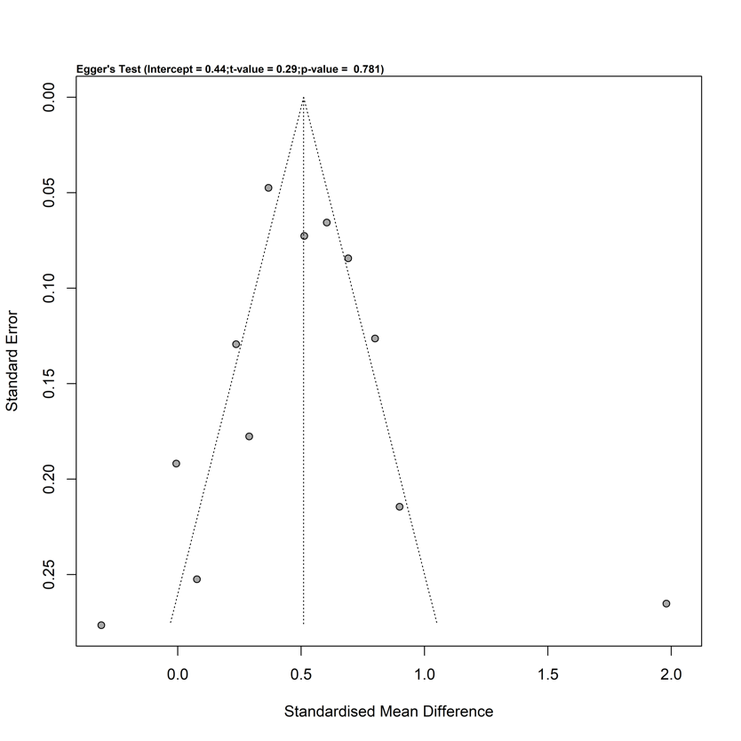

- Mechanical ventilation time (hours)

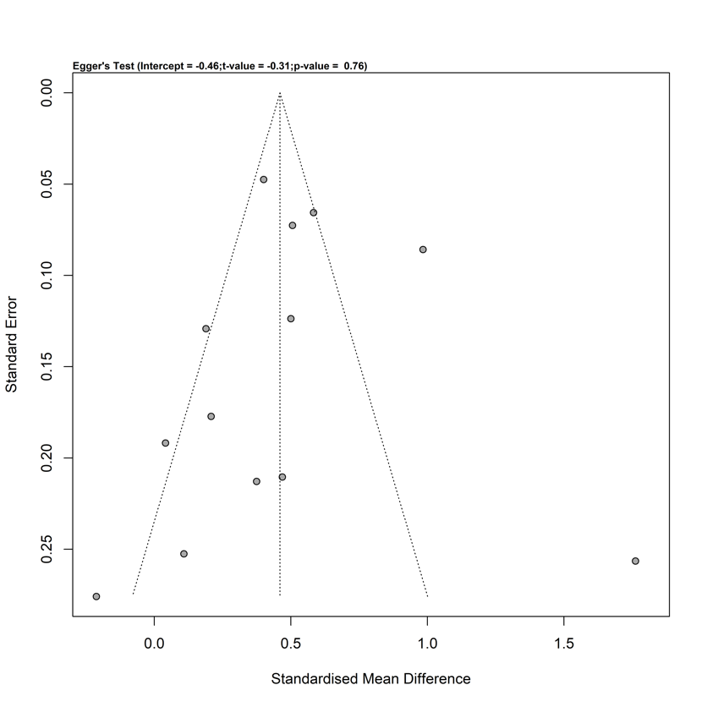

- Mortality (pooled prevalence)

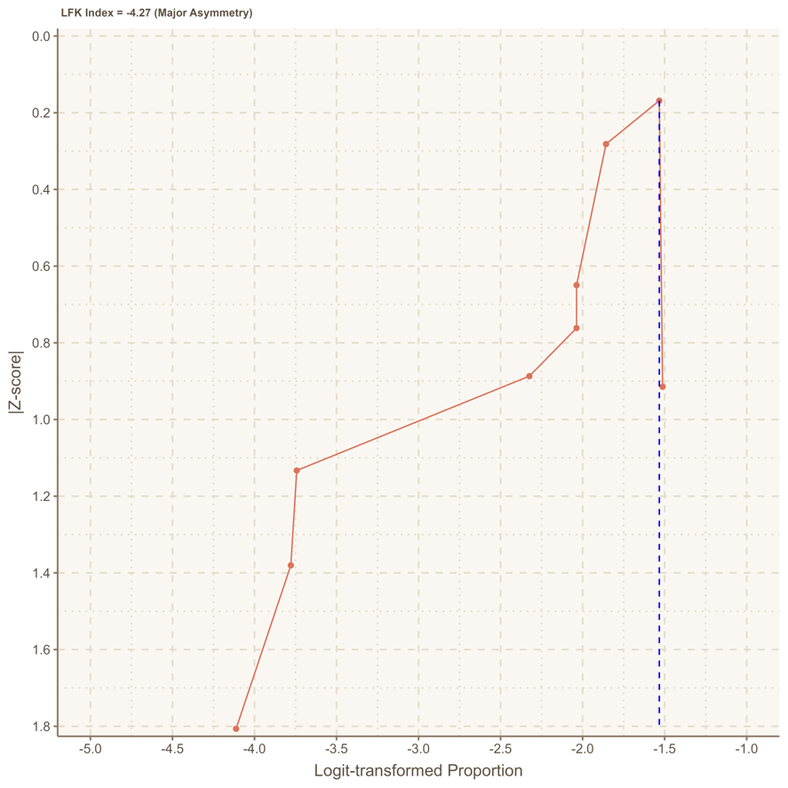

- Age (months)
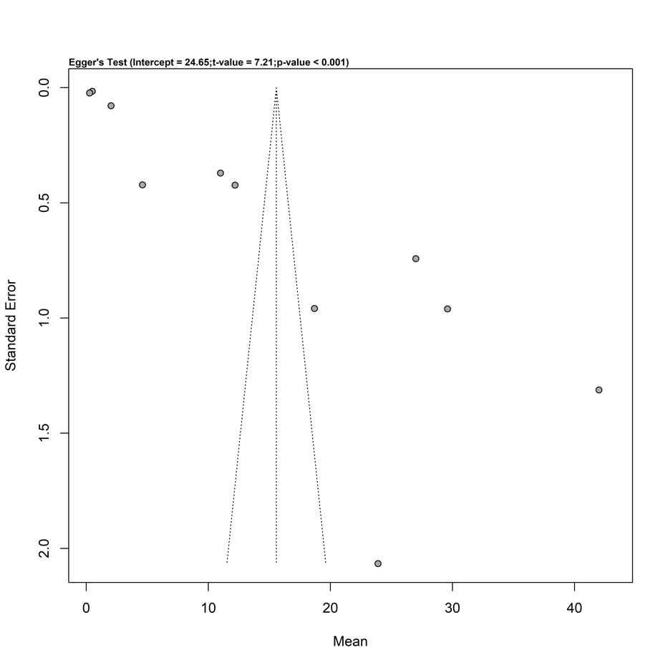

Supplementary Figure S2. Leave-one-out sensitivity analysis

- Length of stay in the hospital (days)
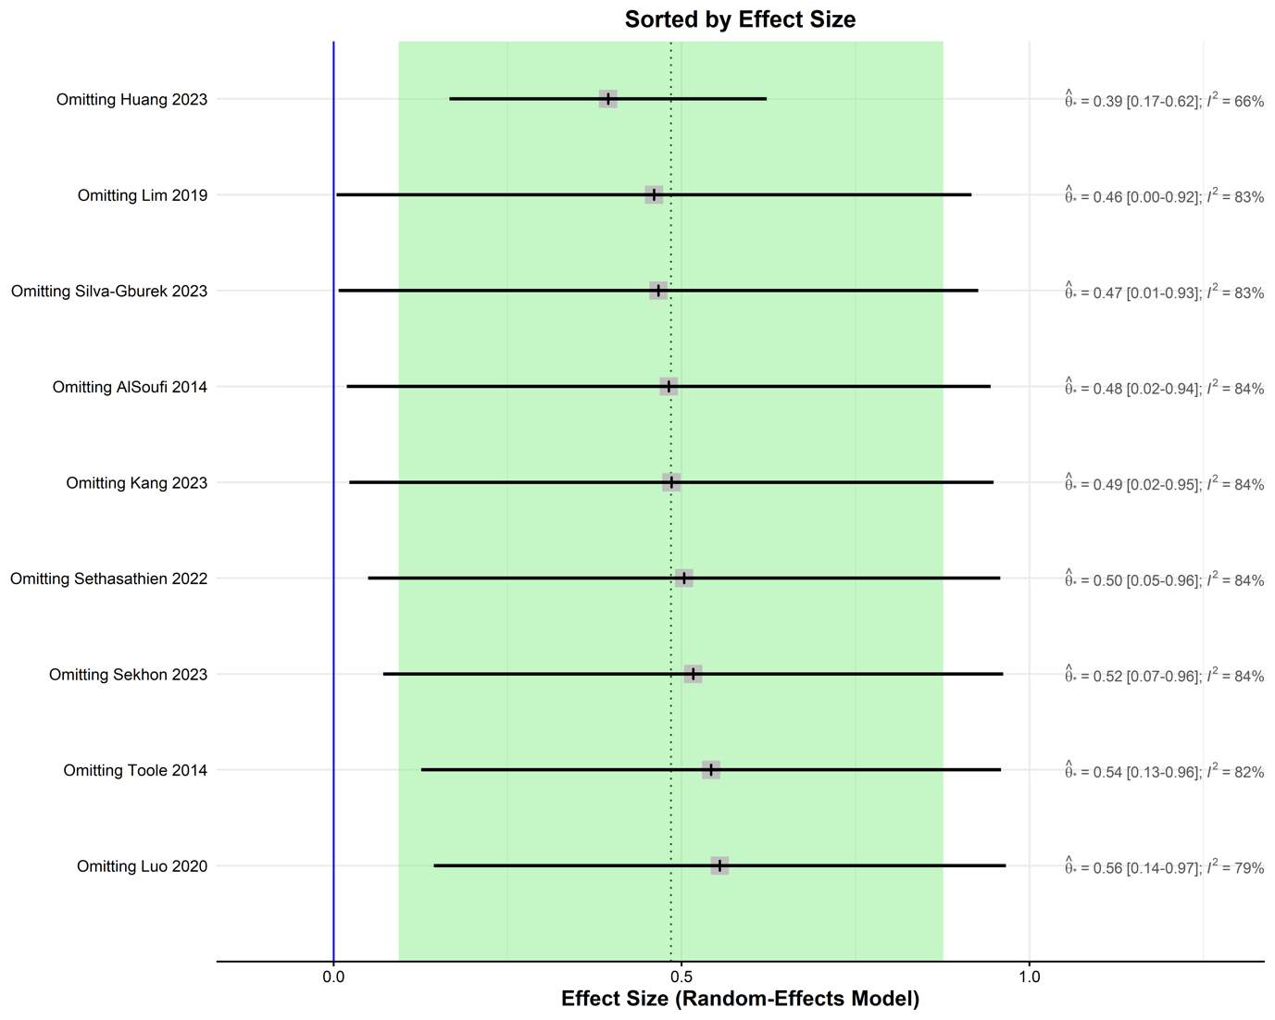

- Length of stay in the intensive care unit (days)
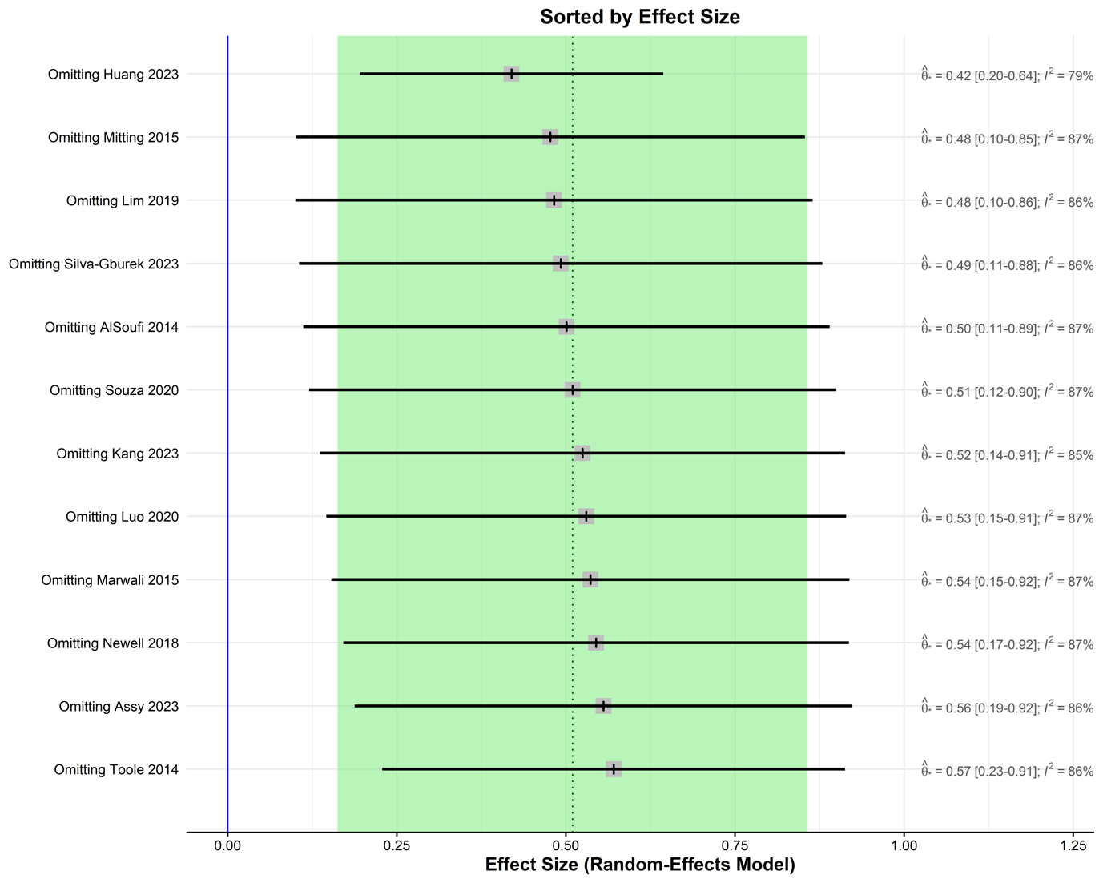

- Risk Adjustment for Congenital Heart Surgery-1 (RACHS-1) or the Society of Thoracic Surgeons-European Association for Cardio-Thoracic Surgery (STAT) score >4
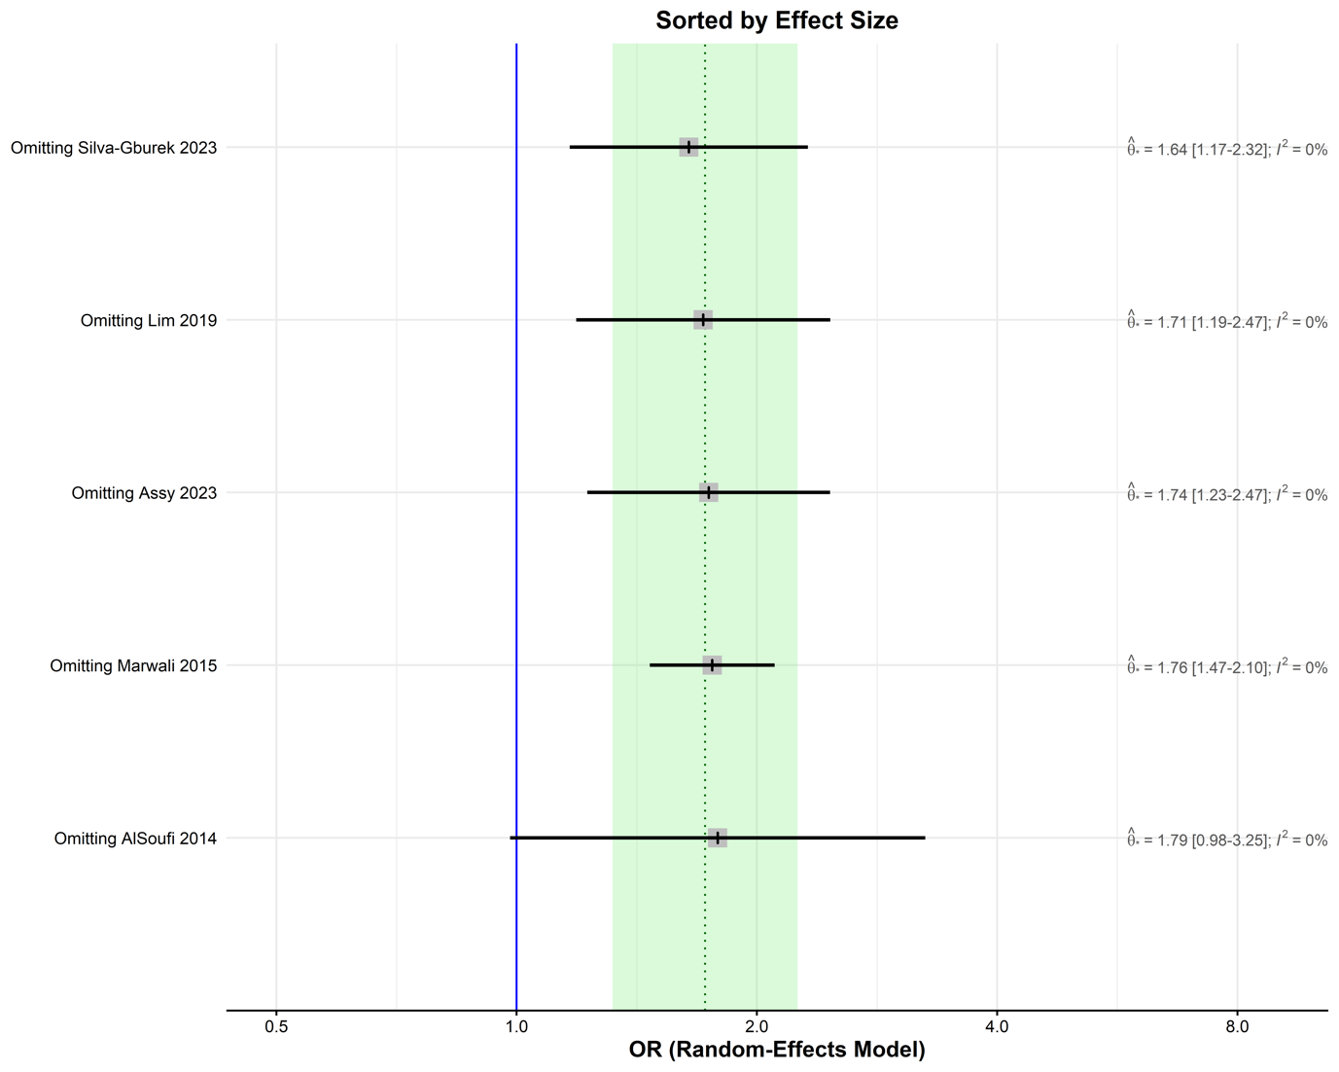

- Mechanical ventilation time (hours)
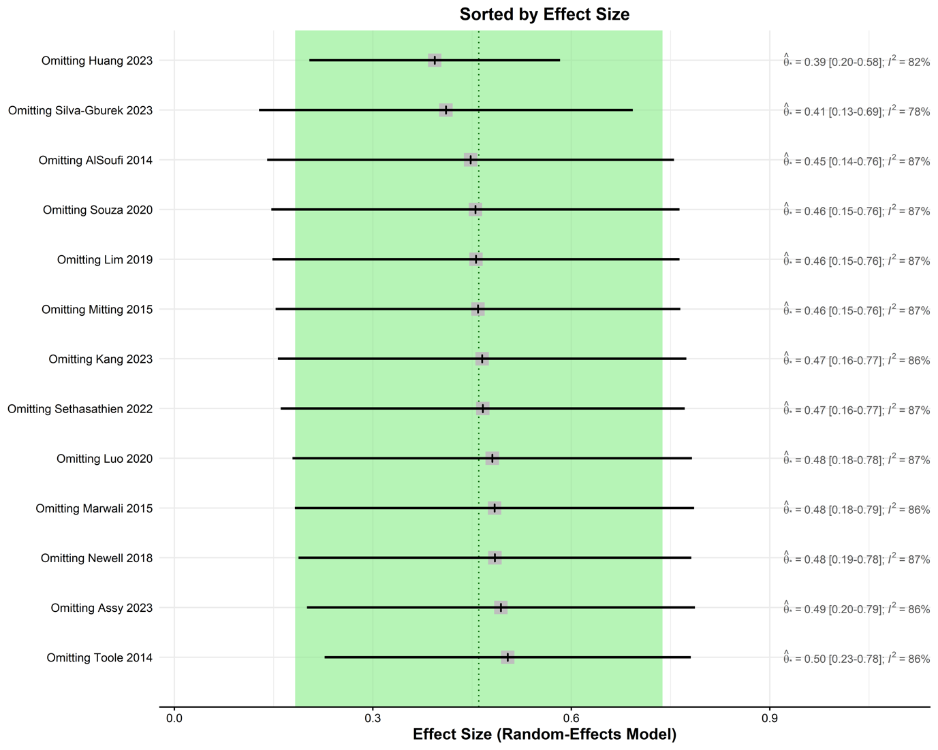

- Mortality (odds ratio between malnourished and well-nourished patients)
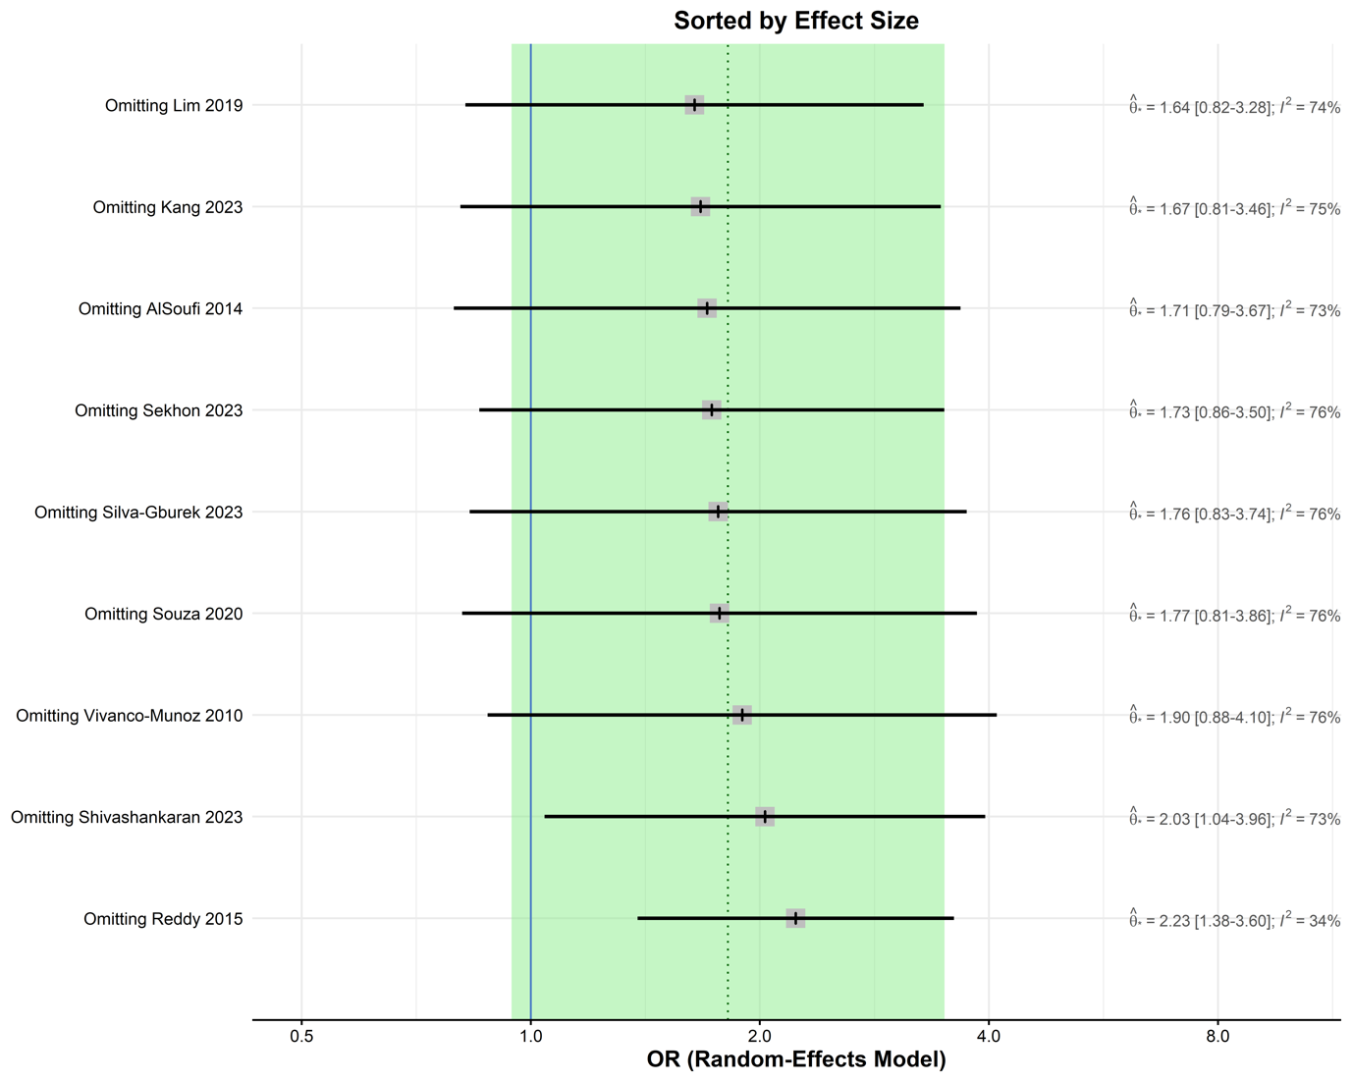

- Post-operative infections (odds ratio between malnourished and well-nourished patients)

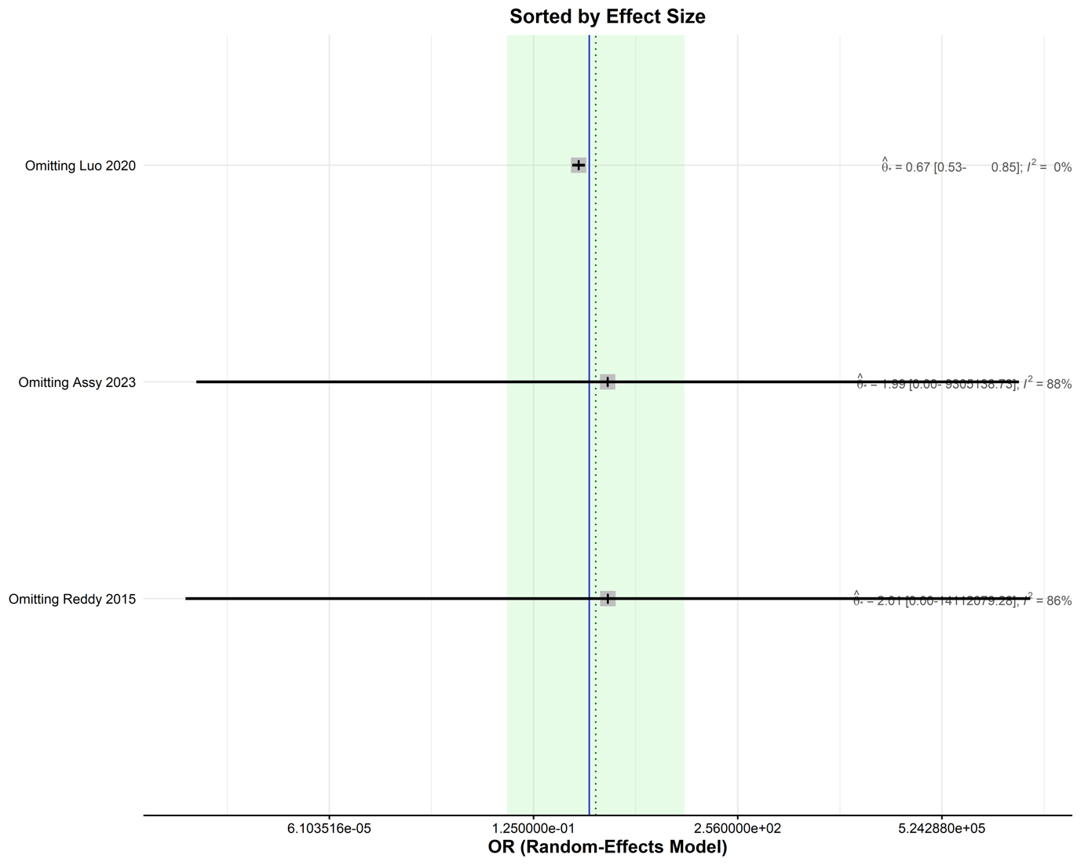

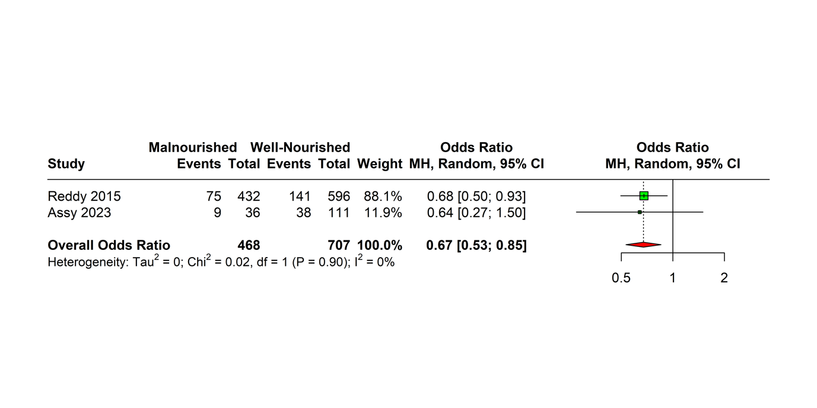

Supplementary Figure S3. Pooled adjusted ratios

Mortality
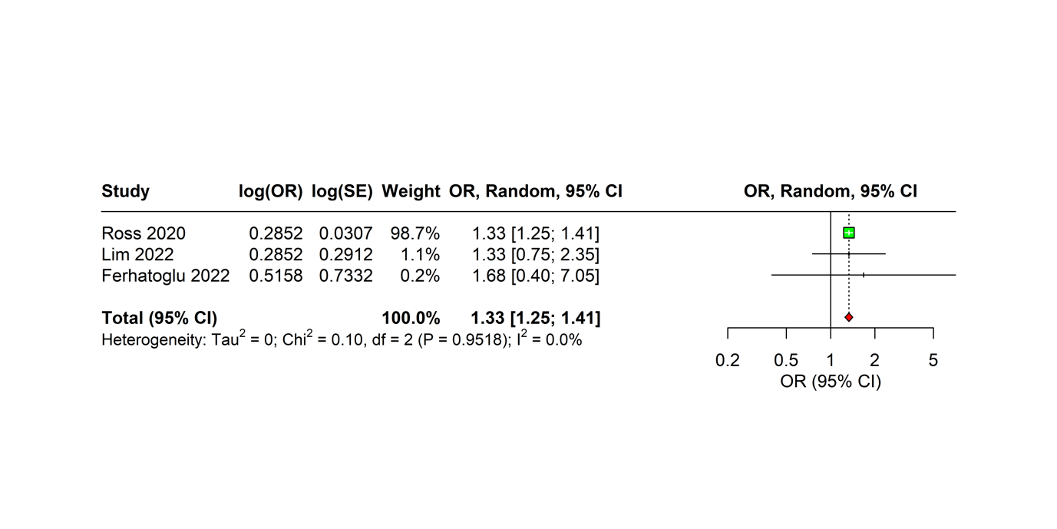

References

1. O’Neal Maynord, P., Johnson, M., Xu, M., Slaughter, J. C. & Killen, S. A. S. A Multi-Interventional Nutrition Program for Newborns with Congenital Heart Disease. J. Pediatr. 228, 66-73.e2 (2021).
2. Newcombe, J. & Fry-Bowers, E. A Post-operative Feeding Protocol to Improve Outcomes for Neonates With Critical Congenital Heart Disease. J. Pediatr. Nurs. Nurs. Care Child. Fam. 35, 139–143 (2017).
3. Luna, A. O. et al. ABNORMAL GROWTH PARAMETERS ARE ASSOCIATED WITH WORSE OUTCOMES IN CHILDREN UNDERGOING CONGENITAL HEART SURGERY IN LOW- AND MIDDLE-INCOME COUNTRIES. J. Am. Coll. Cardiol. 81, 2373 (2023).
4. Godown, J. et al. Abnormal nutrition affects waitlist mortality in infants awaiting heart transplant. J. Heart Lung Transplant. 33, 235–240 (2014).
5. Mara, J. et al. An evaluation of enteral nutrition practices and nutritional provision in children during the entire length of stay in critical care. BMC Pediatr. 14, 186 (2014).
6. Sagiv, E. et al. Assessing the Association Between Pre-operative Feeding and the Development of Oral Feeding Skills in Infants with Single Ventricle Heart Disease: An Analysis of the NPC-QIC Dataset. Pediatr. Cardiol. 43, 1141–1155 (2022).
7. Zheng, Y. et al. Assessment of dietary nutrient intake and its relationship to the nutritional status of children with congenital heart disease in Guangdong province of China. Asia Pac. J. Clin. Nutr. 31, 520–525 (2022).
8. Toh, S. et al. Association between admission body mass index and outcomes in critically ill children: A systematic review and meta-analysis. Clin. Nutr. 40, 2772–2783 (2021).
9. Souza, N. M. G. de et al. Association of nutritional status and clinical outcomes in pediatric cardiac surgery. Acta Paul. Enferm. 33, eAPE20190083 (2020).
10. Rogers, E. J., Gilbertson, H. R., Heine, R. G. & Henning, R. Barriers to adequate nutrition in critically ill children. Nutrition 19, 865–868 (2003).
11. Siemienski, K., Lessen, R., Pohlig, R. & Trabulsi, J. Breastfeeding and Growth in Infants with Congenital Heart Disease. J. Acad. Nutr. Diet. 119, A73 (2019).
12. Weisberg, E. M. Breastfeeding infants with congenital heart disease. (University of Delaware, 2018).
13. Rickman, R. R. Breastfeeding infants with congenital heart disease. (University of Delaware, 2017).
14. Carmona, F. et al. Catch-up growth in children after repair of Tetralogy of Fallot. Cardiol. Young 22, 507–513 (2012).
15. Pentony, M. et al. 826 Challenges in nutrition and growth supporting pre-operative infants undergoing surgical repair of ventricular septal defect and complete atrioventricular septal defect. Arch. Dis. Child. 108, A386–A387 (2023).
16. Gomaa, L. H., Elasheer, O. M. & Mohammed, N. A. Nutritional management in children with congenital heart diseases in Assiut University Children Hospital. J. Curr. Med. Res. Pract. 6, 363 (2021).
17. He, H. et al. Clinical Effect of an Improved Post-Operative Feeding Protocol “in Transition” Infants of Congenital Heart Disease with Pulmonary Hypertension. Congenit. Heart Dis. 16, 655–673 (2021).
18. Menon, S. C. et al. Clinical Outcomes and Resource Use for Infants With Hypoplastic Left Heart Syndrome During Bidirectional Glenn: Summary From the Joint Council for Congenital Heart Disease National Pediatric Cardiology Quality Improvement Collaborative Registry. Pediatr. Cardiol. 34, 143–148 (2013).
19. Spillane, N. T., Kashyap, S., Bateman, D., Weindler, M. & Krishnamurthy, G. Comparison of Feeding Strategies for Infants With Hypoplastic Left Heart Syndrome: A Randomized Controlled Trial. World J. Pediatr. Congenit. Heart Surg. 7, 446–453 (2016).
20. Pierick, A. R., Pierick, T. A. & Reinking, B. E. Comparison of growth and feeding method in infants with and without genetic abnormalities after neonatal cardiac surgery. Cardiol. Young 30, 1826–1832 (2020).
21. Steltzer, M. M., Sussman-Karten, K., Kuzdeba, H. B., Mott, S. & Connor, J. A. Creating Opportunities for Optimal Nutritional Experiences for Infants With Complex Congenital Heart Disease. J. Pediatr. Health Care 30, 599–605 (2016).
22. Zhang, Q.-L., Zhou, S.-J., Chen, X.-H., Cao, H. & Chen, Q. Creating the optimal preoperative nutritional status for neonates undergoing cardiac surgery by implementing a preoperative nutritional support plan. J. Paediatr. Child Health 59, 901–905 (2023).
23. Moon, J. R. et al. Development and Application of a Feeding Program for Infants Postoperatively following Cardiac Surgery. J. Korean Acad. Nurs. 39, 508–517 (2009).
24. Fitria, L., Caesa, P., Joe, J. & Marwali, E. M. Did Malnutrition Affect Post-Operative Somatic Growth in Pediatric Patients Undergoing Surgical Procedures for Congenital Heart Disease? Pediatr. Cardiol. 40, 431–436 (2019).
25. Hansson, L., Öhlund, I., Lind, T., Stecksén-Blicks, C. & Rydberg, A. Dietary intake in infants with complex congenital heart disease: a case–control study on macro- and micronutrient intake, meal frequency and growth. J. Hum. Nutr. Diet. 29, 67–74 (2016).
26. Godown, J. et al. Differential effect of body mass index on pediatric heart transplant outcomes based on diagnosis. Pediatr. Transplant. 18, 771–776 (2014).
27. Sahu, M. K. et al. Early enteral nutrition therapy in congenital cardiac repair postoperatively: A randomized, controlled pilot study. Ann. Card. Anaesth. 19, 653–661 (2016).
28. Shi, H. et al. Early Growth Trajectory of Infants With Simple Congenital Heart Disease and Complex Congenital Heart Disease Undergoing Cardiac Repair: A Prospective Cohort Study in China. J. Parenter. Enter. Nutr. 45, 1181–1191 (2021).
29. Chen, X. et al. Early high-energy feeding in infants following cardiac surgery: a randomized controlled trial. Transl. Pediatr. 10, 2439–2448 (2021).
30. Manuri, L. et al. Early hybrid approach and enteral feeding algorithm could reduce the incidence of necrotising enterocolitis in neonates with ductus-dependent systemic circulation. Cardiol. Young 27, 154–160 (2017).
31. Naik, R. B., Srivastava, C. P., Arsiwala, S., Mathur, A. & Sharma, S. Early outcomes after the on pump bidirectional Glenn procedure: A single center experience. J. Card. Surg. 36, 3207–3214 (2021).
32. Hill, G. D. et al. Effect of feeding modality on interstage growth after stage I palliation: a report from the National Pediatric Cardiology Quality Improvement Collaborative. J. Thorac. Cardiovasc. Surg. 148, 1534–1539 (2014).
33. Aryafar, M., Mahdavi, M., Shahzadi, H. & Nasrollahzadeh, J. Effect of feeding with standard or higher-density formulas on anthropometric measures in children with congenital heart defects after corrective surgery: a randomized clinical trial. Eur. J. Clin. Nutr. 76, 1713–1718 (2022).
34. Effect of malnutrition on length of hospital stay in children. http://turkarchpediatr.org/en/effect-of-malnutrition-on-length-of-hospital-stay-in-children-131184.
35. Liu, J.-F. et al. Effects of different feeding intervals on the feeding outcomes of infants who underwent surgical repair of ventricular septal defects. J. Card. Surg. 36, 4134–4138 (2021).
36. Gioia, G. D. et al. Effects of Malnutrition on Left Ventricular Mass in a North-Malagasy Children Population. PLOS ONE 11, e0154523 (2016).
37. Yoshimura, S. et al. Efficacy of an Enteral Feeding Protocol for Providing Nutritional Support after Paediatric Cardiac Surgery. Anaesth. Intensive Care 43, 587–593 (2015).
38. Zhang, J. et al. Energy and Protein Requirements in Children Undergoing Cardiopulmonary Bypass Surgery: Current Problems and Future Direction. J. Parenter. Enter. Nutr. 43, 54–62 (2019).
39. Nydegger, A. & Bines, J. E. Energy metabolism in infants with congenital heart disease. Nutrition 22, 697–704 (2006).
40. Goday, P. S. et al. Energy- and protein-enriched formula improves weight gain in infants with malnutrition due to cardiac and noncardiac etiologies. J. Parenter. Enter. Nutr. 46, 1270–1282 (2022).
41. Braudis, N. J. et al. Enteral feeding algorithm for infants with hypoplastic left heart syndrome poststage I palliation. Pediatr. Crit. Care Med. 10, 460 (2009).
42. Howley, L. W. et al. Enteral feeding in neonates with prostaglandin-dependent congenital cardiac disease: international survey on current trends and variations in practice. Cardiol. Young 22, 121–127 (2012).
43. Natarajan, G., Reddy Anne, S. & Aggarwal, S. Enteral Feeding of Neonates with Congenital Heart Disease. Neonatology 98, 330–336 (2010).
44. Tume, L. N. et al. Enteral Feeding Practices in Infants With Congenital Heart Disease Across European PICUs: A European Society of Pediatric and Neonatal Intensive Care Survey*. Pediatr. Crit. Care Med. 19, 137 (2018).
45. Hofner, G., Behrens, R., Koch, A., Singer, H. & Hofbeck, M. Enteral Nutritional Support by Percutaneous Endoscopic Gastrostomy in Children with Congenital Heart Disease. Pediatr. Cardiol. 21, 341–346 (2000).
46. Zhang, Y. et al. Evaluation of a new digital pediatric malnutrition risk screening tool for hospitalized children with congenital heart disease. BMC Pediatr. 23, 126 (2023).
47. Zhang, Y. Evaluation Of A New Digital Pediatric Malnutrition Screening Tool For Hospitalized Children With Congenital Heart Disease. Clin. Nutr. ESPEN 54, 540 (2023).
48. REBEC. https://ensaiosclinicos.gov.br/rg/RBR-9tn862.
49. Blasquez, A. et al. Evaluation of nutritional status and support in children with congenital heart disease. Eur. J. Clin. Nutr. 70, 528–531 (2016).
50. Exclusive Human Milk Feeding in Infants With Single Ventricle Physiology (H-36602). https://www.bcm.edu/healthcare/clinical-trials/h-36602 (2017).
51. Shi, H. et al. Explainable machine learning model for predicting the occurrence of postoperative malnutrition in children with congenital heart disease. Clin. Nutr. 41, 202–210 (2022).
52. Sundar, V. V., Allavudin, S. F. S. & Easaw, M. E. P. M. Factors influencing adequate protein and energy delivery among critically ill children with heart disease in pediatric intensive care unit. Clin. Nutr. ESPEN 43, 353–359 (2021).
53. Wheeler, D., Dent, C., Manning, P. & Nelson, D. Factors prolonging length of stay in the cardiac intensive care unit following the arterial switch operation. Cardiol. Young (2008).
54. Malviya, A., Kalita, J. P., Jha, P. K. & Mishra, A. Fatal complication of ductal arteritis in a malnourished child. Indian Heart J. 68, S241–S242 (2016).
55. Kalra, R. et al. Feasibility of initiating early enteral nutrition after congenital heart surgery in neonates and infants. Clin. Nutr. ESPEN 25, 100–102 (2018).
56. Wolovits, J. S. & Torzone, A. Feeding and nutritional challenges in infants with single ventricle physiology. Curr. Opin. Pediatr. 24, 295 (2012).
57. Hoch, J. M., Fatusin, O., Yenokyan, G., Thompson, W. R. & Lefton-Greif, M. A. Feeding methods for infants with single ventricle physiology are associated with length of stay during stage 2 surgery hospitalization. Congenit. Heart Dis. 14, 438–445 (2019).
58. Jones, C. et al. Feeding outcomes in post-discharge feeding clinic for infants following cardiac surgery. Cardiol. Young 32, 628–635 (2022).
59. Medoff-Cooper, B., Naim, M., Torowicz, D. & Mott, A. Feeding, growth, and nutrition in children with congenitally malformed hearts. Cardiol. Young 20, 149–153 (2010).
60. Hames, D. L. et al. Fluid Restriction Contributes to Poor Nutritional Adequacy in Patients With Congenital Heart Disease Receiving Renal Replacement Therapy. J. Ren. Nutr. 32, 78–86 (2022).
61. Li, X. et al. Growth and development of children under 5 years of age with tetralogy of Fallot in a Chinese population. Sci. Rep. 11, 14255 (2021).
62. Shine, A. M., Foyle, L., Gentles, E., Ward, F. & McMahon, C. J. Growth and Nutritional Intake of Infants with Univentricular Circulation. J. Pediatr. 237, 79-86.e2 (2021).
63. da Silva, V. M., de Oliveira Lopes, M. V. & de Araujo, T. L. Growth and Nutritional Status of Children With Congenital Heart Disease. J. Cardiovasc. Nurs. 22, 390 (2007).
64. Trivedi, A., Browning Carmo, K., James-Nunez, K., Jatana, V. & Gordon, A. Growth and risk of adverse neuro-developmental outcome in newborns with congenital heart disease: A single-centre retrospective study. Early Hum. Dev. 183, 105798 (2023).
65. Paneitz, D. C. et al. Growth Differentiation Factor 15: A Novel Growth Biomarker for Children With Congenital Heart Disease. World J. Pediatr. Congenit. Heart Surg. 13, 745–751 (2022).
66. Daymont, C., Neal, A., Prosnitz, A. & Cohen, M. S. Growth in Children With Congenital Heart Disease. Pediatrics 131, e236–e242 (2013).
67. Costello, C. L., Gellatly, M., Daniel, J., Justo, R. N. & Weir, K. Growth Restriction in Infants and Young Children with Congenital Heart Disease. Congenit. Heart Dis. 10, 447–456 (2015).
68. Maya, S., Gunawijaya, E., Yantie, N. P. V. K. & Windiani, I. G. A. T. Growth, Development, and Quality of Life in Children with Congenital Heart Disease Children. Open Access Maced. J. Med. Sci. 8, 613–618 (2020).
69. Ni, P. et al. High-Energy Enteral Nutrition in Infants After Complex Congenital Heart Surgery. Front. Pediatr. 10, (2022).
70. Castleberry, C. et al. Hypoalbuminemia and poor growth predict worse outcomes in pediatric heart transplant recipients. Pediatr. Transplant. 18, 280–287 (2014).
71. Gongwer, R. C., Gauvreau, K., Huh, S. Y., Sztam, K. A. & Jenkins, K. J. Impact of a Standardized Clinical Assessment and Management Plan (SCAMP®) on growth in infants with CHD. Cardiol. Young 28, 1093–1098 (2018).
72. Staehler, H. et al. Impact of calorie intake and weight gain after Norwood procedure on the outcome of stage II palliation. Cardiol. Young 34, 876–883 (2024).
73. Khan, A. et al. Impact of International Quality Improvement Collaborative on Congenital Heart Surgery in Pakistan. Heart 103, 1680–1686 (2017).
74. Nicholson, G. T. et al. Impact of Palliation Strategy on Interstage Feeding and Somatic Growth for Infants With Ductal-Dependent Pulmonary Blood Flow: Results from the Congenital Catheterization Research Collaborative. J. Am. Heart Assoc. 9, e013807 (2020).
75. Hong, B. J. et al. Impact of postoperative nutrition on weight gain in infants with hypoplastic left heart syndrome. J. Thorac. Cardiovasc. Surg. 147, 1319–1325 (2014).
76. Gu, Y. et al. Implementation of an Evidence-Based Guideline of Enteral Nutrition for Infants With Congenital Heart Disease: A Controlled Before-and-After Study*. Pediatr. Crit. Care Med. 21, e369 (2020).
77. Kaufman, J. et al. Improved Nutrition Delivery and Nutrition Status in Critically Ill Children With Heart Disease. Pediatrics 135, e717–e725 (2015).
78. Stenbøg, E. V. et al. Improvement in growth, and levels of insulin-like growth factor-I in the serum, after cavopulmonary connections. Cardiol. Young 10, 440–446 (2000).
79. Marino, L. V. et al. Improving growth of infants with congenital heart disease using a consensus-based nutritional pathway. Clin. Nutr. 39, 2455–2462 (2020).
80. Piggott, K. D. et al. Inadequate preoperative nutrition might be associated with acute kidney injury and greater illness severity postoperatively. J. Thorac. Cardiovasc. Surg. 155, 2104–2109 (2018).
81. ISRCTN - ISRCTN10130540: Investigating the effect of adequate energy and protein intake for children after cardiopulmonary bypass surgery. https://www.isrctn.com/ISRCTN10130540 doi:10.1186/ISRCTN10130540.
82. Rooze, S. et al. Is a semi-elemental diet better than a polymeric diet after congenital heart surgery? Eur. J. Pediatr. 179, 423–430 (2020).
83. Butto, A. et al. Longitudinal growth in patients with single ventricle cardiac disease receiving tube-assisted feeds. Congenit. Heart Dis. 14, 1058–1065 (2019).
84. Larsen, B. M. K. et al. Low Energy Intakes Are Associated With Adverse Outcomes in Infants After Open Heart Surgery. J. Parenter. Enter. Nutr. 37, 254–260 (2013).
85. De Staebel, O. Malnutrition in Belgian children with congenital heart disease on admission to hospital. J. Clin. Nurs. 9, 784–791 (2000).
86. Vaidyanathan, B. et al. Malnutrition in children with congenital heart disease (CHD) determinants and short term impact of corrective intervention. Indian Pediatr. 45, 541–546 (2008).
87. Beke, D. M., Braudis, N. J. & Lincoln, P. Management of the pediatric postoperative cardiac surgery patient. Crit. Care Nurs. Clin. North Am. 17, 405–416, xi (2005).
88. Argent, A. C., Balachandran, R., Vaidyanathan, B., Khan, A. & Kumar, R. K. Management of undernutrition and failure to thrive in children with congenital heart disease in low- and middle-income countries. Cardiol. Young 27, S22–S30 (2017).
89. Correia, G. D. S. et al. Metabolic Profiling of Children Undergoing Surgery for Congenital Heart Disease. Crit. Care Med. 43, 1467 (2015).
90. Chaloupecký, V. et al. Nitrogen balance, 3-methylhistidine excretion, and plasma amino acid profile in infants after cardiac operations for congenital heart defects: The effect of early nutritional support. J. Thorac. Cardiovasc. Surg. 114, 1053–1060 (1997).
91. Rahmati Najarkolaei, F., Ghaffarpasand, E., Gholami Fesharaki, M. & Jonaidi Jafari, N. Nutrition and physical activity educational intervention on CHD risk factors: a systematic review study. Arch. Iran. Med. 18, 51–57 (2015).
92. Wakita, M., Fukatsu, A. & Amagai, T. Nutrition assessment as a predictor of clinical outcomes for infants with cardiac surgery: using the prognostic nutritional index. Nutr. Clin. Pract. Off. Publ. Am. Soc. Parenter. Enter. Nutr. 26, 192–198 (2011).
93. Tsintoni, A., Dimitriou, G. & Karatza, A. A. Nutrition of neonates with congenital heart disease: existing evidence, conflicts and concerns. J. Matern. Fetal Neonatal Med. 33, 2487–2492 (2020).
94. Pan, L. et al. Nutrition risk profile of 62 408 inpatients based on electronic health records in a tertiary children’s hospital. Nutrition 85, 111137 (2021).
95. Singal, A., Sahu, M., Chalattil, B. & Kumar, G. Nutritional Challenges in Pediatric Congenital Cardiac Care. 172 (2019).
96. Horsley, M., Pathak, S., Morales, D., Lorts, A. & Mouzaki, M. Nutritional outcomes of patients with pediatric and congenital heart disease requiring ventricular assist devices. J. Parenter. Enter. Nutr. 46, 1553–1558 (2022).
97. Shahid, R., Liu, W. & Amdani, S. (1132) Nutritional Risk Index - A Novel Objective Nutritional Assessment Tool That Identifies Children at Increased Risk for Worse Outcomes after Heart Transplant. J. Heart Lung Transplant. 42, S486 (2023).
98. Woldesenbet, R., Murugan, R., Mulugeta, F. & Moges, T. Nutritional status and associated factors among children with congenital heart disease in selected governmental hospitals and cardiac center,Addis Ababa Ethiopia. BMC Pediatr. 21, 538 (2021).
99. Aghaei-Moghadam, E. et al. Nutritional Status in Iranian Non-Syndromic Patients with Acyanotic Congenital Heart Disease Undergoing Surgical Repair. J. Compr. Pediatr. 10, (2019).
100. Mirzaaghayan, M. R., Ghamari, A., Salimi, A. & Moghadam, E. A. Nutritional Status in Non-Syndromic Cyanotic Congenital Heart Diseases Patients: A Single Tertiary Center Study in Iran. Iran. J. Pediatr. 30, (2020).
101. Monteiro, F. P. M. et al. Nutritional status of children with congenital heart disease. Rev. Lat. Am. Enfermagem 20, 1024–1032 (2012).
102. Ratanachu-Ek, S. & Pongdara, A. Nutritional status of pediatric patients with congenital heart disease: pre- and post cardiac surgery. J. Med. Assoc. Thail. Chotmaihet Thangphaet 94 Suppl 3, S133-137 (2011).
103. Vaidyanathan, B. et al. Outcome of ventricular septal defect repair in a developing country. J. Pediatr. 140, 736–741 (2002).
104. Steward, D. K., Ryan-Wenger, N., Harrison, T. M. & Pridham, K. F. Patterns of Growth and Nutrition From Birth to 6 Months in Infants With Complex Congenital Cardiac Defects. Nurs. Res. 69, S57 (2020).
105. Alten, J. A. et al. Perioperative feeding management of neonates with CHD: analysis of the Pediatric Cardiac Critical Care Consortium (PC4) registry. Cardiol. Young 25, 1593–1601 (2015).
106. Westin, V., Stoltz Sjöström, E., Ahlsson, F., Domellöf, M. & Norman, M. Perioperative nutrition in extremely preterm infants undergoing surgical treatment for patent ductus arteriosus is suboptimal. Acta Paediatr. 103, 282–288 (2014).
107. Westin, V., Vanpée, M., Norman, M. & Sjöström, E. S. Perioperative nutrition in extremely preterm infants undergoing surgery for patent ductus arteriosus. Clin. Nutr. Exp. 33, 60–71 (2020).
108. El-Ganzoury, M. M., El-Farrash, R. A., Ahmed, G. F., Hassan, S. I. & Barakat, N. M. Perioperative nutritional prehabilitation in malnourished children with congenital heart disease: A randomized controlled trial. Nutr. Burbank Los Angel. Cty. Calif 84, 111027 (2021).
109. Koth, A. M. et al. Postoperative feeding problems in patients with tetralogy of Fallot, pulmonary atresia, and major aortopulmonary collaterals undergoing unifocalisation surgery. Cardiol. Young 28, 1329–1332 (2018).
110. Aryafar, M., Mahdavi, M., Shahzadi, H., Gabeleh, F. & Nasrollahzadeh, J. Pre-operative nutritional status and its association with short-term post-operative outcomes in Iranian children with CHD. Cardiol. Young 33, 579–589 (2023).
111. Pinheiro, P. de S., Azevedo, V. M. P. & Rocha, G. Predicting Factors of Surgical Mortality in Children and Adolescents Undergoing Correction of Tetralogy of Fallot. Int J Cardiovasc Sci 36, (2022).
112. Anderson, J. B. et al. Predictors of Poor Weight Gain in Infants with a Single Ventricle. J. Pediatr. 157, 407-413.e1 (2010).
113. Brief, F. et al. Prevalence and Associated Factors of Long-term Growth Failure in Infants with Congenital Heart Disease Who Underwent Cardiac Surgery Before the Age of One. Pediatr. Cardiol. 43, 1681–1687 (2022).
114. Yahya, S. Prevalence and factors associated with undernutrition among children with congenital heart disease at three tertiary hospitals in Nairobi, Kenya. Theses Diss. (2022).
115. Viswanathan, S., Ong, K. J. F. & Kakavand, B. Prevalence and Risk Factors for Tube-Feeding at Discharge in Infants following Early Congenital Heart Disease Surgery: A Single-Center Cohort Study. Am. J. Perinatol. 41, e2832–e2841 (2023).
116. Payne, E. et al. Prolonged Enteral Tube Feeding in Infants With a Functional Single Ventricle Is Associated With Adverse Outcomes After Fontan Completion. J. Pediatr. 257, (2023).
117. Avitzur, Y. et al. Resting energy expenditure in children with cyanotic and noncyanotic congenital heart disease before and after open heart surgery. J. Parenter. Enter. Nutr. 27, 47–51 (2003).
118. Sohn, A. H. et al. Risk factors and risk adjustment for surgical site infections in pediatric cardiothoracic surgery patients. Am. J. Infect. Control 38, 706–710 (2010).
119. Seo, Y. M., Sung, I. K. & Yum, S. K. Risk factors associated with prolonged mechanical ventilation after surgical patent ductus arteriosus ligation in preterm infants. J. Matern. Fetal Neonatal Med. 35, 3714–3721 (2022).
120. Kesumarini, D., Widyastuti, Y., Boom, C. E. & Dinarti, L. K. Risk Factors Associated With Prolonged Mechanical Ventilation and Length of Stay After Repair of Tetralogy of Fallot. World J. Pediatr. Congenit. Heart Surg. 15, 81–88 (2024).
121. Rosanova, M. T. et al. Risk factors for infection after cardiovascular surgery in children in Argentina. Braz. J. Infect. Dis. 13, 414–416 (2009).
122. Vivanco-Muñoz, N., Talavera, J. O., Juanico-Enríquez, A. & Clark, P. Risk factors for nosocomial infections in children who had open-heart surgery. J. Pediatr. Infect. Dis. 5, 339–345 (2010).
123. Zhang, M. et al. Risk factors of malnutrition in Chinese children with congenital heart defect. BMC Pediatr. 20, 213 (2020).
124. Leite, H. P., Fisberg, M., de Carvalho, W. B. & de Camargo Carvalho, A. C. Serum albumin and clinical outcome in pediatric cardiac surgery. Nutrition 21, 553–558 (2005).
125. Short stature among children undergoing cardiac surgery for congenital heart defects. Arch. Argent. Pediatr. 117, (2019).
126. Tesfaye, K. & Tsega, T. Short-Term Impact of Cardiac Intervention on the Nutritional Status of Malnourished Children with Congenital Heart Disease &ndash; A Report from a Developing African Country, Ethiopia. Pediatr. Health Med. Ther. 14, 465–475 (2023).
127. Xu, L.-P., Lin, S.-H., Zhang, Q.-L., Zheng, Y. & Lin, G. Short-Term Nutritional Support Improves The Preoperative Nutritional Status of Infants With Non-Restrictive Ventricular Septal Defect: A Prospective Controlled Study. Heart Surg. Forum 25, E745–E749 (2022).
128. Ono, M. et al. Somatic development long after the Fontan operation: Factors influencing catch-up growth. J. Thorac. Cardiovasc. Surg. 134, 1199-1206.e2 (2007).
129. Tokel, K. et al. Somatic growth after corrective surgery for congenital heart disease. Turk. J. Pediatr. 52, 58–67 (2010).
130. Vaidyanathan, B. et al. Somatic growth after ventricular septal defect in malnourished infants. J. Pediatr. 149, 205–209 (2006).
131. Lisanti, A. J. et al. Standardized Feeding Approach Mitigates Weight Loss in Infants with Congenital Heart Disease. J. Pediatr. 231, 124-130.e1 (2021).
132. Menon, G. Studies of nutrition and growth in infants with chronic cardiopulmonary disease. (2005).
133. Secker, D. J. & Jeejeebhoy, K. N. Subjective Global Nutritional Assessment for children2. Am. J. Clin. Nutr. 85, 1083–1089 (2007).
134. Di Maria, M. V. et al. Supplemental Tube Feeding Does Not Mitigate Weight Loss in Infants with Shunt-Dependent Single-Ventricle Physiology. Pediatr. Cardiol. 34, 1350–1356 (2013).
135. Tefuarani, N., Hawker, R., Vince, J., Sleigh, A. & Williams, G. Surgical programme at Royal Alexandra Hospital, Sydney, for Papua New Guinea children with congenital heart disease, 1978–1994. J. Paediatr. Child Health 38, 178–182 (2002).
136. Floh, A. A. et al. Systemic Inflammation Increases Energy Expenditure Following Pediatric Cardiopulmonary Bypass. Pediatr. Crit. Care Med. 16, 343 (2015).
137. Zhang, Q.-L., Lei, Y.-Q., Liu, J.-F., Chen, Q. & Cao, H. Telehealth education improves parental care ability and postoperative nutritional status of infants after CHD surgery: A prospective randomized controlled study. Paediatr. Child Health 27, 154–159 (2022).
138. Furlong-Dillard, J. M. et al. The association between feeding protocol compliance and weight gain following high-risk neonatal cardiac surgery. Cardiol. Young 29, 594–601 (2019).
139. Salim, M. et al. The Effect of Cardiac Catheterization Intervention on The Nutritional Status of Children with Acyanotic Congenital Heart Disease. Pharmacogn. J. 15, 338–342 (2023).
140. Surmeli-Onay, O. et al. The effect of corrective surgery on serum IGF-1, IGFBP-3 levels and growth in children with congenital heart disease. J. Pediatr. Endocrinol. Metab. 24, 483–487 (2011).
141. The Effect of High-Calorie Formula on Nutritional and Clinical Outcomes Among Infants After Congenital Heart Surgery. ctv.veeva.com https://ctv.veeva.com/study/the-effect-of-high-calorie-formula-on-nutritional-and-clinical-outcomes-among-infants-after-congenit.
142. Marwali, E. M., Kekalih, A. & Haas, N. A. The effect of malnutrition on T3 levels in pediatric patients undergoing congenital heart surgery. Crit. Care Shock 15, 104–110 (2012).
143. Geukers, V. G. et al. The effect of short-term high versus normal protein intake on whole-body protein synthesis and balance in children following cardiac surgery: a randomized double-blind controlled clinical trial. Nutr. J. 14, 72 (2015).
144. Tasci, O. The Effect of Transcatheter Ventricular Septal Defect Closure on Children’s Appetite, Hormones and Growth. Erciyes Med. J. (2022) doi:10.14744/etd.2022.41848.
145. Mcneil, D. The Incidence and Correlates of Feeding Problems in Premature Infants Post Neonatal Intensive Care. in (2008).
146. Pan, L. et al. Nutrition risk profile of 62 408 inpatients based on electronic health records in a tertiary children’s hospital. Nutrition 85, 111137 (2021).
147. Hossain, Dr. M. M., Mamun, Dr. Md. B. A. & Ahmed, Dr. S. The Prevalence of Malnutrition and its Impact on Children with Congenital Heart Disease in Post Cardiac Surgery. Sch. J. Appl. Med. Sci. 9, 1782–1785 (2021).
148. Kataria-Hale, J. et al. The Relationship Between Preoperative Feeding Exposures and Postoperative Outcomes in Infants With Congenital Heart Disease. Pediatr. Crit. Care Med. J. Soc. Crit. Care Med. World Fed. Pediatr. Intensive Crit. Care Soc. 22, e91–e98 (2021).
149. Alshehri, A., Afshar, K., Bedford, J., Hintz, G. & Skarsgard, E. D. The relationship between preoperative nutritional state and adverse outcome following abdominal and thoracic surgery in children: Results from the NSQIP database. J. Pediatr. Surg. 53, 1046–1051 (2018).
150. Pons Leite, H., Fisberg, M., Gilberto Henriques Vieira, J., Brunow De Carvalho, W. & Chwals, W. J. The role of insulin-like growth factor I, growth hormone, and plasma proteins in surgical outcome of children with congenital heart disease. Pediatr. Crit. Care Med. 2, 29 (2001).
151. Battersby, C. et al. The United Kingdom National Neonatal Research Database: A validation study. PLOS ONE 13, e0201815 (2018).
152. Shamir, R. et al. Thiamine deficiency in children with congenital heart disease before and after corrective surgery. JPEN J. Parenter. Enteral Nutr. 24, 154–158 (2000).
153. To Assess the Efficacy of Early Administration of Energy Enriched and Protein Enriched Formula in Post Cardiac Repair Infants: a Randomized Controlled Trial, Comparative Study. ctv.veeva.com https://ctv.veeva.com/study/to-assess-the-efficacy-of-early-administration-of-energy-enriched-and-protein-enriched-formula-in-po.
154. Schidlow, D. N. et al. Transposition of the Great Arteries in the Developing World: Surgery and Outcomes. J. Am. Coll. Cardiol. 69, 43–51 (2017).
155. Lin, Y.-F. et al. Using Human Milk Fortifiers to Improve the Preoperative Nutritional Status of Infants With Non-restricted Ventricular Septal Defect. Front. Pediatr. 10, (2022).
156. Batte, A. et al. Wasting, underweight and stunting among children with congenital heart disease presenting at Mulago hospital, Uganda. BMC Pediatr. 17, 10 (2017).
157. Medoff-Cooper, B. et al. Weight change in infants with a functionally univentricular heart: from surgical intervention to hospital discharge. Cardiol. Young 21, 136–144 (2011).
158. Verger, J. Weight, energy expenditure and energy intake in infants with congenital heart disease post cardiac surgery. Diss. Available ProQuest (2006).
159. Vaidyanathan, B., Radhakrishnan, R., Sarala, D. A., Sundaram, K. R. & Kumar, R. K. What Determines Nutritional Recovery in Malnourished Children After Correction of Congenital Heart Defects? Pediatrics 124, e294–e299 (2009).
160. Ni, P., Zhang, M., Wu, Y., Luo, W. & Xu, Z. What is the postoperative nutrition intake in children with congenital heart disease? A single-center analysis in China. BMC Pediatr. 22, 470 (2022).
161. Yavuz, Y. & Ukil Isildak, F. Preoperative nutritional status effects postoperative outcome in patients undergoing surgery for congenital heart disease. Nutr. Clin. Métabolisme 35, 253–259 (2021).
162. Elbarbary, M. et al. 253: EFFECT OF NUTRITIONAL STATUS OF CHILDREN WITH CONGENITAL HEART DISEASE ON POST-OPERATIVE OUTCOME. Crit. Care Med. 43, 65 (2015).
163. Hill, R. Nutritional status and its relationship with infection-related complications in children after cardiac surgery. (University of Central Lancashire, 2019).

