Supplementary Information

Discovery of Z1362873773: A Novel Fascin Inhibitor from a Large Chemical Library for Colorectal Cancer
Alejandro Rodríguez-Martínez¹, Lucía Giraldo-Ruiz², Maria C. Ramos³, Irene Luque², Diogo Ribeiro⁴, Fátima Postigo-Corrales⁴, Begoña Alburquerque-González⁴, Silvia Montoro-García⁴, Ana Belén Arroyo-Rodríguez⁵, Pablo Conesa-Zamora^{4,5}, Ana María Hurtado³, Ginés Luengo-Gil^{4,5,*}, Horacio Pérez-Sánchez^{1,*}

¹ Structural Bioinformatics and High Performance Computing Research Group (BIO-HPC), UCAM Universidad Católica de Murcia (UCAM), 30107 Murcia, Spain
² Departamento de Química Física, Instituto de Biotecnología y Unidad de Excelencia de Química aplicada a Biomedicina y Medioambiente Universidad de Granada. Campus Fuentenueva s/n 18071 Granada, Spain
³ Fundación MEDINA, PTS Health Sciences Technology Park, Avenida del Conocimiento 34, 18016, Granada, Spain
⁴ Genetics, Molecular Pathology and Rare Diseases Research Group, Universidad Católica de Murcia (UCAM); Guadalupe, 30107, Spain
⁵ Molecular Pathology and Pharmacogenetics Research Group, Instituto Murciano de Investigación Biosanitaria (IMIB), Hospital General Universitario Santa Lucía; Cartagena, 30202, Spain

* Corresponding authors: hperez@ucam.edu, gluengo@ucam.edu

Table of Contents
Ligand-based virtual screening by Ligand Scout 2
DSF Reveals Potential Destabilization of Fascin by Z1362873773 Compound 3
Organoids 5
Molecular modeling and docking 6
MD simulation analysis for Fascin-Z1362873773 and Fascin-NP-G2-029 complexes 7
Drug-like property predictions 15
Feasibility of the synthesis pathways for Z1362873773 20

Ligand-based virtual screening by Ligand Scout

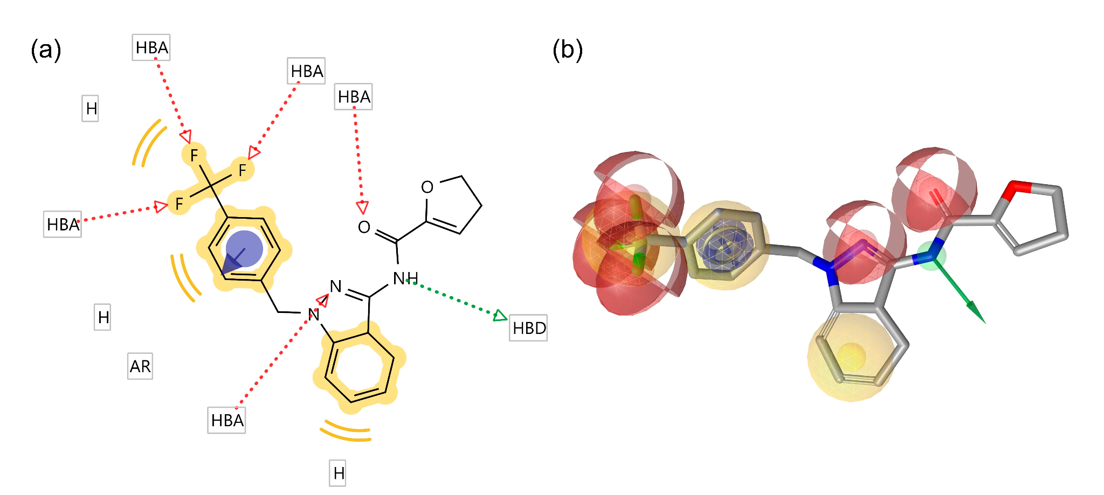

Figure S1. (a) 2D representation of the pharmacophore model for the G2 compound generated by LigandScout. (b) 3D representation of the pharmacophore model for the G2 compound generated by LigandScout. HBA (red): hydrogen-bond acceptor; HBD (green): hydrogen-bond donor; H (yellow): hydrophobic.

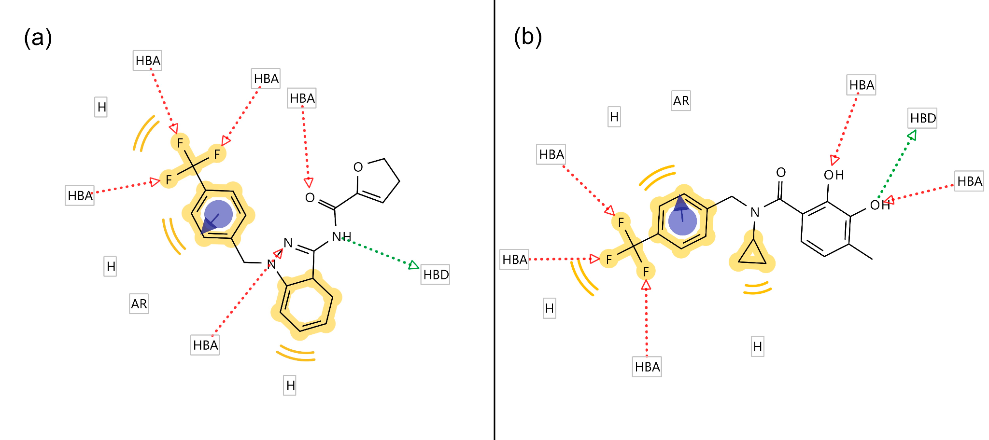
Figure S2. Comparison between the chemical structure and pharmacophore model of the G2 compound (a) and the compound obtained via VS from the Enamime library (Z1362873773).

DSF Reveals Potential Destabilization of Fascin by Z1362873773 Compound
The ability of Z1362873773 to bind fascin was evaluated using differential scanning fluorimetry (DSF). At a pH of 7.4, fascin unfolds through a singular transition without showing any dependency on concentration and exhibits a high level of DMSO tolerance. Average melting temperatures (Tm) for unbound fascin were recorded using different internal filters (FAM, HEX, and T-Red), serving as references to assess Tm changes upon compound binding (Tm,FAM = 55.6 ± 0.5 °C, Tm,HEX = 56.0 ± 0.0 °C, Tm,Tred = 56.2 ± 0.6 °C, with error values representing the standard deviation for the seven replicates used as internal controls on each plate). Some compounds altered the thermal unfolding profiles, making it difficult to accurately determine Tm values, possibly due to interferences with the SYPRO fluorescence signal.
While the DSF curve for Z1362873773 suggests a potential destabilization of the protein, it is not possible to extract a specific shift from the curve. Therefore, we can conclude that the presence of Z1362873773 may destabilize the protein structure, but we cannot determine an exact shift in Tm or exclude the possibility of interferences with SYPRO occurring.

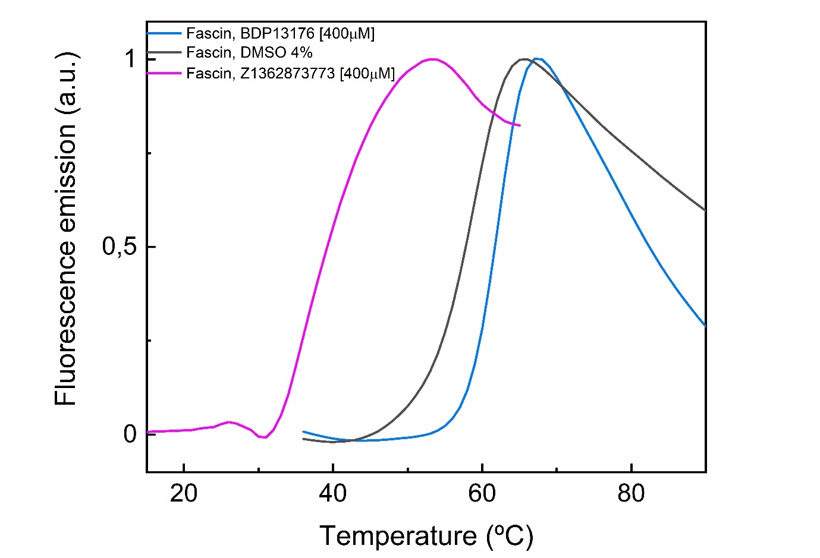
Figure S3. Differential Scanning Fluorimetry (DSF) profiles of Fascin-1. The graph shows the thermal denaturation profiles of Fascin 1 obtained recording the fluorescence emission of SYPRO orange as a function of temperature. The black curve corresponds to the free protein (Fascin-1 with 4% DMSO), and the blue curve shows the effect of the known ligand BDP13176 (400 µM) on Fascin-1 (1 µM) stability. These curves are used as negative and positive quality controls respectively to evaluate assay performance. The pink curve corresponds to the thermal denaturation of Fascin 1 in presence of compound Z1362873773 (400 µM). Assays were performed in 20 mM HEPES, 100 mM NaCl, pH 7.35. Fluorescence intensity data were normalized by subtracting the fitted low-temperature linear baseline from the raw values. Data were then scaled between 0 and 1 taking the initial post-transition point values for normalisation.

Organoids

Organoid | Histological cancer classification | pTNM stage | MSI status | Fascin mRNA expression and protein levels
 |  |  |  | RNAseq | IHQ
107T | Conventional Adenocarcinoma | pT3a N0 | MSS | 122,614171 tpm | Positive
114T | Conventional Adenocarcinoma | pT3 N0 | MSS | NA | Positive
6MH | Metastasis originated from Conventional Adenocarcinoma | pT3b N1b | MSS | 117,472328 tpm | Positive

Table S1. Histological classification of organoid cancer, indicating fascin protein expression levels.

Molecular modeling and docking
Software | Docking Score  (kcal/mol) | Hydrophobic  Interactions (Å) | Hydrogen Bonds (Å) | π-Stacking Interactions (Å) | π-Cation Interactions (Å)
AutoDock Vina | -8.35 | Phe14 (3.53),  Leu48 (3.80),  Ile93 (3.66, 3.30),  Glu215 (3.48) | Trp101 (2.81), Arg217 (3.94) | Trp101 (4.76) | Arg217 (4.86)
LeadFinder | -8.27 | Phe14 (3.82),  Leu16 (3.37),  Ile93 (3.33, 3.27), Trp101 (3.15, 3.39), Val134 (3.67, 3.58), Phe216 (3.06) | Trp101 (4.06), Phe216 (3.00, 3.04, 2.81), Arg217 (3.41) | - | -

Table S2. Interactions between Z1362873773 and fascin residues were detected using AutoDock Vina and Lead Finder calculations.

MD simulation analysis for Fascin-Z1362873773 and Fascin-NP-G2-029 complexes

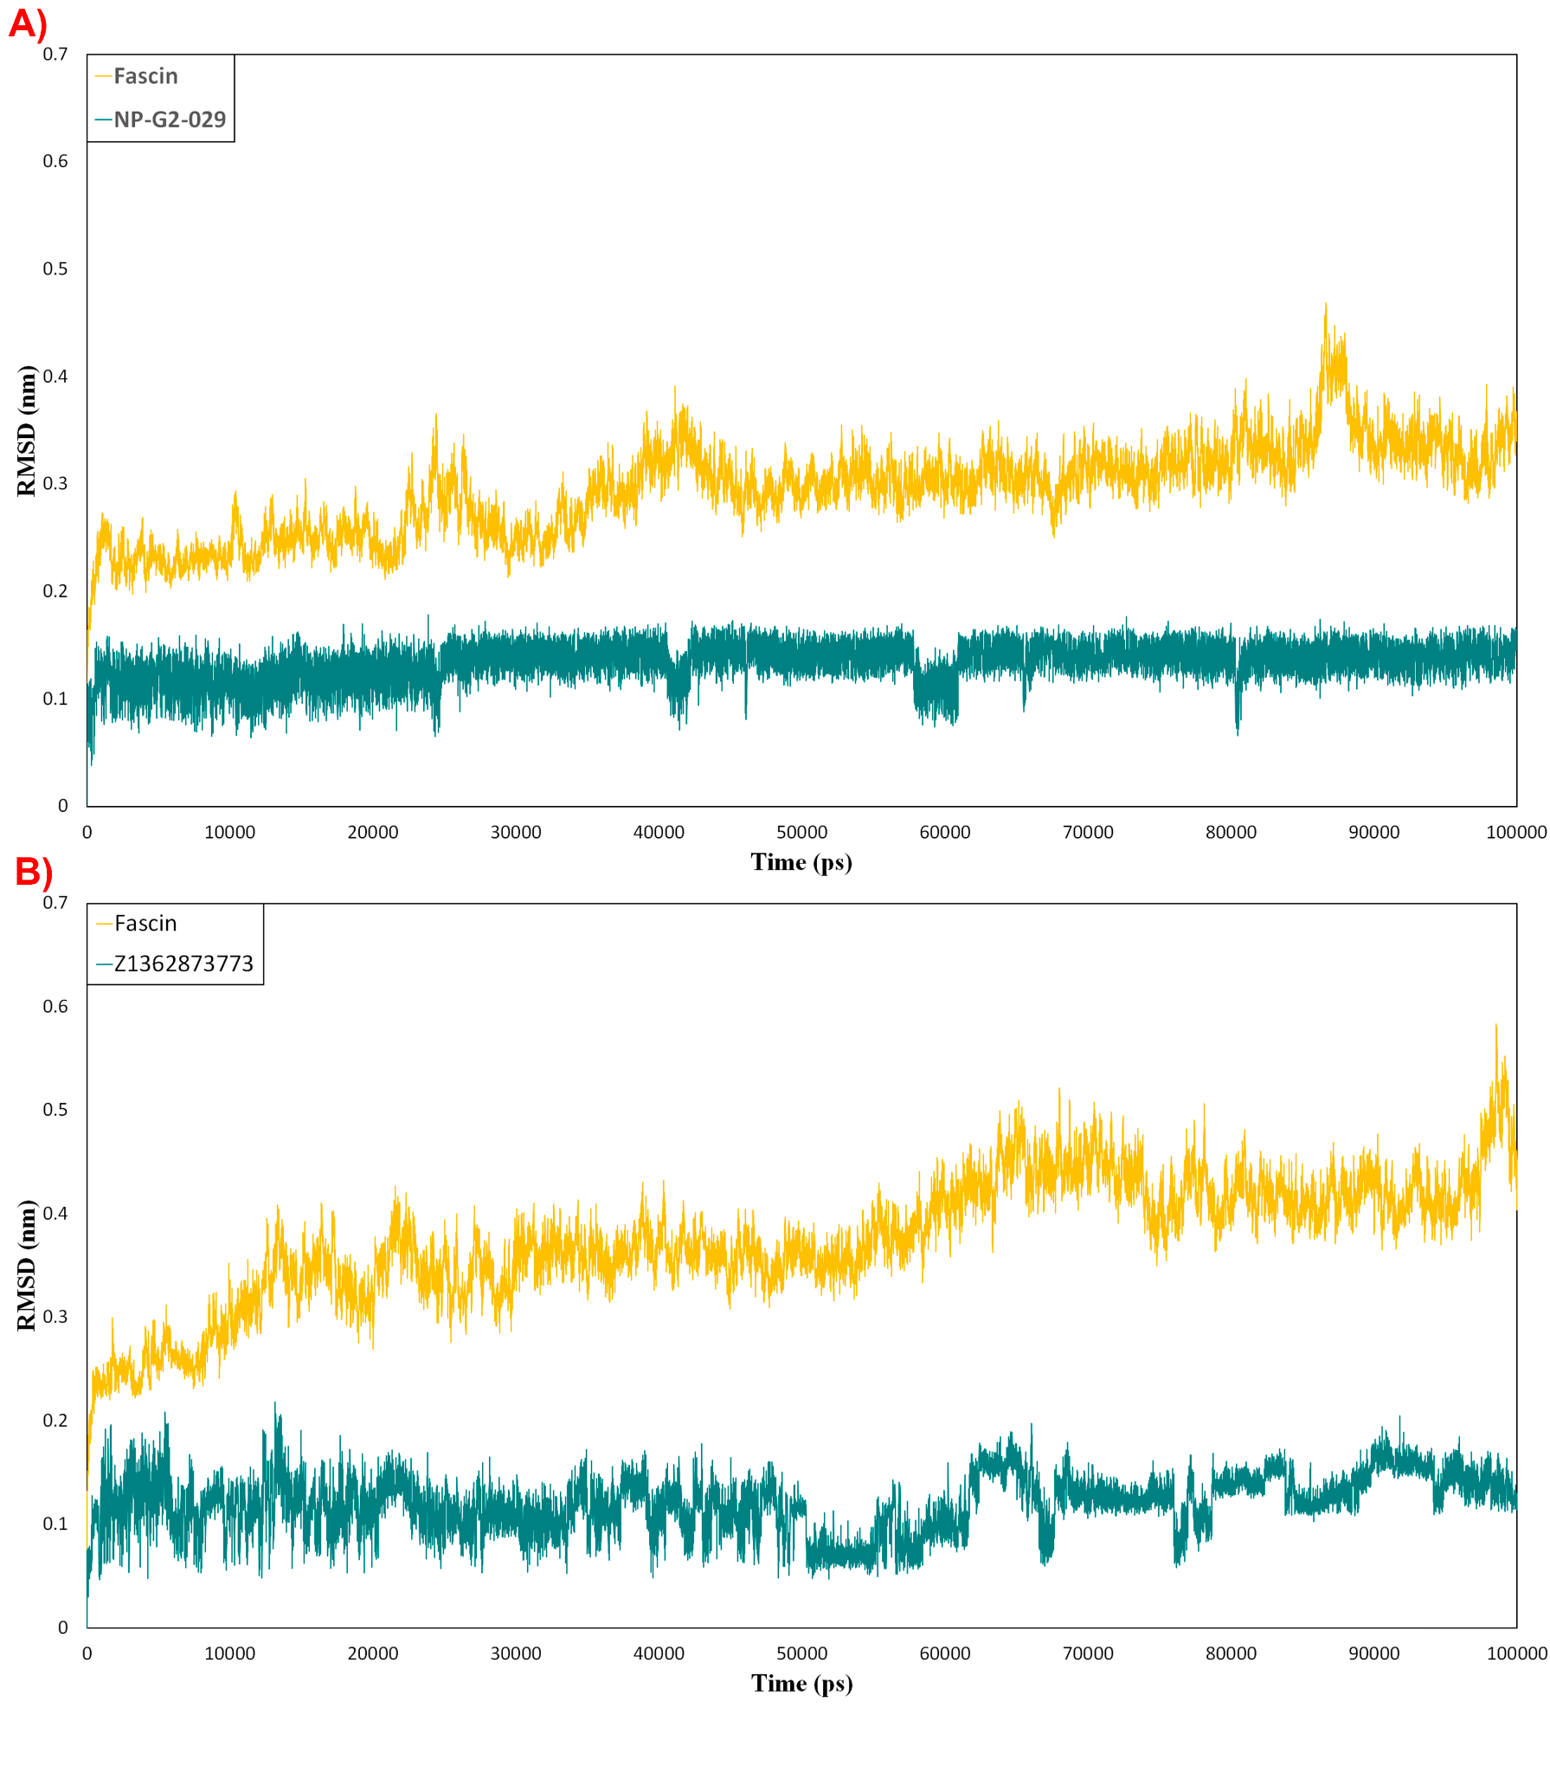
Figure S4: RMSD for protein (amber color) and ligand (teal color) in NP-G2-029-fascin (A) and Z1362873773-fascin (B) complexes during MD simulation.

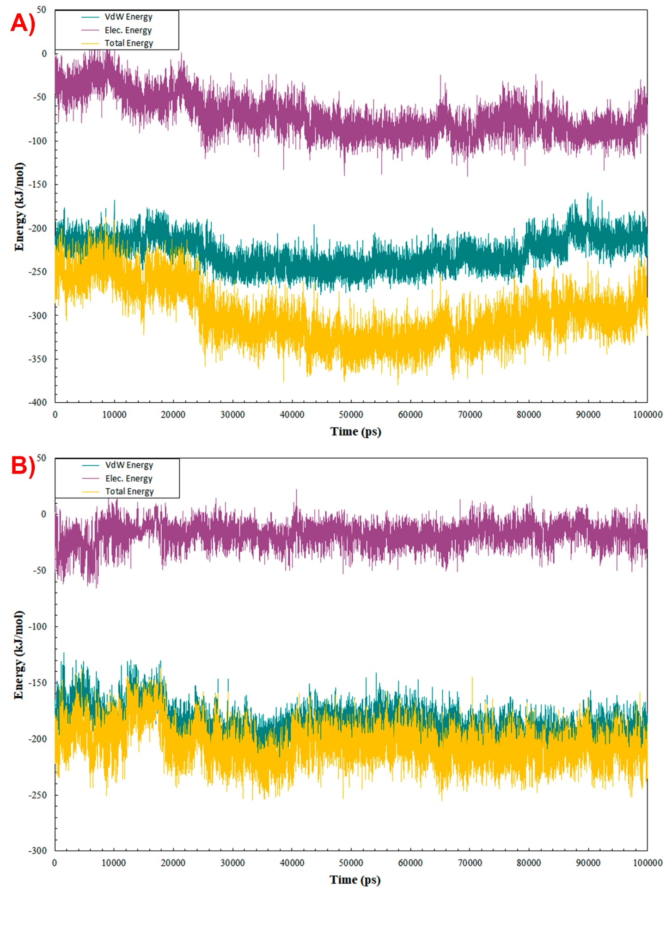
Figure S5. MMPBSA analysis of NP-G2-029-fascin (A) and Z1362873773-fascin (B) complexes. The graph shows the van der Waals contribution (VdW Energy, in teal color) and electrostatic contribution (Elec.. Energy, in plum color), and Total Energy (in amber color).

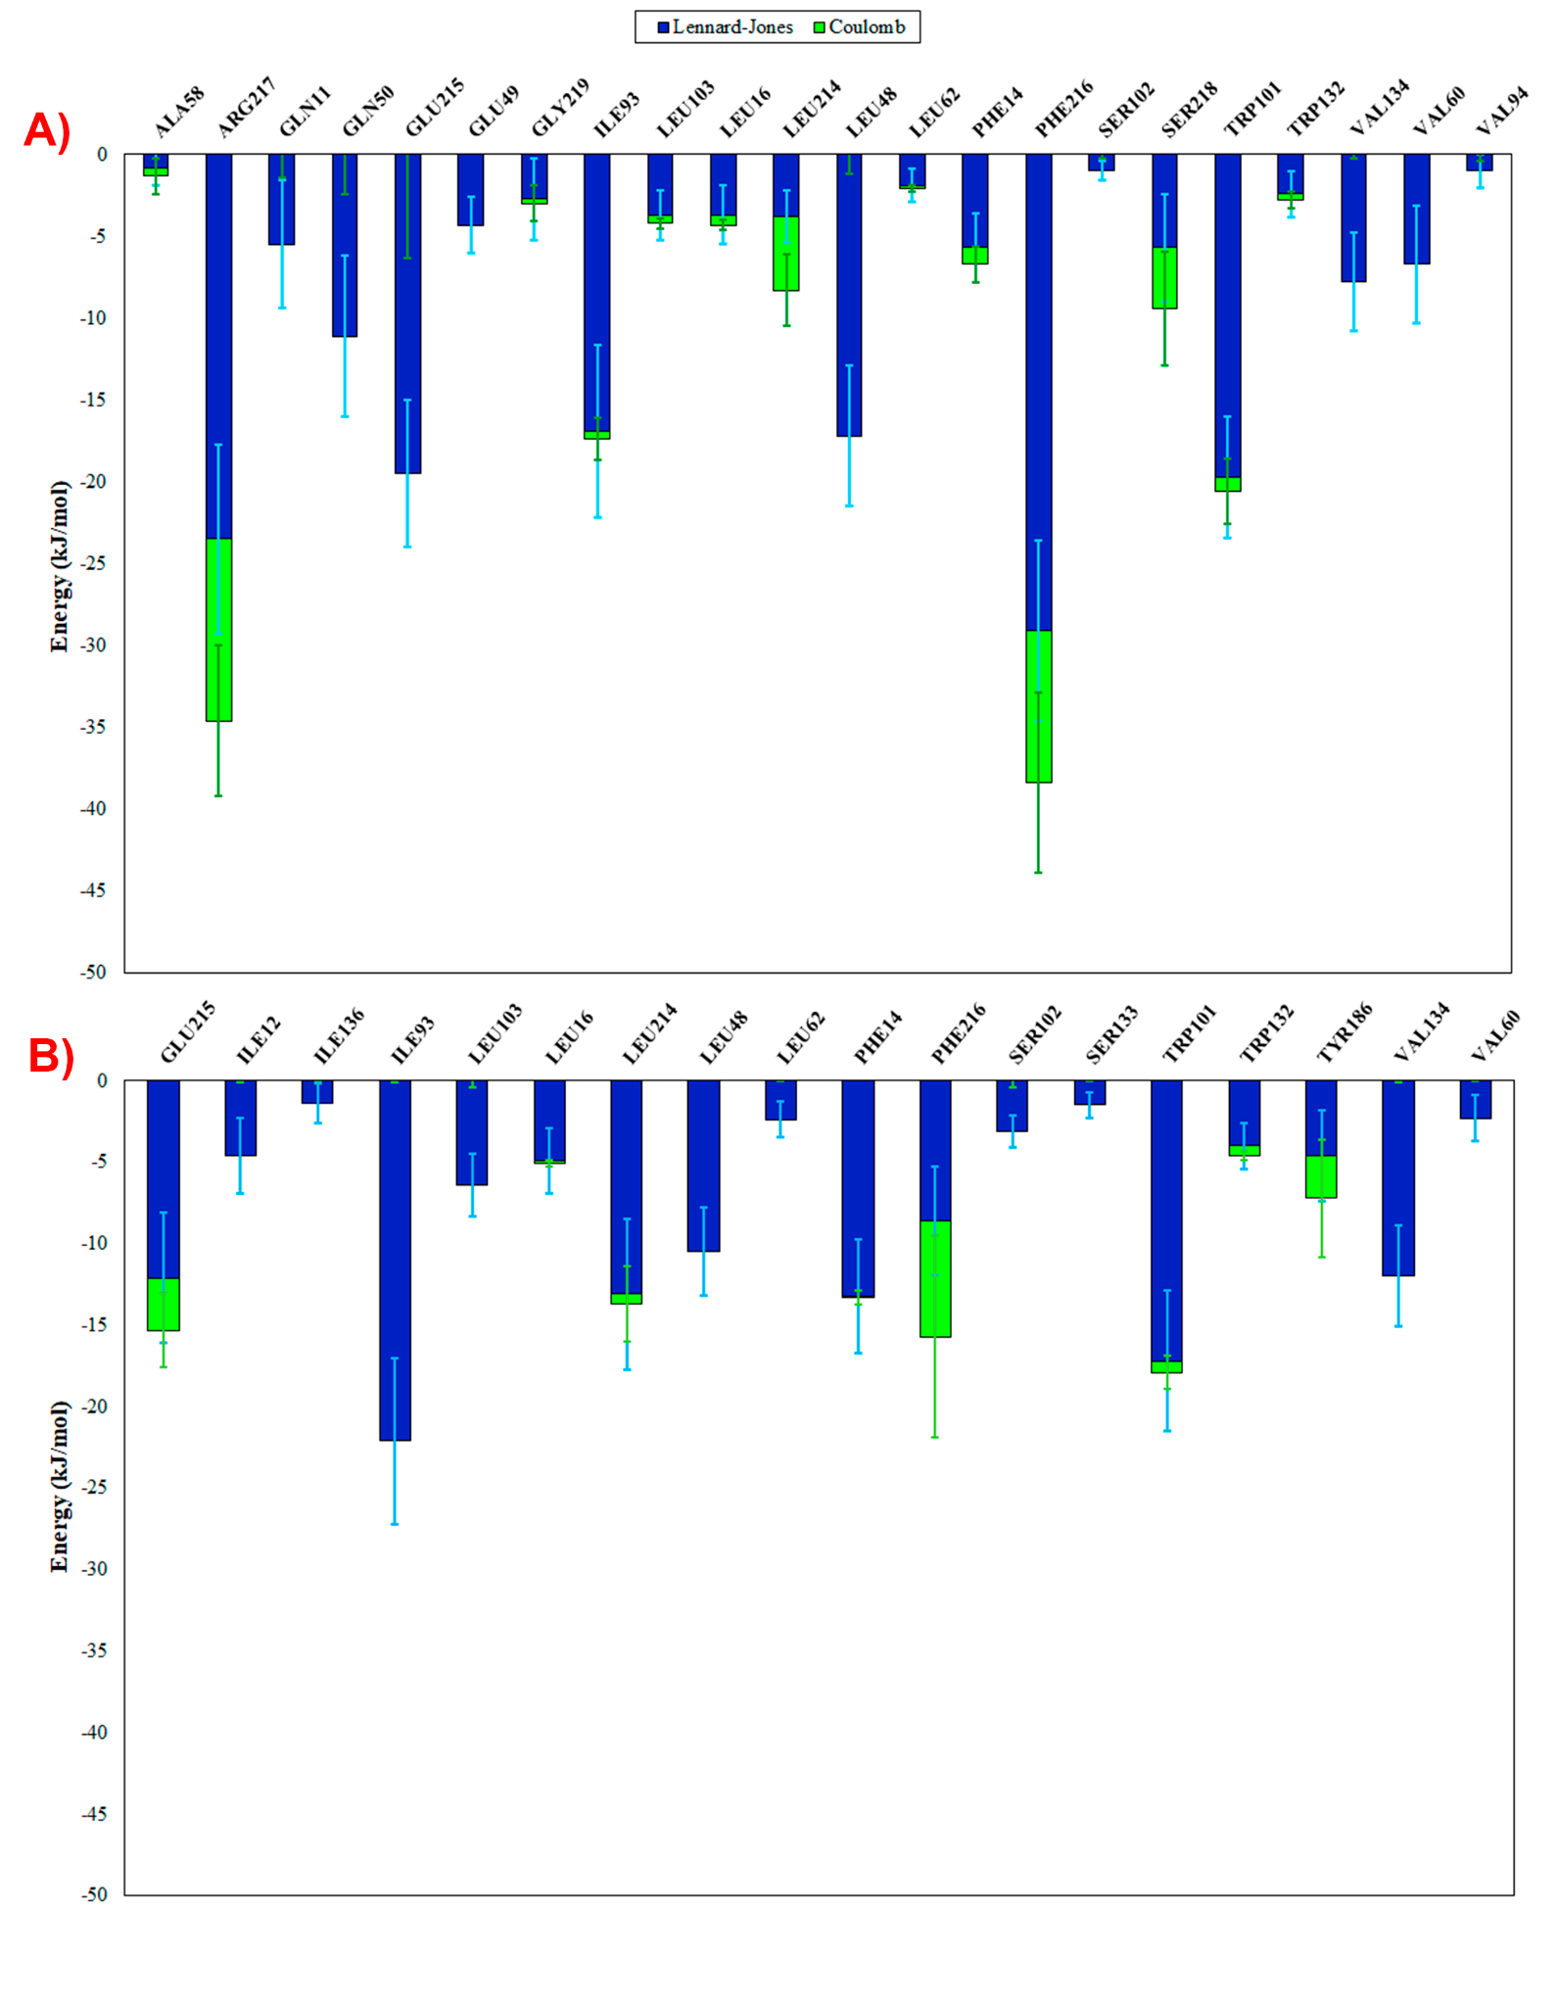
Figure S6. Non-bonded interaction analysis plots for the NP-G2-029-fascin (A) and Z1362873773-fascin (B) complexes. The graph plots indicate the energy for each key residue split into different contributions (LJ (blue) and Coulomb (green)).

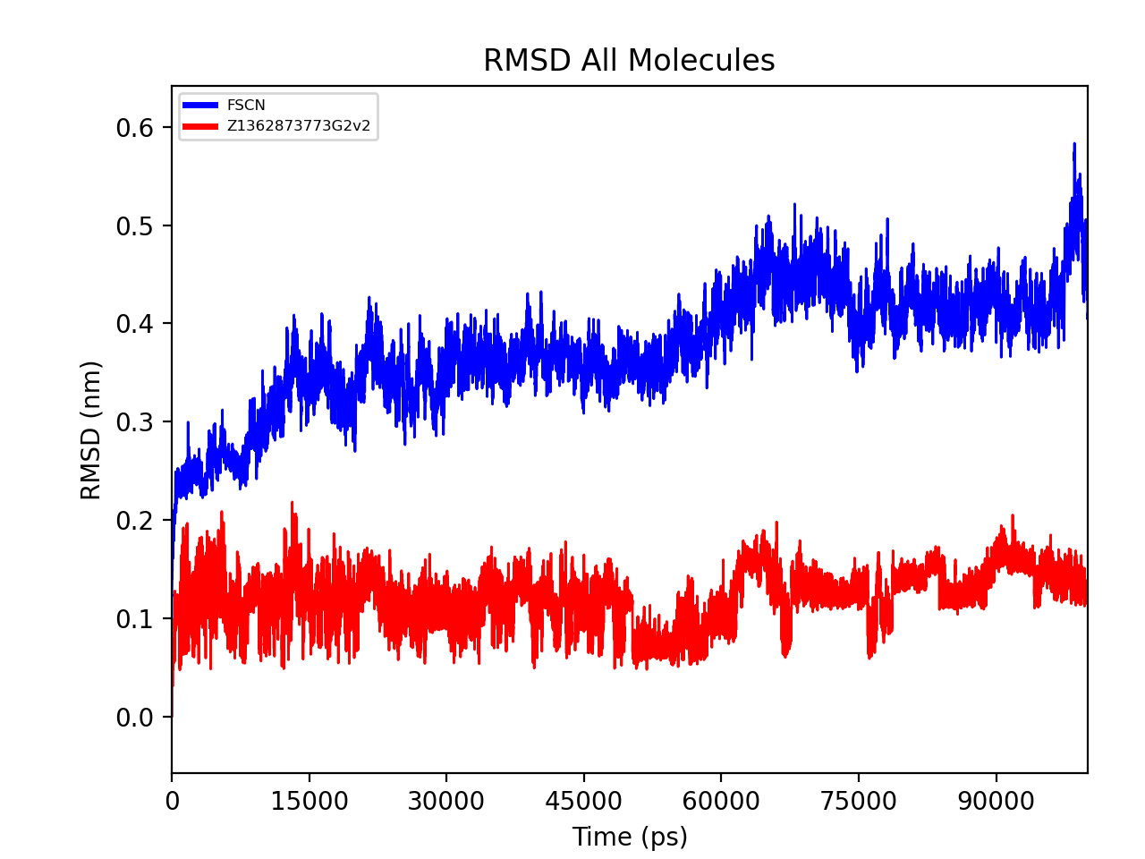
Figure S7. Root mean square deviation (RMSD) during MD simulations for Fascin1 structure and the Z136873773 compound.
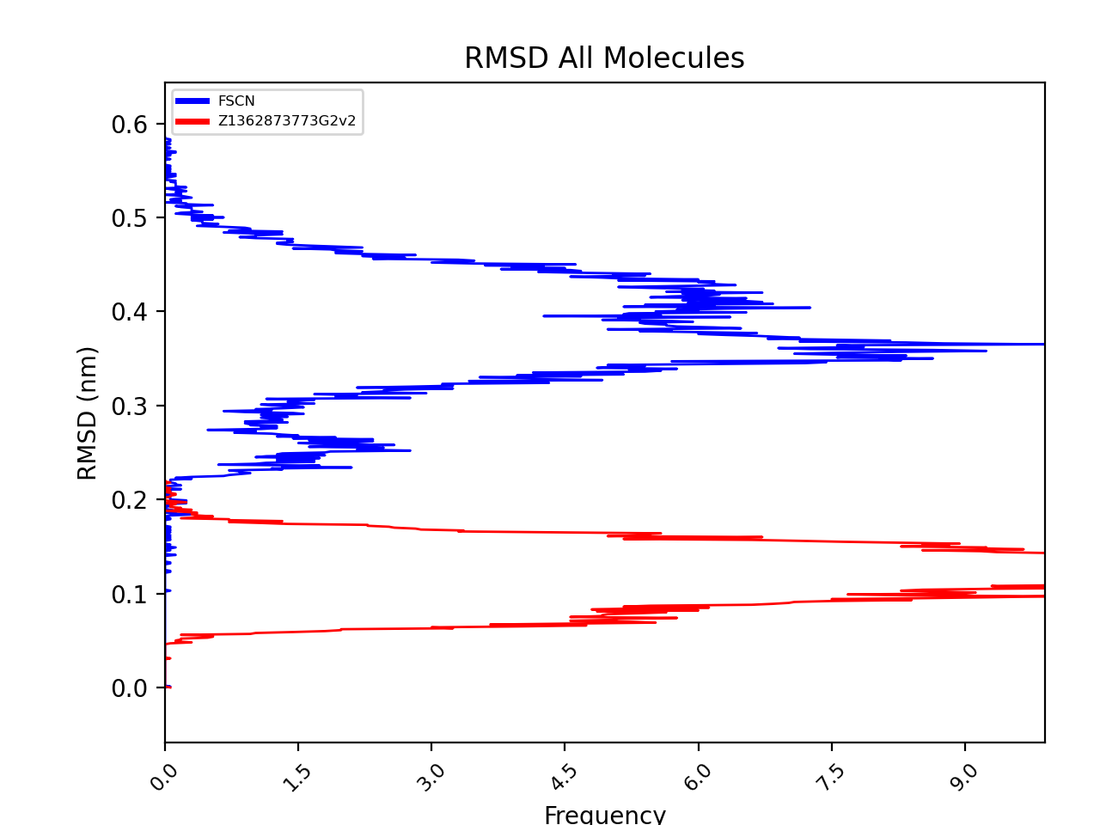
Figure S8. Root mean square deviation (RMSD) frequency for Fascin1 structure and the ligand (Z136873773)
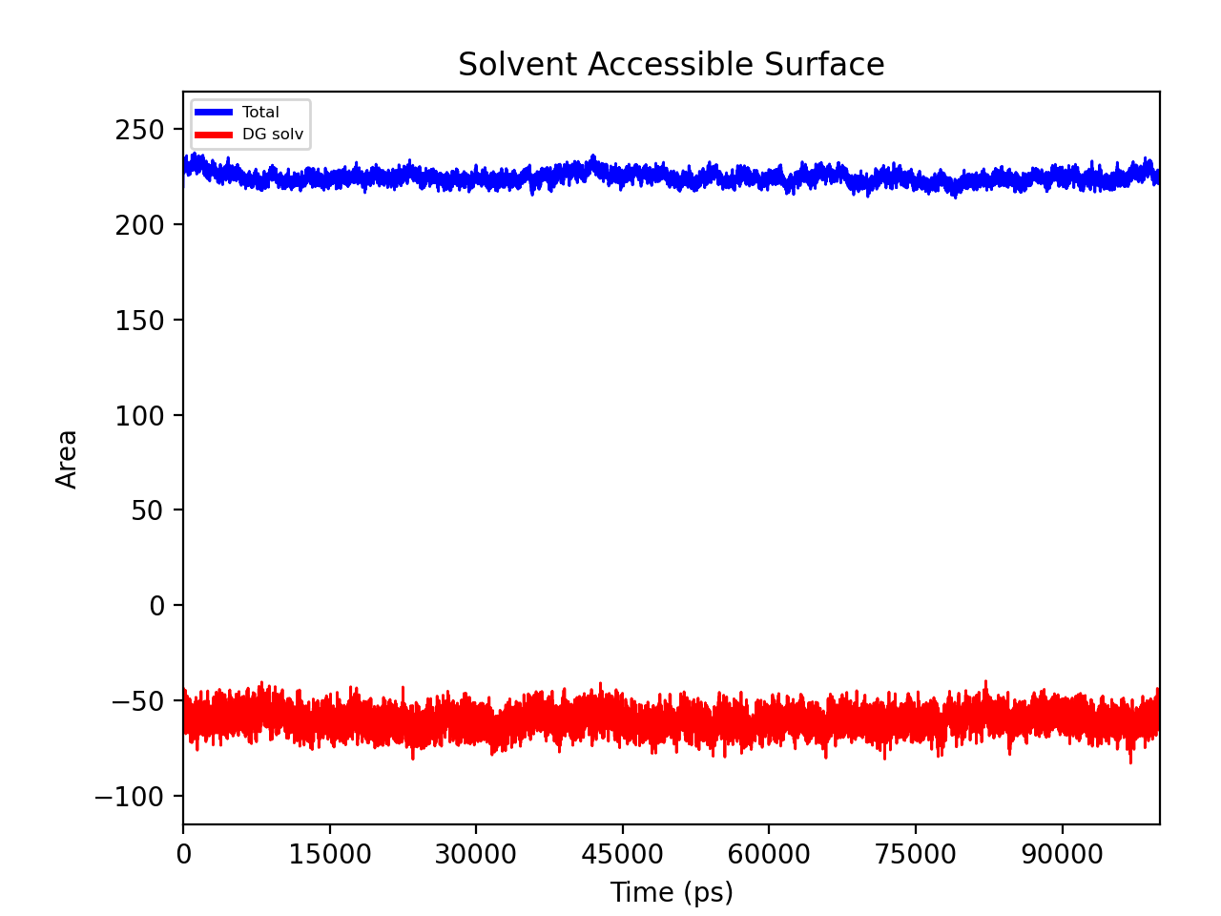
Figure S9. Solvent Accessible Surface Analysis for MD simulation.
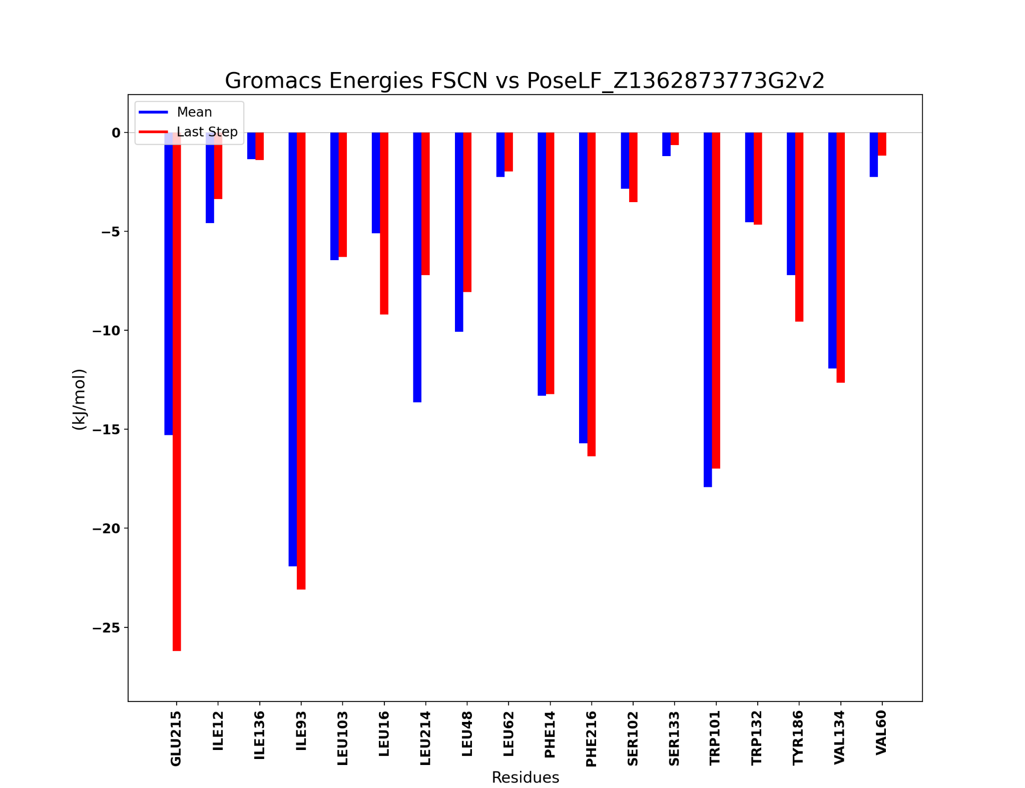
Figure S10. Mean (blue) and last step (red) interaction energies for the key residues during MD simulation.
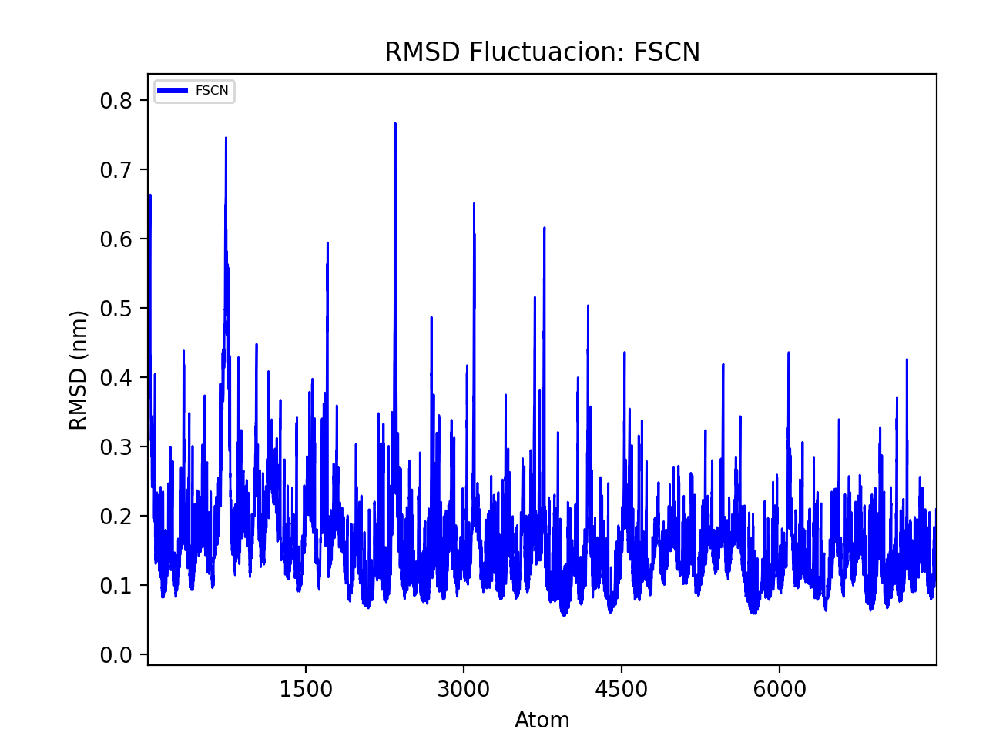
Figure S11. RMSF for the fascin structure during MD simulation.
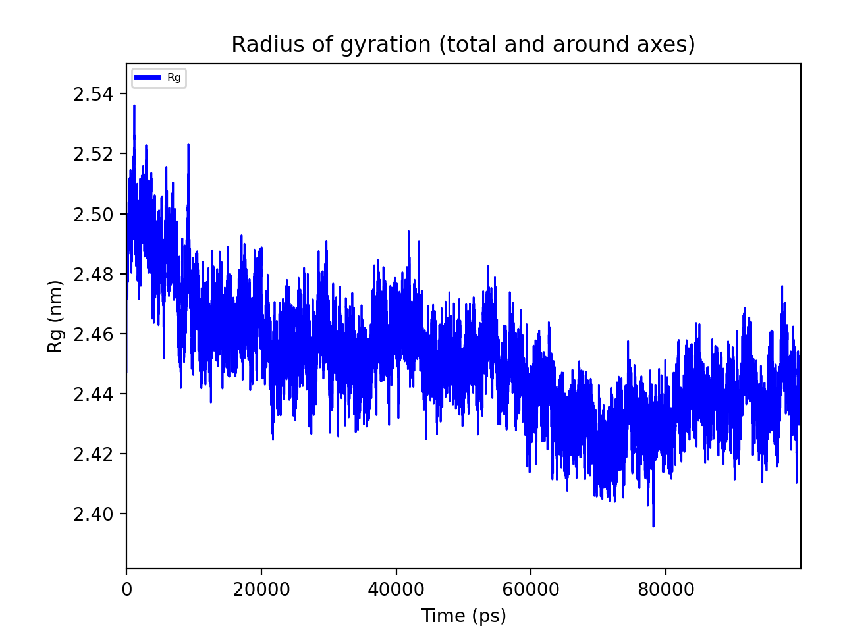
Figure S12. Radius of gyration for the Fascin structure during the MD simulation

Drug-like property predictions
Compound | Z73 | G2 | NP-G2 | BDP | Ralt. | Migras. | Imip. | Range
MWª | 365.4 | 389.4 | 399.4 | 497.4 | 444.4 | 489.6 | 280.4 | 130.0 / 725.0
SASA_{total}^{b} | 619.6 | 653.4 | 665.1 | 767.1 | 716.4 | 716.1 | 571.9 | 300.0 /1000.0
SASA_{hfob}^{c} | 220.7 | 212.3 | 126.5 | 186.0 | 279.5 | 499.8 | 277.2 | 0.0 / 750.0
SASA_{hphi}^{d} | 100.2 | 61.4 | 42.3 | 136.9 | 215.9 | 203.9 | 3.6 | 7.0 / 330.0*
NRB^{e} | 6 | 4 | 4 | 4 | 7 | 8 | 4 | 0.0 / 15.0
HBD^{f} | 1 | 1 | 1.0 | 2 | 2 | 2 | 0 | 0.0 / 6.0
HBA^{g} | 3.5 | 4.25 | 4 | 9.5 | 11.25 | 10.4 | 2.5 | 2.0 / 20.0
Glob^{h} | 0.828 | 0.817 | 0.808 | 0.789 | 0.801 | 0.876 | 0.85 | 0.75 / 0.95
IP^{i} | 9.0 | 8.0 | 8.2 | 9.3 | 9.4 | 9.9 | 7.9 | 7.9 / 10.5*
logP_{AQS}^{j} | -5.831 | -6.484 | -6.795 | -5.424 | -4.383 | -4.289 | -4.124 | -6.5 / 0.5
logP_{CI}^{k} | -5.762 | -6.372 | -6.937 | -5.726 | -4.778 | -4.748 | -3.41 | -6.5 / 0.5
logK_{hsa}^{l} | 0.656 | 0.777 | 0.856 | 0.364 | -0.34 | 0.308 | 0.708 | -1.5 / 1.5
log BR/BL^{m} | -0.481 | -0.002 | 0.183 | -0.424 | -1.985 | -1.689 | 0.688 | -3.0 / 1.2
NPM^{n} | 4 | 4 | 3 | 3 | 4 | 11 | 7 | 1.0 / 8.0
log HERGº | -5.2 | -5.7 | -6.4 | -7.2 | -5.6 | -3.6 | -6.1 | concern below -5
C2P^{p} | 1111 | 2591 | 3933 | 124 | 88 | 115 | 2285 | <25 poor, >500 great
MDCK^{q} | 2488 | 6099 | 9790 | 297 | 65 | 47 | 1337 | <25 poor, >500 great
log Kp^{r} | -2.157 | -0.587 | -1.344 | -4.615 | -4.213 | -4.466 | -2.238 | >-5 great
Lipinski^{s} | 0 | 1 | 1 | 0 | 1 | 0 | 0 | maximum is 4
Jorgensen^{t} | 1 | 1 | 1 | 0 | 0 | 1 | 1 | maximum 3
HOA GI^{u} | 100 | 100 | 100 | 84 | 58 | 80 | 100 | <25% poor,>80% high
QM HOA^{v} | High | High | High | High | Medium | High | High | <25% poor,>80% high

Table S3. ADMET properties were calculated using QikProp tools from MAESTRO for Z (Z73), G2, NP-G2-044 (NP-G2), BDP (BDP-13176), and raltegravir (Ralt.), Migrastatin (Migras.), and imipramine (imipramine; Imip). Green indicates that the value is within the range, and red indicates that it is out of range. An orange indicates that the value is one of the limits of the range. a) Molecular Weight (Da); b) Total solvent-accessible molecular surface (Å2); c) Hydrophobic solvent-accessible molecular surface (Å2); d) Hydrophilic solvent-accessible molecular surface (Å2); e) Number of rotatable bond; f) Hydrogen Bond Donated; g) Hydrogen Bond Accepted; h) Globularity (Sphere=1) i) Ionization Potential (eV) j) logP for aqueous solubility; k) log P for conformation independent; l) log of constant to human serum albumin; m) log of predicted blood/brain barrier partition coefficient; n) Number of Primary Metabolites; o) log IC50 value for HERG K+ Channel Blockage; p) Apparent Caco-2 Permeability (nm/sec); q) Apparent MDCK Permeability (nm/sec); r) log Kp for skin permeability; s) Number of violations for Lipinski rule; r) Number of violations for Jorgensen rule; u) Human Oral Absorption in gastrointestinal tract; v) Qualitative Model for Human Oral Absorption.

Rank | Code | Name | Structure | Score | Target | Function
1 | DB05861 | Tasquinimod | 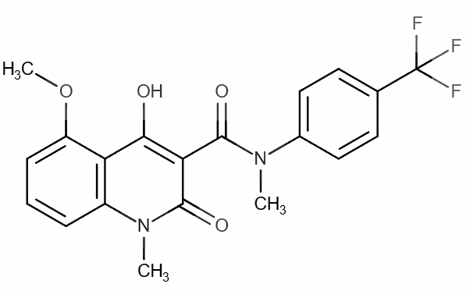 | 0.785 | Not known | Anti-angiogenic agent, anti-prostate cancer efficacy
2 | DB14885 | PF-05180999 | 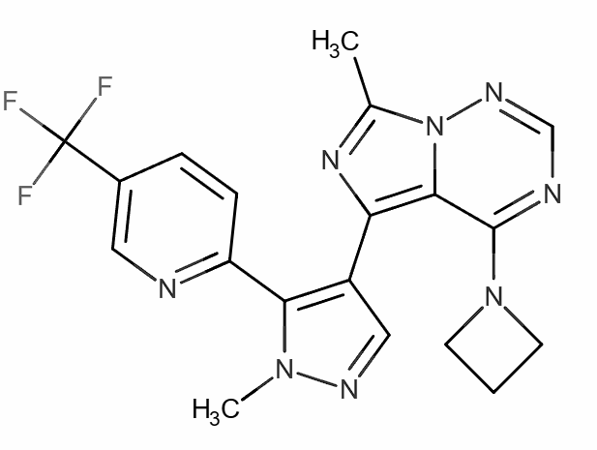 | 0.727 | Not known | Not known
3 | DB06481 | Manitimus | 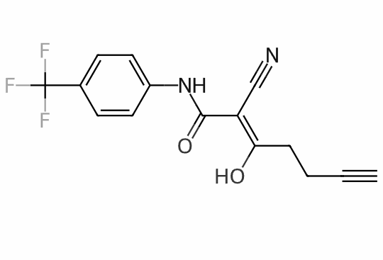 | 0.725 | Dihydroorotate dehydrogenase (quinone), mitochondrial | Not known
4 | DB08880 | Teriflunomide | 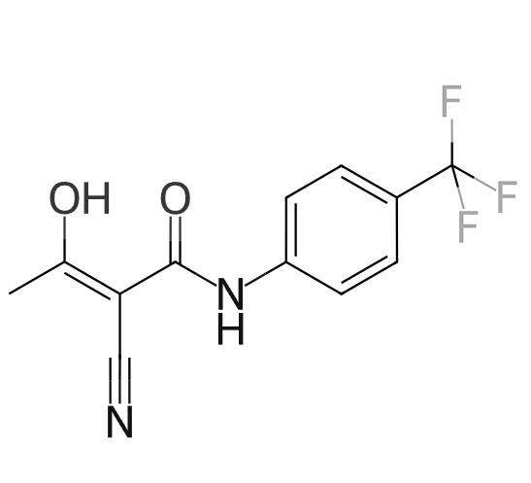 | 0.725 | Dihydroorotate dehydrogenase (quinone), mitochondrial | Immunomodulatory agent
5 | DB06280 | Senicapoc | 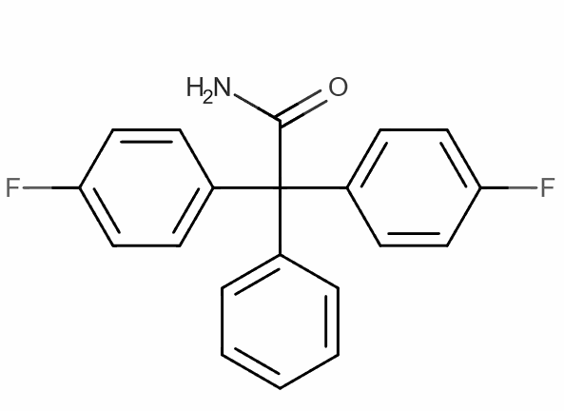 | 0.724 | Not known | Not known
6 | DB07963 | N-[(2',4'-DIFLUORO-4-HYDROXY-5-IODOBIPHENYL-3-YL)CARBONYL]-BETA-ALANINE | 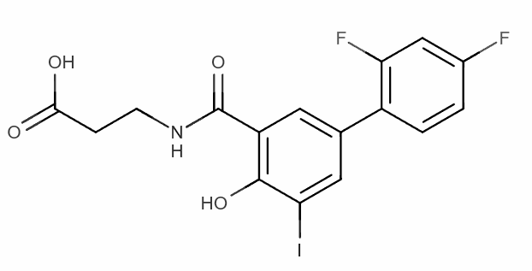 | 0.723 | Transthyretin | Not known
7 | DB08478 | N-[2-Chloro-5-(trifluoromethyl)phenyl]imidodicarbonimidic diamide | 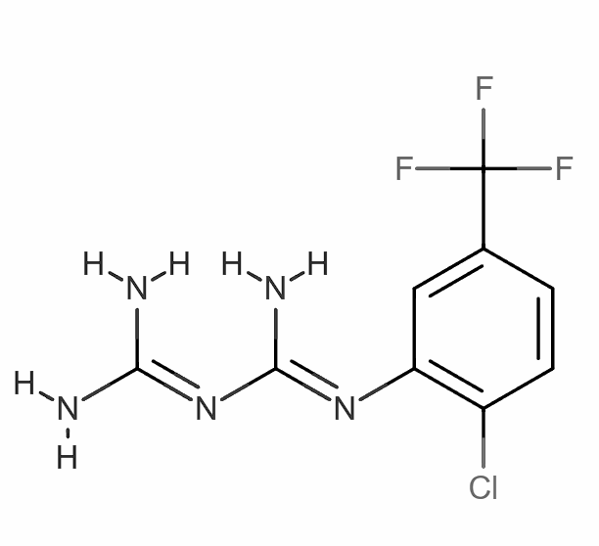 | 0.722 | Thymidylate synthase | Not known
8 | DB07594 | CCT-018159 | 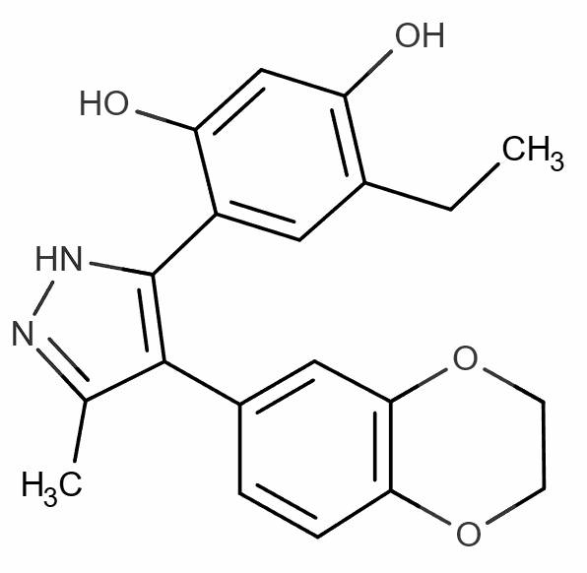 | 0.722 | Heat shock protein HSP 90-beta, Heat shock protein HSP 90-alpha | Not known
9 | DB05498 | KW-7158 | 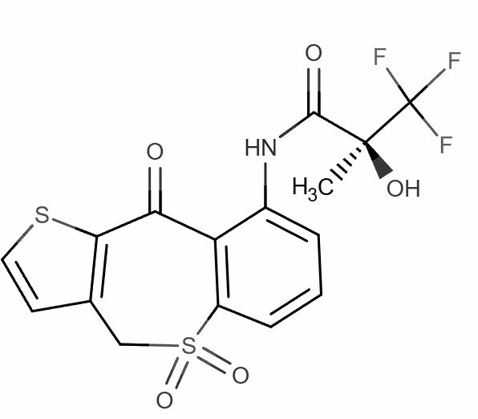 | 0.722 | Not known | Treatment of "urinary urgency," "frequent urination" and "urinary incontinence"
10 | DB12461 | GLPG-0492 | 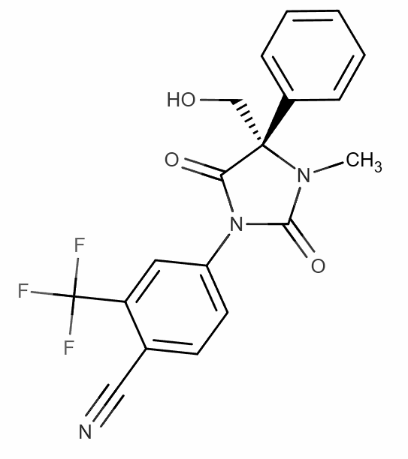 | 0.720 | Not known | Not known
11 | DB07121 | 4-({4-[(4-Aminobut-2-ynyl)oxy]phenyl}sulfonyl)-N-hydroxy-2,2-dimethylthiomorpholine-3-carboxamide | 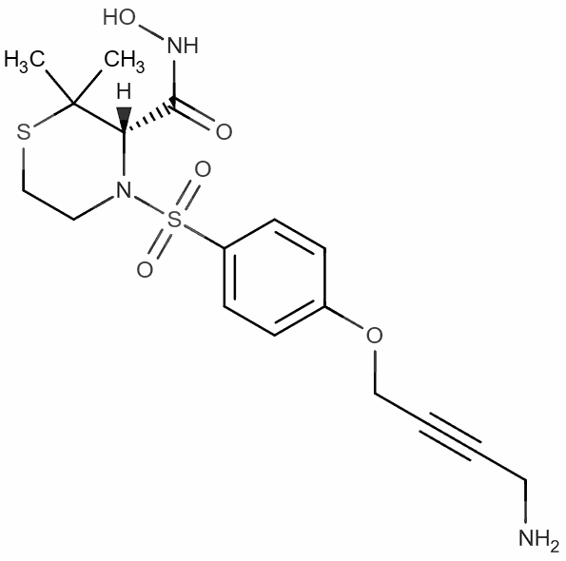 | 0.720 | Not known | Disintegrin and metalloproteinase domain-containing protein 17
* Information about the compounds' targets and functions was obtained from the DrugBank website.

Table S4. Results for Drug Target prediction were obtained from the model generated with all the features found by Ligand Scout for the Z1362873733 compound. Compounds with known functions in angiogenesis or cancer treatment are highlighted in green.
Rank | Code | Name | Structure | Score | Target | Function
1 | DB14995 | NP-G2-044 | 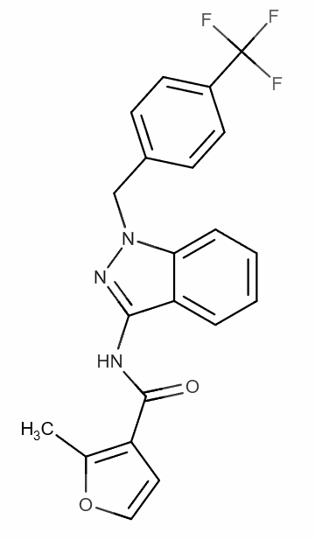 | 0.976 | Fascin | Cell migration
2 | DB12535 | AC-430 | 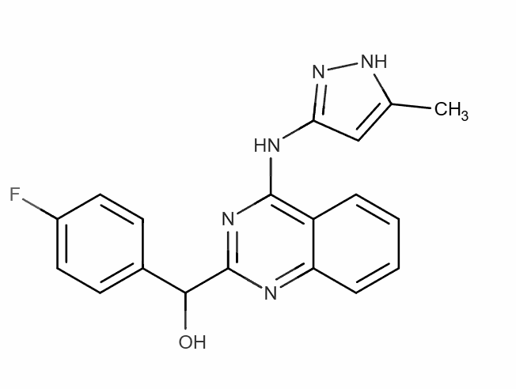 | 0.965 | Not known | Rheumatoid Arthritis
3 | DB11985 | Dapaconazole | 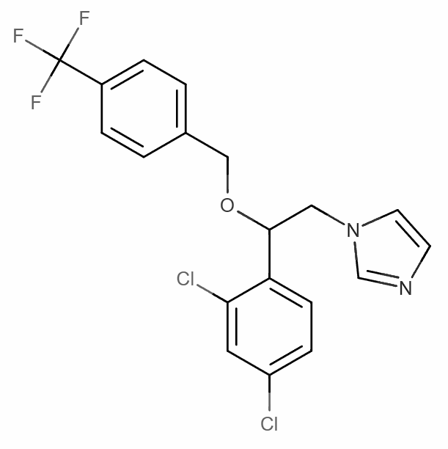 | 0.884 | Not known | Tinea Pedis
4 | DB08472 | (R)-Fluoxetine | 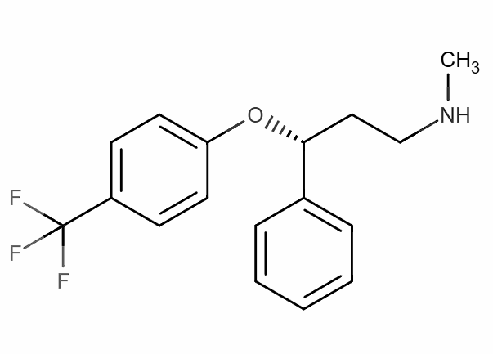 | 0.881 | Not known | Antidepressant drug
5 | DB07419 | S-23 | 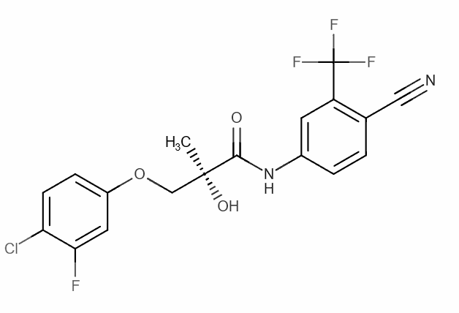 | 0.878 | Androgen receptor | An androgen receptor modulator
6 | DB13874 | Enasidenib | 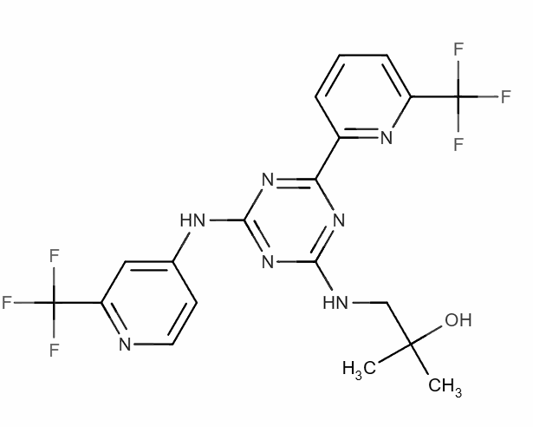 | 0.878 | Isocitrate dehydrogenase [NADP], mitochondrial | Treatment of adult patients with relapsed or refractory acute myeloid leukemia (AML)
7 | DB00213 | Pantoprazole | 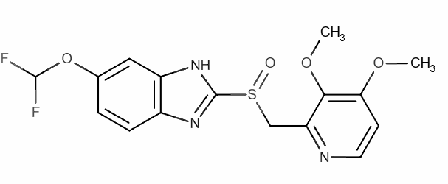 | 0.875 | Potassium-  transporting ATPase | Not known
8 | DB08976 | Floctafenine | 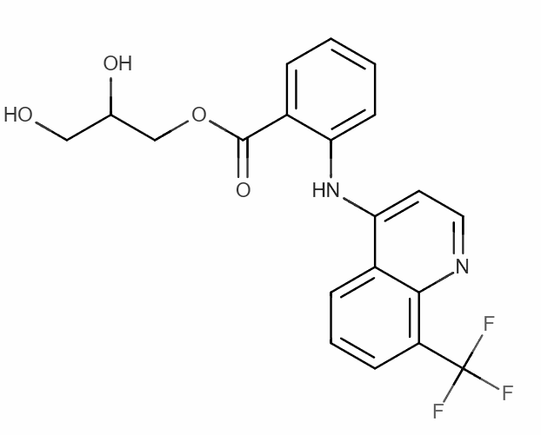 | 0.875 | Not known | Anti- inflammatory analgesic
9 | DB02932 | (R)-Bicalutamide | 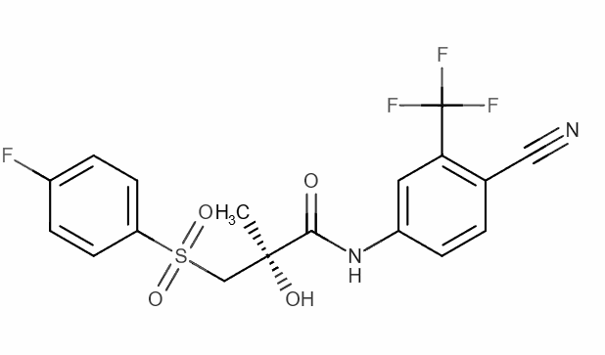 | 0.875 | Androgen receptor | Not known
* Information about the compounds' targets and functions was obtained from the DrugBank website.

Table S5. The results for Drug Target prediction obtained from the model were generated only from features that coincided with the G2 pharmacophore model. In green, compounds with a known function in angiogenesis or cancer treatment are highlighted.

Feasibility of the synthesis pathways for Z1362873773

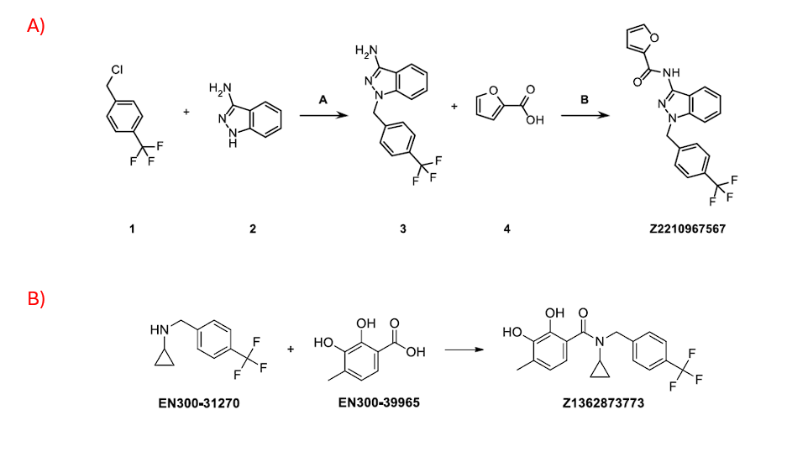
Figure S13. Synthesis pathways indicating the corresponding steps and compounds in each one of them for G2 (A) and Z1362873773 (B)

