S1. Comparison of national ESV and GDP
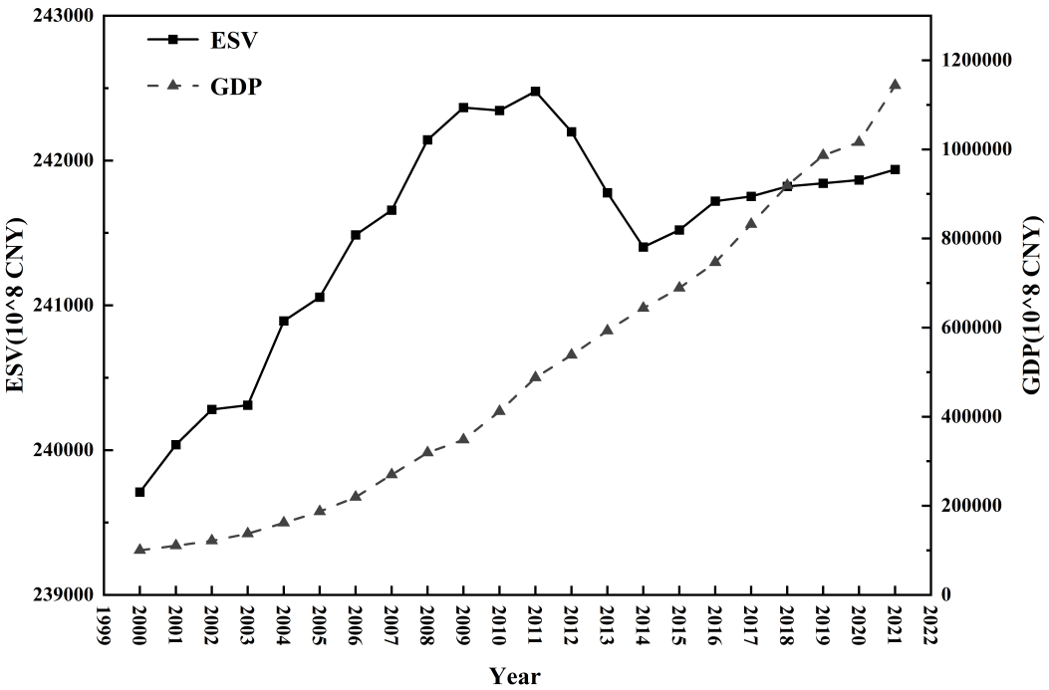
Figure 1. Comparison of national ESV and GDP

S2. Changes in ESV types across the country
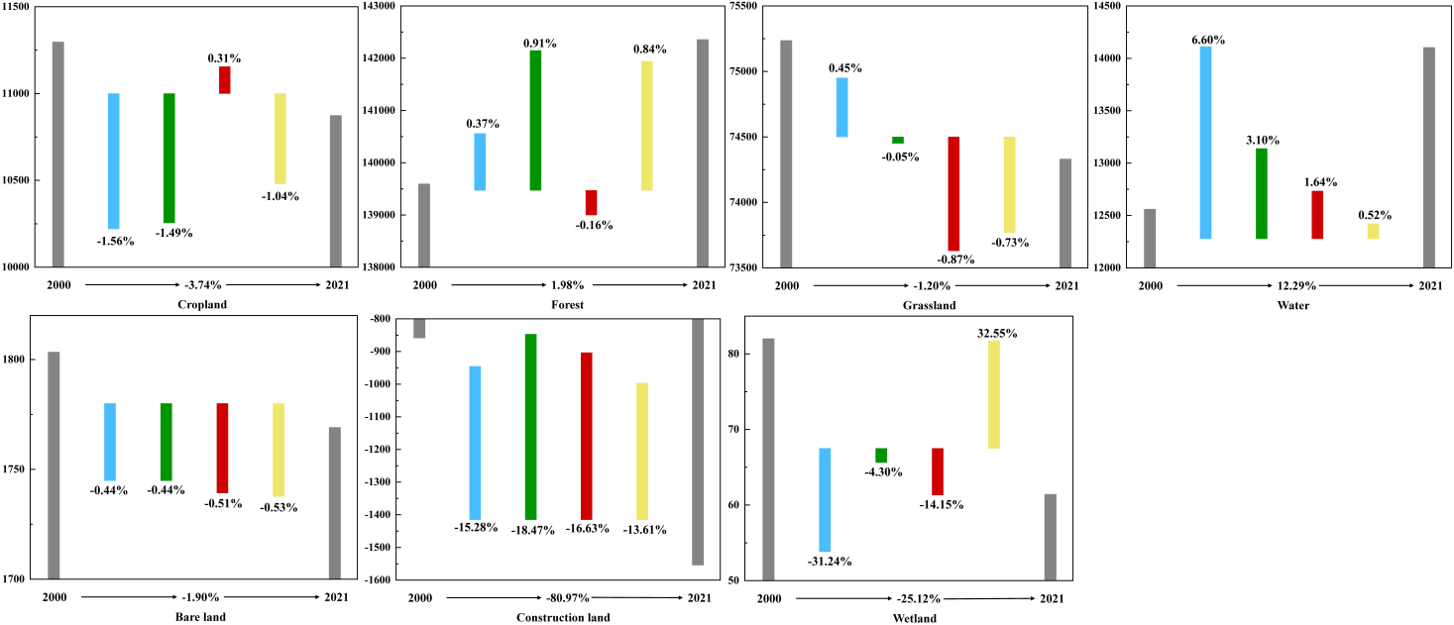
Figure 2. Changes in ESV types across the country from 2000 to 2021

S3. ESV for different land-use types
Year | Cropland | Forest | Grassland | Water | Barren | Construction land | Wetland
2000 | 11295.83 | 139593.25 | 75235.27 | 12559.47 | 1803.31 | -858.58 | 82.00
2005 | 11119.30 | 140115.61 | 75571.72 | 13387.86 | 1795.42 | -989.78 | 56.38
2010 | 10953.86 | 141387.87 | 75533.07 | 13802.61 | 1787.47 | -1172.62 | 53.95
2015 | 10987.49 | 141167.30 | 74878.71 | 14029.61 | 1778.40 | -1367.61 | 46.32
2021 | 10873.16 | 142355.00 | 74330.32 | 14102.95 | 1769.05 | -1553.75 | 61.40
Table 1. Evolution of ecosystem service value by land use type from 2000 to 2021（10^8 CNY）

S4. Different ecosystem service ESV
Primary classification | Secondary classification | 2000 | 2005 | 2010 | 2015 | 2021
Provisioning Services | Food production | 37829.41 | 37868.61 | 37926.70 | 37919.58 | 37913.68
Provisioning Services | Raw material Production | 33580.54 | 33615.33 | 33666.89 | 33660.57 | 33655.34
Provisioning Services | Water supply | 58320.49 | 58380.92 | 58470.47 | 58459.49 | 58450.41
Regulating services | Gas regulation | 109719.08 | 109832.78 | 110001.24 | 109980.59 | 109963.50
Regulating services | Climatic conditions | 273166.95 | 273450.01 | 273869.43 | 273818.02 | 273775.46
Regulating services | Purify the environment | 119107.97 | 119231.39 | 119414.27 | 119391.85 | 119373.30
Regulating services | Hydrological regulation | 1051481.31 | 1052570.87 | 1054185.29 | 1053987.43 | 1053823.60
Supporting Services | Soil conservation | 124384.87 | 124513.76 | 124704.73 | 124681.33 | 124661.95
Supporting Services | Maintain nutrient circulation | 11102.10 | 11113.60 | 11130.65 | 11128.56 | 11126.83
Supporting Services | Biodiversity | 162557.11 | 162725.55 | 162975.14 | 162944.55 | 162919.23
Culture Services | Aesthetic landscape | 93203.11 | 93299.69 | 93442.79 | 93425.25 | 93410.73
Table 2. Evolution of various ecosystem service values from 2000 to 2021（10^8 CNY）

