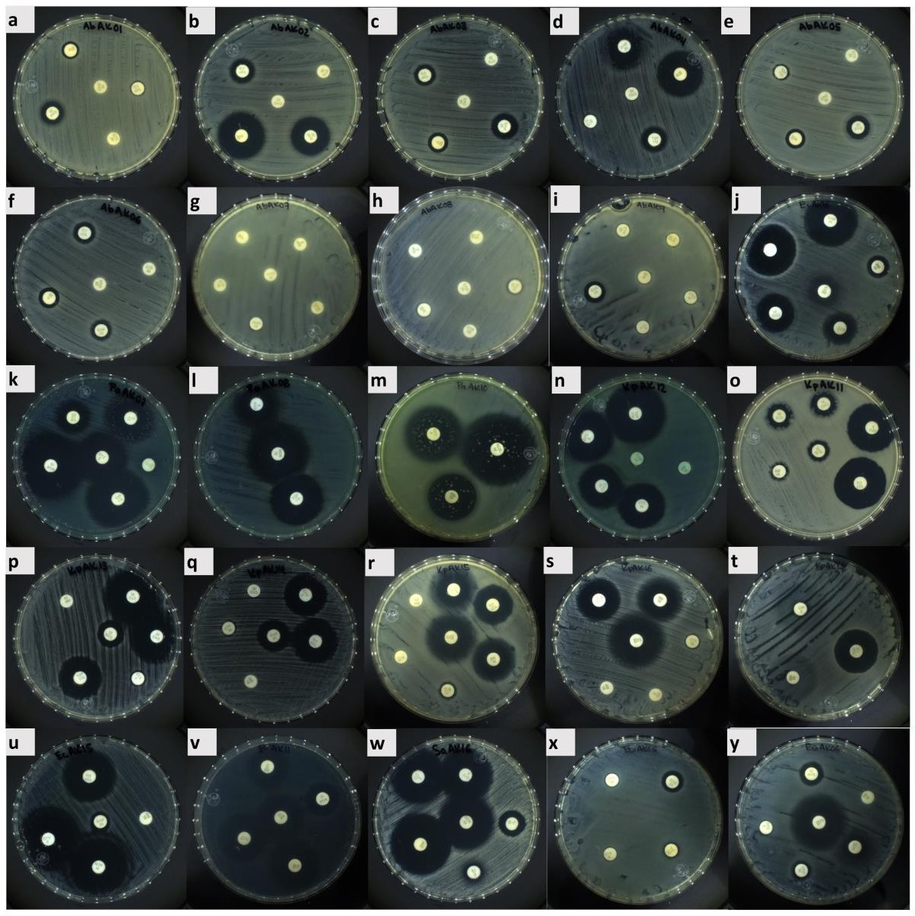
Figure S1. Zone of inhibition using the Kirby-Bauer disk diffusion test. a. AbAK01; b. AbAK02; c. AbAK03; d. AbAK04; e. AbAK05; f. AbAK06; g. AbAK07; h. AbAK08; i. AbAK09; j. AbAK10; k. PaAK07; l. PaAK08; m. PaAK10; n. PaAK11; o. KpAK11; p. KpAK13; q. KpAK14; r. KpAK15; s. KpAK16; t. KpAK17. u. KpAK18; v. EfAK11; w. SaAK16; x. EcoAK05; y. EcoAK06.

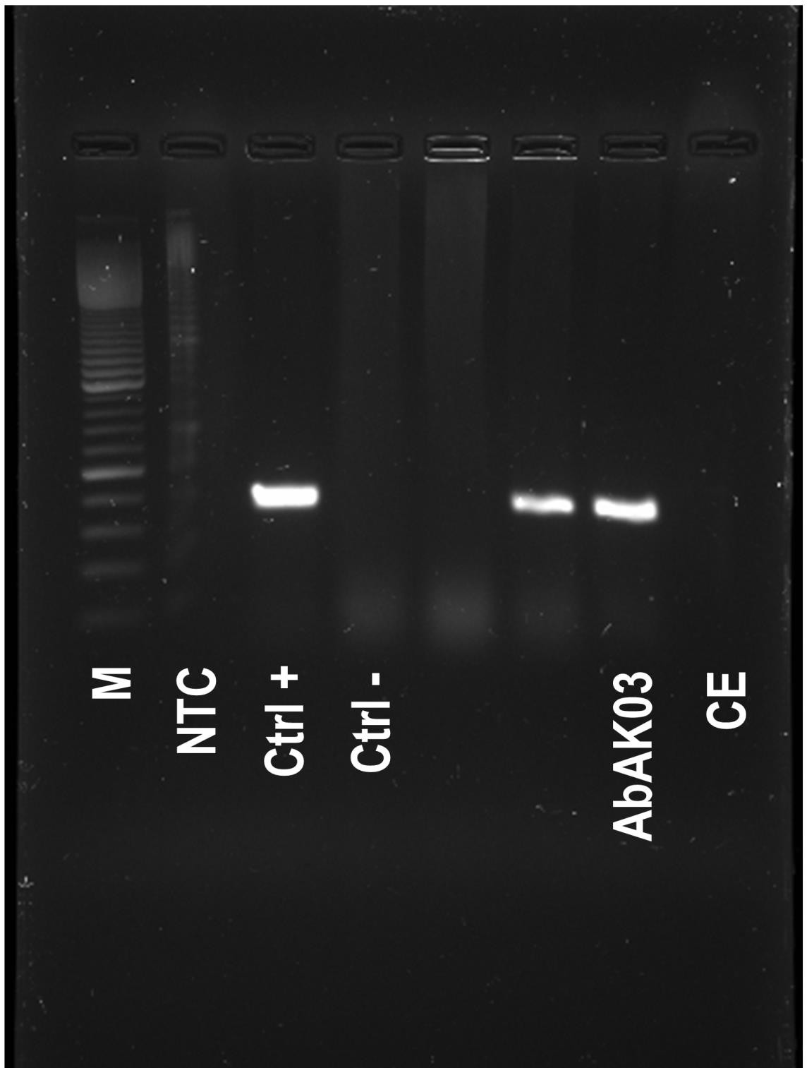
Figure S2. PCR of the blaOXA-51 gene. 1% electrophoresis gels. M: DNA marker 1000 pb. NTC: No template control. Ctrl +: Positive control. Ctrl -. Negative control. CE: Extraction control.

Table S1. Functional classification of 149 ORFs in vB_AbaP_Indie’s genome.
Label | Strand | Start | Stop | Length | Function protein | Organism | Accession | Query Cover | E value | Identidy (%)
 |  |  |  | nt | aa
ORF50 | + | 32147 | 35845 | 3699 |1232 | internal virion protein with endolysin domain protein | [Klebsiella phage VLCpiA1a] | UVX29664.1 | 100% | 0.00E+00 | 97.81%
ORF79 | + | 35847 | 38885 | 3039 |1012 | tail spike | [Klebsiella phage VLC6] | CAK6596186.1 | 27% | 7.00E-178 | 95.02%
ORF20 | + | 29413 | 32097 | 2685 | 894 | internal virion lysozyme motif protein | [Klebsiella phage QL] | WNA15591.1 | 100% | 0.00E+00 | 98.77%
ORF69 | + | 18873 | 21341 | 2469 | 822 | hypothetical protein | [Klebsiella phage pKp11] | UVD41452.1 | 100% | 0.00E+00 | 99.51%
ORF61 | + | 10605 | 12977 | 2373 | 790 | DNA polymerase I | [Klebsiella phage vB_Ko_K66PH128C1] | CAK1344529.1 | 100% | 0.00E+00 | 91.27%
ORF47 | + | 26447 | 28807 | 2361 | 786 | tail tubular protein B | [Klebsiella phage KMI6] | QEG10162.1 | 100% | 0.00E+00 | 98.35%
ORF31 | + | 3662 | 5665 | 2004 | 667 | hypothetical protein | [Klebsiella phage vB_KqP-Goliath] | CAD5239076.1 | 92% | 0.00E+00 | 71.98%
ORF80 | + | 39201 | 41057 | 1857 | 618 | terminase large subunit | [Klebsiella phage VLCpiA1a] | UVX29667.1 | 100% | 0.00E+00 | 99.35%
ORF60 | + | 8805 | 10061 | 1257 | 418 | putative DNA helicase | [Klebsiella phage KP-Rio/2015] | YP_009787361.1 | 99% | 0.00E+00 | 99.04%
ORF4 | + | 5665 | 6696 | 1032 | 343 | peptidase | [Klebsiella phage vB_Kpn_K1PH164C1] | CAK6604547.1 | 99% | 0.00E+00 | 91.23%
ORF45 | + | 24572 | 25591 | 1020 | 339 | capsid and scaffold protein | [Klebsiella phage KMI3] | QEG10008.1 | 100% | 0.00E+00 | 98.53%
ORF14 | + | 16732 | 17700 | 969 | 322 | exonuclease | [Klebsiella phage vB_KpnP_SU503] | YP_009199912.1 | 100% | 0.00E+00 | 99.07%
ORF17 | + | 23686 | 24546 | 861 | 286 | head scaffolding protein | [Klebsiella phage VLCpiA1a] | UVX29711.1 | 100% | 0.00E+00 | 99.30%
ORF65 | + | 14568 | 15410 | 843 | 280 | large tegument protein | [Klebsiella phage vB_KpnP_Bp5] | QDJ96081.1 | 82% | 8.00E-167 | 97.84%
ORF37 | + | 13523 | 14338 | 816 | 271 | metallo-phosphoesterase | [Klebsiella phage VLCpiA1a] | UVX29695.1 | 100% | 0.00E+00 | 99.63%
ORF6 | + | 7804 | 8589 | 786 | 261 | DNA primase | [Klebsiella phage KPPK108.1] | UFK09477.1 | 100% | 0.00E+00 | 98.47%
ORF44 | + | 22949 | 23671 | 723 | 240 | head-tail adaptor | [Klebsiella phage VLCpiA1a] | UVX29710.1 | 100% | 1.00E-166 | 99.17%
ORF49 | + | 30659 | 31282 | 624 | 207 | - | - | - | - | - | -
ORF | - | 5080 | 4466 | 615 | 204 | - | - | - | - | - | -
107
ORF24 | + | 42262 | 42861 | 600 | 199 | endolysin | [Klebsiella phage F19] | YP_009006073.1 | 100% | 7.00E-139 | 94.97%
ORF19 | + | 28810 | 29397 | 588 | 195 | putative internal virion protein | [Klebsiella phage vB_KpnP_IME337] | QEQ50399.1 | 100% | 2.00E-135 | 98.46%
ORF | - | 31212 | 30634 | 579 | 192 | - | - | - | - | - | -
116
ORF2 | + | 1807 | 2382 | 576 | 191 | hypothetical protein | [Klebsiella phage VLCpiA1m] | UVX29164.1 | 100% | 2.00E-132 | 97.91%
ORF46 | + | 25877 | 26437 | 561 | 186 | tail tubular protein A | [Escherichia phage vB_EcoP_ZX6] | QXO10387.1 | 100% | 5.00E-118 | 85.48%
ORF90 | - | 35122 | 34571 | 552 | 183 | - | - | - | - | - | -
ORF81 | + | 41151 | 41630 | 480 | 159 | hypothetical protein | [Klebsiella phage KMI5] | QEG10063.1 | 51% | 4.00E-45 | 91.46%
ORF | - | 32985 | 32518 | 468 | 155 | hypothetical protein | [Clostridiales bacterium] | MBD5132003.1 | 42% | 3.50E-02 | 39.13%
114
ORF32 | + | 6677 | 7144 | 468 | 155 | HNH endonuclease | [Klebsiella phage VLCpiA1g] | UVX31755.1 | 100% | 2.00E-106 | 94.19%
ORF68 | + | 18270 | 18731 | 462 | 153 | nucleotide kinase | [Klebsiella phage phiBO1E] | YP_009784829.1 | 50% | 2.00E-47 | 97.40%
ORF5 | + | 7147 | 7605 | 459 | 152 | hypothetical protein | [Klebsiella phage SKP1]
ORF | - | 6602 | 6156 | 447 | 148 | - | - | - | - | - | -
146
ORF70 | + | 21366 | 21806 | 441 | 146 | hypothetical protein | [Klebsiella phage vB_KpnP_KpV48] | YP_009787593.1 | 100% | 3.00E-98 | 95.89%
ORF16 | + | 20047 | 20487 | 441 | 146 | - | - | - | - | - | -
ORF96 | - | 20650 | 20225 | 426 | 141 | - | - | - | - | - | -
ORF93 | - | 25360 | 24935 | 426 | 141 | hypothetical protein | [Caudoviricetes sp.] | DAH76667.1 | 100% | 9.00E-56 | 68.09%
ORF15 | + | 17851 | 18273 | 423 | 140 | endonuclease | [Klebsiella phage Kp2] | YP_009188344.1 | 100% | 7.00E-96 | 99.29%
ORF52 | + | 41630 | 42034 | 405 | 134 | spanin | [Klebsiella phage VLC3] | QGZ00881.1 | 100% | 4.00E-86 | 98.51%
ORF10 | + | 10648 | 11049 | 402 | 133 | hypothetical protein | [Klebsiella phage AltoGao] | YP_009792064.1 | 51% | 1.00E-17 | 56.52%
ORF92 | - | 26362 | 25967 | 396 | 131 | - | - | - | - | - | -
ORF | - | 19685 | 19293 | 393 | 130 | - | - | - | - | - | -
136
ORF98 | - | 15958 | 15566 | 393 | 130 | - | - | - | - | - | -
ORF7 | + | 9196 | 9579 | 384 | 127 | - | - | - | - | - | -
ORF | - | 17372 | 16992 | 381 | 126 | - | - | - | - | - | -
138
ORF51 | + | 41057 | 41434 | 378 | 125 | hypothetical protein | [Klebsiella phage KMI6] | QEG10112.1 | 100% | 5.00E-81 | 98.40%
ORF13 | + | 15997 | 16368 | 372 | 123 | hypothetical protein | [Staphylococcus epidermidis] | MCC3681358.1 | 100% | 3.00E-69 | 86.99%
ORF76 | + | 32265 | 32627 | 363 | 120 | - | - | - | - | - | -
ORF8 | + | 10039 | 10401 | 363 | 120 | hypothetical protein | [Klebsiella phage vB_KpnP_IME337] | QEQ50427.1 | 95% | 9.00E-43 | 64.71%
ORF | - | 13783 | 13424 | 360 | 119 | - | - | - | - | - | -
101
ORF3 | + | 3565 | 3909 | 345 | 114 | hypothetical protein | [Klebsiella phage pKP-M186-2.2] | UZN24307.1 | 100% | 3.00E-74 | 97.37%
ORF63 | + | 13854 | 14192 | 339 | 112 | - | - | - | - | - | -
ORF58 | + | 8121 | 8459 | 339 | 112 | hypothetical protein | [Caudoviricetes sp.] | DAV46144.1 | 100% | 2.00E-55 | 81.25%
ORF | - | 28167 | 27829 | 339 | 112 | - | - | - | - | - | -
117
ORF | - | 42603 | 42268 | 336 | 111 | hypothetical protein | [Klebsiella phage KPV811] | YP_009787859.1 | 57% | 4.00E-19 | 64.06%
109
ORF | - | 26808 | 26473 | 336 | 111 | - | - | - | - | - | -
119
ORF87 | - | 39580 | 39257 | 324 | 107 | - | - | - | - | - | -
ORF | - | 15822 | 15505 | 318 | 105 | - | - | - | - | - | -
123
ORF | - | 9509 | 9204 | 306 | 101 | - | - | - | - | - | -
143
ORF131 | - | 31850 | 31548 | 303 | 100 | terminase small subunit | [Klebsiella phage Kp2] | YP_009188360.1 | 100% | 7.00E-62 | 99.00%
ORF23 | + | 38899 | 39201 | 303 | 100 | - | - | - | - | - | -
ORF78 | + | 34134 | 34427 | 294 | 97 | - | - | - | - | - | -
ORF86 | - | 40738 | 40445 | 294 | 97 | - | - | - | - | - | -
ORF | - | 10091 | 9804 | 288 | 95 | - | - | - | - | - | -
142
ORF54 | + | 2451 | 2732 | 282 | 93 | - | - | - | - | - | -
ORF75 | + | 27879 | 28157 | 279 | 92 | - | - | - | - | - | -
ORF39 | + | 15719 | 15997 | 279 | 92 | hypothetical protein | [Klebsiella phage 1 TK-2018] | AZF88729.1 | 98% | 5.00E-50 | 89.01%
ORF29 | + | 2729 | 2998 | 270 | 89 | hypothetical protein | [Klebsiella phage AltoGao] | YP_009792051.1 | 100% | 1.00E-51 | 89.89%
ORF43 | + | 21803 | 22066 | 264 | 87 | hypothetical protein | [Anaerococcus sp.] | MDU2828862.1 | 100% | 8.00E-51 | 100.00%
ORF34 | + | 7550 | 7804 | 255 | 84 | hypothetical protein | [Klebsiella phage phiBO1E] | YP_009784807.1 | 80% | 7.00E-34 | 80.88%
ORF38 | + | 15464 | 15718 | 255 | 84 | hypothetical protein | [Staphylococcus epidermidis] | MCC3681359.1 | 100% | 1.00E-46 | 96.43%
ORF82 | + | 42027 | 42278 | 252 | 83 | holin | [Klebsiella phage Kp2] | YP_009188365.1 | 100% | 4.00E-52 | 100.00%
ORF62 | + | 13437 | 13685 | 249 | 82 | - | - | - | - | - | -
ORF | - | 30518 | 30273 | 246 | 81 | - | - | - | - | - | -
132
ORF12 | + | 14965 | 15210 | 246 | 81 | - | - | - | - | - | -
ORF22 | + | 38407 | 38649 | 243 | 80 | - | - | - | - | - | -
ORF99 | - | 15145 | 14903 | 243 | 80 | - | - | - | - | - | -
ORF134 | - | 24032 | 23793 | 240 | 79 | - | - | - | - | - | -
ORF148 | - | 3788 | 3552 | 237 | 78 | - | - | - | - | - | -
ORF72 | + | 22500 | 22730 | 231 | 76 | - | - | - | - | - | -
ORF66 | + | 15501 | 15728 | 228 | 75 | - | - | - | - | - | -
ORF126 | - | 6156 | 5929 | 228 | 75 | - | - | - | - | - | -
ORF73 | + | 22956 | 23183 | 228 | 75 | - | - | - | - | - | -
ORF100 | - | 14509 | 14285 | 225 | 74 | - | - | - | - | - | -
ORF36 | + | 12974 | 13195 | 222 | 73 | hypothetical protein | [Klebsiella phage VLCpiA1g] | UVX31766.1 | 100% | 5.00E-43 | 97.26%
ORF144 | - | 9197 | 8979 | 219 | 72 | - | - | - | - | - | -
ORF57 | + | 5163 | 5378 | 216 | 71 | - | - | - | - | - | -
ORF121 | - | 21960 | 21745 | 216 | 71 | - | - | - | - | - | -
ORF64 | + | 14304 | 14516 | 213 | 70 | hypothetical protein | [Salmonella enterica] | MDJ3280070.1 | 100% | 3.00E-29 | 81.43%
ORF30 | + | 3371 | 3577 | 207 | 68 | hypothetical protein | [Klebsiella phage vB_KpnP_KpV74] | YP_009789246.1 | 100% | 2.00E-40 | 98.53%
ORF1 | + | 166 | 372 | 207 | 68 | hypothetical protein | [Klebsiella phage vB_KpnM-VAC25] | UEW68136.1 | 79% | 2.00E-13 | 72.22%
ORF124 | - | 8187 | 7981 | 207 | 68 | - | - | - | - | - | -
ORF41 | + | 17657 | 17860 | 204 | 67 | hypothetical protein | [Klebsiella phage vB_KpnP_SU503] | YP_009199913.1 | 100% | 4.00E-39 | 98.51%
ORF21 | + | 37633 | 37833 | 201 | 66 | - | - | - | - | - | -
ORF27 | + | 1538 | 1735 | 198 | 65 | hypothetical protein | [Klebsiella phage VLCpiA1h] | UVX30546.1 | 100% | 2.00E-36 | 93.85%
ORF67 | + | 16371 | 16568 | 198 | 65 | hypothetical protein | [Klebsiella phage JKP2] | UUB20331.1 | 100% | 5.00E-40 | 100.00%
ORF59 | + | 8586 | 8780 | 195 | 64 | hypothetical protein | [Klebsiella phage vB_KpnP_IME308] | QEQ50348.1 | 100% | 2.00E-37 | 98.44%
ORF85 | - | 40948 | 40754 | 195 | 64 | - | - | - | - | - | -
ORF135 | - | 21173 | 20979 | 195 | 64 | - | - | - | - | - | -
ORF112 | - | 34833 | 34642 | 192 | 63 | - | - | - | - | - | -
ORF95 | - | 21118 | 20930 | 189 | 62 | - | - | - | - | - | -
ORF120 | - | 25161 | 24973 | 189 | 62 | - | - | - | - | - | -
ORF118 | - | 27744 | 27559 | 186 | 61 | - | - | - | - | - | -
ORF140 | - | 16253 | 16068 | 186 | 61 | - | - | - | - | - | -
ORF18 | + | 25603 | 25788 | 186 | 61 | putative structural protein | [Klebsiella phage vB_KpnP_fHeKpn01] | QFG06590.1 | 93% | 1.00E-25 | 91.23%
ORF53 | + | 42875 | 43060 | 186 | 61 | head fiber protein | [Klebsiella phage vB_Ko_K66PH128C1] | CAK1344497.1 | 98% | 3.00E-12 | 65.00%
ORF55 | + | 3006 | 3191 | 186 | 61 | hypothetical protein | [Klebsiella phage 6995] | URY99674.1 | 100% | 9.00E-29 | 81.97%
ORF84 | - | 42157 | 41975 | 183 | 60 | - | - | - | - | - | -
ORF74 | + | 26100 | 26282 | 183 | 60 | - | - | - | - | - | -
ORF104 | - | 8956 | 8777 | 180 | 59 | hypothetical protein | [Escherichia phage ZH5] | UOL48239.1 | 52% | 5.00E-08 | 80.65%
ORF56 | + | 3195 | 3374 | 180 | 59 | hypothetical protein | [Klebsiella phage VLCpiA1k] | UVX30342.1 | 100% | 1.00E-34 | 98.31%
ORF48 | + | 29633 | 29809 | 177 | 58 | - | - | - | - | - | -
ORF127 | - | 5007 | 4831 | 177 | 58 | - | - | - | - | - | -
ORF125 | - | 7191 | 7015 | 177 | 58 | - | - | - | - | - | -
ORF122 | - | 18033 | 17857 | 177 | 58 | - | - | - | - | - | -
ORF115 | - | 32148 | 31972 | 177 | 58 | - | - | - | - | - | -
ORF28 | + | 1970 | 2146 | 177 | 58 | - | - | - | - | - | -
ORF145 | - | 7565 | 7389 | 177 | 58 | - | - | - | - | - | -
ORF105 | - | 7750 | 7577 | 174 | 57 | - | - | - | - | - | -
ORF88 | - | 37990 | 37817 | 174 | 57 | - | - | - | - | - | -
ORF103 | - | 12457 | 12284 | 174 | 57 | - | - | - | - | - | -
ORF141 | - | 10649 | 10476 | 174 | 57 | hypothetical protein | [Caudoviricetes sp.] | DAV46143.1 | 100% | 4.00E-28 | 89.29%
ORF25 | + | 1073 | 1243 | 171 | 56 | - | - | - | - | - | -
ORF35 | + | 7910 | 8080 | 171 | 56 | hypothetical protein | [Caudoviricetes sp.] | DAV46143.1 | 100% | 4.00E-28 | 89.29%
ORF108 | - | 2578 | 2411 | 168 | 55 | - | - | - | - | - | -
ORF129 | - | 39053 | 38886 | 168 | 55 | - | - | - | - | - | -
ORF77 | + | 33513 | 33677 | 165 | 54 | - | - | - | - | - | -
ORF106 | - | 6073 | 5909 | 165 | 54 | - | - | - | - | - | -
ORF133 | - | 30203 | 30039 | 165 | 54 | - | - | - | - | - | -
ORF130 | - | 37583 | 37419 | 165 | 54 | - | - | - | - | - | -
ORF91 | - | 33937 | 33773 | 165 | 54 | - | - | - | - | - | -
ORF26 | + | 1328 | 1492 | 165 | 54 | hypothetical protein | [Caudoviricetes sp.] | DAW27072.1 | 55% | 5.00E-08 | 83.33%
ORF11 | + | 11515 | 11676 | 162 | 53 | - | - | - | - | - | -
ORF89 | - | 37009 | 36848 | 162 | 53 | - | - | - | - | - | -
ORF147 | - | 5423 | 5262 | 162 | 53 | - | - | - | - | - | -
ORF102 | - | 13072 | 12911 | 162 | 53 | - | - | - | - | - | -
ORF40 | + | 16571 | 16732 | 162 | 53 | hypothetical protein | [Klebsiella phage VLC5] | QIW86400.1 | 100% | 8.00E-29 | 100.00%
ORF97 | - | 19108 | 18947 | 162 | 53 | - | - | - | - | - | -
ORF149 | - | 2318 | 2160 | 159 | 52 | - | - | - | - | - | -
ORF137 | - | 17630 | 17472 | 159 | 52 | - | - | - | - | - | -
ORF111 | - | 35352 | 35194 | 159 | 52 | - | - | - | - | - | -
ORF94 | - | 21304 | 21146 | 159 | 52 | - | - | - | - | - | -
ORF71 | + | 22122 | 22280 | 159 | 52 | - | - | - | - | - | -
ORF128 | - | 42809 | 42654 | 156 | 51 | - | - | - | - | - | -
ORF113 | - | 33888 | 33733 | 156 | 51 | - | - | - | - | - | -
ORF110 | - | 41103 | 40948 | 156 | 51 | - | - | - | - | -
ORF33 | + | 7295 | 7450 | 156 | 51 | - | - | - | - | -
ORF9 | + | 10453 | 10608 | 156 | 51 | hypothetical protein | [Klebsiella phage KpV475] | YP_009280684.1 | 100% | 1.00E-26 | 94.12%
ORF42 | + | 17996 | 18151 | 156 | 51 | hypothetical protein | [Salmonella enterica] | MDJ3280076.1 | 98% | 7.00E-25 | 98.00%
ORF83 | - | 43282 | 43127 | 156 | 51 | - | - | - | - | - | -
ORF139 | - | 16433 | 16281 | 153 | 50 | - | - | - | - | - | -

