STable The clinical characteristics among the training and validation sets
Characteristics | training set | vaildation set | P value
Characteristics | (N=227263) | (N=97398) | P value
Grade |  |  | 0.09
Ⅰ | 55315 (24.3%) | 24103 (24.7%)
Ⅱ | 102610 (45.2%) | 43724 (44.9%)
Ⅲ | 68915 (30.3%) | 29381 (30.2%)
Ⅳ | 423 (0.2%) | 190 (0.2%)
Histology |  |  | 0.19
Ductal | 181092 (79.7%) | 77544 (79.6%)
Mixed | 12722 (5.6%) | 5410 (5.6%)
Lobular | 21604 (9.5%) | 9193 (9.4%)
Other | 11845 (5.2%) | 5251 (5.4%)
Subsite |  |  | 0.60
Central portion | 10143 (4.5%) | 4298 (4.4%)
Lower-inner quadrant | 13019 (5.7%) | 5583 (5.7%)
Lower-outer quadrant | 17622 (7.8%) | 7685 (7.9%)
Upper-outer quadrant | 75785 (33.3%) | 32283 (33.1%)
Upper-inner quadrant | 29946 (13.2%) | 12955 (13.3%)
Other | 80748 (35.5%) | 34594 (35.5%)
Age of diagnosis |  |  | 0.13
young | 11850 (5.2%) | 4977 (5.1%)
middle | 85323 (37.5%) | 36893 (37.9%)
old | 130090 (57.2%) | 55528 (57.0%)
Laterality |  |  | 0.32
Left | 114989 (50.6%) | 49096 (50.4%)
Right | 112274 (49.4%) | 48302 (49.6%)
Radiotherapy |  |  | 0.71
NRT | 89309 (39.3%) | 38342 (39.4%)
RT | 137954 (60.7%) | 59056 (60.6%)
Size |  |  | 0.34
<2cm | 142450 (62.7%) | 61091 (62.7%)
>2cm,<5cm | 68448 (30.1%) | 29432 (30.2%)
>5cm | 16365 (7.2%) | 6875 (7.1%)
Clinical lymph node status |  |  | 0.46
0 positive | 161541 (71.1%) | 69470 (71.3%)
≥1positive | 65722 (28.9%) | 27928 (28.3%)
Pathological stage |  |  | 0.22
I stage | 125601 (55.3%) | 53906 (55.3%)
II stage | 78518 (34.5%) | 33767 (34.7%)
III stage | 23144 (10.2%) | 9725 (10.0%)
Chemotherapy |  |  | 0.42
No/Unknown | 135359 (59.6%) | 135359 (59.6%)
Yes | 91904 (40.4%) | 91904 (40.4%)
Married Stage |  |  | 0.09
Married | 191830 (84.4%) | 81983 (84.2%)
Single | 35433 (15.6%) | 15415 (15.8%)
Subtype |  |  | 0.37
Luminal A | 171639 (75.5%) | 73824 (75.8%)
Luminal B | 23162 (10.2%) | 9760 (10.0%)
HER2 enriched | 9010 (4.0%) | 3829 (3.9%)
TNBC | 23452 (10.3%) | 9985 (10.3%)

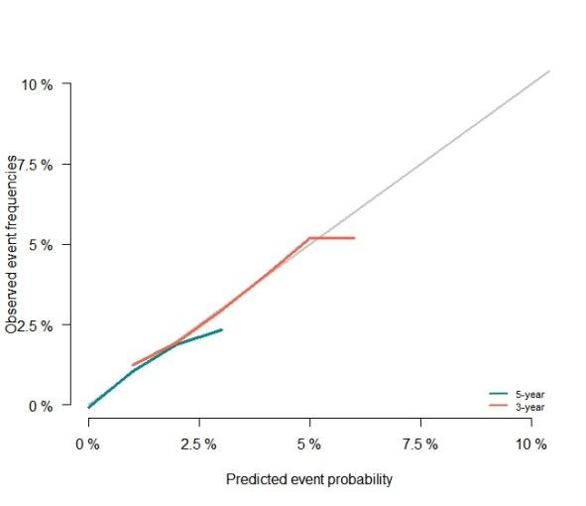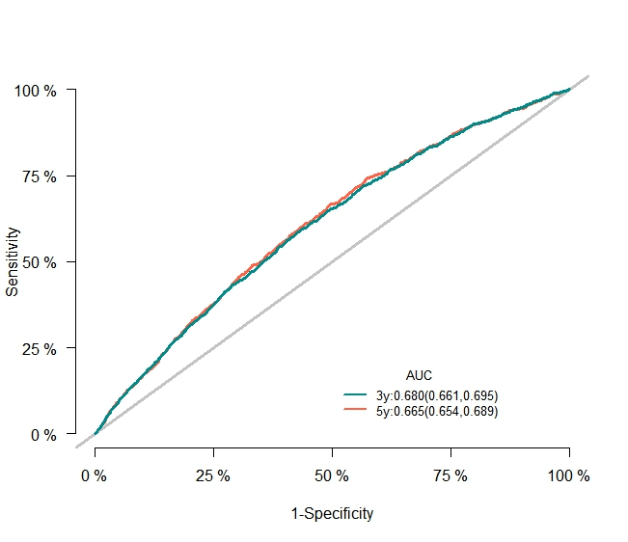
B
A
SFig1 Competing Hazards Model to calculate the (A) the prediction calibration plots and (B)ROC curves for predicting 3- and 5-year probability of EBC in validation set.

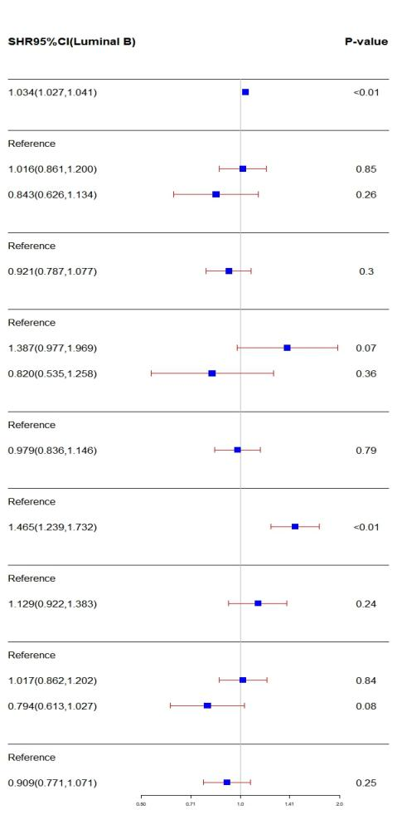
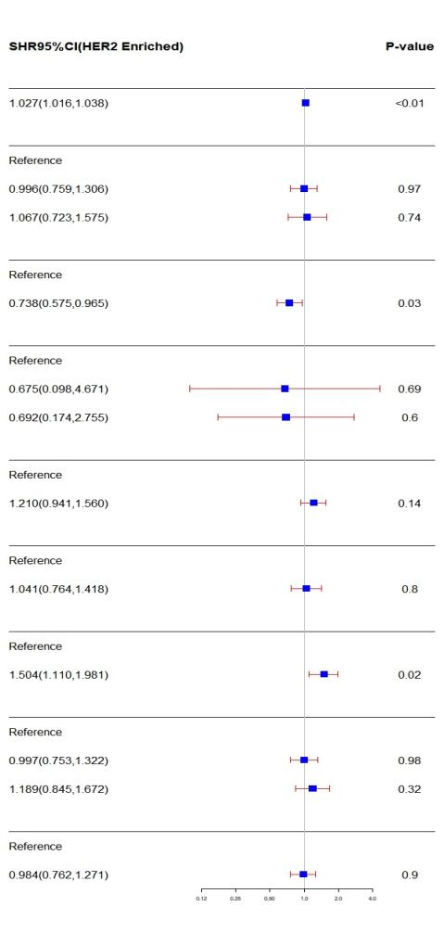
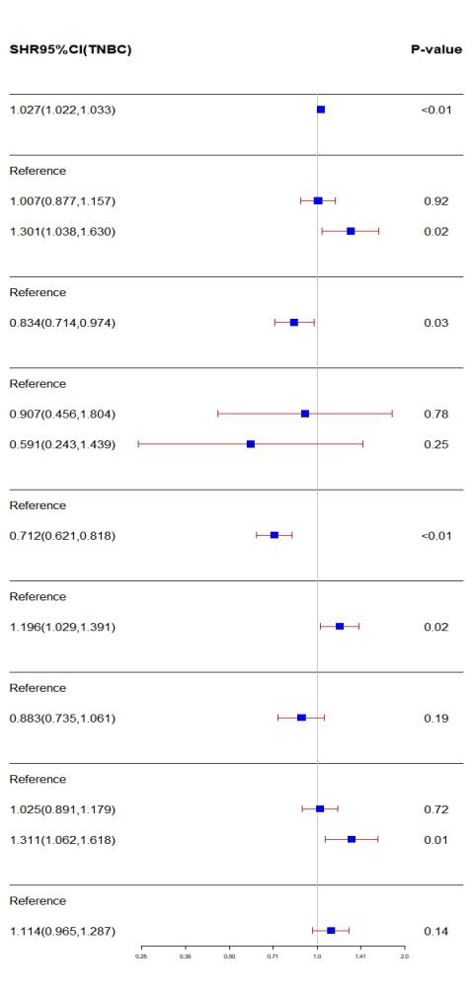
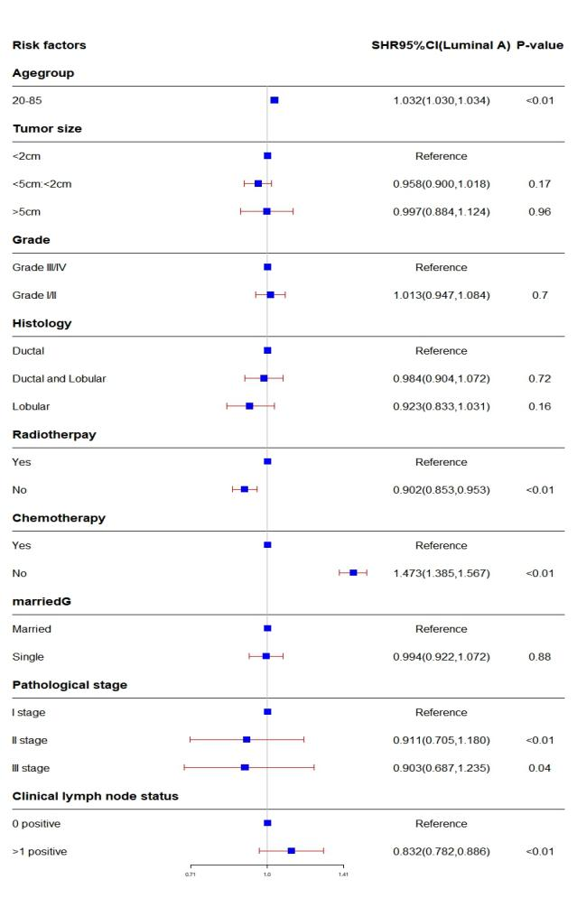
B
A
C
D

SFig 2 Risk factors for EBC fore subtypes by stratification analysis (A) Luminal A; (B) Luminal B; (C) HER2 Enriched; (D) TNBC. Note: including age,tumor size, grade, histology, radiotherapy, chemotherapy, married status, Pathological stage and Clinical lymph node status
Stable 2 Second breast cancer in univariate and multivariate analysis based on competing risk model in training set
Risk Factors | Univariate analysis | P value | Multivariate analysis | P value
Risk Factors | SHR (95% CI) | P value | SHR (95% CI) | P value
AGE group
20-85 | 1.194(1.108,1.287) | <0.01 | 1.122(1.034,1.217) | <0.01
Grade
Grade I/II | Reference |  | Reference
Grade III/IV | 1.069(0.961,1.189） | 0.22 | Reference
Histology
Ductal | Reference |  | Reference
Ductal and Lobular | 0.836(0.660,1.059） | 0.14 | Reference
Lobular | 0.843(0.697,1.019） | 0.08 | Reference
Pathological stage
I stage | Reference |  | Reference
II stage | 0.838(0.750,0.935) | <0.01 | 1.181(0.919,1.517) | 0.19
III stage | 0.910(0.771,1.073) | 0.26 | 1.447(0.996,2.103) | 0.06
Radiotherapy
No | Reference |  | Reference
Yes | 1.235(1.111,1.371) | <0.01 | 1.270(1.141,1.413) | <0.01
Tumor Size
≤2cm | Reference |  | Reference
2-5cm | 0.854(0.762,0.958) | <0.01 | 0.843(0.679,1.047) | 0.12
>5cm | 0.989(0.817,1.197) | 0.91 | 0.928(0.689,1.249) | 0.62
Subtypes
Luminal A | Reference |  | Reference
Luminal B | 0.682(0.558,0.34) | <0.01 | 0.958(0.864,1.064) | <0.01
HER2 enriched | 1.130(0.888,1.144) | 0.32 | 1.374(1.073,1.759) | 0.03
TNBC | 1.384(1.202,1.595) | <0.01 | 1.636(1.405,1.905) | <0.01
Married status
Married | Reference |  | Reference
Single | 1.098(0.959,1.257) | 0.18 | Reference
Chemotherapy
No/Unknown | Reference |  | Reference
Yes | 0.766(0.691,0.850) | <0.01 | 0.744(0.649,0.851) | 0.11
Clinical lymph node status
0 positive | Reference |  | Reference
≥1 positive | 0.810(0.723,0.908) | <0.01 | 0.796(0.649,0.851) | 0.02
AUC in training set: 0.622(0.614,0.632); AUC in validation set: 0.640(0.632,0.655)

Stable 3 Second lung cancer in univariate and multivariate analysis based on competing risk model in training set
Risk Factors | Univariate analysis | P value | Multivariate analysis | P value
Risk Factors | SHR (95% CI) | P value | SHR (95% CI) | P value
AGE group
20-85 | 2.275(2.051,2.525) | <0.01 | 2.286(2.046,2.555) | <0.01
Grade
Grade I/II | Reference |  | Reference
Grade III/IV | 1.194(1.018,1.287） | <0.01 | 1.027(0.849,1.242) | 0.78
Histology
Ductal | Reference |  | Reference
Ductal and Lobular | 0.917(0.651,1.291） | 0.62 | Reference
Lobular | 1.019(0.731,1.436） | 0.88 | Reference
Pathological stage
I stage | Reference |  | Reference
II stage | 0.650(0.549,0.770) | <0.01 | 0.710(0.469,0.975) | 0.04
III stage | 0.496(0.362,0.680) | <0.01 | 0.572(0.302,0.987) | 0.03
Radiotherapy
No | Reference |  | Reference
Yes | 1.138(0.972,1.332) | 0.11 | Reference
Tumor Size
≤2cm | Reference |  | Reference
2-5cm | 0.696(0.851,0.834) | <0.01 | 1.028(0.716,1.475) | 0.88
>5cm | 0.592(0.414,0.846) | <0.01 | 1.054(0.623,1.784) | 0.85
Subtypes
Luminal A | Reference |  | Reference
Luminal B | 0.906(0.696,1.179) | 0.46 | Reference
HER2 enriched | 0.684(0.432,1.082) | 0.1 | Reference
TNBC | 1.125(0.887,1.435) | 0.33 | Reference
Married status
Married | Reference |  | Reference
Single | 0.820(0.654,1.029) | 0.08 | Reference
Chemotherapy
No/Unknown | Reference |  | Reference
Yes | 0.630(0.536,0.742) | <0.01 | 1.155(0.946,1.409) | 0.16
Clinical lymph node status
0 positive | Reference |  | Reference
≥1 positive | 0.605(0.501,0.731) | <0.01 | 0.914(0.659,1.254) | 0.58
AUC in training set: 0.696(0.694,0.698); AUC in validation set: 0.677(0.674,0.679)

Stable 4 Second gynecological cancer in univariate and multivariate analysis based on competing risk model in training set
Risk Factors | Univariate analysis | P value | Multivariate analysis | P value
Risk Factors | SHR (95% CI) | P value | SHR (95% CI) | P value
AGE group
20-85 | 1.279(1.150,1.425) | <0.01 | 1.241(1.106,1.393) | 0.01
Grade
Grade I/II | Reference |  | Reference
Grade III/IV | 0.943(0.792,1.123） | 0.51 | Reference
Histology
Ductal | Reference |  | Reference
Ductal and Lobular | 1.107(0.792,1.547） | 0.55 | Reference
Lobular | 1.068(0.811,1.406） | 0.64 | Reference
Pathological stage
I stage | Reference |  | Reference
II stage | 1.022(0.862,1.211) | 0.8 | 0.950(0.630,1.431) | 0.81
III stage | 0.699(0.516,0.948) | 0.02 | 0.922(0.499,1.702) | 0.80
Radiotherapy
No | Reference |  | Reference
Yes | 0.915(0.775,1.080) | 0.29 | Reference
Tumor Size
≤2cm | Reference |  | Reference
2-5cm | 1.178(0.993,1.378) | 0.06 | 1.384(0.964,1986) | 0.08
>5cm | 0.642(0.436,0.943) | 0.02 | 0.849(0.490,1.472) | 0.56
Subtypes
Luminal A | Reference |  | Reference
Luminal B | 0.662(0.482,0.908) | 0.01 | 0.704(0.507,0.975) | 0.04
HER2 enriched | 0.467(0.263,0.828) | 0.01 | 0.502(0.282,0.896) | 0.02
TNBC | 1.104(0.866,1.407) | 0.43 | 1.125(0.870,1.454) | 0.37
Married status
Married | Reference |  | Reference
Single | 1.176(0.952,1.453) | 0.13 | Reference
Chemotherapy
No/Unknown | Reference |  | Reference
Yes | 0.798(0.676,0.942) | <0.01 | 0.980(0.796,1.201) | 0.85
Clinical lymph node status
0 positive | Reference |  | Reference
≥1 positive | 0.745(0.612,0.879) | <0.01 | 0.792(0.591,1.062) | 0.58
AUC in training set: 0.636(0.630,0.639); AUC in validation set: 0.620(0.610,0.628)

STable5 Stratification analysis of EBC subtypes
Variables | Luminal A | Luminal B | HER2 enriched | TNBC
Variables | Reference | HR(95%CI) | HR(95%CI) | HR(95%CI)
Age
<40 | Reference | 0.865(0.588,1.273) | 0.861(0.475,1.560) | 1.121(0.798,1.574)
40-64 | Reference | 0.943(0.845,1.052) | 0.923(0.782,1.089) | 1.294(1.177,1.423)
>65 | Reference | 0.870(0.761,0.995) | 0.800(0.646,0.992) | 1.063(0.950,1.189）
Tumor Size
≤2cm | Reference | 0.848(0.760,0.946) | 0.829(0.364,0.990) | 1.152(1.044,1.271)
2-5cm | Reference | 0.884(0.769,1.017) | 0.823(0.664,1.020) | 1.132(1.008,1.270)
>5cm | Reference | 0.751(0.556,1.014) | 0.830(0.576,1.196) | 1.144(0.903,1.449)
Histology
Ductal | Reference | 1.091(1.011,1.177) | 0.793(0.694,0.906) | 0.825(0.754,0.902)
Ductal and Lobular | Reference | 0.756(0.491,1.164) | 0.588(0.148,2.332) | 0.536(0.222,1.298)
Lobular | Reference | 1.217(0.855,1.730) | 0.425(0.059,3.048) | 0.979(0.487,1.968)
Radiotherapy
No | Reference | 0.889(0.783,1.008) | 0.784(0.645,0.952) | 0.972(0.862,1.095)
Yes | Reference | 0.808(0.724,0.901) | 0.836(0.706,0.991) | 1.210(1.108,1.321)
Pathological stage
I stage | Reference | 0.813(0.719,0.919) | 0.756(0.616,0.927) | 1.084(0.974,1.208)
II stage | Reference | 0.951(0.838,1.080) | 0.866(0.709,1.058) | 1.280(1.151,1.424)
III stage | Reference | 0.716(0.559,0.917) | 0.996(0.744,1.331) | 1.579(1.285,1.940)
Chemotherapy
No/Unknown | Reference | 1.013(0.880,1.166) | 0.752(0.571,1.092) | 1.143(1.001,1.306)
Yes | Reference | 0.958(0.858,1.068) | 1.022(0.879,1.187) | 1.369(1.247,1.501)
Married status
Married | Reference | 0.822(0.750,1.009) | 0.746(0.647,1.163) | 1.139(1.056,1.230)
Single | Reference | 0.909(0.747,1.107) | 1.106(0.838,1.459) | 0.971(0.809,1.166)
Grade
Grade III/IV | Reference | 0.813(0.716,0.923) | 0.755(0.642,0.889) | 1.093(0.993,1.203)
Grade I/II | Reference | 0.881(0.787,0.987) | 1.009(0.807,1.263) | 1.316(1.145,1.513)

