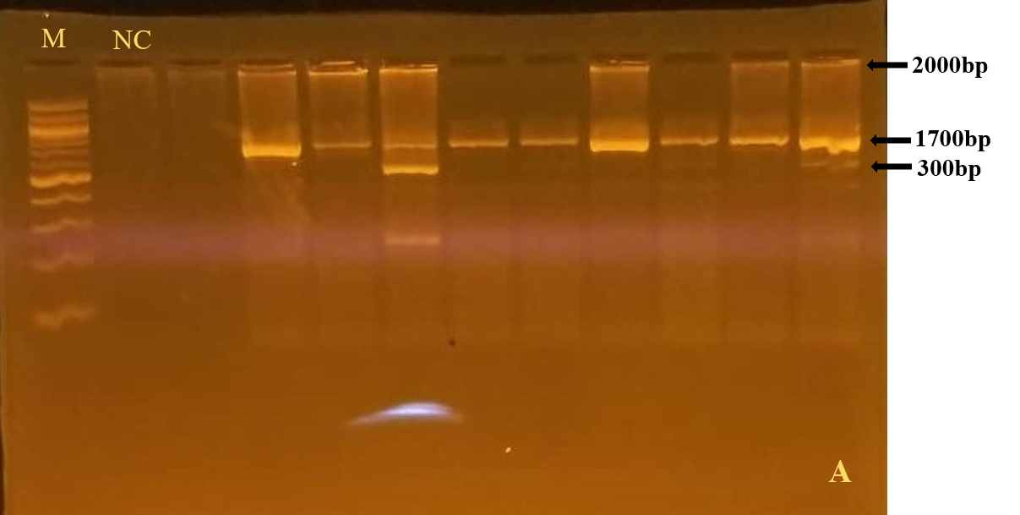
Figure S1: Agarose gel electrophoresis for Apa 1 VDR gene variant
Legend: M: 2Kbp ladder, NC: Negative control

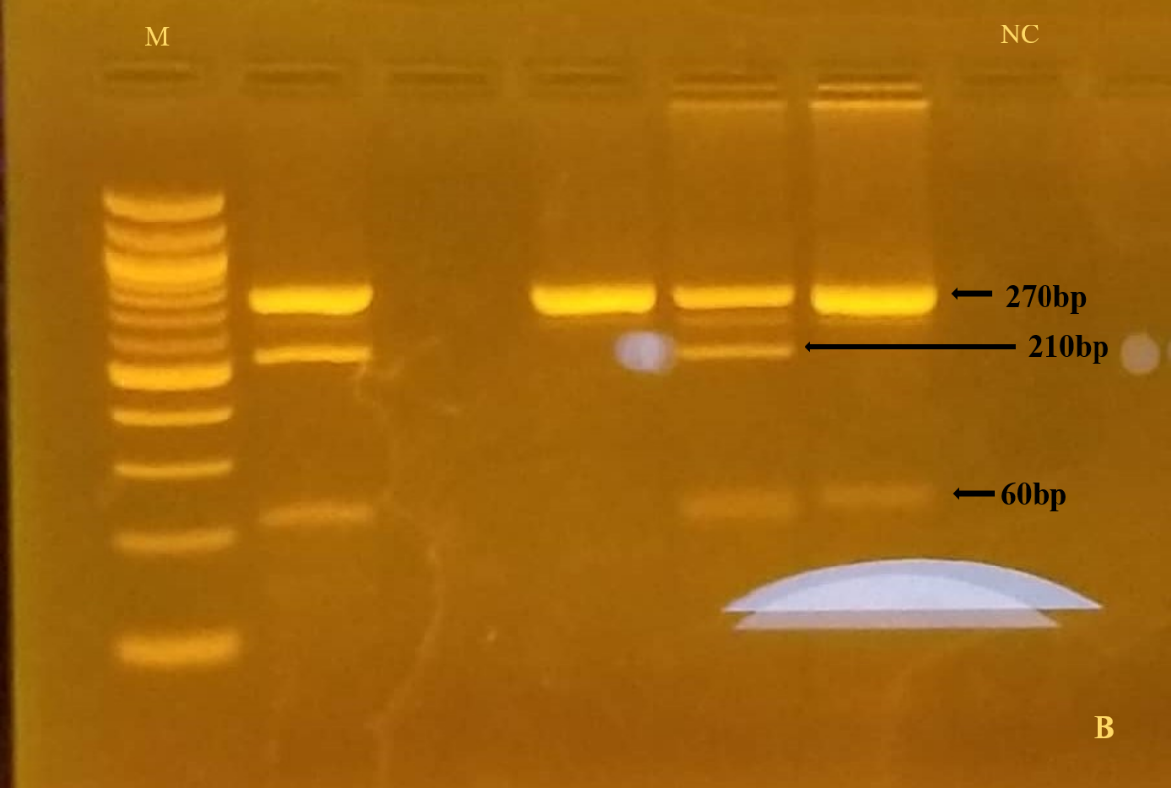
Figure S2: Agarose gel electrophoresis for Fok 1 VDR gene variant
Legend: M: 100bp ladder, NC: Negative control

