Online Supplementary Material

Comparison of FeetMe Insoles with a Motion Capture System Coupled to Force Plates for Assessing Gait and Posture

Supplementary methods
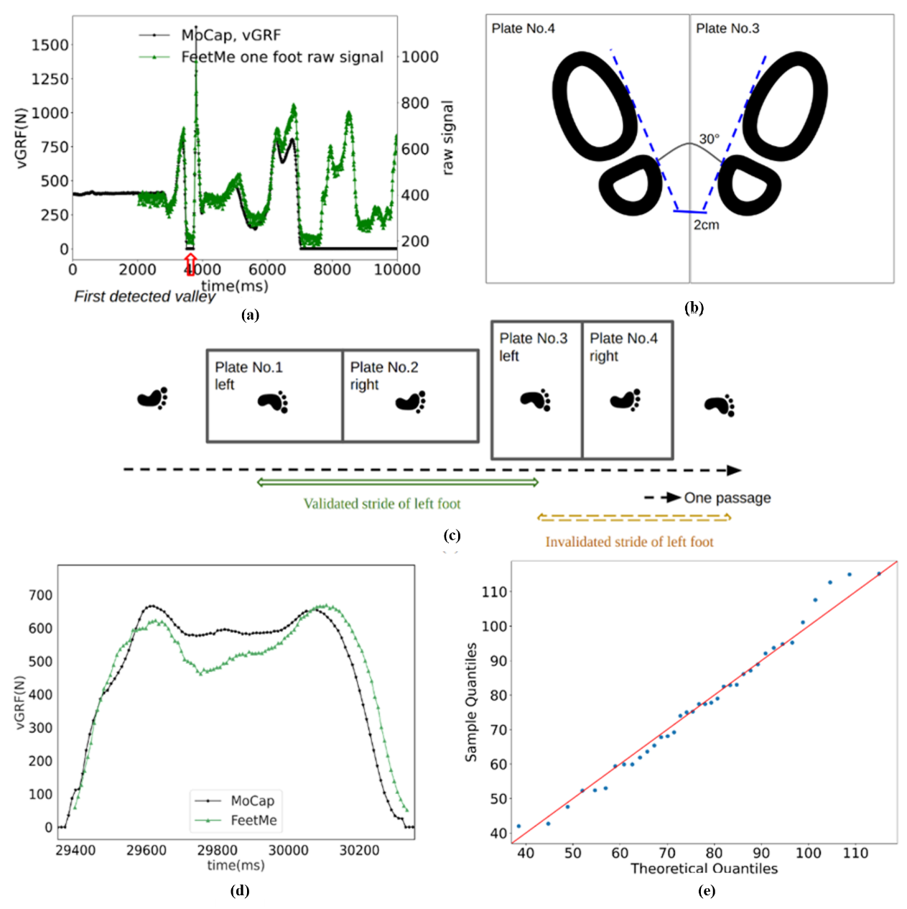
Figure S1. Synchronization and foot positions during the static stabilometry and walking tests. (a) Graph illustrating the synchronization of signals between FeetMe and the force platform in response to a jumping motion. The first detected valley is marked by a red arrow. (b) Schematic representation of the static test position on the force platforms. Prior to the test, two lines were marked on the platforms (one dashed and one solid blue line) to ensure that the volunteer's feet were positioned correctly. The lines were marked at an angle of 30° between the feet and a 2 cm distance between the heels. The volunteer was asked to place the inner side of their foot along the dashed blue line and their heel at the level of the solid blue line. (c) Illustration of a valid and invalid stride with the left foot during passage over force platforms 1, 2, 3 and 4. (d) Representative progression plot of vertical ground reaction force (vGRF) versus time during a dynamic walking test from the FeetMe (green) and Vicon marker-based motion capture (MoCap; black) systems. vGRF under each foot is characterized by an initial small spike followed by a double-peaked curve: the first peak (maximum weight acceptance or heelmax load) reflects the impact of a heel-strike, and the second peak (push-off or toemax load) reflects how the body's center of mass is being accelerated upwards. (e) Quantile-quantile (Q-Q) plot for the weight distribution of the healthy participants.

Supplementary results
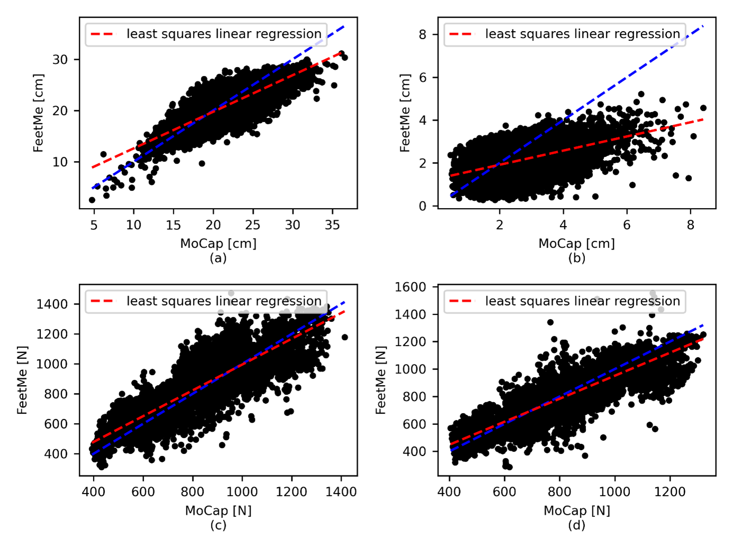
Figure S2. Linear regression analyses of the kinetic parameters recorded with the FeetMe and MoCap/FP systems during walking. (a) Dynamic uCoP AP dim during a stance, (b) Dynamic uCoP ML dim during a stance, (c) Heelmax load and (d) Toemax load (n=11515 for all measurements). The dashed red line represents the line of least squares linear regression and dashed blue line represents the x=y line of perfect match. uCoP AP = anterior posterior of unipodal center of pressure, uCoP ML = medial-lateral of unipodal center of pressure, dim = dimensions, N = number.

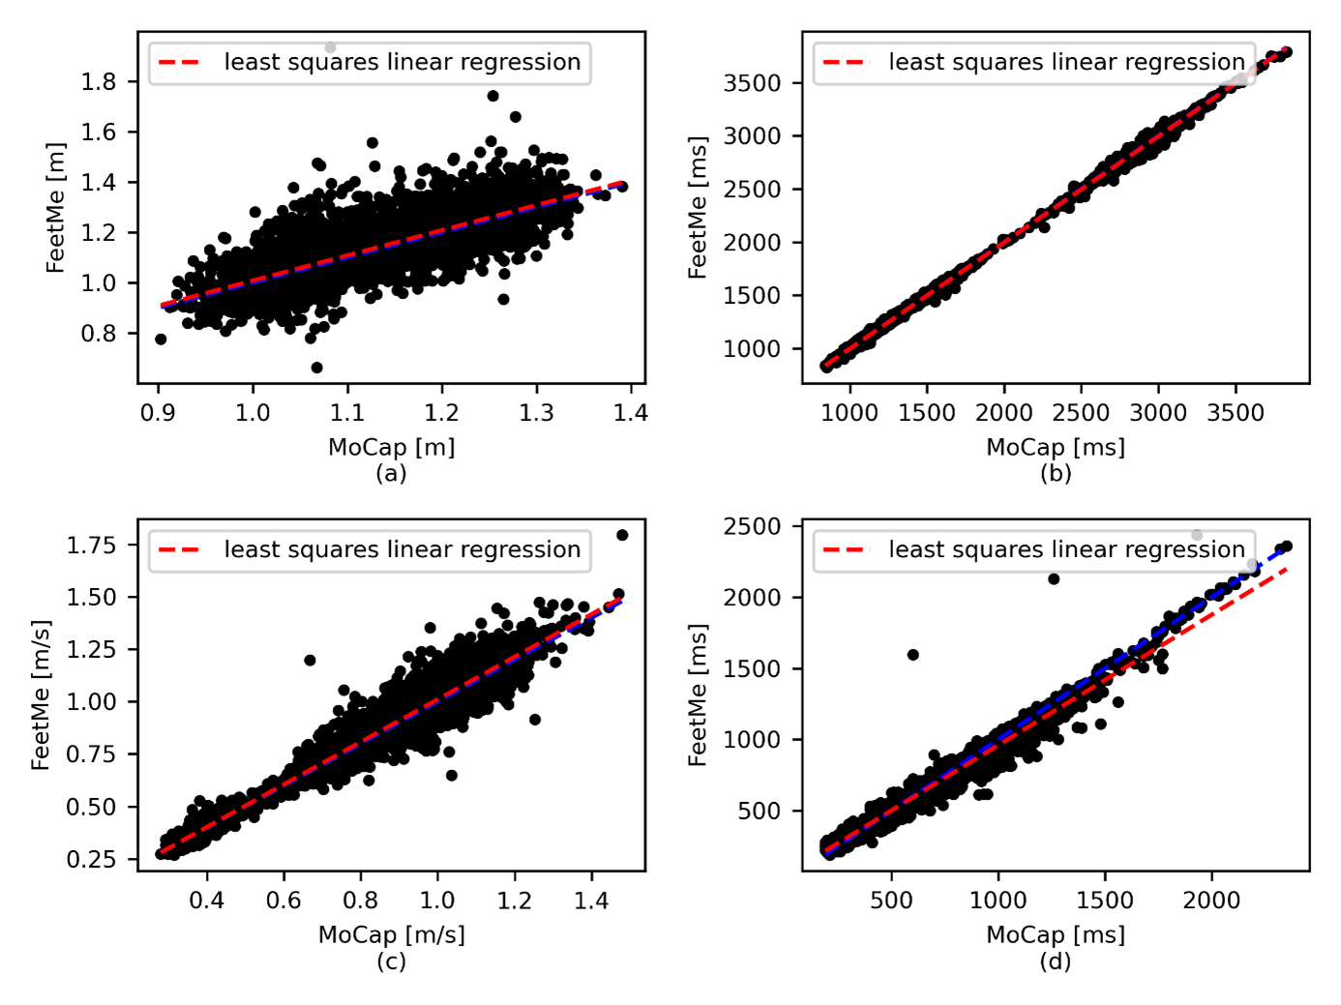
Figure S3. Linear regression analysis of the FeetMe and MoCap/FP measurements of spatiotemporal parameters per stride (a) stride length (StrideLen; stride n=5250), (b) stride duration (StanceDur; stride n=5250), (c) velocity (stride n=5250) and (d) double support duration (DoubleSupDur; stride n=4782). The dashed red line represents the line of least squares linear regression and dashed blue line represents the x=y line of perfect match.

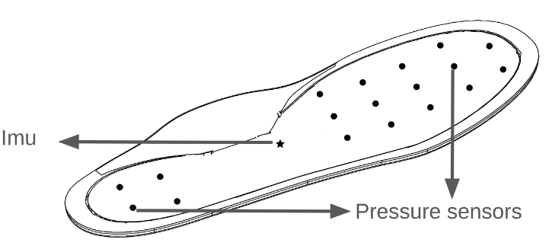
Figure S4. Position of the capacitive pressure sensors and the IMU inside the FeetMe Insole. A star represents the IMU, and dots represent the centers of each pressure sensor.

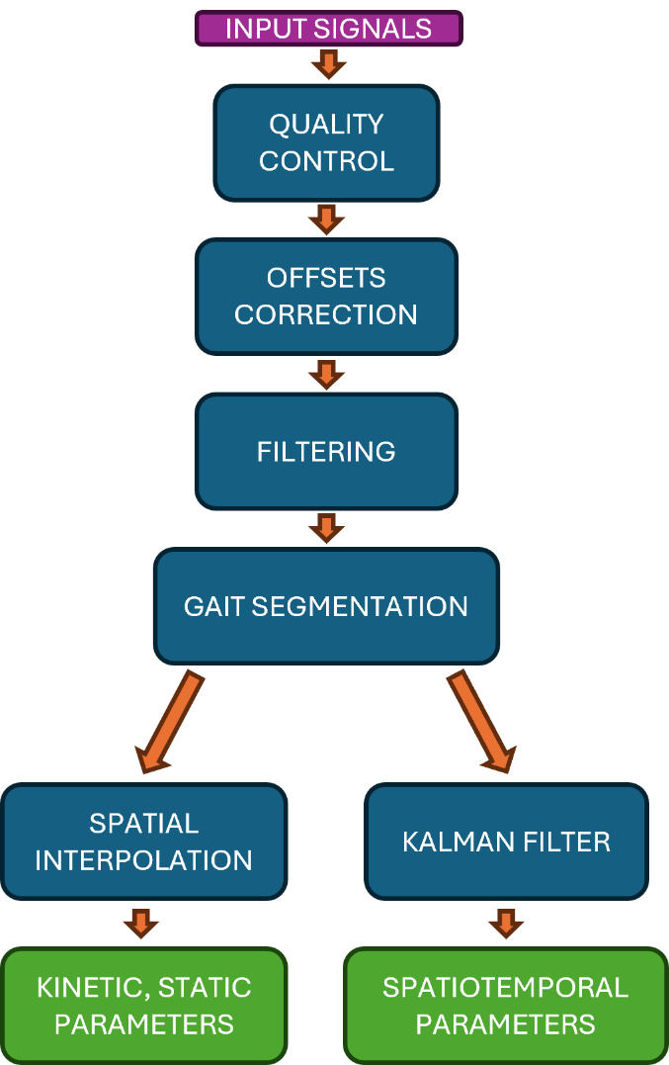
Figure S5: Data processing flowchart.
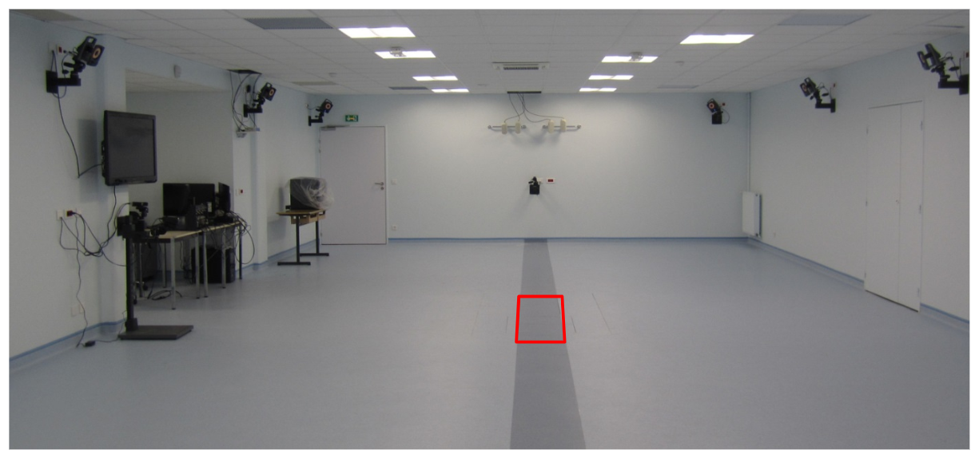
Figure S6. Picture of the gait laboratory in which the study took place. The position of the Force Plates is indicated with a red frame. The six cameras shown in the picture are positioned at around 2.4 meters above ground level.

