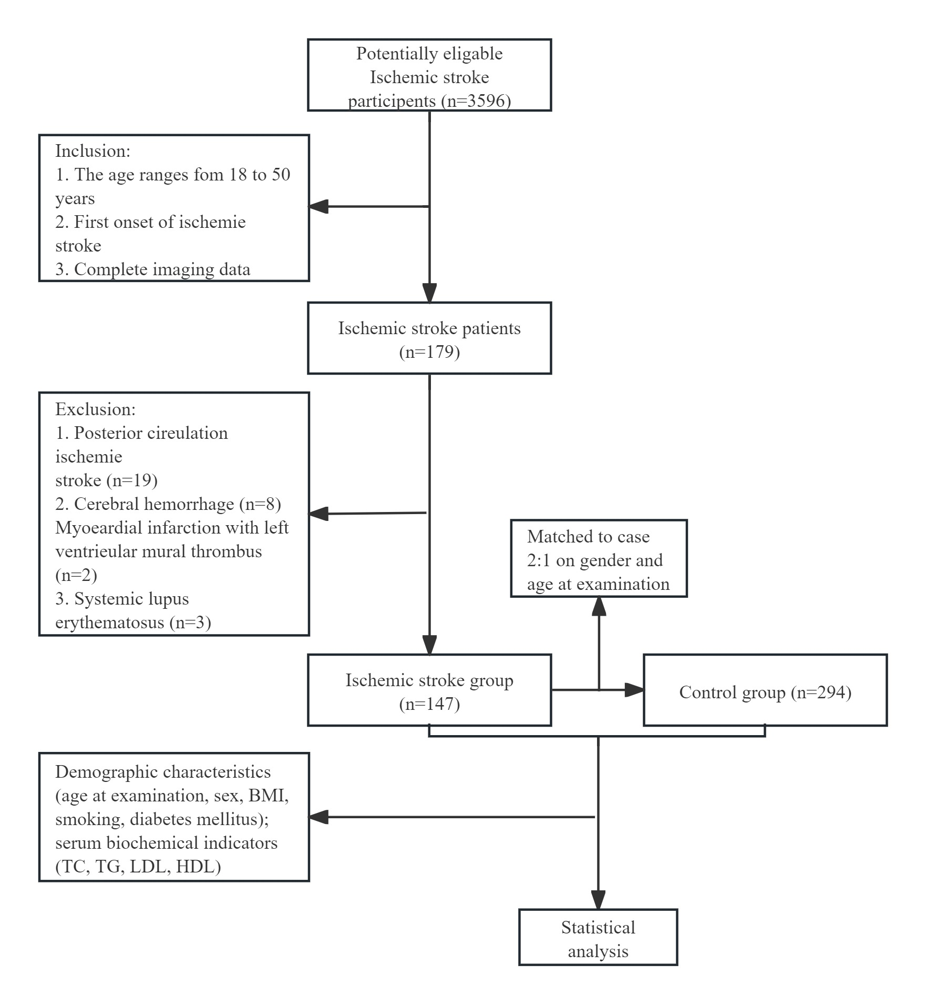
Supplementary Figure S1
Flow chart of the study
Abbreviations: BMI, body mass index; TC, total cholesterol; TG, triglycerides; LDL, low density lipoprotein; HDL, high density lipoprotein

