Supplementary Figures

Supplementary Figure 1. A scatterplot showing average coverage of WES samples and the average quality score of bases.

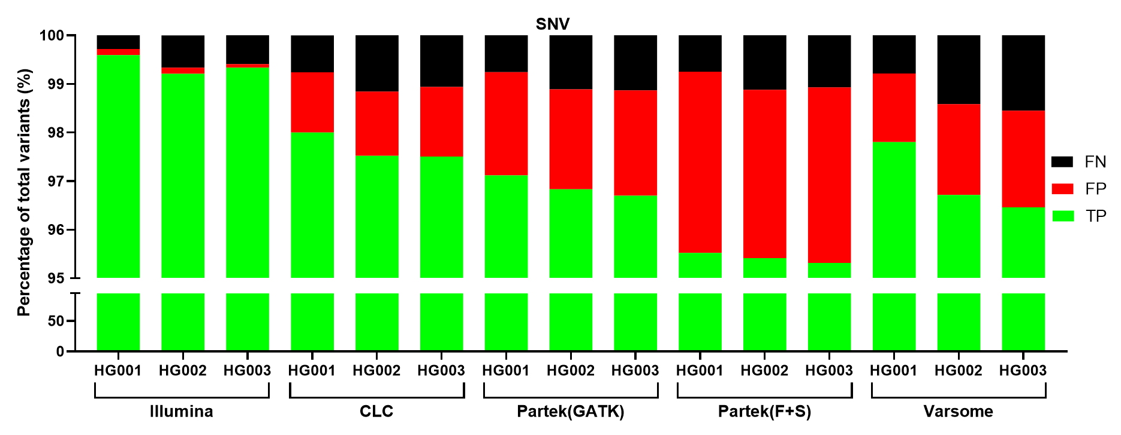
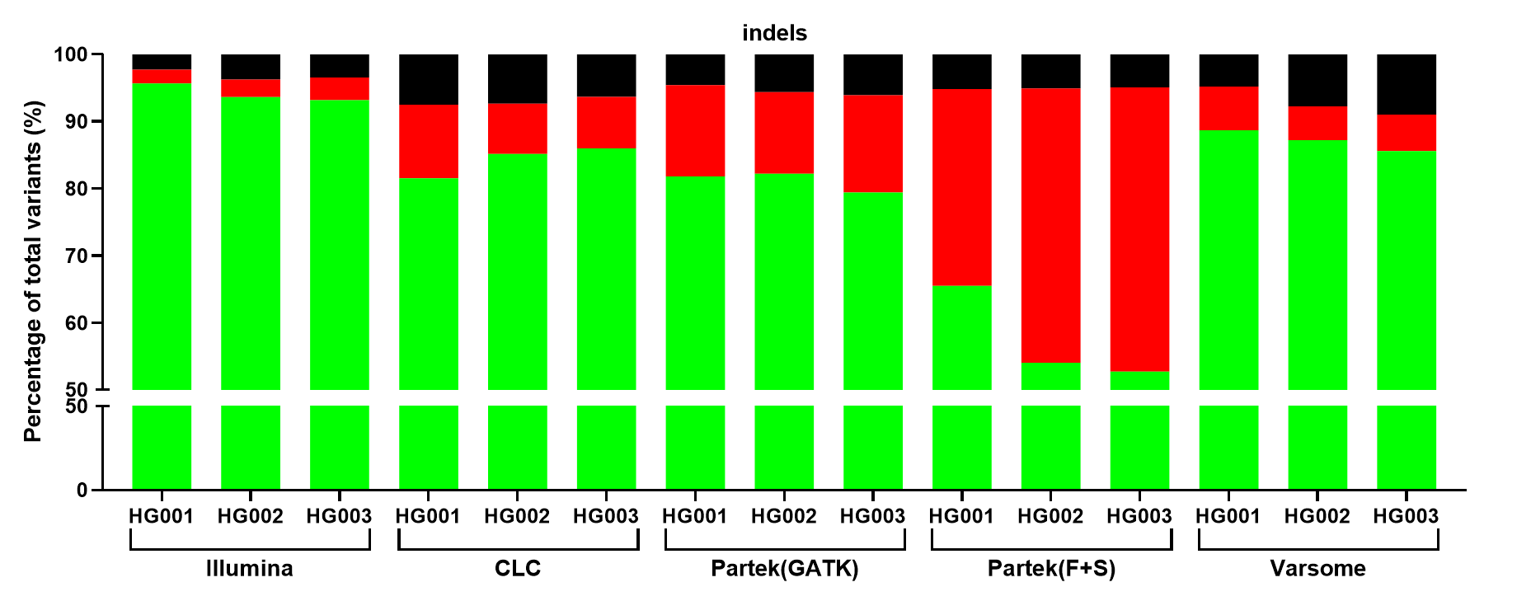
Supplementary Figure 2. Comparison of variant calling performance across five different tools for SNVs (A) and indels (B). Proportion of true positives (TP, green), false positives (FP, red), and false negatives (FN, black) across HG001, HG002, and HG003.
A)
B)
s

