Supplementary Results
Supplementary Table 1. Optimized hyperparameters and AUC scores of machine learning algorithms across models.
Algorithm | Model | Best Point Hyperparameters | ROC AUC Score
KNN | 1st Machine Learning Model | Number of neighbors: 55, Distance metric: Cosine, Distance weight: Inverse, Standardize data: true | 0.76
Logistic Regression | 1st Machine Learning Model | C: 4.40, penalty: l1 | 0.80
Decision Tree | 1st Machine Learning Model | Maximum number of splits: 4, Split criterion: Gini’s diversity index | 0.71
SVM | 1st Machine Learning Model | Multiclass Method: One-vs-All, Box Constraint Level: 956.4212, Kernel Scale: 267.8599, Kernel Function: Gaussian, Standardize data: false | 0.8
Ensemble | 1st Machine Learning Model | Ensemble method: Bag, Number of learners: 488, Maximum number of splits: 38, Number of predictors to sample: 28 | 0.79
Naive Bayes | 1st Machine Learning Model | Distribution names: Gaussian | 0.75
Neural Networks | 1st Machine Learning Model | Number of fully connected layers: 1, Activation: ReLU, Standardize data: Yes, Regularization strength (Lambda): 8.4731e-06, 1st layer size: 1 | 0.79
KNN | 2nd Machine Learning Model | Number of neighbors: 31, Distance metric: Euclidean, Distance weight: Inverse, Standardize data: false | 0.75
Logistic Regression | 2nd Machine Learning Model | C: 14.86, penalty: l2, solver:liblinear, maximum iteration:500 | 0.80
Decision Tree | 2nd Machine Learning Model | Maximum number of splits: 32, Split criterion: Gini’s diversity index | 0.75
SVM | 2nd Machine Learning Model | Multiclass Method: One-vs-All, Box Constraint Level: 0.044, Kernel Function: Linear, Standardize data: false | 0.8
Ensemble | 2nd Machine Learning Model | Ensemble method: AdaBoost, Number of learners: 139, Maximum number of splits: 4, Learning rate: 0.691 | 0.79
Naive Bayes | 2nd Machine Learning Model | Distribution names: Kernel, Kernel type: Box | 0.75
Neural Networks | 2nd Machine Learning Model | Number of fully connected layers: 1, Activation: ReLU, Standardize data: Yes, Regularization strength (Lambda): 1.202e-05, 1st layer size: 1 | 0.8
KNN | 3rd (Last) Machine Learning Model | Number of neighbors: 45, Distance metric = Hamming, Distance weight = Squared inverse, Standardize data: False | 0.74
Logistic Regression | 3rd (Last) Machine Learning Model | C = 0.37, max_iter: 50, penalty:l2, solver: Newton-cg | 0.75
Decision Tree | 3rd (Last) Machine Learning Model | Split criterion:Gini’s diversity index, Maximum number of split = 10 | 0.68
SVM | 3rd (Last) Machine Learning Model | Multiclass Method: One-vs-All, Box Constraint Level: 0.007, Kernel Function: Linear, Standardize data: true | 0.76
Ensemble | 3rd (Last) Machine Learning Model | Ensemble method: LogitBoost, Number of learners: 16, Learning rate: 0.20, Maximum number of splits: 860 | 0.73
Naive Bayes | 3rd (Last) Machine Learning Model | Distribution names: Gaussian | 0.74
Neural Networks | 3rd (Last) Machine Learning Model | Number of fully connected layers:2, Activation:Tanh, Standardize data: Yes, Regularization strength (Lambda): 0.006, 1st layer size: 150, 2nd layer size:6 | 0.76

- The table shows the highest AUC values obtained as a result of hyperparameter optimization of the algorithms used in machine learning models and the optimum parameters for which these values are achieved.

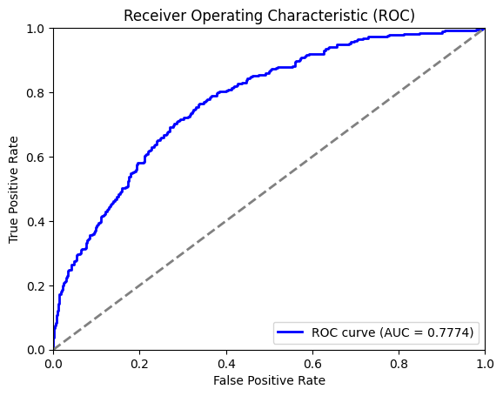

Supplementary Fig. 1. ROC curve for the neural network model's prediction of DSM-5 SRL1 item 11. Receiver Operating Characteristic (ROC) curve demonstrating the performance of the neural network model in predicting responses to DSM-5 Self-Rated Level 1 Cross-Cutting Symptom Measure Question 11 (thoughts of self-harm). The model was trained using DSM-5 SRL1 subdomains excluding item 11. The achieved Area Under the Curve (AUC) of 0.7774 demonstrates the model's ability to generalize across different suicide\self harm assessment measures.The blue line represents the ROC curve, while the dashed gray line represents random classifier (AUC = 0.5).

Supplementary Table 2. Feature importance analysis results of integrated gradients method across datasets

Feature | Importance Score in First Data Set | Importance Score in Validation Data Set
Anhedonia | 0.2136 | 0.1415
Depressed Mood | 0.3891 | 0.2413
Anger | 0.1092 | 0.1009
Mania | 0.0703 | 0.1350
Anxiety | -0.4629 | -0.3292
Somatization | 0.0429 | 0.1026
Psychosis | 0.0534 | 0.2259
Sleep | -0.0251 | 0.0077
Memory | 0.0565 | 0.0558
Repetitive Thoughts | -0.2090 | -0.1850
Dissociation | 0.0979 | 0.0860
Personality Functioning | 0.3493 | 0.2089
Substance Use | 0.0784 | 0.1249

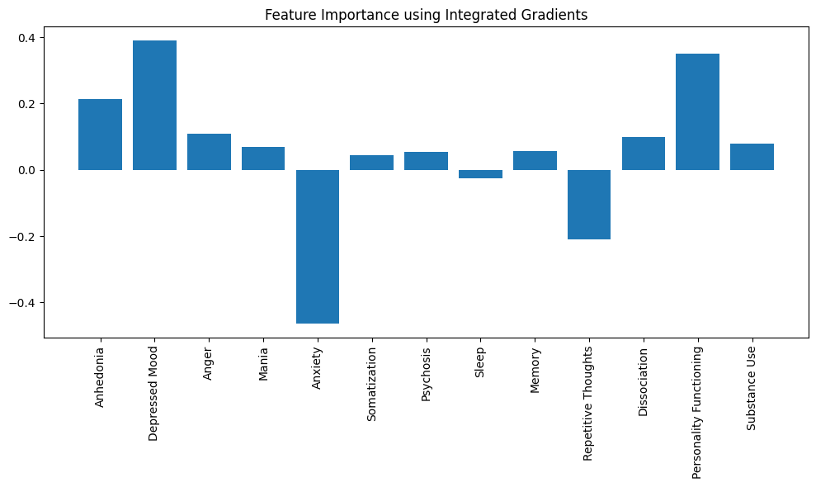
Supplementary Fig. 2.
Integrated Gradient Analysis Graph of First Dataset feature importance analysis using Integrated Gradients for the prediction of suicidal ideation based on the DSM-5 SRL1 subdomains. The chart highlights the relative contributions of each subdomain to the neural network model's prediction. Notably, Depressed Mood, Anhedonia, and Personality Functioning exhibited positive contributions, while Anxiety and Repetitive Thoughts showed negative contributions to the model's prediction of suicidal ideation in the first dataset.

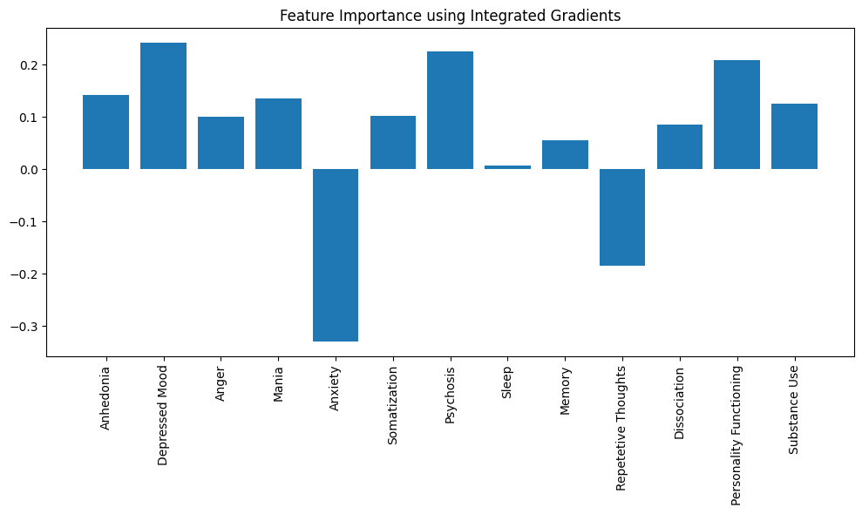

Supplementary Fig. 3.
Integrated Gradient Analysis Graph of External Dataset feature importance analysis using Integrated Gradients for external validation of the model predicting suicidal ideation based on DSM-5 SRL1 subdomains. In this validation, Depressed Mood, Personality Functioning, and Anhedonia continue to show strong positive contributions, while Anxiety and Repetitive Thoughts contribute negatively to the predictions. The results closely mirror those of the first dataset analysis, reaffirming the significant role of these subdomains in predicting suicidal ideation.

