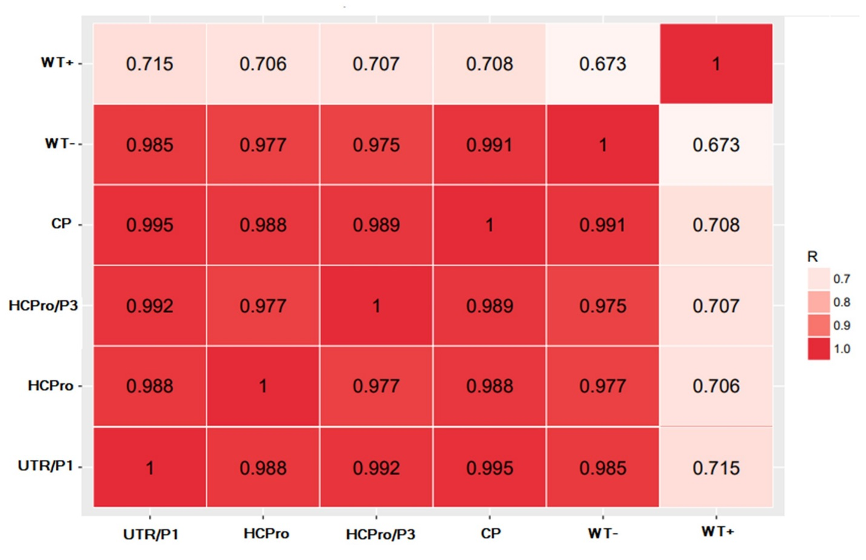

Additional file 3: Fig S1. Pearson correlation of miRNA expression levels among six samples (transgenic lines harboring UTR/P1, HC-Pro, HC-Pro/P3, CP hairpin constructs, infected wild-type (WT+) and uninfected (WT-)).

