Assessment of lncRNA biomarkers based on NETs for prognosis and therapeutic response in ovarian cancer
Jingmeng Wang^{1,2}, Yusen Liang^{1,2}, Yimei Meng^{1,2}, Jialin Chen^{1,2}, Lei Fang¹, Peiling Li^{1*}, Huike Yang^{2,3*}
¹Department of Gynecology and Obstetrics, the Second Affiliated Hospital of Harbin Medical University, Harbin, China
²Laboratory of Department of Anatomy, Harbin Medical University, Harbin, China
³Key Laboratory of Preservation of Human Genetic Resources and Disease Control in China, Harbin Medical University, Ministry of Education, Harbin, China
*Correspondence:
Peiling Li
peiley@126.com
Huike Yang
huikeyang@hrbmu.edu.cn

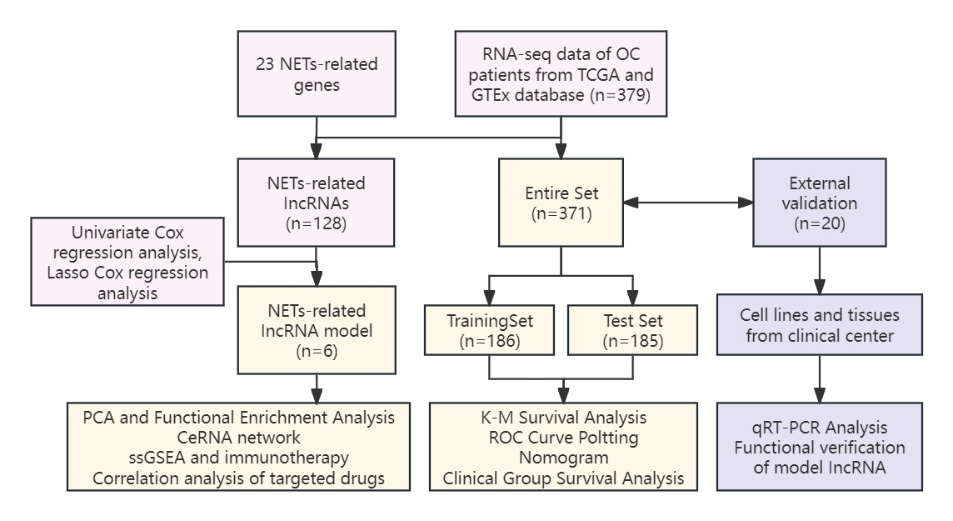
Supplementary Figure 1. Flow chart of the experimental design of NETs-related lncRNAs model in ovarian cancer.

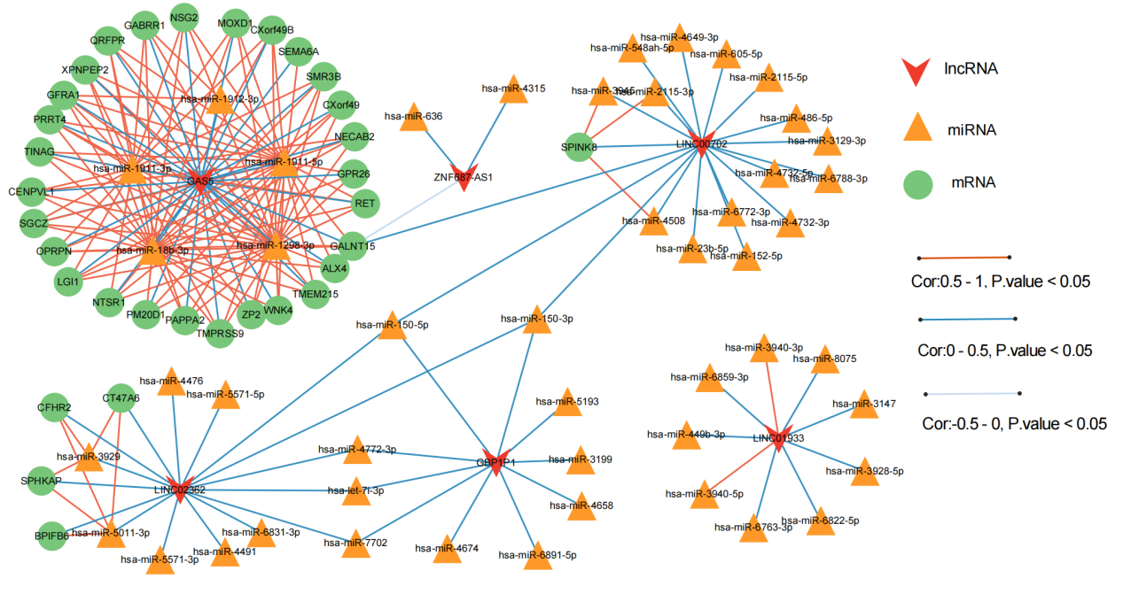
Supplementary Figure 2. The co-expression network based on NETs-related model of lncRN–miRNA–mRNA relationship in OC.

Supplementary Figure 3. Landscape of mutation profiles in high- and low-risk OC patients. (A, B) The TMB in high- and low-risk OC patients. (C) The difference of TMB was significant in OC patients with different risk. (D) The TMB was negatively correlated with the risk score in OC patients. (E, F) Comparison of OS in BC patients with different risks and different TMBs.

Supplementary Figure 4. Correlation analysis of targeted drugs. (A) Correlations between IC50 levels of five targeted drugs (bexarotene, bicalutamide, embelin, GDC0941 and thapsigargin) and expression of model lncRNAs. (B) Differences in sensitivity to targeted drugs between high-risk and low-risk groups.

