Supplementary Materials: Enhanced Detection of Glioblastoma Vasculature with Superparamagnetic Iron Oxide Nanoparticles and MRI

Phillip W. Janowicz, Thomas Boele, Richard T. Maschmeyer, Yaser H. Gholami, Emma G. Kempe, Brett W. Stringer, Shihani P. Stoner, Marie Zhang, Taymin du Toit-Thompson⁶, Fern Williams⁶, Aude Touffu⁶, Lenka Munoz⁴, Zdenka Kuncic^{2,8}, Caterina Brighi¹ and David E. J. Waddington¹

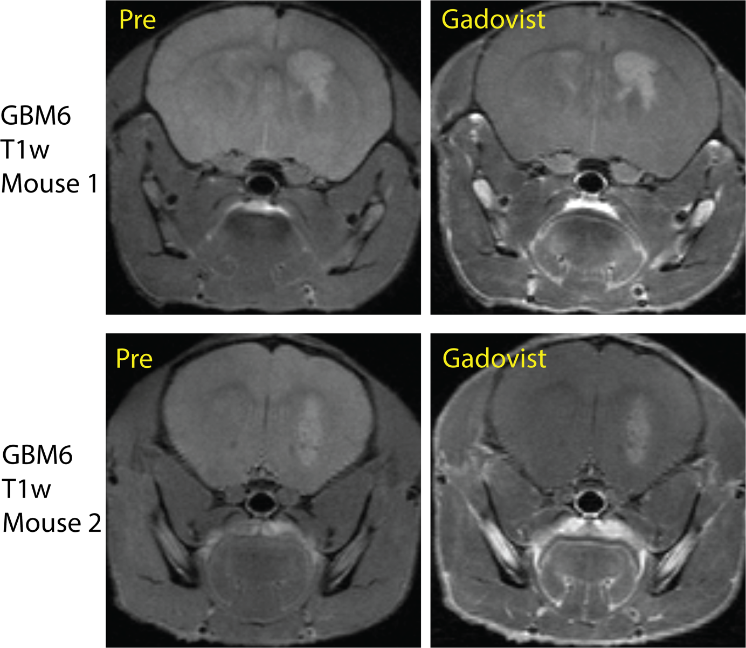

Figure S1 – Two examples of patient derived xenograft GBM6 pre- and post- Gadovist (0.1 mmol/kg), as shown in T1-weighted turbo spin echo scans. Permeability of the tumour BBB appears limited at this stage of growth due to modest Gadovist (Gadolinium) enhancement.

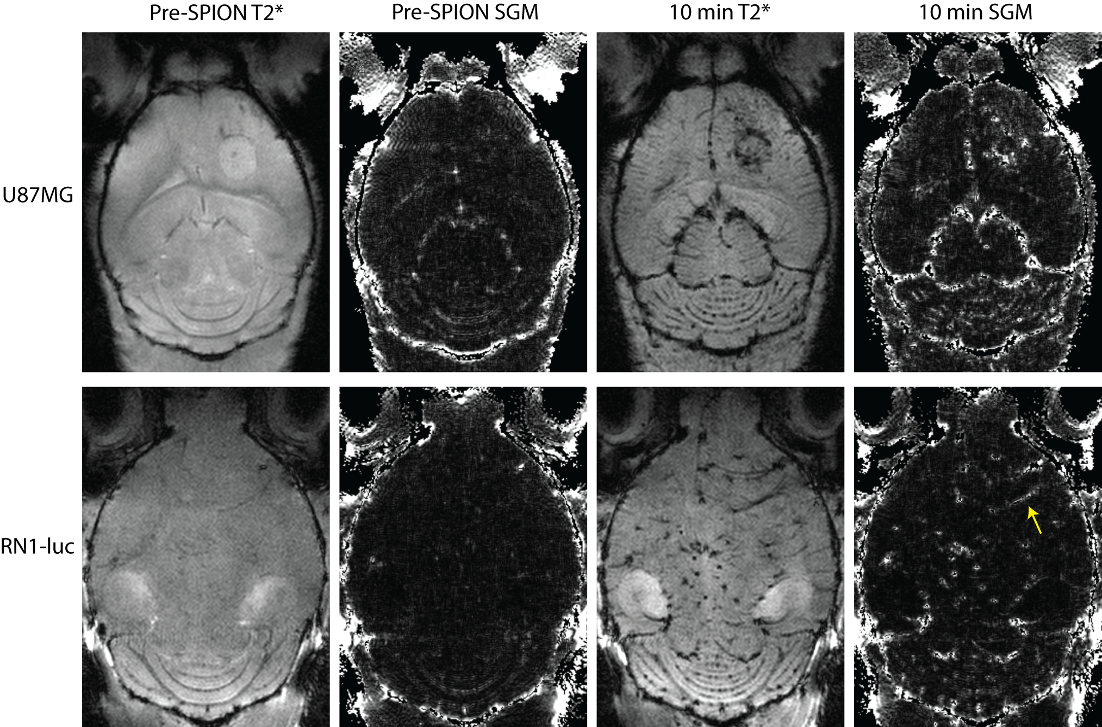

Figure S2: Additional susceptibility gradient mapping (SGM) images adjacent to source T2* gradient recalled echo sequences in U87MG and RN1-luc glioblastoma xenografts pre and post- 10 mg/kg PEG-SPION from a horizontal field of view. Yellow arrow points to an example of diffuse glioblastoma angiogenesis as shown by PEG-SPION positive contrast in SGM.

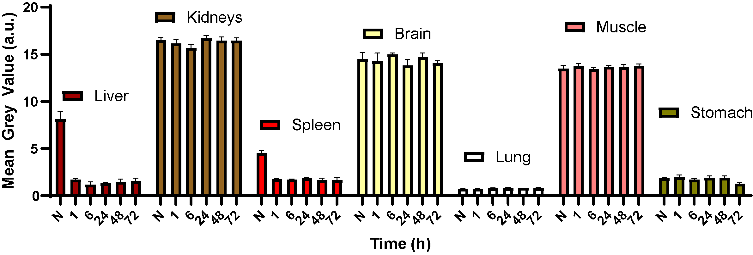
Figure S3: Mean + SEM pharmacokinetic biodistribution of 2 mg/kg ferumoxytol from T2*-weighted gradient recalled echo sequences (biological n=1, number of ROIs across slices per timepoint = 2 to 8).

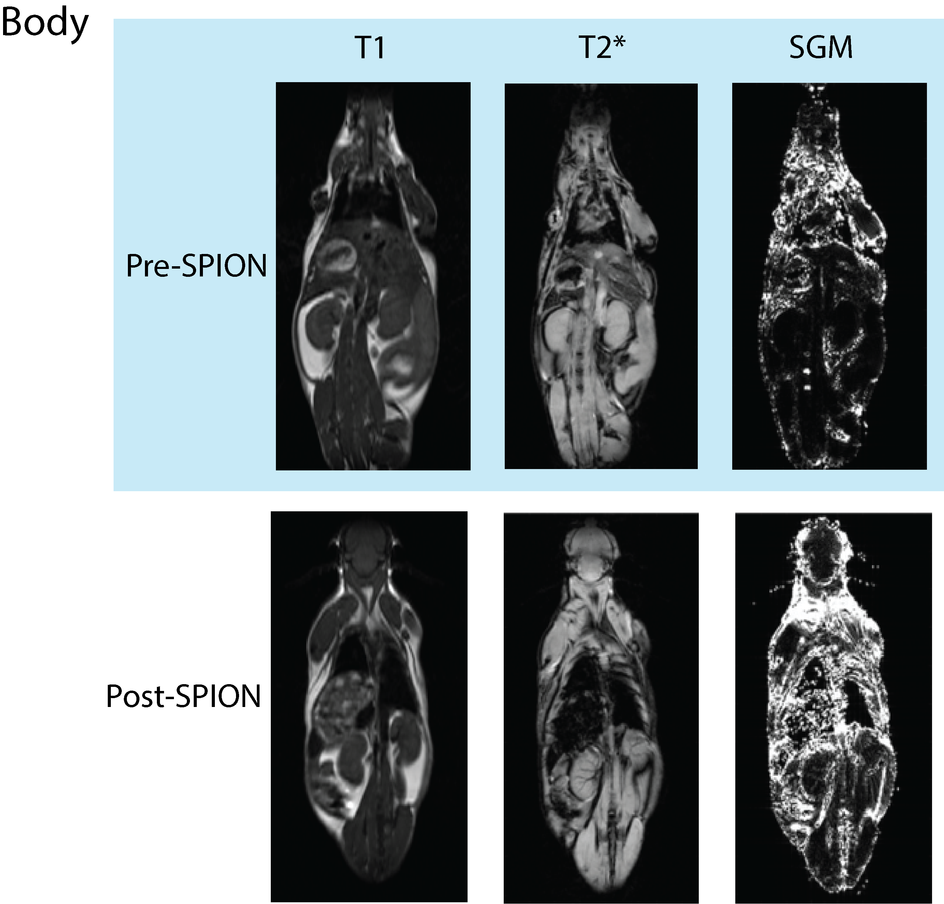

Figure S4: Mouse body 3 T T1 weighted and T2* weighted scans, plus susceptibility gradient maps pre and 60 minutes post 10 mg/kg PEG-SPION injection.

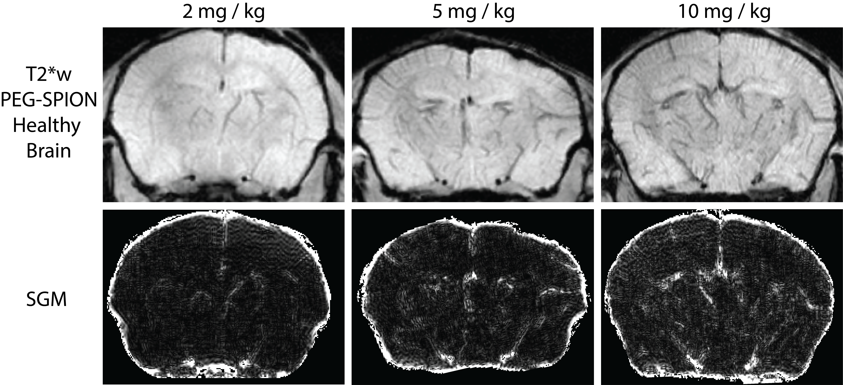

Figure S5: 7T T2* weighted images of healthy mouse brains 10 minutes post 2, 5 and 10 mg/kg PEG-SPION injection, showing a marked vascular T2* signal at all three doses. Susceptibility gradient maps (SGM) corresponding to the above first row images are shown in the second row.

