How anxiety and depression mediate the link between sleep quality and health perception during crisis periods
Luiz Antônio Alves de Menezes-Júnior^{a,b,c*}, Samara Silva de Moura^{a,b}; George Luiz Lins Machado-Coelho^{a,d}, Adriana Lúcia Meireles^{a,b,c}
ª Postgraduate Program in Health and Nutrition, School of Nutrition, Federal University of Ouro Preto, Ouro Preto, Minas Gerais, Brazil
^{b} Research and Study Group on Nutrition and Public Health (GPENSC), Federal University of Ouro Preto, Ouro Preto, Minas Gerais, Brazil
^{c} Department of Clinical and Social Nutrition, School of Nutrition, Federal University of Ouro Preto, Ouro Preto, Minas Gerais, Brazil
^{d} School of Medicine, Federal University of Ouro Preto, Ouro Preto, Minas Gerais, Brazil

Corresponding author: Luiz Antônio Alves de Menezes-Júnior, Dietitian, Assistant Professor, Federal University of Ouro Preto, R. Diogo de Vasconcelos, 122, Ouro Preto - MG, Brazil. E-mail: luiz.menezes@ufop.edu.br

Supplementary material:
The supplementary material provides additional insights and supporting information for the main findings of the study.
- Table S1: This table serves as a portfolio outlining the relationships between all variables included in our theoretical causal model. It provides a detailed rationale for the associations and interactions hypothesized between these variables.
- Table S2: This table demonstrates the interaction model between explanatory variables, the mediating variable, and the outcome. It highlights how these variables interplay within the context of the study's theoretical framework.
- Table S3 and Figure S1: These present the key results derived from the study, assessed through Poisson regression modeling. They summarize the primary statistical analyses and outcomes discussed in the manuscript.

Supplementary Table 1. Health-related pathways overview illustrated in the directed acyclic graph (DAG)
Pathway | Rationale | References
Age → Chronic disease | Many chronic diseases, such as cardiovascular disease, diabetes, and certain types of cancer, have an increased incidence with age due to the accumulation of risk factors over a lifetime and the deterioration of physiological systems. | doi.org/10.1186/s12889-019-7762-5
Age → Movement behaviors | Age directly influences movement behavior. Younger individuals generally have high levels of physical activity. They are more likely to participate in active games, sports and other forms of exercise. However, with the increased use of electronic devices and changes in lifestyle, there has been a growing trend towards sedentary behavior. Adult’s face decreased physical activity due to work and family responsibilities. Time spent in sedentary behaviors, such as sitting at work or during leisure time, tends to increase. With ageing, there is a natural tendency for physical function to decline, which can lead to a reduction in physical activity and an increase in sedentary behavior. Health issues, fear of falls and lack of mobility can contribute to this increase in sedentary behavior. Socioeconomic factors also affect accessibility to physical activity at all ages, and policies that encourage active lifestyles are crucial to promoting health and well-being. | doi.org/10.1016/j.arr.2022.101807; doi.org/10.3390/ijerph19148798; doi.org/10.1186/s12966-020-0912-4;
Age → Self-rated health | Age directly affects self-rated health as aging is associated with an increase in chronic diseases, loss of functionality and a decline in quality of life. Over time, these limitations negatively impact the perception of one's own health, while the opposite direction (self-assessment influencing age) is biologically impossible. | doi.org/10.1080/14034940600975674  doi.org/10.1016/j.actpsy.2022.103651
Age → Sleep quality | Changes in sleep structure occur with advancing age, such as a decrease in the deep and REM sleep phases and an increase in sleep fragmentation. Older people may have difficulty initiating and maintaining sleep, and are more prone to disorders such as sleep apnea and restless legs syndrome. In addition, changes in circadian rhythms can lead to changes in habitual bedtimes and wake-up times, affecting sleep quality | doi.org/10.1136/bmjopen-2016-014920
Age → Symptoms of anxiety or depression | Studies show that younger people are more likely to suffer from mental disorders. In general, cases of depression and anxiety begin in adolescence and young adulthood (18-25 years) and may be related to hormonal, social, or academic factors. This is also the age of graduation, a time when young people face a number of life changes. | doi.org/10.1097/YCO.0b013e32816ebc8c; doi.org/10.1038/s41380-021-01161-7
Alcohol and tobacco consumption → Chronic diseases | Alcohol and tobacco consumption are established risk factors for a variety of chronic diseases, including cardiovascular diseases, chronic respiratory diseases and certain types of cancer. Both behaviors are associated with inflammatory processes and oxidative damage that contribute to the development of these health conditions. | doi.org/10.3390/nu14091954; doi.org/10.5888/pcd19.220086
Alcohol and tobacco consumption → Sleep quality | Excessive alcohol consumption and smoking are associated with sleep disorders such as insomnia and sleep fragmentation. Alcohol can interfere with sleep patterns and induce nocturnal awakenings, while nicotine can have stimulating effects that impair sleep quality. | doi.org/10.1017/S1368980020004553; doi.org/10.1016/j.sleepe.2022.100028; doi.org/10.7759/cureus.49162; doi.org/10.5888/pcd19.220086
Alcohol consumption → Self-rated health | Alcohol consumption can influence the perception of health by affecting physical and mental functioning. In excess, alcohol is associated with liver disease, cardiovascular disease and mood disorders, which contribute to a negative assessment of health. Thus, consumption precedes and shapes the perception of health, while the reverse would be implausible without other mediators. | doi.org/10.3389/fpubh.2023.1257459  doi.org/10.1136/bmjopen-2018-028878
Comorbidities → Self-rated health | The presence of comorbidities directly affects the perception of health, as chronic diseases or multiple conditions cause physical and psychological limitations. Individuals with multiple conditions tend to report lower self-rated health due to the cumulative impact of diseases on daily life and quality of life. | doi.org/10.1111/nhs.12585  doi.org/10.1590/1981-22562020023.200311
Education level → Family income | A higher level of education is often correlated with greater employment and income opportunities. Education provides skills and knowledge that increase employability and earning potential, as well as opening doors to more specialized and well-paid careers. This, in turn, can lead to a higher family income and a better quality of life. | doi.org/10.22158/ijafs.v6n1p50;
Education level → Movement behaviors | The level of education may be related to movement behaviors. Individuals with a higher level of education may have more knowledge about the benefits of physical activity and may therefore engage in more active behaviors. In addition, people with a higher level of education may have more resources to access environments conducive to physical activity | doi.org/10.3390/clockssleep6010007; doi.org/10.3389/fpubh.2024.1197150
Education level → Sleep quality | Individuals with higher levels of education may have greater knowledge about the importance of sleep and sleep hygiene practices, leading to better sleep quality. However, the stress associated with academic or professional careers that require high qualifications can negatively impact sleep. Education can also provide better working and living conditions, which are important factors for quality sleep. | doi.org/10.1590/1413-81232023284.14132022EN; doi.org/10.2147/NSS.S266493
Family income → Movement behaviors | Families with higher incomes generally have more access to resources that promote an active lifestyle, such as gyms, sports clubs and exercise equipment. On the other hand, families with lower incomes may face financial and environmental barriers, such as a lack of safe spaces for physical activity, which limit the adoption of healthy movement behaviors. | doi.org/10.1186/s12966-023-01491-5; doi.org/10.1123/jpah.2022-0196
Family income → Self-rated health | Family income affects the perception of health by influencing access to essential resources such as quality food, adequate housing and health services. Individuals from families with higher incomes generally report better perceived health due to less exposure to risk factors and greater ability to cope with adversity. The relationship is causal and unidirectional, as income precedes the formation of the conditions that shape the perception of health. | doi.org/10.1016/j.socscimed.2020.112884  doi.org/ 10.3390/ijerph16162884  doi.org/10.1016/j.ssmph.2022.101035
Family income → Sleep quality | Family income can affect sleep quality, as families with lower incomes may live in environments with more noise, pollution and other stressors that disturb sleep. In addition, financial worries and jobs with irregular or demanding hours can contribute to poor sleep patterns and insomnia. | doi.org/10.1016/j.sleh.2023.09.009; doi.org/10.3390/ijerph20054572; doi.org/10.1016/j.rpped.2015.01.011
Movement behaviors → Mental health | Physical activity can act as a protective factor against mental health problems, such as anxiety and depression, by improving neurochemical regulation, promoting the release of endorphins and improving neuroplasticity, as well as increasing self-esteem. In contrast, sedentary behaviors can contribute to a decline in mental health, potentially due to social isolation and a lack of physical and cognitive stimulation | doi.org/10.1186/s12889-023-17136-y; 10.1136/bjsports-2022-106195; 10.3389/fpsyt.2023.1252986
Movement behaviors → Self-rated health | Movement-related behaviors, such as physical activity or sedentary lifestyles, influence perceived health by impacting energy, mood and the risk of chronic diseases. Active individuals tend to rate themselves more highly in terms of health due to the physical and psychological benefits of exercising. A sedentary lifestyle, on the other hand, contributes to a negative self-assessment by increasing the risk of metabolic and cardiovascular problems. | doi.org/10.1016/j.puhe.2022.10.012  doi.org/10.1186/s12889-020-09447-1  doi.org/10.1186/1471-2458-8-352
Movement behaviors → Sleep quality | Movement behaviors, including physical activity and sedentary behavior, influence sleep quality. Regular physical activity is associated with better sleep quality due to its ability to regulate circadian rhythms, exposure to natural light during the day, as well as reducing stress and anxiety. On the other hand, prolonged sedentary behavior, especially before bedtime, can impair sleep quality by promoting inactivity and exposure to artificial light. | doi.org/10.1093/aje/kwac212; doi.org/10.1007/s12529-016-9609-0; 10.3389/fphar.2023.1282357
Sex → Movement behaviors | Gender can determine differences in movement behaviors due to biological factors, such as hormonal differences, and sociocultural factors, such as gender norms and social expectations. Men may be encouraged to participate in more vigorous physical activity, while women may face social barriers that influence the frequency and type of physical activity practiced. | doi.org/10.1371/journal.pone.0255353
Sex → Self-rated health | Sex influences self-rated health due to biological, social and cultural differences. Women, for example, may be more likely to report chronic conditions or symptoms such as anxiety and depression, while men often under-report health problems. These structural and social differences precede and shape the subjective perception of health. | doi.org/10.1186/s12877-021-02484-4  doi.org/10.1016/j.archger.2019.103994
Sex → Sleep quality | Gender can influence sleep quality due to biological, hormonal and behavioral differences between men and women. For example, hormonal fluctuations throughout the menstrual cycle can affect women's sleep patterns. In addition, social factors, such as family responsibilities and gender roles, can also influence sleep patterns. | doi.org/10.3390/life12122003; doi.org/10.1007/978-3-030-40842-8_5
Sex → Symptoms of anxiety or depression | The female sex is associated with higher levels of mental disorders when compared to the male sex. This difference can be explained by genetic and biological factors, including hormonal characteristics, personal stigma, greater sensitivity to traumatic events, as well as the fact that women recognize mental health problems better and seek more help from health services compared to men. | doi.org/10.1093/pubmed/fdab406; doi.org/10.1017/CBO9780511984945.017; doi.org/10.1016/j.bpsgos.2023.100283
Skin color → Education level | Skin color can affect educational attainment through unequal access to quality educational resources and differentiated social expectations. Racial stereotypes can influence the perceptions of teachers and peers, affecting students' academic performance and self-esteem. Institutional and socioeconomic barriers can also limit opportunities for advanced education for ethnic minorities, resulting in educational disparities. | doi.org/10.3390/socsci11010015; doi.org/10.1177/0731121415580026
Skin color → Family income | Skin color can influence family income due to social and economic structures that perpetuate racial inequality. Discrimination in the labor market can result in wage disparities and limit access to qualified job opportunities for individuals of certain ethnicities, thus affecting overall family income. In addition, racial prejudice can influence the distribution of educational and professional resources, perpetuating cycles of poverty in marginalized communities. | doi.org/10.1371/journal.pone.0190640; doi.org/10.4054/DemRes.2014.31.24
Skin color → Sleep quality | Skin color can influence sleep quality for various reasons. Ethnic/racial minorities often face discrimination, which can lead to chronic stress and anxiety, negatively affecting sleep. Socioeconomically, individuals with darker skin can face higher levels of stress, which can result in sleep disturbances. In addition, factors such as unequal access to healthcare and more stressful living environments can also contribute to poorer sleep quality. | doi.org/10.1093/oso/9780190930448.001.0001; doi.org/10.1186/1471-2458-10-475 ; doi.org/10.1007/s11469-020-00378-x
Skin color → Symptoms of anxiety or depression | Non-white skin color is related to a higher prevalence of mental disorders such as anxiety and depression. This association can be explained, at least in part, by the perceived racial discrimination that racial/ethnic minorities suffer compared to other groups. Racial/ethnic minorities experience crime, hate speech and microaggressions more often, which can negatively affect mental well-being. | doi.org/10.1016/j.socscimed.2022.115387; doi.org/10.1086/682162; doi.org/10.1590/1413-812320172212.19782016
Sleep quality → Self-rated health | The quality of sleep directly affects the subjective perception of health, as poor nights' sleep can cause tiredness, fatigue, cognitive deficits and changes in mood. These factors not only impair the individual's physical and mental functionality, but also influence how they assess their general state of health. In addition, sleep disorders are associated with chronic conditions such as hypertension and obesity, which can exacerbate the perception of negative health. Thus, the impact of sleep occurs before and is a determining factor in the assessment of subjective health. | doi.org/10.1016/j.sleep.2021.10.028  doi.org/10.11606/s1518-8787.2019053001067
Sleep quality → Anxiety | Sleep quality directly influences anxiety levels, as poor nights' sleep impairs emotional regulation and increase reactivity to stress. Sleep deprivation or fragmentation can increase activity in the sympathetic nervous system and exacerbate cortisol responses, predisposing individuals to anxiety symptoms. In addition, inadequate sleep negatively affects connectivity between the amygdala and prefrontal cortex, brain regions critical for emotional control. The causal direction is from sleep quality to anxiety, as changes in sleep precede worsening mental health. | doi.org/10.1186/s12889-020-09400-2  doi.org/ 10.3390/bs13100861
Sleep quality → Depression | Poor sleep quality affects depression due to the dysregulation of neurotransmitters such as serotonin and dopamine, which are linked to both mood and the sleep-wake cycle. Sleep disorders, such as insomnia, often precede depressive episodes and can amplify negative thoughts through increased fatigue and cognitive difficulties. Longitudinal studies show that inadequate sleep is a predictor for the development of depressive symptoms, indicating the causal direction of sleep for depression. | doi.org/10.1080/02699931.2016.1247035  doi.org/10. 1016/j.ebiom.2024. 105313
Sleep quality → Movement behaviors | Sleep quality influences movement-related behaviors, such as physical activity and sedentary time, by impacting energy and mood levels. Inadequate sleep reduces motivation and physical capacity, making exercise less likely and increasing sedentary behavior. The causality is clear, as lack of sleep precedes decreased physical performance, while the opposite requires more complex mediators, such as the prolonged impact of physical activity on sleep quality. | doi.org/ 10.1007/s40279-022-01706-y  doi.org/ 10.1007/s40279-022-01706-y
Smoking → Self-rated health | Smoking negatively influences self-rated health due to its adverse effects on the cardiovascular, respiratory and immune systems. Individuals who smoke often report worse perceived health due to the impact of the habit on energy, functionality and general well-being. Causality is unidirectional: smoking precedes and negatively impacts perceived health. | doi.org/10.1007/s11739-024-03817-y  doi.org/10.18332/tpc/162721
Symptoms of anxiety or depression → Self-rated health | Symptoms of anxiety and depression negatively affect the way individuals perceive their health. These disorders can cause demotivation, fatigue and difficulty in taking care of themselves, which is reflected in an impaired self-assessment of health. The causal order is clear, as the presence of psychological symptoms directly impacts the perception of quality of life, while the reverse would be unlikely without clear mediation. | 10.1080/09638237.2021.2022610  10.47626/1516-4446-2023-3331

Supplementary Table 2. Interaction between sleep quality and symptoms of anxiety and depression in self-rated health (COVID-Inconfidentes Study)
 |  | Odds ratio | 95%CI | p-value
Exposure variable | Sleep quality | 2.92 | 1.89-4.53 | <0.001
Mediators variables | Anxiety | 3.02 | 1.83-4.98 | <0.001
Mediators variables | Depression | 2.47 | 1.44-4.21 | <0.001
Interaction | Sleep quality * Anxiety | 1.30 | 0.54-3.14 | 0.553
Interaction | Sleep quality * Depression | 0.69 | 0.28-1.73 | 0.429
Interaction | Sleep quality * Anxiety * Depression | 1.97 | 0.42-2.12 | 0.276
The table shows the main effects and the interaction effect between sleep quality (good or poor) and anxiety (present or absent) or depression (present or absent) on self-rated health (good or poor). Multivariate logistic regression adjusted adjusted for the minimum and sufficient set of variables: sex, age, family income, alcohol and tobacco consumption and chronic diseases. The coefficients are presented as odds ratios (OR) with 95% confidence intervals (95% CI) and p-values.

Supplementary Table 3. Poisson regression about association of sociodemographic, health, and behavioral characteristics with self-rated health, during the COVID-19 pandemic (COVID-Inconfidentes Study).
 | Prevalence ratio | CI_{95%}
Characteristics | Prevalence ratio | Lower bound | Upper bound | p-value*
Sex
Male | 1.00 |  |  | < 0.001
Female | 1.90 | 1.37 | 2.65 | < 0.001
Age
18-34 years | 1.00
35-59 years | 1.46 | 0.90 | 2.37 | 0.124
≥ 60 years | 2.86 | 1.65 | 4.96 | < 0.001
Skin color¹
White | 1.00 |  |  | 0.588
Black, brown, yellow and indigenous | 1.14 | 0.70 | 1.85 | 0.588
Marital status²
Married | 1.00 |  |  | 0.505
Not married | 1.13 | 0.79 | 1.60 | 0.505
Education
0-8 years | 1.00
9-11 years | 2.15 | 1.51 | 3.08 | < 0.001
> 12 years | 4.49 | 3.03 | 6.65 | < 0.001
Family income³
≤ 2 MW | 1.00
> 2 a ≤ 4 MW | 0.86 | 0.60 | 1.23 | 0.420
> 4 MW | 0.79 | 0.49 | 1.28 | 0.341
Worker⁴
No | 1.00 |  |  | <0.001
Yes | 0.47 | 0.35 | 0.63 | <0.001
Smoking
No | 1.00 |  |  | 0.785
Yes | 0.95 | 0.63 | 1.43 | 0.785
Alcohol consumption
No | 1.00 |  |  | 0.003
Yes | 0.57 | 0.39 | 0.82 | 0.003
Physical activity⁵
Active | 1.00 |  |  | 0.014
Inactive | 1.97 | 1.15 | 3.38 | 0.014
Sedentary behavior⁶
< 9h | 1.00 |  |  | 0.975
> 9h | 1.01 | 0.56 | 1.82 | 0.975
Comorbidities⁷
No | 1.00 |  |  | <0.001
Yes | 3.10 | 1.90 | 5.04 | <0.001
Sleep quality⁸
Good | 1.00 |  |  | <0.001
Poor | 2.58 | 1.91 | 3.48 | <0.001
Anxiety⁹
No | 1.00 |  |  | <0.001
Yes | 2.04 | 1.44 | 2.87 | <0.001
Depression⁹
No | 1.00 |  |  | <0.001
Yes | 2.21 | 1.48 | 3.31 | <0.001
MW: Minimum wage. *p-value of Pearson's chi-square test.
¹ Skin color: Self-reported, black, brown, indigenous, white or yellow.
² Not married: Widowed, divorced, single.
³ Minimum wage value: BRL 1045.00 z USD 194.25 (1 USD ¼ 5.3797 BRL).
⁴ Not workers: Unemployed, pensioner, retiree.
⁵ Physically inactive (< 150 minutes/week of moderate PA or < 75 minutes/week of vigorous activity).
⁶ Sedentary behavior was measured by total time spent sitting.
⁷ Chronic diseases assessed by self-reported medical diagnosis: hypertension, diabetes, asthma, lung disease, chronic kidney disease, cancer, heart disease, and thyroid disorders. Classified as without comorbidities (no) or with at least one comorbidity (yes).
⁸ Sleep quality assessed by the Pittsburgh Sleep Quality Index.
⁹ Anxiety and depression were evaluated by symptoms with GAD-7 and PHQ-9, self-reported medical diagnosis, and use of medications.

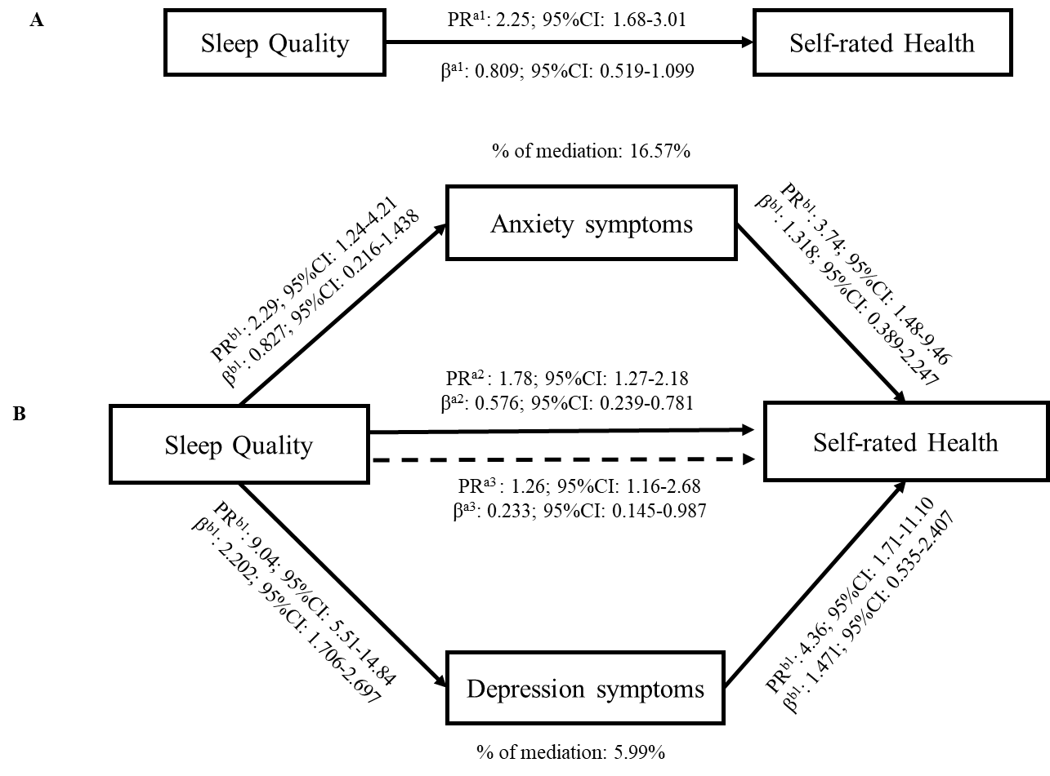

Supplementary Figure 1: Path diagram of the mediation analysis of the role of sleep quality in self-rated health using symptoms of depression and symptoms of anxiety disorders, based on Poisson regression modeling (COVID-Inconfidentes Study).
Legend: Path analysis based on multivariate poisson regression, adjusted for the minimum and sufficient set of variables: sex, age, family income, alcohol and tobacco consumption, and chronic diseases. Total, direct, and indirect effects were assessed using the Karlson-Holm-Breen method. a1​ indicates the total effect of sleep quality on self-rated health; b1​ represents the effect of sleep on anxiety; c1​ represents the effect of sleep on depression; b2​ represents the effect of anxiety on self-rated health; c2​ represents the effect of depression on self-rated health; a2​ indicates the direct effect of sleep on self-rated health; a3​ indicates the indirect effect of sleep on self-rated health.

