Additional file 2：Molecular docking

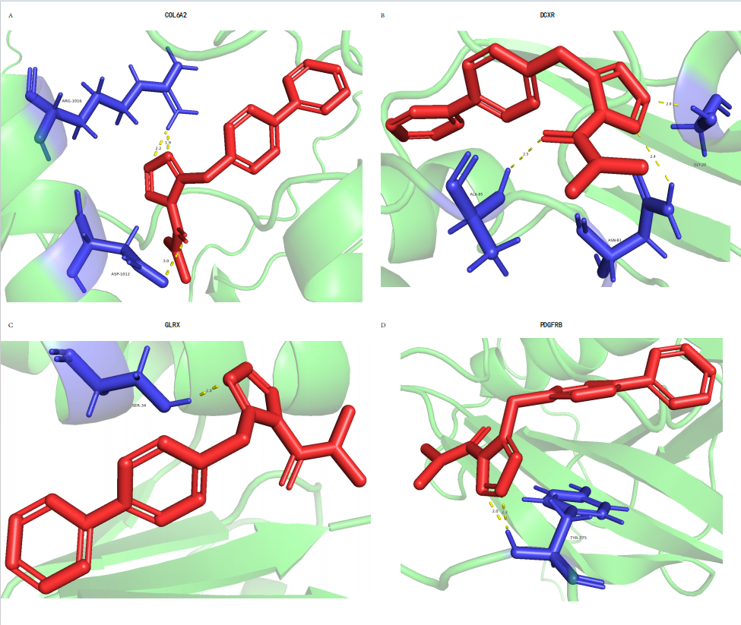
Molecular docking
- D) Visualization of the docking of genes COL6A2, DCXR, GLRX, PDGFRB and LY-2183240. Red represents LY-2183240, blue represents amino acid residues, yellow represents hydrogen bonds, numbers represent hydrogen bond lengths, and letters represent amino acid residue names.

