Additional file 3：Validation of the key genes
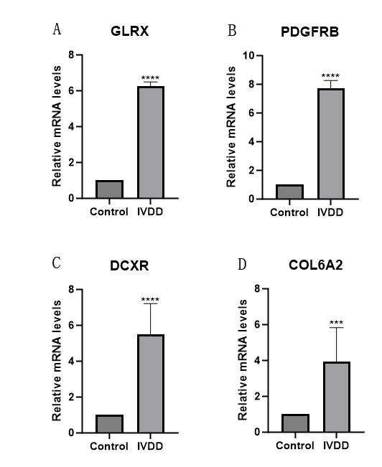
(A-D)The expression of four key genes in normal intervertebral disc tissues and IVDD tissues. COL6A2, DCXR, GLRX and PDGFRB were significantly expressed in IVDD tissues.***P < 0.001, ****P < 0.0001.

