Supplemental Materials
PBPK model equations
Rates of psilocin changes in the lung, brain, adipose, slowly perfused tissues, rapidly perfused tissues, gut, liver, and kidney were mathematically described as a flow-limited model (Eqs. 1-19) as follows:
Rate of psilocin changes in the lung (Eqs. 1-2):
dA_{Lu} / dt = QC * (C_{V} – C_{ALu}) (1)
C_{ALu} = C_{Lu} / PC_{Lu} = A_{Lu} / (V_{Lu} * PC_{Lu}) (2)
where A_{Lu} is the amount of psilocin in the lung (μg), t is the time (hr), QC is the cardiac output (L/h), C_{V} is the venous concentration of psilocin (μg/L), C_{ALu} is the psilocin concentration of arterial blood leaving the lung (μg/L), C_{Lu} is the concentration in the lung (μg/L), V_{Lu} is the lung volume (L), and PC_{Lu} is the partition coefficient of psilocin in the lung.
Rate of psilocin changes in the brain, adipose, slowly perfused and rapidly perfused tissues (Eqs. 3-4):
dA_{T} / dt = Q_{T} * (C_{A} – C_{VT}) (3)
C_{VT} = C_{T} / P_{T} = A_{T} / (V_{T} * PC_{T}) (4)
where A_{T} is the amount of psilocin in the tissue (μg), Q_{T} is blood flow to the tissue (L/h), C_{A} is the arterial concentration of psilocin (μg/L), C_{VT} is the psilocin concentration of venous blood leaving the tissue (μg/L), C_{T} is the concentration in the tissue (μg/L), V_{T} is the tissue volume (L), and PC_{T} is the partition coefficient of psilocin in the tissue.
Rate of psilocin changes in the gut (Eqs. 5-9):
dA_{Gut} / dt = [Q_{Gut} * (C_{A} – C_{VGut})] – [dA_{UGT1A10} / dt] + Oral_{in} (5)
C_{VGut} = C_{Gut} / PC_{Gut} = A_{Gut} / (V_{Gut} * PC_{Gut}) (6)
where A_{Gut} is the amount of psilocin in the gut (μg), Q_{Gut} is blood flow to the gut (L/h), C_{VGut} is the psilocin concentration of venous blood leaving the gut (μg/L), C_{Gut} is the concentration in the gut (μg/L), V_{Gut} is the gut volume (L), PC_{Gut} is the partition coefficient of psilocin in the gut, and dA_{UGT1A10}/dt is the rate of psilocin metabolism via UGT1A10 in the gut as calculated from Eq. 7. Oral_{in} is added to the gut to describe the amount of psilocin in the blood after oral administration, calculated from Eqs. 8-9.
dA_{UGT1A10}/ dt = (V_{max_UGT1A10} * C_{VGut}) / (K_{m_UGT1A10} + C_{VGut}) (7)
where V_{max_UGT1A10} is the maximum velocity of UGT1A10 (μmol/h), and K_{m_} _{UGT1A10} is the binding affinity of UGT1A10 (μmol/L).
Oral_{in} = K_{a} * A_{GU} (8)
A_{GU} = (Dose *BW * F*0.72) (9)
where A_{GU} is the amount of psilocin the gut lumen after oral administration (μg), Dose is body weight (mg/kg), BW is the body weight (kg), K_{a} is the absorption rate constant (h⁻¹), F is the bioavailability, and a biorelevant conversion factor of 0.72 applies from moles of psilocybin to moles of psilocin.
Rate of psilocin changes in the liver (Eqs.10-12):
dA_{Li} / dt = [Q_{Li} * (C_{A} – C_{VLi})] – [dA_{UGT1A9} / dt] (10)
C_{VLi} = C_{Li} / PC_{Li} = A_{Li} / (V_{Li} * PC_{Li}) (11)
where A_{Li} is the amount of psilocin in the liver (μg), Q_{Li} is blood flow to the liver (L/h), C_{VLi} is the psilocin concentration of venous blood leaving the liver (μg/L), C_{Li} is the concentration in the liver (μg/L), V_{Li} is the liver volume (L), PC_{Li} is the partition coefficient of psilocin in the liver, and dA_{UGT1A9}/dt is the rate of psilocin metabolism via UGT1A9 in the liver as calculated from Eq. 12.
dA _{UGT1A9} / dt = (V_{max_ UGT1A9} * C_{VLi}) / (K_{m_ UGT1A9} + C_{VLi}) (12)
where V_{max_ UGT1A9} is the maximum velocity of UGT1A9 (μmol/h), and K_{m_ UGT1A9} is the binding affinity of UGT1A9 (μmol/L).
Rate of psilocin changes in the kidney (Eqs. 13-15):
dA_{Ki} / dt = [Q_{Ki} * (C_{A} – C_{VKi})] – [dA_{NS} / dt] (13)
C_{VKi} = C_{Ki} / PC_{Ki} = A_{Ki} / (V_{Ki} * PC_{Ki}) (14)
where A_{Ki} is the amount of psilocin in the kidney (μg), Q_{Ki} is blood flow to the kidney (L/h), C_{VKi} is the psilocin concentration of venous blood leaving the kidney (μg/L), C_{Ki} is the concentration in the kidney (μg/L), V_{Ki} is the kidney volume (L), PC_{Ki} is the partition coefficient of psilocin in the kidney, and dA_{NS}/dt is the rate of psilocin metabolism via non-specific enzyme in the kidney as calculated from Eq. 15
dA_{NS} / dt = (V_{max_NS} * C_{VKi}) / (K_{m_NS} + C_{VKi}) (15)
where V_{max_NS}is the maximum velocity of non-specific enzyme (μmol/h), and K_{m_NS} is the binding affinity of non-specific enzyme (μmol/L).
Rate of psilocin changes in the blood (Eqs. 16-18):
Intraperitoneal, subcutaneous, intravenous, administration:
dA_{V} / dt = [(Q_{F} * C_{VF} + Q_{BR} * C_{VBR} + Q_{SP} * C_{VSP} + Q_{RP} * C_{VRP} + Q_{Li} * C_{VLi}+ Q_{Ki} * C_{VKi}) – (QC * C_{V})] + Rate_{in} (16)
Rate_{in} = (Dose * BW*0.72) / Time_{in} (17)
Oral administration (Eq. 18):
dA_{V} / dt = [(Q_{F} * C_{VF} + Q_{BR} * C_{VBR} + Q_{SP} * C_{VSP} + Q_{RP} * C_{VRP} + Q_{Li} * C_{VLi}+ Q_{Ki} * C_{VKi} + Q_{Gut} * C_{VGut}) – (QC * C_{V})] (18)
where A_{V} is the amount of psilocin in venous blood (μg), Q_{F}, Q_{SP} and Q_{RP}, are blood flows to adipose, slowly perfused, and rapidly perfused tissues, respectively (L/h), C_{VF} ,C_{VSP} and C_{VRP} are concentrations of psilocin of venous blood leaving the adipose, slowly perfused tissues and rapidly perfused tissues, respectively (μg/L), and Rate_{in} is the amount of psilocin in venous blood after intraperitoneal, subcutaneous, intravenous administration calculated from Eq. 17.
Another equation related to the PBPK model is shown below.
V_{max} = V_{max,human liver microsome} *MPPGL*LW (19)
The V_{max}, representing the maximum velocity of metabolic activity $(µmole/h)$, is calculated using the conversion factor of 52.5 milligrams of microsomal protein per gram of liver and the liver weight (µmole/h/mg protein) ratio of 1,820 grams per 70 kilograms, as reported in studies by Iwatsubo, et al.[1] and Davies, Morris [2], respectively.
V_{max,human} =(V_{max,animal} *BWh^{0.75})/ BW^{0.75} (20)
Vmax represents the maximum velocity of the metabolic process, measured in micromoles per hour, while BW denotes the body weight of the individual in kilograms [3].
Ka,rat = (Ka,mouse* BWrat^{-0.25} )/BWmouse^{-0.25} (21)
In the equation, K_{a} represents the absorption rate constant (h⁻¹), and BW denotes body weight [3].
Additional data related to computer coding can be found in the Word file named "Computer coding" in data availability file.
Absolute sensitivity coefficient (%) = absolute {((C_{Tbaseline} -C_{T1%change})/C_{Tbaseline} )*100} [4] (22)
Where C_{T}1%change = tissue concentration when 1‰ increase of the parameter value at time and C_{Tbaseline} is a concentration before increase [5]. The sensitivity coefficients data are presented in the Excel file titled "Sensitivity analysis.xlsx" within the data availability section.
For the partition coefficient, we employ the Poulin equation [6], setting the fraction unbound in tissues and plasma to one, and log D to 0.267, log p to 1.45. The fractional volume contents of neutral lipid, phospholipids, and water in plasma or tissue are denoted as fnl, fpl, and fw, respectively. More data on partition coefficients can be found in the Excel file titled "Partition.xlsx."
Table 1S Summary of Pharmacokinetic Studies on Psilocybin and Psilocin Supporting Physiologically Based Pharmacokinetic Model Development and Evaluation
Study | Species | Sex | N | Route | Dose | Time (h) | Sample | R²
Horita, et al. [7] | Mice | M | 6 | IP | 72 mg PI | 0.5 | Brain | 0.55
 |  |  | 6 |  |  |  | Liver | 0.69
 |  |  | 6 |  |  |  | Kidney | 0.70
Horita, et al. [7] | Mice | M | 6 | IP | 100 mg PY | 0.5 | Brain | 0.68
 |  |  | 6 |  |  |  | Liver | 0.08
 |  |  | 6 |  |  |  | Kidney | 0.74
Saito, et al. [8] | Rats | M | 4 | IP | 5 mg/kg PY | 4.0 | plasma | 0.85
Higgins, et al. [9] | Rats | M | 5 | SC | 0.05 mg/kg PY | 6.0 | plasma | 0.81
 |  |  | 5 |  | 0.1 mg/kg PY |  | plasma | 0.90
 |  |  | 5 |  | 1 mg/kg PY |  | plasma | 0.99
 |  |  | 5 |  | 10 mg/kg PY |  | plasma | 0.74
Chen, et al.[10] | Rats | NR | 10 | Oral | 10.1 mg/kg PI* | 7.0 | plasma | 0.53
Hasler, et al.[11] | Humans | F/M | 6 | oral | 15 mg PY | 6.5 | plasma | 0.96
 |  |  | 6 | IV | 1mg PY | 2.0 | plasma | 0.76
Lindenblatt, et al.[12] | Humans | NR | 7 | oral | 10 mg PY | 6.0 | plasma | 0.49
Brown, et al.[13] | Humans | F/M | 12 | oral | 25 mg PY | 12.0 | plasma | 0.90
Madsen, et al.[4] | Humans | F/M | 1 | oral | 3 mg PY | 8.0 | plasma | 0.94
 |  |  | 1 |  | 6 mg PY |  | plasma | 0.95
 |  |  | 1 |  | 12 mg PY |  | plasma | 0.76
 |  |  | 1 |  | 15 mg PY |  | plasma | 0.98
 |  |  | 1 |  | 18 mg PY |  | plasma | 0.91
 |  |  | 1 |  | 24 mg PY |  | plasma | 0.70
 |  |  | 1 |  | 24 mg PY |  | plasma | 0.32
 |  |  | 1 |  | 30 mg PY |  | plasma | 0.83
Madsen, et al. [14] | Humans | F/M | 15 | oral | 19 mg PY | 6.0 | plasma | 0.99
Holze, et al.[15] | Humans | F/M | 28 | oral | 15 mg PY | 24.0 | plasma | 0.91
 |  |  | 28 | oral | 30 mg PY | 24.0 | plasma | 0.86
Ley, et al.[16] | Humans | F/M | 32 | oral | 20 mg PY | 24.0 | plasma | 0.93
Note: N= sample size; M= male; F= female; NR= not report; PY= psilocybin; PI= psilocin; IP = intraperitoneal; SC =subcutaneous; * = psilocin extract from of Gymnopilus spectabilis extract. R² = coefficient of determination

PBPK model simulation in humans
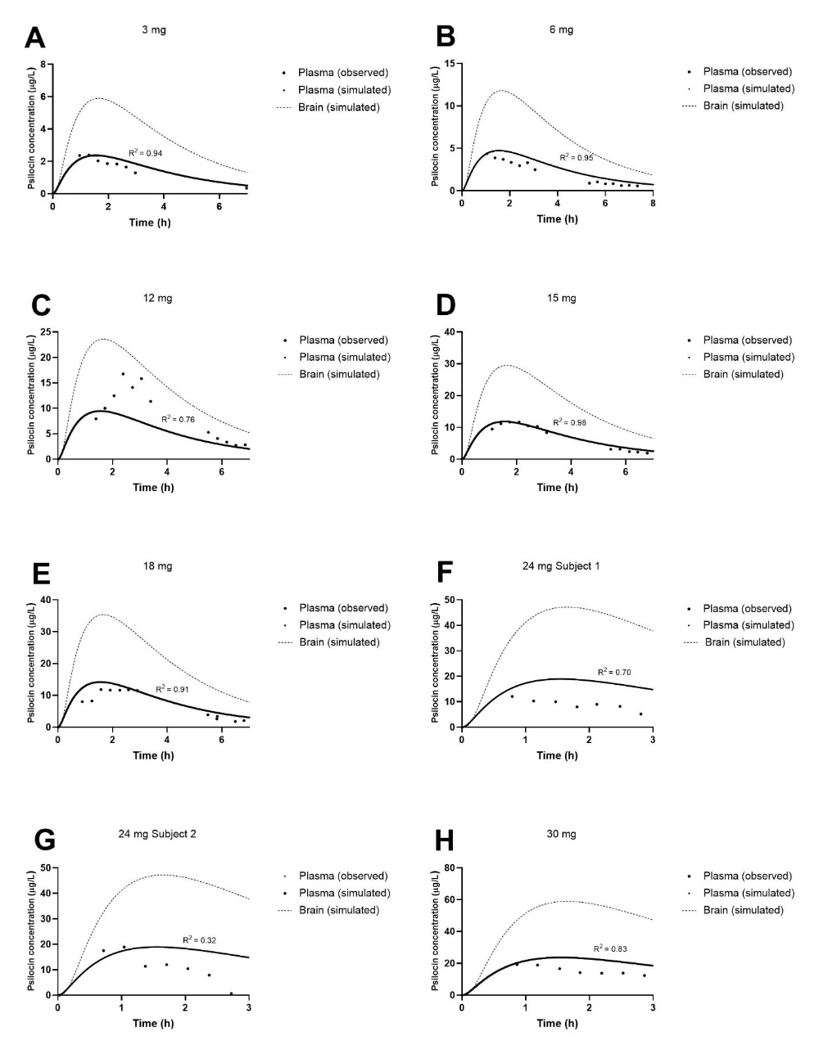
Fig. 1S Concentration-time profiles of psilocin in plasma (solid line, model simulation; circles, observed data) and brain (dashed line, model simulation) in humans, following a single-dose oral administration of 3 (A), 6 (B), 12 (C), 15 (D), 18 (E), 24 (F), 24 (G) and 30 (H) mg of psilocybin [4].

Interspecies-psilocybin administration simulation
Fig. 2S Simulation of concentration-time courses of psilocin in plasma (solid line), brain (dashed line), kidney (dotted line), and liver (dash-dotted line) following intraperitoneal administration of 100mg/kg psilocybin in mice (A), oral administration of 10.1 mg/kg psilocin in rats (B), and oral administration of 20 mg psilocybin in humans (C). Notably, in Fig 14 C, the kidney and plasma lines overlap.

Sensitivity analysis
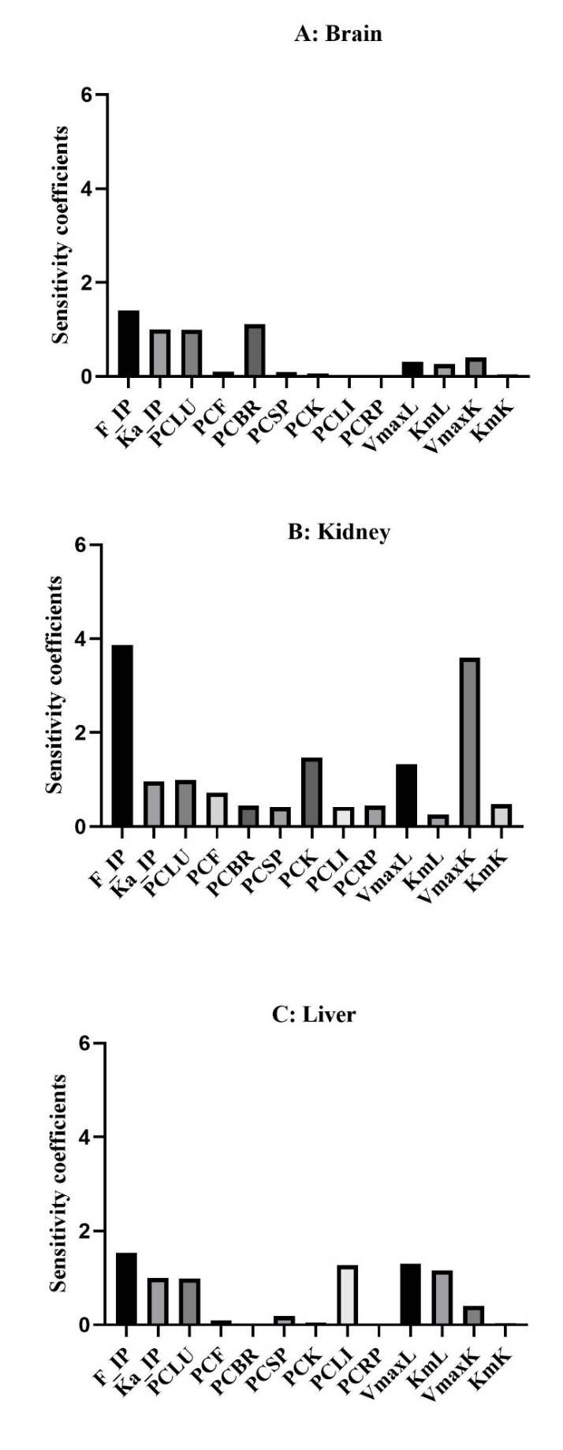
Fig. 3S The absolute maximum sensitivity coefficients of psilocin physiologically based pharmacokinetic (PBPK) parameters in mice following intraperitoneal injection at 72 mg/kg psilocin shows the influence of several factors on psilocin concentrations in the brain, kidney, and liver. These parameters include F_IP (intraperitoneal bioavailability), Ka_IP (intraperitoneal absorption rate constant), PCLU (partition coefficient lung to plasma), PCF (partition coefficient fat to plasma), PCBR (partition coefficient brain to plasma), PCSP (partition coefficient muscle to plasma), PCK (partition coefficient kidneys to plasma), PCLI (partition coefficient liver to plasma), PCRP (partition coefficient heart to plasma), KmL (liver Michaelis constant), VmaxL (liver maximum reaction velocity), KmK (kidney Michaelis constant), and VmaxK (kidney maximum reaction velocity). The absolute maximum sensitivity coefficients are categorized as high (absolute value ≥ 0.5), medium (absolute value ≥ 0.2 but < 0.5), or low (absolute value ≥ 0.1 but < 0.2), depending on their impact on the psilocin concentrations in these organs.

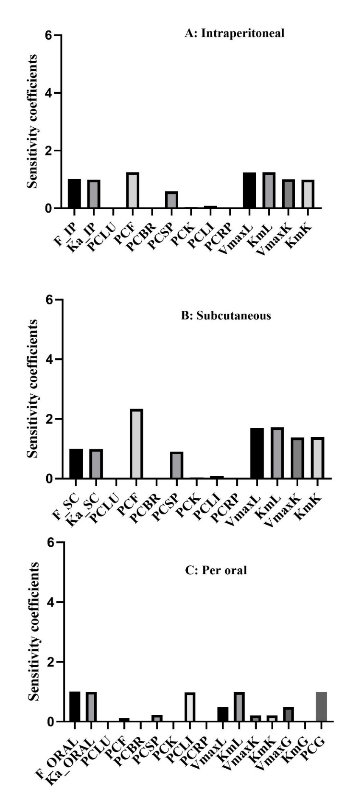
Fig. 4S The absolute maximum sensitivity coefficients of psilocin physiologically based pharmacokinetic (PBPK) parameters in rats following intraperitoneal (IP), subcutaneous (SC), and oral administration of psilocybin. These parameters include F_IP (intraperitoneal bioavailability), Ka_IP (intraperitoneal absorption rate constant), F_SC (subcutaneous bioavailability), Ka_SC (subcutaneous absorption rate constant), F_oral (oral bioavailability), Ka_oral (oral absorption rate constant), PCLU (partition coefficient lung to plasma), PCF (partition coefficient fat to plasma), PCBR (partition coefficient brain to plasma), PCSP (partition coefficient muscle to plasma), PCK (partition coefficient kidneys to plasma), PCLI (partition coefficient liver to plasma), PCRP (partition coefficient heart to plasma), PCG (9), KmL (liver Michaelis constant), VmaxL (liver maximum reaction velocity), KmK (kidney Michaelis constant), VmaxK (kidney maximum reaction velocity), KmG (gut Michaelis constant), and VmaxG (gut maximum reaction velocity). These parameters were observed following intraperitoneal injection at doses of 5 mg/kg (A), subcutaneous injection at doses of 0.05 mg/kg (B), and oral administration of psilocybin at a dose of 10.1 mg/kg psilocin (C). The sensitivity coefficients are categorized as high (absolute value ≥ 0.5), medium (absolute value ≥ 0.2 but < 0.5), or low (absolute value ≥ 0.1 but < 0.2), depending on their impact on the psilocin plasma concentration.

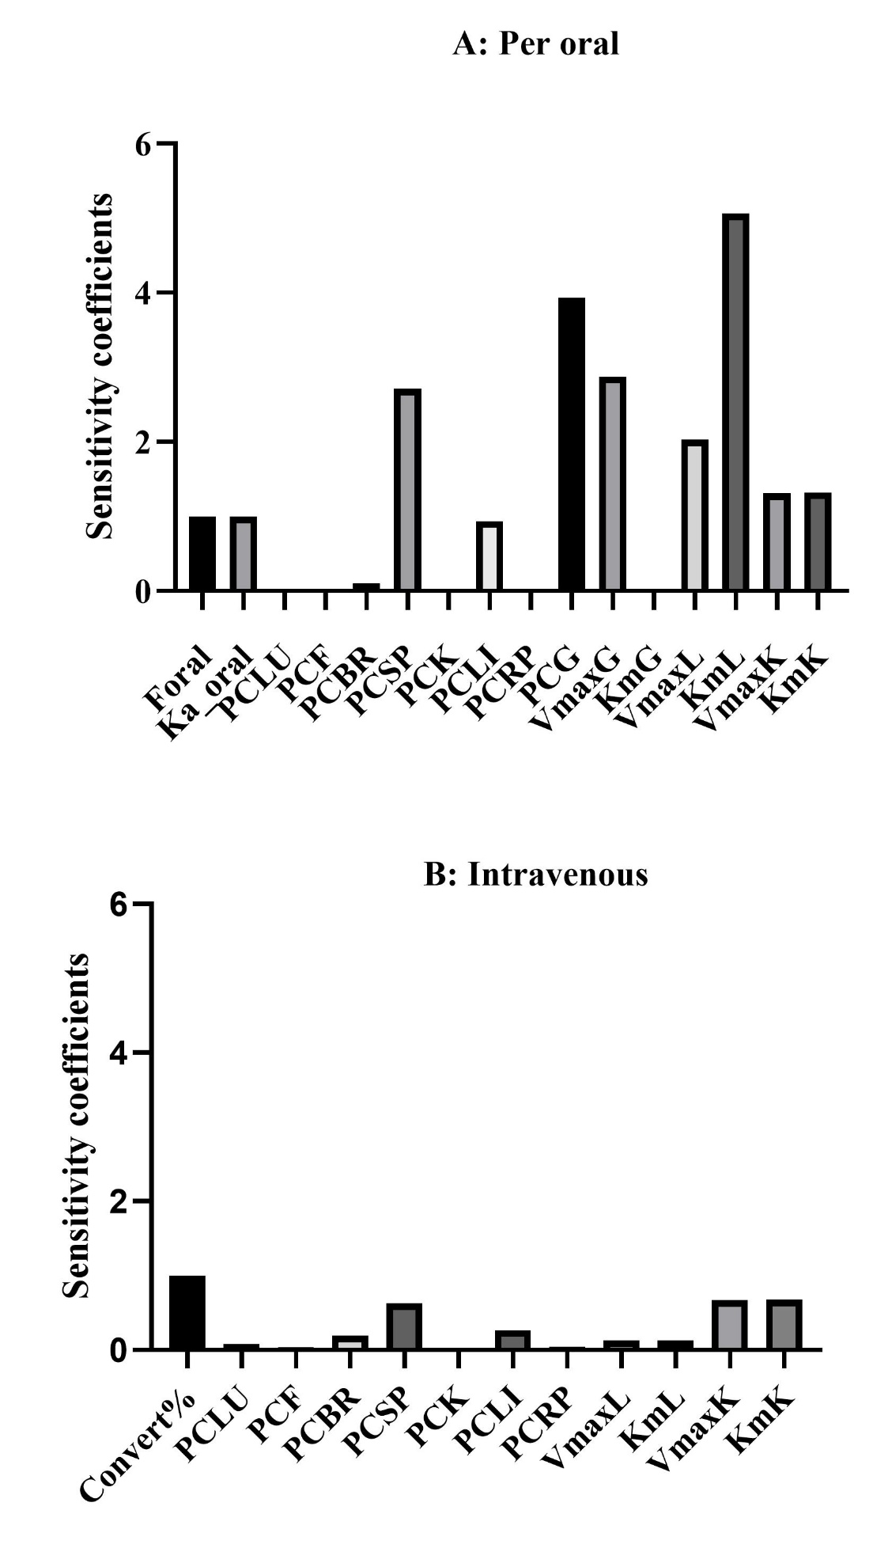

Fig. 5S The absolute maximum sensitivity coefficients of psilocin physiologically based pharmacokinetic (PBPK) parameters following oral and intravenous administration of psilocybin in humans. These parameters include Convert% (percentage of psilocybin converted to psilocin), F_oral (oral bioavailability), Ka_oral (oral absorption rate constant), PCLU (partition coefficient lung to plasma), PCF (partition coefficient fat to plasma), PCBR (partition coefficient brain to plasma), PCSP (partition coefficient muscle to plasma), PCK (partition coefficient kidneys to plasma), PCLI (partition coefficient liver to plasma), PCRP (partition coefficient heart to plasma), PCG (partition coefficient gut to plasma), KmL (liver Michaelis constant), VmaxL (liver maximum reaction velocity), KmK (kidney Michaelis constant), VmaxK (kidney maximum reaction velocity), KmG (gut Michaelis constant), and VmaxG (gut maximum reaction velocity). These parameters were observed following oral administration at doses of 15 mg psilocybin (A) and intravenous psilocybin at a dose of 1 mg (B) in humans. The sensitivity coefficients are categorized as high (absolute value ≥ 0.5), medium (absolute value ≥ 0.2 but < 0.5), or low (absolute value ≥ 0.1 but < 0.2), depending on their impact on psilocin concentrations.
Monte Carlo analysis
Table 2S. Humans pharmacokinetics input parameters and parameters of distribution used in the Monte Carlo analysis
Parameters | Distribution | Mean | CV | SD | Lower bound | Upper bound | Sauce
Blood flow fraction (fraction of cardiac output)
Cardiac output (L/h scaled by BW^{3/4}) | Normal | 15 | 0.2 | 3.000 | 9.120 | 20.880 | [17]
Fat (QFC) | Normal | 0.046 | 0.2 | 0.009 | 0.028 | 0.065 | [17]
Liver (QLIC) | Normal | 0.259 | 0.2 | 0.052 | 0.157 | 0.360 | [17]
Muscle (QMUC) | Normal | 0.134 | 0.2 | 0.027 | 0.081 | 0.186 | [17]
Kidney (QKC) | Normal | 0.221 | 0.2 | 0.044 | 0.135 | 0.308 | [17]
Brain (QBRC) | Normal | 0.125 | 0.2 | 0.025 | 0.076 | 0.174 | [17]
Heart (QHC) | Normal | 0.043 | 0.2 | 0.009 | 0.026 | 0.060 | [17]
Gut (QGC) | Normal | 0.196 | 0.2 | 0.039 | 0.119 | 0.273 | [2]
Tissue volume (fraction of body weight)
Body weight (Kg) | Lognormal | 70 | 0.2 | 43.298 | 37.893 | 124.339 | [17]
Fat (VFC) | Normal | 0.1429 | 0.2 | 0.029 | 0.087 | 0.199 | [17]
Liver (VLIC) | Normal | 0.0241 | 0.2 | 0.005 | 0.015 | 0.034 | [17]
Muscle (VMUC) | Normal | 0.5 | 0.2 | 0.100 | 0.304 | 0.696 | [17]
Lung (VLUC) | Normal | 0.0167 | 0.2 | 0.003 | 0.010 | 0.023 | [17]
Kidney (VKC) | Normal | 0.004 | 0.2 | 0.001 | 0.002 | 0.006 | [17]
Brain (VBRC) | Normal | 0.0207 | 0.2 | 0.004 | 0.013 | 0.029 | [17]
Heart (VHC) | Normal | 0.0044 | 0.2 | 0.001 | 0.003 | 0.006 | [17]
Gut (VGC) | Normal | 0.0236 | 0.2 | 0.005 | 0.014 | 0.033 | [2]
Vein (VVC) | Normal | 0.0496 | 0.2 | 0.010 | 0.030 | 0.069 | [17]
Artery (VAC) | Normal | 0.0247 | 0.2 | 0.005 | 0.015 | 0.034 | [17]
Partition coefficients for psilocin
Fat (PF) | Lognormal | 1.72 | 0.20 | 1.064 | 0.931 | 3.055 | [18]
Liver (PLI) | Lognormal | 1.84 | 0.20 | 1.138 | 0.996 | 3.268 | [18]
Muscle (PMU) | Lognormal | 1.40 | 0.20 | 0.866 | 0.758 | 2.487 | [18]
Lung (PLU) | Lognormal | 0.91 | 0.20 | 0.563 | 0.493 | 1.616 | [18]
Kidney (PK) | Lognormal | 1.42 | 0.20 | 0.878 | 0.769 | 2.522 | [18]
Brain (PBR) | Lognormal | 2.56 | 0.20 | 1.583 | 1.386 | 4.547 | [18]
Heart (PH) | Lognormal | 1.16 | 0.20 | 0.718 | 0.628 | 2.060 | [18]
Gut (PG) | Lognormal | 370 | 0.2 | 228.861 | 200.29 | 657.220 | A
Kinetic parameters
Oral bioavailability (F) | Lognormal | 0.52 | 0.2 | 0.322 | 0.281 | 0.924 | [11]
Absorption rate constant (Ka) | Lognormal | 1.307 | 0.2 | 0.808 | 0.708 | 2.321 | [12]
Maximum velocity of gut (VmaxG) | Lognormal | 14504.49 | 0.2 | 8971.640 | 7851.631 | 25763.905 | [19]
Michaelis constant of gut (KmG) | Lognormal | 10.41 | 0.2 | 6.439 | 5.635 | 18.491 | [19]/PG
Maximum velocity of liver (VmaxL) | Lognormal | 9100.83 | 0.2 | 5629.248 | 4926.499 | 16165.540 | [19]
Michaelis constant of liver (KmL) | Lognormal | 552.70 | 0.2 | 341.868 | 299.189 | 981.745 | [19]/PLI
Maximum velocity of kidney (VmaxK) | Lognormal | 628.56 | 0.2 | 388.791 | 340.254 | 1116.492 | B
Michaelis constant of kidney (KmK) | Lognormal | 21.13 | 0.2 | 13.070 | 11.438 | 37.532 | B
Abbreviation: A = optimize B = allometric scaling from mice, PG = partition coefficients for psilocin in gut, and PLI = partition coefficients for psilocin in liver.

Fig. 6S Monte Carlo simulation conducted in individuals who consumed psilocybin orally in doses 10 to 30 mg. The figure displays the mean plasma concentrations (solid line), as well as the mean-standard deviation (dotted line) and the mean+standard deviation (dashed line). These results are compared to the observations reported by A; Hasler, Bourquin, Brenneisen, Bär, Vollenweider [11], B; Lindenblatt, Krämer, Holzmann-Erens, Gouzoulis-Mayfrank, Kovar [12], C; Brown, Nicholas, Cozzi, Gassman, Cooper, Muller, Thomas, Hetzel, Henriquez, Ribaudo, Hutson [13], D; Madsen, Fisher, Burmester, Dyssegaard, Stenbæk, Kristiansen, Johansen, Lehel, Linnet, Svarer, Erritzoe, Ozenne, Knudsen [4], E and F; Holze, Ley, Müller, Becker, Straumann, Vizeli, Kuehne, Roder, Duthaler, Kolaczynska, Varghese, Eckert, Liechti [15], and G; Ley, Holze, Arikci, Becker, Straumann, Klaiber, Coviello, Dierbach, Thomann, Duthaler, Luethi, Varghese, Eckert, Liechti [16].
The Monte Carlo data are displayed in the data availability file.

REFERENCES

[1] Iwatsubo T, Suzuki H, Sugiyama Y. Prediction of species differences (rats, dogs, humans) in the in vivo metabolic clearance of YM796 by the liver from in vitro data. J Pharmacol Exp Ther 1997;283(2):462-9.
[2] Davies B, Morris T. Physiological parameters in laboratory animals and humans. Pharm Res 1993;10(7):1093-5.
[3] Kenyon EM. Interspecies extrapolation. Methods Mol Biol 2012;929:501-20.
[4] Madsen MK, Fisher PM, Burmester D, Dyssegaard A, Stenbæk DS, Kristiansen S, et al. Correction: Psychedelic effects of psilocybin correlate with serotonin 2A receptor occupancy and plasma psilocin levels. Neuropsychopharmacology 2019;44(7):1336-7.
[5] International Programme on Chemical S, Inter-Organization Programme for the Sound Management of C. Characterization and application of physiologically based phamacokinetic models in risk assessment. Geneva: World Health Organization; 2010.
[6] Poulin P, Theil FP. Prediction of pharmacokinetics prior to in vivo studies. II. Generic physiologically based pharmacokinetic models of drug disposition. J Pharm Sci 2002;91(5):1358-70.
[7] Horita A, Weber LJ. Dephosphorylation of psilocybin in the intact mouse. Toxicol Appl Pharmacol 1962;4:730-7.
[8] Saito K, Toyo’oka T, Fukushima T, Kato M, Shirota O, Goda Y. Determination of psilocin in magic mushrooms and rat plasma by liquid chromatography with fluorimetry and electrospray ionization mass spectrometry. Analytica Chimica Acta 2004;527(2):149-56.
[9] Higgins GA, Carroll NK, Brown M, MacMillan C, Silenieks LB, Thevarkunnel S, et al. Low Doses of Psilocybin and Ketamine Enhance Motivation and Attention in Poor Performing Rats: Evidence for an Antidepressant Property. Front Pharmacol 2021;12:640241.
[10] Chen J, Li M, Yan X, Wu E, Zhu H, Lee KJ, et al. Determining the pharmacokinetics of psilocin in rat plasma using ultra-performance liquid chromatography coupled with a photodiode array detector after orally administering an extract of Gymnopilus spectabilis. J Chromatogr B Analyt Technol Biomed Life Sci 2011;879(25):2669-72.
[11] Hasler F, Bourquin D, Brenneisen R, Bär T, Vollenweider FX. Determination of psilocin and 4-hydroxyindole-3-acetic acid in plasma by HPLC-ECD and pharmacokinetic profiles of oral and intravenous psilocybin in man. Pharm Acta Helv 1997;72(3):175-84.
[12] Lindenblatt H, Krämer E, Holzmann-Erens P, Gouzoulis-Mayfrank E, Kovar KA. Quantitation of psilocin in human plasma by high-performance liquid chromatography and electrochemical detection: comparison of liquid-liquid extraction with automated on-line solid-phase extraction. J Chromatogr B Biomed Sci Appl 1998;709(2):255-63.
[13] Brown RT, Nicholas CR, Cozzi NV, Gassman MC, Cooper KM, Muller D, et al. Pharmacokinetics of Escalating Doses of Oral Psilocybin in Healthy Adults. Clin Pharmacokinet 2017;56(12):1543-54.
[14] Madsen MK, Stenbæk DS, Arvidsson A, Armand S, Marstrand-Joergensen MR, Johansen SS, et al. Psilocybin-induced changes in brain network integrity and segregation correlate with plasma psilocin level and psychedelic experience. Eur Neuropsychopharmacol 2021;50:121-32.
[15] Holze F, Ley L, Müller F, Becker AM, Straumann I, Vizeli P, et al. Direct comparison of the acute effects of lysergic acid diethylamide and psilocybin in a double-blind placebo-controlled study in healthy subjects. Neuropsychopharmacology 2022;47(6):1180-7.
[16] Ley L, Holze F, Arikci D, Becker AM, Straumann I, Klaiber A, et al. Comparative acute effects of mescaline, lysergic acid diethylamide, and psilocybin in a randomized, double-blind, placebo-controlled cross-over study in healthy participants. Neuropsychopharmacology 2023;48(11):1659-67.
[17] Brown RP DM, Lindstedt SL, Rhomberg LR, Beliles RP. . Physiological parameter values for physiologically based pharmacokinetic models. . Toxicol Ind Health 1997 Jul-Aug;13(4):407-84.
[18] Poulin P TF. Prediction of pharmacokinetics prior to in vivo studies. 1. Mechanism-based prediction of volume of distribution. . J Pharm Sci 2002;Jan;91(1):129-56.
[19] Manevski N, Kurkela M, Höglund C, Mauriala T, Court MH, Yli-Kauhaluoma J, et al. Glucuronidation of psilocin and 4-hydroxyindole by the human UDP-glucuronosyltransferases. Drug Metab Dispos 2010;38(3):386-95.

