Supplementary Materials

Pharmacological agents and injection stress, but not social isolation,
alter cognitive judgement bias in the mouse touchscreen operant chamber

Ashlyn Y. Hersey, Paul A. S. Sheppard, Ryan Kim, Thu N. M. Pham,
Laura López-Cruz, Timothy J. Bussey, & Lisa M. Saksida

Supplemental Figures

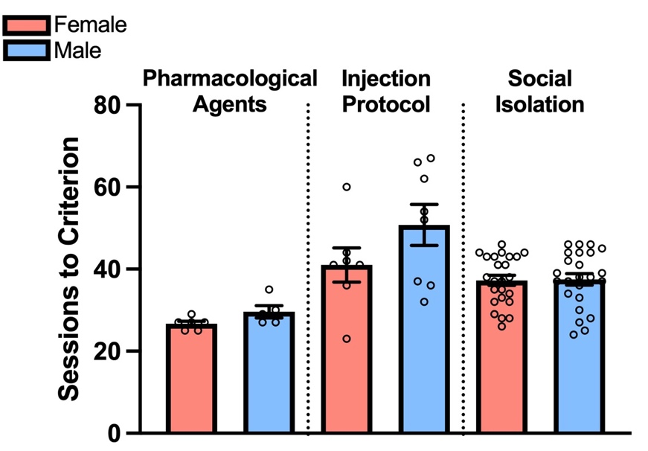

Supplementary Figure 1: Training duration of mice on the cognitive judgement bias task.
Mice required between 25 and 67 sessions of training prior to baseline probes with ambiguous stimuli. The number of sessions varied by experiment, likely because of differences in training protocol (e.g. addition of S+ vs “snowflake” discrimination stage and changes in advancement criterion). No differences between sexes within an experiment were observed (ps>0.081).

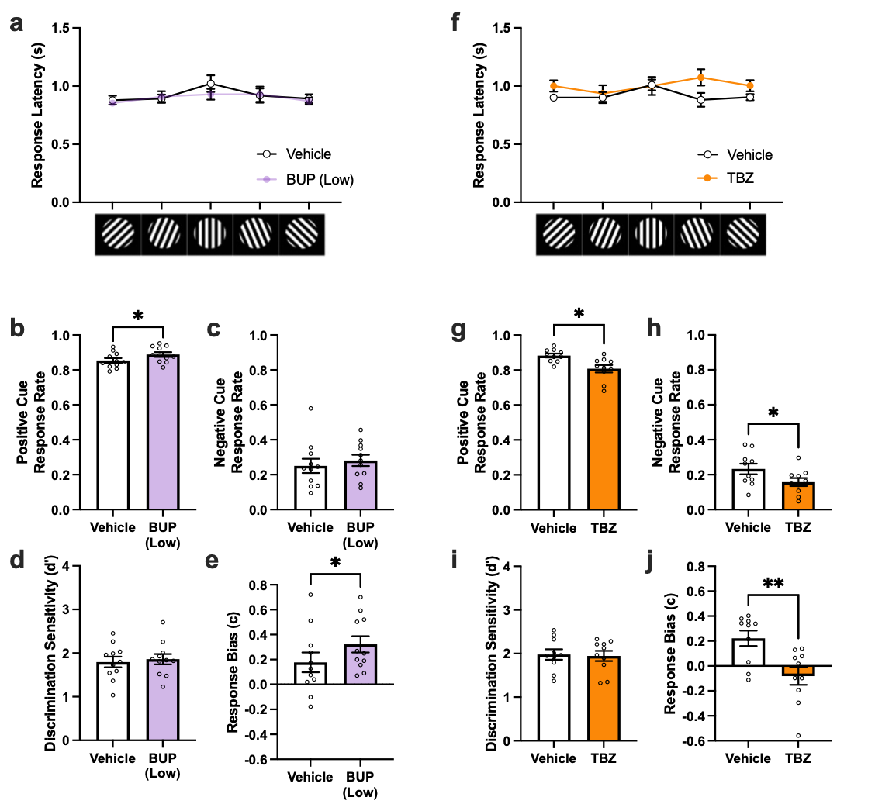
Supplementary Figure 2. Effects of BUP (5 mg/kg) and TBZ (6 mg/kg) on CJB responding a) BUP did not affect response latencies for the five cues b) BUP significantly increased response rate for the positive cue c) BUP did not affect the response rate for the negative cue d) BUP did not affect discrimination sensitivity (d’) e) BUP induced a more liberal response bias (c) f) TBZ did not affect response latencies for the five cues g) TBZ significantly reduced response rate for the positive cue h) TBZ significantly reduced response rate for the negative cue i) TBZ did not affect discrimination sensitivity (d’) j) TBZ induced a more conservative response bias (c).

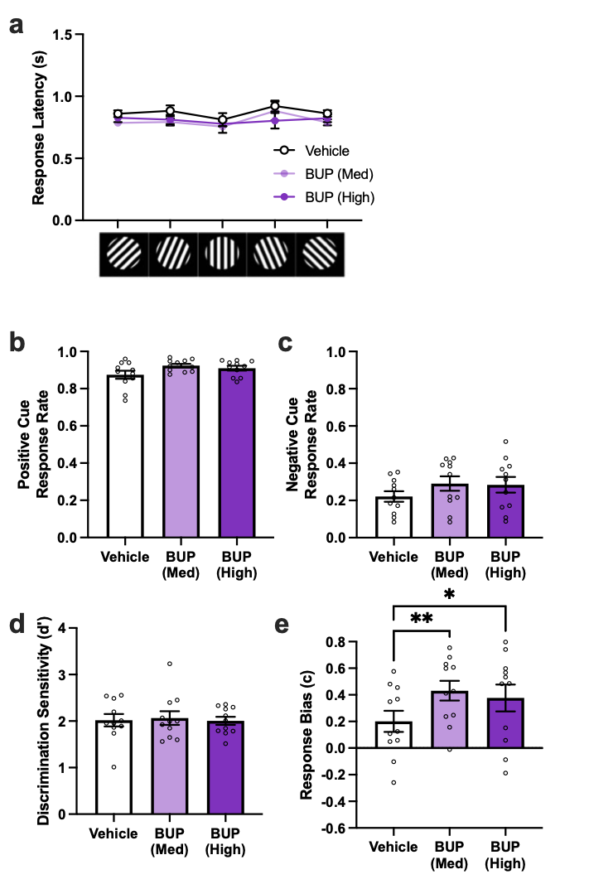
Supplementary Figure 3. Effects of BUP (7.5 and 10 mg/kg) CJB responding a) BUP did not affect response latencies for the five cues b) BUP significantly increased response rate for positive cue, but post hoc tests were non-significant c) BUP non-significantly increased response rate for the negative cue d) BUP did not affect discrimination sensitivity (d’) e) BUP induced a more liberal response bias (c) at 7.5 and 10 mg/kg.

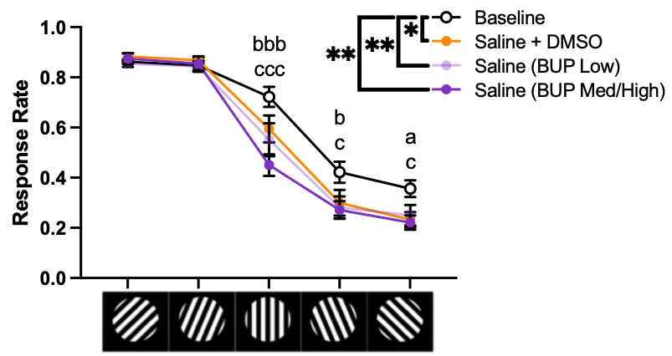
Supplemental Figure 4. Comparison of vehicle injection groups to initial baseline CJB curves. All vehicle injection groups produced CJB curves significantly lower than baseline. These differences were most robust at the true ambiguous, near-negative, and negative cues. At the true ambiguous cue, both saline groups (BUP Low and BUP Med/High) had lower response rates than baseline. Saline (both BUP Low and BUP Med/High) reduced response rate to the near-negative cue and saline + DMSO and saline (BUP Med/High) reduced response rate to the negative cue. Holm post hocs for main effects of condition: *p<0.05, **p<0.01. Holm post hocs for cue x condition interaction: Baseline vs saline + DMSO – a p<0.05, Baseline vs saline (BUP Low) – b p<0.05, bbb p<0.001, baseline vs saline (BUP Med/High) – c p<0.05, ccc p<0.001. Data depicted as mean±SEM.
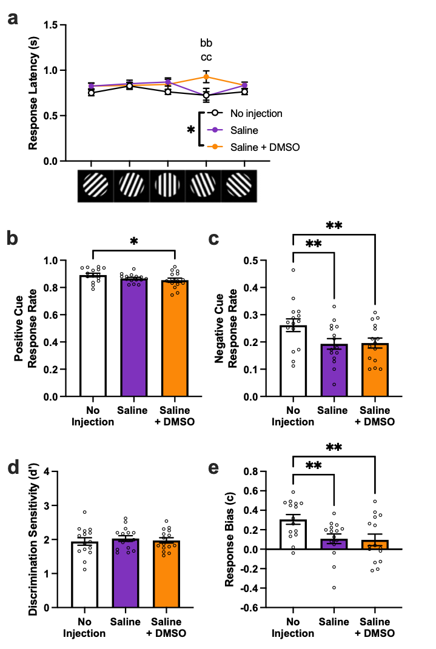
Supplementary Figure 5. Effects of saline and saline + DMSO on CJB responding a) Response latencies were higher for saline + DMSO compared to both no-injection and saline at the near-negative cue, but values fell within response window b) Response rate for the positive cue was different between saline + DMSO and no-injection only c) Both injection conditions decreased response rate for the negative cue d) Condition did not affect discrimination sensitivity (d’) e) Both injection conditions produced more conservative response biases (c).

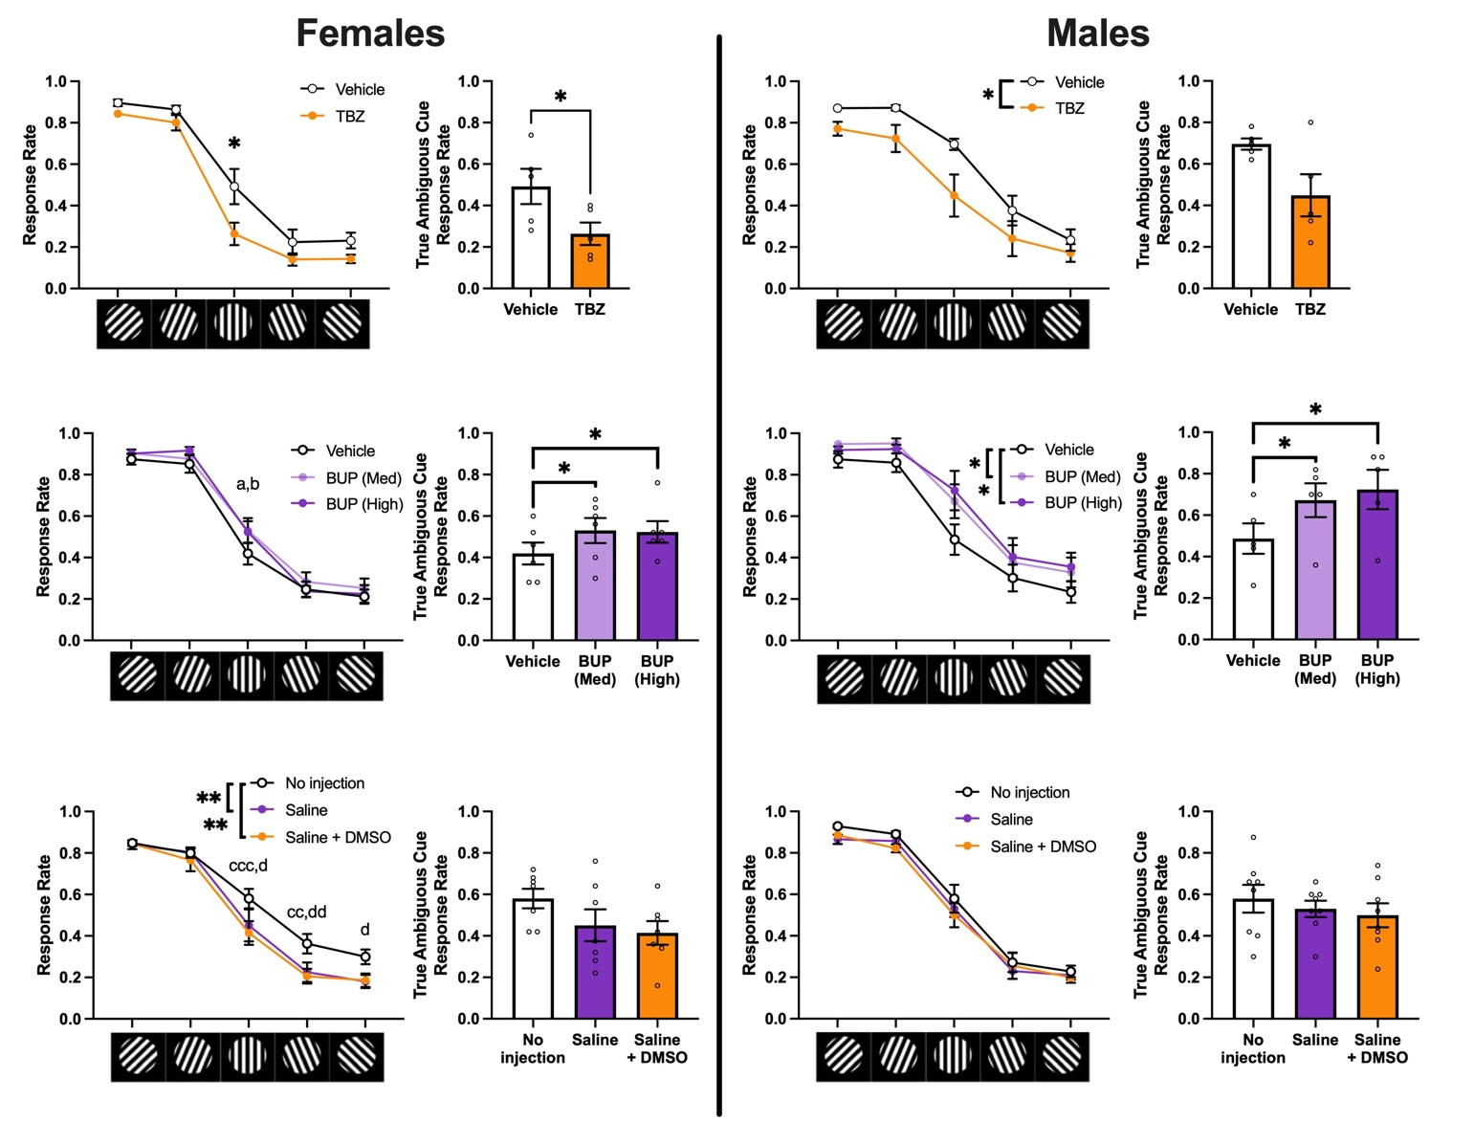
Supplementary Figure 6: Exploratory sex-stratified analyses of the effects of TBZ, BUP, and injection procedure on CJB.
Overall, male and female mice showed similar responses to intervention. In females, response rate to the true ambiguous stimulus was reduced with TBZ and vehicle injection procedures and increased with BUP. In males, overall response rate was reduced with TBZ and increased with BUP, with a priori analyses showing increases in response rate to the true ambiguous stimulus. There was no statistically significant change in response rate of the males overall or to the true ambiguous stimulus with the injection procedure; however, these data suggest a modest decrease in response rate. Note: these data are of low statistical power and should be treated only as exploratory. Further investigations into sex differences in CJB following these interventions are needed. *p < 0.05, ** p < 0.01, ª p < 0.05 comparing BUP (Med) and Vehicle, ^{b} p < 0.05 comparing BUP (High) and Vehicle, ^{cc} p < 0.01 and ^{ccc} p < 0.001 comparing Saline and No Injection, ^{d} p < 0.05 and ^{dd} p < 0.01 comparing Saline + DMSO and No Injection. Data depicted as mean±SEM.
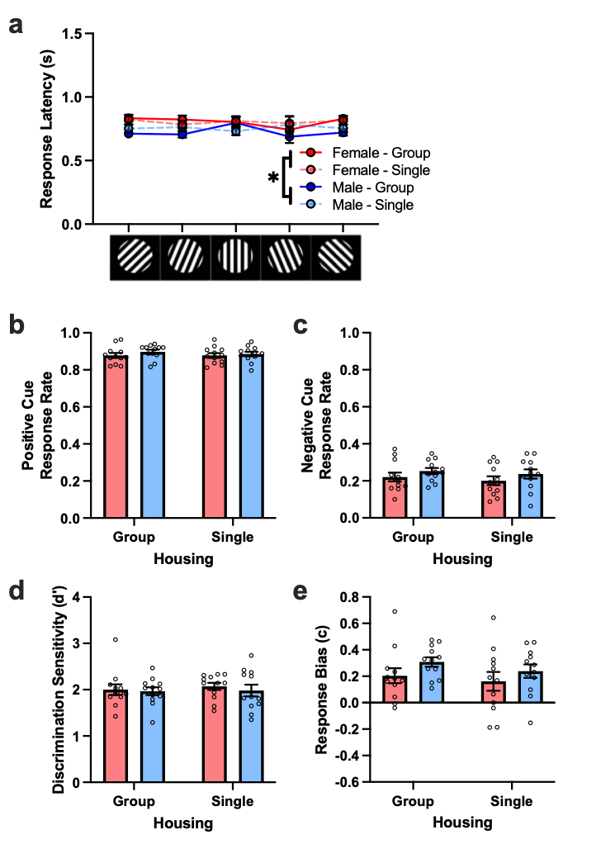
Supplementary Figure 7. Effects of 8-week social isolation on CJB Responding. a) Isolation did not affect response latencies for the five cues, however females had higher latencies than males b) Isolation did not affect response rate for positive cue c) Isolation did not affect response rate for the negative cue d) Isolation did not affect discrimination sensitivity (d’) e) Isolation did not affect response bias (c).

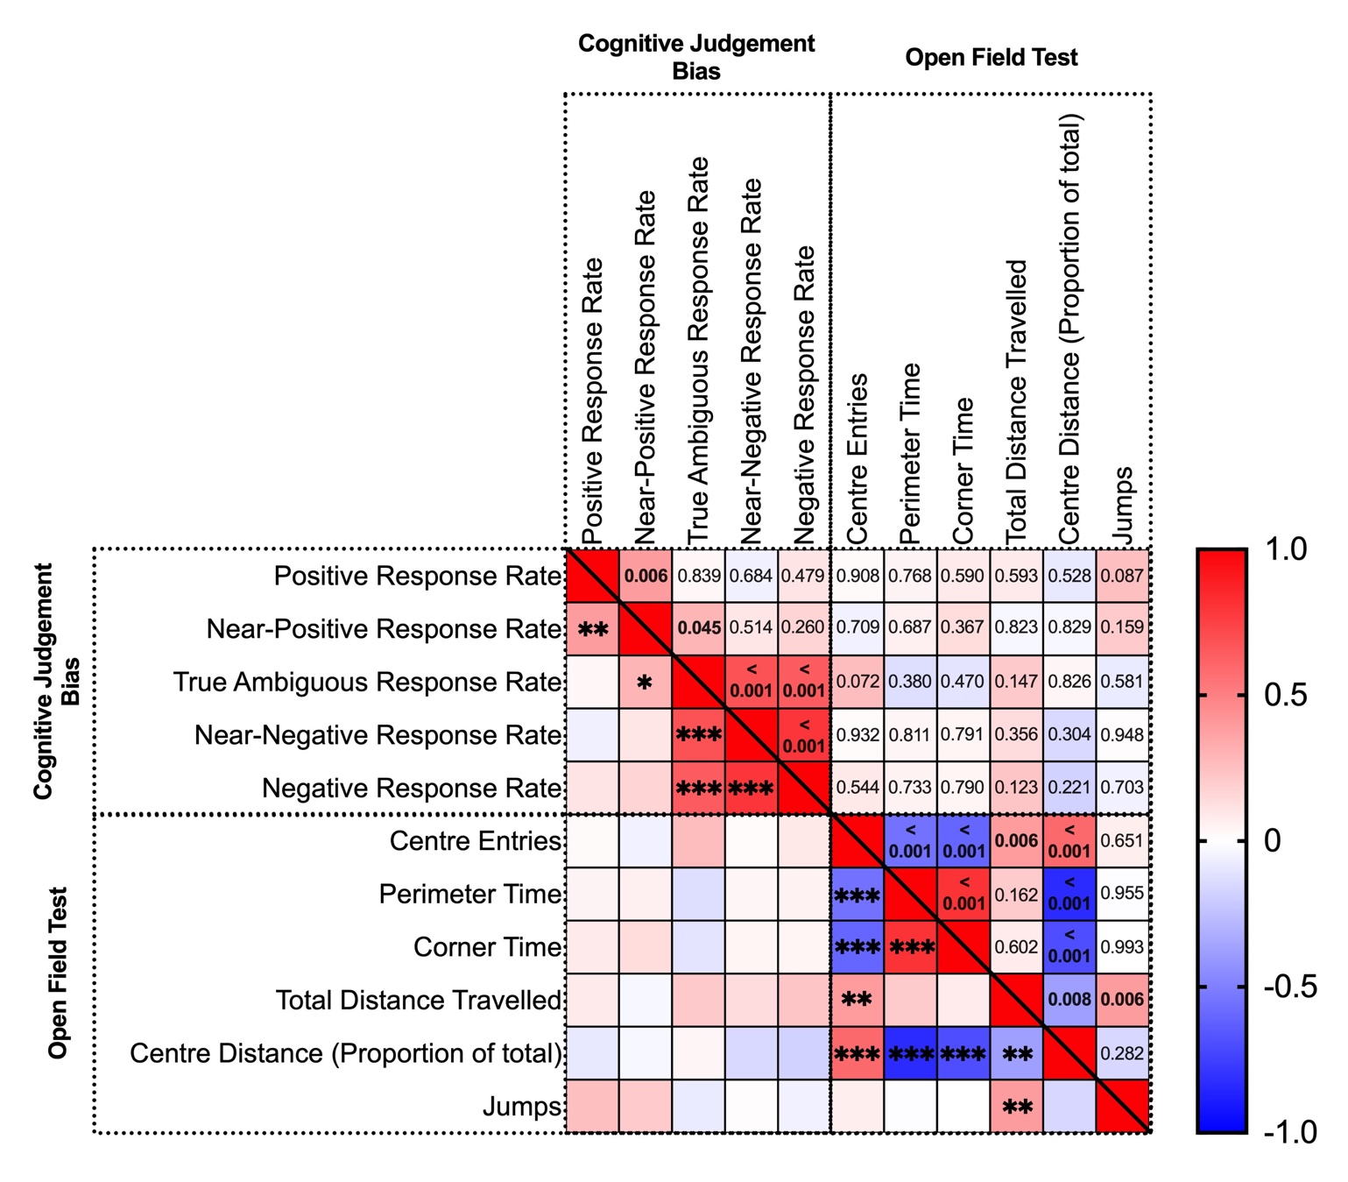
Supplementary Figure 8: Measures within the CJB task and open field test correlate highly within each task but do not correlate between tasks.
Statistically significant correlations were found comparing measures within each of the tasks; however, no statistically significant correlations were found between the tasks on any measure. Colour gradient indicates Pearson’s r values, with red as positive correlations and blue as negative correlations. The upper-right portion of the matrix indicates p-values. Statistical significance is indicated with asterisks in the lower-left portion of the matrix. *p < 0.05, **p < 0.01, ***p < 0.001.

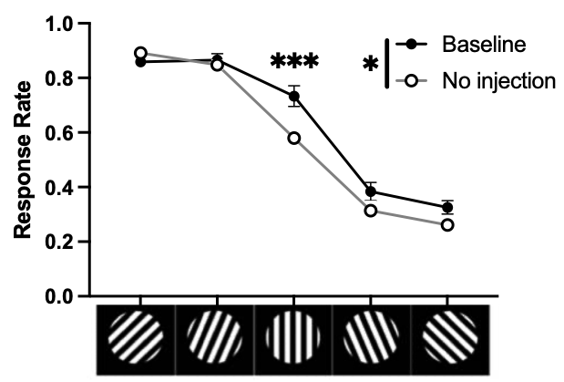
Supplementary Figure 9. Comparison of baseline and no-injection condition CJB response rate curves. Compared to baseline, the no-injection group had a significantly lower CJB response rate curve overall. Post hoc analyses revealed a significant difference in response rate between the timepoints (i.e. baseline and no-injection) only at the true ambiguous cue. *p < 0.05, *** p < 0.001. Data depicted as mean±SEM (SEM for No injection group are too small to be depicted).

Supplementary Results
Comparing Baseline and Initial Vehicle Injection Conditions (Pharmacological Intervention Experiment)
It was observed that there was a drop in CJB response rates from the initial baseline measurement to any treatment during the pharmacological treatment experiment, including to vehicle treatments alone (Supplementary Figure 3). To assess the effect of repeated testing and/or injection handling stress on CJB responding, a two-way repeated measures ANOVA was performed with cue and condition (baseline versus vehicle) as within subject’s factors. There was an interaction of condition x cue (F_{(12, 108)} = 5.29, η² = 0.021, p < 0.001), a main effect of cue (F_{(1.152, 108)} = 136.846, η² = 0.838, p < 0.001), and main effect of condition (F_{(3, 108)} = 6.226, η² = 0.021, p = 0.004). Holm post hoc tests revealed significant differences between baseline and saline + DMSO (p = 0.033) and both saline conditions (BUP Low: p = 0.008; BUP Med/High: p = 0.004). Interrogating the condition x cue interaction revealed significant differences decreases in baseline response rates to true ambiguous (Saline [BUP Low]: p < 0.001, Saline [BUP Med/High]: p < 0.001), near-negative (Saline [BUP Low]: p = 0.042, saline [BUP Med/High]: p = 0.021), and negative cues (Saline [BUP Med/High]: p = 0.05, Saline + DMSO: p = 0.05). There were no differences between injection condition groups. These results show a drop in CJB response rates between baseline and probes which could result from either repeated exposure to the ambiguous cues (i.e. learning that responses at these cues do not result in reward) or to stress from the injection procedure. These were subsequently addressed by the Injection and Handling experiment. These data collectively suggest that there is a decrease in responding between these groups as a combined result of repeated exposure and injection handling stress.
Comparing Baseline and No-Injection Condition (Injection and Handling Stress Experiment)
To assess the effect of repeated testing on CJB responding, a two-way repeated measures ANOVA was performed with cue and condition (baseline versus no-injection probes) as within-subjects factors. There was an interaction of condition x cue (F_{(2.177, 30.485)} = 8.716, η² = 0.014, p < 0.001; Supplementary Figure 5), a main effect of cue (F_{(2.577, 36.078)} = 222.394, η² = 0.869, p < 0.001; Supplementary Figure 5) and main effect of condition (F_{(1, 14)} = 4.920, η² = 0.011, p = 0.044; Supplementary Figure 5). Post hoc tests revealed significant differences between no-injection and baseline at the true ambiguous cue only (p < 0.001; Supplementary Figure 5). Overall, these results suggest that there was a significant decrease in response rate at the true ambiguous cue when comparing baseline to the no-injection condition. This indicates a decrease in response to the ambiguous and unrewarded cues following initial baseline measurement. However, as the saline condition showed significant decreases in ambiguous cue response rate compared to the no-injection condition, with these conditions counterbalanced via Latin square design, the changes to responding in the initial pharmacological experiment following baseline are likely due to a combination of learning that the ambiguous cues are unrewarded and further negative shifts in cognitive bias.

