Human-Generative AI Collaboration Enhances Task Performance but Undermines Human’s Intrinsic Motivation

Supplementary Material

Introduction:

As all study materials, including the original questionnaire (printed version, survey flow chart, and the Qualtrics survey file), the anonymized raw data, raters’ evaluation records, cleaned data used for analyses, and data analysis codes, have been shared publicly in the Open Science Framework (https://osf.io/xyjwh/?view_only=1c80758370cf4f8f8f2261a0b81398d3), in this Supplementary Materials document, we only present the most necessary information or materials to facilitate readers’ understanding of the design and procedures of this research.

Contents:

List of Figures:
- Supplementary Table 1. Disclosure of Preregistration Deviations
- Supplementary Figure 1. Embedding ChatGPT within a Qualtrics Survey
- Supplementary Figure 2. Sample Evaluation Form (for Study 1 Task 1 Outputs)
- Supplementary Figure 3. Sample Evaluation Form (for Study 1 Task 2 Outputs)
- Supplementary Figure 4. Sample Evaluation Form (for Study 2 Task 2 Outputs)
- Supplementary Figure 5. Sample Evaluation Form (for Study 3 Task 2 Outputs)

Supplementary Table 1. Disclosure of Preregistration Deviations
Deviations
# | Details |  | Original Wording | Deviation Description | Reader Impact
1 | Type | Analysis | Under the question “Describe the key dependent variable(s) specifying how they will be measured.” across the preregistrations of the three studies, we reported perceived sense of control, boredom, and intrinsic motivation as mediators and task engagement and task performance as dependent variables. | In analyzing our data from the three studies, we first tested what we originally proposed, and our data generally offered support for our original idea, that is, human-GenAI collaboration would influence individuals’ psychological experiences, which would further influence their task engagement and task performance. However, the primary insights derived from our data analysis revealed a significant impact of the collaboration on specific psychological experiences, which emerged as central to our research narrative. This refocusing was driven by the compelling nature of the data rather than a preconceived intention. | Originally, our study was designed to investigate these psychological experiences—specifically, perceived sense of control, intrinsic motivation, and boredom—as mediators in the relationship between human-GenAI interaction and task-related outcomes. While we initially aimed to explore these as mediators, our analysis uncovered such strong direct impacts of GenAI collaboration on these psychological states that we shifted our narrative to emphasize these primary effects. This refocused narrative does not neglect the originally intended mediation analysis but enhances it by highlighting the profound and direct influence of human-GenAI collaboration on individual psychological states.
1 | Reason | Other (Please Explain)
1 | Timing | After data access
2 | Type | Covariates | Under the question “Anything else you would like to pre-register? (e.g., secondary analyses, variables collected for exploratory purposes, unusual analyses planned?)” across the preregistrations of the three studies, we wrote that “We will measure and control task load using two items (Reid & Nygren, 1988) after each task, respectively.” | Instead of using the two items adapted from Reid & Nygren (1988), we opted for a single item: “How did the cognitive load of the task feel to you?” This overarching item assessed participants’ general cognitive load perception, beyond the specific mental and psychological stress load assessed by Reid & Nygren (1988). This decision is made for simplicity and clarity, aiming to reduce participant burden and potentially improve response accuracy considering that it was placed at the very end of post-task questionnaire.  In addition, in our original preregistration, we intended to measure and control task workload but did not specify the method of control. We reevaluated task workload as a crucial indicator of cognitive investment, leading us to examine its variations across different conditions. Our findings revealed that while participants’ perceived workload did not vary for Task 2 across conditions, those in the human-GenAI collaboration conditions in Studies 2 and 3 reported significantly lower task workload for Task 1, highlighting the cognitive benefits of GenAI assistance. However, this reduction in cognitive strain did not translate into enhanced experiences in subsequent solo tasks, suggesting that while GenAI collaboration conserves cognitive resources, it may also impact motivational and engagement aspects negatively when transitioning back to solo work. This paradox underscores the need for further research on the long-term psychological impacts of AI assistance across diverse task contexts. | The change in measures may affect the comparability of our findings with those of studies using the original Reid & Nygren (1988) items.  Also, in our original preregistration, we planned to measure and control task workload but did not detail our control methods. Upon analyzing our data, we recognized task workload as a key indicator of cognitive investment, prompting us to examine its variations across conditions. Our findings highlight that while GenAI collaboration reduces task workload, easing cognitive demands, it does not enhance motivation or engagement in subsequent solo tasks. This suggests that while AI can decrease cognitive strain, its impact on long-term psychological engagement is complex and requires further study. This challenges us to rethink how AI is integrated in work settings, balancing cognitive efficiency with sustainable worker engagement.
2 | Reason | Other (Please Explain)
2 | Timing | After data access
3 | Type | Analysis | Under the question “Anything else you would like to pre-register? (e.g., secondary analyses, variables collected for exploratory purposes, unusual analyses planned?)” across the preregistrations of the three studies, we wrote that “For exploratory purposes, we will measure individual self-construal, creative role identity, and cognitive styles, investigating their moderating effects.” | These variables were measured but were not analyzed in the final manuscript. The decision to include these variables was made to broaden the scope of our research and to explore potential influences that might refine our understanding of the primary outcomes. This approach allows us to remain flexible and responsive to emergent data patterns that could reveal novel insights or theoretical advancements. It is important to note that while these variables are being measured, the analyses involving them are exploratory in nature. This means that they are not bound by the same expectations for hypothesis testing as our primary analyses. | By omitting the exploratory analyses, we focused on the primary research question. However, this deviation means that the potential moderating effects of individual self-construal, creative role identity, and cognitive styles on the proposed relationships were not explored, which may limit readers’ understanding regarding individual differences in our study.
3 | Reason | Other (Please Explain)
3 | Timing | Before data collection

Supplementary Figure 1. Embedding ChatGPT within a Qualtrics Survey
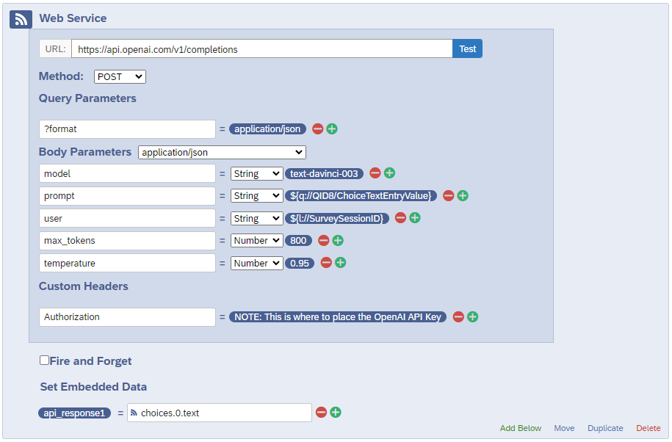

Note: As detailed by Velez (2023), the ChatGPT chat interface can be seamlessly integrated into a Qualtrics survey using the Qualtrics’ Web Service feature. This function facilitates an API call to an external platform, in this instance, OpenAI’s ChatGPT at https://api.openai.com/v1/completions. The following provides a step-by-step elucidation:

1. Participants complete a text-entry prompt within the Qualtrics survey.
2. Upon transitioning to the subsequent page, the pre-configured Web Service function is activated. For configuration:
- Utilize the URL: https://api.openai.com/v1/completions.
- Select the Method: POST.
- Within Query Parameters, opt for the appropriate format, such as application/json.
3. Regarding Body Parameters:
- Specify the model to a desired version, e.g., text-davinci-003, gpt-3.5-turbo, etc.
- Assign the participant’s input as the prompt, using Qualtrics’ “Insert Piped Text” function.
- Adjust parameters like “max_tokens” and “temperature” based on research requirements.
4. Proper Authorization is vital; hence, the OpenAI API key must be securely placed in the designated space.
5. Once appropriately configured, the OpenAI API interprets the input and formulates a response.
6. This output is subsequently captured using Qualtrics’ “Embedded Data” function, exemplified by the “api.response” à “choices.0.text” mapping.
7. As participants proceed to the next survey page, they are presented with ChatGPT’s interpretative response to their initial prompt.

Supplementary Figure 2. Sample Evaluation Form (for Study 1 Task 1 Output)

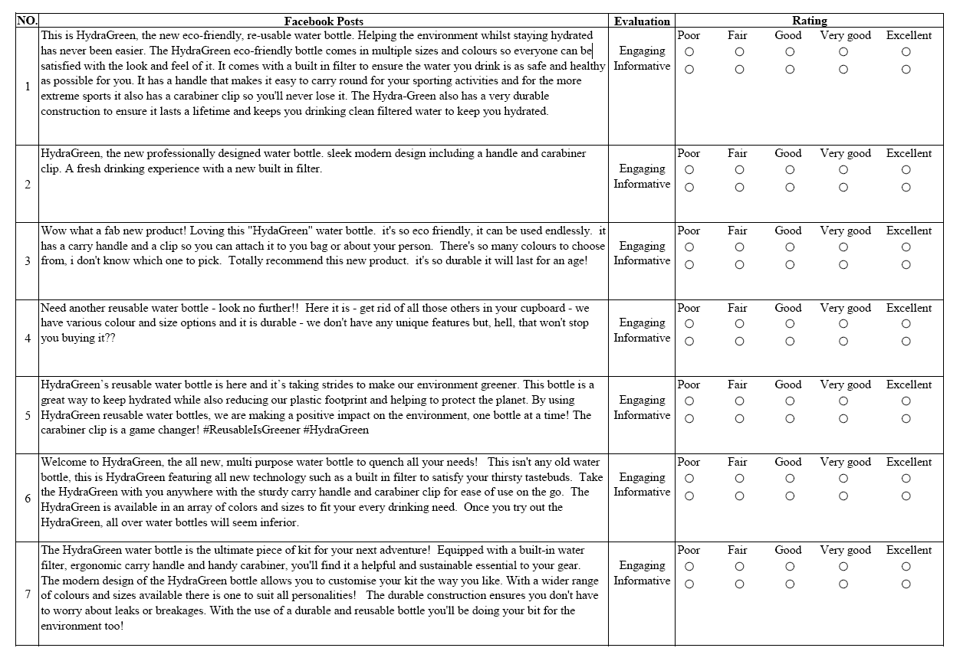

Note: Each post is evaluated based on two criteria: how Engaging and how Informative it is. A five-point rating scale, ranging from “Poor” to “Excellent”, is employed to quantify the assessment of each post for both criteria.

Supplementary Figure 3. Sample Evaluation Form (for Study 1 Task 2 Output)

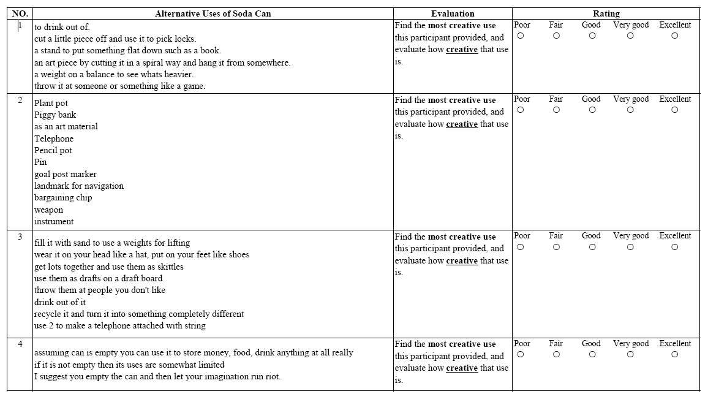

Note: The table delineates the alternative uses of soda cans as proposed by various participants. Each entry presents a list of innovative applications ranging from practical utilities to imaginative constructs. The accompanying evaluation column emphasizes the objective of identifying the most creative use from each participant’s list. The subsequent rating column adopts a five-point scale, from “Poor” to “Excellent”, designed to assess the creativity of the participant’s output.

Supplementary Figure 4. Sample Evaluation Form (for Study 2 Task 2 Output)

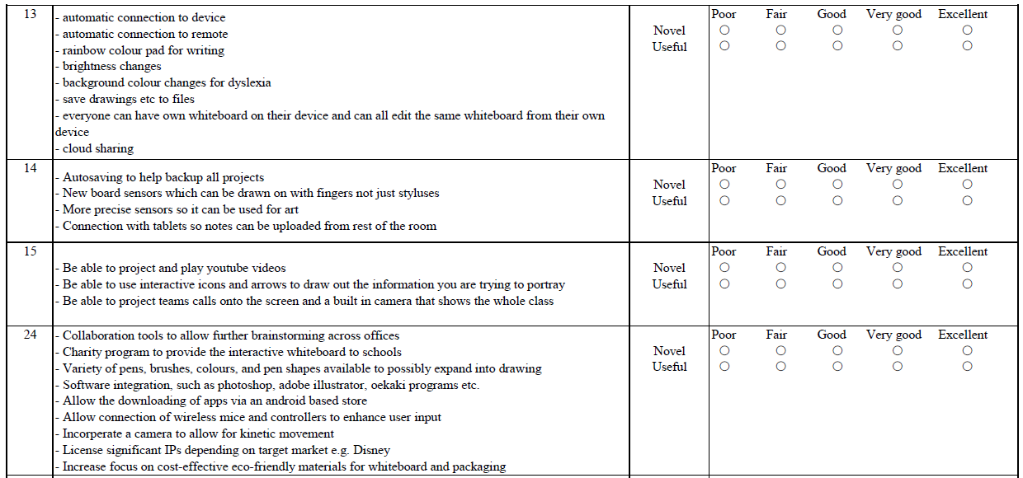

Note: The coding of these ideas, generated from the perspective of a product manager for Everwrite Co., focuses on enhancing the Interactive Whiteboard by assessing the ideas on two dimensions: novelty and usefulness. Novelty refers to the extent to which an idea is innovative and unique, while usefulness pertains to the idea’s ability to address the evolving demands of customers in modern work environments. Raters scored responses from each participant from “Poor” to “Excellent”.

Supplementary Figure 5. Sample Evaluation Form (for Study 3 Task 2 Output)

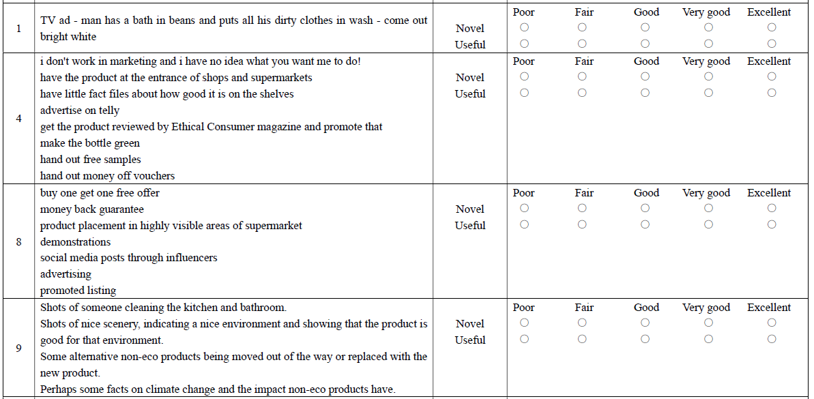

Note: The coding of these ideas, generated from the perspective of a marketing manager for EcoPure, focuses on enhancing marketing promotions by assessing the ideas on two dimensions: novelty and effectiveness. Novelty refers to the extent to which an idea is innovative and unique, while effectiveness pertains to the idea’s ability to captivate customers and spark their curiosity and interest in the environmentally friendly cleaning product. Responses from each participant were rated on a five-point scale ranging from “Poor” to “Excellent”.

