Alterations in looking at face pareidolia images in autism

Jessica Galli^{1,2*}, Marika Vezzoli³, Erika Loi^{1,2}, Serena Micheletti², Anna Molinaro^{1,2}, Lucia Tagliavento², Stefano Calza³, Alexander N. Sokolov⁴, Marina A. Pavlova^{4†} and Elisa M. Fazzi^{1,2†}

¹ Department of Clinical and Experimental Sciences, University of Brescia, Brescia, Italy
² Unit of Child Neurology and Psychiatry, ASST Spedali Civili of Brescia, Brescia, Italy
³ BDbiomed, BODaI Lab, University of Brescia, Brescia, Italy
⁴ Social Neuroscience Unit, Department of Psychiatry and Psychotherapy, Tübingen Center for Mental Health (TüCMH), Medical School and University Hospital, Eberhard Karls University of Tübingen, Tübingen 72076, Germany

*Correspondence
Corresponding Author: Jessica Galli, MD, PhD, Department of Clinical and Experimental Sciences, University of Brescia, Brescia 25123, Italy. E-mail: jessica.galli@unibs.it

†These authors share senior authorship

Supplementary Materials
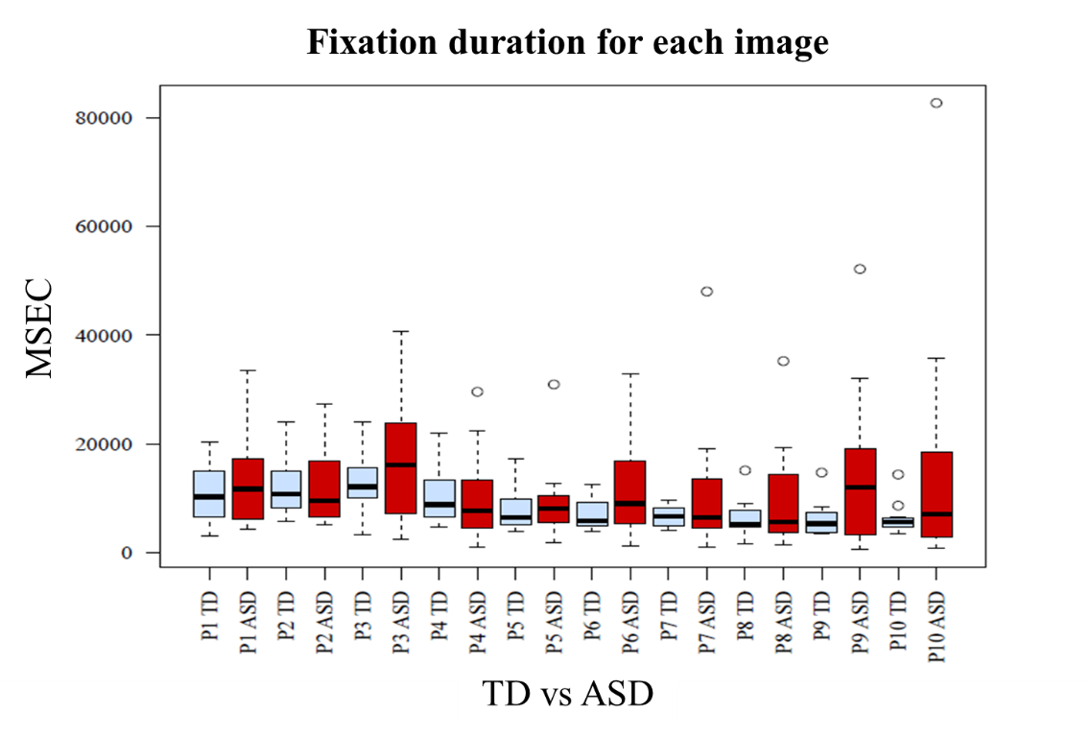

Figure S.1. Boxplots for the time spent on each image P₁ – P₁₀ (in msec) separately for the TD (light blue) and ASD (red) groups. The looking time significantly decreases across the ten images from the least to most resembling a face only in the TD control group (TD group, p < 0.001; ASD group, p = 0.46).

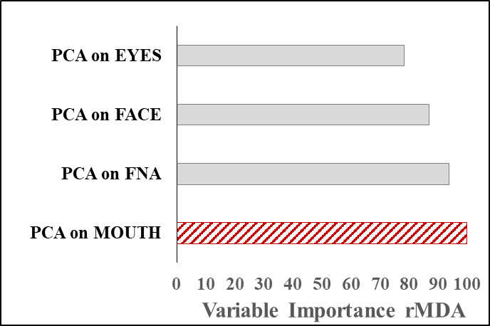

Figure S.2. Variable importance measure rMDA extracted from a Random Forest analysis where the number of images identified as a face is predicted by the four PC_{j} (based on the time spent looking at each area). CFA, complementary face area. For the ASD and TD groups pooled together, the most powerful predictor of face response is provided by PCA on mouth. This does not indicate how (positively or negatively) the face response is associated with single PCAs; this is shown in Fig. S.3.
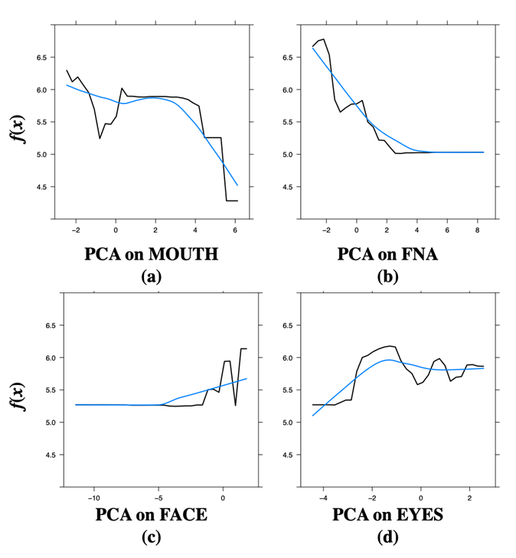

Figure S.3. PDPs of the Random Forest analysis for the ASD and TD groups pooled together, in which the number of images identified as faces is predicted by the PC_{j} (ROI-specific loads): (a) Mouth, (b) CFA, (c) Face, and (d) Eyes. PCA scales are based on time spent looking at specific ROIs. Blue curves represent the smoothing of the function. The longer the participants looked either at the face or eyes areas, the more face responses they gave. By contrast, the longer the participants looked either at the mouth or CFA, the fewer face responses they provided.

Table S.1. Summary statistics on the proportion of time spent looking at the ROIs of each image ($f_{j_{P_{l}}}$with j=1,…,4 and $l$=1,…,10) both in total and stratified for the diagnosis.

Images | TD (N_{TD}=16) | ASD (N_{ASD}=16) | Total (N=32) | p-value
Image ₁
Face | f_{FACE_P1} | f_{FACE_P1} | f_{FACE_P1} | 0.970
Mean (SD) | 0.872 (0.293) | 0.869 (0.131) | 0.870 (0.223)
Median | 1.000 | 0.891 | 0.968
Range | 0.050 - 1.000 | 0.541 - 1.000 | 0.050 - 1.000
Mouth | f_{MOUTH_P1} | f_{MOUTH_P1} | f_{MOUTH_P1} | 0.315
Mean (SD) | 0.093 (0.102) | 0.061 (0.071) | 0.077 (0.088)
Median | 0.065 | 0.025 | 0.048
Range | 0.000 - 0.329 | 0.000 - 0.172 | 0.000 - 0.329
Eyes | f_{EYES_P1} | f_{EYES_P1} | f_{EYES_P1} | 0.270
Mean (SD) | 0.142 (0.093) | 0.179 (0.091) | 0.160 (0.092)
Median | 0.119 | 0.178 | 0.154
Range | 0.000 - 0.387 | 0.043 - 0.338 | 0.000 - 0.387
CFA | f_{CFA_P1} | f_{CFA_P1} | f_{CFA_P1} | 0.914
Mean (SD) | 0.637 (0.245) | 0.629 (0.145) | 0.633 (0.198)
Median | 0.729 | 0.659 | 0.678
Range | 0.000 - 0.938 | 0.352 - 0.810 | 0.000 - 0.938
Image ₂
Face | f_{FACE_P2} | f_{FACE_P2} | f_{FACE_P2} | 0.175
Mean (SD) | 0.889 (0.214) | 0.799 (0.143) | 0.844 (0.185)
Median | 0.954 | 0.843 | 0.889
Range | 0.115 - 1.000 | 0.464 - 0.970 | 0.115 - 1.000
Mouth | f_{MOUTH_P2} | f_{MOUTH_P2} | f_{MOUTH_P2} | 0.495
Mean (SD) | 0.050 (0.064) | 0.034 (0.066) | 0.042 (0.065)
Median | 0.019 | 0.000 | 0.010
Range | 0.000 - 0.202 | 0.000 - 0.220 | 0.000 - 0.220
Eyes | f_{EYES_P2} | f_{EYES_P2} | f_{EYES_P2} | 0.829
Mean (SD) | 0.127 (0.112) | 0.119 (0.099) | 0.123 (0.104)
Median | 0.118 | 0.086 | 0.105
Range | 0.000 - 0.417 | 0.000 - 0.349 | 0.000 - 0.417
CFA | f_{CFA_P2} | f_{CFA_P2} | f_{CFA_P2} | 0.341
Mean (SD) | 0.712 (0.199) | 0.646 (0.184) | 0.679 (0.191)
Median | 0.760 | 0.691 | 0.714
Range | 0.060 - 0.946 | 0.197 - 0.886 | 0.060 - 0.946
Image 3
Face | f_{FACE_P3} | f_{FACE_P3} | f_{FACE_P3} | 0.798
Mean (SD) | 0.927 (0.190) | 0.911 (0.144) | 0.919 (0.166)
Median | 1.000 | 0.983 | 0.994
Range | 0.264 - 1.000 | 0.466 - 1.000 | 0.264 - 1.000
Mouth | f_{MOUTH_P3} | f_{MOUTH_P3} | f_{MOUTH_P3} | 0.159
Mean (SD) | 0.104 (0.084) | 0.061 (0.083) | 0.083 (0.085)
Median | 0.115 | 0.033 | 0.053
Range | 0.000 - 0.279 | 0.000 - 0.314 | 0.000 - 0.314
Eyes | f_{EYES_P3} | f_{EYES_P3} | f_{EYES_P3} | 0.689
Mean (SD) | 0.205 (0.104) | 0.224 (0.154) | 0.215 (0.130)
Median | 0.196 | 0.190 | 0.192
Range | 0.000 - 0.397 | 0.000 - 0.587 | 0.000 - 0.587
CFA | f_{CFA_P3} | f_{CFA_P3} | f_{CFA_P3} | 0.871
Mean (SD) | 0.618 (0.159) | 0.626 (0.135) | 0.622 (0.145)
Median | 0.635 | 0.602 | 0.611
Range | 0.244 - 0.812 | 0.413 - 0.865 | 0.244 - 0.865
p-values <0.05 are highlighted in bold and italic

Table S.1 (cont’d).
Photos | TD (N_{TD}=16) | ASD (N_{ASD}=16) | Total (N=32) | p value
Image ₄
Face | f_{FACE_P4} | f_{FACE_P4} | f_{FACE_P4} | 0.508
Mean (SD) | 0.938 (0.200) | 0.895 (0.161) | 0.917 (0.180)
Median | 1.000 | 0.953 | 0.983
Range | 0.193 - 1.000 | 0.408 - 1.000 | 0.193 - 1.000
Mouth | f_{MOUTH_P4} | f_{MOUTH_P4} | f_{MOUTH_P4} | 0.682
Mean (SD) | 0.155 (0.149) | 0.135 (0.135) | 0.145 (0.140)
Median | 0.118 | 0.124 | 0.124
Range | 0.000 - 0.547 | 0.000 - 0.380 | 0.000 - 0.547
Eyes | f_{EYES_P4} | f_{EYES_P4} | f_{EYES_P4} | 0.122
Mean (SD) | 0.267 (0.143) | 0.184 (0.150) | 0.226 (0.150)
Median | 0.274 | 0.176 | 0.214
Range | 0.015 - 0.583 | 0.000 - 0.533 | 0.000 - 0.583
CFA | f_{CFA_P4} | f_{CFA_P4} | f_{CFA_P4} | 0.352
Mean (SD) | 0.516 (0.167) | 0.576 (0.193) | 0.546 (0.180)
Median | 0.526 | 0.558 | 0.552
Range | 0.073 - 0.824 | 0.267 - 0.994 | 0.073 - 0.994
Image ₅
Face | f_{FACE_P5} | f_{FACE_P5} | f_{FACE_P5} | 0.028
Mean (SD) | 0.895 (0.150) | 0.752 (0.198) | 0.824 (0.187)
Median | 0.941 | 0.740 | 0.926
Range | 0.435 - 1.000 | 0.378 - 1.000 | 0.378 - 1.000
Mouth | f_{MOUTH_P5} | f_{MOUTH_P5} | f_{MOUTH_P5} | 0.263
Mean (SD) | 0.142 (0.142) | 0.095 (0.085) | 0.119 (0.117)
Median | 0.130 | 0.065 | 0.108
Range | 0.000 - 0.550 | 0.000 - 0.294 | 0.000 - 0.550
Eyes | f_{EYES_P5} | f_{EYES_P5} | f_{EYES_P5} | 0.281
Mean (SD) | 0.271 (0.129) | 0.216 (0.155) | 0.244 (0.143)
Median | 0.291 | 0.210 | 0.281
Range | 0.000 - 0.470 | 0.000 - 0.460 | 0.000 - 0.470
CFA | f_{CFA_P5} | f_{CFA_P5} | f_{CFA_P5} | 0.469
Mean (SD) | 0.481 (0.136) | 0.441 (0.173) | 0.461 (0.155)
Median | 0.474 | 0.421 | 0.469
Range | 0.281 - 0.780 | 0.143 - 0.754 | 0.143 - 0.780
Image ₆
Face | f_{FACE_P6} | f_{FACE_P6} | f_{FACE_P6} | 0.311
Mean (SD) | 0.950 (0.180) | 0.892 (0.135) | 0.921 (0.159)
Median | 1.000 | 0.937 | 1.000
Range | 0.280 - 1.000 | 0.528 - 1.000 | 0.280 - 1.000
Mouth | f_{MOUTH_P6} | f_{MOUTH_P6} | f_{MOUTH_P6} | 0.772
Mean (SD) | 0.056 (0.068) | 0.067 (0.137) | 0.061 (0.107)
Median | 0.044 | 0.017 | 0.038
Range | 0.000 - 0.272 | 0.000 - 0.556 | 0.000 - 0.556
Eyes | f_{EYES_P6} | f_{EYES_P7} | f_{EYES_P7} | 0.605
Mean (SD) | 0.223 (0.141) | 0.245 (0.093) | 0.234 (0.118)
Median | 0.228 | 0.254 | 0.244
Range | 0.035 - 0.517 | 0.086 - 0.387 | 0.035 - 0.517
CFA | f_{CFA_P6} | f_{CFA_P6} | f_{CFA_P6} | 0.153
Mean (SD) | 0.672 (0.179) | 0.581 (0.172) | 0.626 (0.179)
Median | 0.677 | 0.606 | 0.646
Range | 0.151 - 0.885 | 0.211 - 0.847 | 0.151 - 0.885
p-values <0.05 are highlighted in bold and italic
Table S.1 (cont’d).

Photos | TD (N_{TD}=16) | ASD (N_{ASD}=16) | Total (N=32) | p value
Image ₇
Face | f_{FACE_P7} | f_{FACE_P7} | f_{FACE_P7} | 0.050
Mean (SD) | 0.940 (0.168) | 0.814 (0.183) | 0.877 (0.184)
Median | 1.000 | 0.874 | 0.972
Range | 0.324 - 1.000 | 0.465 - 1.000 | 0.324 - 1.000
Mouth | f_{MOUTH_P7} | f_{MOUTH_P7} | f_{MOUTH_P7} | 0.696
Mean (SD) | 0.052 (0.094) | 0.066 (0.103) | 0.059 (0.097)
Median | 0.000 | 0.012 | 0.000
Range | 0.000 - 0.324 | 0.000 - 0.363 | 0.000 - 0.363
Eyes | f_{EYES_P7} | f_{EYES_P7} | f_{EYES_P7} | 0.616
Mean (SD) | 0.095 (0.079) | 0.080 (0.090) | 0.087 (0.084)
Median | 0.092 | 0.062 | 0.074
Range | 0.000 - 0.245 | 0.000 - 0.301 | 0.000 - 0.301
CFA | f_{CFA_P7} | f_{CFA_P7} | f_{CFA_P7} | 0.079
Mean (SD) | 0.793 (0.210) | 0.668 (0.178) | 0.730 (0.202)
Median | 0.851 | 0.667 | 0.784
Range | 0.185 - 1.000 | 0.426 - 0.913 | 0.185 - 1.000
Image ₈
Face | f_{FACE_P8} | f_{FACE_P8} | f_{FACE_P8} | 0.808
Mean (SD) | 0.883 (0.222) | 0.868 (0.124) | 0.876 (0.177)
Median | 0.952 | 0.886 | 0.932
Range | 0.115 - 1.000 | 0.527 - 1.000 | 0.115 - 1.000
Mouth | f_{MOUTH_P8} | f_{MOUTH_P8} | f_{MOUTH_P8} | 0.937
Mean (SD) | 0.030 (0.038) | 0.031 (0.066) | 0.030 (0.053)
Median | 0.000 | 0.000 | 0.000
Range | 0.000 - 0.110 | 0.000 - 0.263 | 0.000 - 0.263
Eyes | f_{EYES_P8} | f_{EYES_P8} | f_{EYES_P8} | 0.071
Mean (SD) | 0.172 (0.089) | 0.102 (0.120) | 0.137 (0.110)
Median | 0.195 | 0.041 | 0.111
Range | 0.004 - 0.334 | 0.000 - 0.338 | 0.000 - 0.338
CFA | f_{CFA_P8} | f_{CFA_P8} | f_{CFA_P8} | 0.461
Mean (SD) | 0.682 (0.189) | 0.735 (0.210) | 0.709 (0.199)
Median | 0.707 | 0.783 | 0.729
Range | 0.030 - 0.860 | 0.232 - 1.000 | 0.030 - 1.000
Image ₉
Face | f_{FACE_P9} | f_{FACE_P9} | f_{FACE_P9} | 0.229
Mean (SD) | 0.914 (0.205) | 0.816 (0.244) | 0.865 (0.228)
Median | 0.983 | 0.914 | 0.958
Range | 0.161 - 1.000 | 0.046 - 1.000 | 0.046 - 1.000
Mouth | f_{MOUTH_P9} | f_{MOUTH_P9} | f_{MOUTH_P9} | 0.613
Mean (SD) | 0.058 (0.070) | 0.046 (0.067) | 0.052 (0.068)
Median | 0.023 | 0.014 | 0.014
Range | 0.000 - 0.229 | 0.000 - 0.213 | 0.000 - 0.229
Eyes | f_{EYES_P9} | f_{EYES_P9} | f_{EYES_P9} | 0.018
Mean (SD) | 0.170 (0.124) | 0.073 (0.090) | 0.122 (0.117)
Median | 0.230 | 0.034 | 0.091
Range | 0.000 - 0.396 | 0.000 - 0.320 | 0.000 - 0.396
CFA | f_{CFA_P9} | f_{CFA_P9} | f_{CFA_P9} | 0.899
Mean (SD) | 0.686 (0.239) | 0.697 (0.234) | 0.691 (0.233)
Median | 0.685 | 0.742 | 0.721
Range | 0.066 - 0.973 | 0.018 - 1.000 | 0.018 - 1.000
p-values <0.05 are highlighted in bold and italic

Table S.1 (cont’d).
Photos | TD (N_{TD}=16) | ASD (N_{ASD}=16) | Total (N=32) | p value
Image ₁₀
Face | f_{FACE_P10} | f_{FACE_P10} | f_{FACE_P10} | 0.523
Mean (SD) | 0.931 (0.211) | 0.893 (0.114) | 0.912 (0.168)
Median | 1.000 | 0.889 | 1.000
Range | 0.153 - 1.000 | 0.629 - 1.000 | 0.153 - 1.000
Mouth | f_{MOUTH_P10} | f_{MOUTH_P10} | f_{MOUTH_P10} | 0.232
Mean (SD) | 0.109 (0.099) | 0.073 (0.065) | 0.091 (0.085)
Median | 0.086 | 0.082 | 0.085
Range | 0.000 - 0.292 | 0.000 - 0.164 | 0.000 - 0.292
Eyes | f_{EYES_P10} | f_{EYES_P10} | f_{EYES_P10} | 0.944
Mean (SD) | 0.178 (0.125) | 0.181 (0.100) | 0.179 (0.111)
Median | 0.163 | 0.209 | 0.177
Range | 0.000 - 0.460 | 0.000 - 0.293 | 0.000 - 0.460
CFA | f_{CFA_P10} | f_{CFA_P10} | f_{CFA_P10} | 0.935
Mean (SD) | 0.645 (0.205) | 0.639 (0.154) | 0.642 (0.178)
Median | 0.647 | 0.607 | 0.625
Range | 0.143 - 1.000 | 0.418 - 0.877 | 0.143 - 1.000
p-values <0.05 are highlighted in bold and italic

PC_{j} | Proportion of Variance
PC_{FACE} | 0.715
PC_{EYES} | 0.285
PC_{MOUTH} | 0.405
PC_{CFA} | 0.475
Table S.2. Proportion of variance explained by each first PC_{j} (where j=1,…,4 are the regions of interest) for the ASD and TD groups pooled.

Table S.3. Loadings of each first PC_{j} (where j=1,…,4 are the regions of interest) across images P₁ through P₁₀ for the ASD and TD groups pooled.
Image | PC_{FACE} | PC_{EYES} | PC_{MOUTH} | PC_{CFA}
P₁ | 0.267 | -0.100 | 0.357 | 0.289
P₂ | 0.348 | 0.470 | 0.383 | 0.412
P₃ | 0.336 | 0.121 | 0.346 | 0.295
P₄ | 0.348 | 0.215 | 0.246 | 0.258
P₅ | 0.288 | 0.463 | 0.213 | 0.269
P₆ | 0.358 | -0.025 | 0.359 | 0.338
P₇ | 0.310 | 0.283 | 0.348 | 0.343
P₈ | 0.342 | 0.246 | 0.161 | 0.380
P₉ | 0.235 | 0.466 | 0.390 | 0.310
P₁₀ | 0.307 | 0.368 | 0.268 | 0.221

Table S.4. Outcome of the four GLMs built for the number of images identified as a face. Covariates are the PC_{j} (ROI-based loads related to time spent looking at respective areas), diagnosis, and interaction term. Coefficients are expressed with an exponential function; LCL/UCL, lower/upper 95% confidence-interval limits for respective odds ratios. The only model covariate predicting the number of face responses is the diagnosis.

GLM model, family=Poisson | Odds Ratio | p-value
MODEL 1: FACE
PC_{FACE}  (LCL; UCL) | 1.026  (0.965; 1.109) | 0.469
ASD vs TD (Diagnosis)  (LCL; UCL) | 0.719  (0.530; 0.972) | 0.033
PC_{FACE} |ASD  (LCL; UCL) | 0.978  (0.852; 1.128) | 0.756
MODEL 2: EYES
PC_{EYES}  (LCL; UCL) | 0.986  (0.878; 1.103) | 0.808
ASD vs TD (Diagnosis)  (LCL; UCL) | 0.650  (0.470; 0.890) | 0.008
PC_{EYES} |ASD  (LCL; UCL) | 0.895  (0.734; 1.084) | 0.262
MODEL 3: MOUTH
PC_{MOUTH}  (LCL; UCL) | 0.945  (0.855; 1.041) | 0.260
ASD vs TD (Diagnosis)  ( LCL; UCL) | 0.665  (0.488; 0.899) | 0.009
PC_{MOUTH} |ASD  (LCL; UCL) | 0.957  (0.803; 1.126) | 0.608
MODEL 4:CFA
PC_{CFA}  (LCL; UCL) | 1.053  (0.970; 1.162) | 0.261
ASD vs TD (Diagnosis)  (LCL; UCL) | 0.723  (0.537; 0.970) | 0.031
PC_{CFA} |ASD  (LCL; UCL) | 1.027  (0.874; 1.206) | 0.745

p-values <0.05 are highlighted in bold and italics

