Molecular insights into antibiofilm inhibitors of Streptococcus mutans glucosyltransferases through in silico approaches

Lubna Atta¹, Ali Raza Siddiqui¹, Mamona Mushtaq², Sajida Munsif², Mohammad Nur-e-Alam³, Aftab Ahmed⁴ and Zaheer Ul Haq²*

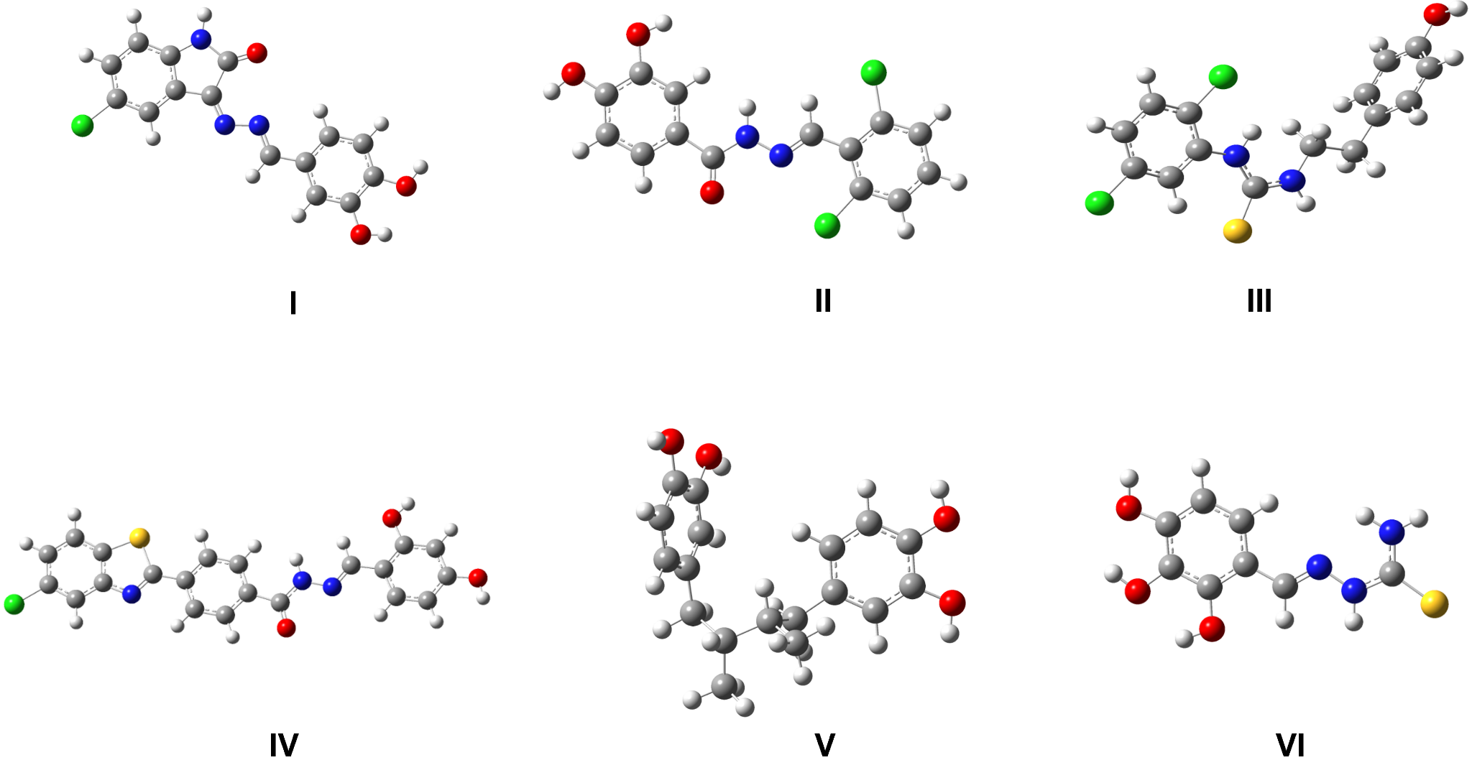
Figure S1: Optimized geometric structures of Compounds I-VI.

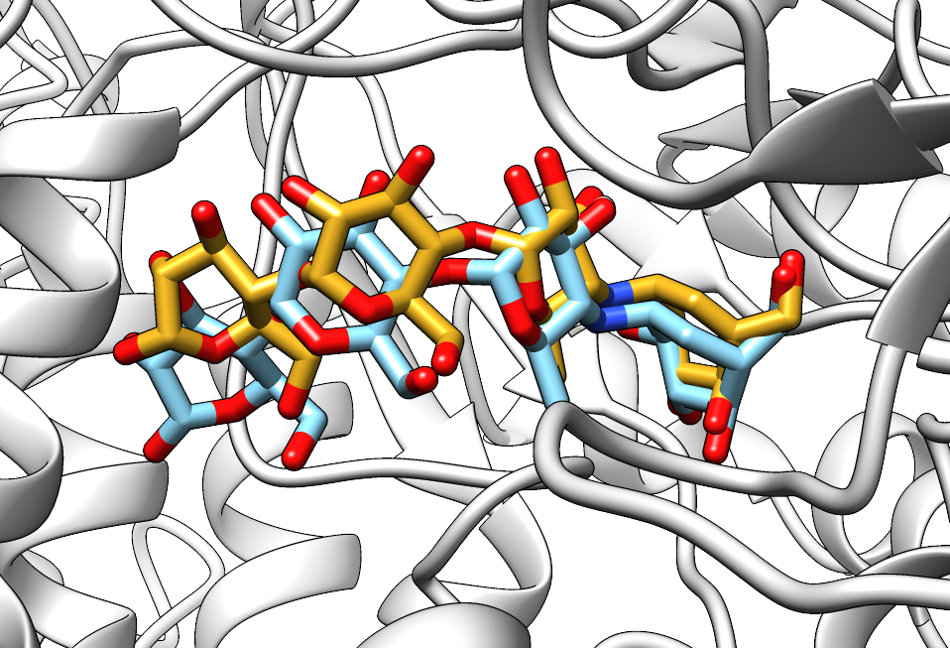
Figure S2: The superimposition of the structural coordinates from protein data bank data with the corresponding PDB ID of 3AIC (goldenrod sticks) and the docked pose (cyan) generated via docking, aimed at the benchmarking of the docking protocol. The redocking revealed the RMSD value of 0.72 Å.

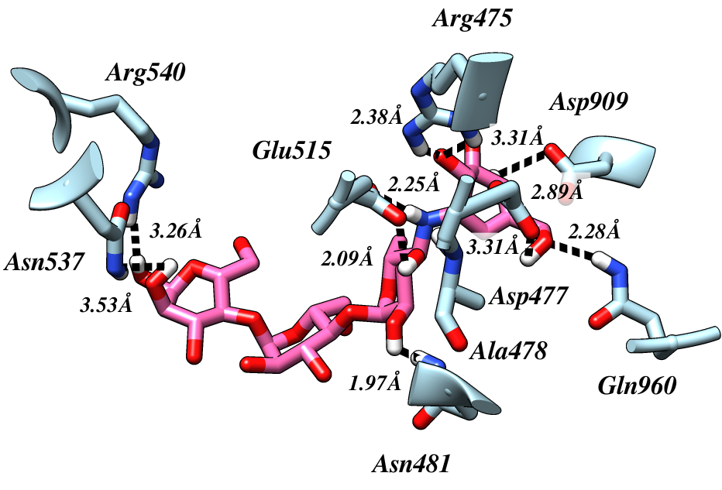
Figure S3: Mapping the 3D interaction landscape of Acarbose within the protein's binding site.

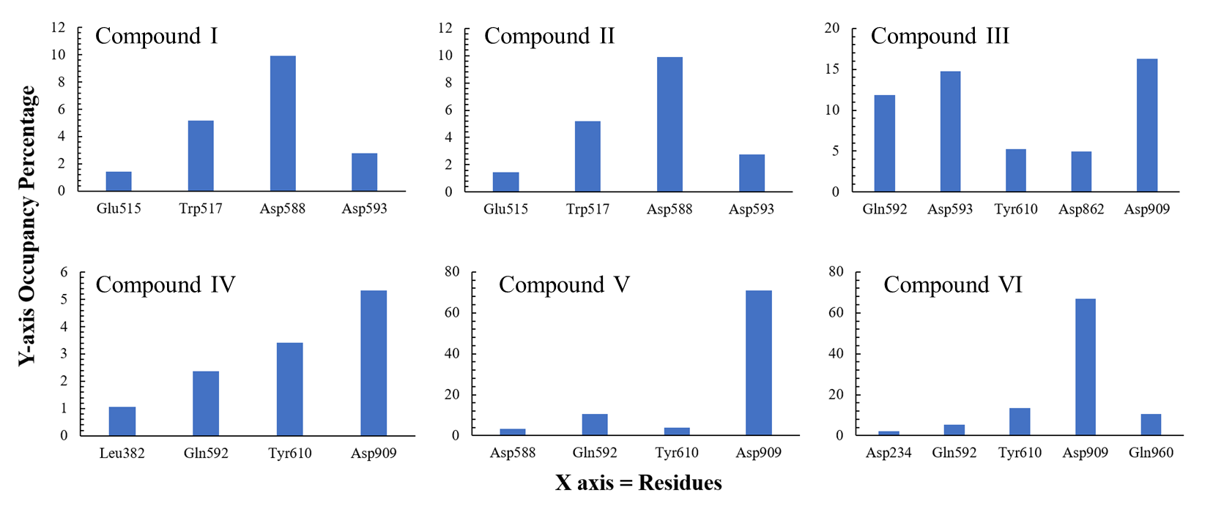
Figure S4: An overview of the electrostatic contacts i.e., hydrogen bonds observed during the simulation period for the tested compounds and the binding pocket residues.

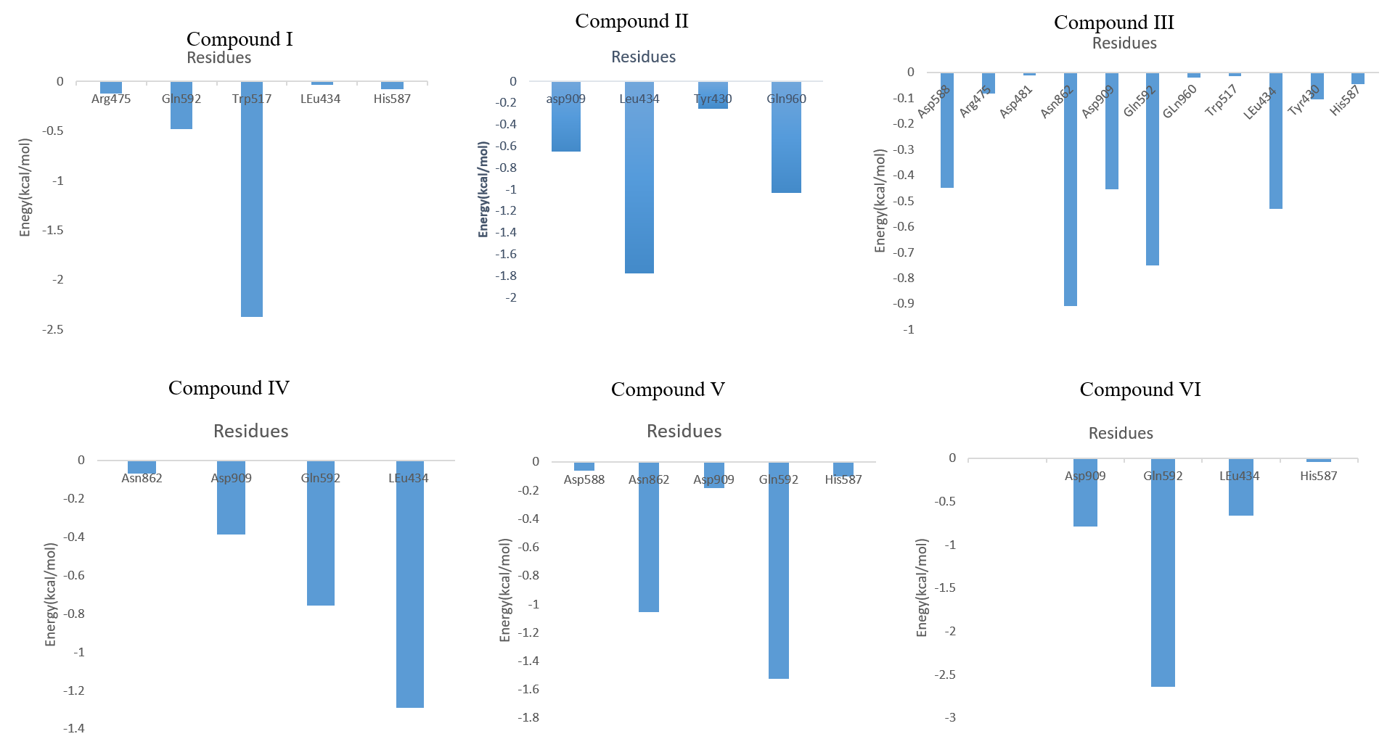

Figure S5: Per residue energy decomposition for the selected protein ligand complexes.

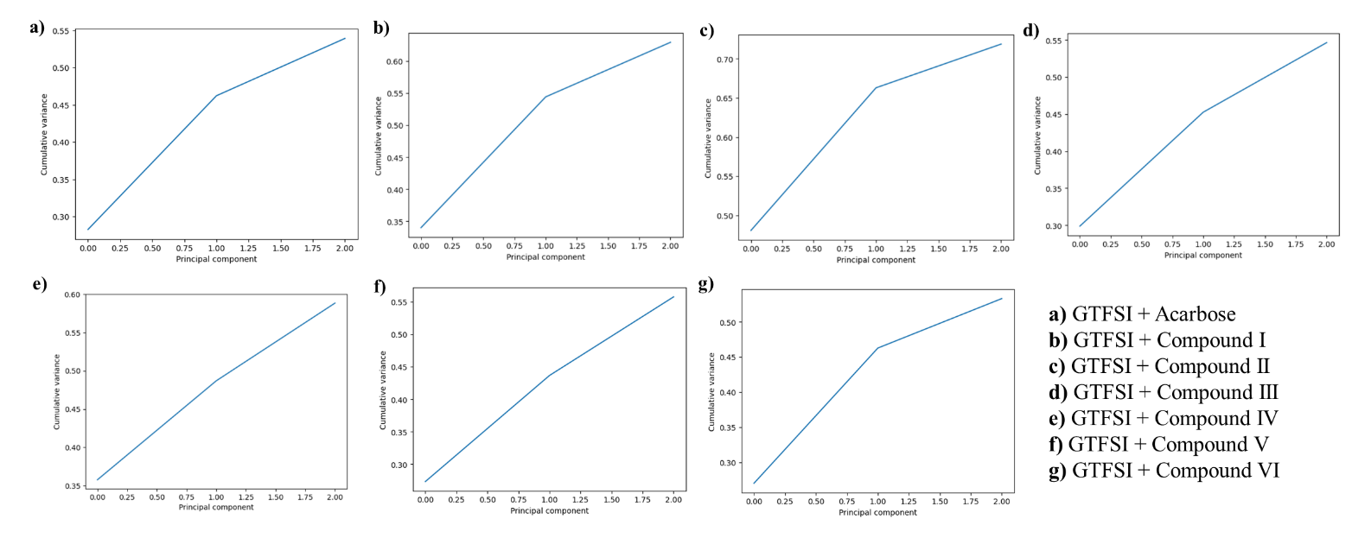Figure S6: Cumulative variance plot observed for GTFSI bound to a) Acarbose, b) Compound I, c) Compound II, d) Compound III, e) Compound IV, f) Compound V, and g) Compound VI.

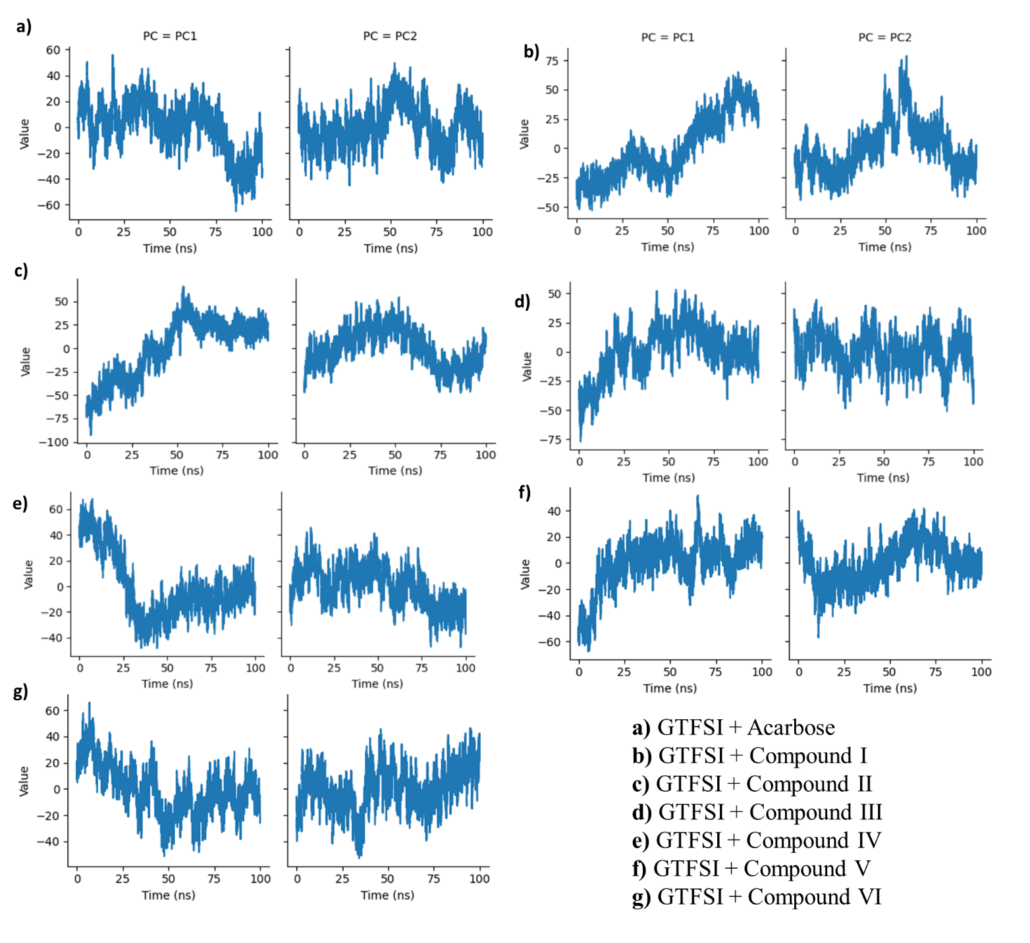
Figure S7: Time-dependent principal components of GTFSI bound to a) Acarbose, b) Compound I, c) Compound II, d) Compound III, e) Compound IV, f) Compound V, and g) Compound VI.

