Supplementary Information
Single-Element Ultrasound System for High-Resolution Jugular Venous Pulse Contour Detection

Navya Rose George^{1*}, P. M. Nabeel^{1,2}, Kiran V. Raj^{1,2}, Rahul Manoj¹, Mohanasankar Sivapraksam^{1,2}, and Jayaraj Joseph¹

- Distribution of JVP diameter (Dmax, Dmin) ranges in the male and female study population measured using the proposed single-element ultrasound system
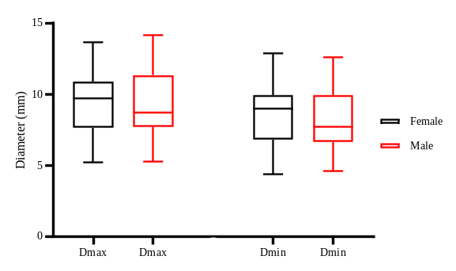
Fig.1. Distribution of JVP Diameter ranges in study population- Male vs Female

- Comparison of JVP Contour Features- Amplitude and Timing of Occurrence variation in the study population (N= 65)
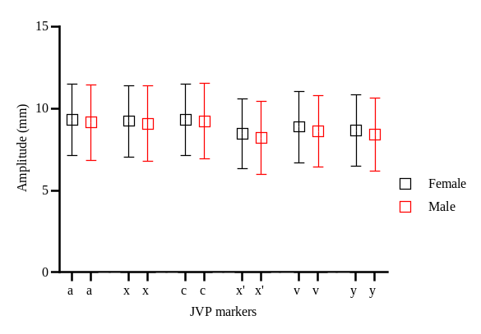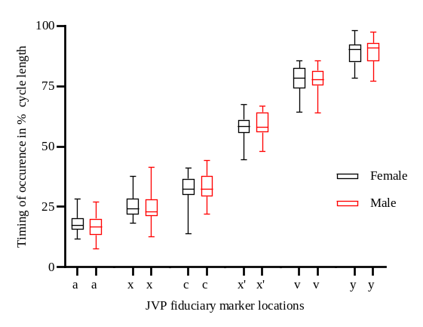
Fig.2. (a) Mean deviation plot representing the JVP contour feature amplitude variation in the cohort (b) Box-plot comparison of the timing of occurrence as a percentage of cardiac cycle length in male and female groups
- Comparison of Hit rate -A-mode vs B-mode in identifying the JVP contour markers on the entire study population (N= 65)
Hit rate is the ratio of the number of cycles in which the contour features were correctly identified by the algorithm to the total number of acquired cycles
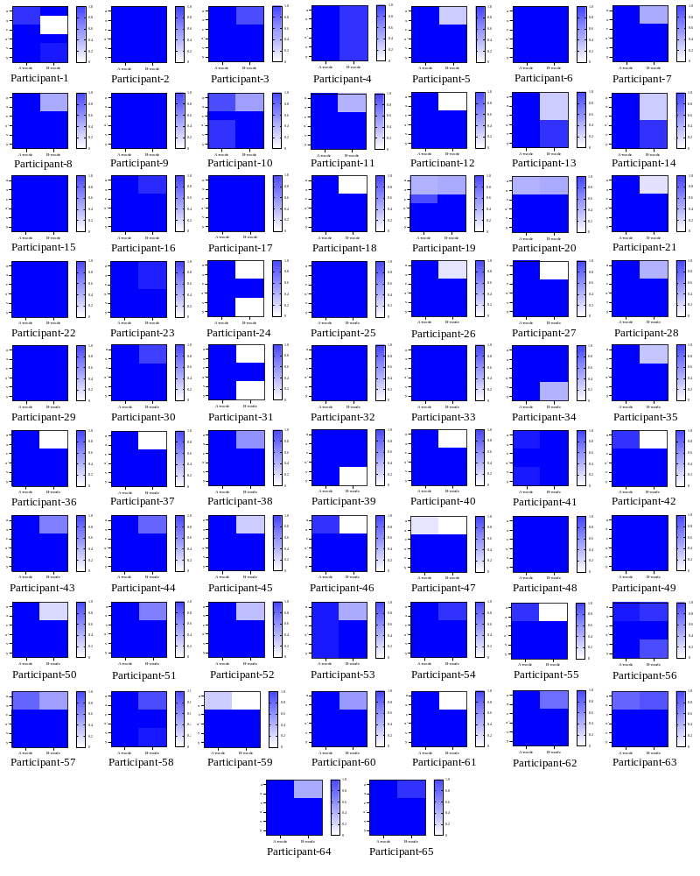
Fig. 3 Hit rate matrix of the study population (N= 65)
- Consistency in JV Diameter measurements measured using proposed vs. reference imaging system in short-axis and longitudinal axis
(a) (b) (c)
Fig. 4 (a) Location of the JV identified using transverse scan (below) and location labeled on the neck (above); (b) JV longitudinal section (below) location labelled (above); and (c) proposed ultrasound probe positioned on the intersection of longitudinal and transverse labels (above) Frame from JV vessel indicating proximal and distal wall echoes (below)
To mitigate any inconsistency in JVP measurements, the jugular vein (JV) location was meticulously identified and marked using a standardized labeling protocol with a skin marker. Initially, the ultrasound imaging system was utilized to locate the JV along the transverse axis of the neck. The imaging probe was aligned perpendicularly to the vein's orientation, and the location was labeled based on real-time visualization of the JV cross-section. Subsequently, the probe was rotated and aligned along the longitudinal axis to trace the vein’s length, marking its path on the skin surface. The intersection of the transverse and longitudinal labels was used as the reference point for placing the single-element ultrasound probe. This protocol ensured that the probe was consistently aligned with the JV's anatomical location during measurements, minimizing positional variability.
We conducted a cross-sectional study in a cohort of 20 participants, where we compared the jugular venous diameter measured by the proposed system against the JV diameter measured along both the longitudinal and transverse axes of the imaging scans. The measurements were performed by a skilled operator, and the results indicated no significant difference between the diameter measurements from the longitudinal and transverse axes. Fig. 5 represents the Bland Altman comparison of the diameter values measured in short-axis and longitudinal axis orientations. The comparison of diameter measurements between the proposed system and B-mode imaging in the short-axis orientation revealed that the D_{max} showed a mean bias of -0.12 mm with a standard deviation of 0.73 mm, while the D_{min} exhibited a mean bias of -0.05 mm and a standard deviation of 0.66 mm. These results indicate minimal bias and variability, suggesting a strong agreement with the diameter measurements evaluated using the reference system in the short-axis plane. In contrast, the comparison between the A-mode system and B-mode imaging in the longitudinal orientation revealed a mean bias of -0.04 mm with a standard deviation of 0.39 mm for D_{max}, while the D_{min} demonstrated a mean bias of -0.12mm and a standard deviation of 0.62 mm. The results from this analysis demonstrated no significant bias between the measurements, supporting the reliability of the JV diameter measurements.
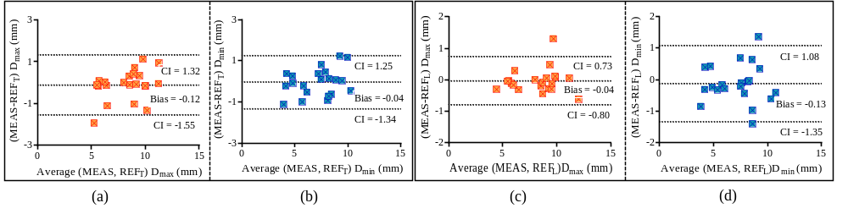 Fig. 5. BA plot comparison of the measured D_{max} and D_{min} (a) and (b) versus the reference short-axis-based diameter measurements; (c) and (d) versus the reference longitudinal axis-based diameter measurement vs reference short axis D_{max}

