Sl no. | Isolate  code | Form | G. R | Ci.T | C.T | O. T | M.R. T | H. L | C | De | Dl | F | G | I | Ml | Me | Sl | Se | T | X
1 | AST1 | Rod | – | +++ | ++ | – | – | – | + | + | + | + | ++ | + | + | + | ++ | + | + | ++
2 | AST3 | Rod | + | – | + | – | – | – | + | + | + | ++ | + | + | + | + | + | + | + | +
3 | AST4 | Rod | – | ++ | + | – | – | – | ++ | ++ | + | + | + | + | + | + | ++ | + | ++ | +
4 | KH 2 | Rod | – | + | + | + | – | – | + | ++ | – | ++ | + | + | + | + | + | + | ++ | –
5 | SG 1 | Rod | + | – | – | – | – | – | + | ++ | + | + | + | ++ | ++ | ++ | + | + | + | +
6 | SG 2 | Rod | – | – | – | – | – | – | ++ | + | – | + | + | + | + | + | ++ | ++ | + | –
7 | YG 1 | Rod | – | – | + | + | – | – | + | + | + | ++ | + | – | + | + | + | + | + | –
8 | YG 2 | Rod | + | ++ | + | + | – | – | + | + | + | + | ++ | – | + | + | + | + | + | –
Supplementary Table 1. Morphological and biochemical characterization of isolates. The symbols ‘±’ represent weakly positive; ‘±±’ represent moderately positive; ‘±±±’represent strongly positive; and ‘–’ represent negative. G.R, gram reaction; Ci.T, citrate test; C.T, catalase test; O.T, oxidase test; M.R.T, methyl red test; H.L, hydrolysis of lipids; C, cellobiose; De, dextrose; Du, dulcitol; F, fructose; G, glucose; I, inositol; Ml, mannitol; Me, mannose; Sl, sorbitol; Se, sucrose; T, trehalose; X, xylitol.

Sl no. | Isolate  code | Form | G. R | Ci.T | C.T | O. T | M.R. T | H. L | C | De | Dl | F | G | I | Ml | Me | Sl | Se | T | X
1 | AST2 | Rod | – | ++ | ++ | – | – | – | – | + | + | + | + | + | + | + | + | + | + | +
2 | AST5 | Rod | + | – | + | – | – | – | + | + | + | – | + | + | ++ | + | + | + | + | +
3 | AST6 | Rod | + |  | + | – | – | – | + | + | + | + | + | + | + | + | + | + | + | +
4 | AST7 | Rod | – | + | + | + | – | – | + | ++ | – | ++ | + | + | + | + | + | + | + | –
5 | AST8 | Rod | – | – | – | – | – | – | + | + | + | + | + | – | – | ++ | + | + | + | +
6 | AST9 | Rod | + | + | – | – | – | – | + | + | – | + | + | + | + | + | + | ++ | + | –
7 | AST10 | Rod | – | – | + | + | – | – | + | + | + | – | + | – | + | + | + | + | + | –
8 | AST11 | Rod | + | ++ | + | + | – | – | + | + | + | + | ++ | – | + | + | + | + | + | –
9 | AST12 | Rod | – | – | + | – | – | – | + | + | + | + | + | + | + | + | + | + | + | +
10 | AST13 | Rod | + | + | + | – | – | – | + | + | + | + | + | + | + | + | + | + | + | –
11 | AST14 | Rod | + | + | + | – | – | – | + | + | + | + | + | + | + | + | + | + | + | –
12 | AST15 | Rod | + | + | + | – | – | – | + | + | + | + | + | + | ++ | + | + | + | + | –
13 | AST16 | Rod | + | – | – | – | – | – | + | + | + | + | + | + | + | + | + | + | + | –
14 | BE1 | Oval | + | – | – | – | – | – | + | + | + | + | + | + | + | + | + | + | + | –
15 | BE2 | Oval | – | – | – | – | – | – | + | + | + | + | + | + | + | + | + | + | + | –
16 | CH1 | Rod | – | + | + | + | – | – | + | + | + | + | + | + | + | + | + | + | + | –
17 | CH2 | Rod | – | + | + | + | – | – | + | + | + | + | + | + | + | + | + | + | + | –
18 | CH3 | Rod | – | + | + | + | – | – | + | + | + | + | + | + | + | + | + | + | + | –
19 | CH4 | Rod | – | + | + | + | – | – | + | + | + | + | + | + | + | + | + | + | + | –
20 | CH5 | Rod | + | + | + | + | – | – | + | + | + | + | + | + | + | + | + | + | + | –
21 | CH6 | Rod | + | + | + | + | – | – | + | + | + | + | + | + | + | + | + | + | + | –
22 | CH7 | Rod | + | + | + | + | – | – | + | + | + | + | + | + | + | + | + | + | + | –
23 | CH8 | Rod | + | + | + | + | – | – | + | + | + | + | + | + | + | + | + | + | + | –
24 | GZ1 | Oval | – | + | + | + | – | – | + | + | + | + | + | + | + | + | + | + | + | –
25 | GZ2 | Rod | – | – | – | – | – | – | + | + | + | + | + | + | + | + | + | + | + | –
26 | GZ3 | Rod | – | – | – | – | – | – | + | + | + | + | + | + | + | + | + | + | + | –
27 | GZ4 | Rod | – | – | – | – | – | – | + | + | + | + | + | + | + | + | + | + | + | –
28 | GZ5 | Rod | – | – | – | – | – | – | + | + | + | + | + | + | + | + | + | ++ | + | –
29 | GZ6 | Rod | + | – | – | – | – | – | + | + | + | + | + | + | + | + | + | + | + | –
30 | GZ7 | Rod | + | – | – | – | – | – | + | + | + | + | + | + | + | + | + | + | + | –
31 | GZ8 | Rod | + | – | – | – | – | – | + | + | + | + | ++ | + | + | + | + | + | + | –
32 | GZ9 | Rod | + | – | – | – | – | – | + | + | + | + | + | + | + | + | + | + | + | –
33 | GZ10 | Oval | + | – | – | – | – | – | + | + | + | + | + | + | + | + | + | + | + | –
34 | GZ11 | Rod | + | + | + | + | – | – | + | + | + | + | + | + | + | + | + | + | + | –
35 | GZ12 | Rod | + | + | + | + | – | – | + | + | + | + | + | + | + | + | + | + | + | –
36 | GZ13 | Rod | + | + | + | + | – | – | + | ++ | + | + | + | + | + | + | + | + | + | –
37 | GZ14 | Rod | + | + | + | + | – | – | + | + | ++ | + | + | + | + | + | + | + | + | –
38 | KL2 | Oval | – | + | + | + | – | – | + | + | + | + | + | + | + | + | + | + | + | –
39 | KL3 | Oval | – | + | + | + | – | – | + | + | + | + | + | + | + | + | + | + | + | –
41 | KH3 | Rod | – | – | – | – | – | – | + | + | + | + | + | + | + | + | + | + | + | –
42 | KH4 | Rod | – | – | – | – | – | – | + | + | + | + | + | + | + | + | + | + | + | –
43 | KH5 | Rod | – | – | – | – | – | – | + | + | + | + | + | + | + | + | + | + | + | –
44 | KH6 | Rod | – | – | – | – | – | – | + | + | ++ | + | + | + | + | + | + | + | + | –
45 | KH7 | Rod | – | – | – | + | – | – | + | + | + | + | + | + | + | + | + | + | + | +
46 | KH8 | Rod | – | – | – | + | – | – | + | + | + | + | + | + | + | + | + | + | + | +
47 | RT1 | Rod | – | + | – | + | – | – | + | + | + | + | + | + | + | + | + | + | + | +
48 | RT2 | Rod | + | + | – | + | – | – | + | + | + | + | + | + | + | + | + | + | + | –
49 | RT3 | Rod | + | + | – | + | – | – | + | + | + | + | + | + | + | + | + | + | + | –
50 | RT4 | Rod | – | + | – | + | – | – | + | + | ++ | + | + | + | + | + | + | + | + | –
51 | RT5 | Rod | + | + | – | + | – | – | + | + | + | + | + | + | + | + | + | + | + | –
52 | US1 | Rod | + | – | – | + | – | – | + | + | + | + | + | + | + | + | + | + | + | –
53 | US2 | Rod | + | – | + | + | – | – | + | + | + | + | + | + | + | + | + | + | + | –
54 | US3 | Rod | + | – | + | – | – | – | + | + | + | + | + | + | + | + | + | + | + | –
55 | US4 | Oval | + | – | – | – | – | – | + | + | + | + | + | + | + | + | + | + | + | –
56 | US5 | Oval | + | – | – | – | – | – | ++ | + | + | + | + | + | + | + | + | + | + | –
57 | US6 | Oval | + | – | – | – | – | – | + | + | + | + | + | + | + | + | + | + | + | –
58 | US7 | Oval | + | – | – | + | – | – | + | + | + | + | + | + | + | + | + | + | + | –
59 | YG3 | Rod | + | – | – | + | – | – | + | + | + | + | + | + | + | + | + | + | ++ | –
60 | YG4 | Rod | + | – | + | + | – | – | + | + | + | + | + | + | + | + | + | + | + | –
61 | YG5 | Rod | + | + | + | + | – | – | + | + | + | + | + | + | + | + | + | + | + | –
62 | YG6 | Rod | + | + | + | + | – | – | + | + | + | + | + | + | + | + | + | + | + | –
Supplementary Table 2. Morphological and biochemical characterization of isolates. The symbols ‘±’ represent weakly positive; ‘±±’ represent moderately positive; ‘±±±’represent strongly positive; and ‘–’ represent negative. G.R, gram reaction; Ci.T, citrate test; C.T, catalase test; O.T, oxidase test; M.R.T, methyl red test; H.L, hydrolysis of lipids; C, cellobiose; De, dextrose; Du, dulcitol; F, fructose; G, glucose; I, inositol; Ml, mannitol; Me, mannose; Sl, sorbitol; Se, sucrose; T, trehalose; X, xylitol.

Sl no. | Isolate  code | IAA | Ammonia | Protease activity | Nitrogen  fixing | PSI  (cm) | ZSI  (cm) | Siderophore
1 | AST2 | + | + | + | + | 0.5±0.01 | 1.3±0.12 | –
2 | AST5 | + | + | + | + | 1.1±0.06 | 2.1±0.34 | –
3 | AST6 | – | + | – | + | 0.9±0.02 | 1.2±0.01 | –
4 | AST7 | – | – | – | – | 0.6±0.19 | 1±0.01 | –
5 | AST8 | – | – | – | – | 0.4±0.03 | 0.9±0.02 | –
6 | AST9 | – | – | – | – | 1.2±0.15 | 0.3±0.01 | –
7 | AST10 | – | – | – | – | 1.4±0.09 | 1.4±0.03 | –
8 | AST11 | – | – | – | – | 1.6±0.17 | 2.2±0.17 | –
9 | AST12 | – | – | – | – | 0.5±0.07 | 2.5±0.18 | –
10 | AST13 | – | – | – | – | 0.4±0.03 | 1.4±0.08 | –
11 | AST14 | – | – | – | – | 1.2±0.06 | 1.5±0.75 | –
12 | AST15 | – | – | – | – | 1.8±0.07 | 1.2±0.09 | –
13 | AST16 | – | – | – | – | 1.1±0.01 | 1.5±0.04 | –
14 | BE1 | ++ | + | – | – | 0.5±0.05 | 2.5±0.2 | –
15 | BE2 | + | + | – | – | 1.3±0.03 | 1.9±0.3 | –
16 | CH1 | – | – | – | – | 1.6±0.5 | 1.3±0.09 | –
17 | CH2 | – | – | – | – | 0.9±0.7 | 1.8±0.04 | –
18 | CH3 | – | – | – | – | 0.7±0.01 | 2.3±0.08 | –
19 | CH4 | – | + | – | + | 0.8±0.23 | 2.1±0.04 | –
20 | CH5 | – | + | – | + | 0.7±0.4 | 1.8±0.4 | –
21 | CH6 | + | + | – | + | 0.6±0.03 | 1.6±0.04 | –
22 | CH7 | – | – | + | – | 1.4±0.3 | 2.1±0.05 | –
23 | CH8 | – | – | – | – | 1.6±0.32 | 2.3±0.06 | –
24 | GZ1 | – | – | – | – | 1.7±0.9 | 2.4±0.5 | –
25 | GZ2 | – | – | – | – | 1.9±0.43 | 1.5±0.6 | –
26 | GZ3 | – | – | – | – | 1.3±0.56 | 2.1±0.8 | –
27 | GZ4 | – | – | – | – | 1.1±0.16 | 0.9±0.04 | –
28 | GZ5 | – | – | – | – | 0.5±0.75 | 1.4±0.2 | –
29 | GZ6 | – | – | – | – | 0.7±0.67 | 0.8±0.01 | –
30 | GZ7 | ++ | – | – | – | 1.2±0.43 | 1.4±0.1 | –
31 | GZ8 | + | – | – | – | 0.9±0.07 | 2.4±0.15 | –
32 | GZ9 | + | – | – | – | 1.2±0.08 | 1.5±0.13 | –
33 | GZ10 | – | + | – | – | 1.4±0.06 | 0.5±0.04 | –
34 | GZ11 | – | – | – | – | 0.5±0.45 | 0.6±0.02 | –
35 | GZ12 | – | – | – | – | 0.7±0.33 | 0.7±0.06 | –
36 | GZ13 | – | – | – | – | 0.9±0.14 | 1.5±0.01 | –
37 | GZ14 | – | – | – | – | 0.4±0.55 | 2.4±0.13 | –
38 | KL2 | – | – | – | – | 1.6±0.34 | 2.5±0.12 | –
39 | KL3 | – | – | – | – | 1.4±0.65 | 1.3±0.4 | –
40 | KL4 | – | – | – | – | 1.6±0.55 | 0.7±0.09 | –
41 | KH3 | – | + | – | + | 1.2±0.1 | 0.9±0.03 | +
42 | KH4 | – | + | – | + | 0.9±0.44 | 0.8±0.02 | +
43 | KH5 | – | + | – | + | 0.5±0.32 | 1.2±0.1 | +
44 | KH6 | – | – | – | – | 0.7±0.4 | 1.3±0.2 | +
45 | KH7 | – | – | – | – | 2.1±0.15 | 1.6±0.15 | –
46 | KH8 | – | – | – | – | 1.3±0.09 | 1.8±0.14 | –
47 | RT1 | – | + | – | + | 1.7±0.5 | 1.5±0.23 | –
48 | RT2 | – | + | – | + | 2.2±0.73 | 0.6±0.02 | –
49 | RT3 | – | + | – | + | 0.9±0.07 | 0.9±0.05 | –
50 | RT4 | – | + | – | + | 1.2±0.06 | 0.4±0.02 | –
51 | RT5 | – | – | – | – | 1.1±0.1 | 2.3±0.66 | –
52 | US1 | – | – | – | – | 1.4±0.01 | 1.8±0.45 | –
53 | US2 | – | – | – | – | 1.5±0.3 | 2.5±0.23 | –
54 | US3 | – | – | + | – | 1.8±0.6 | 1.9±0.33 | –
55 | US4 | ++ | – | + | – | 0.8±0.05 | 0.8±0.02 | –
56 | US5 | – | – | + | – | 0.4±0.06 | 0.5±0.01 | –
57 | US6 | – | – | – | – | 0.3±0.01 | 0.9±0.03 | –
58 | US7 | – | – | – | – | 0.5±0.04 | 2.3±0.4 | –
59 | YG3 | – | + | – | + | 2.1±0.3 | 1.5±0.1 | +
60 | YG4 | – | ++ | – | + | 1.4±0.02 | 1.4±0.02 | +
61 | YG5 | + | + | – | + | 1.8±0.6 | 1.2±0.3 | +
62 | YG6 | + | – | – | – | 1.2±0.06 | 1.1±0.01 | +
Supplementary Table 3. Qualitative assessment of plant growth promoting traits for bacterial isolates. Data are shown as the mean and standard deviation of triplicates. The symbols represent the intensity of the observed traits: ‘+’ indicate weakly positive; ‘++’ indicate moderately positive; ‘+++’ indicate highly positive; and ‘-’ indicate negative.

Sl no. | Isolate  code | IAA (µg.mL^{–1}) | PS (µg.mL^{–1}) | Ammonia (mM) | GA₃ (µg.mL^{–1})
1 | AST2 | 28.67±0.1 | 51.52±0.3 | 48.4±0.1 | 7.3±0.2
2 | AST5 | 18.16±0.2 | 110.64±0.1 | 32.8±0.3 | 8.02±0.06
3 | AST6 | 32.12±0.03 | 74.75±0.2 | 26.5±0.04 | 9.2±0.02
4 | AST7 | 15.8±0.4 | 80.05±0.01 | 33.09±0.01 | 11.09±0.13
5 | AST8 | 11.32±0.2 | 59.76±0.03 | 28.06±0.21 | 15.2±0.16
6 | AST9 | 12.5±0.1 | 84.17±0.4 | 42.07±0.19 | 13.6±0.03
7 | AST10 | 14.04±0.3 | 50.64±0.04 | 55.23±0.34 | 5.2±0.04
8 | AST11 | 18.54±0.4 | 83.29±0.15 | 60.1±0.45 | 4.23±0.09
9 | AST12 | 33.12±0.05 | 53.33±0.09 | 44.32±0.2 | 9.5±0.41
10 | AST13 | 25.09±0.4 | 62.11±0.01 | 43.87±0.5 | 3.23±0.18
11 | AST14 | 19.01±0.03 | 94.76±0.02 | 53.4±0.09 | 5.21±0.14
12 | AST15 | 13.8±0.4 | 72.11±0.06 | 45.5±0.05 | 4.8±0.18
13 | AST16 | 31.6±0.16 | 89.17±0.16 | 35.5±0.09 | 3.32±0.17
14 | BE1 | 10.76±0.13 | 93.58±0.14 | 32.9±0.01 | 5.45±0.01
15 | BE2 | 14.9±0.05 | 74.76±0.04 | 23.5±0.1 | 6.08±0.23
16 | CH1 | 17.9±0.4 | 80.94±0.02 | 21.7±0.1 | 3.55±0.54
17 | CH2 | 23.8±0.12 | 59.19±0.01 | 18.5±0.1 | 6.12±0.09
18 | CH3 | 12.56±0.1 | 95.94±0.01 | 34.2±0.01 | 7.45±0.34
19 | CH4 | 13.6±0.11 | 101.43±0.04 | 46.2±0.01 | 8.45±0.12
20 | CH5 | 14.07±0.04 | 65.95±0.03 | 55.43±0.01 | 9.44±0.13
21 | CH6 | 19.43±0.02 | 80.35±0.05 | 52.8±0.01 | 10.4±0.37
22 | CH7 | 13.02±0.1 | 77.56±0.12 | 46.34±0.02 | 11.24±0.01
23 | CH8 | 16.09±0.04 | 87.56±0.13 | 45.9±0.05 | 10.5±0.32
24 | GZ1 | 13.77±0.03 | 83.17±0.17 | 37.3±0.01 | 9.4±0.02
25 | GZ2 | 15.03±0.01 | 75.94±0.6 | 32.8±0.02 | 8.45±0.38
26 | GZ3 | 38.49±0.01 | 89.06±0.04 | 33.2±0.01 | 6.09±0.08
27 | GZ4 | 34.67±0.04 | 98.75±0.02 | 45.9±0.05 | 5.34±0.03
28 | GZ5 | 15.29±0.02 | 103.43±0.7 | 43.1±0.04 | 7.45±0.04
29 | GZ6 | 11.4±0.03 | 99.07±0.1 | 58.2±0.05 | 6.80±0.01
30 | GZ7 | 10.87±0.12 | 110.45±0.71 | 55.2±0.01 | 15.4±0.04
31 | GZ8 | 13.65±0.01 | 68.98±0.16 | 47.6±0.06 | 4.3±0.05
32 | GZ9 | 18.43±0.19 | 75.04±0.5 | 33.9±0.02 | 6.45±0.04
33 | GZ10 | 44.56±0.4 | 81.77±0.04 | 45.1±0.23 | 13.2±0.01
34 | GZ11 | 12.29±0.16 | 63.23±0.01 | 34.8±0.04 | 11.09±0.1
35 | GZ12 | 18.49±0.13 | 107.6±0.04 | 36.2±0.01 | 12.4±0.02
36 | GZ13 | 16.52±0.01 | 98.43±0.02 | 38.7±0.36 | 13.67±0.3
37 | GZ14 | 14.17±0.01 | 87.66±0.01 | 45.2±0.34 | 12.76±0.23
38 | KL2 | 34.17±0.1 | 101.44±0.3 | 56.4±0.16 | 14.34±0.02
39 | KL3 | 50.29±0.02 | 100.7±0.04 | 39.01±0.12 | 16.4±0.04
40 | KL4 | 18.58±0.1 | 86.55±0.12 | 48.3±0.08 | 15.8±0.03
41 | KH3 | 10.35±0.03 | 82.43±0.18 | 36.6±0.09 | 14.6±0.01
42 | KH4 | 18.06±0.02 | 78.90±0.5 | 27.4±0.3 | 6.34±0.03
43 | KH5 | 10.55±0.01 | 56.44±0.2 | 38.5±0.1 | 9.34±0.14
44 | KH6 | 20.07±0.13 | 67.42±0.1 | 43.1±0.1 | 8.04±0.01
45 | KH7 | 24.8±0.3 | 98.76±0.4 | 45.8±0.32 | 7.89±0.01
46 | KH8 | 20.04±0.18 | 99.04±0.03 | 39.5±0.09 | 6.34±0.02
47 | RT1 | 19.54±0.4 | 104.8±0.01 | 32.4±0.5 | 5.67±0.19
48 | RT2 | 17.96±0.3 | 95.44±0.04 | 23.9±0.13 | 4.35±0.03
49 | RT3 | 24.7±0.02 | 97.34±0.02 | 19.44±0.16 | 5.76±0.16
50 | RT4 | 23.9±0.2 | 87.64±0.01 | 20.4±0.4 | 3.66±0.05
51 | RT5 | 13.77±0.01 | 104.34±0.03 | 52.3±0.02 | 4.87±0.15
52 | US1 | 18.09±0.02 | 68.09±0.01 | 51.02±0.02 | 3.8±0.04
53 | US2 | 31.08±0.01 | 71.44±0.02 | 40.8±0.2 | 5.3±0.18
54 | US3 | 21.76±0.1 | 76.08±0.07 | 43.21±0.2 | 6.1±0.03
55 | US4 | 28.5±0.18 | 82.01±0.6 | 45.07±0.34 | 6.7±0.01
56 | US5 | 33.09±0.07 | 79.04±0.4 | 34.22±0.14 | 6.03±0.04
57 | US6 | 44.5±0.02 | 68.03±0.13 | 33.87±0.23 | 7.06±0.01
58 | US7 | 9.66±0.04 | 75.08±0.16 | 32.12±0.1 | 8.5±0.02
59 | YG3 | 21.07±0.12 | 101.87±0.5 | 46.32±0.01 | 9.4±0.06
60 | YG4 | 12.8±0.16 | 88.03±0.2 | 52.09±0.09 | 11.5±0.09
61 | YG5 | 16.9±0.01 | 98.06±0.02 | 36.2±0.41 | 15.2±0.12
62 | YG6 | 28.6±0.03 | 112.54±0.1 | 39.4±0.38 | 6.3±0.01
Supplementary Table 4. Quantitative estimation of plant growth promoting traits in bacterial isolates. Data are shown as the mean and standard deviation of triplicates.

Isolate code | Strain | In vitro activity | In vivo observation
AST1 | Klebsiella variicola | Highest IAA, ammonia, protease, nitrogen fixation, phosphate and zinc solubilization, siderophore and GA₃ production | Highest root length, fresh and dry root weight, fresh and dry leaf weight
AST3 | Bacillus cereus | Highest ammonia production; IAA, protease, nitrogen fixation, phosphate and zinc solubilization, siderophore and GA₃ production | In-vivo growth promotion of tomato seedlings
AST4 | Enterobacter sichuanensis | Highest phosphate and zinc solubilization; IAA, ammonia, protease, nitrogen fixation, siderophore and GA₃ production | In-vivo growth promotion of tomato seedlings
KH2 | Enterobacter mori | IAA, ammonia, protease, nitrogen fixation, phosphate and zinc solubilization, siderophore and GA₃ production | In-vivo growth promotion of tomato seedlings
SG1 | Bacillus cereus | IAA, ammonia, protease, nitrogen fixation, phosphate and zinc solubilization, siderophore and GA₃ production | Highest shoot length,
SG2 | Enterobacter sichuanensis | Highest siderophore and GA₃ production; IAA, ammonia, protease, nitrogen fixation, phosphate and zinc solubilization | Highest germination rates,
YG 1 | Enterobacter asburiae | IAA, ammonia, protease, nitrogen fixation, phosphate and zinc solubilization, siderophore and GA₃ production | Highest germination rates, number of leaves, fresh and dry shoot weight
YG 2 | Priestia aryabhattai | IAA, ammonia, protease, nitrogen fixation, phosphate solubilization, siderophore and GA₃ production | Highest germination rates
Supplementary Table 5. Characterization of Bacterial Strains Based on In Vitro and In Vivo Performance.

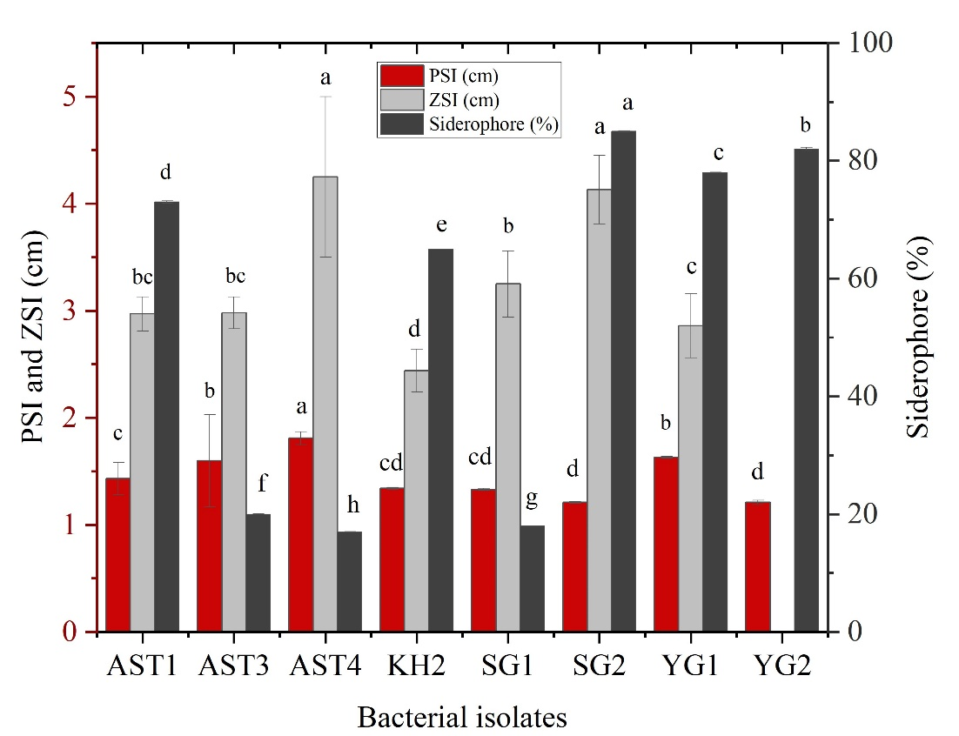

Supplementary Figure 1. Qualitative assessment of plant growth-promoting traits, including PSI (cm), ZSI (cm), and Siderophore (%) for bacterial isolates. Data are presented as the mean and standard deviation of triplicates. Letters a, b, c, indicate differences among treatments based on Duncan’s multiple range test (DMRT) at (p<0.05). PSI: phosphate solubilization index. ZSI: zinc solubilization index.

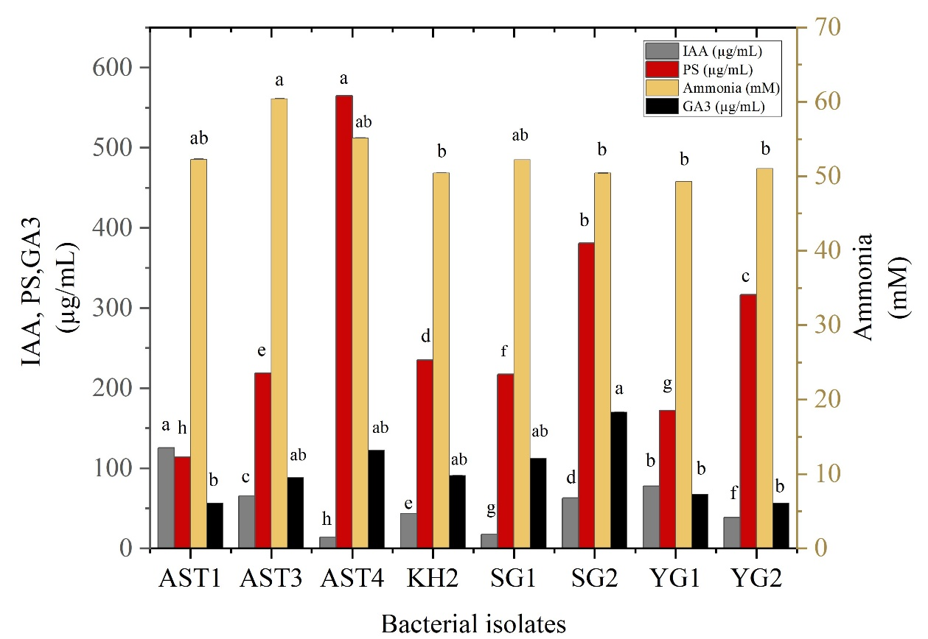

Supplementary Figure 2. Quantitative estimation of plant growth-promoting traits including production of IAA (µg.mL^{–1}), PS (µg.mL^{–1}), GA₃ (µg.mL^{–1}), and ammonia (mM) in bacterial isolates. Data are presented as the mean and standard deviation of triplicates. Letters a, b, c, indicate differences among treatments based on Duncan’s multiple range test (DMRT) at (p<0.05). IAA: Indole-3-acetic acid. PS: Phosphate solubilization.

