Opioid Quantification via Microsampling Techniques to Assess Opioid Use in Human Laboratory Studies
Ramisa Fariha¹, Emma Rothkopf¹, Carolina L. Haass-Koffler^{2,3,4,5}, Anubhav Tripathi¹*

1. Brown University Center for Biomedical Engineering, Brown University, Providence, RI, USA
2. Brown University Department of Psychiatry and Human Behavior, Alpert Medical School, 3. Center for Alcohol and Addiction Studies, 4. Department of Behavioral and Social Sciences, School of Public Health, 5. Carney Institute for Brain Science, Brown University, Providence, RI, USA;

Supplemental
Supplemental Figure 1. JANUS deck layout for calibrator and patient sample plating, together with extraction steps, and supernatant.
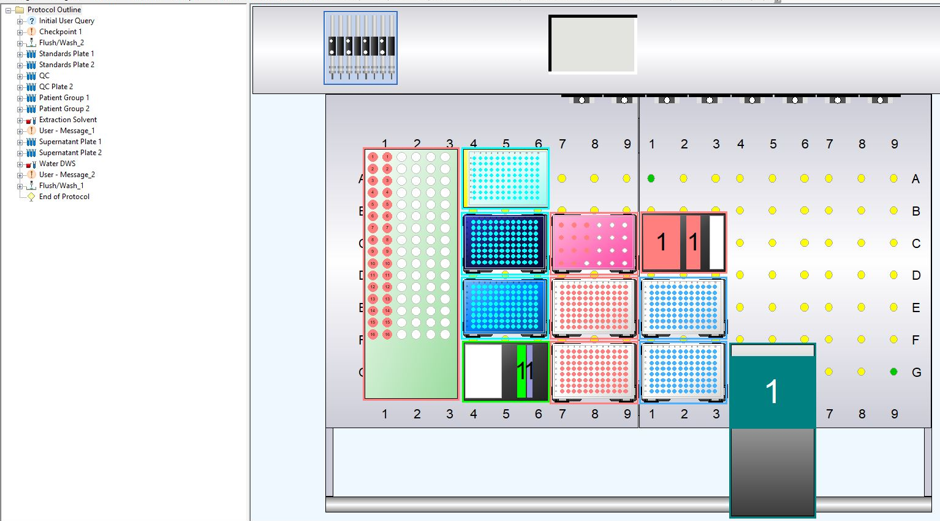

Supplemental Figure 2. Raw individual patient data for six opioids (MRMs), grouped by oxytocin treatment (-1= baseline, 0= placebo, 1= stimulation for both).

Supplemental Table 1. Direct method comparison highlighting major differences between the described assay against methods published in literature [23-27].
 | Fariha et al. 2024 | Liao et al., 2022 | Swortwood et al., 2016 | Mathias et al., 2014 | Kim et al. 2011 | Kacinko, 2008
Number of Analytes | 6 opioids | 24 opioids | 1 opioid (buprenorphine and 6 of its metabolites) | 3 opioids and their metabolites (total 20) | 12 drugs | 1 opioid (buprenorphine and 3 of its metabolites)
Matrix | Serum | Urine | Plasma and breastmilk | Urine | Plasma | Urine
Number of Steps for Sample Preparation | 5 | 5 | 15 | 3 | 4 | 10
Sample volume required | 20 µL | Not specified | 100 µL | 100 µL | 20 µL | 200 µL
Sample Preparation Method | Protein Precipitation and Dilution | Dilute-and-Shoot | Protein Precipitation and Solid Phase Extraction (SPE) | Dilute-and-Shoot | Protein Precipitation and Dilution | Solid Phase Extraction (SPE)
Sample Preparation:  Step 1 | Add 80 µL extraction solvent (acidified acetonitrile and methanol solution with 2.5 µg/L IS) | Urine samples centrifuged for 1 min at 17,000 rpm. | Add IS (50 µg/L) | Urine samples centrifuged for 1 min at 17,000 rpm. | Add IS and reserpine | Add IS
Sample Preparation:  Step 2 | Shake at 700 rpm at 45 °C for 5 minutes | 10 µL of supernatant was diluted with 90 µL water | Add 300 µL of ACN | Add IS (in 4 different combinations and volumes, concentration not specified) | Add 1000 µL acetonitrile | Acidification of mixture
Sample Preparation:  Step 3 | Centrifuge at 0 °C for 10 minutes | Add IS | Centrifuge at 8000 g at 4 °C for 10-minutes | Dilute and analyze | Mix (30 seconds) | Vortex
Sample Preparation:  Step 4 | Extract 50 µL supernatant, add 167 µL DWS (acidified water with 2.5 µg/L IS) | Foil heat seal | Supernatant transfer and acidification | N/A | Centrifuge (1400 g for 5 minutes) and analyze | SPE- Addition to cartridge
Sample Preparation:  Step 5 | Shake at 400 rpm at 25 °C for 30 seconds and analyze | Centrifuge and analyze | Vortex | N/A | N/A | SPE- Wash (1)
Sample Preparation:  Step 6 | N/A | N/A | SPE- Addition to cartridge | N/A | N/A | SPE- Wash (2)
Sample Preparation:  Step 7 | N/A | N/A | SPE- Wash (1) | N/A | N/A | SPE- Dry (1)
Sample Preparation:  Step 8 | N/A | N/A | SPE- Wash (2) | N/A | N/A | SPE- Wash (3)
Sample Preparation:  Step 9 | N/A | N/A | SPE- Dry (1) | N/A | N/A | Nitrogen drying of eluents
Sample Preparation:  Step 10 | N/A | N/A | SPE- Wash (3) | N/A | N/A | Reconstititue and analyze
Sample Preparation:  Step 11 | N/A | N/A | Nitrogen drying of eluents | N/A | N/A | N/A
Sample Preparation:  Step 12 | N/A | N/A | Reconstititue | N/A | N/A | N/A
Sample Preparation:  Step 13 | N/A | N/A | Vortex | N/A | N/A | N/A
Sample Preparation:  Step 14 | N/A | N/A | Centrifuge (1) | N/A | N/A | N/A
Sample Preparation:  Step 15 | N/A | N/A | Centrifuge (2) and analyze | N/A | N/A | N/A
Injection Volume | 10 µL | 10 µL | 50 µL | Not Specified | 1 µL | 15 µL
Instrumentation Type | LC-MS/MS | LC-MS/MS | LC-MS/MS | LC-MS/MS | LC-MS/MS | LC-MS/MS (ion-trap)
Run Time Per Sample | 3.5 minutes | 26 minutes | 8 min | 8 minutes | 6 minutes | 20 minutes
Concentration Range | 10-2000 ng/mL | 10-10,000 ng/mL | 2ng/mL to 100ng/mL | N/A | 100 ng/mL-10,000 ng/mL | 5−1,000 ng/mL

