Supplementary Material

Table S-1: Component characterization of oil samples.
Formation | Component | Mol % | Weight % | Mwt. (g/mol) | Density (kg/m3)
G-1 | Methane | 0.01 | 0 | 16 | 300
G-1 | Ethane | 0.04 | 0.01 | 32 | 377
G-1 | Propane | 0.21 | 0.04 | 44.1 | 508
G-1 | iso-Butane | 0.11 | 0.03 | 58.1 | 563
G-1 | n-Butane | 0.56 | 0.14 | 58.1 | 585
G-1 | iso-Pentane | 0.57 | 0.17 | 72.2 | 625
G-1 | n-Pentane | 1.01 | 0.31 | 72.2 | 631
G-1 | Hexanes | 3.22 | 1.16 | 86.18 | 665
G-1 | Heptanes | 5.57 | 2.26 | 96.91 | 708
G-1 | Octane | 8.65 | 4.05 | 111.65 | 723
G-1 | Nonanes | 7.99 | 4.28 | 127.9 | 732
G-1 | Decanes | 8.29 | 4.78 | 137.6 | 762
G-1 | Undacanes | 7.41 | 4.65 | 149.76 | 778
G-1 | C¹²⁺ | 56.36 | 78.14 | 330.95 | 915
K-1 | Methane | 0 | 0 | 16 | 300
K-1 | Ethane | 0 | 0 | 32 | 377
K-1 | Propane | 0.25 | 0.05 | 44.1 | 508
K-1 | iso-Butane | 1.02 | 0.26 | 58.1 | 563
K-1 | n-Butane | 1.02 | 0.26 | 58.1 | 585
K-1 | iso-Pentane | 1 | 0.32 | 72.2 | 625
K-1 | n-Pentane | 1.97 | 0.62 | 72.2 | 631
K-1 | Hexanes | 7.63 | 2.87 | 86.18 | 665
K-1 | Heptanes | 7.15 | 3.04 | 97.31 | 705
K-1 | Octane | 8.97 | 4.29 | 109.57 | 732
K-1 | Nonanes | 7.09 | 3.93 | 127.11 | 742
K-1 | Decanes | 6.35 | 3.81 | 137.46 | 760
K-1 | Undacanes | 5.07 | 3.29 | 148.69 | 787
K-1 | C¹²⁺ | 52.49 | 77.27 | 337.25 | 936
S-1 | Methane | 0 | 0 | 16 | 300
S-1 | Ethane | 0.05 | 0.01 | 32 | 377
S-1 | Propane | 0.7 | 0.12 | 44.1 | 508
S-1 | iso-Butane | 0.39 | 0.09 | 58.1 | 563
S-1 | n-Butane | 1.92 | 0.44 | 58.1 | 585
S-1 | iso-Pentane | 1.49 | 0.42 | 72.2 | 625
S-1 | n-Pentane | 2.4 | 0.68 | 72.2 | 631
S-1 | Hexanes | 5.63 | 1.9 | 86.18 | 665
S-1 | Heptanes | 3.66 | 1.36 | 94.67 | 720
S-1 | Octane | 6.07 | 2.64 | 110.97 | 725
S-1 | Nonanes | 5.75 | 2.86 | 127.06 | 743
S-1 | Decanes | 4.69 | 2.53 | 137.56 | 762
S-1 | Undacanes | 3.61 | 2.01 | 142.18 | 808
S-1 | C¹²⁺ | 63.63 | 84.94 | 340.67 | 973
F-1 | Methane | 0 | 0 | 16 | 300
F-1 | Ethane | 0.01 | 0 | 32 | 377
F-1 | Propane | 0.19 | 0.04 | 44.1 | 508
F-1 | iso-Butane | 0.13 | 0.04 | 58.1 | 563
F-1 | n-Butane | 0.69 | 0.2 | 58.1 | 585
F-1 | iso-Pentane | 0.75 | 0.27 | 72.2 | 625
F-1 | n-Pentane | 1.37 | 0.49 | 72.2 | 631
F-1 | Hexanes | 3.84 | 1.64 | 86.18 | 665
F-1 | Heptanes | 5.37 | 2.57 | 96.62 | 738
F-1 | Octane | 6.63 | 3.67 | 111.56 | 723
F-1 | Nonanes | 5.76 | 3.59 | 125.97 | 742
F-1 | Decanes | 5.05 | 3.45 | 137.58 | 760
F-1 | Undacanes | 4.26 | 3.11 | 146.9 | 785
F-1 | C¹²⁺ | 65.94 | 80.93 | 247.59 | 908
F-2 | Methane | 0 | 0 | 16 | 300
F-2 | Ethane | 0.05 | 0.01 | 32 | 377
F-2 | Propane | 0.29 | 0.06 | 44.1 | 508
F-2 | iso-Butane | 0.14 | 0.04 | 58.1 | 563
F-2 | n-Butane | 0.86 | 0.24 | 58.1 | 585
F-2 | iso-Pentane | 0.84 | 0.3 | 72.2 | 625
F-2 | n-Pentane | 1.58 | 0.55 | 72.2 | 631
F-2 | Hexanes | 4.78 | 1.99 | 86.18 | 665
F-2 | Heptanes | 5.91 | 2.78 | 97.05 | 706
F-2 | Octane | 7.09 | 3.83 | 111.58 | 723
F-2 | Nonanes | 6.15 | 3.78 | 126.96 | 744
F-2 | Decanes | 5.64 | 3.75 | 137.6 | 763
F-2 | Undacanes | 3.95 | 2.85 | 149.01 | 785
F-2 | C¹²⁺ | 62.71 | 79.83 | 263.15 | 930

Table S-2: Physical properties of crude oil samples.
Properties | Formation
Properties | G-1 | K-1 | S-1 | F-1 | F-2
Mean molecular weight (g/mol)  Density of oil (kg/m3)  Molecular weight C7+(g/mol)  Density of C7+ (kg/m3)  Molecular weight C10+ (g/mol)  Density of C10+ (kg/m3)  Molecular weight C12+(g/mol)  Density of C12+ (kg/m3)  Viscosity @ T=20 | 238.7  869.1  249  874  290  896  331  915  7.3 | 229.1  877.01  251  892  302  920  337  936  14 | 255.2  923.74  299  960  343  984  366  996  130.9 | 299  960  299  960  343  984  366  996  10 | 206.7  879.95  219  891  247  916  263  930  17.7

Table S-3: Utilized cores' properties.
Core Characteristic | Core 1 | Core 2
Core ID  Length (cm)  Diameter (cm)  Grain density (g/cc)  Area (cm²)  Bulk volume (cc)  Porosity (%)  Permeability (mD)  Pore volume (cc) | 8H  5.33  3.77  2.65  11.2  59.4  15.07  1.69  8.96 | 6V  6.11  3.76  2.65  11.1  67.8  19.75  1.93  10.22

Table S-4: Calculations of salt concentrations for different LSW/SmW.
Tests' Category | Brine | CaCl₂.2H₂O (g/l) | MgCl₂.6H₂O  (g/l) | NaHCO₃  (g/l) | Na₂SO₄  (g/l) | KCl  (g/l) | NaCl  (g/l)
LSW | SW  5DSW  20DSW  40DSW | 1.69  0.34  0.08  0.04 | 12.80  2.56  0.64  0.32 | 0.21  0.04  0.01  0.01 | 4.75  0.95  0.24  0.12 | 0.52  0.10  0.03  0.01 | 27.82  5.56  1.39  0.70
SmW | SW0Ca  SW0S  SW0Mg  SW2Ca  SW2S  SW2Mg  SW3Ca  SW3S  SW3Mg  SW4Ca  SW4S  SW4Mg  SW0Ca0Mg  SW0Ca0S  SW0Mg0S | 0.00  1.69  1.69  3.37  1.69  1.69  5.06  1.69  1.69  6.75  1.69  1.69  0.00  0.00  1.69 | 12.80  12.80  0.00  12.80  12.80  25.60  12.80  12.80  38.38  12.80  12.80  51.19  0.00  12.80  0.00 | 0.21  0.21  0.21  0.21  0.21  0.21  0.21  0.21  0.21  0.21  0.21  0.21  0.21  0.21  0.21 | 4.75  0.00  4.75  4.75  9.49  4.75  4.75  14.24  4.75  4.75  18.99  4.75  4.75  0.00  0.00 | 0.52  0.52  0.52  0.52  0.52  0.52  0.52  0.52  0.52  0.52  0.52  0.52  0.52  0.52  0.52 | 29.09  32.56  33.81  26.54  23.07  21.83  25.27  18.33  15.83  24.00  13.58  9.84  35.08  33.84  38.56
Table S-5: The density of various LSW/SmW and dD*g for different crude oils.
Injection Brines | Density (g/ml) | S-1:  dD.g, (g/ml) | K-1:  dD.g, (g/ml) | G-1:  dD.g, (g/ml) | F-1:  dD.g, (g/ml) | F-2:  dD.g, (g/ml)
SW  5DSW  20DSW  40DSW  SW0Ca  SW2Ca  SW3Ca  SW4Ca  SW0Mg  SW2Mg  SW3Mg  SW4Mg  SW0S  SW2S  SW3S  SW4S  SW0Ca0Mg  SW0Ca0S  SW0Mg0S | 1.102  1.058  1.0532  1.05  1.0834  1.0838  1.084  1.086  1.084  1.092  1.102  1.112  1.086  1.0868  1.0878  1.096  1.082  1.082  1.082 | 1.860  1.429  1.382  1.350  1.678  1.682  1.684  1.703  1.684  1.762  1.860  1.958  1.703  1.711  1.721  1.802  1.664  1.664  1.664 | 2.452  2.020  1.973  1.942  2.269  2.273  2.275  2.295  2.275  2.354  2.452  2.550  2.295  2.303  2.312  2.393  2.256  2.256  2.256 | 2.207  1.775  1.728  1.697  2.024  2.028  2.030  2.050  2.030  2.109  2.207  2.305  2.050  2.058  2.067  2.148  2.010  2.010  2.010 | 2.286  1.855  1.807  1.776  2.104  2.108  2.109  2.129  2.109  2.188  2.286  2.384  2.129  2.137  2.147  2.227  2.090  2.090  2.090 | 2.697  2.265  2.218  2.187  2.515  2.518  2.520  2.540  2.520  2.599  2.697  2.795  2.540  2.548  2.558  2.638  2.501  2.501  2.501
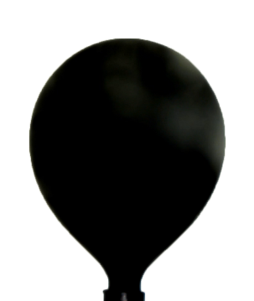 |  | 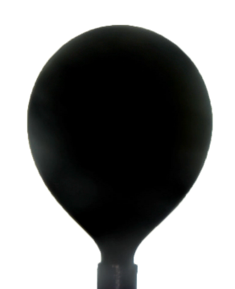 |  | 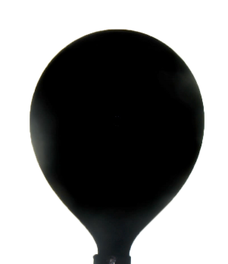
SW | IFT: 29.033 mN/m | SW0Mg | IFT: 23.483 mN/m | SW0Ca | IFT: 22.772 mN/m
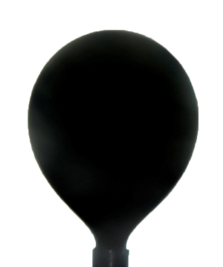 |  | 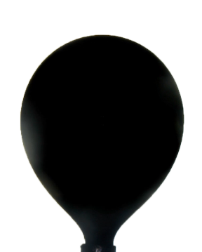
SW2S | IFT: 23.858 mN/m | SW0Ca0Mg | IFT: 23.813 mN/m
Figure S-1: The last image before the droplet separation for IFT measurement, the best performance LSW/SmW samples for S-1 crude oil.

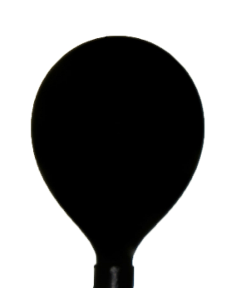 |  |  |  | 
SW | IFT: 31.423 mN/m | 5DSW | IFT: 25.575 mN/m | SW0Ca0Mg | IFT: 25.482 mN/m
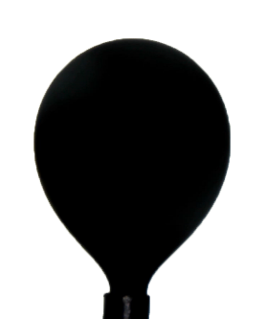 |  |  |  | 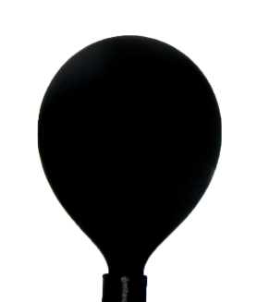
SW2S | IFT: 25.792 mN/m | SW2Ca | IFT: 26.200 mN/m | SW3Mg | IFT: 26.853 mN/m
Figure S-2: The last image before the droplet separation for IFT measurement, the best performance LSW/SmW samples for K-1 crude oil.

 |  |  |  | 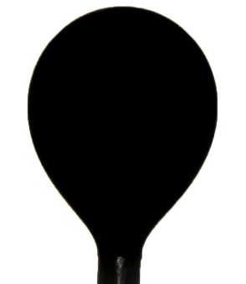
SW | IFT: 28.624 mN/m | SW0Mg | IFT: 26.784 mN/m | 20DSW | IFT: 27.014 mN/m
 |  | 
SW3Ca | IFT: 27.943 mN/m | SW3S | IFT: 28.178 mN/m
Figure S-3: The last image before the droplet separation for IFT measurement, the best performance LSW/SmW samples for F-1 crude oil.

 |  | 
SW | IFT: 26.388 mN/m | SW0Ca | IFT: 22.772 mN/m
 |  | 
SW0Mg | IFT: 24.613 mN/m | SW4S | IFT: 25.324 mN/m
Figure S-4: The last image before the droplet separation for IFT measurement, the best performance LSW/SmW samples for F-2 crude oil.

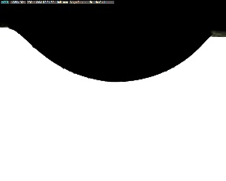 |  | 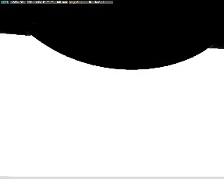 |  | 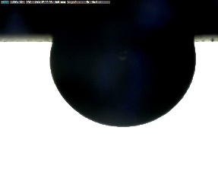 |  | 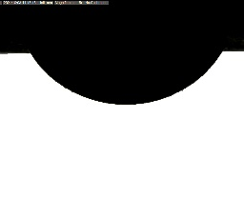
SW | 134.235° | FW | 146.090° | SW2S | 83.780° | SW3Mg | 113.295°
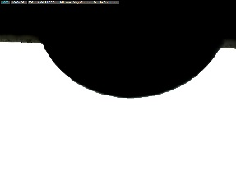 |  | 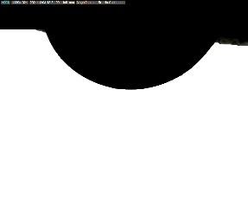 |  | 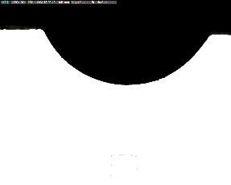
SW0Ca0Mg | 115.485° | SW0Ca | 120.725° | 40DSW | 125.195°
Figure S-5: Images and average contact angle for samples with significant wettability alteration for K-1 formation.

 |  |  |  |  |  | 
SW | 132.585° | FW | 144.595° | SW2S | 81.855° | SW2Ca | 95.865°
 |  |  |  | 
SW0Mg0S | 103.865° | 5DSW | 107.775° | SW4Mg | 108.255°
Figure S-6: Images and average contact angle for samples with significant wettability alteration for F-1 formation.

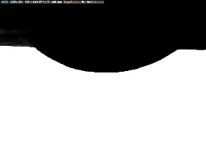 |  | 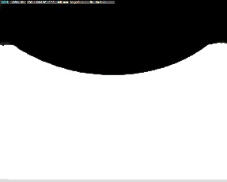 |  | 
SW | 142.505° | FW | 150.680° | SW2S | 84.960°
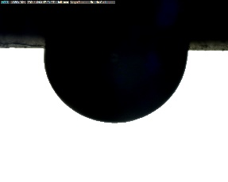 |  | 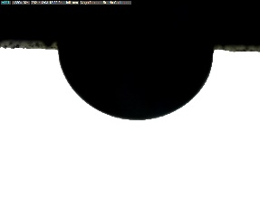 |  | 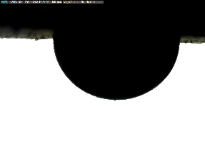
20DSW | 95.345° | SW4Ca | 95.260° | SW0Mg0S | 97.860°
Figure S-7: Images and average contact angle for samples with significant wettability alteration for F-2 formation.

 |  |  |  | 
SW | 141.440° | FW | 154.930° | SW2S | 100.435°
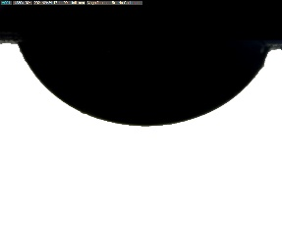 |  | 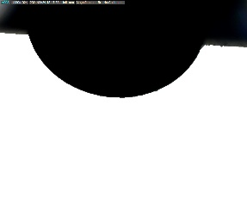
SW4Ca | 115.645° | SW0Ca0S | 116.362°
Figure S-8: Images and average contact angle for samples with significant wettability alteration for S-1 formation.

