Radiation Detector Based on Coupling Between Defect Mode and Topological Edge State Mode in Photonic Crystal
Zaky A. Zaky ^{1, 2, 3,} *, Ali Alzahrani ⁴, Galal H. Khedr ⁵, M. A. Elsharkawy ⁶, Mohammed Sallah⁷
¹ Physics Department, Faculty of Sciences, Beni-Suef University, Beni Suef 62514, Egypt.
² Academy of Scientific Research and Technology (ASRT), Cairo, Egypt
³ Frank Laboratory of Neutron Physics, Joint Institute for Nuclear Research, 141980, Dubna, Russia
⁴ Department of Physics, Al-Qunfudah University college, Umm Al-Qura University, Makkah, 21955, Saudi Arabia
⁵ Radiology and Medical Imaging Technology, Faculty of Applied Health Sciences Technology, Misr University for Science & Technology, Giza, Egypt.
⁶ Radiation protection specialist, general department of radiology, Ministry of health, Egypt
⁷ Department of Physics, College of Sciences, University of Bisha, P.O. Box 344, Bisha 61922, Saudi Arabia

* Correspondence: zaky.a.zaky@science.bsu.edu.eg

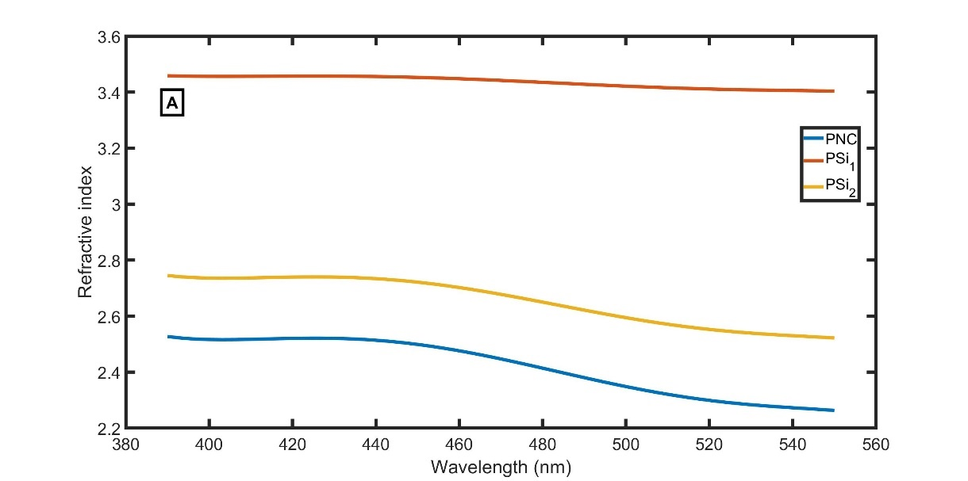
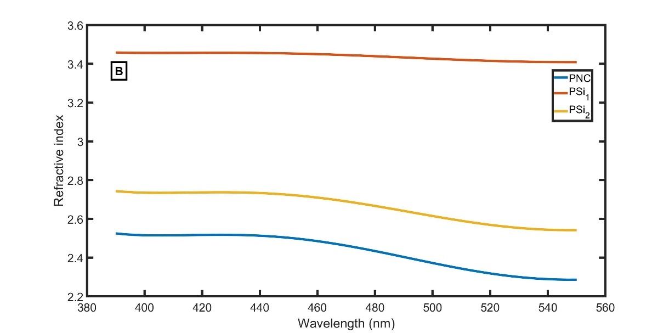
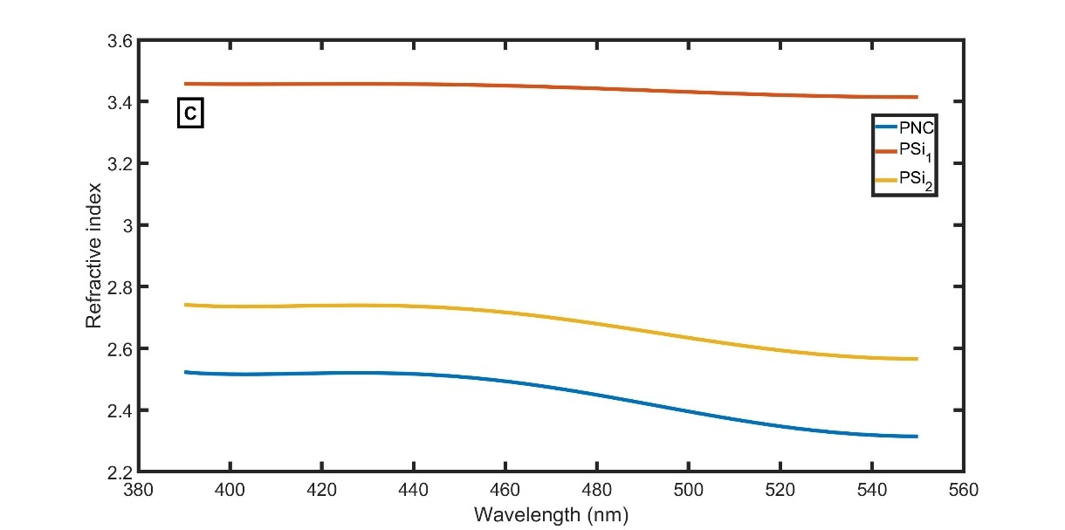
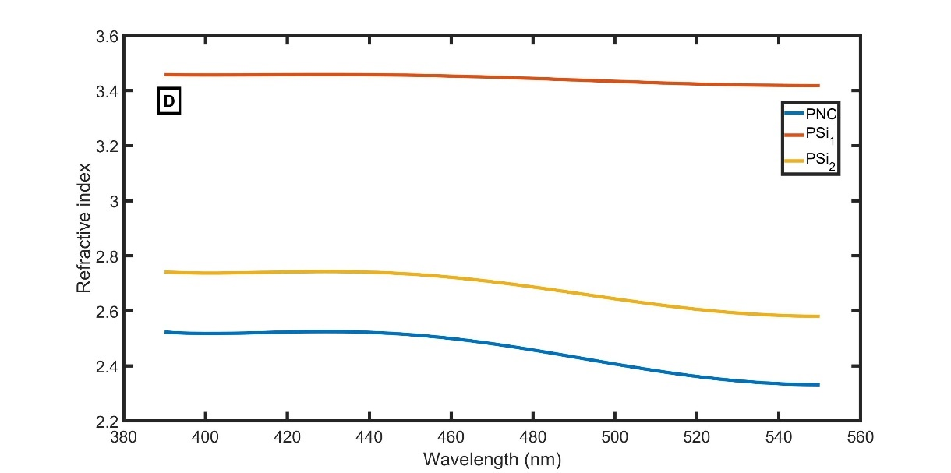
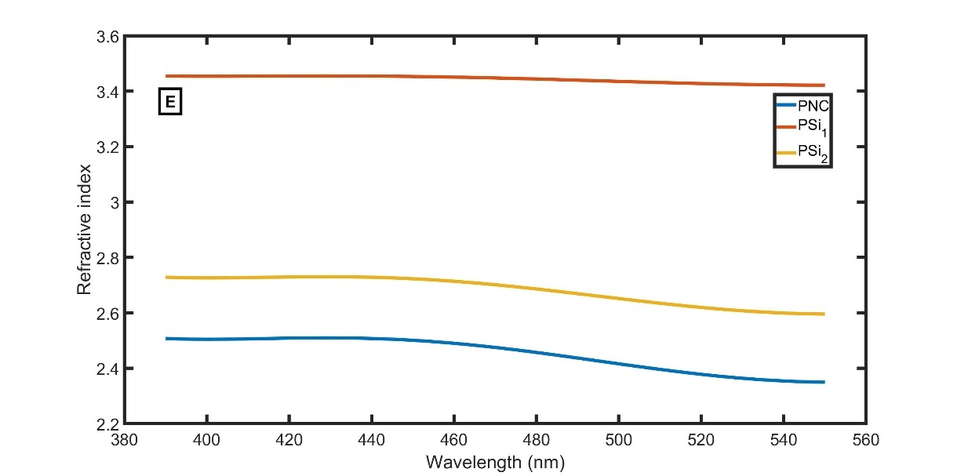
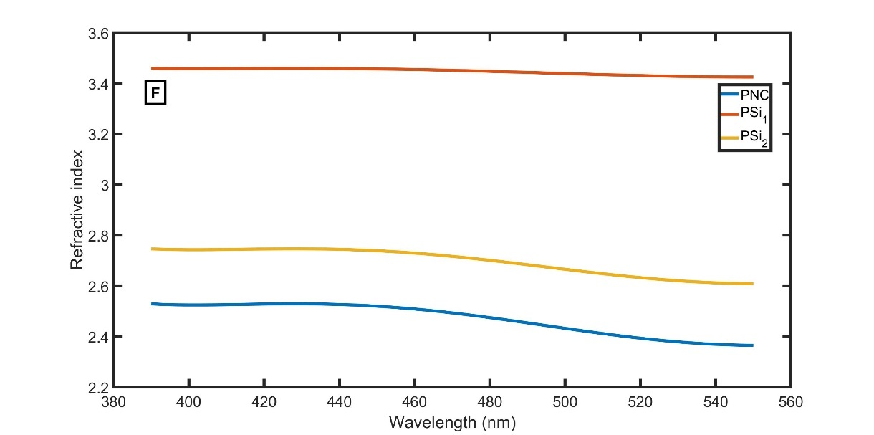
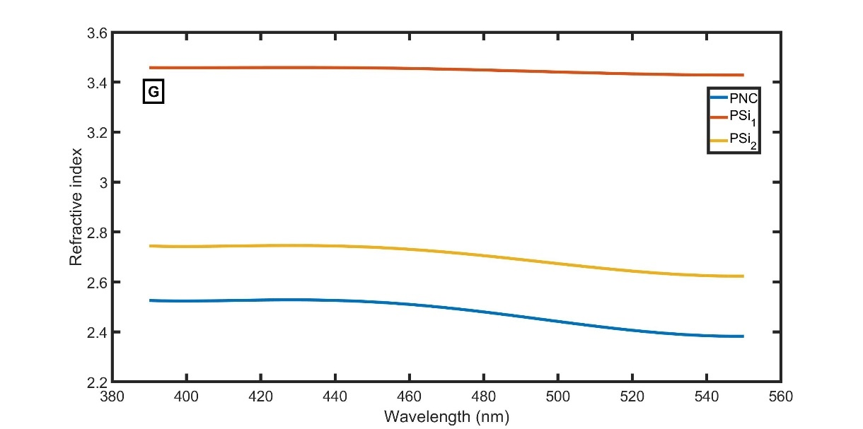
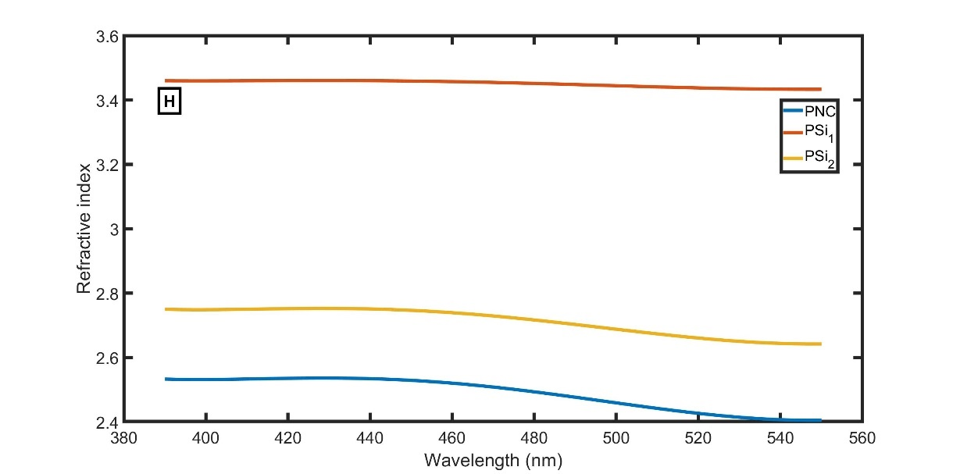
S1: RIs of PNC, ${PSi}_{1}$, and ${PSi}_{2}$ at different γDs; (A) at 0 Gy, (B) at 10 Gy, (C) at 20 Gy, (D) at 30 Gy, (E) at 40 Gy, (F) at 50 Gy, (G) at 60 Gy, and (H) at 70 Gy.

