Supplementary material

Effect | SS | Degrees of Freedom | MS | F | p
Intercept | 1098.62 | 1 | 1098.62 | 3924.13 | <0.001
Group | 3.18 | 1 | 3.18 | 11.35 | 0.002
Error | 7.56 | 27 | 0.28
Vision | 0.03 | 1 | 0.03 | 0.12 | 0.73
Vision * Group | 0.03 | 1 | 0.03 | 0.15 | 0.71
Error | 5.37 | 27 | 0.2

Table S1. Results of the 2 (Group: Tactile, NoTactile) x 2 (Vision: Direct, Mirror) ANOVA, showing a significant Group effect on the logarithmic data of the integrated PSD accelerometer signal for the 5-45 Hz range (i.e., preferred response frequencies of tactile SAI and FAI afferents). The PSD was lower in the NoTactile group than in the Tactile group within this frequency range. However, there was no significant main effect of Visual condition, nor a significant interaction effect between Visual condition and Group.

Effect | SS | Degrees of Freedom | MS | F | p
Intercept | 221.69 | 1 | 221.69 | 3484.6 | <0.001
Group | 0.41 | 1 | 0.41 | 6.38 | 0.017
Error | 1.71 | 27 | 0.06
Vision | 0.00 | 1 | 0.00 | 0.00 | 0.99
Vision * Group | 0.01 | 1 | 0.01 | 0.27 | 0.6
Error | 0.99 | 27 | 0.04

Table S2. The results of the 2 (Group: Tactile, NoTactile) x 2 (Vision: Direct, Mirror) mixed ANOVA on the logarithmic data of the square root value of the integrated PSD accelerometer signal above 10 Hz (index of vertical acceleration amplitude) revealing a significant effect for the Group factor (lower PSD in the NoTactile group than in the Tactile group).

Effect | SS | Degrees of Freedom | MS | F | p
Intercept | 7.18 | 1 | 7.18 | 195.52 | <0.001
Group | 3.08 | 1 | 3.08 | 83.93 | <0.001
Error | 1.06 | 29 | 0.037
Vision | 0.001 | 1 | 0.001 | 0.51 | 0.48
Vision * Group | 0.0001 | 1 | 0.0001 | 0.07 | 0.8
Error | 0.06 | 29 | 0.002

Table S3. The results of the 2 (Group: Tactile, NoTactile) x 2 (Vision: Direct, Mirror) mixed ANOVA on the logarithmic data of the coefficient of friction (COF) yielded a significant effect of the Group factor (lower COF in the NoTactile group than in the Tactile group). However, there was no significant effect of the Visual condition factor, suggesting consistent friction levels between the Mirror and Direct vision conditions.

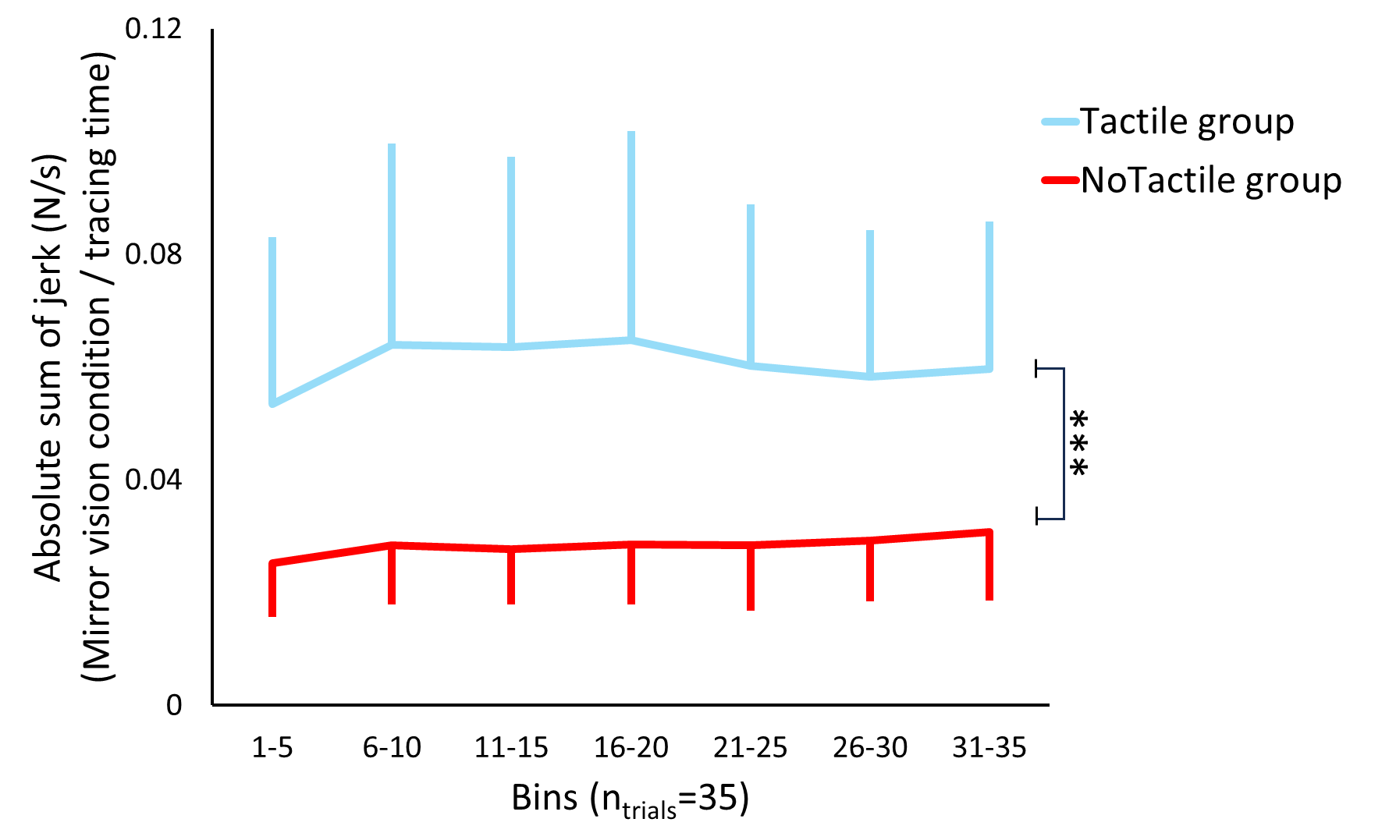
Fig. S1 | The evolution of the absolute sum of jerk index over the course of the 35 trials for the Tactile (blue) and the NoTactile group (red) during tracing with mirror vision. Jerk index values were normalized with respect to tracing time (see Methods). Data were pooled in 7 bins of 5 consecutive trials, enabling the assessment of time-related effects (e.g., fatigue) and adaptation to the sensory conflict in the Mirror condition. ***: p < 0.001.

Effect | SS | Degrees of Freedom | MS | F | p
Intercept | 0.396 | 1 | 0.396 | 111.7 | <0.001
Group | 0.048 | 1 | 0.048 | 13.6 | 0.001
Error | 0.096 | 27 | 0.004
Bin | 0.001 | 6 | 0.0002 | 1.9 | 0.07
Group * Bin | 0.0005 | 6 | 0.0001 | 0.9 | 0.44
Error | 0.0139 | 162 | 0.0001

Table S4. Results of the 2 (Group: Tactile, NoTactile) x 7 (Bin: Bin₁₋₅, Bin₆₋₁₀, Bin_{11-15,} Bin₁₆₋₂₀, Bin₂₁₋₂₅, Bin₂₆₋₃₀, Bin₃₁₋₃₅) mixed ANOVA on the normalized absolute sum of jerk during the Mirror condition, revealing a significant main effect of the Group factor. The other factors and their interactions were not significant. Importantly, the relatively constant jerk across the 35 trials provides behavioral bases for comparing, between groups, the averaged EEG activity computed from all trials.

Effect | SS | Degrees of Freedom | MS | F | p
Intercept | 0.1 | 1 | 0.1 | 195.3 | <0.001
Group | 0.01 | 1 | 0.01 | 19.14 | 0.0001
Error | 0.015 | 29 | 0.0005
Vision | 0.001 | 1 | 0.0014 | 10.18 | 0.003
Vision * Group | 0.001 | 1 | 0.0011 | 7.78 | 0.009
Error | 0.004 | 29 | 0.0001

Cell number | Group | Vision | {1}  0.044 | {2}  0.062 | {3}  0.027 | {4}  0.028
1 | Tactile | Direct |  | 0.0003 | 0.036 | 0.02
2 | Tactile | Mirror | 0.0003 |  | 0.0002 | 0.0001
3 | NoTactile | Direct | 0.036 | 0.0002 |  | 0.78
4 | NoTactile | Mirror | 0.02 | 0.0001 | 0.78

Table S5 & S6. Results of the 2 (Group: Tactile, NoTactile) × 2 (Vision: Direct, Mirror) mixed ANOVA on the average absolute sum of jerk index data (S5 top Table), and of the Newman-Keuls post-hoc test (S6 lower Table). Significant main Group and Vision effects were yielded. However, the decomposition of the significant Vision*Group interaction revealed that the jerk index significantly increased during mirror tracing only in the Tactile group, indicating performance deterioration. Crucially, the NoTactile group showed no significant changes in jerk index between mirror and direct conditions.

Effect | SS | Degrees of Freedom | MS | F | p
Intercept | 1.58 | 1 | 1.58 | 841.69 | <0.001
Group | 0.009 | 1 | 0.09 | 4.78 | 0.038
Error | 0.05 | 27 | 0.002
Vision | 0.01 | 1 | 0.01 | 3.18 | 0.09
Vision * Group | 0.002 | 1 | 0.002 | 4.6 | 0.04
Error | 0.009 | 27 | 0.0003

Cell number | Group | Vision | {1}  0.16 | {2}  0.14 | {3}  0.18 | {4}  0.18
1 | Tactile | Direct |  | 0.01 | 0.25 | 0.39
2 | Tactile | Mirror | 0.01 |  | 0.03 | 0.03
3 | NoTactile | Direct | 0.25 | 0.03 |  | 0.8
4 | NoTactile | Mirror | 0.39 | 0.03 | 0.8

Table S7 & S8. Results of the 2 (Group: Tactile, NoTactile) × 2 (Vision: Direct, Mirror) mixed ANOVA on the mean absolute current amplitude over the left postcentral gyrus ROI (S7 top Table), and of the Newman-Keuls post-hoc test (S8 lower Table). A statistically significant effect was revealed for the Group factor but not for the Vision factor. However, the breakdown of the significant Group x Vision interaction indicated that the postcentral gyrus activity decreased in the Mirror condition only in the Tactile group, with the visual condition having no significant effect on this activity in the NoTactile group.

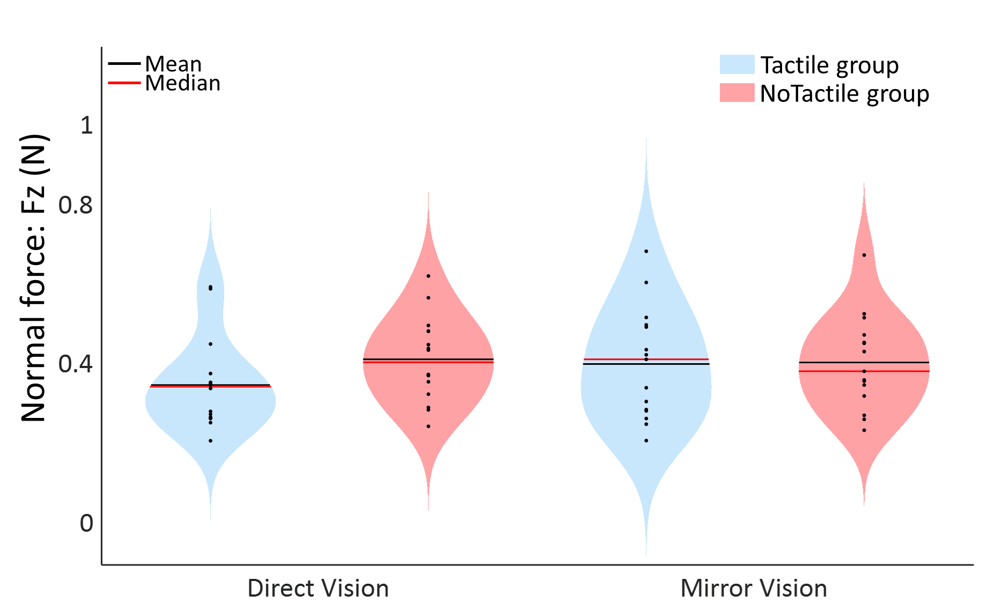
Fig. S2 | Normal force remains consistent across all experimental groups and vision conditions. Violin plots showing the mean normal force of all the trials during shape tracing for the Tactile group (blue) and NoTactile group (red) in both Direct and Mirror conditions. Individual data points are represented with scatter plots within each violin plot.

Effect | SS | Degrees of Freedom | MS | F | p
Intercept | 9.69 | 1 | 9.69 | 416.86 | <0.001
Group | 0.008 | 1 | 0.008 | 0.34 | 0.57
Error | 0.67 | 29 | 0.02
Vision | 0.02 | 1 | 0.02 | 3.62 | 0.067
Vision * Group | 0.01 | 1 | 0.01 | 2.85 | 0.10
Error | 0.14 | 29 | 0.005

Table S9. Results of the 2 (Group: Tactile, NoTactile) × 2 (Vision: Direct, Mirror) mixed ANOVA on the logarithmic data of the normal force. No significant effects were found for either Group or Vision factors, nor for the interaction between Vision and Group. These findings indicate that both experimental groups applied a consistent range of normal force on the surface under both direct or mirror-reversed visual feedback.

Effect | SS | Degrees of Freedom | MS | F | p
Intercept | 13.6 | 1 | 13.6 | 118.1 | <0.001
Group | 0.54 | 1 | 0.54 | 4.72 | 0.04
Error | 2.3 | 20 | 0.12
Vision | 0.09 | 1 | 0.09 | 7.57 | 0.01
Vision * Group | 0.06 | 1 | 0.06 | 5.17 | 0.03
Error | 0.23 | 20 | 0.011

Cell number | Group | Vision | {1}  0.59 | {2}  0.75 | {3}  0.44 | {4}  0.45
1 | Tactile | Direct |  | 0.002 | 0.36 | 0.22
2 | Tactile | Mirror | 0.002 |  | 0.037 | 0.029
3 | NoTactile | Direct | 0.36 | 0.037 |  | 0.74
4 | NoTactile | Mirror | 0.22 | 0.029 | 0.74

Table S10 & S11. Results of the 2 (Group: Tactile, NoTactile) × 2 (Vision: Direct, Mirror) mixed ANOVA (S10 top Table) and the Newman-Keuls post-hoc test (S11 lower Table) on the average absolute sum of jerk index data of the control experiment. The ANOVA revealed significant effects of Group and Vision and a significant Group x Vision interaction. Consistent with the findings from the main experiment, decomposition of this interaction showed that the jerk index increased significantly during mirror tracing only in the Tactile group, indicating performance deterioration under sensory conflict. In contrast, the NoTactile group exhibited no significant changes in jerk index between the mirror and direct vision conditions.

Effect | SS | Degrees of Freedom | MS | F | p
Intercept | 13468.73 | 1 | 13468.73 | 10504.5 | <0.001
Group | 138.26 | 1 | 138.26 | 10.78 | 0.004
Error | 256.43 | 20 | 12.82
Vision | 242.29 | 1 | 242.29 | 28.87 | <0.001
Vision * Group | 116.19 | 1 | 116.19 | 13.84 | 0.001
Error | 167.86 | 20 | 8.39

Cell number | Group | Vision | {1}  15.3 | {2}  23.24 | {3}  15 | {4}  16.44
1 | Tactile | Direct |  | <0.001 | 0.83 | 0.41
2 | Tactile | Mirror | <0.001 |  | <0.001 | <0.001
3 | NoTactile | Direct | 0.83 | <0.001 |  | 0.48
4 | NoTactile | Mirror | 0.41 | <0.001 | 0.48

Table S12 & S13. Results of the 2 (Group: Tactile, NoTactile) × 2 (Vision: Direct, Mirror) mixed ANOVA (S12 top Table) and Newman-Keuls post-hoc test (S13 lower Table) on the mean zero-line crossings in the index finger velocity profile for the x and y axes in the control experiment. Significant main effects of both Group and Vision were observed. However, the breakdown of the significant Vision × Group interaction revealed that the number of zero-line crossings increased during mirror tracing only in the Tactile group, reflecting reduced movement smoothness under sensory conflict. In contrast, the NoTactile group exhibited no significant differences in the number of zero-line crossings between mirror and direct vision conditions.

Effect | SS | Degrees of Freedom | MS | F | p
Intercept | 72.55 | 1 | 72.55 | 728.2 | 0.000
Group | 0.6 | 1 | 0.6 | 6 | 0.02
Error | 1.99 | 20 | 0.1
Vision | 2.11 | 1 | 2.11 | 21.88 | <0.001
Vision * Group | 0.42 | 1 | 0.42 | 4.33 | 0.05
Error | 1.93 | 20 | 0.1

Cell number | Group | Vision | {1}  1.08 | {2}  1.72 | {3}  1.05 | {4}  1.29
1 | Tactile | Direct |  | <0.001 | 0.78 | 0.13
2 | Tactile | Mirror | <0.001 |  | <0.001 | 0.002
3 | NoTactile | Direct | 0.78 | <0.001 |  | 0.18
4 | NoTactile | Mirror | 0.13 | 0.002 | 0.18

Table S14 & S15. Results of the 2 (Group: Tactile, NoTactile) × 2 (Vision: Direct, Mirror) mixed ANOVA on the distance/segment index data of the control experiment (S14 top Table) and the Newman-Keuls post-hoc test (S15 low Table). Significant main effects of both Group and Vision were yielded. Crucially, however, the decomposition of the significant Vision*Group interaction revealed that the distance/segment index increased during mirror tracing only in the Tactile group. In contrast, the NoTactile group showed no significant differences in distance/segment index between mirror and direct vision conditions. These findings indicate impaired kinematic performance under sensory conflict only when participants traced the shape with their bare index finger.

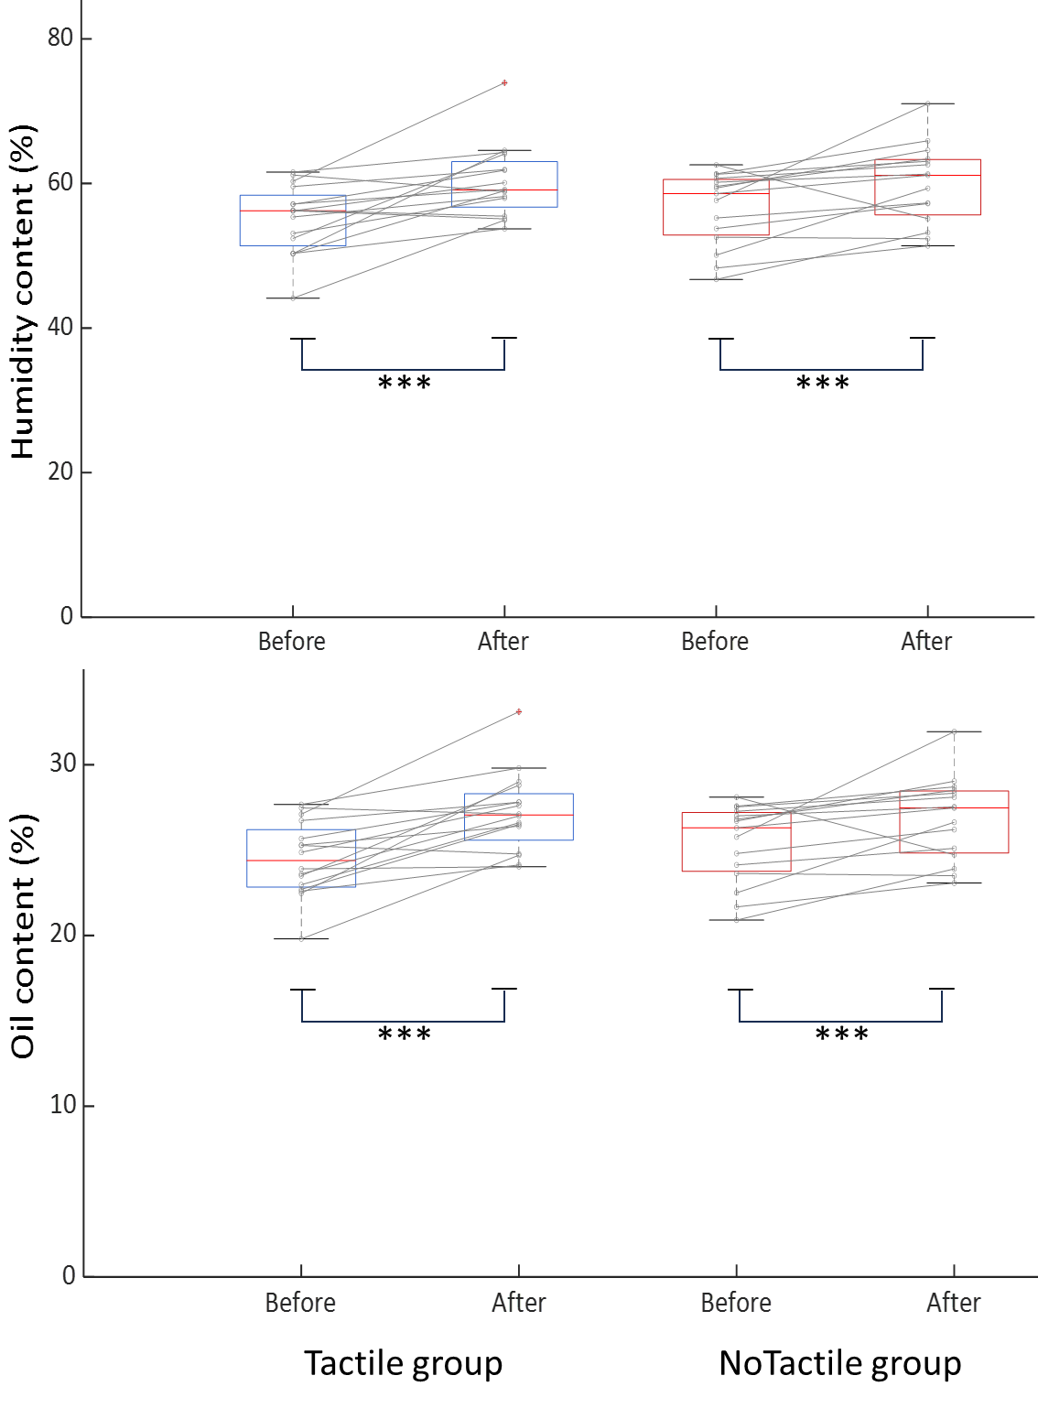
Fig. S3 | Humidity and oil content of the index finger. Boxplots with paired observations illustrating the index finger composition, measured before and after the experimental session using a skin analyzer for the Tactile (blue) and NoTactile (red) groups. The measurements are characterized by humidity (top) and oil (lower) content. Two separate 2 (Group: Tactile, NoTactile) x 2 (Time: Before, After) mixed ANOVAs for humidity and oil content, revealed no significant Group effect or Group x Time interaction, indicating similar finger composition values for the groups. However, both ANOVAs revealed a significant main effect of Time (p< 0.001 for both humidity and oil content), demonstrating that humidity and oil levels increased throughout the experiment, likely due to sweating induced by the repetition of the tracing motor task. ***: p < 0.001.

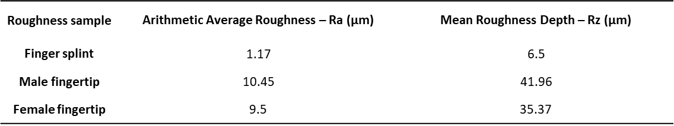

Table S16. Values of the sample’s roughness as measured using a stylus profilometer (MarSurf PS 10) with Inductive skidded probe (resolution 8 nm). The roughness of the fingertips was obtained using a resin mold of the operator’s fingertips. Ra is a measure of the average deviation of the surface valleys and peaks from the mean line of the surface within a sampling length, making it an effective indicator of the overall roughness of a sample. Rz represents the vertical distance between the highest peak and the lowest valley within the sampling length, providing insight into the height of the surface irregularities. The values are obtained by averaging the Ra and Rt values obtained on 6 different profiles measured along perpendicular directions (3 lines per direction) on both the fingertip contact zone and the corresponding area of the finger splint.

