SUPPLEMENTARY INFORMATION

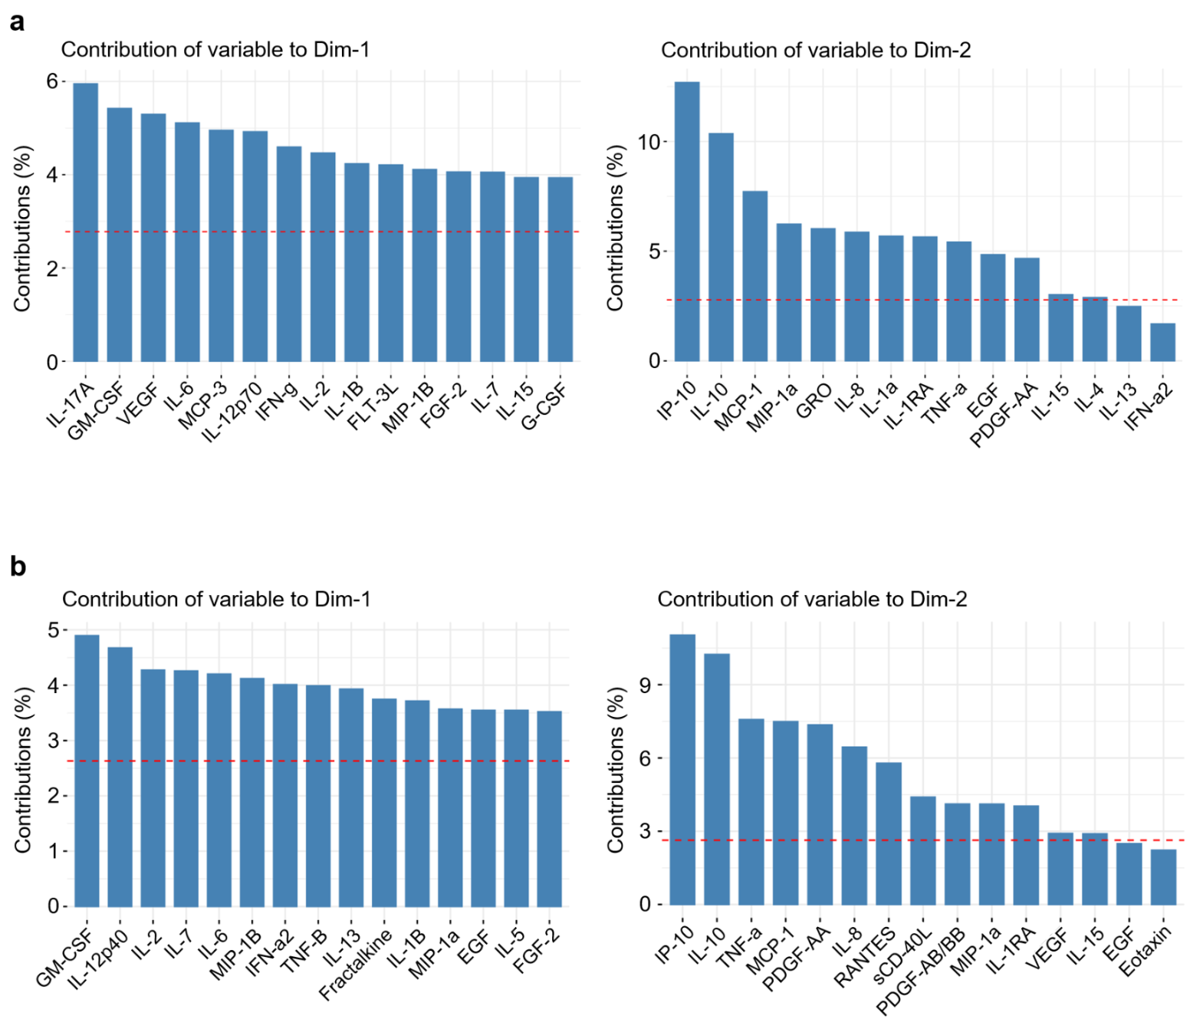

Supplementary Figure 1. The top 15 cytokines most contributed to PC1 (Dim-1) and PC2 (Dim-2) in the PCA analysis of (a) cross-sectional study and (b) longitudinal study. The red dash horizontal line indicates the expected average of all contributions.

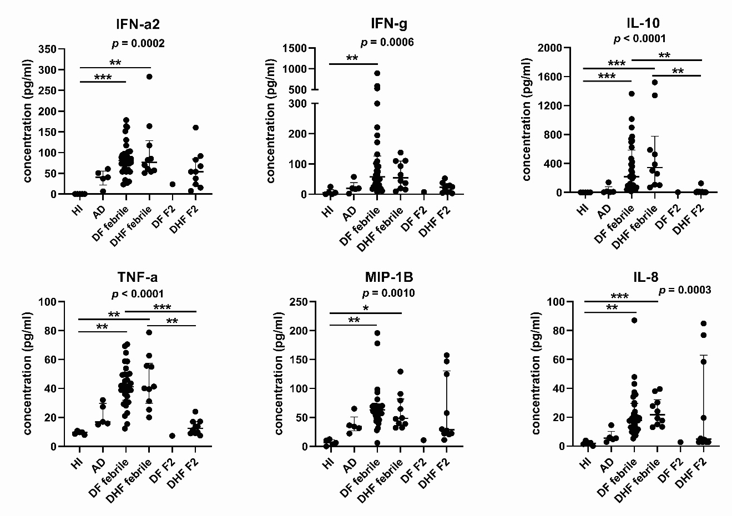

Supplementary Figure 2. Baseline cytokine levels of IFN-α2, IFN-γ, IL-10, TNF-α, MIP-1β, and IL-8 in HI samples compared to AD and SD cases. SD samples from the febrile phase (D-1 and D-2) and the 2-month follow-up were included in this analysis. The Kruskal-Wallis test was used to compare 3 groups of independent data (p value indicated in each graph). Kruskal-Wallis statistics with Dunn's multiple comparisons test were used to compare between 2 groups indicated. *p<0.05, **p<0.01, ***p<0.001, ****p<0.0001. Median and interquartile ranges were shown in each group.

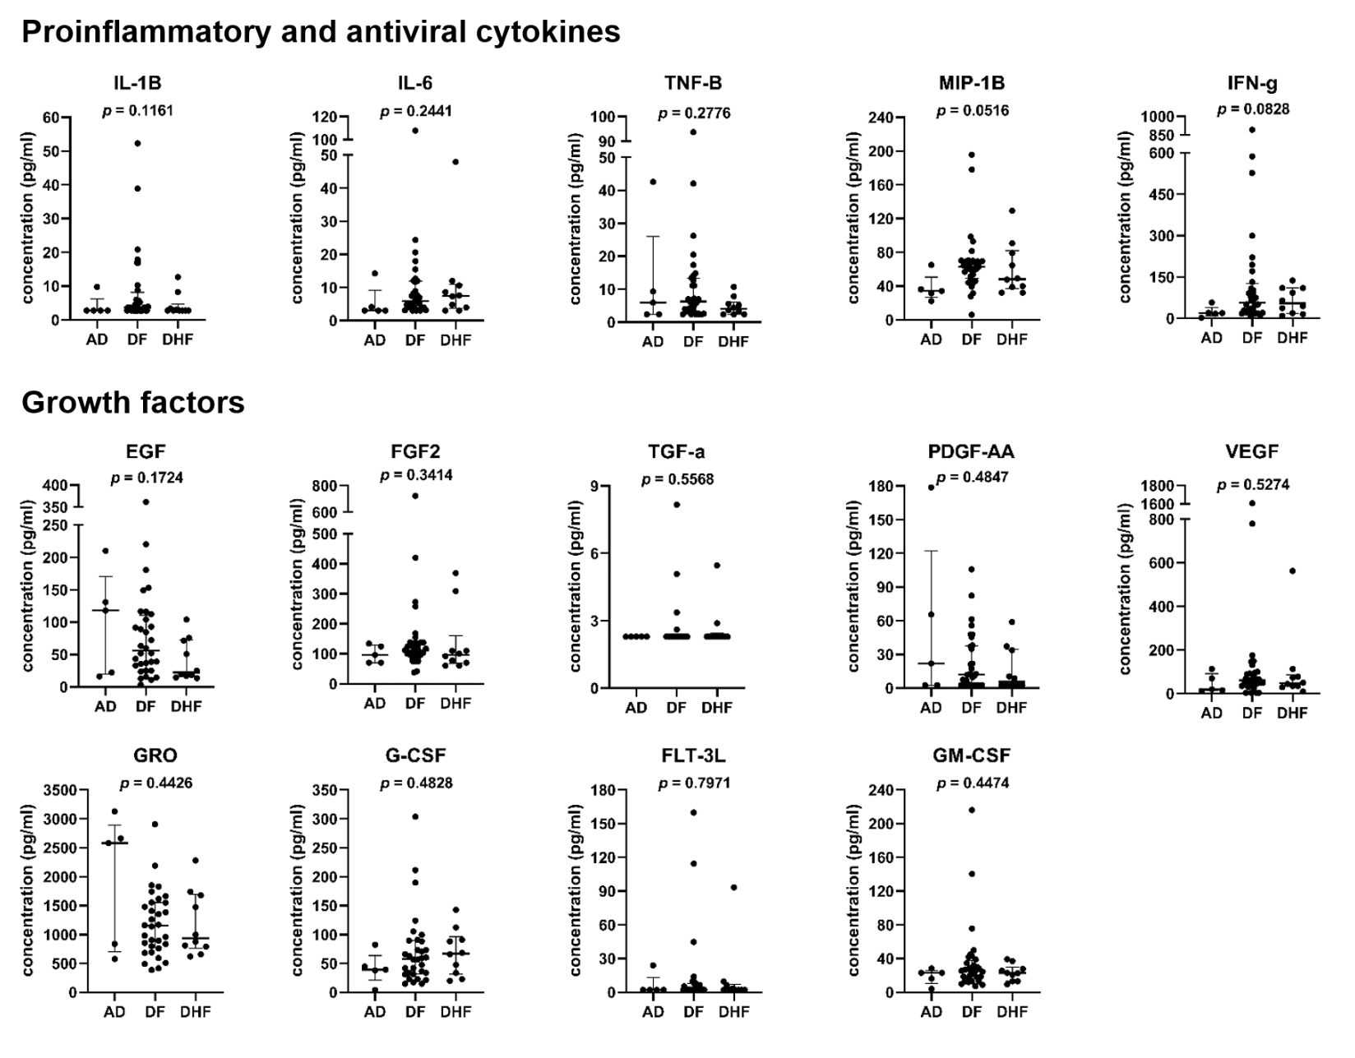
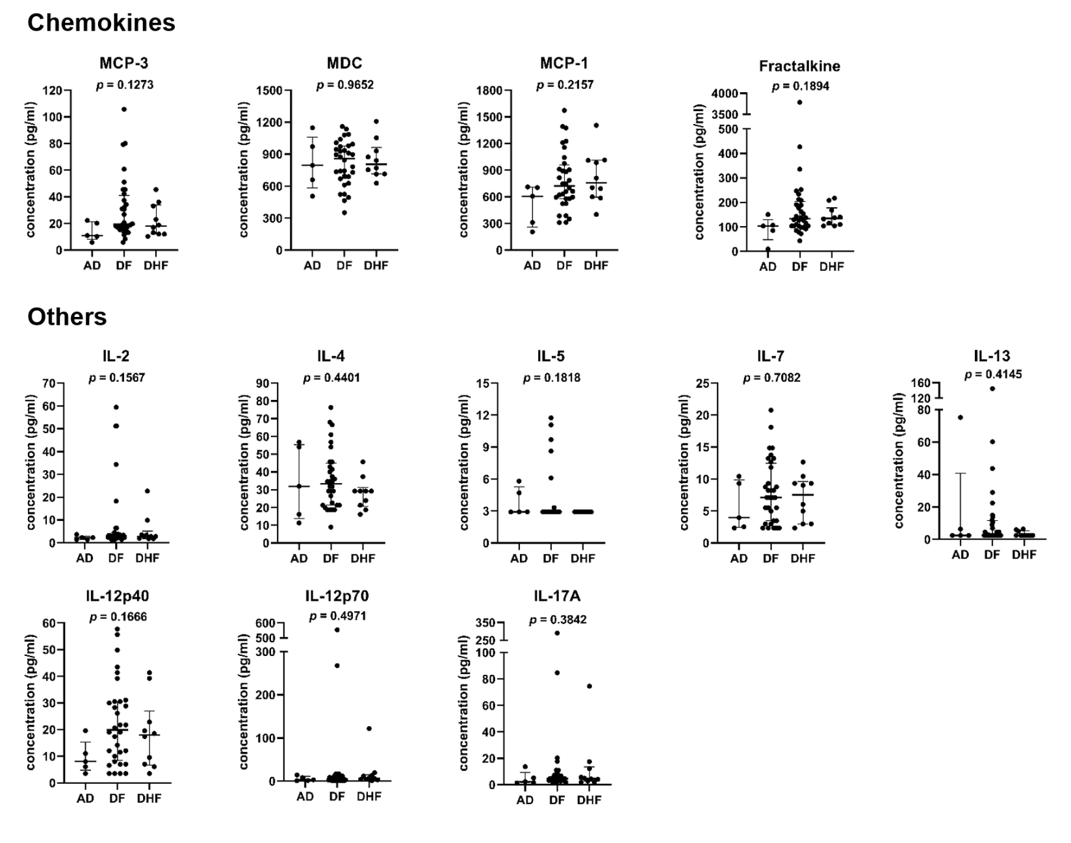
Supplementary Figure 3. Levels of cytokines with non-significant differences among AD, DF and DHF samples. P-value calculated by non-parametric Kruskal-Wallis test showed in each graph. Median and interquartile ranges were shown in each group.
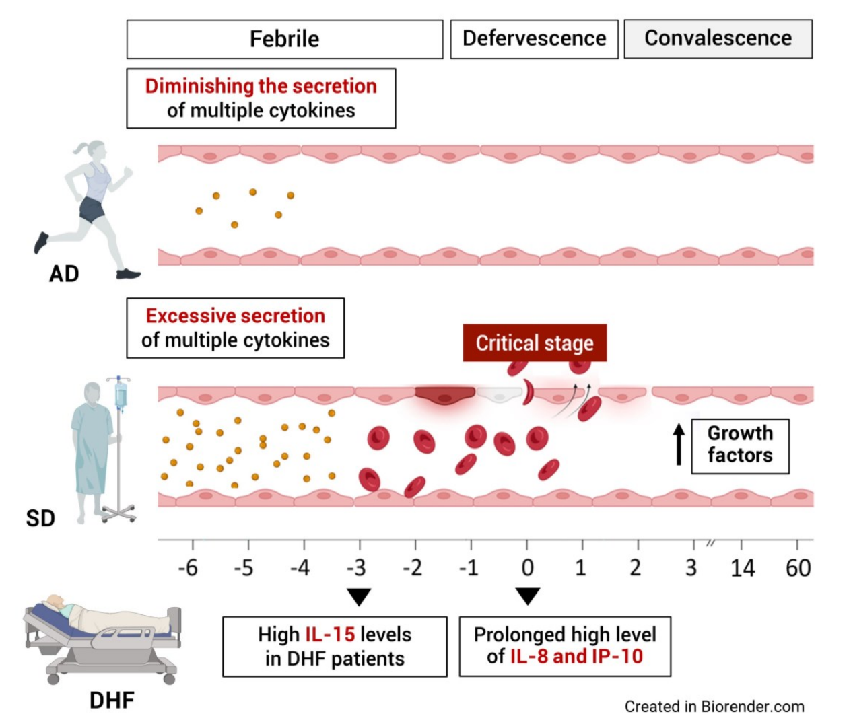

Supplementary Figure 4. Proposed model of the soluble immune response upon natural dengue infection in different disease severities. The schematic model highlights the signatures of plasma mediator secretion in the AD and SD, the kinetic cytokine secretion over the course of SD infection, and the cytokines associated with DHF.

 | AD | DF | DHF | P-value
Number (n) | 5 | 32 | 10
Gender (n)
male | 3 | 15 | 3
female | 2 | 17 | 7
Age (median, range) | 34 (19-63) | 20.5 (8-65) | 26 (15-38) | 0.3954ª
Infection (n)
N/A | 1
primary infection | 1 | 2
secondary infection | 3 | 30 | 10
Serotypes (n)
DENV1 | 1 | 4 | 2
DENV2
DENV3 | 2 | 15 | 3
DENV4 | 2 | 14 | 5
Viral copies/ml (febrile) | 1.64 x 10⁶, | 2.65 x 10⁶, | 3.47 x 10⁶, | 0.5172ª
(median, IQR) | 6.38x10³ - 3.78x10⁶ | 3.1x10⁴ - 5.62x10⁷ | 3.06x10⁴ - 9.18x10⁶
ª Statistical analysis by Kruskal Wallis test

Supplementary Table 1. Demographic and clinical characteristics of the study population in cross-sectional study. SD samples collected upon febrile phase (1-2 days before fever subsided) and AD samples collected upon active viremia were used for this study. N/A: data is not available.

 | DF | DHF | P-value*
Number (n) | 15 | 22
Gender (n) |  |  | 0.5490ª
male | 9 | 11
female | 6 | 11
Age (median, range) | 21 (9-37) | 21 (15-64) | 0.5349^{b}
Infection (n)
N/A | 1 | 1
primary infection | 1 | 0
secondary infection | 13 | 21
Serotypes (n)
N/A | 1
DENV1 | 0 | 5
DENV2 | 0 | 1
DENV3 | 3 | 8
DENV4 | 11 | 8
Viral copies/ml (febrile) | 11.15 x 10⁷, | 80.1 x 10⁷, | 0.4316^{b}
(median, IQR) | 3.7x10⁷ - 1.38x10⁹ | 2.47x10⁷ - 2.84x10⁹
Viral copies/ml (defervescence) | 0, | 0, | 0.6808^{b}
(median, IQR) | 0 - 6.14x10⁴ | 0 - 1.78 x 10⁵
P-value# | 0.0001^{c} | <0.0001^{c}
* P-value calculated by comparing DF and DHF samples
# P-value calculated by comparing viral load of febrile and defervescence
ª Statistiscal analysis by chi-squre test
^{b} Statistical analysis by Mann-Whitney U test
^{c} Statistical analysis by Wilcoxon signed rank test

Supplementary Table 2. Demographic and clinical characteristics of the study population in longitudinal study of SD infection. Samples from 15 DF and 22 DHF patients were collected at 4 time points: D-3, D0, F1 and F2, resulting in a total of 100 samples used for this study. N/A: data is not available.

Samples | Severity | Age | Sex | Serotype | Infection | Viremia (febrile) | Time-point
1 | AD | 63 | M | 3 | Secondary | 1.64E+06 | N/A
2 | AD | 25 | M | 3 | Secondary | 1.17E+04 | N/A
3 | AD | 19 | M | 4 | N/A | 2.19E+06 | N/A
4 | AD | 34 | F | 4 | Secondary | 5.37E+06 | N/A
5 | AD | 38 | F | 1 | Primary | 1.06E+03 | N/A
6 | DF | 39 | M | 3 | Secondary | 2.76E+04 | D-1
7 | DF | 32 | F | 3 | Secondary | 5.44E+02 | D-1
8 | DF | 19 | F | 3 | Secondary | 2.74E+03 | D-1
9 | DF | 22 | F | 3 | Secondary | 5.34E+03 | D-1
10 | DF | 8 | M | 3 | Secondary | 8.71E+05 | D-1
11 | DF | 31 | F | 3 | Secondary | 1.25E+07 | D-1
12 | DF | 15 | M | 3 | Primary | 1.16E+08 | D-1
13 | DF | 65 | F | 4 | Secondary | 2.65E+06 | D-1
14 | DF | 15 | F | 4 | Secondary | 1.77E+06 | D-1
15 | DF | 49 | M | 4 | Secondary | 2.88E+08 | D-1
16 | DF | 12 | M | 4 | Secondary | 3.03E+08 | D-1
17 | DF | 45 | F | 1 | Secondary | 9.35E+03 | D-1
18 | DF | 19 | M | 3 | Secondary | 2.80E+04 | D-2
 |  |  |  | 4 | N/A | 8.53E+05
19 | DF | 19 | M | 3 | Secondary | 2.74E+06 | D-2
20 | DF | 14 | M | 3 | Secondary | 4.15E+06 | D-2
21 | DF | 18 | M | 3 | Secondary | 1.96E+07 | D-2
22 | DF | 11 | F | 3 | Secondary | 3.45E+07 | D-2
23 | DF | 15 | F | 3 | Secondary | 7.46E+07 | D-2
24 | DF | 14 | F | 3 | Secondary | 8.11E+07 | D-2
25 | DF | 11 | M | 3 | Primary | 1.48E+08 | D-2
26 | DF | 48 | F | 4 | Secondary | 3.43E+04 | D-2
27 | DF | 19 | F | 4 | Secondary | 8.99E+05 | D-2
28 | DF | 28 | F | 4 | Secondary | 1.35E+06 | D-2
29 | DF | 37 | M | 4 | Secondary | 1.77E+06 | D-2
30 | DF | 60 | F | 4 | Secondary | 7.04E+06 | D-2
31 | DF | 26 | F | 4 | Secondary | 4.79E+07 | D-2
32 | DF | 22 | M | 4 | Secondary | 6.45E+07 | D-2
33 | DF | 50 | M | 4 | Secondary | 0 | D-2
34 | DF | 46 | F | 4 | Secondary | 6.99E+08 | D-2
35 | DF | 38 | M | 1 | Secondary | 3.52E+02 | D-2
36 | DF | 10 | M | 1 | Secondary | 1.17E+05 | D-2
37 | DF | 18 | F | 1 | Secondary | 8.22E+06 | D-2
38 | DHF | 17 | M | 3 | Secondary | 6.87E+03 | D-1
39 | DHF | 23 | F | 3 | Secondary | 3.35E+04 | D-1
40 | DHF | 29 | M | 3 | Secondary | 5.28E+06 | D-1
41 | DHF | 34 | F | 4 | Secondary | 5.79E+06 | D-1
42 | DHF | 38 | M | 4 | Secondary | 1.41E+07 | D-1
43 | DHF | 16 | F | 1 | Secondary | 2.20E+04 | D-1
44 | DHF | 33 | F | 4 | Secondary | 8.61E+05 | D-2
45 | DHF | 20 | F | 4 | Secondary | 1.66E+06 | D-2
46 | DHF | 35 | F | 4 | Secondary | 4.79E+08 | D-2
47 | DHF | 15 | F | 1 | Secondary | 7.54E+06 | D-2

Supplementary Table 3. A total of 47 samples from 5 AD, 32 DF and 10 DHF patients were used for the cross-sectional study. SD samples collected upon febrile phase (1-2 days before fever subsided) and AD samples collected upon active viremia were used for this study. N/A: data is not available.

 |  |  |  |  |  | Viral copies/ml |  | Time-points
Sample | Severity | Age | Sex | Serotype | Infection | Viremia (febrile) | Viremia (D0) | D-3 | D0 | F1 | F2
T1 | DF | 21 | F | 3 | Secondary | 1.05E+10 | 5.27E+04
T2 | DF | 20 | M | 4 | Secondary | 4.10E+07 | 0
T3 | DF | 19 | F | 3 | Primary | 1.82E+11 | 1.31E+06
T4 | DF | 29 | M | 4 | Secondary | 1.11E+08 | 4.89E+06
T5 | DF | 32 | F | 3 | Secondary | 7.22E+08 | 0
T6 | DF | 16 | F | 4 | Secondary | 8.70E+06 | 0
T7 | DF | 27 | M | 4 | Secondary | 7.24E+05 | 0
T8 | DF | 12 | M | 4 | Secondary | 2.48E+07 | 0
T9 | DF | 10 | F | 4 | Secondary | 4.21E+08 | 0
T10 | DF | 37 | M | N/A | Secondary | N/A | N/A
T11 | DF | 36 | M | 4 | Secondary | 1.12E+08 | 0
T12 | DF | 16 | M | 4 | Secondary | 4.52E+07 | 3.96E+04
T13 | DF | 9 | M | 4 | Secondary | 1.25E+08 | 0
T14 | DF | 34 | M | 4 | N/A | 3.35E+09 | 8.75E+04
T15 | DF | 26 | F | 4 | Secondary | 5.39E+07 | 0
T16 | DHF | 27 | F | 3 | Secondary | 6.13E+06 | 0
T17 | DHF | 21 | M | 3 | Secondary | 6.67E+08 | 0
T18 | DHF | 19 | M | 1 | Secondary | 1.12E+10 | 3.71E+03
T19 | DHF | 28 | M | 3 | Secondary | 4.94E+09 | 7.08E+05
T20 | DHF | 18 | F | 1 | Secondary | 1.99E+10 | 9.71E+08
T21 | DHF | 15 | M | 3 | Secondary | 1.59E+09 | 0
T22 | DHF | 20 | F | 1 | Secondary | 9.35E+08 | 0
T23 | DHF | 19 | M | 2 | Secondary | 3.82E+09 | 1.50E+06
T24 | DHF | 55 | F | 4 | Secondary | 2.64E+06 | 0
T25 | DHF | 18 | F | 1 | Secondary | 1.67E+09 | 2.42E+04
T26 | DHF | 24 | M | 3 | Secondary | 1.26E+09 | 4.00E+04
T27 | DHF | 19 | F | 4 | Secondary | 1.24E+05 | 0
T28 | DHF | 21 | F | 3 | Secondary | 2.98E+08 | 0
T29 | DHF | 27 | F | 3 | Secondary | 2.71E+07 | 1.19E+06
T30 | DHF | 35 | M | 3 | Secondary | 7.01E+10 | 1.21E+05
T31 | DHF | 20 | M | 4 | Secondary | 1.74E+07 | 0
T32 | DHF | 54 | M | 4 | Secondary | 3.40E+08 | 0
T33 | DHF | 22 | F | 1 | N/A | 1.05E+09 | 0
T34 | DHF | 64 | F | 4 | Secondary | 2.66E+08 | 1.43E+02
T35 | DHF | 18 | M | 4 | Secondary | 2.51E+09 | 3.48E+05
T36 | DHF | 58 | F | 4 | Secondary | 6.45E+07 | 0
T37 | DHF | 18 | M | 4 | Secondary | 4.28E+05 | 0
 |  |  |  |  |  |  |  |  | Presence
 |  |  |  |  |  |  |  |  | Absence
Supplementary Table 4. A total of 100 samples from 15 DF and 22 DHF patients were used for the longitudinal study of SD infection. The 4 time-points included D-3, D0, F1 and F2. N/A: data is not available.

 | Kruskal wallis | Post-hoc test (Dunn's test)
 | Kruskal wallis | D-3/D0 | D-3/F1 | D-3/F2 | D0/F1 | D0/F2 | F1/F2
IL-1Ra | <0.0001 | <0.0001 | <0.0001 | 0.0114 | 0.7012 | >0.9999 | 0.9237
IL-15 | <0.0001 | <0.0001 | <0.0001 | 0.0002 | >0.9999 | >0.9999 | >0.9999
IL-10 | <0.0001 | >0.9999 | <0.0001 | <0.0001 | 0.0001 | 0.0005 | >0.9999
IP-10 | <0.0001 | 0.6592 | <0.0001 | <0.0001 | 0.0011 | <0.0001 | >0.9999
MCP-1 | <0.0001 | 0.0054 | <0.0001 | <0.0001 | 0.0216 | 0.033 | >0.9999
IL-8 | <0.0001 | >0.9999 | <0.0001 | 0.0437 | 0.001 | 0.4856 | 0.5448
TNF-a | <0.0001 | >0.9999 | 0.0004 | 0.0012 | 0.002 | 0.0057 | >0.9999
IFN-g | <0.0001 | 0.0012 | 0.0015 | 0.0117 | >0.9999 | >0.9999 | >0.9999
RANTES | 0.0002 | 0.0962 | 0.975 | >0.9999 | 0.0037 | 0.0022 | >0.9999
MIP-1a | 0.0004 | 0.0552 | 0.0005 | 0.0863 | 0.2907 | >0.9999 | >0.9999
PDGF-AA | 0.0008 | 0.3212 | >0.9999 | 0.3062 | 0.0679 | 0.0009 | >0.9999
MIP-1b | 0.0011 | 0.0044 | 0.0095 | 0.1552 | >0.9999 | >0.9999 | >0.9999
IFN-a2 | 0.0026 | 0.0013 | 0.2582 | >0.9999 | >0.9999 | 0.6802 | >0.9999
EGF | 0.0109 | >0.9999 | 0.9478 | 0.1048 | 0.2432 | 0.0155 | >0.9999
FGF-2 | 0.0186 | >0.9999 | >0.9999 | 0.1281 | 0.4944 | 0.0181 | >0.9999
Fractalkine | 0.0205 | 0.0247 | 0.2449 | >0.9999 | >0.9999 | 0.7379 | >0.9999
PDGF-AB/BB | 0.0265 | 0.4747 | >0.9999 | >0.9999 | 0.9446 | 0.0227 | >0.9999
IL-1a | 0.0311 | 0.9328 | 0.0276 | 0.5712 | 0.4632 | >0.9999 | >0.9999
GM-CSF | 0.0324 | >0.9999 | >0.9999 | 0.3225 | 0.44 | 0.0351 | >0.9999
sCD-40L | 0.0398 | >0.9999 | 0.5584 | 0.0672 | >0.9999 | 0.1542 | >0.9999
IL-6 | 0.0734 | 0.1527 | 0.1995 | >0.9999 | >0.9999 | >0.9999 | >0.9999
IL-3 | 0.1213 | >0.9999 | 0.382 | >0.9999 | 0.1285 | >0.9999 | >0.9999
Eotaxin | 0.1225 | >0.9999 | 0.4952 | 0.7026 | 0.4082 | 0.5867 | >0.9999
VEGF | 0.1479 | >0.9999 | >0.9999 | 0.5139 | 0.8236 | 0.3231 | >0.9999
IL-1b | 0.1944 | >0.9999 | >0.9999 | >0.9999 | 0.7427 | 0.3791 | >0.9999
G-CSF | 0.3094 | 0.6013 | >0.9999 | >0.9999 | >0.9999 | >0.9999 | >0.9999
IL-12(p70) | 0.3473 | >0.9999 | >0.9999 | >0.9999 | >0.9999 | 0.4993 | 0.9277
IL-5 | 0.3517 | >0.9999 | 0.6628 | >0.9999 | >0.9999 | >0.9999 | 0.6278
IL-9 | 0.3614 | >0.9999 | >0.9999 | >0.9999 | >0.9999 | 0.4708 | >0.9999
GRO | 0.3671 | >0.9999 | >0.9999 | >0.9999 | >0.9999 | 0.8215 | >0.9999
IL-12(p40) | 0.4449 | >0.9999 | >0.9999 | >0.9999 | >0.9999 | 0.6929 | >0.9999
IL-2 | 0.5049 | >0.9999 | >0.9999 | >0.9999 | >0.9999 | >0.9999 | >0.9999
IL-13 | 0.676 | >0.9999 | >0.9999 | >0.9999 | >0.9999 | >0.9999 | >0.9999
MCP-3 | 0.6903 | >0.9999 | >0.9999 | >0.9999 | >0.9999 | >0.9999 | >0.9999
TNF-b | 0.7388 | >0.9999 | >0.9999 | >0.9999 | >0.9999 | >0.9999 | >0.9999
IL-4 | 0.7843 | >0.9999 | >0.9999 | >0.9999 | >0.9999 | >0.9999 | >0.9999
FLT-3L | 0.8152 | >0.9999 | >0.9999 | >0.9999 | >0.9999 | >0.9999 | >0.9999
IL-7 | 0.8266 | >0.9999 | >0.9999 | >0.9999 | >0.9999 | >0.9999 | >0.9999
TGF-a | 0.8917 | >0.9999 | >0.9999 | >0.9999 | >0.9999 | >0.9999 | >0.9999
IL-17A | 0.9104 | >0.9999 | >0.9999 | >0.9999 | >0.9999 | >0.9999 | >0.9999
MDC | 0.9485 | >0.9999 | >0.9999 | >0.9999 | >0.9999 | >0.9999 | >0.9999

Supplementary Table 5. The P-value calculated by non-parametric Kruskal-Wallis test with Dunn’s multiple comparison test of each cytokine in longitudinal study. Independent data from both DF and DHF samples were used for this analysis.

