Table S1 Summary for susceptibility pattern, MIC of IPM, and genotypic detection of carbapenemase genes of CRAB isolates.
Isolate number | Susceptibility patterns |  |  |  |  | MIC of IPM (µg/ml) | Carbapenemase genes
Isolate number | CL | IPM | DOX | AK | LEV | MIC of IPM (µg/ml) | Carbapenemase genes
CRAB1 | S | R | R | R | R | 32 | bla _{NDM}, bla _{VIM}
CRAB2 | S | R | R | R | R | 512 | bla _{VIM}
CRAB3 | S | R | R | R | R | 64 | bla _{NDM}, bla _{VIM}
CRAB4 | R | R | R | R | R | 256 | bla _{oxa-23}
CRAB5 | S | R | R | R | R | 256 | bla _{oxa-23}
CRAB6 | S | R | R | R | R | 128 | bla _{VIM}
CL, colistin; IPM, imipenem; DOX, doxycycline; AK, amikacin; LEV, levofloxacin; MIC, minimum inhibitory concentration; bla _{NDM:} New Delhi metallo-beta-lactamase (group B beta-lactamase); bla _{VIM:} Verona integrin associated metallo-beta-lactamase (group B beta-lactamase); bla _{oxa-23:} Oxacillinase beta lactamase (group D beta-lactamase).

Table S2 Feature annotations and open reading frame (ORF) analysis of Acinetobacter baumannii phage VB_AB_Acb75

ORF Number | Feature ORF name | Strand | Interval range
1 | putative tail-fiber/lysozyme protein | + | 9..2057
2 | tail tube initiator-like protein | + | 2089..2673
3 | virion structural protein | + | 2758..3099
4 | baseplate hub | + | 3209..4099
5 | baseplate spike | + | 4080..4625
6 | Tail sheath initiator protein | + | 4728..5225
7 | putative baseplate J-like protein | + | 5222..6406
8 | structural protein | + | 6620..7246
9 | tail fiber protein | + | 7368..8213
10 | tail fiber protein | + | 8258..10657
11 | hypothetical protein | + | 10692..10913
12 | exonuclease of Acinetobacter phage | - | complement (13119.13835)
13 | RecT-like ssDNA annealing protein | - | complement (13871.14770)
14 | hypothetical protein | - | complement (14946.15281)
15 | transcriptional regulator | - | complement (15769.16560)
16 | hypothetical protein | + | 16891..17325
17 | DNA adenine methylase | + | 18147..18857
18 | replication initiation protein | + | 19390..20133
19 | DnaB-like replicative helicase | + | 20139..21482
20 | Phage Protein | + | 21618..21965
21 | Phage Protein | + | 21982..22272
22 | hypothetical protein | + | 22553..23290
23 | hypothetical protein | + | 23386..24024
24 | Phage Endonuclease | + | 25315..25701
25 | Phage Protein | + | 25843..26088
26 | hypothetical protein | + | 26612..26908
27 | hypothetical protein | + | 26905..27294
28 | putative terminase large subunit | + | 28355..29773
29 | phage portal protein | + | 30704..31213
30 | hypothetical protein | + | 32544..32981
31 | hypothetical protein | + | 34049..34402
32 | hypothetical protein | + | 35421..35687
33 | prohead core protein protease | + | 36112..36939
34 | head maturation protease | + | 37113..37481
35 | capsid stabilizing protein | + | 37596..38102
36 | major capsid protein | + | 38184..39176
37 | Hypothetical Protein | + | 39200..39550
38 | hypothetical protein | + | 41755..42444
39 | Phage head protein | + | 42630..43133
40 | Phage cysteine protease | + | 43130..43543
41 | tail completion protein | + | 43570..44034
42 | tail sheath protein | + | 44024..45487

Table S3. The survival rate percentage of the animals examined
Group | Group Description | survival%
a | Control, burned, non-infected, untreated | 100
B | Control, burned, infected, untreated | 50
C | Control, burned, infected, treated with vehicle (control hydrogel) | 75
D | Burned, infected, treated with tested hydrogel | 100
E | Positive Control, burned, infected, treated with beta sitosterol (Mebo®) | 100
F | Positive control, burned, infected, treated with gentamycin 0.1% | 100
G | Normal control, intact, non-infected, untreated | 100

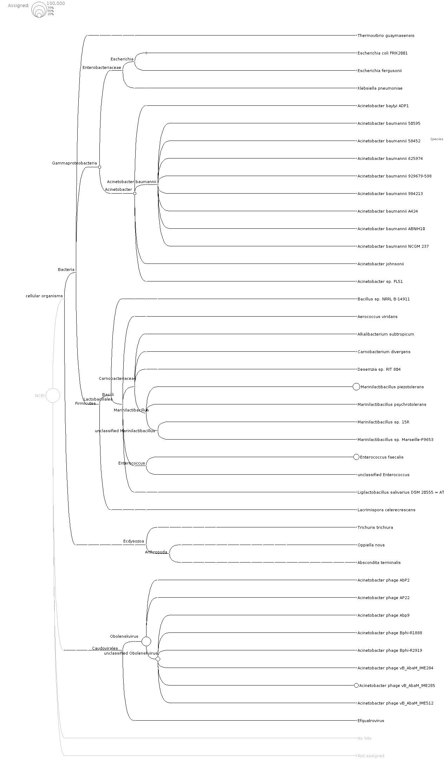
Fig. S1 Phylogenetic tree of A. baumannii phage VB_AB_Acb75.

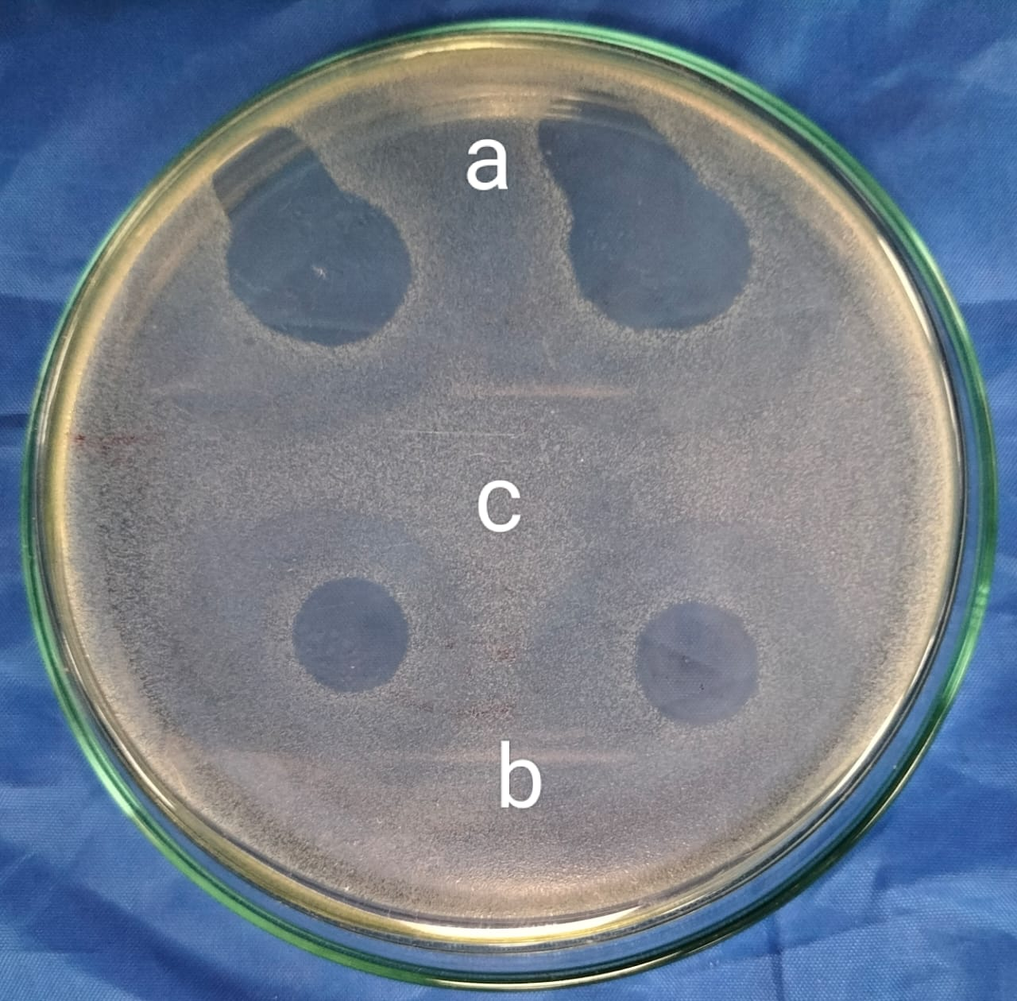

Fig. S2 In vitro lytic activities of A. baumannii phage VB_AB_Acb75 against carbapenem resistant Acinetobacter baumannii clinical isolate (CRAB1): (a) the phage lysate exhibited clear lytic spots; (b) phage-loaded hydrogel showed clear lytic spots similar to zones observed with phage lysate alone; (c) formulated Carbopol 940 hydrogel (1%).showed no antilytic activity

