Head kinematic variability is minimal near preferred cadence and independent of the vestibular control of locomotion

Liam H Foulger¹, Calvin Kuo^{2,3}, Romeo Chua¹, Jean-Sébastien Blouin^{1,4,5*}
¹School of Kinesiology, University of British Columbia, Vancouver, British Columbia, Canada
²School of Biomedical Engineering, University of British Columbia, Vancouver, British Columbia, Canada
³Centre for Hip Health and Mobility, University of British Columbia, Vancouver, British Columbia, Canada
⁴Djavad Mowafaghian Centre for Brain Health, University of British Columbia, Vancouver, British Columbia, Canada
⁵Institute for Computing, Information and Cognitive Systems, University of British Columbia, Vancouver, British Columbia, Canada

Results
Participants walked outdoors at step cadences ranging from 40% to 140% of their natural step cadence. Gait characteristics across the step cadence conditions are presented in Table S1. To characterize the vestibular-evoked balance responses, we calculated the time-dependent coherence between the electrical vestibular stimulation (EVS) and the back, right ankle, and left ankle mediolateral linear accelerations. The pooled time-dependent coherences for each of the IMU measures at each step cadence condition (during the trials with EVS) are presented in Figure S1. $V_{res}$ was calculated using the head IMU data to determine the head kinematic variability across strides during the trials with and without EVS.

$V_{res}$ in trials without EVS
Given that EVS evokes neck muscle responses via the vestibulo-colic reflex and whole-body balance responses¹, we also calculated $V_{res}$ measures from the trials where no EVS was applied. Overall, EVS induced a ~11-23% increase in the mean $V_{res}$ that was mainly driven by a larger residual variability. However, the changes to $V_{res}$ across step cadence conditions were similar between the trials with EVS (presented in the main manuscript) and without EVS (Table S2 and Figure S2).

Head kinematic changes beyond preferred cadence
Significant increases in head kinematic variability beyond the preferred step cadence were the same between the trials with and without EVS (Table S2 and Figure S2), with one exception: there was a significant increase (1.15×) in $V_{res} a_{NET}$ from the 100% to the 120% condition in the trials without EVS that was not significant in the trials with EVS. Similar to the trials with EVS, $V_{res} a_{NET}$ also increased (1.74×) from the 100% step cadence condition to the 140% condition. $V_{res} a_{ML}$ increased from the 100% condition to both the 120% condition (1.34×) and the 140% condition (1.47×).

Fitting head kinematic changes across step cadence and gait speed
Similar to the results with the EVS (see results in the main manuscript), the AIC was lower for the polynomial fits compared to the exponential decay fits across step cadences ($V_{res} a_{NET}$: $∆AIC$= -73.4, polynomial ${\overline{R}}^{2}$= 0.92 ± 0.05; $V_{res} a_{ML}$: $∆AIC$= -30.5, polynomial ${\overline{R}}^{2}$= 0.41 ± 0.59; $V_{res}$ $ω_{NET}$: $∆AIC$= -43.6, polynomial ${\overline{R}}^{2}$= 0.71 ± 0.25; $V_{res}$ $ω_{roll}$: $∆AIC$= -13.5, polynomial ${\overline{R}}^{2}$= 0.57 ± 0.34; Figure S3A) and gait speeds ($V_{res} a_{NET}$: $∆AIC$= -49.4, polynomial ${\overline{R}}^{2}$= 0.77 ± 0.18; $V_{res} a_{ML}$: $∆AIC$= -30.4, polynomial ${\overline{R}}^{2}$= 0.37 ± 0.60; $V_{res}$ $ω_{NET}$: $∆AIC$= -52.0, polynomial ${\overline{R}}^{2}$= 0.56 ± 0.35; $V_{res}$ $ω_{roll}$: $∆AIC$= -28.3, polynomial ${\overline{R}}^{2}$= 0.48 ± 0.43; Figure S3B).
To determine the cadence and speed at which head kinematic variability was minimal during natural locomotion, we extracted the minima for each participant’s 2nd degree polynomial function. The locations of the minima were similar to the trials with EVS (see results in the main manuscript) and varied between 88-120 steps/min across step cadences ($V_{res} a_{NET}$ at 114 ± 7 steps/min; $V_{res} a_{ML}$ at 88 ± 22 steps/min; $V_{res}$ $ω_{NET}$ at 120 ± 16 steps/min; $V_{res}$ $ω_{roll}$ at 120 ± 24 steps/min; Figure S3A) and 0.9-1.4 m/s across gait speeds ($V_{res} a_{NET}$ at 1.3 ± 0.1 m/s; $V_{res} a_{ML}$ at 0.9 ± 0.4 m/s; $V_{res}$ $ω_{NET}$ at 1.4 ± 0.3 m/s; $V_{res}$ $ω_{roll}$ at 1.4 ± 0.3 m/s; Figure S3B).
Bootstrapped Coherence, Gain, and Power Differences
To confirm that the changes in coherence across locomotor cadences we observed represented modulations in vestibulo-motor responses and were not driven only by increased linear acceleration spectral power, we performed bootstrapping of the differences in coherence, gain, and power^{2,3}. We compared responses between the 40% step cadence condition and the 60%, 80%, 100%, 120%, and 140% step cadence conditions. To compute the bootstrapped differences, we randomly selected 12 participants (with replacement), computed the pooled coherence, gain, and spectral power for the desired cadence conditions, and calculated the differences for each measure. This process was repeated 10,000 times. At each time step and frequency, the differences were sorted in ascending order (across the 10,000 resamples). Points (across time and frequency) in the coherence, gain, and spectral power output differences where zero was outside of a 99% confidence interval (50th and 9950th data points) were considered to be significantly different between cadences. In the back, right ankle, and left ankle bootstrapped differences (Figures S4-S6), we observed that gain either decreased concurrently with coherence or did not change in regions where coherence decreased. This confirmed that while spectral power did increase with faster step cadences, the observed reductions in coherence with faster locomotor cadence/speed were not simply a consequence of increased variability in locomotor responses but rather represented modulations in vestibular-evoked motor responses.
Modelling Vestibular Afferent Responses to Head Motion and EVS
The encoding of head kinematic signals by the primary vestibular afferents and central vestibular pathways include non-linearities associated, for example, with larger signal amplitudes^{4,5}. Given that we used linear system analyses to estimate vestibular-evoked responses, these non-linearities could lead to decreased coherence as the amplitude of head kinematic signals increased with step cadence (see Figures 2 and 3 in main manuscript). To confirm that the attenuation of EVS-evoked balance responses at the faster step cadences was not driven by non-linear processes in vestibular pathways, we modelled the peripheral afferents and central responses to head motion and EVS experienced during the locomotor trials. Using the transformed head linear accelerations (with gravity included given the otoliths sense gravito-inertial accelerations⁶) and angular velocities, the motion was first decomposed into the sensing axes of the bilateral canals (anterior, horizontal, posterior) and otolith components (saccule pars superior, saccule pars inferior, utricle pars medialis, and utricle pars lateralis)^{7–10}. In trials with vestibular stimulation, the EVS signal was distributed to all the vestibular organ components because EVS modulates all vestibular afferents^{11,12}. As binaural bipolar EVS induces afferent depolarization on cathode and afferent hyperpolarization on the anode¹³, the EVS signal was multiplied by -1 for the anode-side vestibular organs. Following this, the head motion and EVS signals were passed through motion-to-afferent and EVS-to-afferent transfer functions, respectively, for the canals and otoliths, to determine the regular and irregular afferent firing rate changes as a response to the mechanical and electrical stimuli^{4,11,14}. To account for anatomical differences between nonhuman primates (on which the transfer functions were determined) and humans, a gain of 1/ 9.2248 was applied to the EVS afferent responses. Previously, a gain of 4.23 was used for afferent-to-EVS conversion (or 1/4.23 for EVS-to-afferent conversion), but it was increased to account for the equal activation of all canals and to obtain a conversion ratio of 0.37 mA/(deg/s)^{14,15}. The overall firing rate was calculated as the sum of the resting firing rate (canals = 104 Hz; otoliths = 79 Hz)^{16,17}, the change in firing rate resulting from the head motion, and, when applicable, the change in firing rate from the applied EVS. The overall firing rate was determined for the regular and irregular afferents for all bilateral canals and otolith end-organs. To account for non-linearities in the afferent firing rates due to their inability to fire below 0 Hz or above 270 Hz, a sigmoid function was applied to the raw afferent firing rates^{4,18}. Central vestibular neurons also exhibit non-linearities between their afferent input and output firing rates which can be estimated using a piecewise linear function⁵. We applied this bi-linear function to estimate the central encoding of vestibular stimuli.
Both canal (Figure S8) and otolith (Figure S9) afferent responses mainly occurred in the linear response regions (~50-200 Hz) of the sigmoid functions (less than 2% of responses occurred outside this range, across all conditions), indicating that there was minimal saturation of the vestibular afferents across all step cadences. The irregular otolith afferents displayed the largest variation in afferent responses (i.e., only irregular afferent responses reached < 50 Hz) with some occurring in the non-linear response regions; however, this occurred at both the slow and fast step cadence conditions. These observations suggest it was unlikely that non-linear processing in the vestibular pathways would explain the attenuation of the vestibular-evoked balance responses at faster step cadences.
To confirm that the non-linear processes in vestibular pathways did not affect the linear estimates of the calculated vestibular-evoked balance responses, we computed the stationary coherence between the central vestibular estimate of the EVS signal (that included non-linear processes) and the body kinematics (for the back, right ankle and left ankle as previously described) and the stationary coherence between the true EVS signal and the body kinematics. While we previously used time-dependent coherence in our analyses, we chose to use a stationary coherence analysis here because coherence at specific time intervals was less relevant, and stationary coherence provides an overall summary of the relationship between two signals. To determine the central vestibular estimate of the EVS signal, we first estimated the central encoding (following the non-linear corrections) of the bilateral semicircular canals from 1) the combination of kinematic and EVS inputs and 2) only the kinematic inputs (i.e., only the head motion). To determine the “EVS-only” encoding (accounting for possible saturation due to non-linearities), we then took the difference between these two firing rates. We chose to only use the canals to estimate the central encoding given that the otolith responses to EVS are predicted to almost completely cancel out due to the opposite directions of the response axes^{10,13,19}. Then, the weighted firing rate from each canal was estimated by combining the regular and irregular responses, with an estimated distribution of 3:1 regular-to-irregular afferents^{14,15}. The firing rates from each canal were then projected back to the head reference frame (based on the sensing axes) to determine the XYZ components, sum of which was then taken across all canals on each side. The vector norms were calculated for the right and left sides, and the net firing rate was calculated as the average between the sides¹⁹. Thus, this net firing rate was the estimated central encoding of only the EVS during the trials (while accounting for the non-linear processing in the vestibular pathways). We would expect to observe a difference between the two coherence measures if these non-linearities influenced the calculation of the coherence. However, there were no differences between the stationary coherences calculated (Figure S10). These analyses suggest that non-linear processing in the vestibular pathways did not result in the decrease in vestibular-evoked responses associated with larger locomotor cadences.

 |  | % Natural Cadence
 |  | 40% | 60% | 80% | 100% | 120% | 140%
Step Cadence (steps/min) | No EVS | 43.2 (3.6) | 64.8 (5.6) | 85.9 (7.3) | 107.9 (8.8) | 128.2 (10.9) | 148.5 (10.7)
Step Cadence (steps/min) | EVS | 43.8 (3.8) | 65.0 (5.2) | 86.4 (7.7) | 107.9 (8.8) | 128.4 (10.9) | 149.4 (13.2)
Step Cadence Error (steps/min) | No EVS | 0.3 (0.6) | 0.4 (0.8) | 0.2 (0.6) | 0.6 (1.3) | -0.5 (1.1) | -1.7 (3.6)
Step Cadence Error (steps/min) | EVS | 0.8 (2.1) | 0.7 (1.7) | 0.7 (1.2) | 0.6 (1.1) | -0.3 (0.8) | -0.8 (2.0)
Gait Speed (m/s) | No EVS | 0.4 (0.1) | 0.6 (0.2) | 0.8 (0.1) | 1.1 (0.2) | 1.5 (0.3) | 1.9 (0.3)
Gait Speed (m/s) | EVS | 0.4 (0.1) | 0.6 (0.1) | 1.0 (0.2) | 1.4 (0.3) | 1.8 (0.3) | 2.1 (0.4)
Head Pitch (deg) | No EVS | 4.9 (6.5) | 5.9 (6.8) | 6.5 (7.6) | 8.2 (6.8) | 7.0 (8.8) | 3.3 (9.4)
Head Pitch (deg) | EVS | 4.0 (6.1) | 6.2 (6.7) | 7.2 (6.9) | 8.8 (6.4) | 7.2 (7.7) | 4.9 (8.5)
LTO  (%) | No EVS | 18.0 (3.9) | 14.5 (2.0) | 13.5 (1.5) | 12.3 (1.4) | 10.7 (1.3) | 9.8 (1.7)
LTO  (%) | EVS | 18.0 (5.1) | 14.8 (2.0) | 13.5 (1.4) | 12.3 (1.6) | 10.9 (1.4) | 9.9 (1.7)
LHS  (%) | No EVS | 49.8 (1.6) | 50.1 (1.5) | 50.4 (1.6) | 50.9 (1.6) | 50.9 (0.9) | 50.9 (1.0)
LHS  (%) | EVS | 49.5 (1.0) | 50.3 (1.2) | 50.3 (1.3) | 50.9 (1.4) | 51.1 (0.8) | 50.9 (1.4)
RTO  (%) | No EVS | 68.1 (3.6) | 64.5 (1.5) | 63.5 (1.5) | 62.1 (1.2) | 60.3 (1.3) | 59.3 (1.6)
RTO  (%) | EVS | 68.3 (4.6) | 64.6 (2.0) | 63.5 (1.6) | 62.1 (1.3) | 60.4 (1.4) | 59.6 (1.8)

Table S1. Gait characteristics of participants across cadence conditions. Gait event timings (bottom three rows) are described as percentage of total stride cycle. Data are presented as: mean (standard deviation). Step cadence error describes the difference between the average step cadence during the trial and the target step cadence. No EVS, trials with no electrical vestibular stimulation; EVS, trials with electrical vestibular stimulation; m/s, metres per second; deg, degrees; LTO, left toe-off; LHS, left heel strike; RTO, right toe-off.

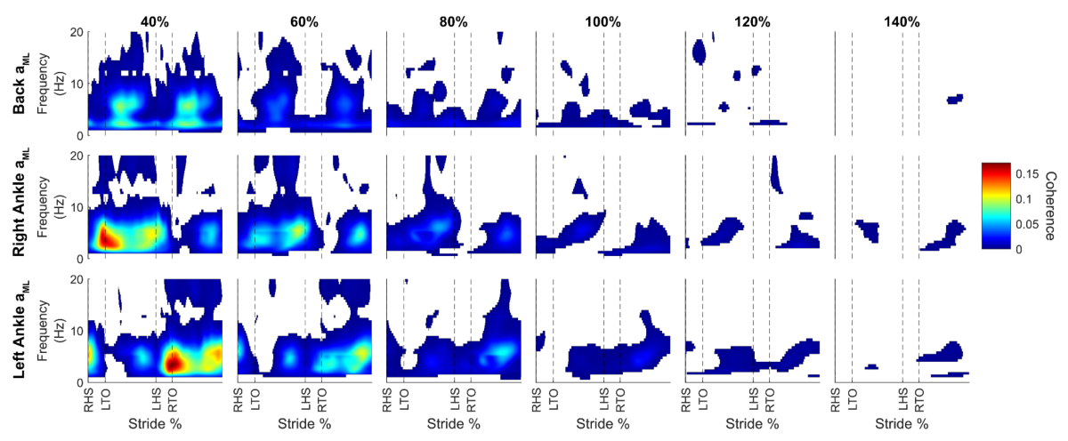
Figure S1. Pooled (n = 12) time-dependent coherence for the three coherence measures across all cadence conditions. Coherence was calculated between the applied electrical vestibular stimulation and the back mediolateral linear acceleration ($a_{ML};$top row), right ankle $a_{ML}$ (middle row), and left ankle $a_{ML}$ (bottom row). Values representing non-significant coherence and gain were removed from the plots. Overall, coherence for all sensors decreased as step cadence increased. RHS, right heel strike; LTO, left toe-off; LHS, left heel strike; RTO, right toe-off.
Measure | rmANOVA  F-statistic | p | Post-hoc student t-test | t-statistic | Cohen’s d | p_{holm}
$$V_{res} a_{NET}$$ | F_{2.781,30.587} = 91.624 | < .001* | 40-100% | t₁₁ = 16.003 | 4.620 | < .001*
$$V_{res} a_{NET}$$ | F_{2.781,30.587} = 91.624 | < .001* | 100-120% | t₁₁ = -2.591 | -0.748 | 0.025†
$$V_{res} a_{NET}$$ | F_{2.781,30.587} = 91.624 | < .001* | 100-140% | t₁₁ = -4.442 | -1.282 | < .001†
$$V_{res} a_{ML}$$ | F_{2.097,22.063} = 6.329 | 0.006* | 40-100% | t₁₁ = 3.176 | 0.917 | 0.012*
$$V_{res} a_{ML}$$ | F_{2.097,22.063} = 6.329 | 0.006* | 100-120% | t₁₁ = -3.405 | -0.983 | 0.012†
$$V_{res} a_{ML}$$ | F_{2.097,22.063} = 6.329 | 0.006* | 100-140% | t₁₁ = -3.084 | -0.890 | 0.010†
$V_{res}$ $ω_{NET}$ | F_{5,55} = 21.230 | < .001* | 40-100% | t₁₁ = 7.426 | 2.144 | < .001*
$V_{res}$ $ω_{NET}$ | F_{5,55} = 21.230 | < .001* | 100-120% | t₁₁ = -0.050 | -0.015 | 0.961
$V_{res}$ $ω_{NET}$ | F_{5,55} = 21.230 | < .001* | 100-140% | t₁₁ = -1.127 | -0.325 | 0.568
$V_{res}$ $ω_{roll}$ | F_{2.128,23.407} = 9.102 | 0.001* | 40-100% | t₁₁ = 4.887 | 1.411 | < .001*
$V_{res}$ $ω_{roll}$ | F_{2.128,23.407} = 9.102 | 0.001* | 100-120% | t₁₁ = 0.071 | 0.020 | 0.945
$V_{res}$ $ω_{roll}$ | F_{2.128,23.407} = 9.102 | 0.001* | 100-140% | t₁₁ = -1.086 | -0.313 | 0.602
Table S2. Statistical analysis of head kinematic variability measures. Statistical analysis of the mean proportion of residual variance ($V_{res}$) calculated from the gravity-corrected and transformed net linear acceleration ($V_{res}$ $a_{NET}$), mediolateral linear acceleration ($V_{res}$ $a_{ML}$), net angular velocity ($V_{res}$ $ω_{NET}$), and roll angular velocity ($V_{res}$ $ω_{roll}$). These measures were calculated from trials without vestibular stimulation. A repeated measures analysis of variance (rmANOVA) was performed for each measure, along with selected post-hoc Student t-tests (corrected with Holm method). Significant results are indicated with boldface type and an asterisk (*) denotes a significant decrease while a dagger (†) denotes a significant increase.

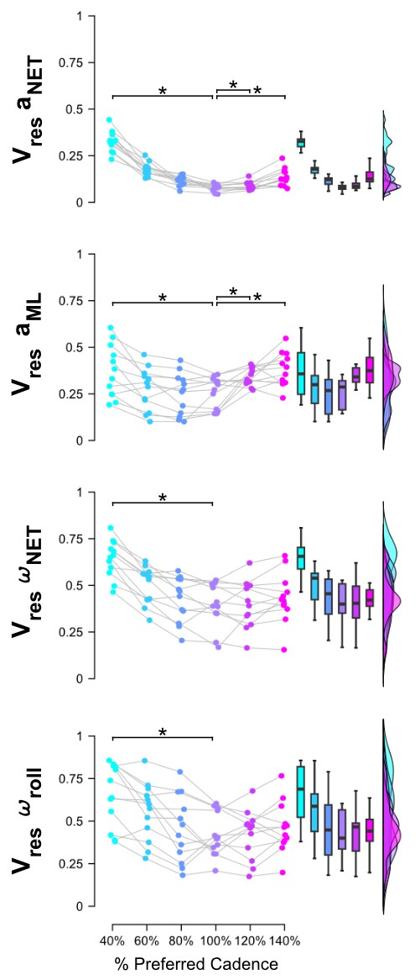
Figure S2. Participant (n = 12) mean proportion of residual variance ($V_{res}$) across step cadence conditions during trials without electrical vestibular stimulation. We calculated $V_{res}$ with the head net linear acceleration ($V_{res} a_{NET}$), mediolateral linear acceleration ($V_{res} a_{ML}$), net angular velocity ($V_{res}$ $ω_{NET}$), and roll angular velocity ($V_{res}$ $ω_{roll}$). There was a significant main effect for all $V_{res}$ measures. Post-hoc Student t-tests revealed that there was a significant decrease from the 40% to 100% step cadence condition for all measures. Increases were only observed in the 100-120% and 100-140% comparisons for the $V_{res} a_{NET}$ and $V_{res} a_{ML}$. Closed circles represent the values from individual participants. Boxplots represent the median and interquartile range of the data. * denotes statistically significant differences (p < 0.05).
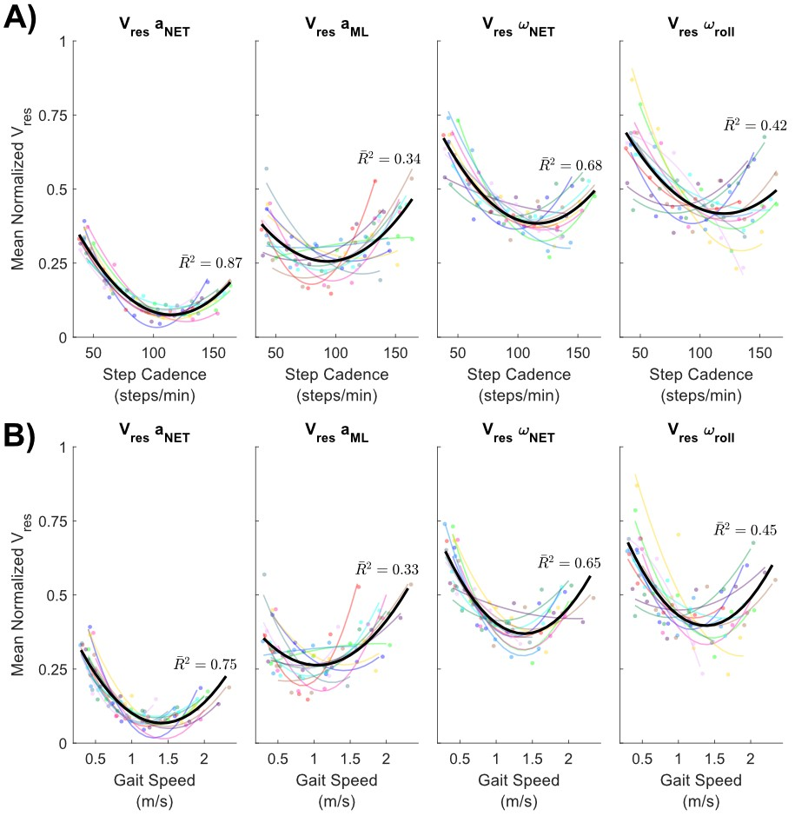
Figure S3. Participant (n = 12) mean normalized proportion of residual variance ($V_{res}$) across A) step cadences and B) gait speeds during trials without electrical vestibular stimulation. $V_{res}$ was calculated with the head net linear acceleration ($V_{res} a_{NET}$), mediolateral linear acceleration ($V_{res} a_{ML}$), net angular velocity ($V_{res}$ $ω_{NET}$), and roll angular velocity ($V_{res}$ $ω_{roll}$). Individual participants are indicated with the same marker colour within and across plots. Thick black lines represent the group 2nd degree polynomial fits for each plot with the adjusted coefficient of determination ( ${\overline{R}}^{2}$) presented. steps/min, steps per minute; m/s, metres per second.

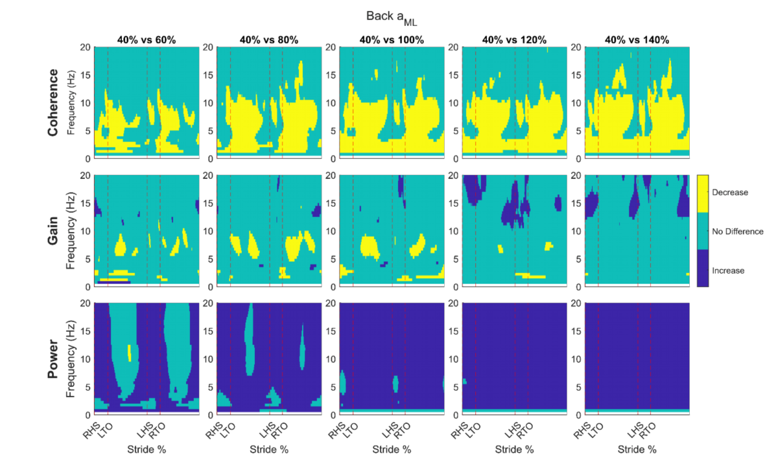
Figure S4. Bootstrapped differences of the coherence (top row), gain (middle row), and spectral power (bottom row) for the back mediolateral linear accelerations ($a_{ML}$). Coherence and gain were calculated between the applied electrical vestibular stimulation and the back $a_{ML}$ and spectral power is the auto spectra of the back $a_{ML}$. Each column contains comparisons between the 40% step cadence condition and a faster step cadence condition (i.e. 60, 80, 100, 120 and 140%). Yellow indicates a decrease in coherence, gain, or power from the 40% condition to the faster step cadence condition, green indicates no significant difference, and blue indicates an increase from the 40% condition. RHS, right heel strike; LTO, left toe-off; LHS, left heel strike; RTO, right toe-off.

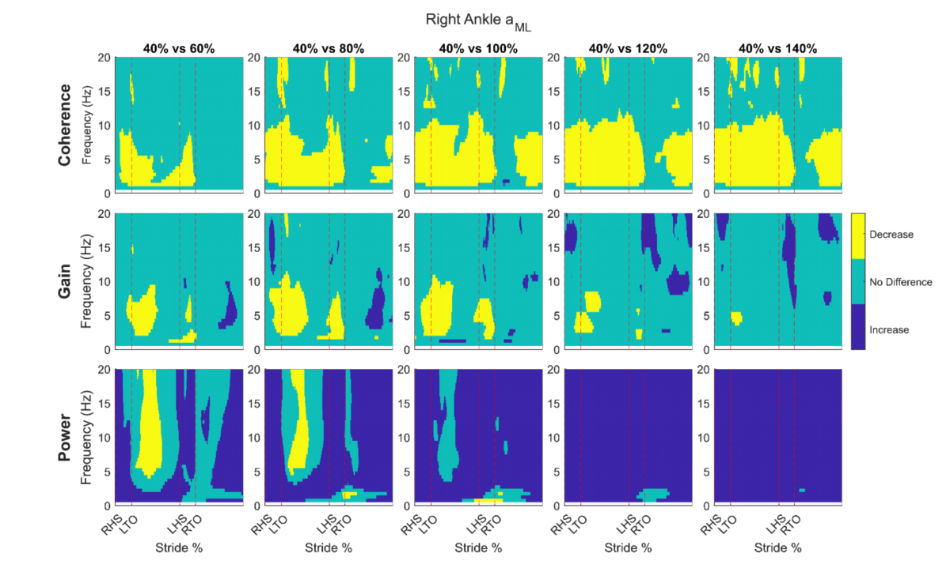
Figure S5. Bootstrapped differences of the coherence (top row), gain (middle row), and spectral power (bottom row) for the right ankle mediolateral linear accelerations ($a_{ML}$). Coherence and gain were calculated between the applied electrical vestibular stimulation and the right ankle $a_{ML}$ and spectral power is the auto spectra of the right ankle $a_{ML}$. Each column contains comparisons between the 40% step cadence condition and a faster step cadence condition (i.e. 60, 80, 100, 120 and 140%). Yellow indicates a decrease in coherence, gain, or power from the 40% condition to the faster step cadence condition, green indicates no significant difference, and blue indicates an increase from the 40% condition. RHS, right heel strike; LTO, left toe-off; LHS, left heel strike; RTO, right toe-off.

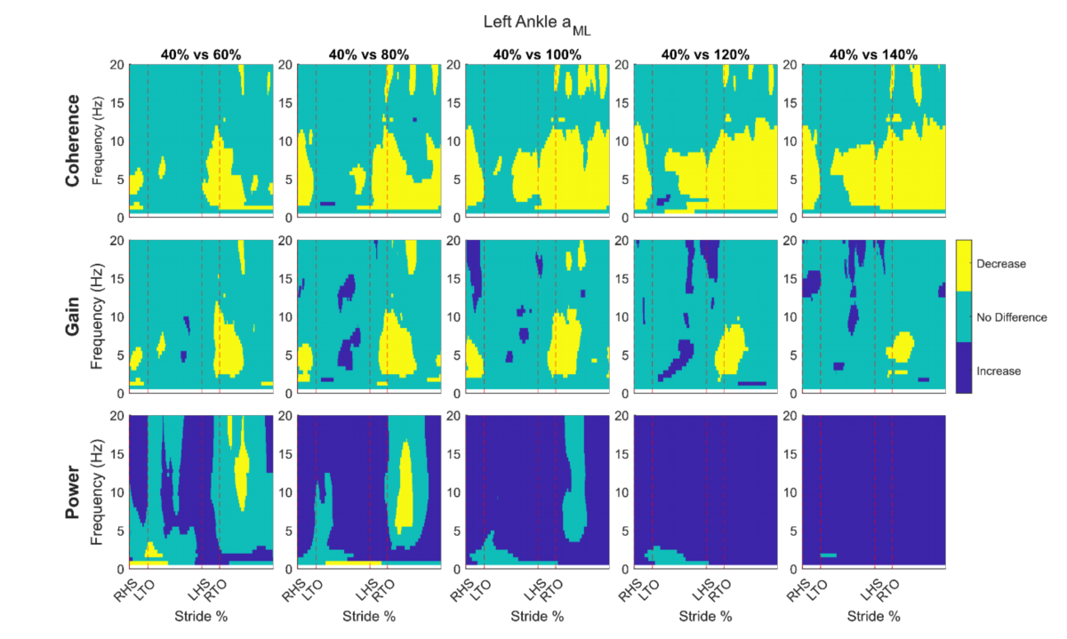
Figure S6. Bootstrapped differences of the coherence (top row), gain (middle row), and spectral power (bottom row) for the left ankle mediolateral linear accelerations ($a_{ML}$). Coherence and gain were calculated between the applied electrical vestibular stimulation and the left ankle $a_{ML}$ and spectral power is the auto spectra of the left ankle $a_{ML}$. Each column contains comparisons between the 40% step cadence condition and a faster step cadence condition (i.e. 60, 80, 100, 120 and 140%). Yellow indicates a decrease in coherence, gain, or power from the 40% condition to the faster step cadence condition, green indicates no significant difference, and blue indicates an increase from the 40% condition. RHS, right heel strike; LTO, left toe-off; LHS, left heel strike; RTO, right toe-off.

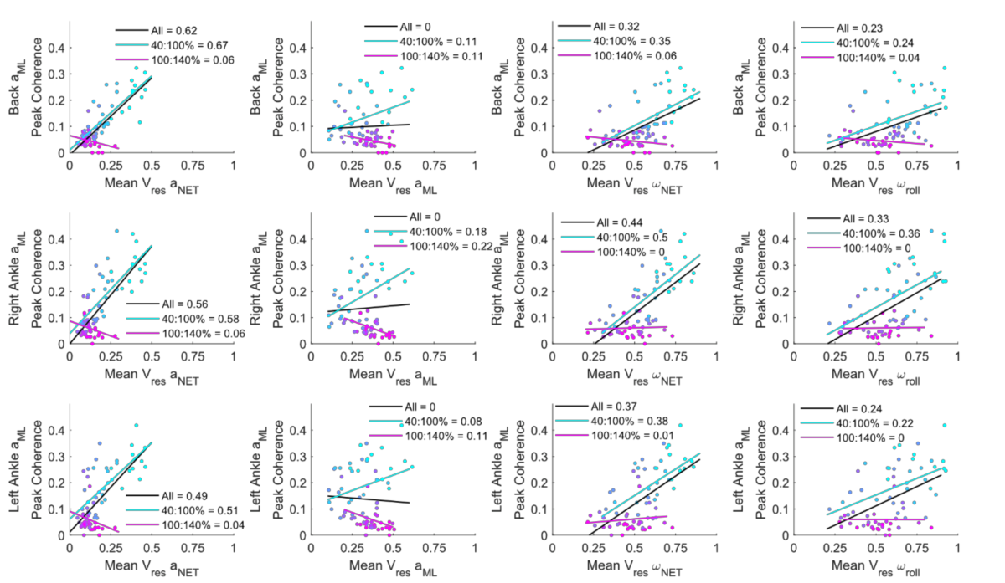
Figure S7. Linear fits between mean proportion of residual variance ($V_{res}$) versus peak coherence for all measures. We calculated $V_{res}$ with the head net linear acceleration ($V_{res} a_{NET}$; first column), mediolateral linear acceleration ($V_{res} a_{ML}$; second column), net angular velocity ($V_{res}$ $ω_{NET}$; third column), and roll angular velocity ($V_{res}$ $ω_{roll}$; fourth column) from the trials with electrical vestibular stimulation. We calculated coherence between the applied electrical vestibular stimulation and the back mediolateral linear acceleration ($a_{ML};$top row), right ankle $a_{ML}$ (middle row), and left ankle $a_{ML}$ (bottom row). The legend indicates the coefficient of determination (R²) for the fit with all the step cadence conditions (“All”, black), the fit with the 40% to 100% step cadence conditions (“40:100%”, light blue), and the fit with the 100% to 140% step cadence conditions (“100:140%”, pink). In all cases, except for $V_{res}$ $ω_{roll}$ vs left ankle $a_{ML}$ coherence, the R² was lower in the fit with all conditions compared to the fit with the 40% to 100% conditions. Closed circles represent the values from individual participants and colour gradient indicates step cadence condition (40%: light blue; 140%: pink).

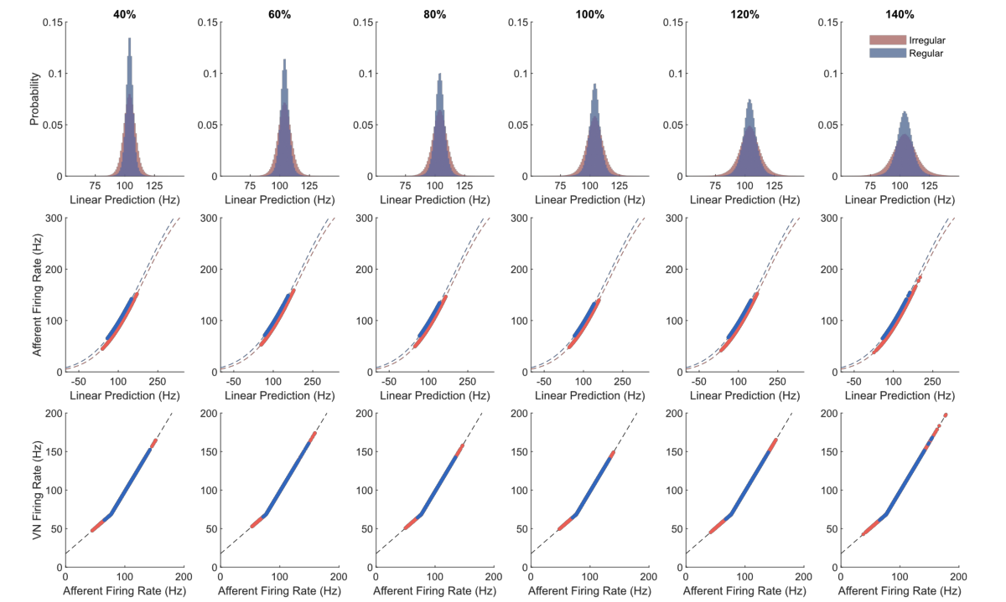
Figure S8. Predicted encoding of canal afferent firing rates from mechanical and electrical stimuli. The firing rates include head kinematic and electrical vestibular stimulation inputs. Top row includes the linear predictions of the firing rates from all irregular (red) and regular (blue) canal afferents in all participants (n = 12). To determine the actual afferent response firing rates (middle row), a sigmoid function (dashed lines) was applied to the linear predictions for irregular and regular primary vestibular afferents. Non-linear processing in central vestibular nuclei (VN) firing rates (bottom row) were estimated with a bi-linear function (dashed black line). Closed circles represent firing rates estimated at a single time step from individual trials and participants.

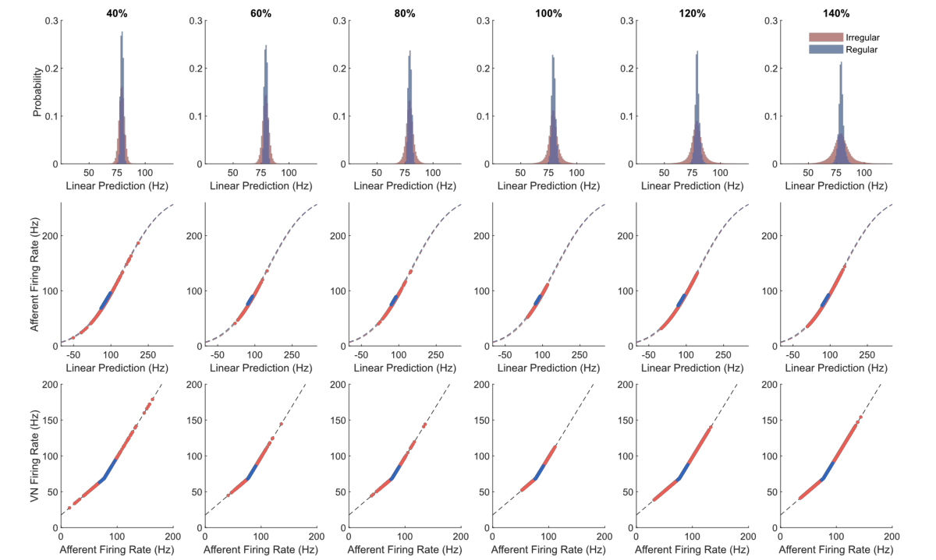
Figure S9. Predicted encoding of otolith afferent firing rates from mechanical and electrical stimuli. The firing rates include head kinematic and electrical vestibular stimulation inputs. Top row includes the linear predictions of the firing rates from all irregular (red) and regular (blue) otolith afferents in all participants (n = 12). To determine the actual afferent response firing rates (middle row), a sigmoid function (dashed lines) was applied to the linear predictions for irregular and regular primary vestibular afferents. Non-linear processing in central, vestibular nuclei (VN) firing rates (bottom row) were estimated with a bi-linear function (dashed black line). Closed circles represent firing rates estimated at a single time step from individual trials and participants.

Figure S10. Comparison of stationary coherence using true electrical vestibular stimulation signals and estimated central vestibular signals. Stationary coherence calculated with the true electrical vestibular stimulation signal (blue line) or the central vestibular encoding estimate (red dashed line) with the back mediolateral acceleration ($a_{ML};$top row), right ankle $a_{ML}$ (middle row), and left ankle $a_{ML}$ (bottom row) across step cadence conditions. The largest difference observed between coherence estimates at a given frequency (across all sensors and conditions) was 0.0089. Horizontal dashed line indicates the 95% confidence threshold for the pooled coherence estimates.

References
1. Forbes, P. A., Siegmund, G. P., Schouten, A. C. & Blouin, J.-S. Task, muscle and frequency dependent vestibular control of posture. Frontiers in Integrative Neuroscience 8, (2015).
2. Foulger, L. H., Charlton, J. M. & Blouin, J.-S. Real-world characterization of vestibular contributions during locomotion. Frontiers in Human Neuroscience 17, (2024).
3. Hannan, K. B., Todd, M. K., Pearson, N. J., Forbes, P. A. & Dakin, C. J. Vestibular attenuation to random-waveform galvanic vestibular stimulation during standing and treadmill walking. Sci Rep 11, 8127 (2021).
4. Schneider, A. D., Jamali, M., Carriot, J., Chacron, M. J. & Cullen, K. E. The increased sensitivity of irregular peripheral canal and otolith vestibular afferents optimizes their encoding of natural stimuli. J. Neurosci. 35, 5522–5536 (2015).
5. Massot, C., Schneider, A. D., Chacron, M. J. & Cullen, K. E. The Vestibular System Implements a Linear–Nonlinear Transformation In Order to Encode Self-Motion. PLOS Biology 10, e1001365 (2012).
6. Dakin, C. J. & Rosenberg, A. Gravity estimation and verticality perception. in Handbook of Clinical Neurology vol. 159 43–59 (Elsevier, 2018).
7. Chen, A. Physiological computations underlying our internal representation of vestibular self-motion. (University of British Columbia, University of British Columbia, 2023).
8. Della Santina, C. C., Potyagaylo, V., Migliaccio, A. A., Minor, L. B. & Carey, J. P. Orientation of human semicircular canals measured by three-dimensional multiplanar CT reconstruction. Journal of the Association for Research in Otolaryngology 6, 191–206 (2005).
9. Mian, O. S., Dakin, C. J., Blouin, J.-S., Fitzpatrick, R. C. & Day, B. L. Lack of otolith involvement in balance responses evoked by mastoid electrical stimulation. The Journal of Physiology 588, 4441–4451 (2010).
10. Tribukait, A. & Rosenhall, U. Directional sensitivity of the human macula utriculi based on morphological characteristics. Audiol Neurootol 6, 98–107 (2001).
11. Kwan, A., Forbes, P. A., Mitchell, D. E., Blouin, J.-S. & Cullen, K. E. Neural substrates, dynamics and thresholds of galvanic vestibular stimulation in the behaving primate. Nature Communications 10, (2019).
12. Goldberg, J. M., Fernandez, C. & Smith, C. E. Responses of vestibular-nerve afferents in the squirrel monkey to externally applied galvanic currents. Brain Research 252, 156–160 (1982).
13. Fitzpatrick, R. C. & Day, B. L. Probing the human vestibular system with galvanic stimulation. Journal of Applied Physiology 96, 2301–2316 (2004).
14. Chen, A., Khosravi-Hashemi, N., Kuo, C., Kramer, J. K. & Blouin, J. S. Development of a conversion model between mechanical and electrical vestibular stimuli. Journal of neurophysiology 123, 548–559 (2020).
15. Chen, A., Kuo, C. & Blouin, J.-S. A portable and low-cost solution for real-time manipulation of the vestibular sense. Journal of Neuroscience Methods 382, 109709 (2022).
16. Sadeghi, S. G., Chacron, M. J., Taylor, M. C. & Cullen, K. E. Neural variability, detection thresholds, and information transmission in the vestibular system. Journal of Neuroscience 27, 771–781 (2007).
17. Jamali, M., Carriot, J., Chacron, M. J. & Cullen, K. E. Strong correlations between sensitivity and variability give rise to constant discrimination thresholds across the otolith afferent population. Journal of Neuroscience 33, 11302–11313 (2013).
18. Mackrous, I., Carriot, J. & Cullen, K. E. Context-independent encoding of passive and active self-motion in vestibular afferent fibers during locomotion in primates. Nat Commun 13, 120 (2022).
19. Forbes, P. A., Kwan, A., Mitchell, D. E., Blouin, J.-S. & Cullen, K. E. The neural basis for biased behavioral responses evoked by galvanic vestibular stimulation in primates. J. Neurosci. 43, 1905–1919 (2023).

