Supplementary information

Development of a flavour wheel for Coffea canephora using rate-all-that-apply

Fabiana M Carvalho^{1*}, Enrique A Alves², Mateus M Artêncio³, Alvaro L L Cassago⁴, Lucas L Pereira⁵

¹Department of Food Science and Nutrition, Faculty of Food Engineering, State University of Campinas (UNICAMP), Campinas, Brazil
²Rondônia Agroforestry Research Center, Brazilian Agricultural Research Corporation (EMBRAPA), Brazil
³Department of Business Administration, School of Economics, Business Administration and Accounting of Ribeirão Preto, University of São Paulo (USP), Brazil
⁴Department of Pharmaceutical Sciences, School of Pharmaceutical Sciences of Ribeirão Preto, University of São Paulo (USP), Brazil
⁵Federal Institute of Education Science and Technology of Espírito Santo (IFES), Venda Nova do Imigrante, Brazil

* Correspondence: Fabiana Carvalho, State University of Campinas, UNICAMP-FEA, Department of Food and Nutrition, Rua Monteiro Lobato, 80, Cidade Universitária, CEP 13083-862, Campinas – SP, Brazil; bibimesq@gmail.com

Supplementary Table S1: Importing (IM) and exporting (EX) graders’ certification, nationality, gender, and years working as coffee grader.
Grader | EX/IM | Gender | Nationality | Certification | Years as grader
1 | EX | male | Switzerland | Q and R grader | 7 years
2 | EX | female | Switzerland | R grader | 8 years
3 | EX | female | Brazil | None | 6 years
4 | EX | female | Italy | Q and R grader | 8 years
5 | EX | male | Switzerland | Q grader | 10 years
6 | EX | female | Italy | Q grader | 7 years
7 | EX | female | Guatemala | Q and R grader | 26 years
8 | EX | female | Netherlands | Q and R Grader | 15 years
9 | EX | female | Switzerland | None | 5 years
10 | EX | male | Colombia | Q and R grader | 10 years
11 | EX | male | Italy | R grader | 37 years
12 | EX | female | Switzerland | Q and R grader | 5 years
13 | EX | male | Netherlands | Q grader | 10+ years
14 | EX | male | Netherlands | Q and R grader | 11 years
15 | EX | male | Germany | R grader | 5 years
16 | EX | male | Costa Rica | Q grader | 7 years
17 | EX | female | Germany | Q and R grader | 32 years
18 | EX | female | Colombia | Q and R grader | 7 years
19 | IM | male | Brazil | Q and R grader | 6 years
20 | IM | male | Brazil | Q grader | 5 years
21 | IM | male | Brazil | Q grader | 4 years
22 | IM | male | Brazil | Q grader | 15 years
23 | IM | female | Brazil | None | 3 years
24 | IM | male | Brazil | Q and R grader | 10 years
25 | IM | female | Brazil | Q grader | 3 years
26 | IM | male | Brazil | R-grader | 21 years
27 | IM | male | Brazil | Q grader | 6 years
28 | IM | female | Brazil | Q grader | 5 years
29 | IM | male | Brazil | None | 4 years
30 | IM | male | Brazil | R-grader | 20 years
31 | IM | female | Brazil | Q grader | 4 years
32 | IM | male | Brazil | Q and R grader | 8 years
33 | IM | female | Brazil | None | 2 years
34 | IM | female | Brazil | None | 2 years
35 | IM | female | Brazil | Q grader | 2 years
36 | IM | female | Brazil | None | 4 years
37 | IM | male | Brazil | Q grader | 8 years
38 | IM | male | Brazil | Q grader | 9 years
39 | IM | male | Brazil | Q grader | 10 years
40 | IM | male | Brazil | Q grader | 20 years
41 | IM | female | Brazil | None | 3 years
42 | IM | female | Brazil | Q grader | 5 years
43 | IM | male | Brazil | R-grader | 9 years
44 | IM | female | Brazil | Q grader | 3 years
45 | IM | female | Brazil | Q grader | 6 years
46 | IM | female | Brazil | None | 3 years
47 | IM | male | Brazil | Q grader | 4 years
48 | IM | female | Brazil | Q grader | 3 years
49 | IM | male | Brazil | Q grader | 6 years

Supplementary Table S2: Characteristics of the water for cupping in Brazil, Switzerland, and the SCA specifications (see reference [18] in the main manuscript).
Characteristic | Brazil  (IFES) | Switzerland (ZHAW) | SCA  specifications
Chlorine (mg/l) | 0 | 0 | 0
Calcium Hardness (ppm CaCO₃) | 60 | 80 | 50–175
pH (before boiling) | 6.5 | 6.5 | 6–8

IFES: Federal Institute of Espirito Santo, Venda Nova do Imigrante, Brazil; ZHAW: Zurich University of Applied Sciences, Coffee Excellence Center, Zurich, Switzerland.

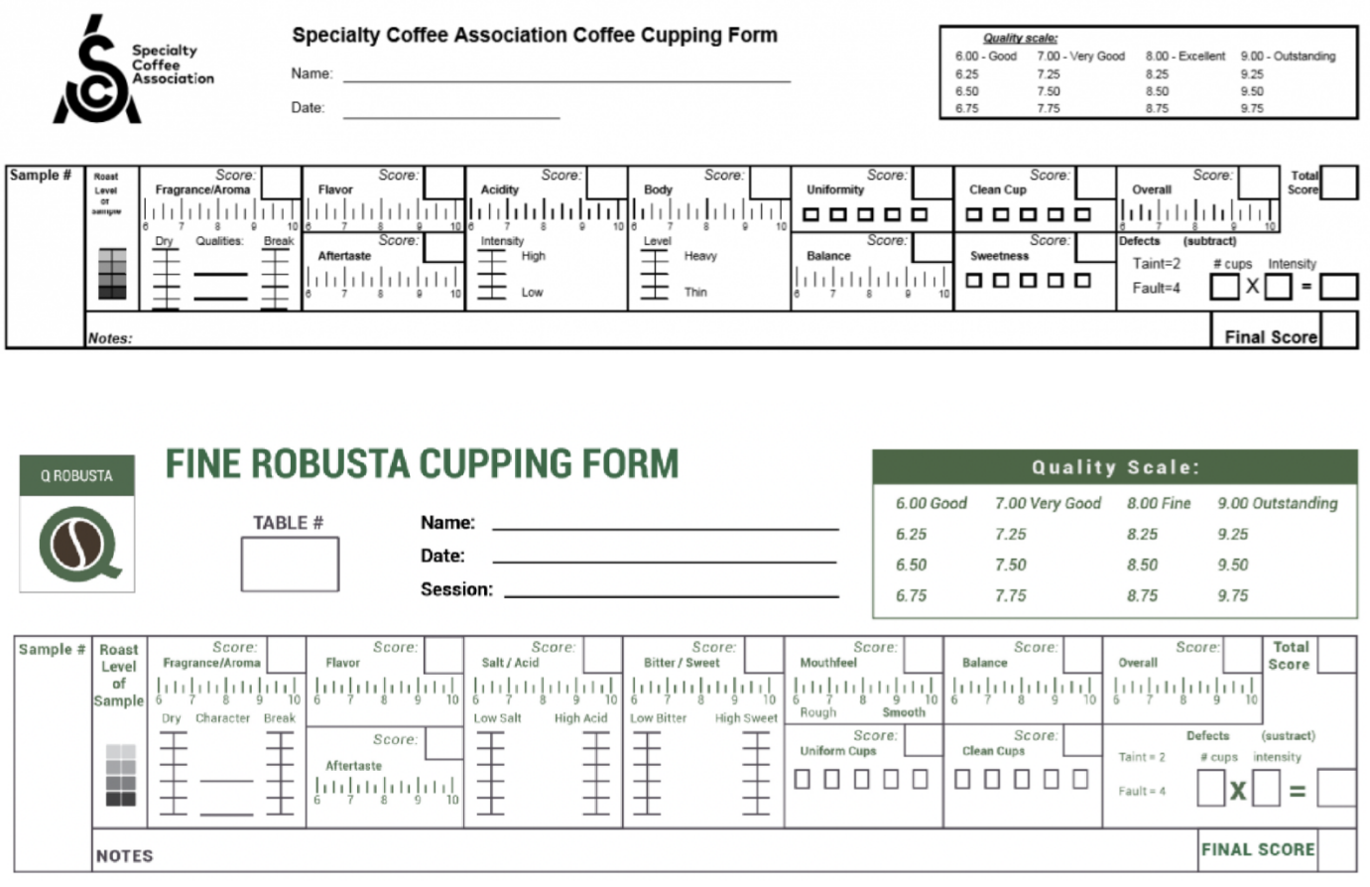
Supplementary Figure S1: Standard cupping protocols for the evaluation of quality of Coffea arabica (top) and Coffea canephora (bottom).

