Supplementary materials

Table S1. Gender-, education-, age-stratified, Q3 ISH-risk for BMI.

Outcome variable BMI |  | Intervention  mean (SD) |  | Control  mean (SD) |  | Adjusted* difference vs control  (95% CI); p-value
Women | Baseline | 28.0 | 2.4 | 27.8 | 2.6 | -
Women | Visit 2 | 27.7 | 2.8 | 27.5 | 2.7 | 0.056 (-0.126 to 0.238) | 0.547
Women | Visit 3 | 28.1 | 2.8 | 27.9 | 2.9 | 0.132 (-0.084 to 0.348) | 0.231
Men | Baseline | 27.6 | 2.0 | 27.6 | 1.9 | -
Men | Visit 2 | 27.4 | 2.1 | 27.4 | 1.9 | -0.002 (-0.282 to 0.277) | 0.988
Men | Visit 3 | 27.7 | 2.2 | 27.6 | 2.0 | 0.077 (-0.275 to 0.430) | 0.666
Age 25-35 | Baseline | 27.9 | 2.5 | 27.7 | 2.3 | -
Age 25-35 | Visit 2 | 27.7 | 2.8 | 27.5 | 2.4 | -0.051 (-0.344 to 0.243) | 0.734
Age 25-35 | Visit 3 | 28.0 | 2.8 | 27.7 | 2.6 | 0.187 (-0.193 to 0.568) | 0.333
Age 36+ | Baseline | 27.7 | 2.1 | 27.8 | 2.3 | -
Age 36+ | Visit 2 | 27.5 | 2.3 | 27.4 | 2.3 | 0.078 (-0.113 to 0.269) | 0.423
Age 36+ | Visit 3 | 27.8 | 2.4 | 27.8 | 2.4 | 0.071 (-0.154 to 0.297) | 0.534
No higher education | Baseline | 27.9 | 2.4 | 27.8 | 2.2 | -
No higher education | Visit 2 | 27.7 | 2.6 | 27.5 | 2.1 | -0.030 (-0.258 to 0.199) | 0.799
No higher education | Visit 3 | 27.9 | 2.7 | 27.7 | 2.3 | 0.087 (-0.212 to 0.387 | 0.567
Higher education | Baseline | 27.6 | 2.0 | 27.6 | 2.3 | -
Higher education | Visit 2 | 27.5 | 2.3 | 27.4 | 2.5 | 0.084 (-0.141 to 0.308) | 0.465
Higher education | Visit 3 | 27.8 | 2.4 | 27.7 | 2.6 | 0.132 (-0.132 to 0.396) | 0.327
25% highest ISH risk in baseline in a study arm | Baseline | 27.8 | 1.9 | 28.0 | 2.1 | - | -
25% highest ISH risk in baseline in a study arm | Visit 2 | 27.6 | 2.0 | 27.7 | 2.2 | 0.064 (-0.225 to 0.353) | 0.664
25% highest ISH risk in baseline in a study arm | Visit 3 | 27.8 | 2.0 | 27.8 | 2.3 | 0.218 (-0.104 to 0.540) | 0.184
*Adjusted to baseline values using analysis of covariance.

Table S2. Outcome analysis of primary and secondary objectives between intervention and control 2 groups.

Outcome variable |  | Intervention  mean (sd) |  | Control 2  mean (sd) |  | Adjusted* difference vs control  (95% CI); p-value
BMI | Baseline | 27.8 | (2.2) | 27.6 | (2.1) | -
BMI | Visit 2 | 27.6 | (2.4) | 27.4 | (2.2) | -0.01 (-0.17 to 0.14) | 0.866
BMI | Visit 3 | 27.9 | (2.5) | 27.6 | (2.3) | 0.07 (-0.12 to 0.27) | 0.444
Waist | Baseline | 92.8 | (8.4) | 92.4 | (8.8) | -
Waist | Visit 2 | 93.7 | (9.3) | 93.0 | (8.6) | 0.51 (-0.16 to 1.18) | 0.138
Waist | Visit 3 | 93.4 | (8.7) | 92.5 | (8.8) | 0.88 ( 0.18 to 1.59) | 0.013
Systolic BP | Baseline | 125.6 | (12.9) | 123.8 | (11.6) | -
Systolic BP | Visit 3 | 124.8 | (12.2) | 123.1 | (11.6) | 0.72 (-0.60 to 2.05) | 0.285
Diastolic BP | Baseline | 79.2 | (9.3) | 77.8 | (9.1) | -
Diastolic BP | Visit 3 | 78.9 | (9.7) | 76.8 | (8.4) | 1.28 (0.25 to 2.30) | 0.014
Cholesterol | Baseline | 5.2 | (1.0) | 5.0 | (0.9) | -
Cholesterol | Visit 3 | 5.2 | (1.0) | 4.9 | (0.9) | 0.09 (-0.01 to 0.18) | 0.081
LDL | Baseline | 3.5 | (0.9) | 3.2 | (0.9) | -
LDL | Visit 3 | 3.5 | (0.9) | 3.2 | (0.9) | 0.04 (-0.05 to 0.13) | 0.398
HDL | Baseline | 1.3 | (0.3) | 1.4 | (0.4) | -
HDL | Visit 3 | 1.4 | (0.4) | 1.4 | (0.4) | 0.02 (-0.02 to 0.06) | 0.442
Blood glucose | Baseline | 5.0 | (0.5) | 5.0 | (0.5) | -
Blood glucose | Visit 3 | 5.1 | (0.6) | 5.0 | (0.5) | 0.05 (-0.01 to 0.11) | 0.119
10-year CVD risk | Visit 3 | 2.2 | (1.2–3.8) | 1.7 | (0.9-2.9) |  | <0.001
*Adjusted to baseline values.

Smoking prevalence and daily smoking
The proportion of daily smokers dropped during the trial by 0.8% in the control arm and by 1.9% in the intervention arm (Figure S1). The McNemar test showed no significant change in daily smoking behaviour between baseline and 12 months in the intervention (χ2 = 0.64, p = 0.4) or the control arm (χ2 = 0, p > 0.99).
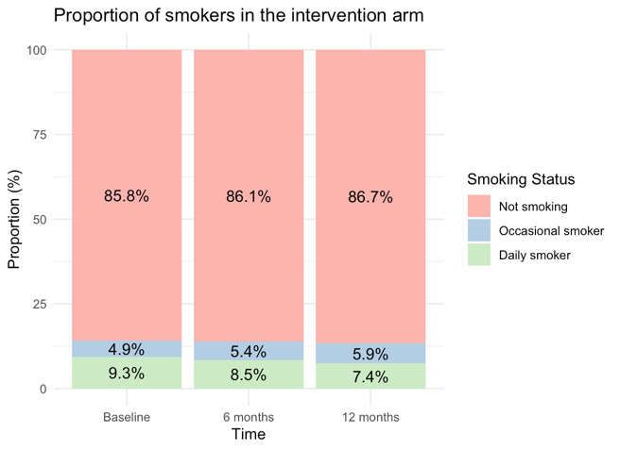 | 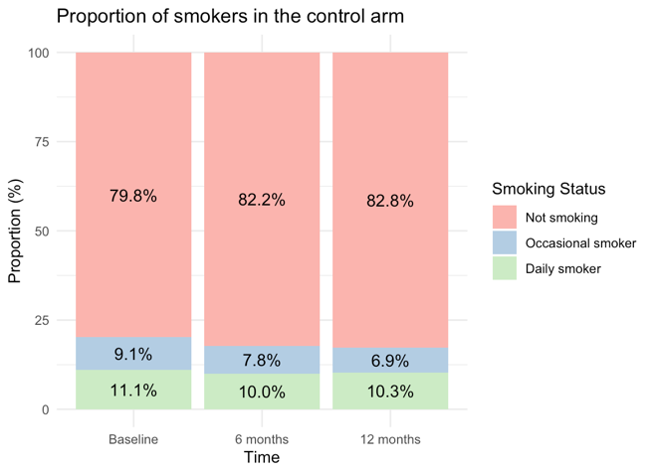
Figure S1. Proportion of smokers in the intervention and control arm.

A t-test found no significant difference in the mean number of smokes between groups at 12 months, t (54.04) = −0.30, p=0.762. A linear mixed model was fitted to examine the effects of study arm allocation and study visit on the number of daily smokes, including their interaction, while accounting for individual variability with a random intercept for participants. The model revealed no significant differences in baseline smoking nor smoking at the end of the trial between groups. There was a slight decline in smoking at 6 months in both groups, but this was not significant. The random effects indicated substantial individual variability in smoking behaviour (variance = 32.51), suggesting that factors beyond group allocation may play a role in smoking habits (Figure S2).
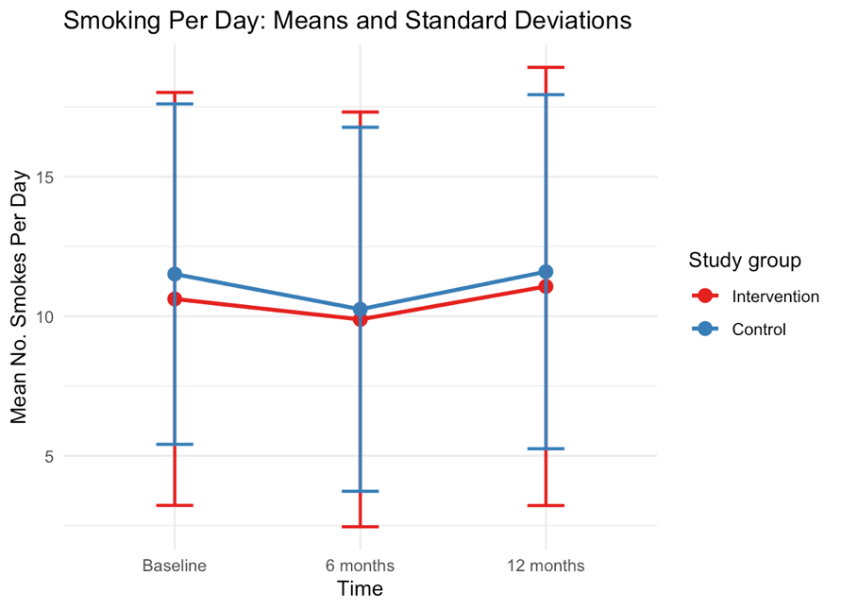
Figure S2. Variation in the average number of cigarettes smoked per day among daily smokers over the course of the trial.

Alcohol consumption
By the end of the trial, the proportion of non-drinkers increased by 2.3%. The McNemar test showed significantly more participants quit drinking (n=84) than started (n=54) (χ² = 6.09, p = 0.014). Both groups showed similar alcohol consumption patterns with no significant changes, likely due to small sample sizes (Figure S3).
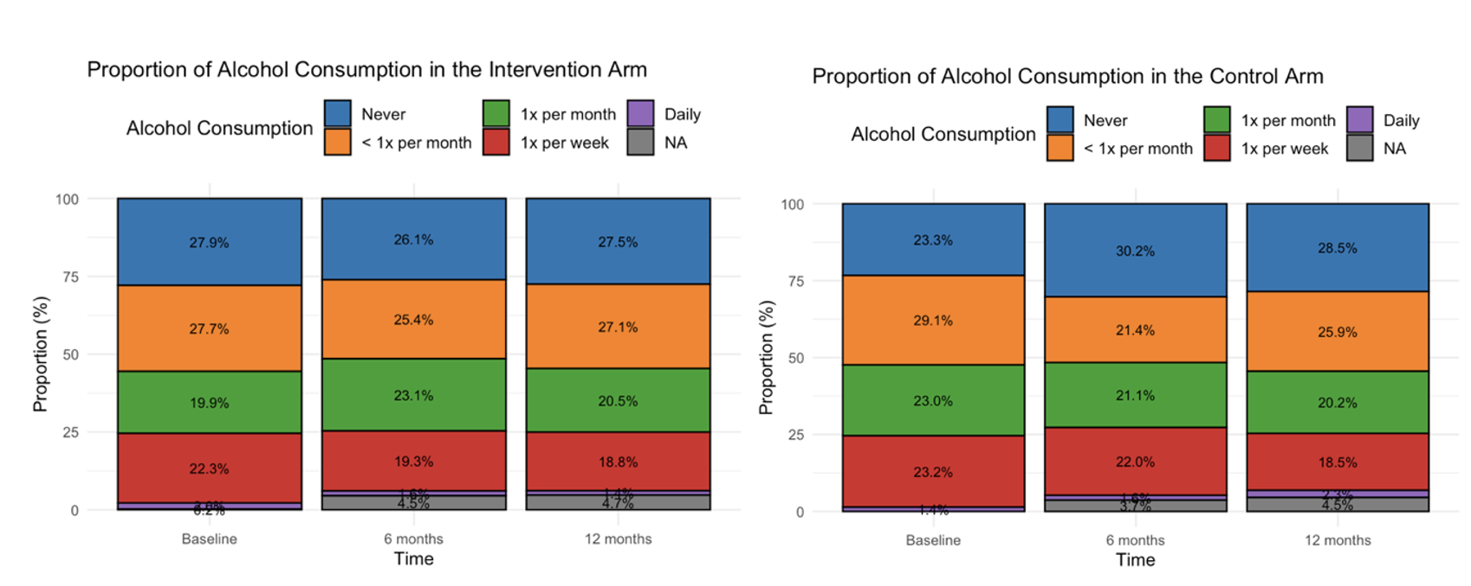
Figure S3. Proportions of alcohol consumption in the intervention (n=451) and control arm (n=441).

Physical activity levels (MET values)
At baseline, mean MET was 2.76 (SD = 0.80) in the intervention group (n=401) and 2.77 (SD = 0.81) in the control group (n=392). After 12 months, MET slightly decreased in the intervention group (2.74, SD = 0.74) but increased in the control group (2.82, SD = 0.84).
A Wilcoxon test showed no significant change in average MET values from baseline to 12 months in the intervention group (p = 0.906), while the control group saw a significant increase (p = 0.034). A Mann-Whitney U-test to compare the distributions of MET values between the intervention and control group at 12 months showed no significant difference between the groups, W = 75 974, p = 0.351. Separate Mann-Whitney U-tests for males and females comparing intervention and control arms at different time points showed no significant differences between groups (Figure S4).
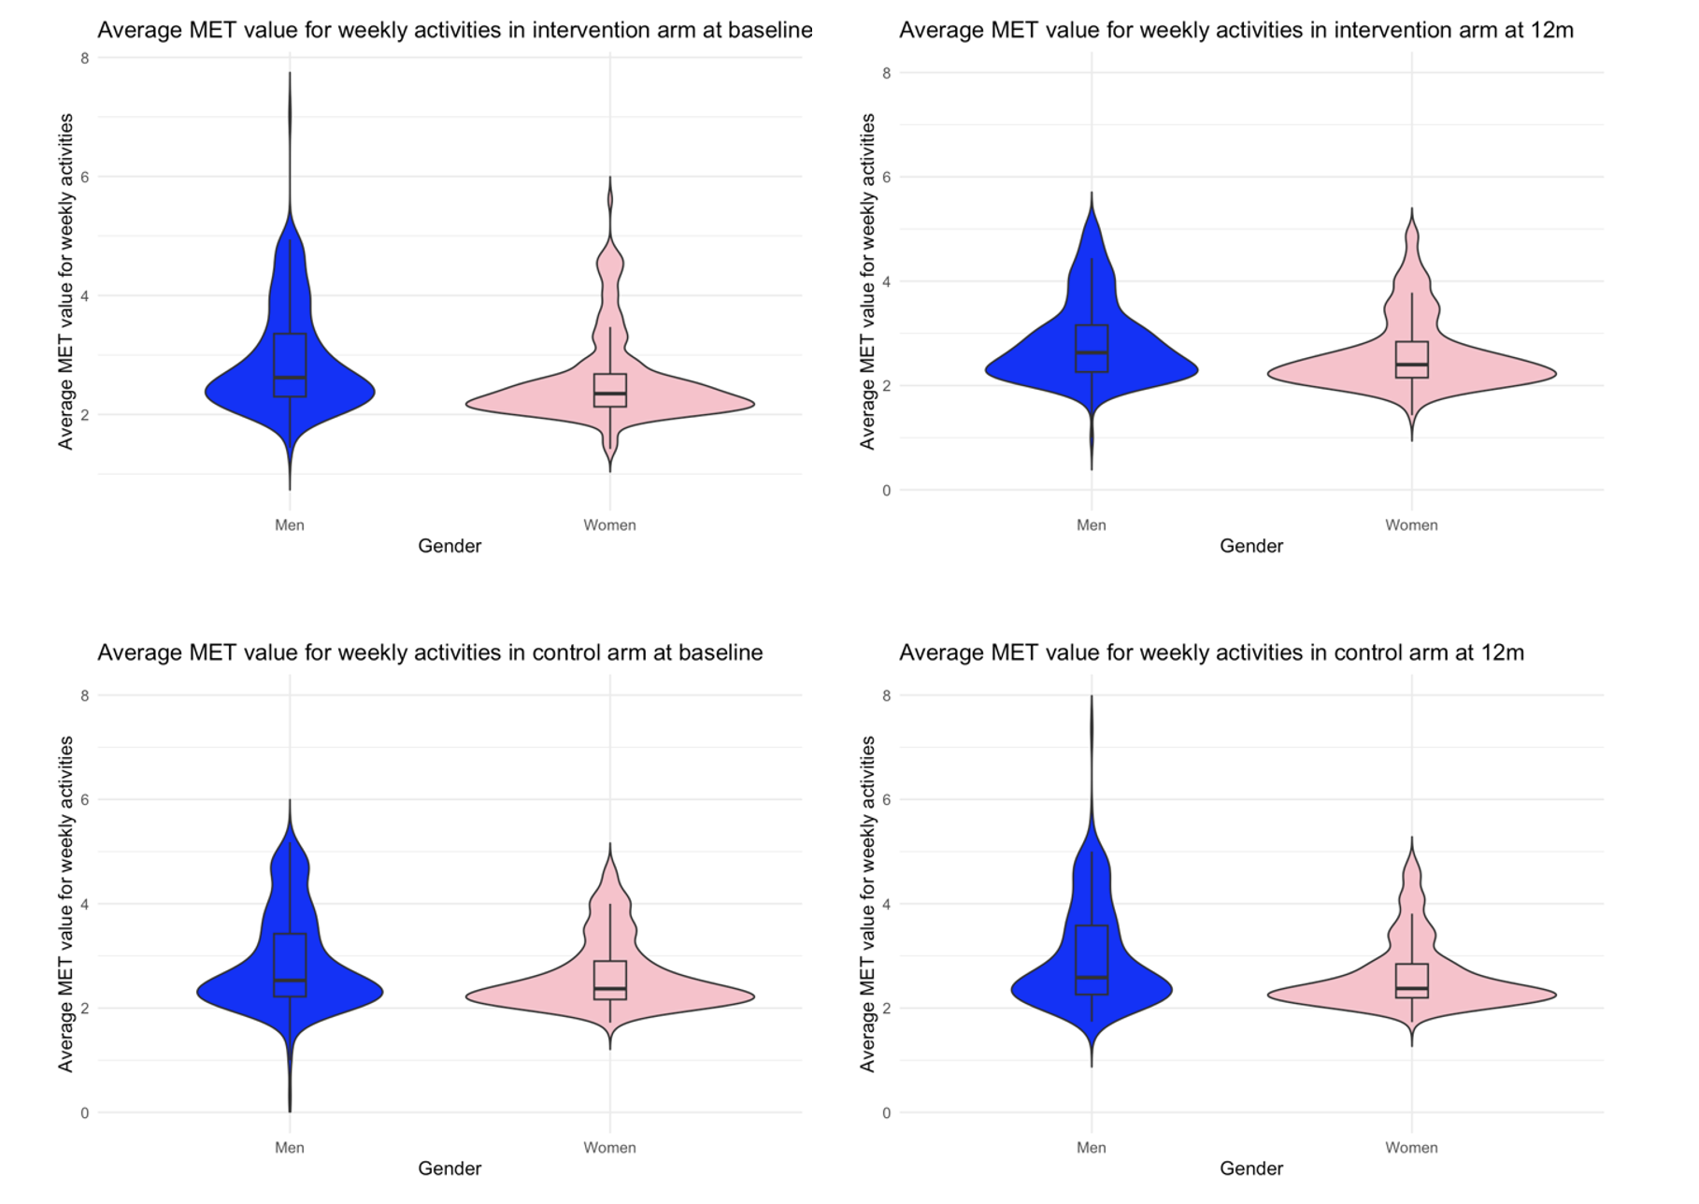
Figure S4. Weekly average MET values assessing physical activity levels in the intervention and control arms at baseline and end of trial.

Changes in dietary patterns

Vegetable consumption
Vegetable consumption was categorized as <300g or ≥300g per day. Baseline chi-square tests showed no significant differences between groups (p=0.31), and this remained at 12 months (p=0.30). In the intervention group, those meeting the 300g target increased from 29% to 39% (χ² = 17.986, df = 1, p < 0.001, McNemar’s test), indicating a significant improvement. The control group showed an increasing trend, but the change was not statistically significant (χ² = 3.0593, df = 1, p=0.080) (Figure S5).

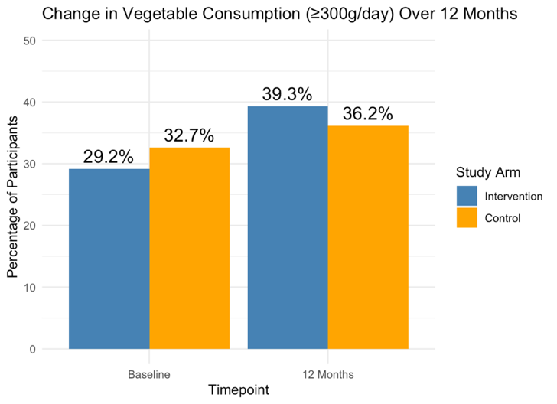

Figure S5. Change in the proportion of individuals meeting the recommended daily vegetable intake in the intervention and control groups from baseline to the end of the trial.

Fruit consumption
Fruit consumption was categorized as <200g or ≥200g/day per health guidelines. Baseline fruit intake was similar between groups (p = 0.45). A logistic regression model with a random intercept for participants assessed the effects of study arm allocation and study visit time. The control group showed no significant change, while the intervention arm significantly increased fruit consumption at 12 months (OR = 1.77, p = 0.011) (Figure S6).
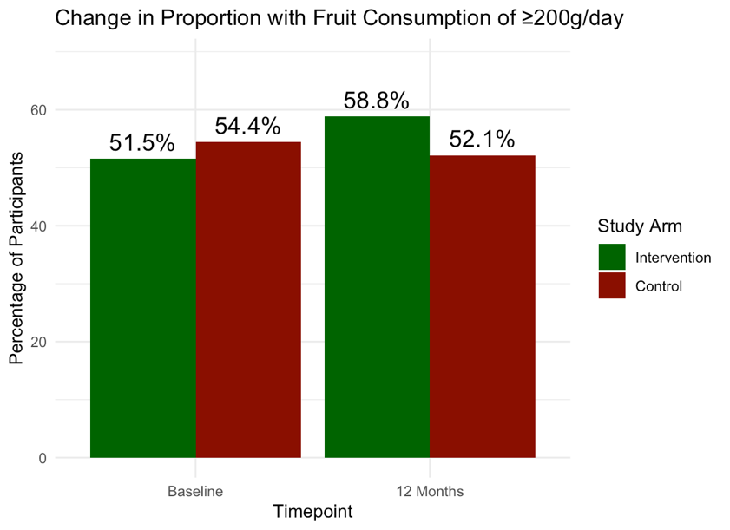

Figure S6. Change in the proportion of individuals meeting the recommended daily fruit intake in the intervention and control groups from baseline to the end of the trial.

