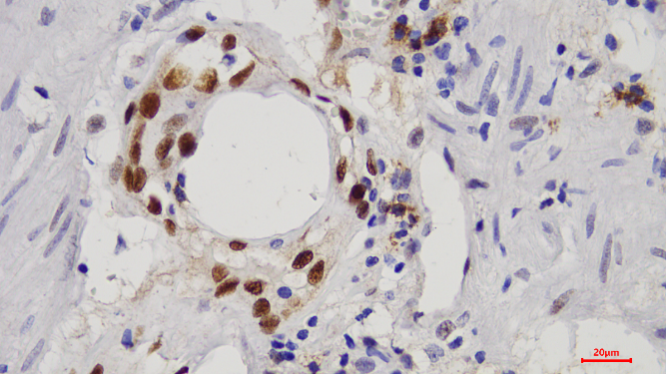  p-STAT3 | 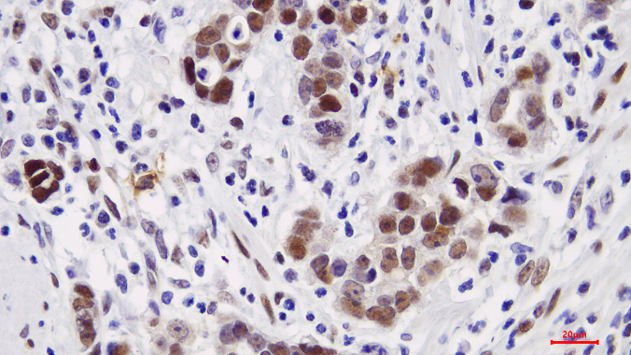
p-STAT3: Positive control | p-STAT3: Strong positive expression (3+)  p-STAT3
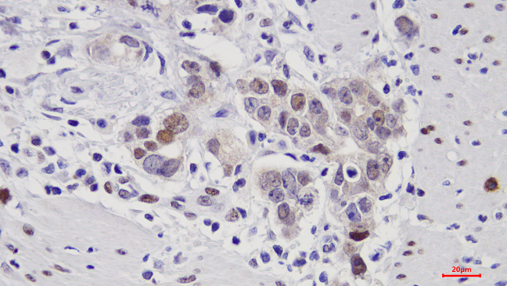  p-STAT3 | 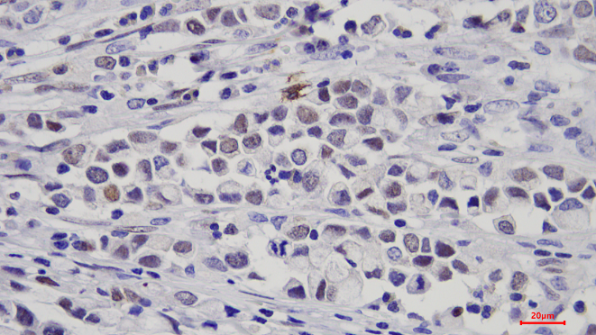  p-STAT3
p-STAT3: Moderate positive expression (2+) | p-STAT3: Weak positive expression (1+)

Supplementary Figure S1. Representative immunohistochemical staining intensity scores of p-STAT3 in gastric cancer tissues. Representative images showing nuclear p-STAT3 immunoreactivity in gastric cancer tissues, classified according to staining intensity as negative (0), weak (1+), moderate (2+), and strong (3+). All images were captured at 400× magnification. Scale bar = 20 μm.

