Supplementary materials

Early hominin arrival in Southeast Asia triggered the evolution of major human malaria vectors

Upasana Shyamsunder Singh^{1,2*†}, Ralph E. Harbach³, Jeffery Hii⁴, Moh Seng Chang⁵, Pradya Somboon⁶, Anil Prakash^{1,7,8}, Devojit Sarma^{1,7,8}, Ben S. Broomfield¹, Katy Morgan¹, Sandra Albert⁹, Aparup Das¹⁰, Yvonne-Marie Linton^{11,12,13}, Jane M. Carlton¹⁴, Catherine Walton^{1*}

Introgression analysis
Using PhyloNet v3.8.0 [1], we reconstructed phylogenetic networks that allow for reticulation between branches. The input comprised of gene trees with one representative individual per species. PhyloNet can infer species networks based on topology alone however, simulations have demonstrated that the accuracy of the inferred species networks can be enhanced by incorporating branch lengths. While using branch lengths, PhyloNet also requires the tree to be ultrametric therefore, input trees were generated in BEAST2 [2], which produces ultrametric trees, with branch lengths. The gene trees were estimated for 2,657 SCO using the R package babette [3] specifying the HKY model of sequence evolution and a chain length of 500,000 iterations. The R script convert_to_newick.r [4] was used to convert the Maximum clade credibility trees produced by BEAST2 for each SCO alignment into Newick format, to combine them into a single input file for PhyloNet. Finally, network searches were performed using “InferNetwork_ML” using branch lengths of gene tree (-bl), allowing 0–3 reticulations and optimising branch lengths and inheritance probabilities (-o). Five iterations were carried out and the log probability of the best inferred network was used to compare log probabilities for 1–3 reticulations (Supplementary Fig. S1) using a log likelihood ratio test. All the networks were visualized using Dendroscope3 [5]. By comparing the fit of models with increasing number of reticulations, we assessed whether the inclusion of additional reticulations significantly improved the model fit. A low p-value (typically < 0.001) suggests that the added reticulation significantly enhances the fit in our data.

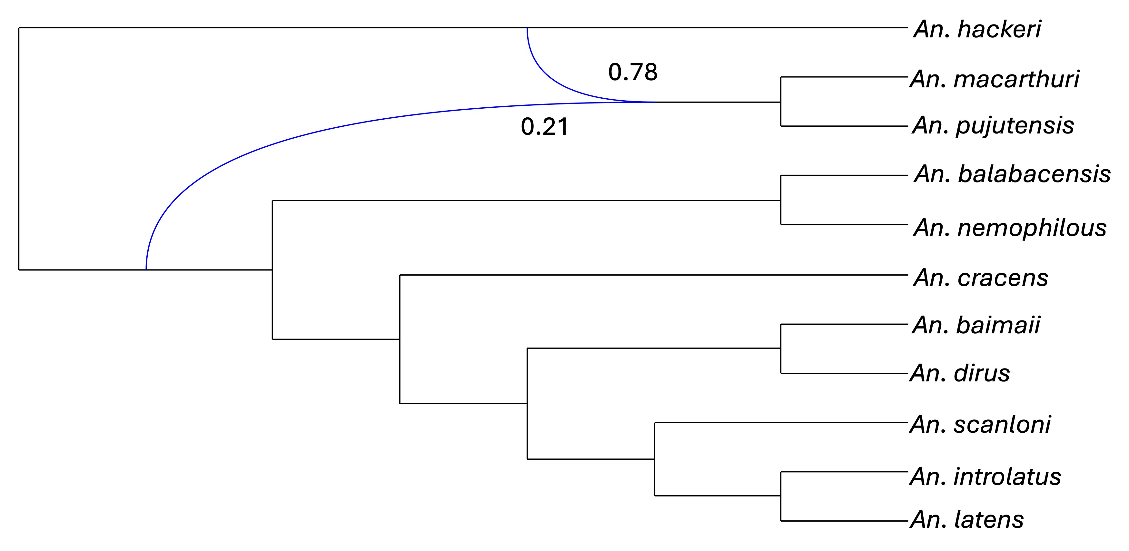

a.

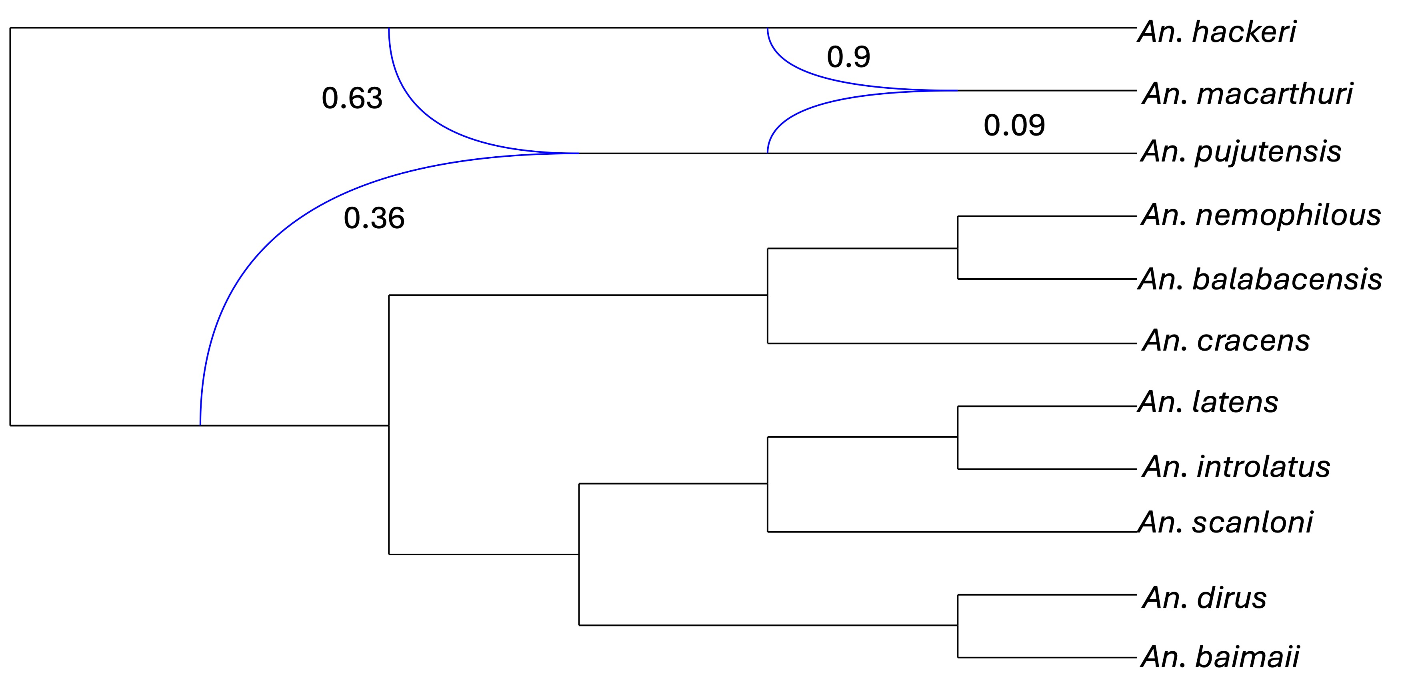

b.

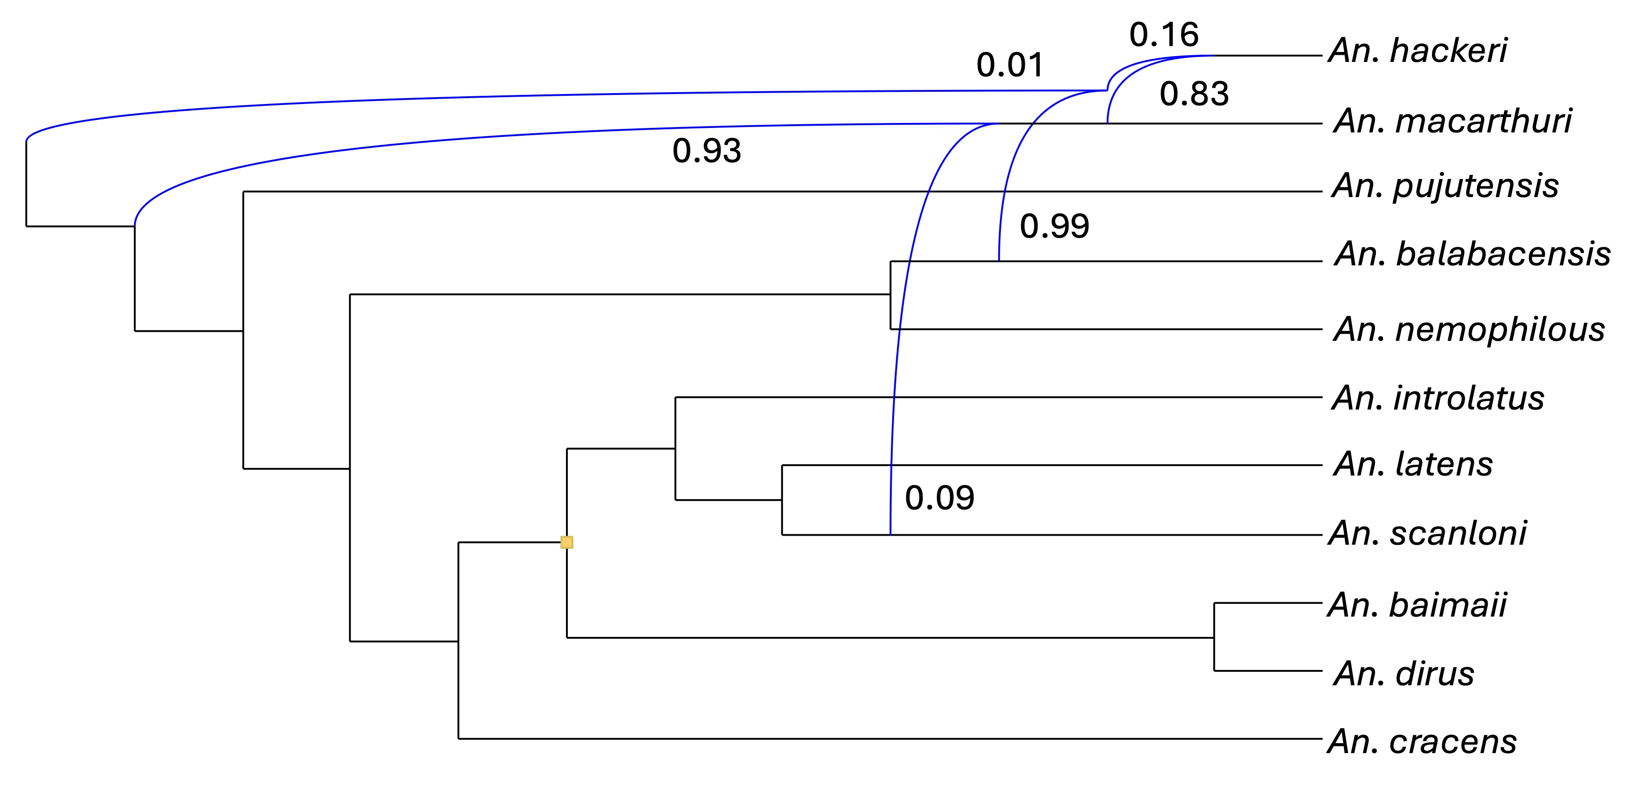

c.

Figure S1. Phylogenetic networks inferred using maximum likelihood in PhyloNet. Optimal networks A, B and C were inferred when the number of reticulations was set to 1, 2 and 3, respectively. The log-likelihoods of the three networks are -1733.79 (a), -1727.66 (b), and -1715.53 (c) with p< 0.001. The backbone network is depicted in black solid lines. The reticulation edges are shown in blue lines. The numbers adjoining reticulation nodes are inheritance probabilities.

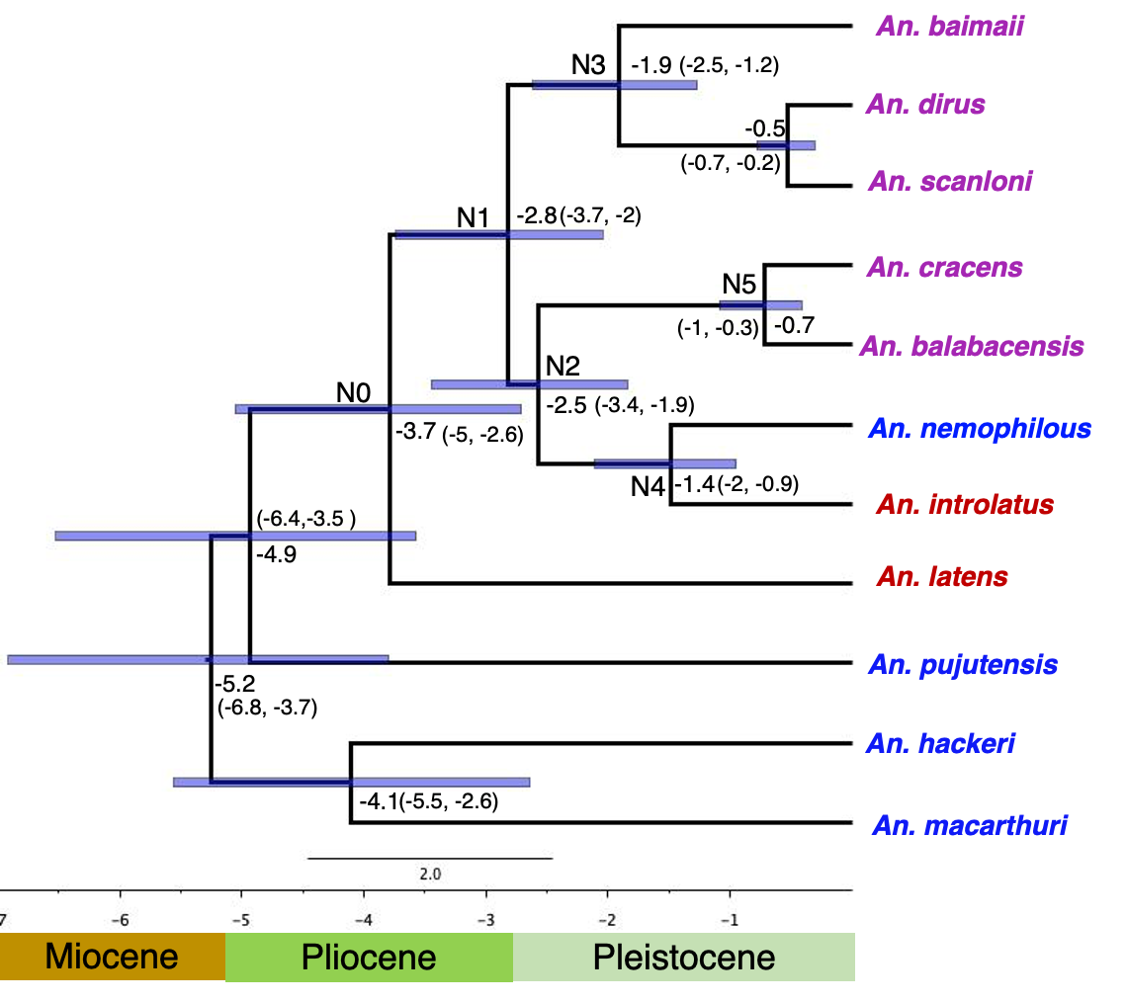
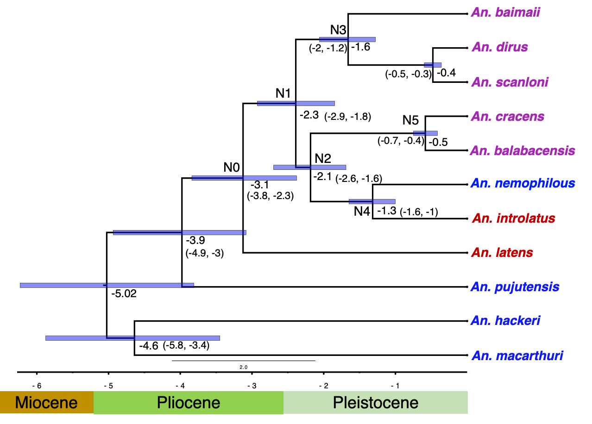

Figure S2. Nuclear chronogram of the Leucosphyrus Group using a Bayesian approach. The divergence dating analysis using 25 clock-like genes both strict clock (on the left) and relaxed clock (on the right) model. The estimated divergence times are indicated by the numbers at the nodes; the blue error bars denote 95% highest posterior densities, and the numbers in parentheses are confidence intervals. The colour of the species names indicates distinct blood-feeding behaviours; blue–NHP feeding, red–mixed-feeding, purple–human feeding.

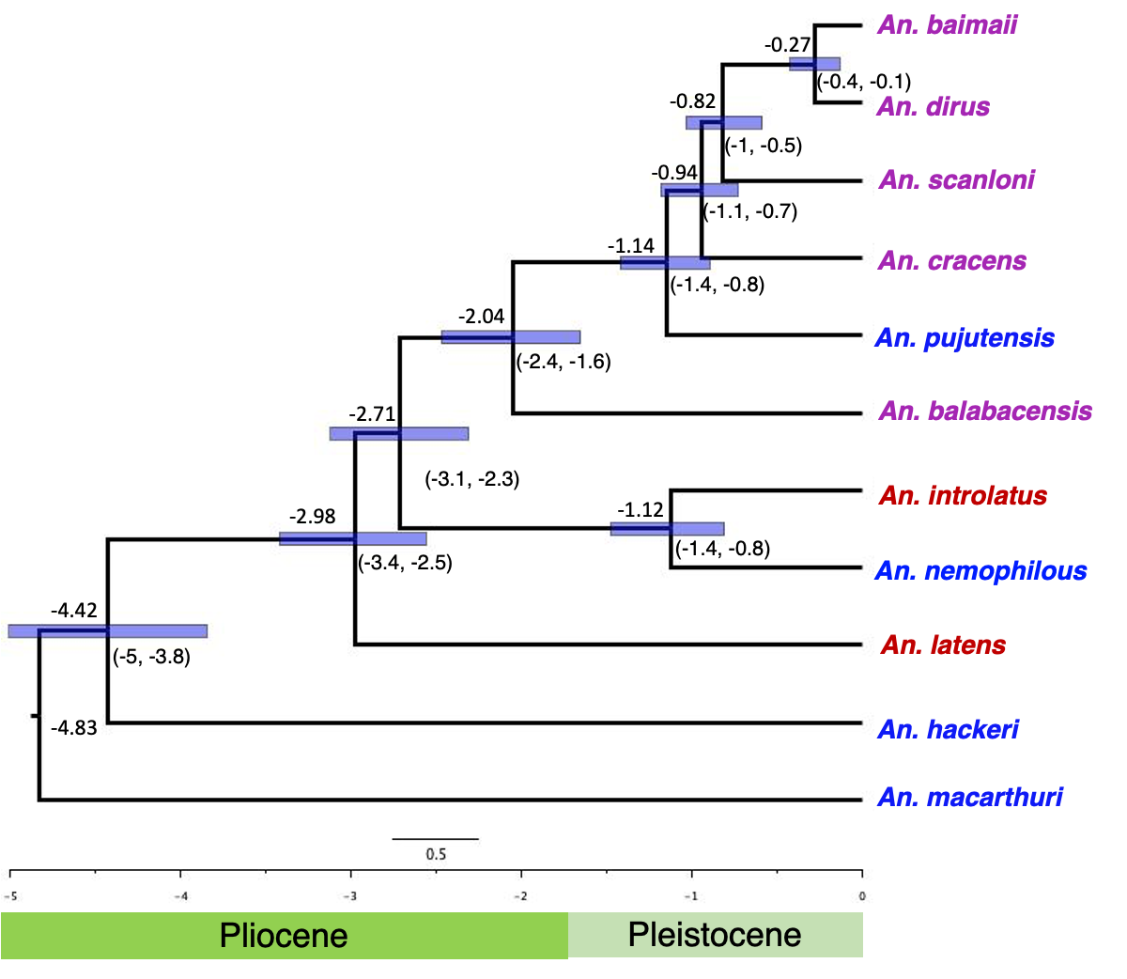
Figure S3. Mitochondrial chronogram of the Leucosphyrus Group using a Bayesian approach. The divergence dating analysis using the mitochondrial COI gene and relaxed clock model. The estimated divergence times are indicated by the numbers at the nodes; the blue error bars denote 95% highest posterior densities, and the numbers in parentheses are confidence intervals.

Table S1. Evidence base for host feeding preferences of species of the Leucosphyrus Group used in this study. The table compiles information from studies that used monkey and human baits variously deployed in the canopy and on the ground to study the feeding behaviour/host preference of Leucosphyrus Group mosquitoes. It also includes comments relevant to host preference made by observations during field collections of mosquitoes used in this study. The last column indicates the feeding category into which species were placed based on this evidence as used in the text and analysis of host preference trait evolution in RASP v4 (Reconstruct Ancestral State in Phylogenies). The three categories are: (A) strictly NHP feeders in the canopy; (B) highly anthropophilic behaviour at ground level and AB- host attraction for both NHP and humans. “Monkey feeding behaviour” is inferred here primarily from host choice experiments that were conducted using monkeys as bait (monkey bait traps [MBT]) however, as an extension we also imply host attraction (for blood feeding) to other NHPs in the forest of Southeast Asia such as gibbons and orangutans. Infection with monkey malarias (P. knowlesi, P. cynomolgi, P. inui, P. coatneyi and P. fieldi) is taken to indicate feeding on NHPs. HLC refers to human landing catches and where substantive numbers are caught indicates a preference for feeding on humans rather than NHPs in the canopy. Mosquito species names have changed over time as more species were discerned. While quotes from papers use the old name, the new name is indicated immediately afterwards in square brackets, where this can be reliably inferred.
Species | Feeding preference from the literature (References) | Comments from mosquito collectors (CW, REH) | Mosquito feeding group
An. hackeri | Distinct preference for monkey bait and host seeking in the canopy [6, 7, 9, 10, 11, 12, 13]. The adults of An. hackeri and An. pujutensis were mostly caught on monkey bait in the canopy and parasite incrimination studies have confirmed that they are vectors of NHP malaria parasites. | Collected as larvae deep in forest in animal wallow | A
An. pujutensis |  | Collected as larvae only in forests | A
An. macarthuri  (formerly An. riparis macarthuri) | Adults of An. macarthuri were only collected on monkey bait in the canopy in primary hill forests [6, 8, 11, 13]. | Strict NHP feeding indicated as mosquitoes were only collected in the larval state in this study (Sarawak, Sabah) but not in synchronous human baited collections in the same area | A
An. nemophilous  (formerly An. balabacensis Fraser’s Hill form or An. dirus species F) | Baimai et al. [14] found that this species feeds primarily above ground level in the forest canopy. It was collected using human bait 12 m above ground level therefore, the author of this paper considers that it could be feeding on monkeys or mammals resting in the forest canopy, where humans are not found [14]. Peyton and Ramalingam [15] commented that this species is much more sensitive to forest cover than An. dirus which may relate to availability of NHP hosts. | Collected extremely rarely in human bait collections in Thailand despite An. dirus and An. baimaii being abundant in the same collections | A
An. latens  (formerly referred to as An. leucosphyrus in Borneo and peninsular Malaysia) | Using human bait only, Baimai et al. [14] collected 37 mosquitoes on a platform, one on the ground in the forest and 32 outside houses in the village, implying that they feed both on the ground and in the canopy, on monkeys and humans.  In village settings (presumably no monkeys present), Colbourne et al. [16] noted, “An. leucosphyrus [An. latens] is anthropophilic: 78.8% fed on humans while the rest fed on dogs, pigs and fowls”.  Wharton et al [11] noted, “A. leucosphyrus [An. latens] and A. b. introlatus [An. introlatus] feed on monkeys in the canopy and bite man on the ground”.  In Sarawak, Malaysian Borneo, Tan et al. [13], noted: “An. latens was the only mosquito positive for sporozoites and it was found to be attracted to both human and monkey hosts. In monkey-baited net traps, it preferred to bite monkeys at the canopy level than at ground level.”  Eyles et al. [17] noted: “An. leucosphyrus [An. latens], does attack man and is considered a human malaria vector in some areas (Sarawak), but in Malaya does not attack man as readily as does A. b. introlatus [An. introlatus]”.  In a recent study, Jeyaprakasam et al [18] reported, “In a village and forest of Peninsular Malaysia, An. latens were infected with P. fieldi and P. inui (10% sporozoite rate).”, indicating feeding on NHP hosts. | Collected readily in human bait collections on the ground in Sarawak | AB
An. introlatus  (formerly An. balabacensis introlatus or A. b. introlatus) | Isolations of P. fieldi [19] and P. cynomolgi [17] (monkey malaria parasites) were made from An. introlatus caught on human bait and monkey bait.  Wharton et al [11] noted: An. leucosphyrus [An. latens] prefers to feed in the canopy, whereas A. b. introlatus [An. introlatus] was caught in about equal numbers in the canopy on monkeys and at ground level on humans.”  According to Warren et al. [9] “An. introlatus readily entered the forest canopy to feed on monkeys and was almost equally prepared to invade human-baited net traps on the ground in the same area”. “Anopheles balabacensis introlatus [An. introlatus] and Anopheles leucosphyrus [An. latens] (both vectors of simian malaria) were trapped in the jungle with man as bait at ground level and monkey as bait in the forest canopy.”  Jeyaprakasam et al. [20] found that both An. introlatus and An. cracens feed on humans and monkeys based on blood meal analysis.  De Ang et al. [21] carried out human landing catches in the forest area where macaques live, and hunting is carried out by villagers. They found that both An. introlatus and An. latens are vectors of NHP malaria parasites in Sarawak with An. introlatus having salivary glands infected with P. knowlesi, P. cynomolgi, P. fieldi, P. inui and P. coatneyi, and An. latens with P. knowlesi.  Jeyaprakasam et al. [22] carried out human landing catches and light trap collections in forests and detected the NHP malaria parasites, P. inui and P. fieldi in An. introlatus and An. cracens.  Jeyaprakasam et al. [18] noted in the forests of Peninsular Malaysia, An. introlatus was predominantly collected using human landing catch and some of them were infected with P. cynomolgi and P. inui. This indicates that it bites both humans and NHPs. | Collected as larvae deep in the forest. | AB
An. cracens  (formerly known as An. balabacensis Perlis Form and An. dirus species B) | Using human landing catches, Baimai et al. [14] collected, seven mosquitoes on a platform in the forest canopy, one mosquito on ground level in forest and nine mosquitoes in a village outside the forest suggesting that this species is highly anthropophilic.  An. cracens (as well as their sibling species An. dirus, An. baimaii and An. scanloni) were collected in substantive numbers using HLC [22].  A preference for biting humans is indicated by Sallum et al [23] who noted: “In Sabang Island (Pulau Weh), Aceh, Sumatra, An. cracens was captured biting humans at night (J. E. Hudson). In west Malaysia, adult females were also captured in human-bait collections at night in secondary tropical rain forest and in villages in localities situated either in mountainous or hilly areas.”  As reported above under An. introlatus, An. cracens was caught using HLC [22], indicating its anthropophilly but was also infected with NHP malaria parasites, P. inui and P. fieldi, indicating it also feeds on monkeys.  According to Jiram et al. [24], “Anopheles cracens was the predominant mosquito biting humans as well as the macaques. It comprised 63.2% of the total collection and was the only species positive for sporozoites of P. knowlesi.” | N/A – colony material only | B
An. balabacensis  (= An. balabacensis balabacensis) | In Peninsular Malaysia “An. balabacensis preferred to bite man more than other animals” [25, 26]  Hii [27] noted, An. balabacensis is an extremely good vector of human malaria parasite and that it bites humans repeatedly while resting in houses.  Harbach et al. [28] noted based on HLC in 1986 in a remote village located in a heavily forested area of South Kalimantan, that “Anopheles leucosphyrus [An. latens] and An. balabacensis comprised 97.7% of the total number of specimens collected outside houses in the village” indicating both species readily feed on humans.  According to Hawkes et al. [29], “HLC caught more An. balabacensis than any other method (3.6 per night). In contrast, no An. balabacensis were collected in MBT collections” implying it likes humans.”  According to Brown et al. [30], “The primary P. knowlesi vector in Sabah, An. balabacensis, was detected at significantly higher numbers near trees with than without macaques; indicating this species is an acceptable host type”.  Brant et al. [31] noted, “the potential ability of An. balabacensis to transmit P. knowlesi between canopy-dwelling simian hosts and ground-dwelling humans”.  Wong et al. [32] in Sabah, detected P. knowlesi infection in An. balabacensis and noted: “Anopheles balabacensis mostly bites humans outdoors in the early evening between 1800 to 2000 hrs.” | Collected readily in human landing catches on the ground and in the canopy in Sabah | B
An. dirus  (formerly known as An. balabacensis or An. dirus species A, from Thailand Cambodia, Lao PDR, Vietnam) | Using HLC, An. dirus, was primarily collected from forests [33, 34], the fringes of primary forests [35] and villages [34]. A high anthropophilic index was reported in all these studies at all the sites indicating that An. dirus prefers humans for blood feeding.  High anthropophilly is further indicated in An. dirus by numerous studies demonstrating its role as a primary vector with high levels of infection with human malarial parasites in Thailand [36-38], Cambodia [34], Laos [39-42] and Vietnam [34, 43].  Anopheles dirus is renowned for maintaining malaria transmission in areas even when numbers are low [39, 44] indicating repeated biting on humans. This is consistent with its high anthropophilic index of 0.69 [45].  Despite its strong preference for humans, Plasmodium parasites of NHP and human malarias have been detected by PCR [46–48] in salivary glands of An. dirus, indicating it is also willing to feed on NHPs. | Collected readily in human bait collections | B
An. baimaii  (formerly known as An. balabacensis or An. dirus species D, from Myanmar, Bangladesh, India and Thailand) | Anopheles baimaii has been identified as a primary vector of human malaria parasites by multiple studies including in northeast India [49, 50], Bangladesh [51], Myanmar [52] and Thailand [53].  In northeast India, An. baimaii was found to have extremely high anthropophilic indices that were inferred from blood meal identifications [49, 50, 54].  In central Myanmar, An. baimaii was reported as a primary vector of human Plasmodium spp. and infected samples were collected using HLC indoors [52].  In a study conducted in Thailand, Tainchum et al. [53] noted: “In Mae Sot, An. dirus and An. baimaii had a preference/attraction to humans with 97% collected on human bait compared to cattle.”  Most collections of An. baimaii were conducted on the ground but Sallum et al. [23] indicated that it may also seek blood meals in the canopy noting: “In Thailand, adults of An. baimaii were collected biting humans in primary and secondary evergreen forest, primary and secondary deciduous forest, primary and secondary rain forest, secondary rain forest mixed with fruit plantations, orchards and rubber plantations, banana and pineapple plantations, villages, villages with fruit plantations, inside houses, and also in the canopy of rain forests 16.5 m above ground level”. | Collected readily in human bait collections | B
An. scanloni  (formerly known as An. balabacensis or An. dirus species C) | An. scanloni was collected using HLC in villages surrounded by forest in Thailand [23, 55–57]. | Collected readily in human bait collections | B

Table S2. Details of mosquito samples, geographical locations and collection method used in the study.

Sample no. | Species | Date of collection | Collection location | Latitude | Longitude | Method of collection
1 | An. baimaii | 21/10/2006 | Myanmar, Taninthari, Dawei, Pakhet Village | 14.12330 | 98.32080 | Larval dipping
2 | An. baimaii | 10/07/2001 | Thailand, Krabi Province, Plai Phraya, Ban Tally Ho | 8.62247 | 98.85439 | Human landing catch
3 | An. baimaii | 15/10/2020 | India, Meghalaya, Garo hills, Gulpani Songmong | 25.20480 | 90.79050 | CDC- light trap
4 | An. baimaii | 08/06/2004 | India, Assam, Dibrugarh, Jorajan | 27.34326 | 95.46376 | CDC-light trap
5 | An. baimaii | 11/10/2006 | Myanmar, Rakhine, ButhiDaung, Tha Daw Village | 20.83087 | 92.41075 | Manual aspiration on cow
6 | An. baimaii | 31/08/1997 | Thailand, Kanchanaburi, Hub-e-Teu | 14.38164 | 98.93928 | Human landing catch
7 | An. balabacensis | 14/11/1996 | Malaysia, Sabah, Papar District, Lingan | 5.62819 | 116.00347 | Human landing catch
8 | An. balabacensis | 30/11/1996 | Malaysia, Sabah, Papar District, Lingan | 5.62819 | 116.00347 | Human landing catch
9 | An. balabacensis | 22/11/1996 | Malaysia, Sabah, Lahad Datu District, Danum Valley Conservation area | 4.96125 | 117.80786 | Larval dipping
10 | An. balabacensis | 21/11/1996 | Malaysia, Sabah, Lahad Datu District, Borneo rainforest Lodge | 5.02519 | 117.75758 | Human landing catch
11 | An. balabacensis | 30/11/1996 | Malaysia, Sabah, Papar District, Lingan | 5.62819 | 116.00347 | Human landing catch
12 | An. cracens | 06/04/1992 | Peninsular Malaysia, Perlis, Padang Besar, US Army Station | 6.64918 | 100.27977 | Lab colony material
13 | An. dirus | 27/08/1995 | Thailand, Tak Province, Mae Sot District, Ban Tam Suea | 16.71386 | 98.57806 | Human landing catch
14 | An. dirus | 28/09/2002 | Thailand, Lampang, Ban Dung | 18.44681 | 99.79431 | Human landing catch
15 | An. dirus | 04/12/2003 | Thailand, Kanchanaburi, Sai yok, Wang Krajae, Bon Bong Ti Noi | 14.26210 | 98.93090 | -
16 | An. dirus | 16/10/1996 | Thailand, Sakhon Nakhon, Khok Si Suphan | 16.99861 | 104.30512 | Human landing catch
17 | An. dirus | 30/10/2003 | Laos, Vientiane, Phon-Hong, Non Som Boon | 18.35013 | 102.27298 | Human landing catch
18 | An. hackeri | 20/11/1996 | Malaysia, Sabah, Lahad Datu District, Danum Valley Conservation area | 4.96125 | 117.80786 | Larval dipping
19 | An. introlatus | 20/11/1996 | Malaysia, Sabah, Lahad Datu District, Danum Valley Conservation area | 4.96125 | 117.80786 | Larval dipping
20 | An. latens | 03/11/1996 | Malaysia, Sarawak, Kuching District, Chupak Village | 1.23122 | 110.43397 | Human landing catch
21 | An. latens | 01/11/1996 | Malaysia, Sarawak, Kuching District, Chupak Village | 1.23122 | 110.43397 | Human landing catch
22 | An. latens | 1997 | Malaysia, Sarawak, Song District, Song | 1.89856 | 112.59390 | Human landing catch
23 | An. latens | 18/07/2001 | Thailand, Phang-nga, Mueang, Ban Song Prak | 8.60002 | 98.55164 | Human landing catch
24 | An. latens | 17/07/2001 | Thailand, Songkhla, Sadao District, Padang Besar, Ban Kwon Kaow Haing | 6.70767 | 100.22986 | Human landing catch
25 | An. macarthuri | 27/11/1996 | Malaysia, Sarawak, Miri District, Lambir National Park | 4.19567 | 114.04631 | Human landing catch
26 | An. macarthuri | 03/11/1996 | Malaysia, Sarawak, Bau District, Tringgus | 1.25833 | 110.09619 | Larval dipping
27 | An. macarthuri | 14/06/1998 | Peninsular Malaysia, Selangor, Ulu Gombak | 3.33131 | 101.77392 | Larval dipping
28 | An. nemophilous | 1995 | Peninsular Malaysia, Perlis, Padang Besar | 6.64918 | 100.27977 | human landing catch
29 | An. nemophilous | 01/09/1997 | Thailand, Kanchanaburi, Hub-e-Teu | 14.38164 | 98.93928 | Human landing catch
30 | An. pujutensis | 27/11/1996 | Malaysia, Sarawak, Miri District, Pujut | 4.40683 | 114.02531 | Larval dipping
31 | An. pujutensis | 28/11/1996 | Malaysia, Sarawak, Miri District, Bukit Kigang | 3.63772 | 114.64264 | Larval dipping
32 | An. pujutensis | 28/11/1996 | Malaysia, Sarawak, Miri District, Bukit Kigang | 3.63772 | 114.64264 | Larval dipping
33 | An. scanloni | 31/08/1997 | Thailand, Kanchanaburi, Hub-e-Teu | 14.38164 | 98.93928 | Human landing catch
34 | An. scanloni | 31/08/1997 | Thailand, Kanchanaburi, Hub-e-Teu | 14.38164 | 98.93928 | Human landing catch
35 | An. scanloni | 22/10/1996 | Thailand, Nakhon Si Thammarat, Thung Song, Ban Nam Tok | 7.96083 | 99.75672 | Human landing catch
36 | An. scanloni | 22/10/1996 | Thailand, Nakhon Si Thammarat, Thung Song, Ban Nam Tok | 7.96083 | 99.75672 | Human landing catch
37 | An. scanloni | 22/10/1996 | Thailand, Nakhon Si Thammarat, Thung Song, Ban Nam Tok | 7.96083 | 99.75672 | Human landing catch
38 | An. scanloni | 22/10/1996 | Thailand, Nakhon Si Thammarat, Thung Song, Ban Nam Tok | 7.96083 | 99.75672 | Human landing catch

Table S3. The current geographical ranges of members of the Leucosphyrus Group mosquitoes from the literature

Species | Geographical range
An. macarthuri | Peninsular Malaysia, Borneo, Thailand K-PL-ISK
An. hackeri | Borneo, Palawan, Peninsular Malaysia, Thailand K-PL-ISK
An. pujutensis | Sumatra, Peninsular Malaysia, Borneo, Thailand below K-PL
An. balabacensis | Palawan, (Sabah and Sarawak/Borneo), Java, Kalimantan, Brunei,
An. latens | Peninsular Malaysia, Borneo, Southern Thailand (below (ISK))
An. introlatus | Peninsular Malaysia, Thailand below K-PL, Indonesia (in Sumatra), Borneo
An. nemophilous | Peninsular Malaysia, Thailand (K-PL-ISK), Northwestern Thailand, Thailand-central to north
An. cracens | Peninsular Malaysia, Thailand K-PL-ISK, Sumatra in Indonesia
An. scanloni | Northwestern Thailand, Thailand K-PL-ISK
An. dirus | Cambodia, Vietnam, Laos, Hainan-China, Thailand (central to north)
An. baimaii | Northeast India including Andaman and West Bengal, Myanmar, Bangladesh, Thailand (K-PL-ISK) + Northwestern Thailand

References :
- D. Wen, Y. Yu, J. Zhu, L. Nakhleh, Inferring phylogenetic networks using PhyloNet. Systematic Biology 67, 735–740 (2018).
- R. Bouckaert, T. G. Vaughan, J. Barido-Sottani, S. Duchêne, M. Fourment, A. Gavryushkina, J. Heled, G. Jones, D. Kühnert, N. De Maio, M. Matschiner, BEAST 2.5: An advanced software platform for Bayesian evolutionary analysis. PLoS Computational Biology 15, e1006650 (2019).
- R. J. C. Bilderbeek, R. S. Etienne, babette: BEAUti 2, BEAST2 and Tracer for R. Methods Ecol. Evol. 9, 2034–2040 (2018).
- M. Malmstrøm, M. Matschiner, O. K. Tørresen, B. Star, L. G. Snipen, T. F. Hansen, H. T. Baalsrud, A. J. Nederbragt, R. Hanel, W. Salzburger, N. C. Stenseth, Evolution of the immune system influences speciation rates in teleost fishes. Nature Genetics 48, 1204–1210 (2016).
- D. H. Huson, C. Scornavacca, Dendroscope 3: an interactive tool for rooted phylogenetic trees and networks. Syst. Biol. 61, 1061–1067 (2012).
- J. A. Reid, Anopheline mosquitoes of Malaya and Borneo. Studies from the Institute for Medical Research Malaysia 31, 520 (1968).
- R. H. Wharton, D. E. Eyles, Anopheles hackeri, a vector of Plasmodium knowlesi in Malaya. Science 134, 279–280 (1961).
- M. Warren, R. H. Wharton, Symposium on simian malaria. The vectors of simian malaria: identity, biology, and geographical distribution. Journal of Parasitology 49, 892–904 (1963).
- M. Warren, W. H. Cheong, H. K. Fredericks, G. R. Coatney, Cycles of jungle malaria in West Malaysia. American Journal of Tropical Medicine and Hygiene 19, 383–393 (1970).
- J. A. Reid, B. Weitz, Anopheline mosquitoes as vectors of animal malaria in Malaya. Annals of Tropical Medicine and Parasitology 55, 180–186 (1961).
- R. H. Wharton, D. E. Eyles, M. Warren, W. H. Cheong, Studies to determine the vectors of monkey malaria in Malaya. Annals of Tropical Medicine and Parasitology 58, 56–77. (1964).
- R. H. Wharton, D. E. Eyles, M. Warren, The development of methods for trapping the vectors of monkey malaria. Ann. Trop. Med. Parasitol. 57, 32–46 (1963).
- C. H. Tan, I. Vythilingam, A. Matusop, S. T. Chan, B. Singh, Bionomics of Anopheles latens in Kapit, Sarawak, Malaysian Borneo in relation to the transmission of zoonotic simian malaria parasite Plasmodium knowlesi. Malaria Journal 7, 1–8 (2008).
- V. Baimai, R. E. Harbach, U. Kijchalao, Cytogenetic evidence for a fifth species within the taxon Anopheles dirus in Thailand. Journal of the American Mosquito Control Association 4, 333–338 (1988a).
- E. L. Peyton, S. Ramalingam, Anopheles (Cellia) nemophilous, a new species of the Leucosphyrus Group from Peninsular Malaysia and Thailand (Diptera: Culicidae). Mosquito Systematics 20, 272–289 (1988).
- M. J. Colbourne, W. H. Huehne, F. S. LaChance, The Sarawak anti-malaria project. Sarawak Museum Journal 9, 215–248 (1959).
- D. E. Eyles, M. Warren, E. Guinn, R. H. Wharton, C. P. Ramachandran, Identification of Anopheles balabacensis introlatus as a vector of monkey malaria in Malaya. Bull. World Health Organ. 28, 134–135 (1963).
- N. K. Jeyaprakasam, V. L. Low, S. Pramasivan, J. W. Liew, W. Y. Wan-Sulaiman, I. Vythilingam, High transmission efficiency of the simian malaria vectors and population expansion of their parasites Plasmodium cynomolgi and Plasmodium inui. PLoS Neglected Tropical Diseases 17, e0011438 (2023).
- D. E. Eyles, The species of simian malaria: taxonomy, morphology, life cycle, and geographical distribution of the monkey species. The Journal of Parasitology 49, 866–887 (1963).
- N. K. Jeyaprakasam, V. L. Low, J. W. Liew, S. Pramasivan, W. Y. Wan-Sulaiman, A. Saeung, I. Vythilingam, Blood meal analysis of Anopheles vectors of simian malaria based on laboratory and field studies. Scientific Reports 12, 1–3 (2022).
- J. X. De Ang, K. Yaman, K. A. Kadir, A. Matusop, B. Singh, New vectors that are early feeders for Plasmodium knowlesi and other simian malaria parasites in Sarawak, Malaysian Borneo. Scientific Reports 11, 7739 (2021).
- N. K. Jeyaprakasam, S. Pramasivan, J. W. Liew, L. Van Low, W. Y. Wan-Sulaiman, R. Ngui, J. Jelip, I. Vythilingam, Evaluation of Mosquito Magnet and other collection tools for Anopheles mosquito vectors of simian malaria. Parasites & Vectors 14, 1–3 (2021).
- M. A. Sallum, E. L. Peyton, B. A. Harrison, R. C. Wilkerson, Revision of the Leucosphyrus group of Anopheles (Cellia) (Diptera, Culicidae). Revista Brasileira de Entomologia 49, 1–152 (2005).
- A. I. Jiram, I. Vythilingam, Y. M. NoorAzian, Y. M. Yusof, A. H. Azahari, M. Y. Fong, Entomologic investigation of Plasmodium knowlesi vectors in Kuala lipis, Pahang, Malaysia. Malaria Journal 11, 1–10 (2012).
- I. Vythilingam, G. L. Chiang, H. L. Lee, K. Singh, Special report on bionomics of important mosquito vectors in Malaysia. Southeast Asian J. Trop. Med. Public Health 23, 581–602. (1992).
- J. L. Hii, Y. Vun, The influence of a heterogeneous environment on host feeding behaviour of Anopheles balabacensis (Diptera: Culicidae). Trop. Biomed 4, 67‒70 (1987).
- J. L. Hii, Evidence for the existence of genetic variability in the tendency of Anopheles balabacensis to rest in houses and to bite man. Southeast Asian J. Trop. Med. Public Health 16, 173‒182 (1985).
- R. E. Harbach, V. Baimai, S. Sukowati, Some observations on sympatric populations of the malaria vectors Anopheles leucosphyrus and Anopheles balabacensis in a village-forest setting in South Kalimantan. Southeast Asian Journal of Tropical Medicine and Public Health 18, 241–247 (1987).
- F. Hawkes, B. O. Manin, S. H. Ng, S. J. Torr, C. Drakeley, T. H. Chua, H. M. Ferguson, Evaluation of electric nets as means to sample mosquito vectors host-seeking on humans and primates. Parasites & Vectors 10, 1–3 (2017).
- R. Brown, M. Salgado-Lynn, A. Jumail, C. Jalius, T. H. Chua, I. Vythilingam, H. M. Ferguson, Exposure of primate reservoir hosts to mosquito vectors in Malaysian Borneo. EcoHealth 19, 233–245 (2022).
- H. L. Brant, R. M. Ewers, I. Vythilingam, C. Drakeley, S. Benedick, J. D. Mumford, Vertical stratification of adult mosquitoes (Diptera: Culicidae) within a tropical rainforest in Sabah, Malaysia. Malaria Journal 15, 1–9 (2016).
- M. L. Wong, T. H. Chua, C. S. Leong, L. T. Khaw, K. Fornace, W. Y. Wan-Sulaiman, T. William, C. Drakeley, H. M. Ferguson, I. Vythilingam, Seasonal and spatial dynamics of the primary vector of Plasmodium knowlesi within a major transmission focus in Sabah, Malaysia. PLoS Neglected Tropical Diseases 9, e0004135 (2015).
- É. A. Vajda, A. Ross, D. Doum, E. L. Fairbanks, N. Chitnis, J. Hii, S. J. Moore, J. H. Richardson, M. Macdonald, S. Sovannaroth, P. Kimheng, Field evaluation of a volatile pyrethroid spatial repellent and etofenprox treated clothing for outdoor protection against forest malaria vectors in Cambodia. Scientific Reports 14, 17348 (2024).
- J. Hii, J. Hustedt, M. J. Bangs, Residual malaria transmission in select countries of Asia-Pacific region: old wine in a new barrel. The Journal of Infectious Diseases 223, S111–S142 (2021).
- A. Vantaux, M. M. Riehle, E. Piv, E. J. Farley, S. Chy, S. Kim, A. G. Corbett, R. L. Fehrman, A. Pepey, K. Eiglmeier, D. Lek, Anopheles ecology, genetics and malaria transmission in northern Cambodia. Scientific Reports 11, 6458 (2021).
- B. Greenwood, K. De Cock, Eds., New and resurgent infections: prediction, detection and management of tomorrow’s epidemics. (Chichester UK: John Wiley & Sons, 1998).
- P. Singhasivanon, K. Thimasarn, S. Yimsamran, K. Linthicum, K. Nualchawee, D. Dawreang, S. Kongrod, N. Premmanisakul, W. Maneeboonyang, N. Salazar, Malaria in tree crop plantations in south-eastern and western provinces of Thailand. Southeast Asian J. Trop. Med. Public Health 30, 399–404 (1999).
- C. Tananchai, S. Manguin, M. J. Bangs, T. Chareonviriyaphap, Malaria vectors and species complexes in Thailand: implications for vector control. Trends in Parasitology 35, 544-558 (2019).
- H. D. Trung, W. Van Bortel, T. Sochantha, K. Keokenchanh, N. T. Quang, L. D. Cong, M. Coosemans, Malaria transmission and major malaria vectors in different geographical areas of Southeast Asia. Trop. Med. Int. Health 9, 230–237 (2004).
- I. Vythilingam, K. Keokenchan, S. Phommakot, S. Nambanya, S. Inthakone, Preliminary studies of Anopheles mosquitos in eight provinces in Lao PDR. Southeast Asian J. Trop. Med. Public Health 32, 83–87 (2001).
- T. Toma, I. Miyagi, T. Okazawa, J. Kobayashi, S. Saita, A. Tuzuki, H. Keomanila, S. Nambanya, S. Phompida, M. Uza, M. Takakura, Entomological surveys of malaria in Khammouane Province, Lao PDR, in 1999 and 2000. Southeast Asian J. Trop. Med. Public Health 33, 532–546 (2002).
- J. Kobayashi, S. Phompida, T. Toma, S. Looreensuwan, H. Toma, I. Miyagi, The effectiveness of impregnated bed net in malaria control in Laos. Acta Tropica 89, 299–308 (2004).
- H. M. Edwards, V. D. Chinh, B. Le Duy, P. V. Thanh, N. D. Thang, D. M. Trang, I. Chavez, J. Hii, Characterising residual malaria transmission in forested areas with low coverage of core vector control in central Viet Nam. Parasites & Vectors 12, 1–6 (2019).
- R. Rosenberg, R. G. Andre, L. Somchit, Highly efficient dry season transmission of malaria in Thailand. Trans. R. Soc. Trop. Med. Hyg. 84, 22–28 (1990).
- S. Marcombe, S. Maithaviphet, R. Reyburn, K. Kunlaya, K. Silavong, B. Hongvanthong, V. Vanisaveth, V. Sengsavath, V. Banouvong, K. Chindavongsa, B. Khamlome, Bionomics of malaria vectors in Lao PDR, 2018–2020: entomological surveillance as a key tool for malaria elimination. Malaria Journal 22, 319 (2023).
- S. Nakazawa, R. P. Marchand, N. T. Quang, R. Culleton, N. D. Manh, Y. Maeno, Anopheles dirus co-infection with human and monkey malaria parasites in Vietnam. Int. J. Parasitol. 39, 1533–1537 (2009).
- Y. Maeno, N. T. Quang, R. Culleton, S. Kawai, G. Masuda, S. Nakazawa, R. P. Marchand, Humans frequently exposed to a range of non-human primate malaria parasite species through the bites of Anopheles dirus mosquitoes in South-central Vietnam. Parasites & Vectors 8, 1–7 (2015).
- R. P. Marchand, R. Culleton, Y. Maeno, N. T. Quang, S. Nakazawa, Co-infections of Plasmodium knowlesi, P. falciparum, and P. vivax among Humans and Anopheles dirus Mosquitoes, Southern Vietnam. Emerging Infectious Diseases 17, 1232 (2011).
- A. Prakash, D. R. Bhattacharyya, P. K. Mohapatra, J. Mahanta, Indoor biting behaviour of Anopheles dirus Peyton and Harrison, 1979 in upper Assam, India. Mosquito Borne Diseases Bulletin 14, 31–37 (1997).
- A. Prakash, D. R. Bhattacharyya, P. K. Mohapatra, J. Mahanta, Malaria transmission risk by the mosquito Anopheles baimaii (formerly known as An. dirus species D) at different hours of the night in North‐east India. Medical and Veterinary Entomology 4, 423–427 (2005).
- M. H. Uddin, U. Habiba, M. R. Hamid, S. B. Rashid, M. A. Shahid, Vector Bionomics of Anopheline Fauna in Malaria Endemic Areas (Three Sentinel Sites) of Bangladesh. Saudi J Med Pharm Sci. 9, 14–23 (2023).
- W. Tun-Lin, M. M. Thu, S. M. Than, M. M. Mya, Hyperendemic malaria in a forested, hilly Myanmar village. J. Am. Mosq. Control Assoc. 11, 401–407 (1995).
- K. Tainchum, W. Ritthison, T. Chuaycharoensuk, M. J. Bangs, T. Chareonviriyaphap, Diversity of Anopheles species and trophic behavior of putative malaria vectors in two malaria endemic areas of northwestern Thailand. Journal of Vector Ecology 39, 424–436 (2014).
- P. Dutta, D. R. Bhattacharyya, S. A. Khan, C. K. Sharma, J. Mahanta, Feeding patterns of Anopheles dirus, the major vector of forest malaria in northeast India. Southeast Asian J. Trop. Med. Public Health 27, 378–381 (1996).
- S. R. Meek, Vector control in some countries of Southeast Asia: comparing the vectors and the strategies. Ann. Trop. Med. Parasitol. 89, 135–147 (1995).
- S. Manguin, P. Kengne, L. Sonnier, R. E. Harbach, V. Baimai, H. D. Trung, M. Coosemans, SCAR markers and multiplex PCR- based identification of isomorphic species in the Anopheles dirus complex in Southeast Asia. Medical and Veterinary Entomology 16, 46–54 (2002).
- S. M. O'Loughlin, P. Somboon, C. Walton, High levels of population structure caused by habitat islands in the malarial vector Anopheles scanloni. Heredity 99, 31–40 (2007).

