Supporting information: Integrating plasma small molecule and gut microbiome markers of Sarcopenia in a pilot study from an Indian cohort

Supplementary Table
Table 1S. Distribution of clinical features of the cohort. Significant differences are bolded (* p-value < 0.05)
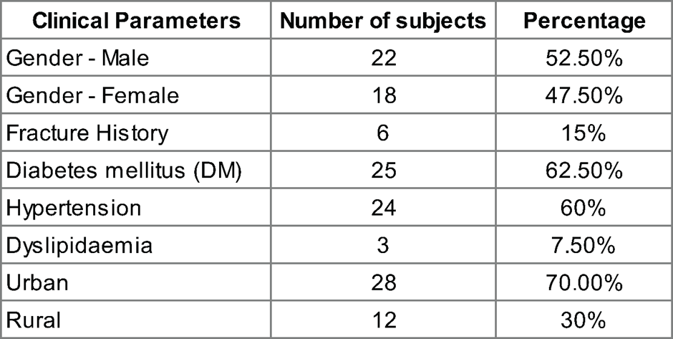

Table 2S. Clinical measurements within the cohort.
Clinical Parameters | Mean | SD
Age (years) | 68.10 | 5.68
BMI (kg/m2) | 26.24 | 4.94
SARCF Score | 2.60 | 2.59
Dominant Hand Grip Strength (kg) | 18.98 | 8.59
Chair stand test time (seconds) | 16.39 | 7.47
psoas-HU | 39.26 | 7.53
Cross Section Area of psoas-HU | 110.90 | 27.61
Skeletal muscle mass index (kg/m2) | 42.32 | 8.71
Serum Creatininie (mg/dL) | 0.98 | 0.19
Total Serum Protien (g/dL) | 7.20 | 0.40
Serum Albumin (g/dL) | 4.27 | 0.28
Bilirubin (mg/dL) | 0.13 | 0.06
Total Bilirubin (mg/dL) | 0.73 | 0.34
Serum Alkaline Phosphatase (U/L) | 84.30 | 20.10
SGOT AST (U/L) | 24.45 | 8.33
SGPT-ALT (U/L) | 21.33 | 8.29
Total Cholesterol (mg/dL) | 185.75 | 40.51
High-density lipoprotein (mg/dL) | 44.23 | 9.46
Direct Low-density lipoprotein (mg/dL) | 117.78 | 29.46
Thyroglobulin Serum (mg/dL) | 162.85 | 77.66
Very Low-density lipoprotein (mg/dL) | 32.65 | 15.43
Total Cholesterol High density lipoprotein | 4.38 | 0.93
Low-density lipoprotein/High-density lipoprotein | 2.70 | 0.72
Specific Gravity | 1.01 | 0.00
pH | 5.71 | 0.78
Haemoglobin (g/dL) | 13.08 | 1.91
Haematocrit (%) | 40.07 | 5.09
Total RBC Count (X 10^6/mm^3) | 4.89 | 0.51
Total WBC Count (X 10^3/mm^3) | 7.50 | 2.00
Neutrophil to Lymphocyte ratio (NLR) | 2.12 | 0.78
Neutrophils (%) | 58.38 | 6.40
Lymphocytes (%) | 29.80 | 6.64
Monocytes (%) | 7.00 | 1.68
Eosinophils (%) | 4.20 | 3.26
Basophils (%) | 0.68 | 0.53
Mean Corpuscular Volume (MCV) (FL) | 81.94 | 8.42
Mean Corpuscular Hemoglobin (MCH) (pg) | 26.80 | 3.31
Mean Corpuscular Hemoglobin Concentration (MCHC) (g/dL) | 32.64 | 0.97
Red Blood Cell Distribution Width (RDW) (%) | 15.01 | 1.68
Platelet Count (X 103/mm3) | 270.90 | 81.87
Erythrocyte Sedimentation Rate (ESR) (mm after 1hr) | 17.10 | 12.82
Hemoglobin A1C (%) | 7.39 | 1.85
Thyroid Stimulating Hormone (TSH) (μlU/ml) | 3.02 | 2.41
Vitamin D3 (ng/ml) | 23.28 | 11.95
Table 3S. Number of subjects in the clinical features between sarcopenic and non-sarcopenic. Significant differences are highlighted (* p-value < 0.05)
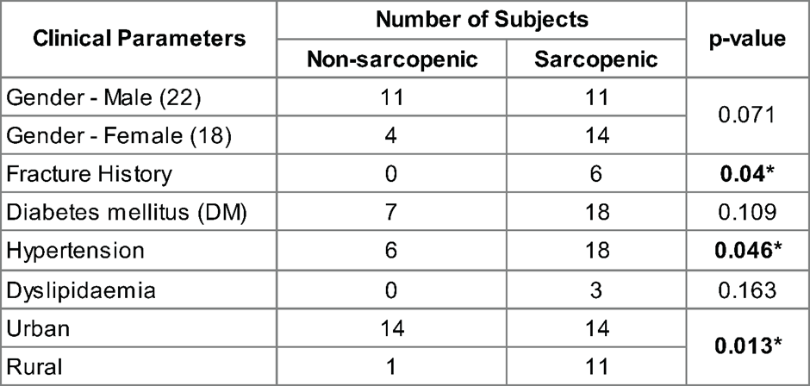

Table 4S. Comparative Analysis of Clinical and Demographic Metadata in Sarcopenic Sub-Groups and Controls. This table investigates the clinical and demographic metadata differences between sarcopenic subgroups. Two-group comparisons (Sarcopenic vs. Non-Sarcopenic) were analyzed using the Mann-Whitney test, while three-group comparisons (Non-Sarcopenic vs. Sarcopenic-G1 vs. Sarcopenic-G2) were analyzed using the Kruskal-Wallis test. Additionally, Dunn's test was conducted to assess the directionality of pairwise comparisons among different groups. Directionality assignment: If the FDR-corrected p-value was ≤ 0.15, the directionality value was multiplied by 3, indicating high confidence in the trend. If the p-value was ≤ 0.05 but the adjusted p-value was higher than 0.15, the directionality value was multiplied by 2. Insignificant comparisons were assigned a value of 1.
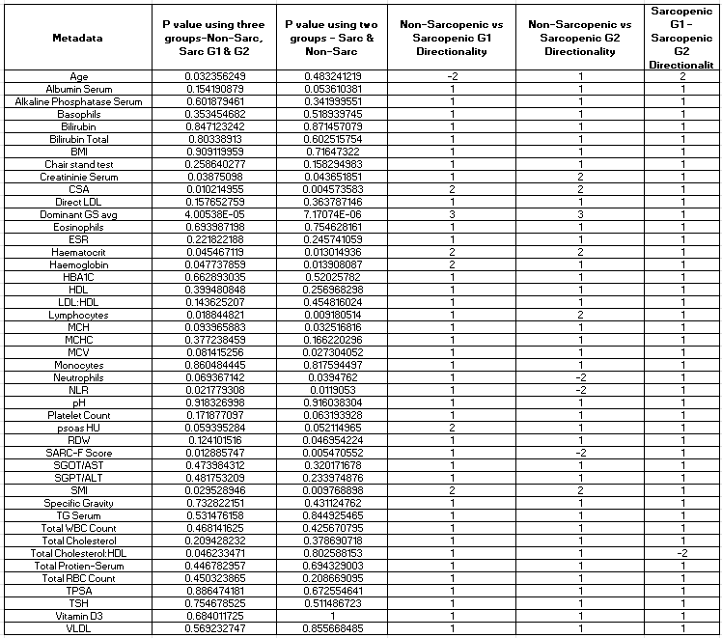

Supplementary Figure
Figure 1S1. ROC plot of clinical parameters significantly correlating with sarcopenia
Figure 2S1: Targeted lipidomic profiling of lipids from human plasma
A. Pie chart represents four major classes detected in targeted lipidomics of human plasma. The percentage and identity of lipid classes are indicated B. Scatter plot of different classes of lipid species and their Spearman rank correlating with sarcopenia. C. ROC analysis (AUROC values are indicated) of a subset of lipid species that correlate significantly with sarcopenia (from Table. 3). The box plot shows LC-MS peak-areas of the respective lipids between sarcopenic and non-sarcopenic subjects (* p <0.05 and ** p <0.01).
Figure 2S2. Serial dilution of SPLASH LipidoMixTM internal standard spiked into pooled human plasma. X-axis indicates percentage dilution of the standard and y-axis indicates LC-MS peak area. The fit of the dilution plot is indicated by the R² value. The SPLASH LIPIDOMIX Mass Spec Standard contains: 15:0-18:1(d7) PC160; 15:0-18:1(d7) PE5; 15:0-18:1(d7) PS5; 15:0-18:1(d7) PG30; 15:0-18:1(d7) PI10; 15:0-18:1(d7) PA7; 18:1(d7) LPC25; 18:1(d7) LPE5; 18:1(d7) Chol Ester350; 18:1(d7) MG2; 15:0-18:1(d7) DG10; 15:0-18:1(d7)-15:0 TG55; 18:1(d9) SM30; Cholesterol (d7)100.
Figure 3S1: Untargeted metabolomic analysis of metabolites from human plasma
A. Pie chart represents nine classes detected in the untargeted metabolomics of human plasma. The percentages and number of metabolites within each metabolite class are indicated. Box plots of B. amino acids, C. exposome and dietary and D. lipid metabolism related metabolites that significantly correlate with sarcopenia. E. Linear regression analysis of Neutrophil/Lymphocyte Ration (NLR) with Arachidonic acid. Spearman correlation coefficient (corr. coeff.) and p-value (p) are indicated. (* p <0.05, ** p <0.01 and *** p <0.001).
Figure 3S2. Serial dilution of QReSS metabolite internal standard spiked into pooled human plasma. X-axis indicates log₁₀ dilution of the standard and y-axis indicates log₁₀ LC-MS peak area. The fit of the dilution plot is indicated by the R² value. QReSS metabolite mix consist of; Creatinine-D3 100 µg/ml; Thymine-15N2 20 µg/ml; Phenylalanine-13C6 100 µg/ml; Vitamin-B3 13C6 5 µg/ml; Hypoxanthine-15C5 10 µg/ml; Tyrosine-13C6 100 µg/ml; Tryptophan-13C11 100µg/ml; Guanosine-15N5 2 µg/ml
Figure 3S3. Metabolites that significantly correlate with sarcopenia
Figure 3S4. Spectral matching of metabolites using the NIST MS/MS spectra library. A. Acquired MS/MS spectrum (above) and the reference NIST spectrum (bottom) matching with the fit score. B. ROC analysis of metabolites identified using the SVM model.
Figure 4S1. List of sixteen metabolites ranked based on relative feature importance from the SVM analysis
Figure 5S1: Distribution of Clinical Parameters Across Control and Sarcopenic Sub-Groups. The violin plots illustrating the distribution of nine clinical parameters among three groups: Control (green), Sarcopenic G2 (blue), and Sarcopenic G1 (orange). Each panel (A-I) represents a different clinical parameter as follows: A. Haemoglobin B. Mean Corpuscular Volume (MCV) C. Neutrophils D. Haematocrit E. Creatinine Serum F. Lymphocytes G. Mean Corpuscular Haemoglobin H. Psoas-HU I. Red Cell Distribution Width (RDW). The violin plots display the kernel density estimates of the data, with overlaid box plots indicating the median and interquartile range. Statistical significance was assessed using the Kruskal-Wallis test, followed by Dunn's test for pairwise comparisons. Significant differences between groups are marked with asterisks, where *p < 0.05, **p < 0.01, ***p < 0.001, and ****p < 0.0001. The analyses highlight key clinical differences between the control group and the sarcopenic subgroups, suggesting potential clinical metadata drivers underlying the observed distinctions in sarcopenic conditions.
Figure 6S1: Core-Microbiome Analysis Across Non-Sarcopenic and Sarcopenic Groups.
A. The median Bray-Curtis distances calculated within each group (Control, Sarcopenic G2, and Sarcopenic G1) based on the core microbiome species identified. Core microbiome species were determined using a prevalence threshold of 65% across samples. Box plots illustrating the distribution of these median distances, with distinct colors representing each group: green for Control, blue for Sarcopenic G2, and orange for Sarcopenic G1. Dunn's test was used for statistical comparisons, and significant differences between groups are indicated by asterisks (*p < 0.05, **p < 0.01, ***p < 0.001). B. Cumulative abundance of core microbiome species common to all groups, analyzed across Non-Sarcopenic, Sarcopenic G2, and Sarcopenic G1 groups. Box plots illustrate the cumulative abundance values for each group. Dunn's test was used for statistical comparisons between groups, with significant differences denoted by asterisks (*p < 0.05). C. Cumulative abundance of core microbiome species specific to the control group, analyzed across Non-Sarcopenic, Sarcopenic G2, and Sarcopenic G1 groups. Box plots display the cumulative abundance values, with colors representing the same groups as in panel B. Statistical comparisons were performed using Dunn's test, with significant differences indicated by asterisks (*p < 0.05).
Figure 7S1: Analysis of Metabolite Associations and Correlations with Taxa. A. The heatmap in illustrates the Spearman correlation coefficients between significant metabolites (evaluated between sarcopenic and control groups) and microbiome species. Each cell in the heatmap represents the correlation coefficient (R-value) for a specific metabolite-species pair. The species which show consistent significant association with at least 2 metabolites are shown here. The intensity of the colour indicates the strength and direction of the correlation, with darker colors representing stronger correlations. Statistical significance is indicated by asterisks, where * denotes p < 0.05, ** denotes p < 0.01, and *** denotes p < 0.001. These annotations highlight the most significant interactions, providing insight into the key relationships between metabolites and microbiome species in the context of sarcopenia. B. Metabolite Trends depicts a heatmap of metabolite trends across the three groups: Control, Sarcopenic G1, and Sarcopenic G2. The heatmap shows significant trends in metabolite levels, with each cell representing a trend for a specific metabolite within a group.
Figure 8S1-4: Box plots of non-significant taxa showing similar positive correlation trends to significantly varying taxa in sarcopenic groups. The distribution of these taxa across the sarcopenic subgroups and non-sarcopenic groups is illustrated. Each box plot represents the abundance of a specific microbial taxon, with the boxes indicating the interquartile range (IQR) and the whiskers extending to 1.5 times the IQR. The median is shown as a horizontal line within each box. Although these taxa did not show statistically significant differences, their correlation patterns align with those of the significantly varying taxa, highlighting potential trends in microbial shifts associated with sarcopenia.

Figure 1S1
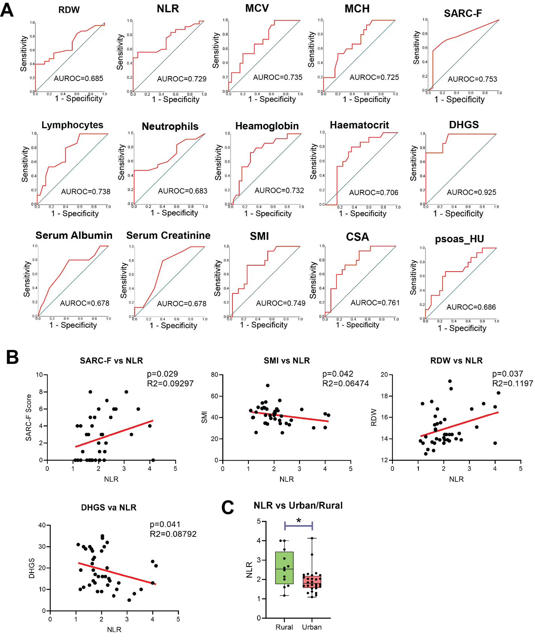

Figure 2S1
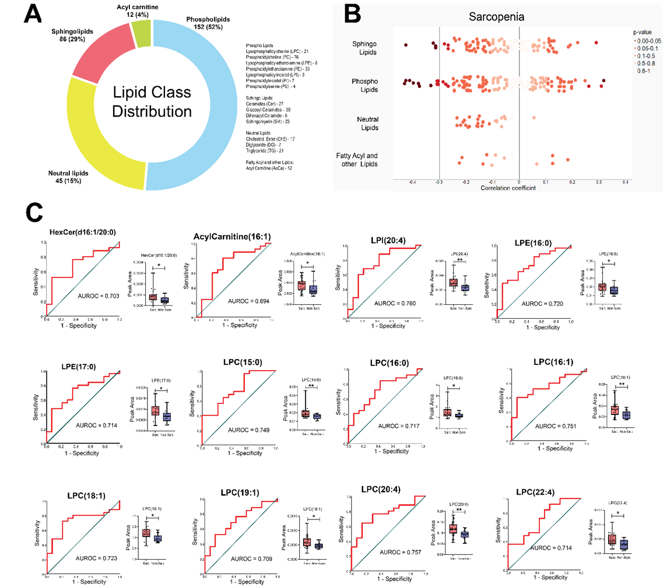

Figure 2S2

Figure 3S1
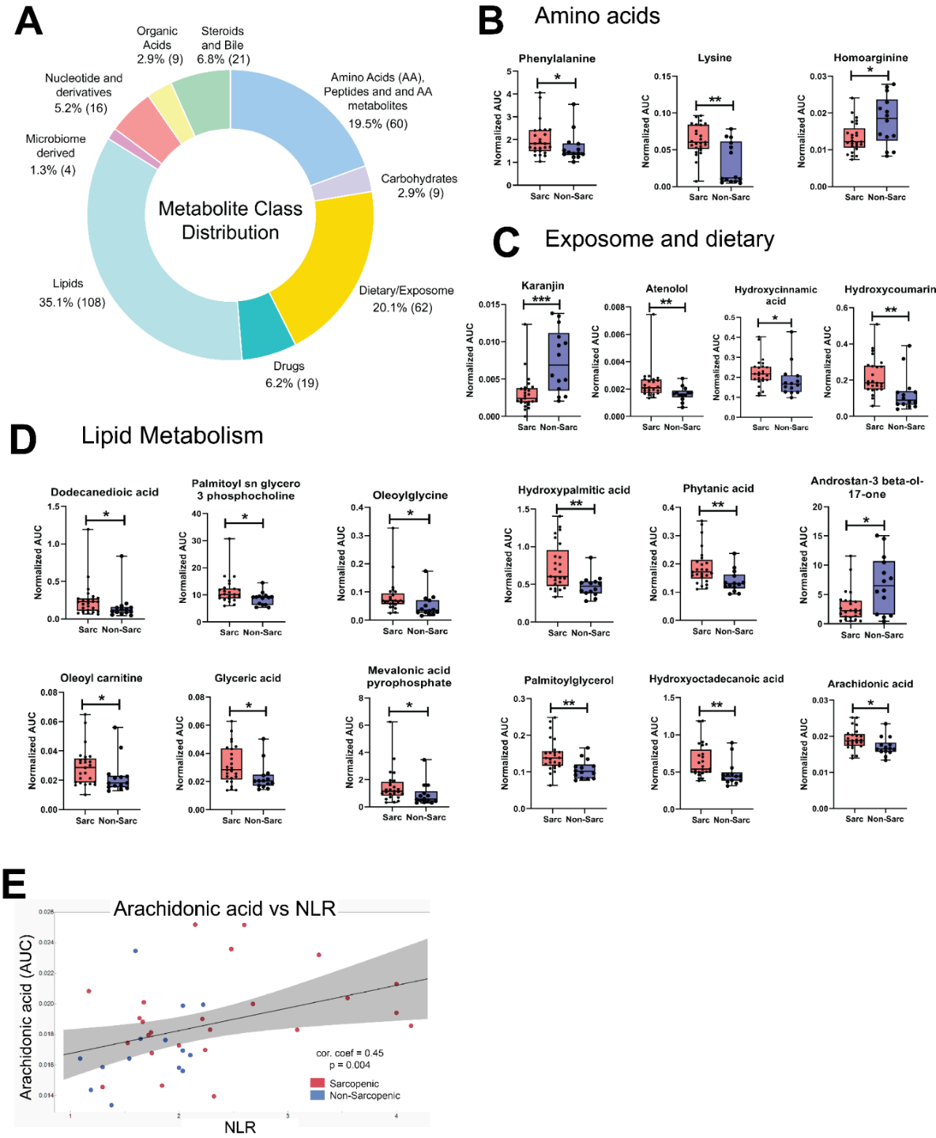

Figure 3S2
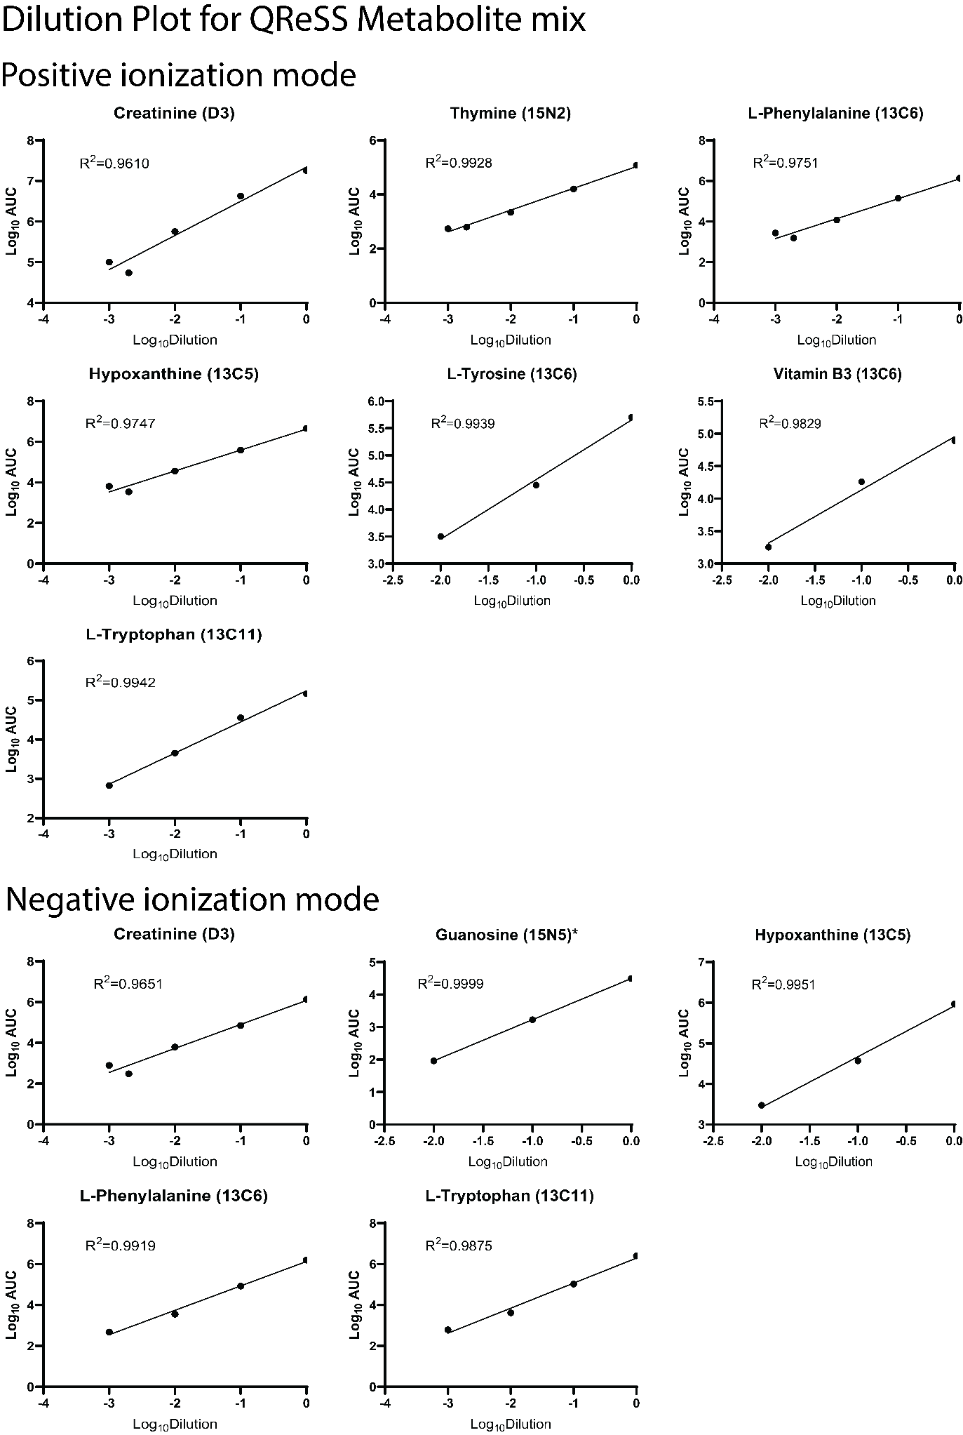

Figure 3S3
Spectral library matching
Glyceric acid
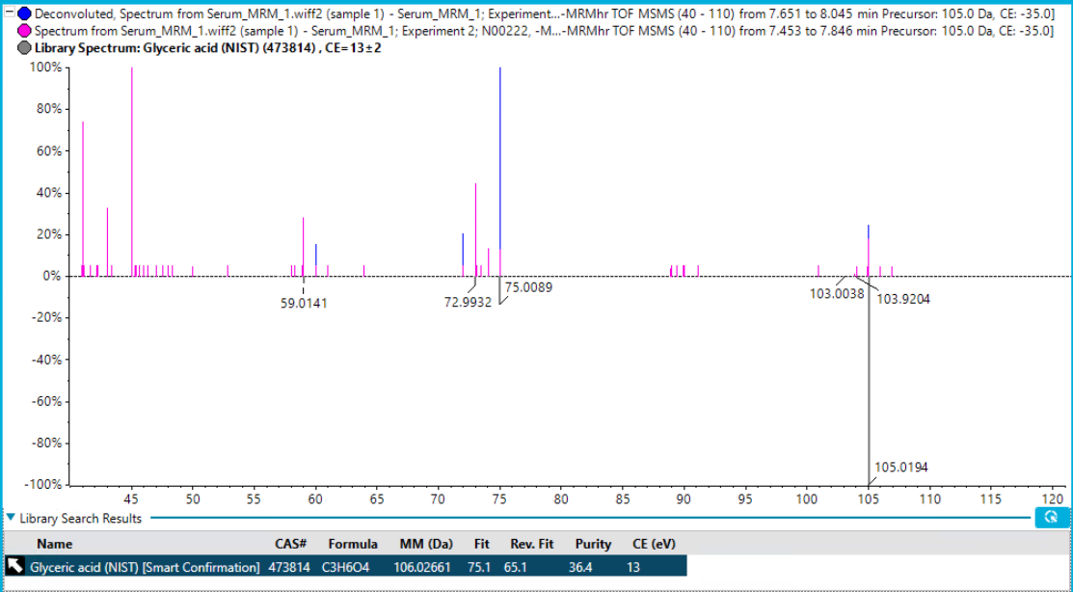

D-Ribose/D-Xylose/ Arabinose
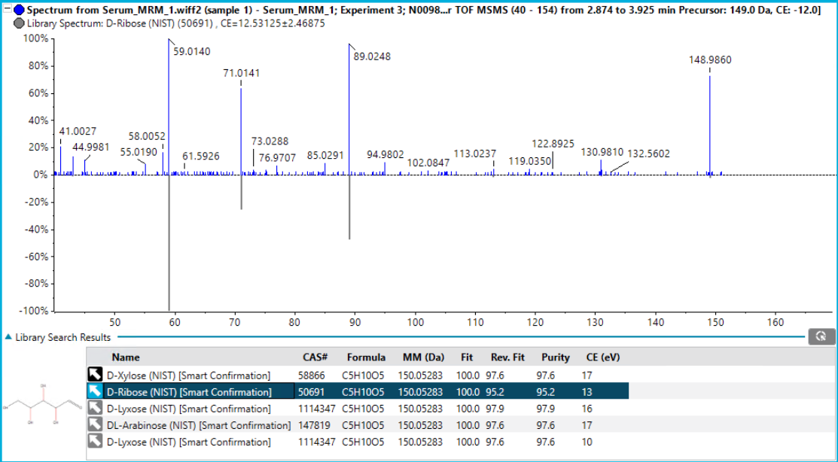
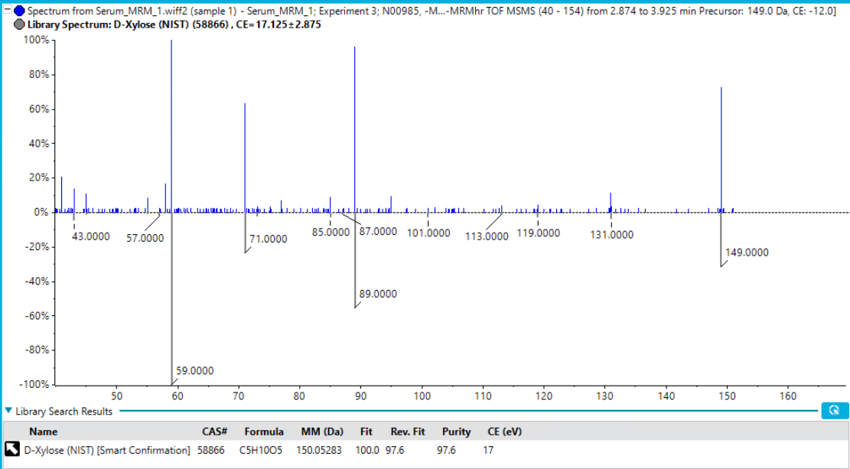

Hydroxycinnamic acid
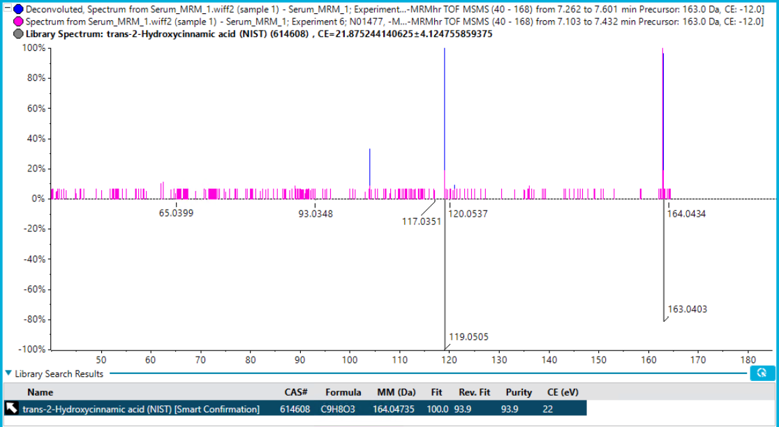

Phenylalanine
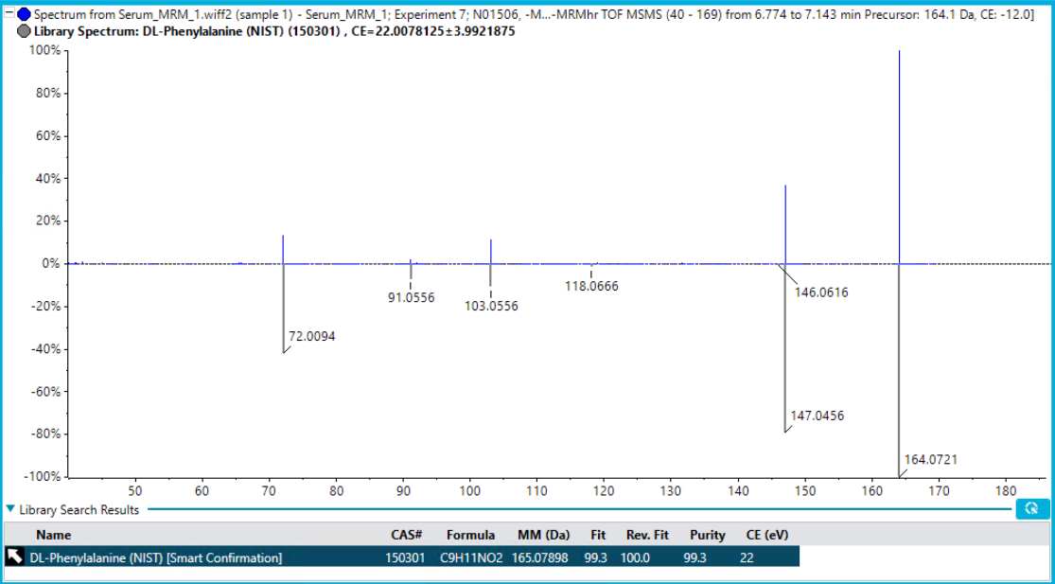

Pantothenic acid
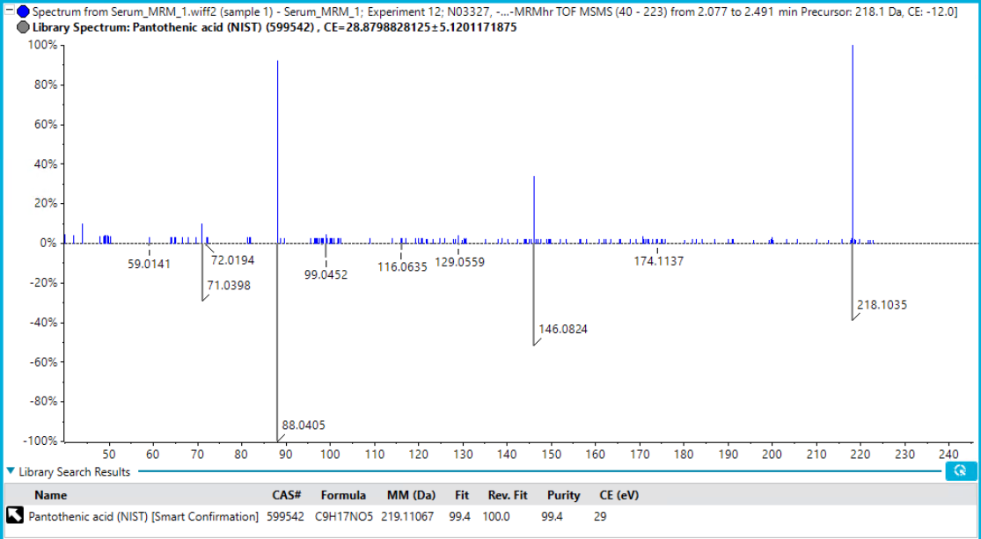

Hydroxypalmitic acid
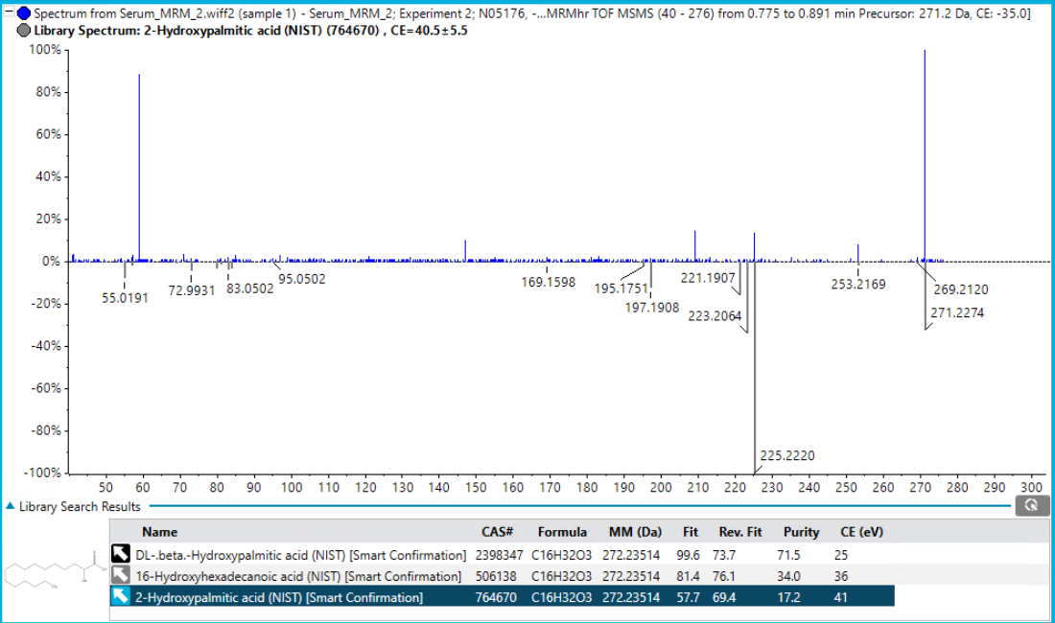

Hydroxyoctadecanoic acid
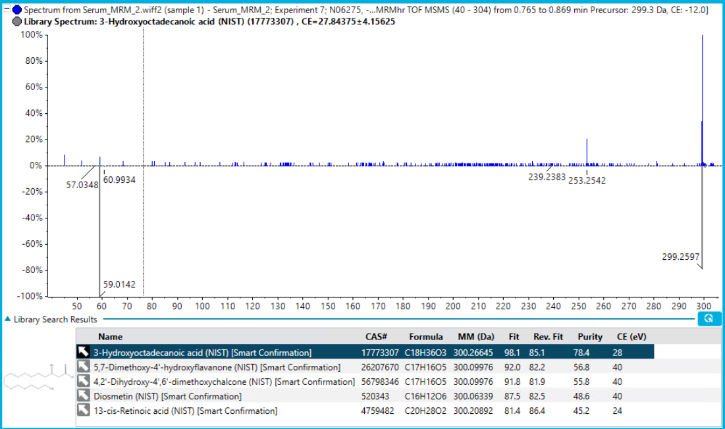

N-Acetyl-D-galactosamine 4-sulfate
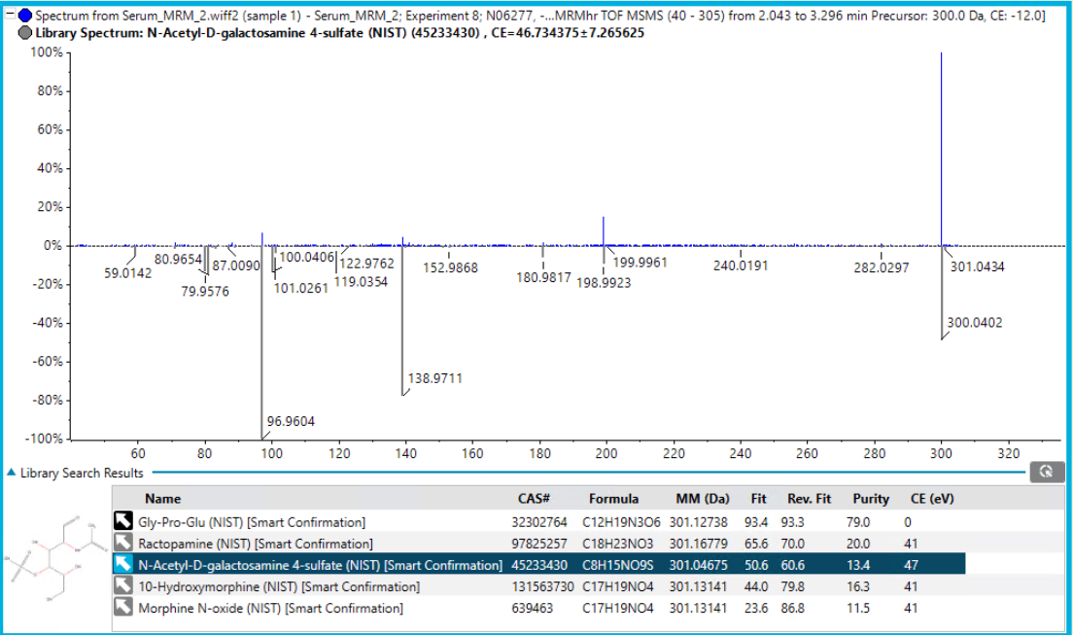

Oleoylglycine
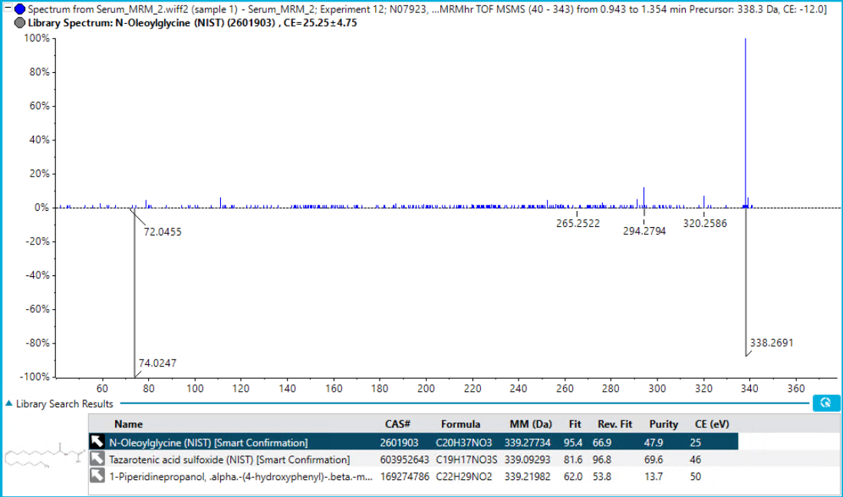

Androstan-3 beta-ol-17-one sulfate
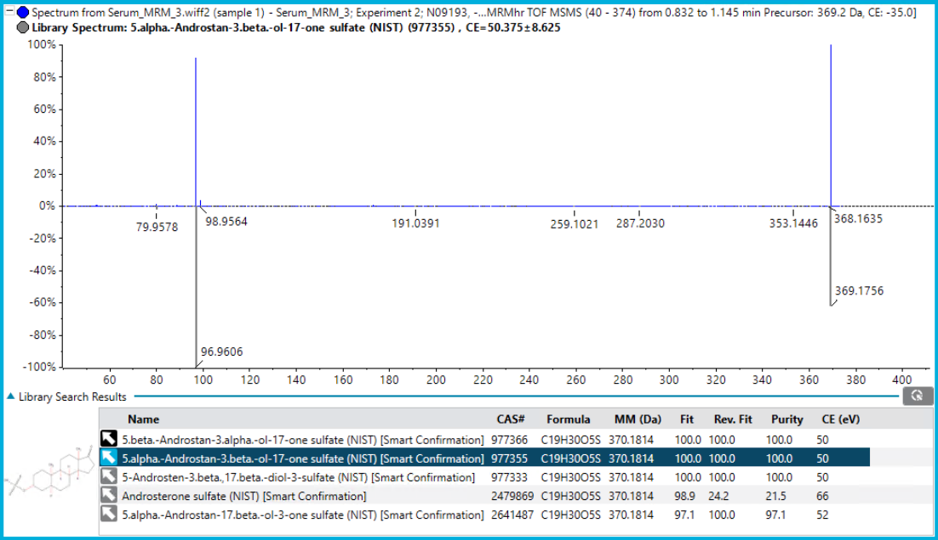

Hydroxycoumarin
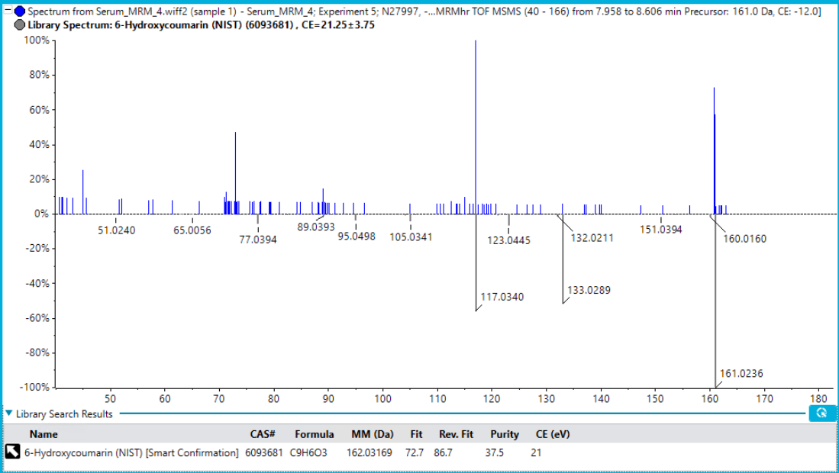

Dodecanedioic acid
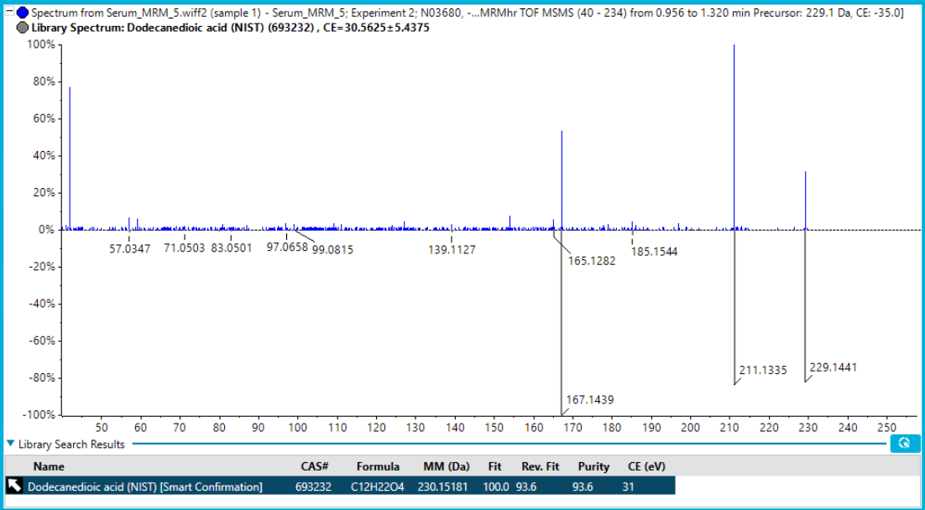

Acetylcholine cation
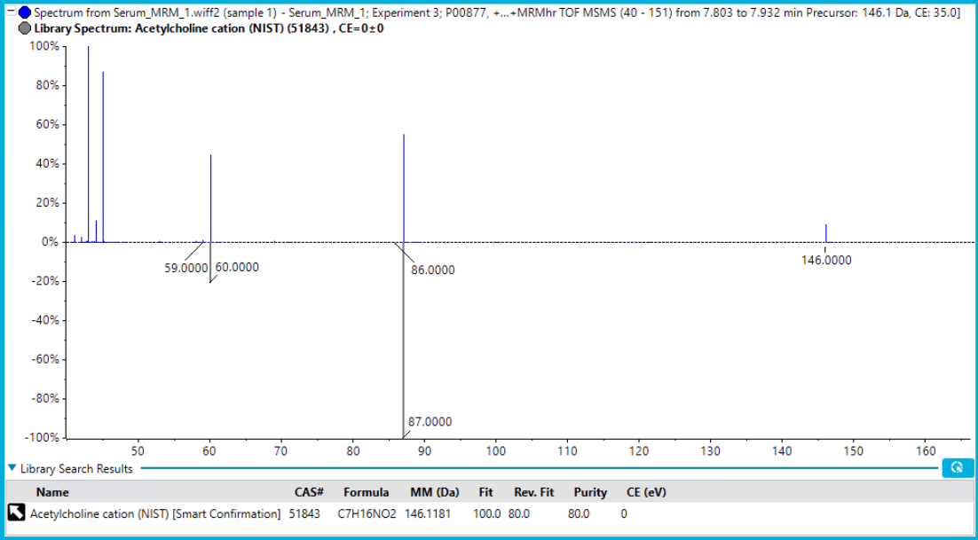

Spermidine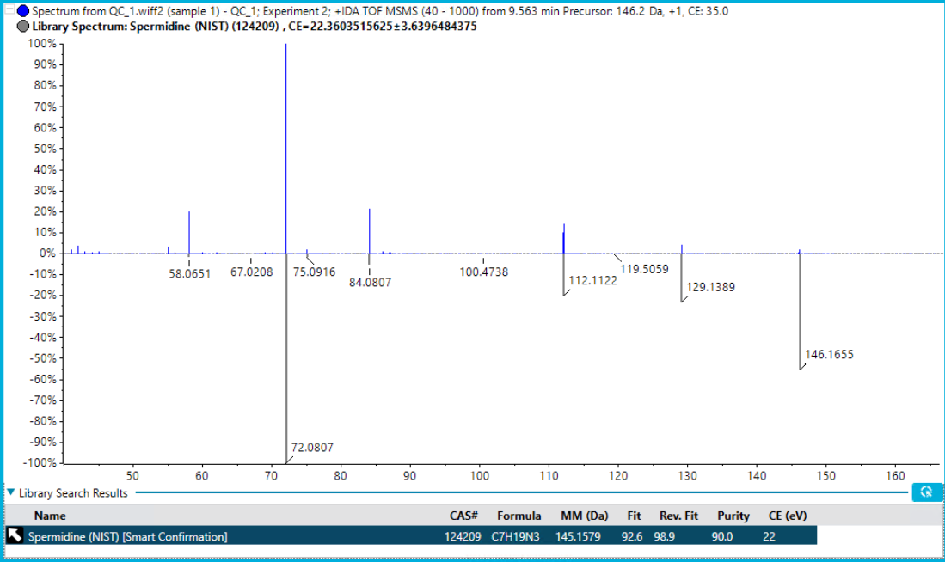

Lysine
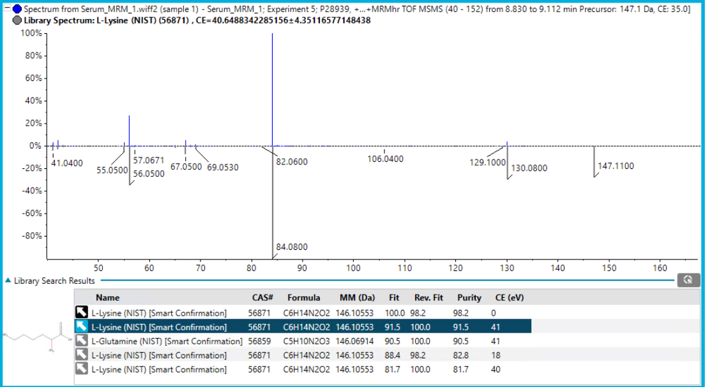

Homoarginine
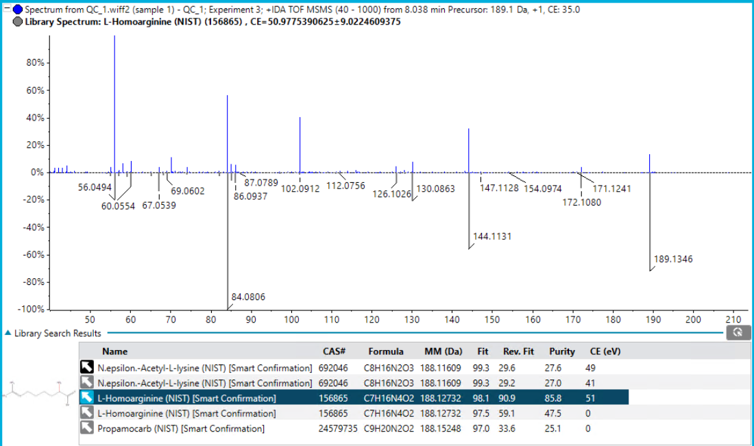

Atenolol
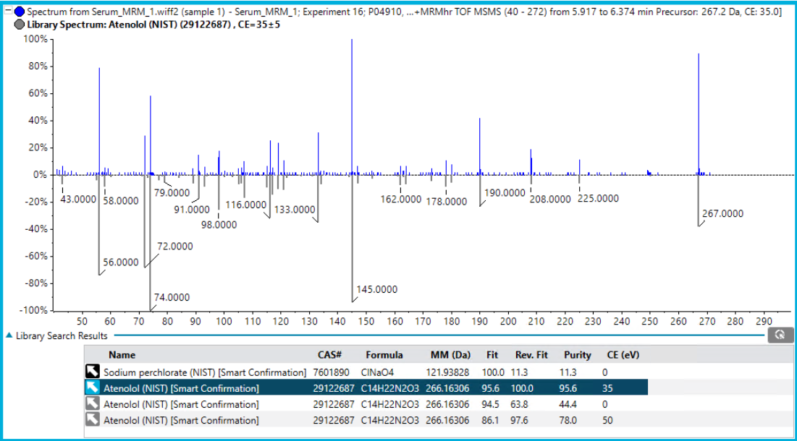

Karanjin
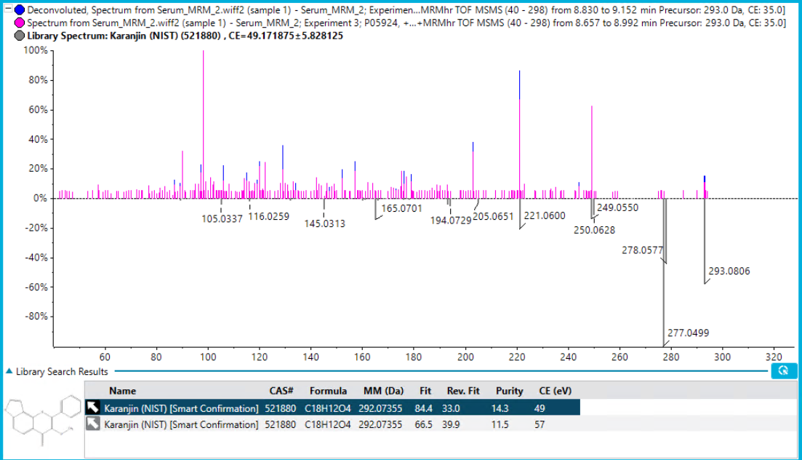

Arachidonic acid
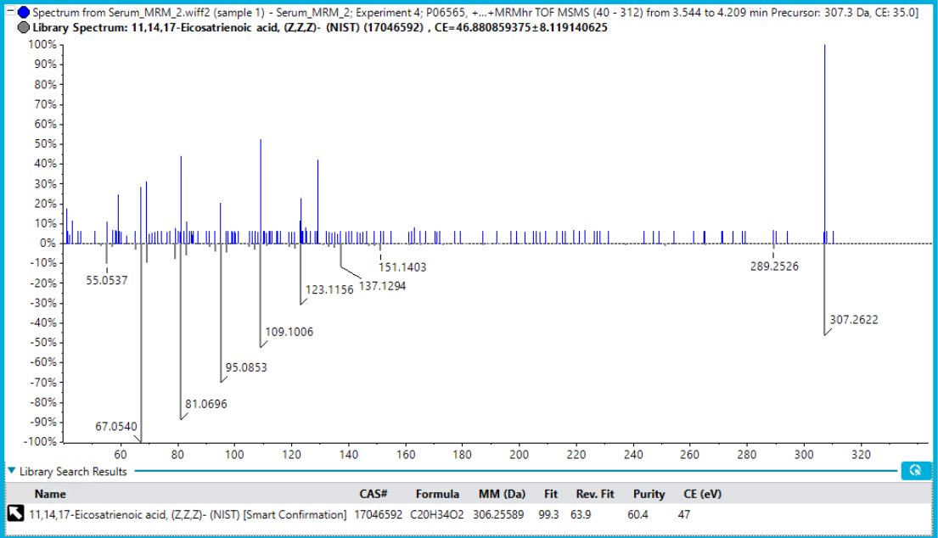

Phytanic acid
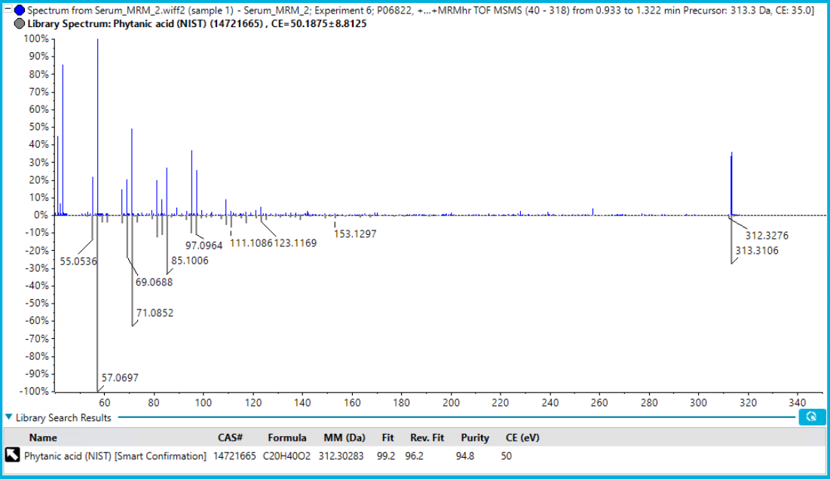

Palmitoylglycerol
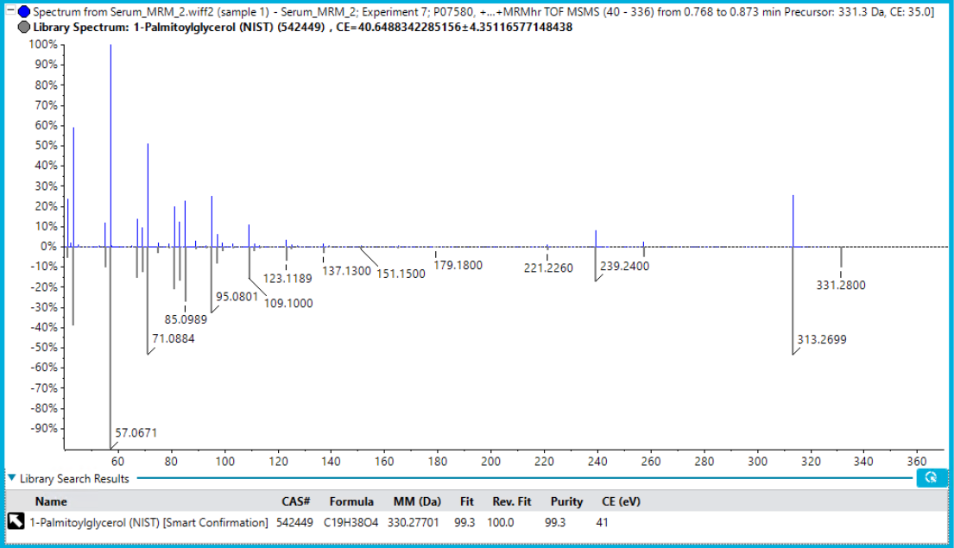

Oleoyl-L-carnitine
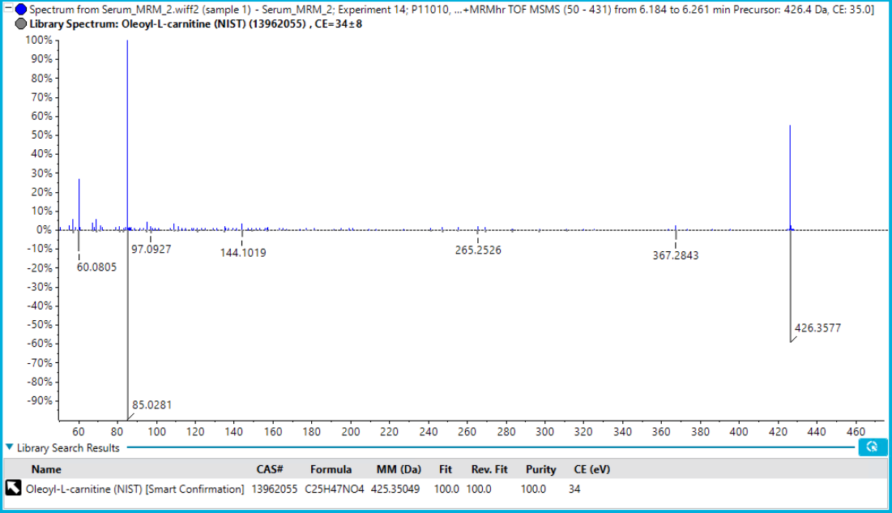

1-Palmitoyl-sn-glycero-3-phosphocholine
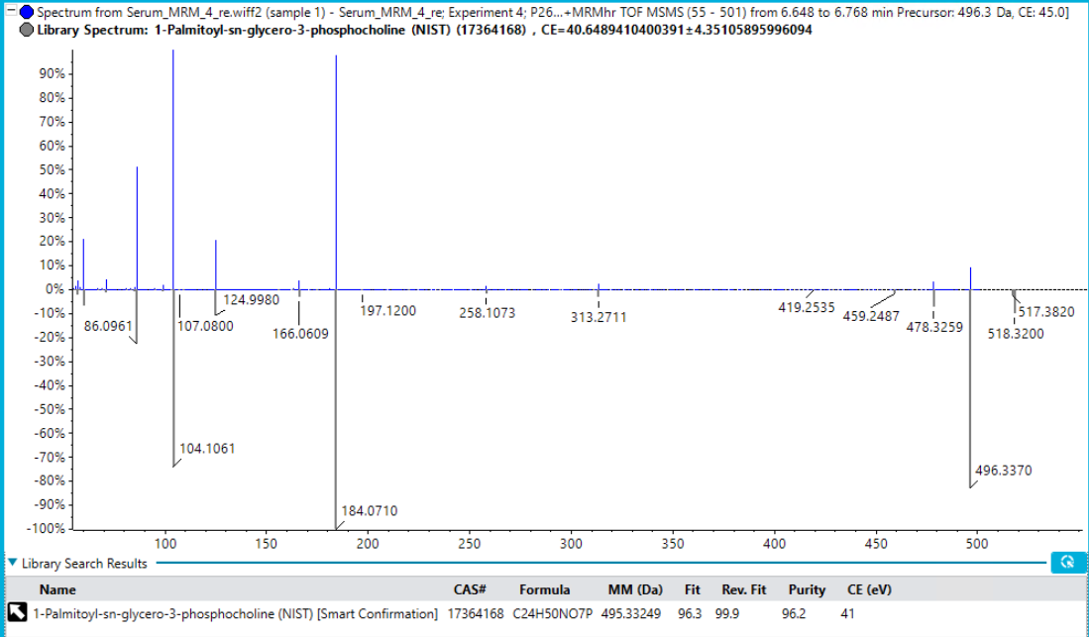

Mevalonic acid 5-pyrophosphate
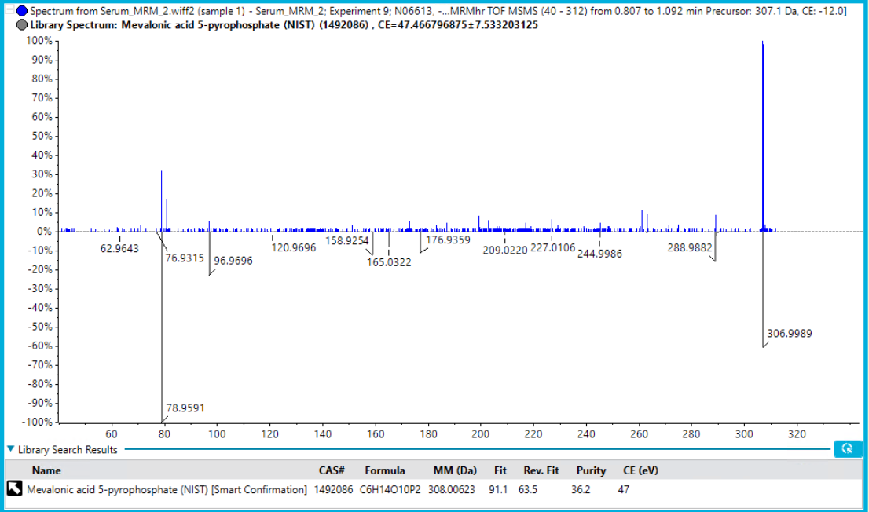

Figure 3S3
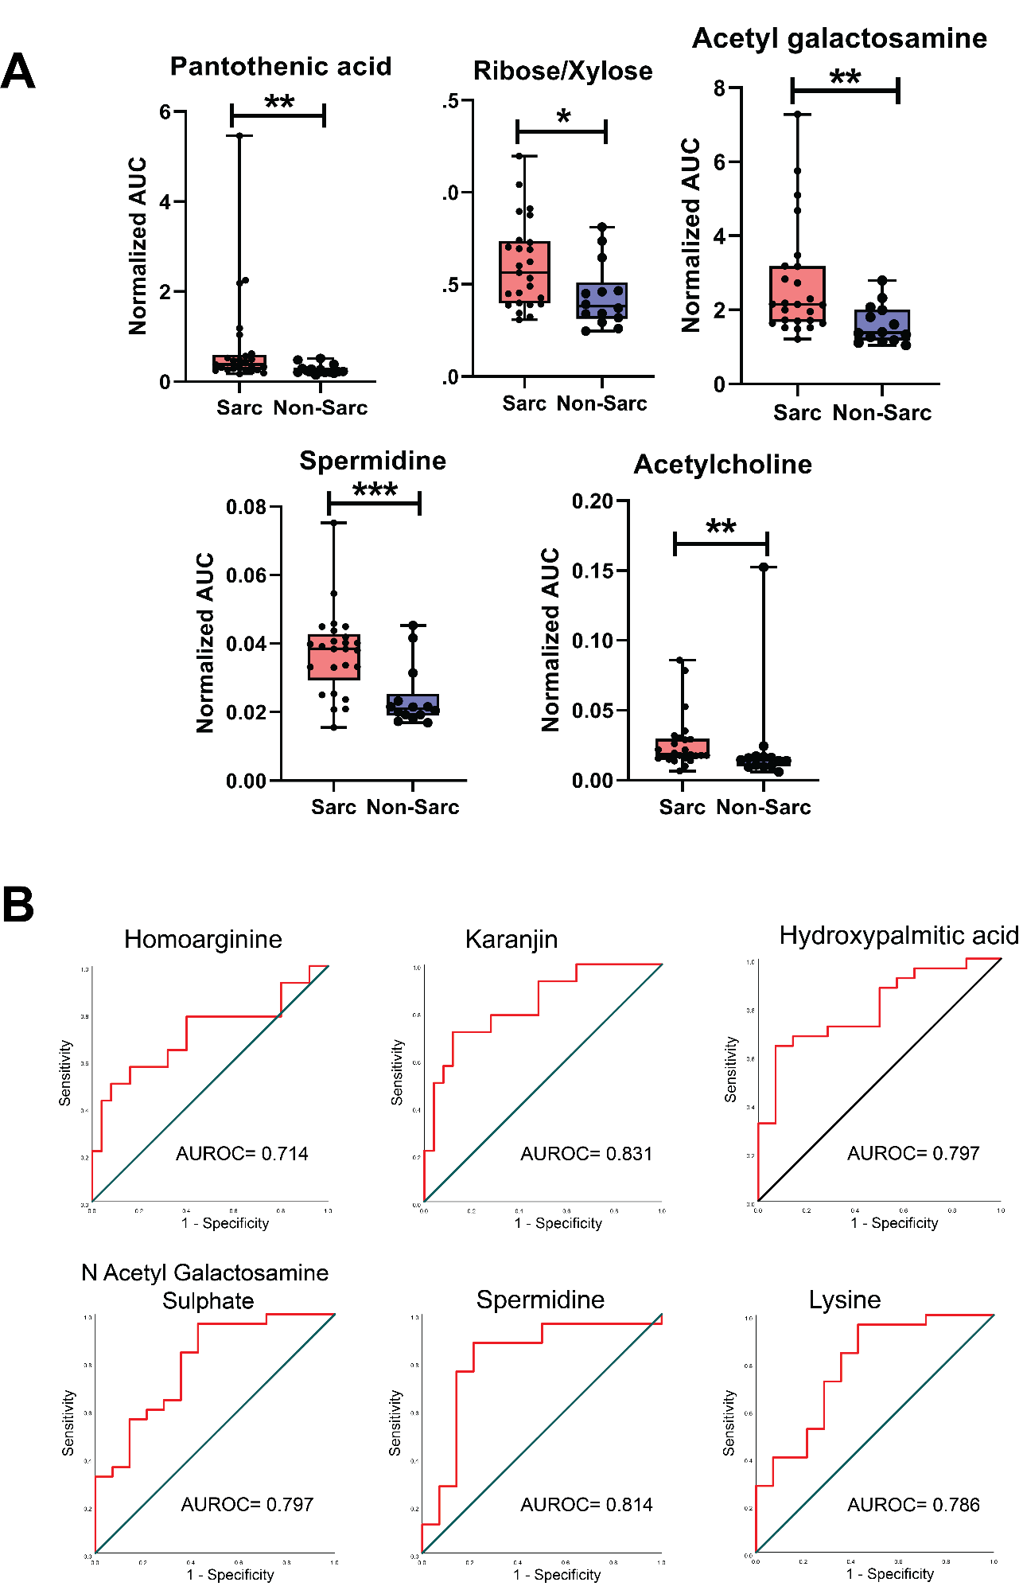

Figure 4S1

Supplementary Figure 5S1:
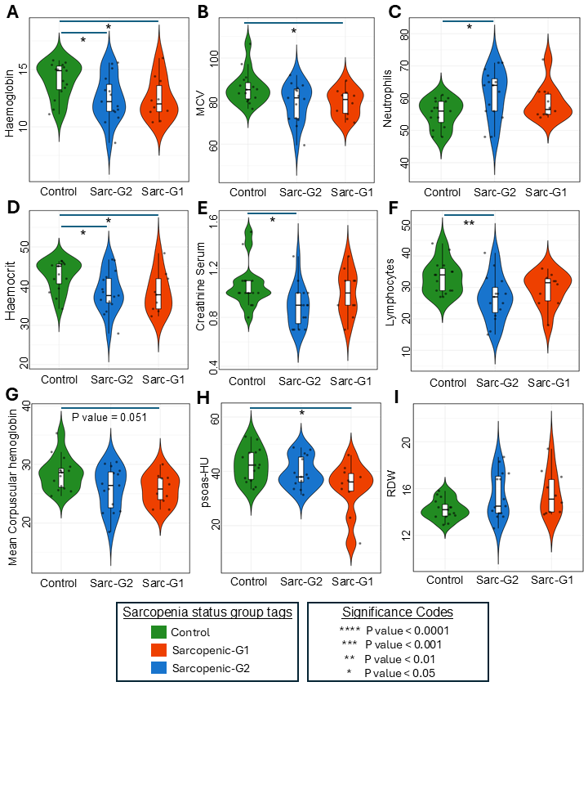

Supplementary Figure 6S1:
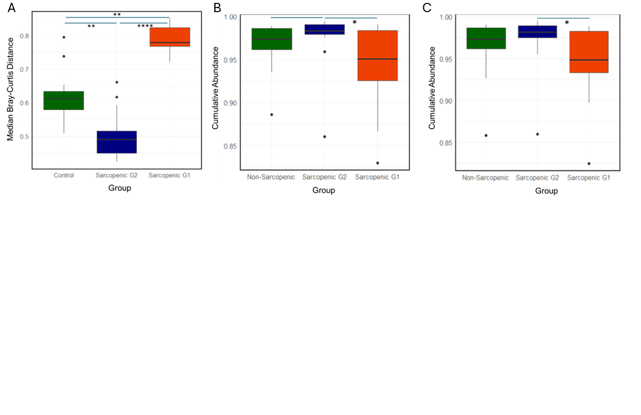

Supplementary Figure 7S1:
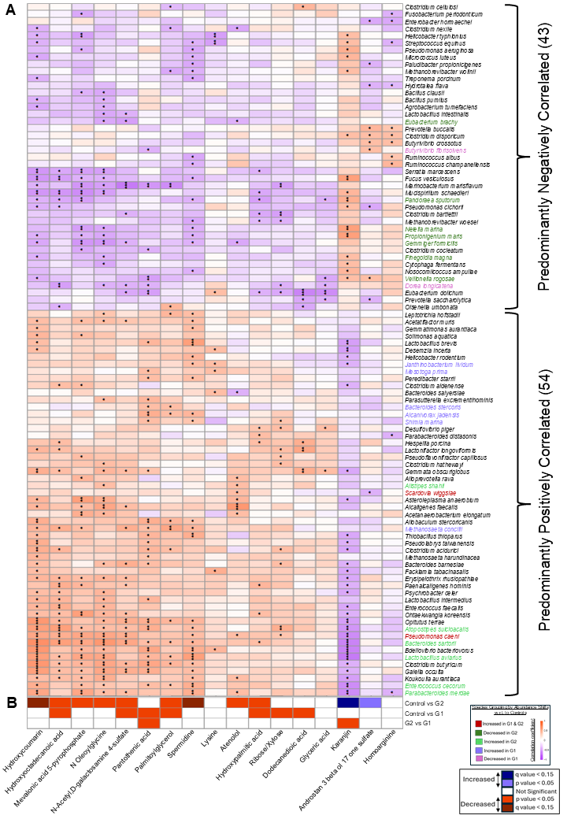

Supplementary Figure 8S1:
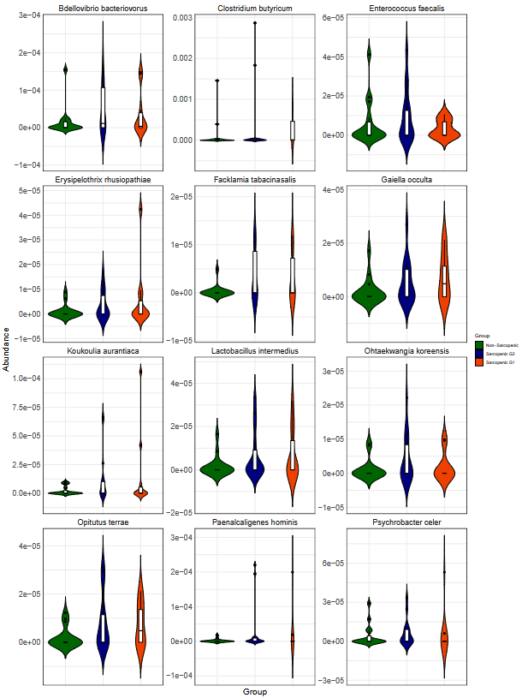

Supplementary Figure 8S2:
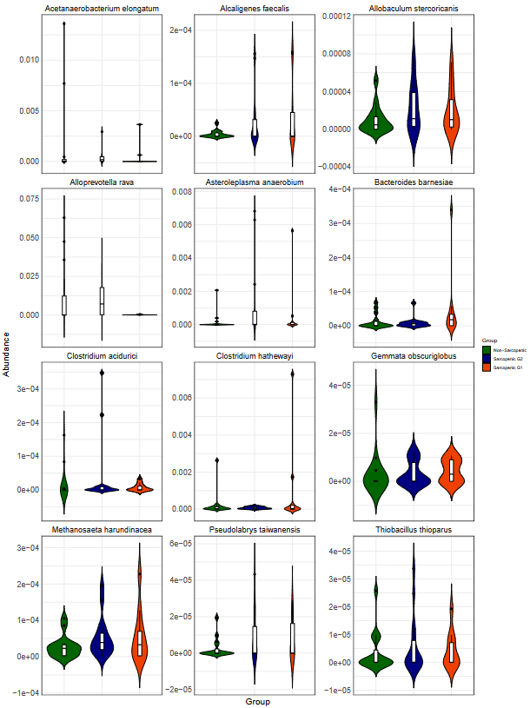

Supplementary Figure 8S3:
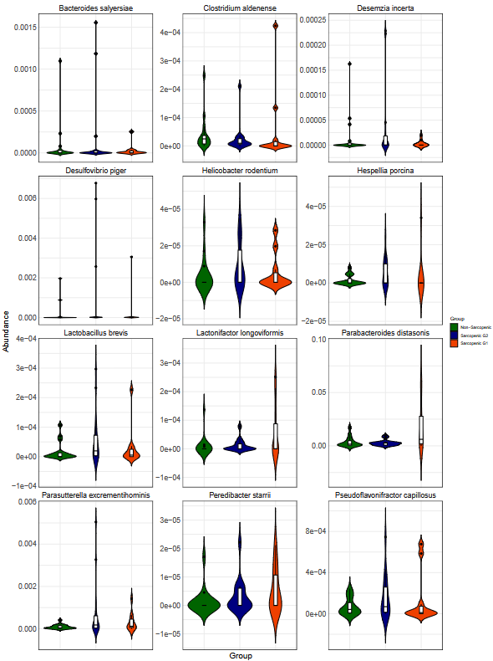

Supplementary Figure 8S4:
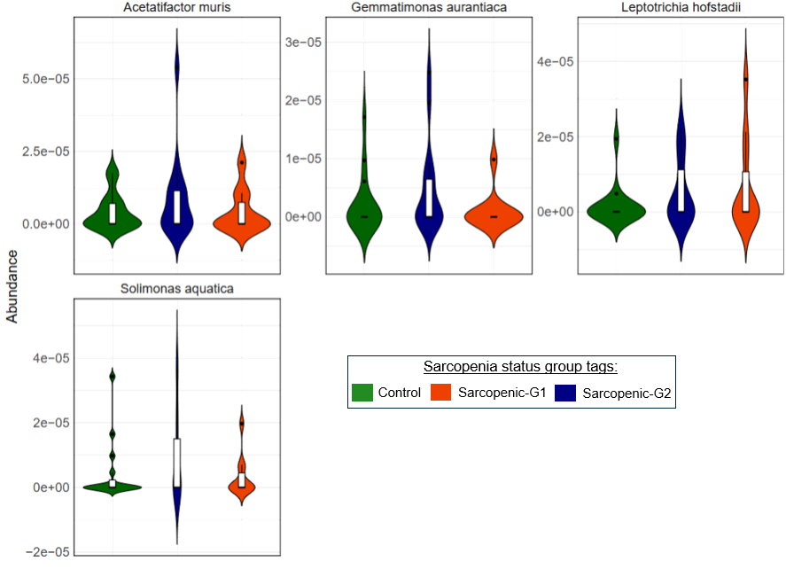

Supplementary method
Clinical Assessment of subjects and their plasma sample collection, storage, and transport
Subjects above the age of sixty were screened for eligibility. Subjects with known history musculo-dystrophies, myopathy, liver disease, diabetes on insulin, malignancies or any acute illness were excluded from the study. Subjects were excluded if they had history of 1) Congenital muscular dystrophy 2) Chronic cardiopulmonary insufficiency 3) Severe liver damage (cut-off of transaminase levels) requiring limited protein intake 4) Presence of malignant neoplastic disease (which may cause Cachexia). Total of 40 subjects (age 60-87 years old) were recruited for the study.
Subjects were then assessed for sarcopenia using strength, assistance walking, rising from a chair, climbing stairs, and falls (SARC-F score). This questionnaire screens patients for self-reported signs suggestive of sarcopenia, which include deficiencies in strength, walking, rising from a chair, climbing stairs, and experiencing falls. All the subjects were then subjected to dominant hand grip strength (DHGS) and five times sit to stand test (standardized protocols for the tests are described in the supplementary methods section).
Following this, the subjects were evaluated using the following tests namely, complete blood count (CBC), erythrocyte sedimentation rate (ESR), lipid profile, glycosylated haemoglobin (HbA1C), liver function tests, serum creatinine, lipid profile, thyroid stimulating hormone, and vitamin D. Stool samples was collected from subjects for the microbiome analysis.
For the plasma sample collection, 5 ml of whole blood was collected in commercially available anticoagulant-treated tubes and mixed 5-6 times. Approximately 3ml of plasma was centrifuged for 10 minutes at 1,000–2,000 x g using a refrigerated centrifuge to remove blood cells. Another centrifugation for 15 minutes at 2,000 x g depletes platelets in the plasma sample. The resulting supernatant is designated plasma which was immediately transferred into a clean polypropylene tube using a Pasteur pipette. The samples were transferred at -20 °C or lower from BBH to inStem biorepository. Here the plasma aliquots were made and neutralized with extraction solvents.

SARC-F questionnaire
The SARC-F questionnaire is a screening tool to identify probable sarcopenia patients. The questionnaire screens patients for self-reported signs suggestive of sarcopenia, which included:
1. History of Alcohol
2. History of Smoking/ tobacco use
3. Fast food: More than Once a week / Less than once a week
4. Exposure to the environmental factors
5. Routine Workout in a week
6. Strength: How much difﬁculty do you have in lifting and carrying 5 kgs?
7. Assistance in walking: How much difﬁculty do you have walking across a room?
8. Rise from a chair: How much difﬁculty do you have transferring from a chair or bed?
9. Climb stairs: How much difﬁculty do you have climbing a ﬂight of 10 stairs?
10. Falls: How many times have you fallen in the past year?
Each of the self-reported parameters receives a minimum and maximum score of 0 and 10, respectively, with the greatest maximum SARC-F score being a score of more than 4 suggests sarcopenia.

Dominant Hand Grip Strength (DHGS)
Subjects have to sit with their shoulder adducted and neutrally rotated, elbow flexed at 90', forearm in neutral position, and wrist between 00 and 30° dorsiflexion and between 00 and 15" ulnar deviation. JAMAR Hand Dynamometer was used to record the grip strength. After the individual is positioned properly, they are instructed to squeeze tight and then relax. Scores of three successive trials for each hand tested and the average score of the three trials were recorded in pounds. Dominant hand was noted for each individual.

Five Times Sit to Stand Test (5XSST)
The 5XSST scoring is based on the amount of time (to the nearest decimal in seconds) a patient is able to transfer from a seated to a standing position and back to sitting five times. The subject was made to sit on the chair by resting their back with folded arms across their chest. Then the subject is instructed to do sit-to-stand five times, as quickly as possible, at the count of go and without their back or leg resting on the chair between the interval of repetition. The entire repetitions are timed using a stopwatch. Inability to complete five repetitions without assistance or use of upper extremity support indicates failure of test.

Skeletal muscle CT imaging and analysis
Computed tomography (CT)-based measurement of the skeletal muscles were performed on Revolution Evo 128 slice CT scan machine from GE with 120KV and smart MA with slice thickness of 1.25mm. CT cross sectional area measurements for the psoas muscles, Para-spinal and Abdominal wall muscles were done manually by tracing the outlines of the above-mentioned muscles, using the area calculation software tool provided by Med Synapse picture archiving and communication systems. The muscular Cross Sectional Area (CSA) was then used to estimate the Skeletal Muscle Index (SMI) by dividing the CSA by the square of the height of the patient. Average muscle density in Hounsfield Unit of bilateral psoas muscles was obtained using the same tool. Areas and densities were averaged across the left and right psoas muscle on images. Average psoas muscle area, psoas muscle density and skeletal muscle index were reported. The skeletal muscle index was computed as a ratio of skeletal muscle area at L3 level to the height of the participant.

Metabolite and lipid extraction protocol
For metabolomics, 50 μl plasma sample was neutralized with extraction solvent (350 μl of 1:2:2 :: water: methanol: ACN containing 10 μl of 1mg/ml 13C-aspartate). The samples were vortexed for 1 min and then centrifuged at 13,000 x g, 4°C for 20 mins. The supernatant was transferred to fresh 1.5ml tube and 2 μl for QReSS metabolite mix was added. The supernatant was then dried and stored at -80°C until use. The samples were resuspended in 100 μl of 50% methanol in water then transferred to autosampler vials.
For lipidomics, 10 μl plasma samples were neutralized in 200 μl of lipid extraction solvent (butanol: methanol: 1:1 with 5 μl avanti splash standard). Samples were sonicated for 30mins, vortexed for 10 sec and then centrifuged for 10 mins at 4°C at 14,000 x rpm. The supernatant formed was collected in autosampler MS vials and used directly. If required, it can be stored at -80°C for weeks.

Lipidomics method
Analysis of extracts was performed on an Agilent 6495 QQQ mass spectrometer with an Agilent 1290 series HPLC system and a ZORBAX eclipse plus C18 column (2.1x100mm, 1.8μm, Agilent) with the thermostat set at 45°C. Mass spectrometry analysis was performed in positive ion mode with dynamic scheduled multiple reaction monitoring (dMRM).
The solvent system consisted of solvent A - 50% H2O / 30% acetonitrile / 20% isopropanol (v/v/v) containing 10mM ammonium formate and with 0.1% formic acid and solvent B - 1% H2O / 9% acetonitrile / 90% isopropanol (v/v/v) containing 10mM ammonium formate and with 0.1% formic acid. We utilized a stepped linear gradient with a 15-minute cycle time per sample and a 1μL sample injection.
The gradient was as follows; starting with a flow rate of 0.4 ml/minute at 15% B and increasing to 50% B over 2.5 minutes, then to 57% over 0.1 minutes, to 70% over 6.4 minutes, to 93% over 0.1 minute, to 96% over 1.9 minutes and finally to 100% over 0.1 minute. The solvent was then held at 100% B for 0.7 minutes. Equilibration was as follows, solvent was decreased from 100% B to 15% B over 0.1 minute and held for an additional 2 minutes. The avanti splash standard was serially diluted to validate the LC method (Fig. 2S2).

Targeted Lipidomics and lipid quantification
LCMS Data were analyzed using the Agilent mass hunter workstation for QQQ Quantitation software. After peak integration, all the peak area were converted into excel sheet. The stringent filters used were: the Pearson correlation for the pooled QC dilutions had to be more than 0.8, the signal to noise ratio had to be greater than 10, and the pooled QC CV% > 30. The qualified species were then quantified to class specific internal standards and then were further subjected to statistical analysis.

Metabolomics method development in Zeno-TOF 7600 LC-MS using QReSS metabolite mix
The LC method was modified from Vorkas et al (2015) [1]. UPLC separation was conducted using Shimadzu UPLC System. Acquity UPLC BEH HILIC 2.1 × 100 mm, 1.8 μm, column (Waters Corp, USA) was used. Column temperature was set at 35 °C. Mobile phase A consisted of acetonitrile (ACN)/water (95:5) and mobile phase B ACN/water (50:50). Both solvents with ammonium acetate 10 mM and formic acid 0.1%. The elution gradient was set as follows: 99% A (0.0−2.0 min; 0.4 mL/min), 99−45% A (2.0−8.0 min; 0.4 mL/min), 45−1% A (8.0−9.0 min; 0.4 mL/min), 1% A (9.0−9.1 min; 0.4−0.8 mL/min), 1% A (9.1−10.0 min; 0.8 mL/min), 1−99% A (10.0−10.1 min; 0.8 mL/min), 99% A (10.1−11.0 min; 0.8 mL/min), 99% A (11.0−14.1 min; 0.8−0.4 mL/min), 99% A (14.1−15.0 min; 0.4 mL/min). An injection volume of 2 μl was used for both positive and negative ionization polarity modes. The autosampler was set at 5 °C. Mass spectrometry was performed using a Premier 7600 Zeno-TOF with an electrospray ionization (ESI) source and CID. The parameters for IDA scan were suggested by the manufacturer. This method was validated with QReSS metabolite mix (Cambridge Isotope Laboratories, Inc. #MSK-QReSS-1) according to manufacturer’s instruction and linearity of serially diluted standard mix was plotted (Fig. 3S2). The spiked internal standards consist of Creatinine-D3 100 µg/ml; Thymine-15N2 20 µg/ml; Phenylalanine-13C6 100 µg/ml; Vitamin-B3 13C6 5 µg/ml; Hypoxanthine-15C5 10 µg/ml; Tyrosine-13C6 100 µg/ml; Tryptophan-13C11 100µg/ml; Guanosine-15N5 2 µg/ml. The fit of the dilution plot is indicated by the R2 value.

Untargeted metabolite library search
IDA LC-MS/MS method was used with the 7600 Zeno-TOF mass spectrometer to acquire data. The data file generated from the pooled sample was used in the SciexOS software for a library search using the NIST metabolite library. The NIST library consists of a 13571 unique metabolite spectral database used for MS/MS validation. Flagging rules for MS/MS and MS only identification was a mass error (ppm) < 10, % difference isotope ratios < 20 and a library Hit score above 50 considering equal weightage. The ID, name of metabolite, m/z, and RT (min) were used for quality checks in SciexOS software and peak integration checks. Each library hit was manually validated using MRM-HR with m/z < 10 ppm and a RT width of 0.4 seconds. Library spectral match is reported with fit score and reference spectrum (Fig. 3S4).

Support Vector Machine Learning Analysis
The 39 subjects were randomly partitioned into training and test sets at a ratio of 3:1. The R package ‘caret v6.0-94’ was used in the following analyses [2]. Recursive Feature Elimination (RFE) with a five-fold repeated cross-validation was performed on the twenty-four metabolites from the training data to assess the feature set that results in the highest model accuracy. A Support Vector machine (SVM) model was then built and optimized with the training dataset, using a linear kernel with grid search and five-fold repeated cross-validation. The value of the “cost” parameter (C) was screened from 0.25 to 100. Predictive accuracy in the test dataset was used to evaluate the predictive performance of the model. The details of the model summary has been described below:
Support Vector Machines with Linear Kernel; 30 samples; 24 predictors; 2 classes: 'yes', 'no'; Pre-processing: centered (24), scaled (24); Resampling: Cross-Validated (5 fold, repeated 5 times)
Summary of sample sizes: 24, 24, 25, 23, 24, 24, ...
Resampling results across tuning parameters:
C | Accuracy | Kappa
1 | 0.7367619 | 0.3906794
5 | 0.7491429 | 0.4180820
10 | 0.7491429 | 0.4180820
50 | 0.7491429 | 0.4180820
100 | 0.7491429 | 0.4180820
Accuracy was used to select the optimal model using the largest value. The final value used for the model was C = 5.
Confusion Matrix and Statistics for Metabolomics data
Prediction/ Reference | Yes | No
Yes | 6 | 1
No | 0 | 2
Accuracy : 0.8889; 95% CI : (0.5175, 0.9972); No Information Rate : 0.6667; P-Value [Acc > NIR] : 0.1431; Kappa : 0.7273; Mcnemar's Test P-Value : 1.0000; Sensitivity : 1.0000; Specificity : 0.6667; Pos Pred Value : 0.8571; Neg Pred Value : 1.0000; Precision : 0.8571; Recall : 1.0000; F1 : 0.9231; Prevalence : 0.6667; Detection Rate : 0.6667; Detection Prevalence : 0.7778; Balanced Accuracy : 0.8333; 'Positive' Class : yes

Confusion Matrix and Statistics for Lipidomics data:
Prediction/ Reference | Yes | No
Yes | 5 | 2
No | 1 | 1
Accuracy : 0.6667; 95% CI : (0.2993, 0.9251); No Information Rate : 0.6667; P-Value [Acc > NIR] : 0.6503; Kappa : 0.1818; Mcnemar's Test P-Value : 1.0000; Sensitivity : 0.8333; Specificity : 0.3333; Pos Pred Value : 0.7143; Neg Pred Value : 0.5000; Precision : 0.7143; Recall : 0.8333; F1 : 0.7692; Prevalence : 0.6667; Detection Rate : 0.5556; Detection Prevalence : 0.7778; Balanced Accuracy : 0.5833; 'Positive' Class : yes

Statistical analysis of the microbiome with clinical and metabolomics data
Data Pre-processing and Generation of Taxonomic Abundance Profiles
All 16s samples were processed using SPINGO taxonomic classification tool [3]. The resulting taxonomic profiles were normalized by row sum normalization technique. Sparse species were filtered out from the dataset using dplyr R package version 1.1.4, (https://github.com/tidyverse/dplyr), retaining species present in at least 20% of the samples.

Statistical analysis of microbiome
Principal Coordinate Analysis (PCoA)
Principal Coordinate Analysis based on Bray-Curtis distance was performed using the vegan package and cmdscale function to assess the overall microbial community structure and to illustrate the separation of the three groups (non-sarcopenic, sarcopenic Group 1, and sarcopenic Group 2) using PC1, PC2 axis. The significance of the clustering patterns was evaluated using PERMANOVA (adonis2 function) This analysis was conducted using the adonis function from the vegan package (version 2.5-7) in R (10.32614/CRAN.package.vegan).

Stratification of Sarcopenic Patients into Two Sub-Groups
To formalize these observations, we implemented a methodology to objectively split the sarcopenic patients into two sub-groups based on their median Euclidean distances to non-sarcopenic samples. These distances were visualized using violin plots generated with ggplot2 (10.1007/978-3-319-24277-4).
Calculation of Median Distances & Classification of Sarcopenic Samples:
First, we calculated the median Euclidean distance of each sarcopenic sample relative to all non-sarcopenic samples in the dataset using PCoA coordinates (Fig 3 A). Then calculated also the distance of all non-sarcopenic to all other non-sarcopenic samples. This approach was chosen to provide a measure of each sample's centrality or outlier status within the overall sample distribution. Visualizing these two distances using boxplots and the distribution of samples, we used the third quadrant line of the boxplot representing median distance of non-sarcopenic samples to all non-sarcopenic samples, as the threshold to divide the sarcopenic samples into two sub-groups (Fig 3 B).
Group 1: Sarcopenic samples with median distances above the threshold, representing the distinctly sarcopenic group.
Group 2: Sarcopenic samples with median distances below the threshold, which appeared more control-like.
We then also utilized PCoA plots to illustrate the separation of the three groups (non-sarcopenic, sarcopenic Group 1, and sarcopenic Group 2) using PC1 and PC2 axis.
Initially, PCoA was performed to reduce the dimensionality of the microbiome data, capturing the maximum variance in the first two principal coordinates (PC1 and PC2). Euclidean distances between samples were then calculated based on their coordinates in this reduced PCoA space. This approach provided a robust measure of dissimilarity between samples within the multidimensional space.

Shannon Diversity Index Calculation
To assess the alpha diversity of the microbial communities across different groups, we calculated the Shannon Diversity Index. The vegan R package (version 2.6-4) was used for calculation, and the results were visualized using violin plots generated with the ggplot2 R package (version 3.4.2). This index, which accounts for both abundance and evenness of species, provides a comprehensive measure of microbial diversity. We compared the Shannon Diversity Index among the control group and two sarcopenic subgroups (Sarc-G1 and Sarc-G2). The violin plot (Fig 3 E) illustrates the distribution of Shannon Diversity values within each group.
Beta Diversity Analysis by calculation of Median Distance to Control Group Centroid Across Groups
A Bray-Curtis distance matrix was computed using the species abundance data. To determine the median distance from non-sarcopenic samples, a custom function was utilized. This function computed the median distances of each sample from the non-sarcopenic samples. Specifically, median distances were calculated for Sarcopenic Group 1 samples from non-sarcopenic samples, Sarcopenic Group 2 samples from non-sarcopenic samples, and non-sarcopenic samples from non-sarcopenic samples (self-reference).
Subsequently, within-group median distances were calculated using a custom function. This function was employed to compute the median distances within each group, namely Sarcopenic Group 1, Sarcopenic Group 2, and Non-Sarcopenic (Control).
This metric quantifies the degree of deviation in microbial community composition between sarcopenic subgroups and the control group. These variations were visualized using violin plots using ggplot2 (version 3.4.2). Distances were calculated using the phyloseq R package (version 1.40.0) [4].
Kruskal-Wallis Test for Clinical Metadata Across Groups
Following the identification of two distinct sub-groups among sarcopenic patients based on median Euclidean distances, we sought to investigate potential clinical metadata that could drive the differences between these sub-groups. To achieve this, we performed the Kruskal Wallis test on the significant clinical parameters we found through Mann-Whitney U test while comparing Sarcopenic and Non-Sarcopenic groups. The stats package (version 4.4.1) was used for the test, and pairwise comparisons were conducted with the dunn.test package (version 1.3.5) (10.32614/CRAN.package.dunn.test).
Core-Microbiome Identification and Analysis across Non-Sarcopenic & Sarcopenic Groups
To assess the prevalence of microbial species and identify the core microbiome within the dataset, a systematic approach was employed. The prevalence of each species was calculated by determining the proportion of samples in which each species was present. This was achieved by iterating over each species and computing the sum of its presence across all samples, divided by the total number of samples.
Finally, to identify the core microbiome species, a prevalence threshold of 65% was applied. Species with a prevalence of 65% or higher across all samples were classified as part of the core microbiome. This classification allowed for the identification of species that were consistently present across a significant portion of the samples, providing insights into the core microbial community associated with each group (Sarcopenic sub-groups, control and by taking all samples altogether as well.
To further analyse the microbial community structure, we calculated the median distances within each group using the Bray-Curtis distance method, focusing on the core microbiome identified in each group. Initially, species profiles were filtered to include only the core species for each group (Control, Sarcopenic G1, and Sarcopenic G2). Rows and columns with zero sums were removed to ensure meaningful distance calculations. For each group, we computed the Bray-Curtis dissimilarity matrix, setting diagonal entries (self-comparisons) to NA to exclude them from the analysis. We then calculated the median distances by taking the median of all pairwise distances for each sample within the group.
To visualize these distances, a boxplot was created using ggplot2 (version 3.4.2), with distinct colours assigned to each group for clarity. To statistically compare the median distances between the groups, we performed Dunn's test for pairwise comparisons.
The cumulative abundance was summarized for each sample, for a group of core species identified across all groups. This was done for samples present across Non-Sarcopenic, Sarcopenic G1 and G2 groups. To perform pairwise comparisons between groups, Dunn's test was used (Fig. 6S1-B).
A boxplot was created using ggplot2 (version 3.4.2) package to visualize the trend across groups. For core species specific to the control group, a similar process was followed to calculate cumulative abundance and perform statistical comparisons (Fig. 6S1-C).
To assess the directional changes in microbiome profiles across sarcopenic subgroups, Wilcoxon rank-sum tests were performed on species abundance data. The analysis specifically focused on pairwise comparisons between Control-Control-like Sarcopenia (C-G2), Control-Distinct Sarcopenia (C-G2), and between G1 and G2 sarcopenic sub-groups. The data preparation involved the following steps:
Sparse Species Removal: Initially, a copy of the species abundance profile was created. All species with abundance greater than zero were converted to binary values (1 if present, 0 if absent). Columns representing species present in at least 20% of the samples were retained to remove sparse species that may introduce noise.
A custom function was designed to perform Wilcoxon rank-sum tests between two groups for each species. The function returns the p-value, directionality (determined by the relative means of the two groups), and the adjusted p-value (using FDR correction). For each species, the directionality was determined based on the mean abundance in each group: if the mean for the first group (x) was greater than the mean for the second group (y), it was assigned a value of 1 (upregulated in group 1); if the reverse was true, it was assigned -1 (downregulated in group 1); otherwise, it was marked as 0 (no difference).
Multiple Comparisons: Pairwise comparisons were made between the Control group (C) and the two sarcopenia groups (G1 and G2). The comparisons were made as follows:
Control vs. Distinct Sarcopenia (C-G1)
Control vs. Control-like Sarcopenia (C-G2)
Distinct Sarcopenia (G1) vs Control-like-Sarcopenia (G2)
The directionality of the differences was assigned as follows: if the FDR-corrected p-value was ≤ 0.15, the directionality value was multiplied by 3, indicating high confidence in the trend. If the p-value was ≤ 0.05 but the adjusted p-value was higher than 0.15, the directionality value was multiplied by 2.
The significant directionality data were then visualized using a heatmap generated by the pheatmap package in R. This heatmap shows the species that exhibited significant directional changes between the two sarcopenia groups (G1 and G2) and the control group. The heatmap highlights the taxa that have either upregulated or downregulated abundance in both sarcopenic subgroups compared to controls, thus providing insights into the microbiome's involvement in sarcopenia. The first heatmap illustrates taxa more abundance in G1 (Fig. 4 A) and the second heatmap for the taxa more abundant in G2 (Fig. 4 B)
The results of the Wilcoxon test-based directionality analysis for the comparisons were visualized using a heatmap for which pheatmap library was used - R package (version 1.0.12) (10.32614/CRAN.package.pheatmap, which identifies taxa with significant changes across the groups. This method allows for an in-depth exploration of microbiome alterations in sarcopenia and offers a clear, visual summary of the directionality of these changes. The heatmap presents taxa that show significant differences between the control and sarcopenia groups, and these findings may have implications for understanding the microbiome's role in sarcopenia pathogenesis.
The stats package (version 4.2.3) in R was used to implement the Wilcoxon rank-sum test via a custom function.
Trends Of Metabolite Changes Across The 3 Groups (Control, Control-Like-Sarcopenic, Distinct Sarcopenic)
To examine the trends in metabolite levels across the three experimental groups, pairwise comparisons were performed using Dunn's test. This approach assesses whether the distribution of metabolites differs significantly between the groups. The dunn.test R package (version 1.3.5) was used for this analysis, calculating adjusted p-values, Z-scores, and overall significance for each metabolite. The procedure was executed with a custom batch function, which processes each metabolite individually, performing Dunn's test with a Benjamini-Hochberg correction for multiple comparisons. The function calculates adjusted p-values, Z-scores, and the overall significance of each comparison.
The results were then summarized in a matrix containing pairwise comparisons for each metabolite, including both the unadjusted p-values and the adjusted p-values. The final trends for each metabolite were determined based on the corrected p-values and Z-scores. A value of 2 was assigned for significant trends at an adjusted p-value ≤ 0.15, while a value of 1 was given for trends with an unadjusted p-value ≤ 0.05 but not significant after correction. Non-significant trends were assigned a value of 0.
A heatmap of the final trends was generated to visualize the significant trends for metabolites across the groups (Fig. 5 A). The metabolites that showed non-zero trends (indicating significant changes between the groups) were highlighted in the heatmap. This visualization helps identify patterns in the metabolite data that may correlate with the different groupings, providing insight into the potential metabolic shifts associated with the study's conditions.
The analysis was performed using the pheatmap function from the R package pheatmap version 1.0.12 to display the trends with a specific focus on metabolites that exhibited significant changes.
A heatmap of the metabolite trends was generated using the pheatmap R package (version 1.0.12), highlighting significant trends (adjusted p-value ≤ 0.15 or unadjusted p-value ≤ 0.05) across the groups.

Correlating Metabolites with Microbiome Species to Identify Key Interactions in Sarcopenia
We performed spearman correlation tests to examine the relationships between each significant metabolite evaluated between sarcopenic vs control group and microbiome species. Specifically, we used the cor.test() function in R, which calculates the correlation coefficient and associated p-value for each metabolite-microbiome species pair. The correlation results were stored in a data frame containing the correlation estimate (R-value) and p-value.
To assess the statistical significance of the correlations, we employed a significance threshold of p < 0.05. We further categorized the p-values into three levels of significance: * for p < 0.05, ** for p < 0.01, and *** for p < 0.001. These annotations were overlaid onto the heatmaps to highlight the most significant correlations (Fig. 5 B).
We identified microbiome species that exhibited a consistent directional change in abundance across sarcopenia-related conditions (control-like-sarcopenic, distinct sarcopenic with respect to controls). The species were classified into six groups: 1) Increased in G1 and G2 compared to controls. 2) Increased in G2 but decreased in G1 compared to controls. 3) Increased G1 compared to controls. 3) Decreased G1 compared to controls. 4) Increased G2 compared to controls. 5) Decreased G2 compared to controls. This classification allowed us to examine group-specific patterns in the correlation between metabolites and microbiome species.

Supplementary references:
- P. A. Vorkas et al., Untargeted UPLC-MS profiling pipeline to expand tissue metabolome coverage: application to cardiovascular disease. Anal Chem 87, 4184-4193 (2015).
- Kuhn, Max (2008). "Building Predictive Models in R Using the caret Package." Journal of Statistical Software, 28(5), 1–26.
- G. Allard, F. J. Ryan, I. B. Jeffery, M. J. Claesson, SPINGO: a rapid species-classifier for microbial amplicon sequences. BMC Bioinformatics 16, 324 (2015).
- McMurdie PJ, Holmes S. phyloseq: an R package for reproducible interactive analysis and graphics of microbiome census data. PLoS One. 2013 Apr 22;8(4):e61217

