Supplementary information
Table S1. Pairwise genetic distance of ITS2 An. maculatus sequences. 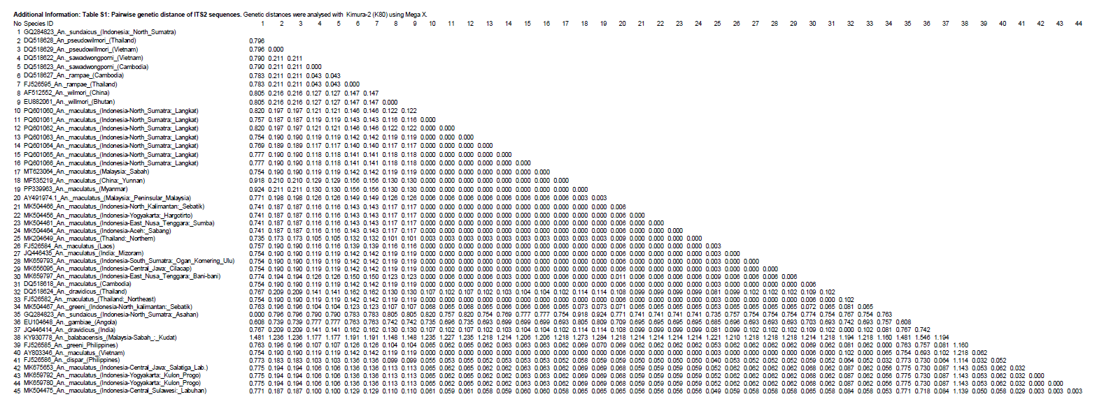
Pairwise genetic distances based on ITS2 sequences among An. maculatus species and populations analysed in this study. Genetic distances were calculated using the Kimura-2 parameter (K80) model implemented in MEGA X. Values represent the number of nucleotide substitutions per site. Sequence codes correspond to specimen IDs, species names, and sampling localities listed in the first column. Intraspecific distances are shown along the diagonal (0.000), while interspecific and interpopulation distances are shown below the diagonal.
Table S2. Pairwise genetic distance of cox1 An. maculatus sequences.
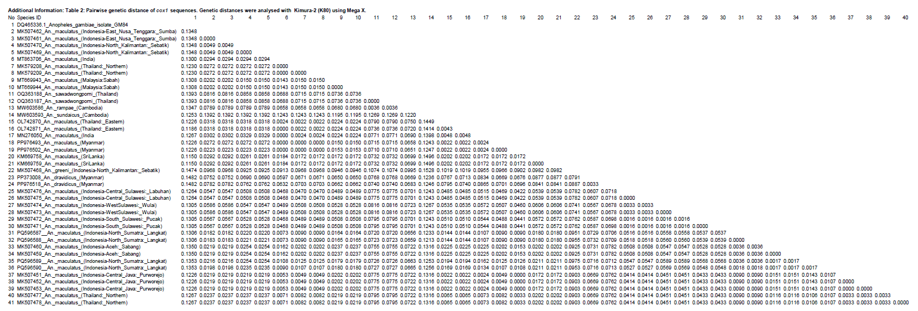
Pairwise genetic distances of cox1 sequences among An. maculatus species and populations analysed in this study. Genetic distances were calculated using the Kimura-2(K80) model implemented in MEGA X. Values represent the number of nucleotide substitutions per site. Specimen codes correspond to species identity and sampling locality. Zero values along the diagonal indicate identical sequences.
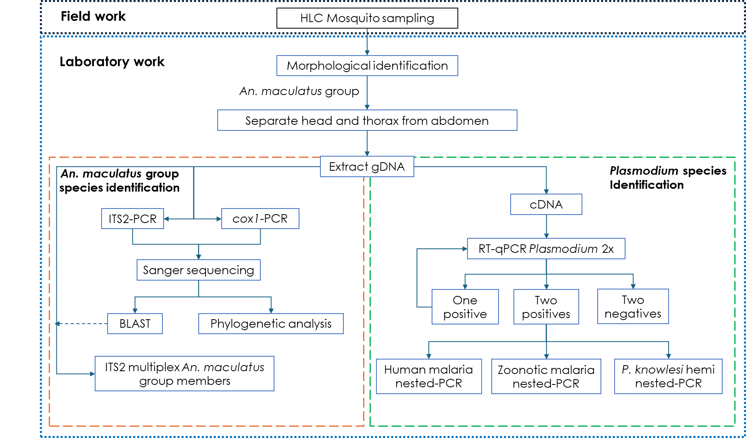
Figure S1. Overview of the methods for Anopheles and Plasmodium species identification

Supplementary Methods: Molecular assays protocol for Anopheles and Plasmodium species identification
- Molecular assays to identify species in the Maculatus Group
- Identification of Anopheles maculatus s.l. by single-point ITS2 PCR
A single-point ITS2 PCR assay (Beebe and Saul, 1995) was used to confirm samples as An. maculatus s.l following morphological identification. The ITS2 gene was amplified using the ITS2A (5’-TGTGAACTGCAGGACACAT-‘3) and ITSB (5’-TATGCTTAAATTCAGGGGGT-‘3) primers. The amplification master mix consisted of 1x GoTaq® flexi green buffer (Promega, WI, USA), 3.0 mM MgCl2 (Promega), 0.2 mM dNTP mix (Promega), 0.5 µM of each ITS2A and ITS2B, 1.25 U GoTaq® Flexi DNA polymerase (Promega), 1µL of DNA template and nuclease-free water (NFW) to a total volume of 30 µL.
The cycling conditions were an initial denaturation step at 95 °C for 2 min, followed by 35 denaturation cycles at 95 °C for 1 min, annealing at 51 °C for 1 min and extension at 72 °C for 1 min, with a final extension step at 72 °C for 10 min. The PCR products were visualised on a 1.5% agarose gel via electrophoresis at 100 volts for 85 minutes. Anopheles maculatus s.l generated an amplification product of approximately 460 bp.

- Identification of An. maculatus s.s. species
A multiplex ITS2 PCR assay was conducted to identify species in the An. maculatus group, as described by Walton et al. (2007). One microliter of gDNA template was added to a master mix containing 1x GoTaq green buffer (Promega), 2.5 mM of MgCl₂ (Promega), 0.2 mM of dNTP mix (Promega), 0.2 µM of primer 5.8F, MAC, PSEU and K, 0.1 µM of primer SAW and DRAV (Table S3), and 1 U GoTaq® Flexi DNA polymerase (Promega), to a final volume of 30 µL using NFW. The cycling conditions were: 95 °C for 2 min, followed by 35 cycles of denaturation at 95 °C for 1 min, annealing at 61 °C for 40 sec and extension at 72 °C for 40 sec, followed by a final extension step at 72 °C for 5 min.
Table S3. Primers to identify the species in the Maculatus Group (Walton et al.,2007)
Primer | Sequence (5′-3′) | Targeted species | Size (bp)
5.8F | ATC ACT CGG CTC GTG GAT CG | universal forward primer
MAC | GAC GGT CAG TCT GGT AAA GT-3 | An. maculatus | 180
PSEU | GCC CCC GGG TGT CAA ACA G | An. pseudowillmori | 203
SAW | ACG GTC CCG CAT CAG GTG C | An. sawadwongporni | 242
K | TTC ATC GCT CGC CCT TAC AA | Form K | 301
DRAV | GCC TAC TTT GAG CGA GAC CA | An. dravidicus | 477

- Identification of Anopheles species based on cox1 gene
The cox1 gene was amplified using the primers CI-N-2087 (5'-AAT TTC GGT CAG TTA ATA ATA TAG-3') and TY-J-1460 (5'-TAC AAT TTA TCG CCT AAA CTT CAG CC-3'), as described by Garjito et al. (2019). A 30 µL master mix was prepared by mixing 1x GoTaq® flexi green buffer (Promega), 2.5 mM MgCl2 (Promega), 0.2 mM dNTP mix (Promega), 0.1 µM of each CI-N-2087 and TY-J-1460 primers, 1.25 U GoTaq® Flexi DNA polymerase (Promega), 2 µL of DNA template and NFW. The PCR amplification conditions were an initial denaturation at 95 °C for 3 min, followed by 5 cycles of denaturation at 94 °C for 30 sec, annealing at 45 °C for 40 sec and extension at 72 °C for 1 min, and then followed by 35 cycles of denaturation at 94 °C for 30 sec, annealing at 55 °C for 40 sec and extension at 72 °C for 1 min, and followed by a final extension step at 72 °C for 10 min. The amplification products were visualized using 1.5% agarose gel electrophoresis
D. Reference ITS2 and cox1 sequences of Anopheles maculatus for phylogenetic analysis
Table S4. ITS2 Anopheles maculatus phylogenetic references list
Anopheles species | Accession  numbers | Geographic  origin | Collection  year | DNA  size (bp)
An. maculatusfrom Indonesia
An. maculatus | MK504464 | Aceh: Sabang | 2019 | 362
An. maculatus | MK659793 | South Sumatra: Ogan Komering Ulu | 2019 | 381
An. maculatus | MK656095 | Central Java: Cilacap | 2019 | 381
An. maculatus var manoreh | MK675653 | Central Java: Salatiga (lab. strain) | 2019 | 379
An. maculatus var manoreh | MK659780 | Central Java: Kulon Progo | 2019 | 379
An. maculatus var manoreh | MK659792 | Yogyakarta: Kulon Progo | 2019 | 379
An. maculatus | MK504475 | Central Sulawesi: Labuhan | 2019 | 362
An. maculatus | MK504466 | North Kalimantan: Sebatik | 2019 | 362
An. maculatus | MK504456 | Yogyakarta: Hargotirto | 2019 | 362
An. maculatus | MK659797 | East Nusa Tenggara: Bani-bani | 2019 | 381
An. maculatus | MK504461 | East Nusa Tenggara: Sumba | 2019 | 362
An. maculatus from Asia countries
An. maculatus | AY491974.1 | Malaysia: Peninsular Malaysia | 2003 | 460
An. maculatus | MT623064 | Malaysia: Sabah | 2020 | 460
An. maculatus | FJ526582 | Thailand: North-eastern | 2009 | 467
An. maculatus | MK204649 | Thailand: northern | 2019 | 351
An. maculatus | AY803346 | Vietnam | 2006 | 509
An. maculatus | PP339963 | Myanmar | 2024 | 325
An. maculatus | DQ518618 | Cambodia | 2006 | 470
An. maculatus | FJ526584 | Laos | 2009 | 467
An. maculatus | MF535219 | China: Yunan | 2017 | 423
An. maculatus | JQ446435 | India: north-eastern (Mizoram) | 2012 | 433
Members of the Maculatus Group
An. dispar | FJ526586 | Philippines | 2009 | 438
An. dravidicus | DQ518624 | Thailand | 2006 | 474
An. dravidicus | JQ446414 | India | 2012 | 462
An. greeni | FJ526585 | Philippines | 2009 | 404
An. greeni | MK504467 | Indonesia: North Kalimantan (Sebatik) | 2019 | 360
An. pseudowilmori | DQ518628 | Thailand | 2006 | 470
An. pseudowilmori | DQ518629 | Vietnam | 2006 | 470
An. rampae | FJ526595 | Thailand | 2009 | 468
An. rampae | DQ518627 | Cambodia | 2006 | 471
An. sawadwongporni | DQ518622 | Vietnam | 2006 | 478
An. sawadwongporni | DQ518623 | Cambodia | 2006 | 478
An. wilmori | AF512552 | China | 2002 | 444
An. wilmori | EU882061 | Bhutan | 2008 | 516
Out of the group of the Maculatus Group
An. sundaicus | GQ284823 | Indonesia: North Sumatra | 2011 | 620
An. gambiae | EU104648 | Angola | 2012 | 616
An. balabacensis | KY930778 | Malaysia: Sabah (Kudat) | 2018 | 739
Table S5. Cox1 Anopheles maculatus phylogenetic references list
Anopheles species | Accession  numbers | Geographic  origin | Collection  year | DNA  size (bp)
An. maculatusfrom Indonesia
An. maculatus | MK507475 | Central Sulawesi: Labuhan | 2019 | 616
An. maculatus | MK507476 | Central Sulawesi: Labuhan | 2019 | 616
An. maculatus | MK507471 | South Sulawesi: Pucak | 2019 | 616
An. maculatus var manoreh | MK507472 | South Sulawesi: Pucak | 2019 | 616
An. maculatus var manoreh | MK507473 | West Sulawesi: Wulai | 2019 | 616
An. maculatus var manoreh | MK507474 | West Sulawesi: Wulai | 2019 | 616
An. maculatus | MK507451 | Central Java: Purworejo | 2019 | 616
An. maculatus | MK507452 | Central Java: Purworejo | 2019 | 616
An. maculatus | MK507453 | Central Java: Purworejo | 2019 | 616
An. maculatus | MK507459 | Aceh: Sabang | 2019 | 616
An. maculatus | MK507460 | Aceh: Sabang | 2019 | 616
An. maculatus | MK507469 | North Kalimantan: Sebatik | 2019 | 616
An. maculatus | MK507470 | North Kalimantan: Sebatik | 2019 | 616
An. maculatus | MK507461 | East Nusa Tenggara: Sumba | 2019 | 616
An. maculatus | MK507462 | East Nusa Tenggara: Sumba | 2019 | 616
An. maculatus from Asia countries
An. maculatus | PP976502 | Myanmar | 2024 | 751
An. maculatus | PP976493 | Myanmar | 2024 | 864
An. maculatus | OL742870 | Thailand: Eastern | 2022 | 708
An. maculatus | OL742871 | Thailand: Eastern | 2022 | 708
An. maculatus | MT863706 | India | 2022 | 615
An. maculatus | MN276050 | India | 2019 | 509
An. maculatus | MK579208 | Thailand: Northern | 2021 | 658
An. maculatus | MK579209 | Thailand: Northern | 2021 | 658
An. maculatus | MK507477 | Thailand: Northern | 2019 | 616
An. maculatus | MK507478 | Thailand: Northern | 2019 | 616
An. maculatus | KM669758 | Sri Lanka | 2015 | 361
An. maculatus | KM669759 | Sri Lanka | 2015 | 361
An. maculatus | MT669943 | Malaysia: Sabah | 2020 | 1501
An. maculatus | MT669944 | Malaysia: Sabah | 2020 | 1501
Members of the Maculatus Group
An. dravidicus | PP373008 | Myanmar | 2024 | 852
An. dravidicus | PP976518 | Myanmar | 2024 | 696
An. greeni | MK507468 | Indonesia: North Kalimantan (Sebatik) | 2019 | 616
An. rampae | MW603586 | Cambodia | 2021 | 619
An. sawadwongporni | OQ363287 | Thailand | 2023 | 838
An. sawadwongporni | OQ363288 | Thailand | 2023 | 838
Out of the group of the Maculatus Group
An. sundaicus | MW603593 | Cambodia | 2021 | 619
An. gambiae | DQ465336 | Nigeria | 2016 | 1115

- Molecular assays to identify Plasmodium
- Plasmodium Detection
Reverse transcriptase real-time polymerase chain reaction (RT-qPCR), as described by Kamau et al. (2011) and Braima et al. (2024), was run to detect Plasmodium from Anopheles samples. The amplification master mix reaction was prepared in a 10 µL duplicate reaction containing 1x Taqman-PCR master mix (Applied Biosystems by Thermo Fisher Scientific, Warrington, UK), 0.4 µM of each KamGF (5’- GCT CTT TCT TGA TTT CTT GGA-‘3) and KamGR (5’-AGC AGG TTA AGA TCT CGT TCG-‘3) primers, 0.2 µM of KamGP probe (FAM-ATG GCC GTT TTT AGT TCG TG-BHQ1), 1 µL of cDNA, and NFW to a final volume of 10 µL. The master mix samples, including positive and negative controls, were performed under the following cycling conditions: 2 min at 60°C, 10 min at 95°C, 45 cycles of 15 sec at 95°C, and 1 min at 60°C. The RT-qPCR assay was performed using Rotor-Gene Q (Qiagen, Hilden, Germany).

- Identification of human malaria parasites
Reverse transcriptase nested PCR (RT-nPCR) assay, as described by Snounou et al. (1993), was conducted to identify the human malaria parasites, Plasmodium falciparum, Plasmodium vivax, Plasmodium malariae and Plasmodium ovale. This assay consisted of two PCR reactions. The nest-1 amplification master-mix contained 1x GoTaq green buffer (Promega), 3 mM of MgCl2 (Promega), 0.2 mM of dNTP mix (Promega), 0.25 µM of each primer rPLU1 and rPLU5 (Table S6), 1.25 U GoTaq® Flexi DNA polymerase (Promega), 4 µL of cDNA template to a final volume to 50 µL with NFW. The cycling conditions were an initial denaturation at 94°C for 4 min, followed by 35 cycles at 94°C for 30 sec, 58°C for 1 min and 72°C for 2 min, with a final extension at 72°C for 4 min.
The amplification products from nest-1 were used as the template for the nest-2 PCR. The master-mix for nest-2 PCR contained 1x GoTaq green buffer (Promega), 3 mM of MgCl2 (Promega), 0.2 mM of dNTP mix (Promega), 0.25 µM of each species-specific Plasmodium primers (Table S6), 1 U GoTaq® Flexi DNA polymerase (Promega), 2 µL of diluted nest-1 PCR product (1:20) and NFW to 20ul. The PCR conditions were an initial denaturation for 4 min at 94°C, 35 cycles of 30 sec at 94°C, 1 min of annealing at 58°C and 1 min at 72°C, followed by 5 min at 72°C for final extension. 1.5% agarose gel electrophoresis was used to separate and visualise the amplified PCR products.

- Identification of simian malaria parasites
Following the protocols of Lee et al. (2011), an RT-nPCR assay identified the simian malaria species Plasmodium inui, Plasmodium cynomolgi, Plasmodium coatneyi, and Plasmodium fieldi. In the first step (nest-1), the master mix included 1x GoTaq green buffer (Promega), 3 mM MgCl₂ (Promega), 0.2 mM dNTPs (Promega), 0.25 µM of each primer (rPLU1 and rPLU5, see Table S6), 1.25 U GoTaq® Flexi DNA polymerase (Promega), and 4 µL of cDNA template, with NFW added to a total volume of 50 µL. The thermal cycling protocol began with denaturation at 94°C for 4 min, followed by 35 cycles of 30 sec at 94°C, 1 min at 58°C, and 2 min at 72°C, concluding with a final 4-minute extension at 72°C.
The second PCR (nest-2) used the first PCR product as the template. The nest-2 master mix contained 1x GoTaq green buffer (Promega), 3 mM MgCl₂ (Promega), 0.2 mM dNTPs (Promega), 0.25 µM of species-specific Plasmodium primers (Table S6), 1 U GoTaq® Flexi DNA polymerase (Promega), 2 µL of diluted nest-1 product (1:10), and NFW to a total volume of 20 µL. PCR cycling conditions began with denaturation at 94°C for 4 min, followed by 35 cycles of 30 sec at 94°C, 1 min of primer-specific annealing (Table S6), and 1 minute at 72°C, ending with a 5 min final extension at 72°C. To analyse and visualise the amplified PCR products, amplicons were separated by electrophoresis on a 1.5% agarose gel.

- Identification of Plasmodium knowlesi
A real time-hemi nested PCR assay, as described by Imwong et al. (2009), identified P. knowlesi. The master mix for the 1-nest was 1x GoTaq green buffer (Promega), 2.5 mM of MgCl2 (Promega), 0.5 mM of dNTP mix (Promega), 0.25 µM of each PKF1160 and PKR1150 primers (Table S6), 1.25 U GoTaq® Flexi DNA polymerase (Promega), 2 µL of cDNA template to a final volume of 25 µL with NFW. The cycling conditions started with an initial denaturation for 5 min at 95°C; 35 cycles of 1 min at 94°C, 1 min at 55°C and 1 min at 72°C, and followed by 5 min at 72°C for a final extension.
For the 2nd-nested PCR, the master mix contained 1x GoTaq green buffer (Promega), 3 mM of MgCl2 (Promega), 0.5 mM of dNTP mix (Promega), 0.25 µM of each primer PKF1140 and PKR1150 primers (Table S6), 1 U GoTaq® Flexi DNA polymerase (Promega), 2 µL of 1-nest PCR product with NFW added to 20 µL. The thermal conditions were an initial denaturation for 5 min at 95°C, followed by 35 cycles of 1 min at 94°C, 1 min at 50°C and 1 min at 72°C, with final extension at 72°C for 5 min. The PCR products were separated and visualised by 1.5% agarose gel electrophoresis.

Table S6. List of primer sequences and modified annealing temperatures of Plasmodium species-specific PCR assays.
References | PCR method | Gene target | Primer/ Probe | Sequence (5′-3′) | Annealing temp. (°C) | Targeted species | DNA size (bp)
Snounou  et al., 1993 | Nested PCR | 18S rRNA | rPLU 1 | TCA AAG ATT AAG CCA TGC AAG TGA | 58 | - | -
Snounou  et al., 1993 | Nested PCR | 18S rRNA | rPLU 5 | CCT GTT GTT GCC TTA AAC TCC | 58 | - | -
Snounou  et al., 1993 | Nested PCR | 18S rRNA | rFAL1 | TTA AAC TGG TTT GGG AAA ACC AAA TAT ATT | 58 | P. falciparum | 205
Snounou  et al., 1993 | Nested PCR | 18S rRNA | rFAL2 | ACA CAA TGA ACT CAA TCA TGA CTA CCC GTC | 58 | P. falciparum | 205
Snounou  et al., 1993 | Nested PCR | 18S rRNA | rVIV1 | CGA CTT CCA AGC CGA AGC AAA GAA AG | 58 | P. vivax | 120
Snounou  et al., 1993 | Nested PCR | 18S rRNA | rVIV2 | TCC TTA CTT CTA GCT TAA TCC ACA TAA CTG ATA C | 58 | P. vivax | 120
Snounou  et al., 1993 | Nested PCR | 18S rRNA | rOVA1 | ATC TCT TTT GCT ATT TTT TAG TAT TGG AGA | 58 | P. ovale | 880
Snounou  et al., 1993 | Nested PCR | 18S rRNA | rOVA2 | GGA AAA GGA CAC ATT ATT CIG TAT CCT AGT G | 58 | P. ovale | 880
Snounou  et al., 1993 | Nested PCR | 18S rRNA | rMAL1 | ATA ACA TAG TTG TAC GTT AAG AAT AAC CGC | 58 | P. malariae | 144
Snounou  et al., 1993 | Nested PCR | 18S rRNA | rMAL2 | AAA ATT CCC ATG CAT AAA AAA TTA TAC AAA | 58 | P. malariae | 144
Lee  et al., 2011 | Nested PCR | 18S rRNA | rPLU 1 | TCA AAG ATT AAG CCA TGC AAG TGA | 58 | - | -
Lee  et al., 2011 | Nested PCR | 18S rRNA | rPLU 5 | CCT GTT GTT GCC TTA AAC TCC | 58 | - | -
Lee  et al., 2011 | Nested PCR | 18S rRNA | PctF1 | CGC TTT TAG CTT AAA TCC ACA TAA CAG AC | 60 | P. coatneyi | 503
Lee  et al., 2011 | Nested PCR | 18S rRNA | PctR1 | GAG TCC TAA CCC CGA AGG GAA AGG | 60 | P. coatneyi | 503
Lee  et al., 2011 | Nested PCR | 18S rRNA | CY2F | GAT TTG CTA AAT TGC GGT CG | 60 | P. cynomolgi | 137
Lee  et al., 2011 | Nested PCR | 18S rRNA | CY4R | CGG TAT GAT AAG CCA GGG AAG T | 60 | P. cynomolgi | 137
Lee  et al., 2011 | Nested PCR | 18S rRNA | PfldF1 | GGT CT TTT TTT TGC TTC GGT AAT TA | 63 | P. fieldi | 421
Lee  et al., 2011 | Nested PCR | 18S rRNA | PfldR2 | AGG CAC TGA AGG AAG CAA TCTA AGA GTT TC | 63 | P. fieldi | 421
Lee  et al., 2011 | Nested PCR | 18S rRNA | PinF2 | CGT ATC GAC TTT GTG GCA TTT TTC TAC | 58 | P. inui | 479
Lee  et al., 2011 | Nested PCR | 18S rRNA | INAR3 | GCA ATC TAA GAG TTT TAA CTC CTC | 58 | P. inui | 479
Imwong  et al., 2009 | Hemi-nested PCR | 18S rRNA | PKF1160 | GAT GCC TCC GCG TAT CGA C | 55 | - | -
Imwong  et al., 2009 | Hemi-nested PCR | 18S rRNA | PKR1150 | GAG TTC TAA TCT CCG GAG AGA AAA GA | 55 | - | -
Imwong  et al., 2009 | Hemi-nested PCR | 18S rRNA | Pkf1140 | GAT TCA TCT ATT AAA AAT TTG CTT C | 50 | P. knowlesi | 410
Imwong  et al., 2009 | Hemi-nested PCR | 18S rRNA | Pkr1550 | GAG TTC TAA TCT CCG GAG AGA AAA GA | 50 | P. knowlesi | 410

