Supplementary file

Supplementary Table 1. The scoring system for various nutritional variables ranged from 0 to 1, based on participants’ responses to dietary questions.
Variable | Categories | Score
Mean daily fruit servings* | ≥4 servings | 1
Mean daily fruit servings* | 3 ≤ and < 4 servings | 0.75
Mean daily fruit servings* | 2 ≤ and < 3 servings | 0.5
Mean daily fruit servings* | 1 ≤ and < 2 serving | 0.25
Mean daily fruit servings* | <1 servings | 0
Mean daily vegetables servings* | ≥4 servings | 1
Mean daily vegetables servings* | 3 ≤ and < 4 servings | 0.75
Mean daily vegetables servings* | 2 ≤ and < 3 servings | 0.5
Mean daily vegetables servings* | 1 ≤ and < 2 serving | 0.25
Mean daily vegetables servings* | <1 servings | 0
Frequency of consuming dairy products | Less than 1 time/month or never | 0
Frequency of consuming dairy products | 1-3 times/month | 0.2
Frequency of consuming dairy products | 1-3 times/week | 0.4
Frequency of consuming dairy products | 4-6 times/week | 0.6
Frequency of consuming dairy products | 1 or 2 times a day | 0.8
Frequency of consuming dairy products | More than 3 times a day | 1
Frequency of consuming fish | Less than 1 time/month or never | 0
Frequency of consuming fish | 1-3 times/month | 0.2
Frequency of consuming fish | 1-3 times/week | 0.4
Frequency of consuming fish | 4-6 times/week | 0.6
Frequency of consuming fish | 1 or 2 times a day | 0.8
Frequency of consuming fish | More than 3 times a day | 1
Frequency of consuming red meat | Less than 1 time/month or never | 0
Frequency of consuming red meat | 1-3 times/month | 0.2
Frequency of consuming red meat | 1-3 times/week | 1
Frequency of consuming red meat | 4-6 times/week | 0.8
Frequency of consuming red meat | 1 or 2 times a day | 0.6
Frequency of consuming red meat | More than 3 times a day | 0.4
Frequency of processed meat consumption | Less than 1 time/month or never | 1
Frequency of processed meat consumption | 1-3 times/month | 0.8
Frequency of processed meat consumption | 1-3 times/week | 0.6
Frequency of processed meat consumption | 4-6 times/week | 0.4
Frequency of processed meat consumption | 1 or 2 times a day | 0.2
Frequency of processed meat consumption | More than 3 times a day | 0
Frequency of sugar-sweetened beverages consumption | Less than 1 time/month or never | 1
Frequency of sugar-sweetened beverages consumption | 1-3 times/month | 0.8
Frequency of sugar-sweetened beverages consumption | 1-3 times/week | 0.6
Frequency of sugar-sweetened beverages consumption | 4-6 times/week | 0.4
Frequency of sugar-sweetened beverages consumption | 1 or 2 times a day | 0.2
Frequency of sugar-sweetened beverages consumption | More than 3 times a day | 0
Legend: Mean daily fruit and vegetable servings were calculated by multiplying the reported number of servings consumed per day by the number of days they were consumed in a week. The result was then divided by 7 to provide an average daily intake over the course of a week.

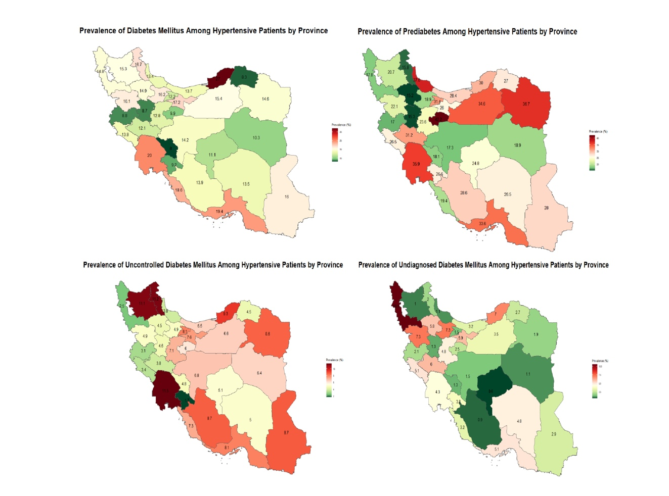 Supplementary Figure 1. Age- and sex-standardized subnational prevalence of diabetes, prediabetes, uncontrolled diabetes, and undiagnosed diabetes across Iranian provinces, illustrating geographic variation among hypertensive patients. Administrative boundaries were obtained from GADM (Global Administrative Areas; www.gadm.org).

Supplementary Table 2. Association between various demographic, clinical, and lifestyle factors and having diabetes.
Variable | Category | Crude Odds ratio | P value | Model 2 ¹ | P value | Model 3 ² | p value
sex | Female | Ref
sex | Male | 0.85(0.71-1.02) | 0.075 | 0.89(0.74-1.06) | 0.193 | 1.11(0.87-1.43) | 0.4
Age (years old) | 25-40 | Ref
Age (years old) | 40-59 | 3.48(2.02-6) | <0.0001 | 3.41(1.98-5.86) | <0.0001 | 2.44(1.43-4.16) | 0.001*
Age (years old) | ≥ 60 | 5.46(3.18-9.39) | <0.0001 | 5.37(3.13-9.22) | <0.0001 | 2.99(1.74-5.14) | <0.0001*
Residential area | Rural | Ref
Residential area | Urban | 1.55(1.3-1.84) | <0.0001 | 1.53(1.28-1.82) | <0.0001 | 1.43(1.18-1.74) | 0.001*
Years of schooling (year) | 0-6 | Ref
Years of schooling (year) | 7 -11 | 0.71(0.55-0.92) | 0.011 | 0.98(0.74-1.29) | 0.867 | 0.81(0.6-1.08) | 0.154
Years of schooling (year) | 12≤ | 0.81(0.65-1.01) | 0.062 | 1.13(0.89-1.43) | 0.326 | 1.05(0.8-1.38) | 0.706
Employment status | Unemployed | Ref
Employment status | employed | 0.54(0.43-0.67) | <0.0001 | 0.67(0.51-0.87) | 0.003 | 0.81(0.61-1.08) | 0.154
Insurance | none | Ref
Insurance | basic | 1.04(0.66-1.64) | 0.86 | 0.94(0.6-1.48) | 0.796
Insurance | basic + complementary | 1.8(1.14-2.84) | 0.012 | 1.43(0.9-2.27) | 0.133
Marital status | Married | Ref
Marital status | Divorced/widowed | 1.26(1-1.58) | 0.045 | 1(0.78-1.3) | 0.981 | 0.93(0.69-1.24) | 0.604
Marital status | Never married | 0.16(0.09-0.3) | <0.0001 | 0.26(0.14-0.51) | <0.0001 | 0.24(0.11-0.52) | 0.001*
Central obesity | No | Ref
Central obesity | Yes | 1.78(1.45-2.19) | <0.0001 | 1.72(1.39-2.13) | <0.0001 | 1. 37(1.1-1.71) | 0.005*
Smoking | No | Ref
Smoking | yes | 0.79(0.58-1.06) | 0.117 | 0.88(0.65-1.2) | 0.424
Physical activity | Inappropriate | Ref
Physical activity | Appropriate | 0.73(0.62-0.87) | 0 | 0.8(0.67-0.95) | 0.018
Healthy diet score | Low diet score | Ref
Healthy diet score | Moderate diet score | 1.28(1.05-1.56) | 0.015 | 1.2(0.98-1.47) | 0.077 | 1.14(0.92-1.4) | 0.228
Healthy diet score | High diet score | 1.58(1.31-1.9) | <0.0001 | 1.57(1.3-1.9) | <0.0001 | 1.38(1.13-1.69) | 0.002*
Hypertension | Aware and treated | Ref
Hypertension | aware and untreated | 0.5(0.34-0.73) | 0 | 0.61(0.42-0.89) | 0.011 | 0.66(0.44-0.99) | 0.046*
Hypertension | unaware | 0.33(0.27-0.4) | <0.0001 | 0.39(0.31-0.49) | <0.0001 | 0.47(0.37-0.59) | <0.0001*
CVD | No | Ref
CVD | Yes | 2.31(1.87-2.86) | <0.0001 | 2 (1.61-2.5) | <0.0001 | 1.45(1.14-1.84) | 0.002*
CKD | No | Ref
CKD | Yes | 2.43(2.01-2.95) | <0.0001 | 2.08(1.71-2.54) | <0.0001 | 1.74(1.42-2.14) | <0.0001*
Dyslipidemia | No | Ref
Dyslipidemia | Yes | 2.06 (1.46-2.91) | <0.0001 | 2.09(1.46-2.99) | <0.0001 | 1.83(1.23-2.72) | 0.003*
Premature CHD family history | No | Ref
Premature CHD family history | Yes | 1.17(0.94-1.45) | 0.172 | 1.23(0.98-1.53) | 0.073
DM family history | No | Ref
DM family history | Yes | 2.86(2.4-3.4) | <0.0001 | 3.21(2.68-3.84) | <0.0001 | 3.06(2.53-3.69) | <0.0001*
Abbreviations: DM: Diabetes Mellitus, CVD: Cardiovascular disease, CKD: Chronic Kidney Disease, WC: Waist circumference; CHD: Coronary heart disease
Crude odds ratios (ORs) along with adjusted ORs from Model 2 and Model 3 are presented with their respective p-values.
¹Model 2 is adjusted for age and sex.
²Model 3 is adjusted for age, sex, waist circumference, residential area, education, employment status, insurance, marital status, hypertension status, history of CVD, history of CKD, dyslipidemia, family history of diabetes mellitus (DM), and healthy diet score.
* P-value ≤ 0.05 indicates statistical significance.

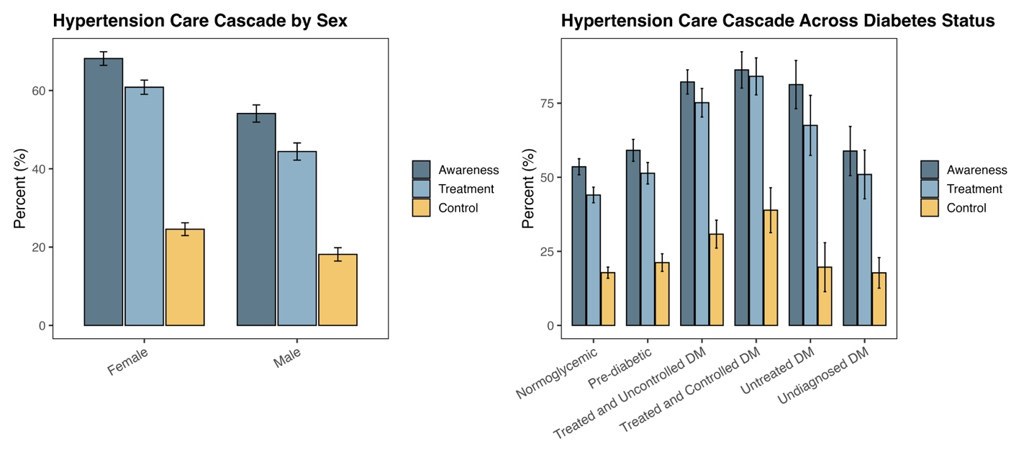Supplementary Figure 2. Hypertension awareness, treatment, and control in males and females (left), and hypertension awareness, treatment and control across different diabetes status (right). The y-axis represents the percentage.

