Supplementary Materials

S1 Parameters used for Water Yield calculation
Table 1 Biophysical table.
description | lucode | root_depth | Kc | LULC_veg
Cropland | 1 | 2000 | 0.65 | 1
Forestland | 2 | 5000 | 1 | 1
Gardenland | 3 | 3000 | 0.7 | 1
Grassland | 4 | 2600 | 0.85 | 1
Construction | 5 | 1 | 0.3 | 0
Transportation | 6 | 1 | 0.85 | 0
Water | 7 | 1 | 1 | 0
Unused land | 8 | 1 | 0.2 | 0
The Z-value is 29.3.

S2 Parameters used for Habitat Quality
Table 2 Threats table.
max_dist (km) | weight | threat | decay
1 | 3 | cropland | linear
5 | 5 | construction | exponential
6 | 2 | transportation | exponential
8 | 5 | unused land | linear
Table 3 Sensitivity table.
lulc | habitat | cropland | construction | transportation | unused land
1 | 0.3 | 0.3 | 0.5 | 0.2 | 0.25
2 | 1 | 0.65 | 0.75 | 0.5 | 0.6
3 | 1 | 0.35 | 0.75 | 0.5 | 0.6
4 | 0.8 | 0.4 | 0.6 | 0.3 | 0.4
5 | 0 | 0 | 0 | 0 | 0
6 | 0 | 0 | 0 | 0 | 0
7 | 1 | 0.7 | 0.8 | 0.6 | 0.3
8 | 0 | 0 | 0 | 0 | 0
The Half-Saturation Constant is 0.5.

S3 Parameters used for Soil conservation
Table 4 C、P table.
lulc | C | P
Cropland | 0.08 | 0.55
Forestland | 0.003 | 1
Gardenland | 0.08 | 0.7
Grassland | 0.004 | 1
Construction | 0.001 | 1
Transportation | 1 | 1
Water | 0 | 0
Unused land | 1 | 1
Threshold Flow Accumulation set to 1000, Borselli K Parameter set to 2, Maximum SDR Value set to 0.8, Borselli IC0 Parameter set to 0.5, Maximum L Value set to 122.

S4 Parameters used for Carbon sequestration
Table 5 Carbon density.
lulc | name | C_above | C_below | C_soil | C_dead
1 | Cropland | 46.5 | 80.7 | 108.4 | 1
2 | Forestland | 20.36 | 67.5 | 170 | 7.8
3 | Gardenland | 20.36 | 67.5 | 170 | 7.8
4 | Grassland | 4.3 | 86.5 | 89.02 | 0
5 | Construction | 0 | 0 | 71 | 0
6 | Transportation | 0 | 0 | 0 | 0
7 | Water | 0 | 0 | 71 | 0
8 | Unused land | 0.74 | 0.13 | 69.92 | 0

S5 Zoning results and confusion matrices under different weighting schemes
Table 6 Area statistics of zoning under different weighting schemes.
Zone type  Weighting schemes | Baseline scheme | Scheme B | Scheme C | Scheme D
Ecological restoration zone | 98.06 km² | 99.21 km² | 98.97 km² | 96.10 km²
Ecological warning zone | 557.58 km² | 556.93 km² | 556.98 km² | 557.68 km²
Ecological Buffer Zone | 1001.44 km² | 1002.05 km² | 1002.07 km² | 998.40 km²
Ecological conservation zone | 200.64 km² | 199.53 km² | 199.70 km² | 205.53 km²
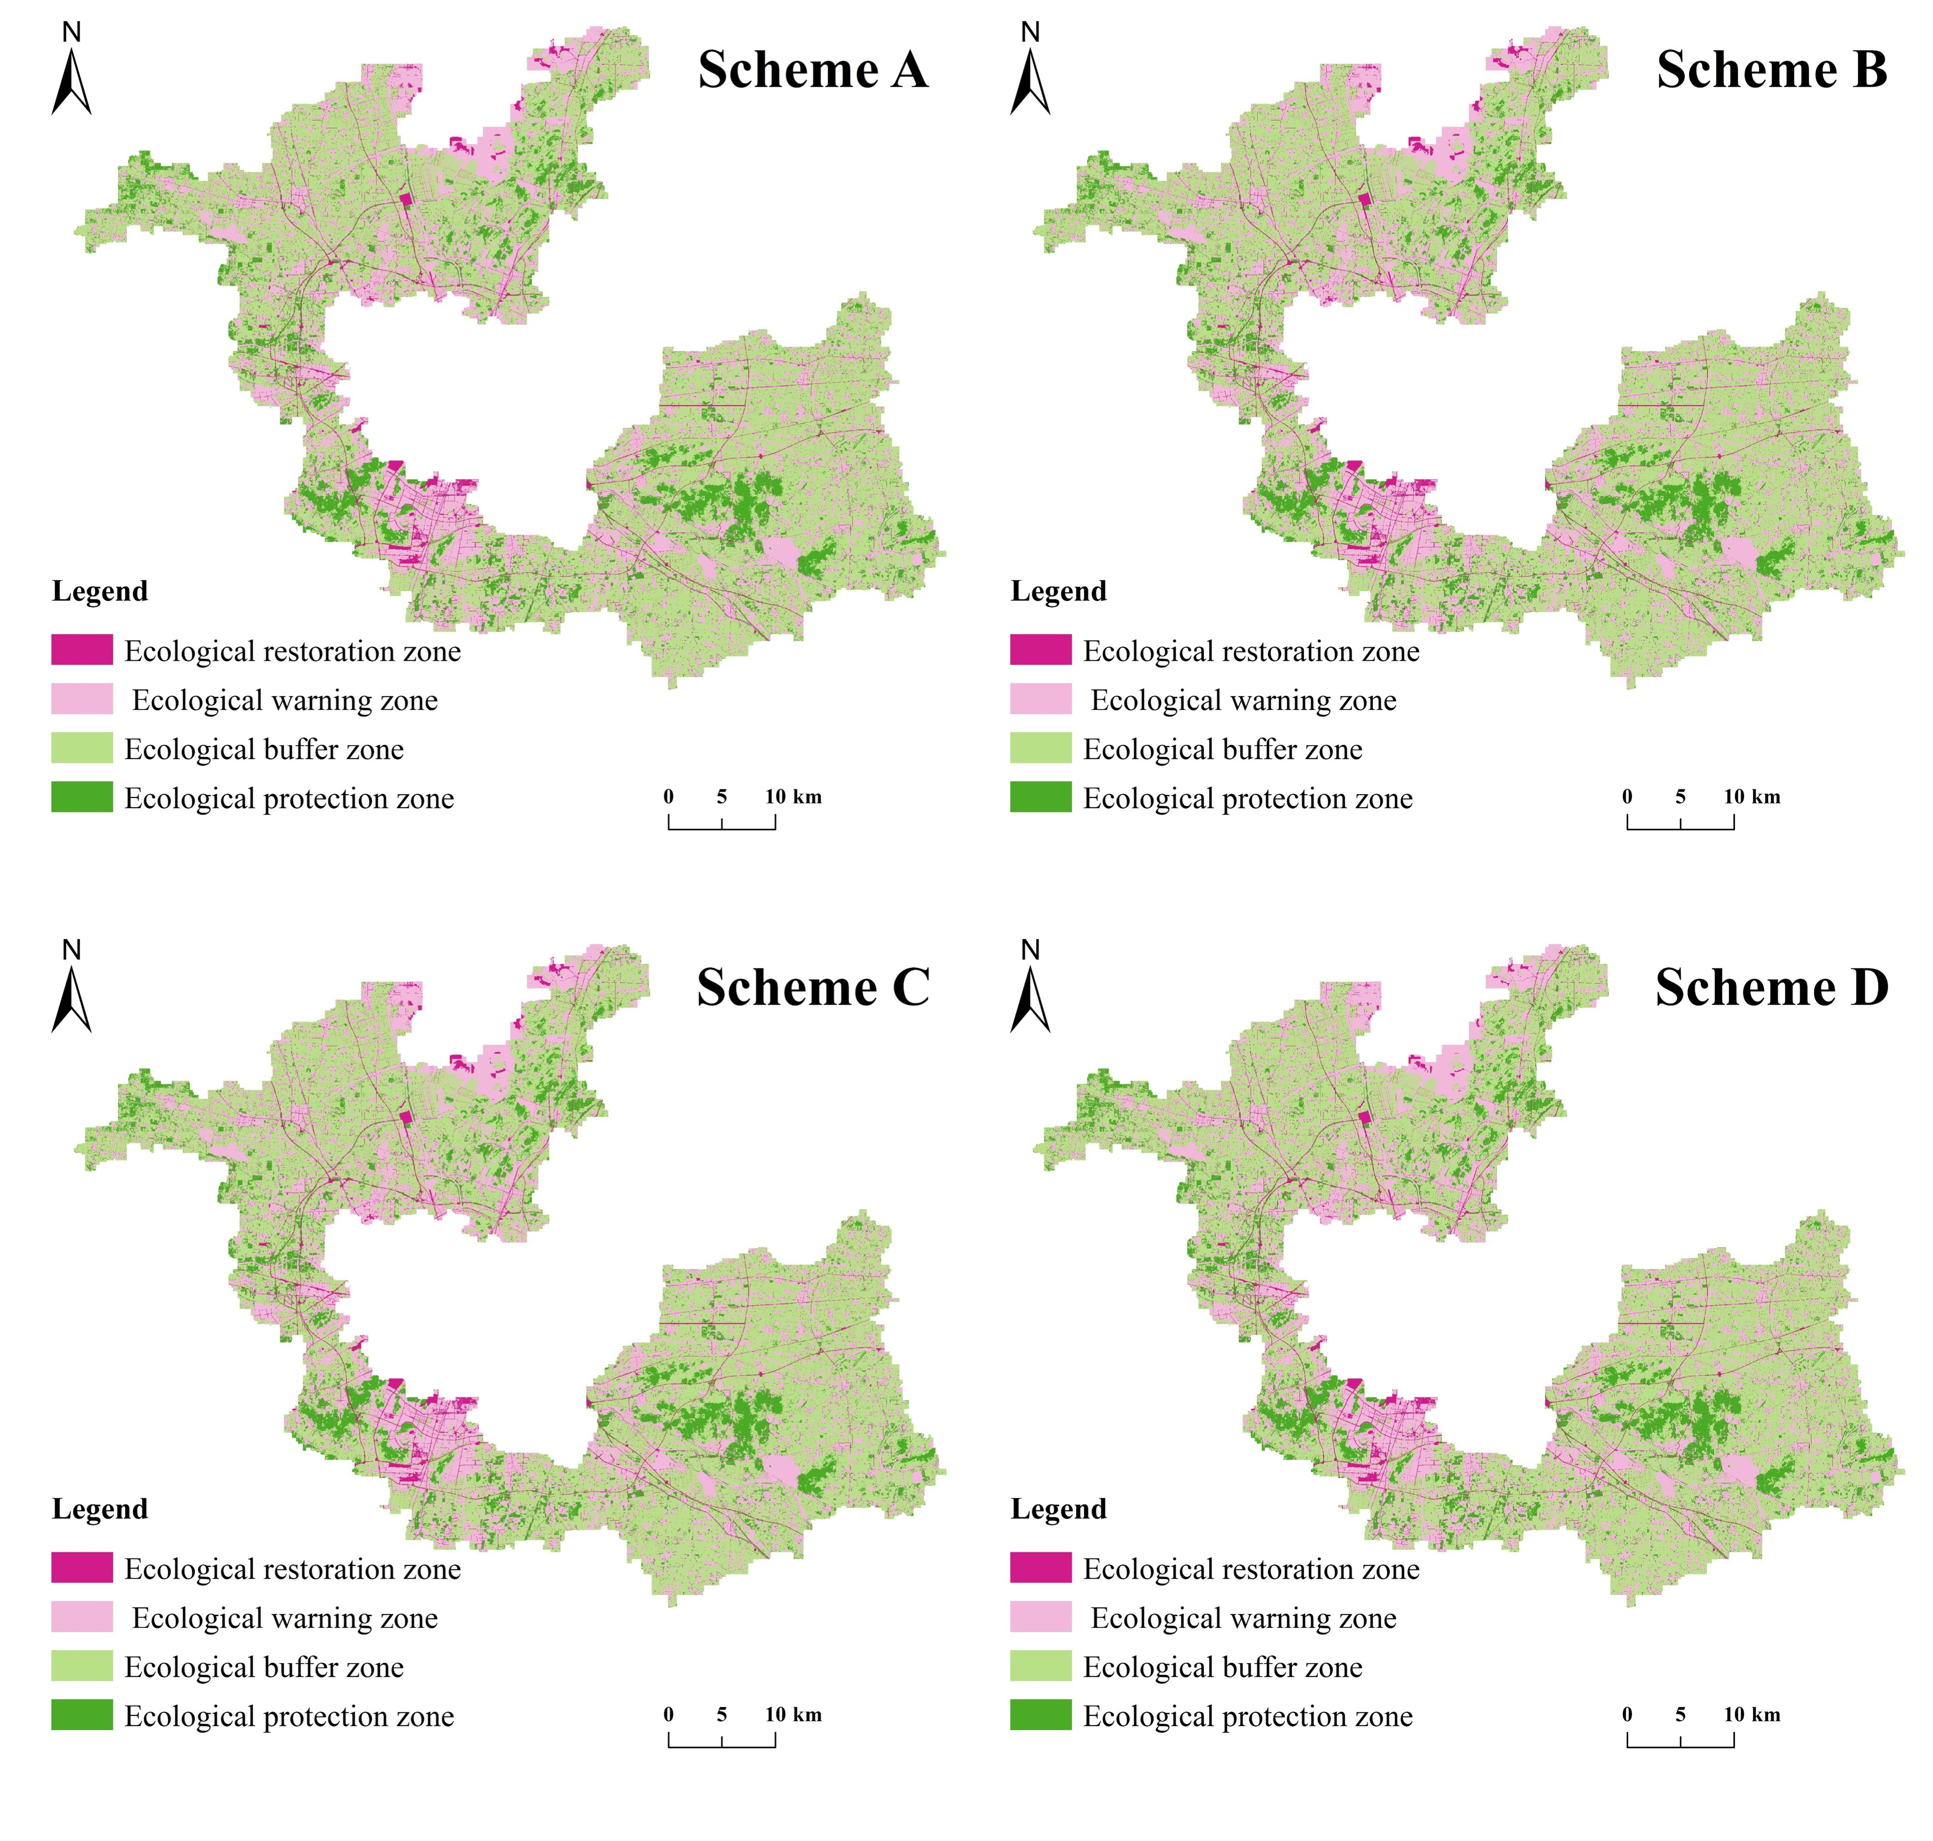
Fig. 1 Spatial distribution of zoning results under different weighting schemes
Table 7 Confusion matrices between the baseline scheme and the alternative weighting schemes.
Confusion matrix (number of pixels) between the baseline scheme and Scheme B
Baseline scheme  Scheme B | Ecological restoration zone | Ecological warning zone | Ecological Buffer Zone | Ecological conservation zone | Row Total
Ecological restoration zone | 108,875 | 81 | 0 | 0 | 108,956
Ecological warning zone | 1,353 | 616,234 | 1,943 | 0 | 619,530
Ecological Buffer Zone | 0 | 2,494 | 1,108,778 | 1,436 | 1,112,708
Ecological conservation zone | 0 | 0 | 2,667 | 220,266 | 222,933
Column Total | 110,228 | 618,809 | 1,113,388 | 221,702 | 2,064,127
Confusion matrix (number of pixels) between the baseline scheme and Scheme C
Baseline scheme  Scheme C | Ecological restoration zone | Ecological warning zone | Ecological Buffer Zone | Ecological conservation zone | Row Total
Ecological restoration zone | 108,899 | 57 | 0 | 0 | 108,956
Ecological warning zone | 1,070 | 616,978 | 1,482 | 0 | 619,530
Ecological Buffer Zone | 0 | 1,831 | 1,109,842 | 1,035 | 1,112,708
Ecological conservation zone | 0 | 0 | 2,084 | 220,849 | 222,933
Column Total | 110,228 | 618,809 | 1,113,388 | 221,702 | 2,064,127
Confusion matrix (number of pixels) between the baseline scheme and Scheme D
Baseline scheme  Scheme D | Ecological restoration zone | Ecological warning zone | Ecological Buffer Zone | Ecological conservation zone | Row Total
Ecological restoration zone | 106,393 | 2,563 | 0 | 0 | 108,956
Ecological warning zone | 385 | 612,246 | 6,899 | 0 | 619,530
Ecological Buffer Zone | 0 | 4,836 | 1,099,233 | 8,639 | 1,112,708
Ecological conservation zone | 0 | 0 | 3,200 | 219,733 | 222,933
Column Total | 110,228 | 618,809 | 1,113,388 | 221,702 | 2,064,127

S6 AHP Calculation Process

(1) Constructing the Hierarchical Structure Model
Taking the construction of the resistance surface as the goal layer, a structural model was built as shown in Fig. 2.
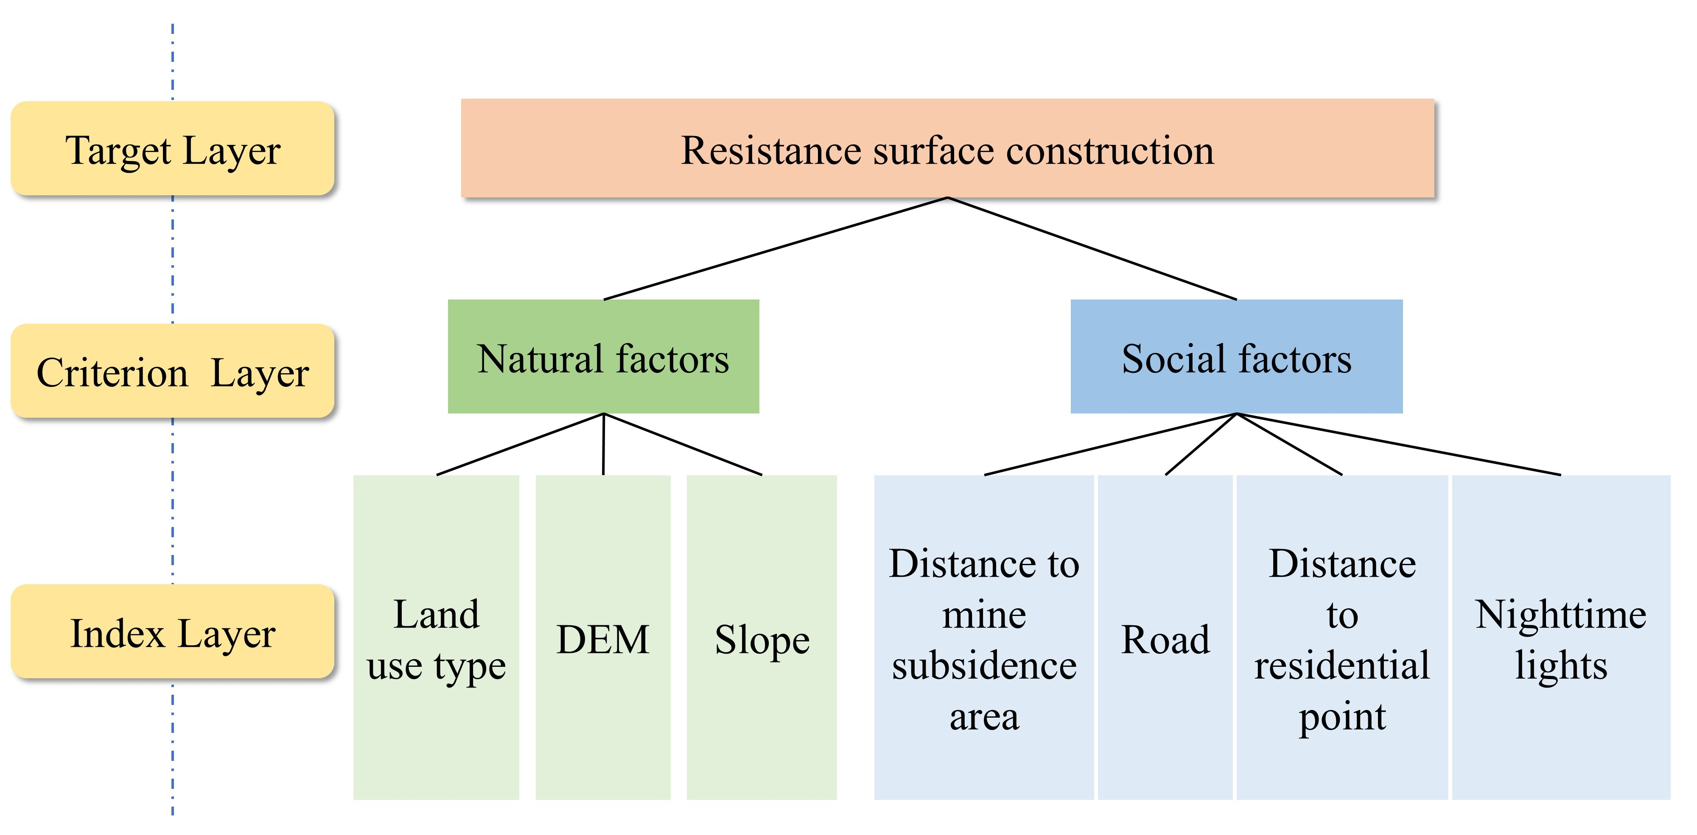
Fig. 2 Hierarchical Structure Model

(2)Constructing the Judgment Matrices
The 1-9 scale method (Table 8) was used for pairwise comparisons. Through multiple rounds of discussion until consensus was reached, the judgment matrices were constructed (Table 9).
Table 8 Scale for Constructing Indicator Importance
Scale | Meaning
1 | Indicates that two elements are of equal importance
3 | Indicates that the former is slightly more important than the latter
5 | Indicates that the former is significantly more important than the latter
7 | Indicates that the former is strongly more important than the latter
9 | Indicates that the former is absolutely more important than the latter
2,4,6,8 | Intermediate values between the above adjacent judgments
Reciprocals 1-9 | Indicates the importance of the reverse comparison when the two factors are swapped
Table 9 Judgment Matrices.
Judgment matrix for first-level indicators
 |  |  | Natural Factor |  |  |  | Social Factors
Natural Factor |  |  | - |  |  |  | 1
Social Factors |  |  | 1 |  |  |  | -
Judgment matrix for natural indicators
 |  | DEM |  |  | Slope |  |  | Land use type
DEM |  | - |  |  | 1 |  |  | 1/7
Slope |  | 1 |  |  | - |  |  | 1/7
Land use type |  | 7 |  |  | 7 |  |  | -
Judgment matrix for social indicators
 | Distance to mine subsidence area |  |  | Distance to residential point |  | Road |  |  | Nighttime lights
Distance to mine subsidence area | - |  |  | 2 |  | 1/3 |  |  | 1/2
Distance to residential point | 1/2 |  |  | - |  | 1/3 |  |  | 1/3
Road | 3 |  |  | 3 |  | - |  |  | 2
Nighttime lights | 2 |  |  | 3 |  | 1/2 |  |  | -

(3) Inputting the structural model and judgment matrices into the yaahp software to calculate the weights and combined consistency results.
Table 10 Weights and Combined Consistency Results.
Resistance Factor | weight | CI | RI(order)
Social factors | 0.500 | 0.0237 | 0.8900(4)
Natural factors | 0.500 | 0.0000 | 0.5200(3)
Land use type | 0.3889 | 0.0000 | 0.0000(2)
DEM/m | 0.0556 | 0.0000 | 0.0000(2)
Slope/° | 0.0556 | 0.0000 | 0.0000(2)
Distance to mine subsidence area/m | 0.0818 | 0.0000 | 0.0000(2)
Road | 0.2238 | 0.0000 | 0.0000(2)
Distance to residential point/m | 0.0530 | 0.0000 | 0.0000(2)
Nighttime lights | 0.1415 | 0.0000 | 0.0000(2)

S7 Results of five ecosystem services in Tongshan District
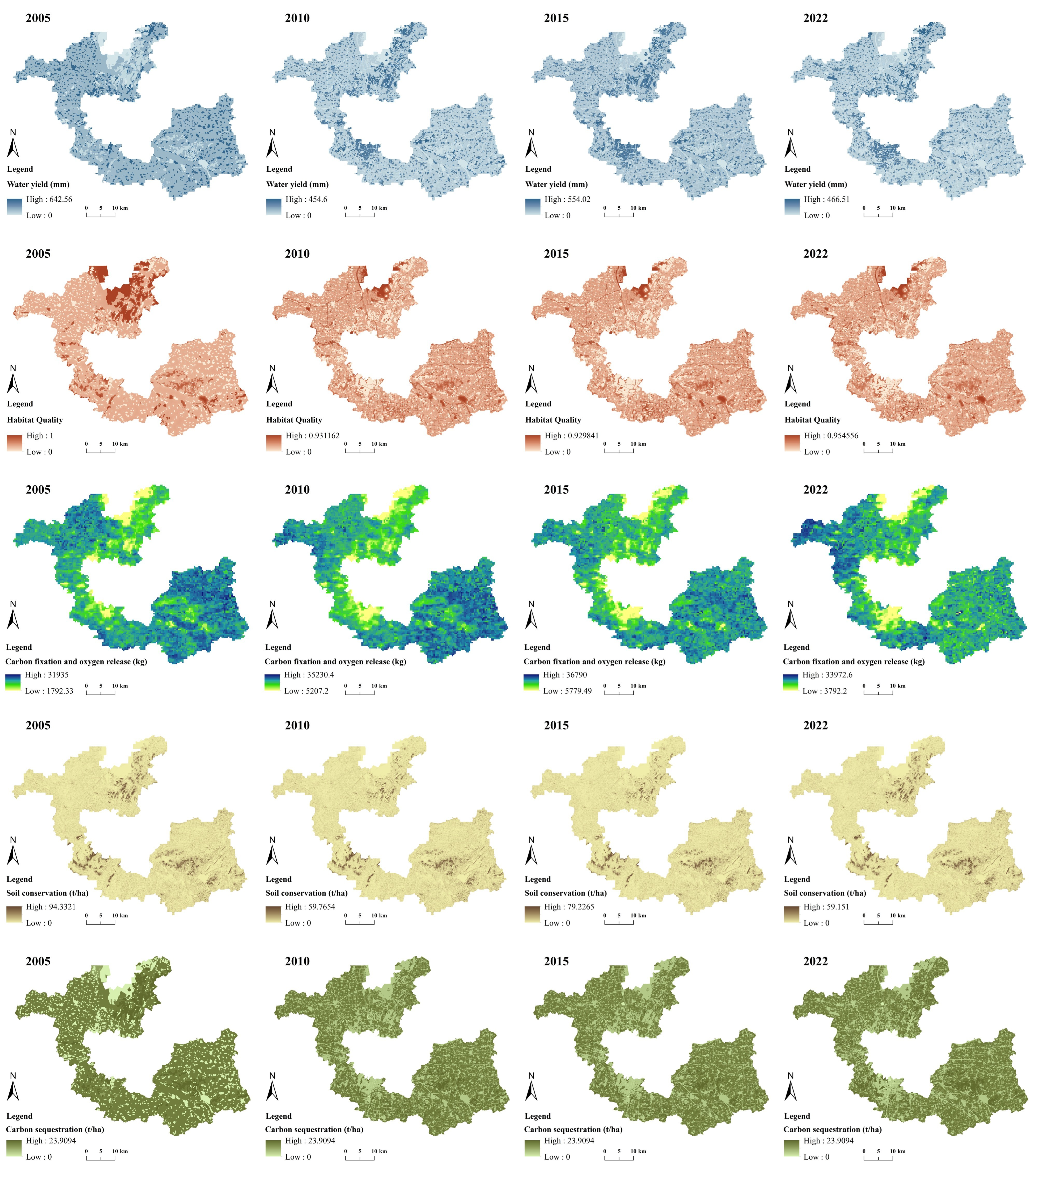
Fig. 3 Spatial distribution of five ecosystem services in Tongshan District
Table 11 mean values of five ecosystem services in Tongshan District
Year | Water yield/mm | Habitat Quality | Carbon fixation and oxygen release/kg | Soil conservation/t | Carbon sequestration/t
2005 | 190.69 | 0.29 | 24288.44 | 4.82 | 18.68
2010 | 94.73 | 0.25 | 26438.19 | 2.77 | 15.83
2015 | 147.33 | 0.25 | 28049.41 | 3.68 | 15.77
2022 | 78.55 | 0.26 | 25043.12 | 2.94 | 15.97

S8 Land Use Transition Matrix in CESI Degradation Areas, 2005–2010
Table 12 Land Use Transition Matrix in CESI Degradation Areas(km2), 2005–2010
2005  2010 | Cropland | Forestland | Gardenland | Grassland | Construction | Transportation | Water | Unused land
Cropland | 3.9258 | 0.0054 | 0.0018 | 0.0639 | 91.4508 | 54.2088 | 131.2362 | 1.8738
Forestland | 19.6497 | 10.071 | 0.3141 | 10.0944 | 24.552 | 2.1456 | 2.8098 | 28.3914
Gardenland | 3.9204 | 0.0000 | 0.0000 | 0.0009 | 1.1637 | 0.3672 | 1.0935 | 0.0000
Grassland | 0.0018 | 0.0072 | 0.0000 | 0.0198 | 2.9484 | 0.513 | 1.5696 | 0.9324
Construction | 0.0000 | 0.0000 | 0.0000 | 0.0000 | 0.0000 | 7.1982 | 0.009 | 0.0000
Transportation | 0.0000 | 0.0000 | 0.0000 | 0.0000 | 0.0000 | 0.0000 | 0.0000 | 0.0000
Water | 0.0000 | 0.0000 | 0.0000 | 0.0000 | 0.0000 | 0.792 | 0.0756 | 0.0000
Unused land | 0.0000 | 0.0000 | 0.0000 | 0.0000 | 0.0000 | 0.0459 | 0.0000 | 0.0009

