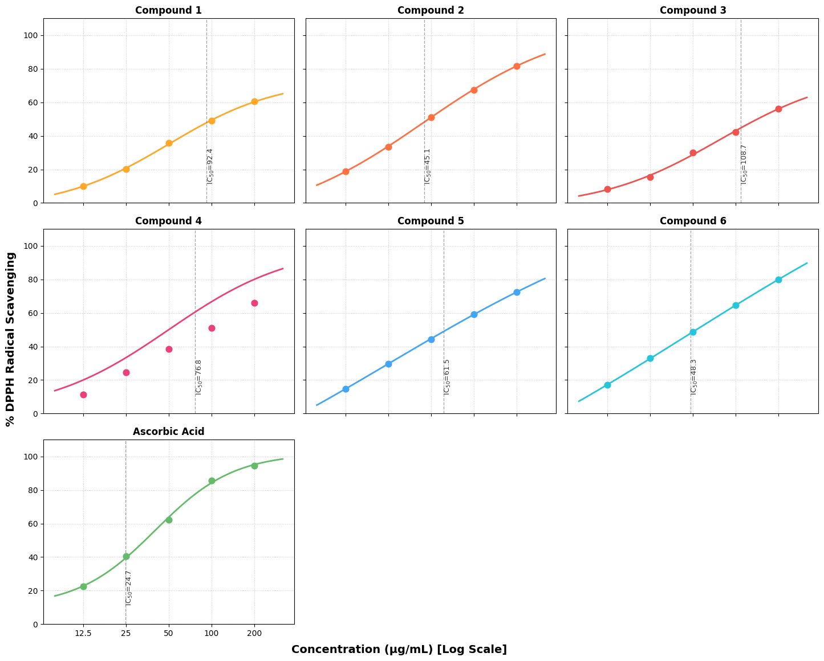
Figure S1. Dose-Response Curve for DPPH Radical Scavenging Activity
Molecular docking against Pneumonia-related targets
To further assess the therapeutic potential of bis-1,2,4-triazole derivatives, molecular docking simulations were conducted against two major virulence factors of Streptococcus pneumoniae implicated in pneumonia pathogenesis: Neuraminidase A (NanA, PDB ID: 2YA5) and Pneumolysin (Ply, PDB ID: 4QQA). These targets were selected based on their critical roles in bacterial colonization, immune system evasion, and tissue damage. Molecular docking offers predictive insight into the strength and nature of the interactions between the studied compounds and their biological targets. All docking studies were performed using AutoDock Vina, and the binding affinities were reported in kcal/mol, where more negative values indicate stronger predicted binding. The results of the docking rungs are presented in Table S1.
Table S1. Binding affinities of compounds 2and 6 against pneumonia-associated targets
Protein | Compound | Best Affinity (kcal/mol) | No. of H-Bonds | Pi / Hydrophobic Interactions | Unique Interactions | Key Hydrophobic Residues
2YA5 | 2 | -5.9 | 5 | 7 | Lys490, Asp538, Tyr446, Gln537, Arg461 | Val480, Pro541, Ile460, Lys444
2YA5 | 6 | -8.1 | 3 | 9 | Lys490, Tyr504, Asp538, Thr445 | Val480, Pro541, Ile460, Met523, Tyr438
4QQA | 2 | -5.6 | 2 | 5 | His156, Gln189 | Thr154, Val259, Leu53, Ile153
4QQA | 6 | -6.8 | 3 | 9 | Lys255, Ser256, Asn470 | Arg359, Leu447, Tyr358
Molecular docking of compound 2 into the active site of Streptococcus pneumoniae neuraminidase A (PDB: 2YA5) revealed a best-scoring pose (mode 1) with a binding affinity of –5.9 kcal/mol and essentially zero RMSD relative to itself. A second pose also scored –5.9 kcal/mol, though with an RMSD of approximately 29 Å (LB/U B ≈ 28.96/33.11 Å), indicating a markedly different orientation elsewhere in the binding cavity. Subsequent poses (modes 3–5) clustered at slightly lower affinities (–5.8 to –5.7 kcal/mol) and had RMSD values around 2.3–2.6 Å, reflecting minor conformational shifts around the same binding region. In the top-scoring orientation, five hydrogen bonds anchored compound 2 within the catalytic pocket. The most prominent interaction was a conventional hydrogen bond between the donor hydrogen of Lys490 and one of the triazole nitrogen atoms at a distance of 2.19 Å, effectively positioning the triazole core close to the enzyme’s conserved Lys490. Two carbon–hydrogen bonds were also observed: Tyr446 donating a weak C–H hydrogen to the same nitrogen acceptor (distance ≈ 3.52 Å) and Gln537 similarly donating a C–H hydrogen at roughly 3.69 Å to the triazole ring. Additionally, a carbon–hydrogen bond between one of compound 2’s sp² carbons and the backbone carbonyl oxygen of Arg461 at 3.61 Å served to further stabilize the ligand orientation deep in the pocket. A fifth hydrogen bond, classified as a pi-donor type, formed between the backbone amide hydrogen of Asp538 and the aromatic π-system of the ligand at 2.65 Å, suggesting that Asp538 helps anchor the ligand’s aromatic ring. Beyond these polar contacts, a network of hydrophobic interactions contributed to overall stabilization. Two distinct alkyl–alkyl contacts between Val480 and the ligand’s aliphatic pentyl chain occurred at 5.33 Å and 4.09 Å, indicating that Val480 cradles the alkyl spacer in a hydrophobic subpocket. A similar alkyl stacking with Pro541 at 4.79 Å further buttressed the hydrophobic tail. Ile460 engaged the ligand via both pure alkyl (distance ≈ 5.49 Å) and pi–alkyl interactions (≈ 4.97 Å), suggesting that the extended alkyl chain of compound 2 lies against Ile460’s side chain. Last, another aliphatic contact occurred between Lys444 and one of the ligand’s carbons at 5.07 Å. Taken together, these contacts explain why compound 2 exhibits moderate affinity (–5.9 kcal/mol), with a balance of polar anchoring to Lys490 and Asp538 and hydrophobic support from Val480, Ile460, Pro541, and Lys444.
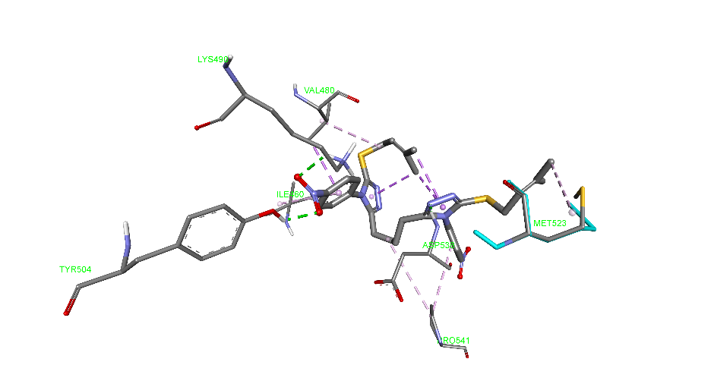
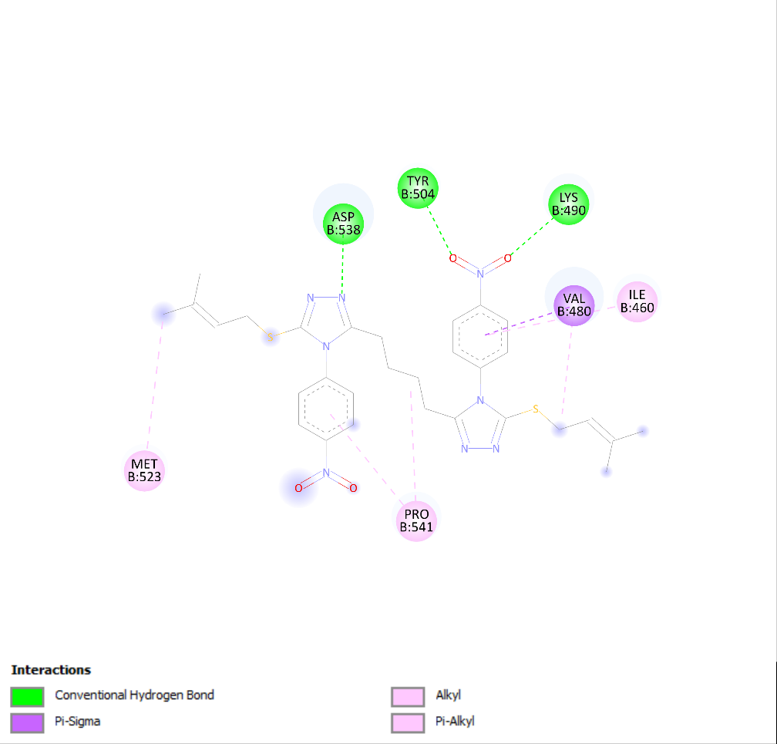
Figure S2. Non-bond interactions between NanA and compound 6 in 3D (above) and 2D (below) representation.
Docking of compound 6 into the same NanA active site yielded a markedly stronger best-scoring pose (mode 1, affinity –8.1 kcal/mol, RMSD = 0.00 Å). Two additional poses (modes 2 and 3) both scored –7.8 kcal/mol, showing slight RMSD deviations of 1.20 Å and 1.08 Å, respectively, indicating similar binding orientations to the top pose. Subsequent poses (modes 4–9, affinities –7.7 to –7.6 kcal/mol) either clustered within 1.5–3.3 Å RMSD around the same region or appeared as outliers (RMSD > 19 Å). In the most favorable orientation, three strong conventional hydrogen bonds pinned down compound 6. The first was between the ε-amino hydrogen of Lys490 and a ligand carbonyl oxygen at 2.30 Å, anchoring the nitrophenyl–triazole bicyclic core. A second H-bond formed between the phenolic hydroxyl hydrogen of Tyr504 and the same carbonyl oxygen at just 2.11 Å, reinforcing this polar interaction. A third H-bond connected the backbone amide hydrogen of Asp538 to a triazole nitrogen at 2.06 Å, securing the ligand’s triazole unit near the C-terminal loop. In addition to these polar interactions, multiple pi–sigma and hydrophobic contacts further stabilized the molecule. Val480’s γ-methyl group engaged the aromatic π-system of compound 6 in a pi–sigma interaction at 3.76 Å, suggesting that Val480’s side chain sits directly beneath the aromatic ring. Intramolecular stacking within the ligand itself was evident from three pi–sigma distances between ligand carbons and the ligand’s own π-orbitals (3.70 Å, 3.89 Å, and 3.86 Å), indicating a folded conformation that maximizes internal π interactions. A separate alkyl contact between Val480 and the ligand’s aliphatic moiety (distance ≈ 4.23 Å) supported the hydrophobic nitrophenyl group. Pro541 contributed with an alkyl–alkyl contact at 5.47 Å, while Met523 contacted the ligand’s aromatic system at 5.39 Å via an alkyl interaction. Ile460 participated through a pi–alkyl contact (distance ≈ 4.67 Å), placing the ligand’s aromatic ring above Ile460’s side chain. A second pi–alkyl contact between the ligand and Pro541 at 5.21 Å reinforced the hydrophobic packing (Figure S2). Thus, compound 6’s affinity of –8.1 kcal/mol stems from three strong hydrogen bonds (Lys490, Tyr504, Asp538) combined with extensive hydrophobic and π interactions involving Val480, Pro541, Met523, and Ile460—explaining why its binding energy is roughly 2.2 kcal/mol more favorable than compound 2.
Docking into Pneumolysin (Ply; PDB: 4QQA) revealed further distinctions. When compound 2 was docked into Ply, the top mode exhibited a binding energy of –5.6 kcal/mol with zero RMSD relative to itself. The second pose scored –4.9 kcal/mol (RMSD ≈ 17.88 Å), clearly occupying a different region. A cluster of poses (modes 5, 8, 9) with affinities –4.7 to –4.6 kcal/mol and low RMSDs (≈ 1.73–1.82 Å) suggested that small adjustments in orientation occurred within the same pocket. In the best pose, two conventional hydrogen bonds stood out. One formed between the hydrogen of His156 and a triazole nitrogen at 2.63 Å, anchoring the ligand to the central β-strand region of domain 1. The second H-bond connected the hydrogen of Gln189 to the same triazole nitrogen at 2.53 Å, creating a snug fit between two polar residues and the triazole moiety. Surrounding hydrophobic contacts included a pi–sigma interaction between Thr154’s methyl and the triazole ring at 3.86 Å, indicating that Thr154 underlies the aromatic core. A 4.83 Å alkyl–alkyl contact with Val259 suggested that the aliphatic trunk of compound 2 protrudes into a hydrophobic groove. Further alkyl–alkyl interactions with Leu53 (4.65 Å) and Ile153 (5.43 Å) indicated that the ligand’s hexyl chain lies in proximity to a cluster of nonpolar residues. A pi–alkyl interaction between His156’s aromatic ring and the alkyl tail (4.46 Å) hinted that His156 both polar-anchors and pi-interacts with the ligand. Finally, additional pi–alkyl contacts with Leu53 at 5.21 Å and 5.43 Å underscored how the ligand’s shape conforms to the pocket near the F-loop region. These interactions suggest that compound 2 occupies a hydrophobic latch near the oligomerization interface of Ply, with moderate affinity (–5.6 kcal/mol) driven by two H-bonds and a cluster of hydrophobic contacts that likely impede subunit–subunit assembly.
By contrast, compound 6 docked into Ply achieved a best-scoring pose with affinity –6.8 kcal/mol (mode 1, RMSD = 0 Å). A second pose at –6.6 kcal/mol (RMSD ≈ 19.79 Å) again highlighted a distant, noncompetitive orientation, while modes 4–8 (affinities –6.4 to –6.3 kcal/mol, RMSDs ≈ 1.33–3.28 Å) formed a cluster near the principal binding locus. Three conventional H-bonds anchored compound 6: Lys255’s backbone amide hydrogen donated to a ligand carbonyl at 2.78 Å; Ser256’s backbone amide similarly bonded to the same carbonyl at 2.23 Å; and Asn470’s side-chain amide hydrogen donated to a triazole nitrogen at 2.86 Å, collectively locking the triazole–nitrophenyl bicyclic core into a crevice near the membrane-binding domain. A pi–cation interaction between Arg359’s guanidinium NH₂ and the ligand’s aromatic π-system at 3.41 Å further intensified polar contribution. Weaker hydrogen bonding included a carbon–hydrogen bond from Ser256 to the carbonyl oxygen (3.55 Å). Intramolecular stacking in the ligand was again observed via pi–sigma (3.69 Å) and pi–pi T-shaped (4.85 Å) contacts within compound 6, suggesting that it adopts a folded conformation maximizing π overlap. Hydrophobic (alkyl) contacts extended to Arg359 (5.39 Å), Leu447 (5.36 Å and 4.30 Å), Ile447’s side chain, and Tyr358 via a pi–alkyl interaction at 4.80 Å. Arg359 also contributed two additional pi–alkyl contacts at 3.96 Å and 5.26 Å, effectively wrapping the ligand’s bicyclic core. Collectively, these interactions explain why compound 6 binds Ply more strongly (–6.8 kcal/mol) than compound 2. The three robust hydrogen bonds, one pi–cation interaction, and extensive hydrophobic envelope around the nitrophenyl ring all work in concert to impede Ply’s ability to oligomerize and form membrane pores.
Comparatively, compound 6 outperforms compound 2 across both targets. In NanA, compound 6’s –8.1 kcal/mol affinity is about 2.2 kcal/mol better than compound 2’s –5.9 kcal/mol affinity—a difference attributable to an extra H-bond from Tyr504 to the ligand’s carbonyl and strengthened hydrophobic packing around the nitrophenyl core. In Pneumolysin, compound 6’s –6.8 kcal/mol is 1.2 kcal/mol better than compound 2’s –5.6 kcal/mol, thanks to an additional conventional H-bond from Ser256 and a pi–cation interaction with Arg359 that reinforce binding at a key interface. In each case, compound 6 leverages its para-nitrophenyl substituent to form stronger polar interactions without sacrificing hydrophobic engagement, while compound 2 relies more heavily on its hexyl chain for an extended but less polar fit. These docking results suggest that compound 6 is the superior bis-triazole derivative for dual inhibition of Neuraminidase A and Pneumolysin in Streptococcus pneumoniae, as it clearly engages more catalytic and oligomerization-critical residues with higher affinities. Development efforts should therefore focus on further optimizing compound 6’s physicochemical properties, while in vitro and in vivo studies can validate its capacity to attenuate both enzymatic virulence and pore-forming cytotoxicity.
ADMET results
This section provides the comprehensive raw data from the in silico Absorption, Distribution, Metabolism, Excretion, and Toxicity (ADMET) analysis and physicochemical property predictions for all synthesized bis-1,2,4-triazole derivatives (1–6). All data were generated using the publicly available SwissADME web platform.
Table S2. Detailed Physicochemical Properties of Bis-1,2,4-triazole Derivatives (1–6).
Property | Unit | Cmpd 1 | Cmpd 2 | Cmpd 3 | Cmpd 4 | Cmpd 5 | Cmpd 6
Formula | – | C₂₀H₄₂N₆S₂ | C₂₉H₅₀N₆S₂ | C₃₁H₅₄N₆S₂ | C₃₃H₅₈N₆S₂ | C₂₉H₃₄N₆S₂ | C₃₀H₃₄N₈O₄S₂
Molecular Weight (MW) | g/mol | 430.72 | 546.88 | 574.93 | 602.98 | 530.75 | 634.77
Num. Heavy Atoms | – | 28 | 37 | 39 | 41 | 37 | 44
Num. Arom. Heavy Atoms | – | 0 | 10 | 10 | 10 | 22 | 22
Fraction Csp³ | – | 0.90 | 0.72 | 0.74 | 0.76 | 0.31 | 0.33
Num. Rotatable Bonds | – | 12 | 20 | 22 | 24 | 12 | 15
Num. H-Bond Acceptors | – | 6 | 4 | 4 | 4 | 4 | 8
Num. H-Bond Donors | – | 4 | 0 | 0 | 0 | 0 | 0
Molar Refractivity | – | 149.22 | 164.21 | 173.83 | 183.44 | 156.29 | 178.74
TPSA (Topological Polar Surface Area) | Å² | 105.20 | 112.02 | 112.02 | 112.02 | 112.02 | 203.66

Table S3. Predicted Lipophilicity and Aqueous Solubility of Bis-1,2,4-triazole Derivatives (1–6).
Property | Method | Unit | Cmpd 1 | Cmpd 2 | Cmpd 3 | Cmpd 4 | Cmpd 5 | Cmpd 6
Log P | iLOGP | – | 4.74 | 5.93 | 6.63 | 6.63 | 5.50 | 4.30
Log P | XLOGP3 | – | 5.28 | 8.80 | 9.88 | 10.97 | 7.58 | 7.60
Log P | WLOGP | – | 01.04 | 8.32 | 9.10 | 9.88 | 7.14 | 8.39
Log P | MLOGP | – | 3.80 | 5.27 | 5.65 | 06.02 | 5.77 | 4.15
Log P | SILICOS-IT | – | 1.91 | 8.18 | 09.03 | 9.89 | 6.21 | 3.17
Consensus Log P | – | – | 3.35 | 7.30 | 08.06 | 8.68 | 6.44 | 5.52
Log S | ESOL | – | -5.04 | -7.65 | -8.37 | -9.09 | -7.55 | -7.94
Log S | Ali | – | -7.24 | -11.04 | -12.16 | -13.29 | -9.77 | -11.71
Log S | SILICOS-IT | – | -4.35 | -8.76 | -9.53 | -10.30 | -8.99 | -8.98
Solubility Class (ESOL) | – | – | Moderately soluble | Poorly soluble | Poorly soluble | Poorly soluble | Poorly soluble | Poorly soluble

Table S4. Predicted Pharmacokinetic, Druglikeness, and Medicinal Chemistry Alerts (1–6).
Property | Rule / Method | Cmpd 1 | Cmpd 2 | Cmpd 3 | Cmpd 4 | Cmpd 5 | Cmpd 6
GI Absorption | – | High | Low | Low | Low | Low | Low
BBB Permeant | – | No | No | No | No | No | No
P-gp Substrate | – | No | Yes | Yes | Yes | Yes | No
CYP1A2 Inhibitor | – | No | No | No | No | No | No
CYP2C19 Inhibitor | – | Yes | No | No | No | Yes | No
CYP2C9 Inhibitor | – | No | No | No | No | Yes | No
CYP2D6 Inhibitor | – | No | No | No | No | No | No
CYP3A4 Inhibitor | – | Yes | Yes | Yes | Yes | Yes | Yes
Log Kp (Skin Perm.) | cm/s | -5.18 | -3.39 | -2.79 | -2.19 | -4.16 | -4.78
Lipinski Rule | (Violations) | Yes (0) | No (2) | No (2) | No (2) | No (2) | No (2)
Veber Rule | (Violations) | No (1) | No (1) | No (1) | No (1) | No (1) | No (2)
Bioavailability Score | – | 0.55 | 0.17 | 0.17 | 0.17 | 0.17 | 0.17
PAINS Alert | – | 0 | 0 | 0 | 0 | 0 | 0
Brenk Alert | – | 1 (isolated_alkene) | 1 (isolated_alkene) | 1 (isolated_alkene) | 1 (isolated_alkene) | 1 (isolated_alkene) | 2 (isolated_alkene, nitro_group)
Synthetic Accessibility | – | 5.89 | 5.00 | 5.25 | 5.51 | 4.35 | 4.63

