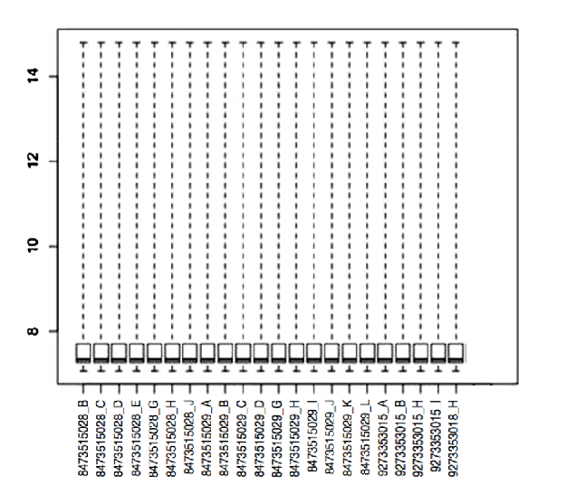
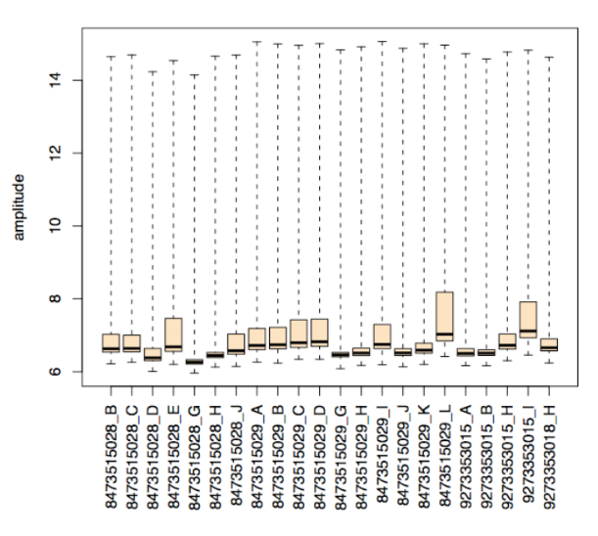

Supplementary Figure 1: Box-plots before (a) and after (b) normalization (tumor and control samples were grouped to perform differential expression analysis with obtained data from normalization).

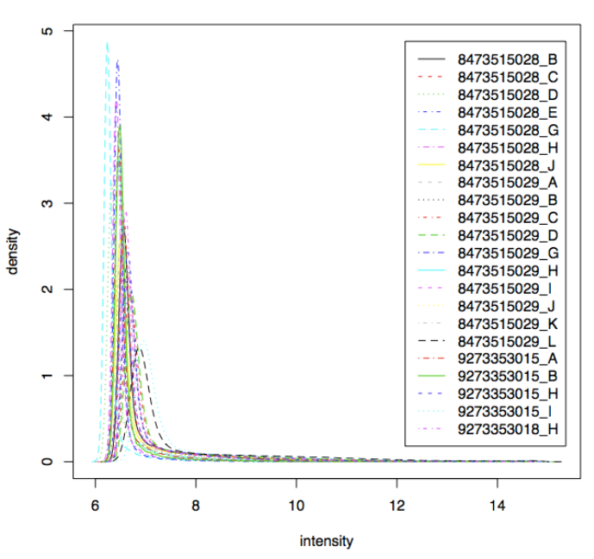
Supplementary Figure 2: Density plot (tumor and control samples were grouped to perform differential expression analysis with obtained data from normalization)

Molecular and Cellular Functions | p-value | #Molecules
Post-Translational Modification | 2,87E⁻⁴ – 5,78E⁻¹⁰ | 4
Protein Degradation | 2,87E⁻⁰⁴ – 5,78E⁻¹⁰ | 4
Cell Death and Survival | 2,61E⁻⁰³ – 1,25E⁻⁰⁷ | 11
Cellular movement | 2,16E⁻⁰³ – 8,76E⁻⁰⁶ | 8
Cell to cell signaling signaling and interaction | 3.25E⁻⁰⁴ to 1.29E⁻⁰⁴ | 5
Supplementary Table 1: Molecular and Cellular Biofunctional Analysis

Diseases and disorders | p-value | #Molecules
Cancer | 1.59E⁻⁰³ to 5.62E⁻⁰³ | 10
Immunological disease | 1.48E⁻⁰³ to 4.35E⁻⁰³ | 6
Inflammatory response | 1.23E⁻⁰³ to 3.20E^{-0.3} | 3
Supplementary Table 2: Top Diseases and Disorders Analysis

Molecular Functions and Top Diseases | p-value | Score | Molecules in Network
Cell cycle, cancer, reproductive  system disease | 1.08E⁻⁰⁴ to 1.14E⁻⁰⁴ | 32 | CCNA2, CDC20, CDC45,  STAT1, STAT2, TUBB3
Cell-to-cell signaling and interaction,  inflammatory response | 3.25E⁻⁰⁴ to 1.29E⁻⁰⁴ | 30 | MMP1, MMP3,MMP9,MMP10,  TNFSF10, TNFRSF1A
Supplementary Table 3: Network Analysis

Diseases or Functions Annotation | p-Value | Molecules | # Molecules
metastasis | 5,03E⁻⁰⁷ | MMP1, MMP10, MMP3, MMP9, STAT1, TNFRSF1A, TUBB3 | 7
neoplasia of tumor cell lines | 1.43E⁻⁰⁶ | MMP1, MMP10, MMP3, MMP9, STAT1 | 5
metastasis of tumor cell lines | 5,26E⁻⁰⁶ | MMP1, MMP10, MMP3, MMP9 | 4
progression of tumor | 1.65E⁻⁰⁵ | MMP1, MMP9, STAT1, TUBB3 | 4
incidence of tumor | 3.86E⁻⁰⁵ | MMP1, MMP9, STAT1, TNFRSF1A | 4
angiogenesis of tumor | 4.35E⁻⁰⁵ | MMP1, MMP3, MMP9 | 3
invasion of tumor cells | 1,40E⁻⁰⁴ | MMP1, MMP3, MMP9 | 3
progression of malignant tumor | 1,50E⁻⁰⁴ | MMP1, MMP9, T UBB3 | 3
growth of malignant tumor | 1,57E⁻⁰⁴ | MMP1, MMP3, MMP9, STAT1 | 4
growth of tumor | 1,68E⁻⁰⁴ | MMP1, MMP3, MMP9, STAT1, TUBB3 | 5
invasion of tissue | 1,89E⁻⁰⁴ | MMP1, MMP3, MMP9 | 3
hyperplasia of tissue | 2,20E⁻⁰⁴ | CCNA2, MMP1, MMP9 | 3
cancer of cells | 5,43E⁻⁰⁴ | CDC45, MMP1, MMP10, MMP3, MMP9, STAT1, TNFRSF1A, TUBB3 | 8
invasion of epithelial tissue | 6,28E⁻⁰⁴ | MMP1, MMP9 | 2
Supplementary Table 4: Gene ontology analysis

