Supplemental Figures

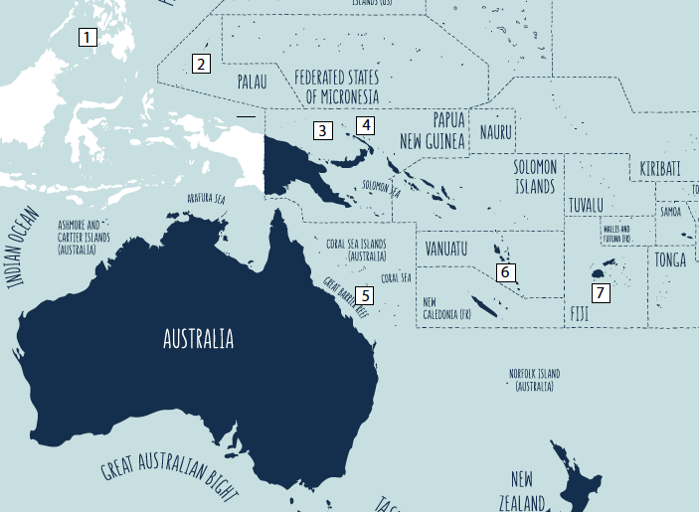
Supplemental Figure 1. Location of tracking: Philippines (1), Palau (2), Manus Island (PNG) (3), Kavieng (PNG), (4)), Osprey Reef (AU) (5), Vanuatu (6), Fiji (7)
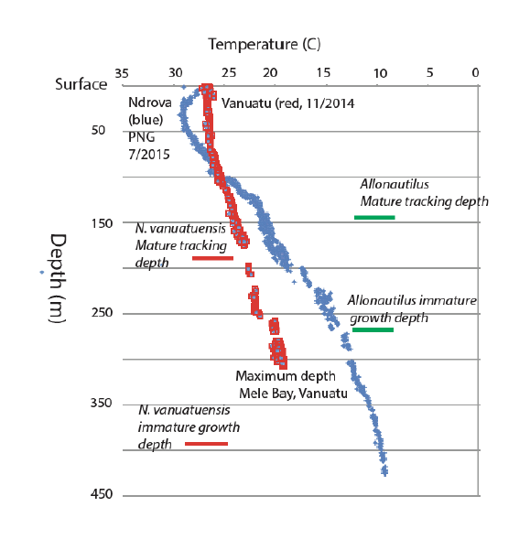
Supplemental Figure 2. Temperature depth profiles - from acoustic transmitters attached to tracked Nautilus vanuatuensis in Mele Bay, Vanuatu (2014), and offshore Ndrova, Papua New Guinea, 2015. The Ndrova data suggest to us that that the mature nautiluses living in this large bay by did not grow there, as there are no depths in the bay deep enough to produce water as cold as that obtained from multiple specimens collected in the bay, based on the data that we obtained from the roving, tagged specimens that were observed. We interpret these data to mean that the mature specimens of Nautilus vanuatuensis grew at sites offshore of the island coast, instead of the large bay that is they grew elsewhere, in water far deeper than anywhere in Mele Bay, and thus offshore of the coastline of this island of the Vanuatu Archipelago. The geography of Mele Bay is shown in Supplemental Figure 6.
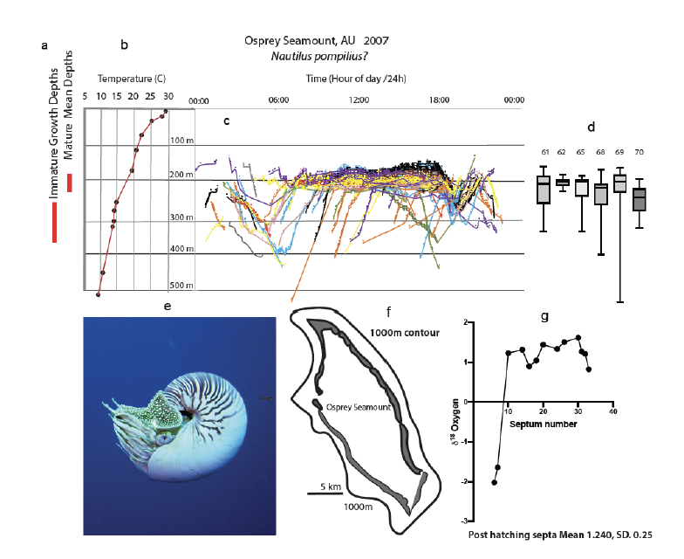
Supplemental Figure 3. Information from Osprey Reef, Queensland, Australia, showing the methodology used in this study. a. We interpret to these results to show that that the mean depth of habitation in the mature (finished growth and now sexually mature) nautiloids was shallower than the mean depth of habitation of the immature, still growing specimens: they grew in colder (and thus deeper) water than the temperature of the average habitat depths of the mature specimens. This does not mean that the adults never dive down in depths of 400m or greater. From the graph above, they clearly do. But in every population that we studied, mature specimens live at much shallower average depths than the immatures. b. Temperature depth profile, from Dunstan et al, 2011. c. Aggregate tracking records from six tagged specimens. d. The mean data obtained from the raw data of the tracks shown in c, mean depths and range for the six specimens shown. e. Photograph of Nautilus n. sp, with the characteristic thin stripes, small umbilical plug, and numerous, raised prongs on the hood. f. Map outline of Osprey Reef, a seamount more than 130 km offshore of the outer walls of the Great Barrer Reef. g. First record of oxygen isotopes of specimens from this locality. From these data the average habitat of shell formation was calculated.
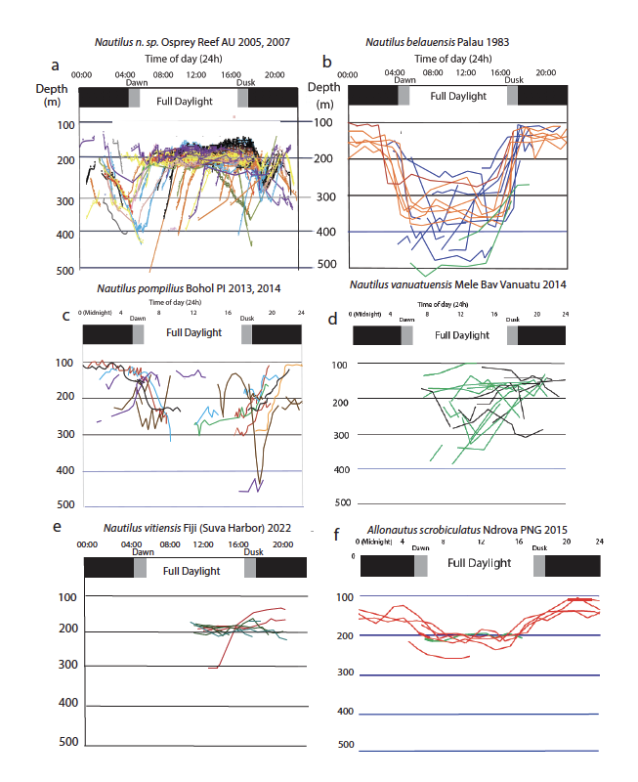
Supplemental Figure 4. Comparison of daily movement testing the hypothesis of universal, twice daily vertical migration: Six different species, including both extant genera: no uniformity in behavior was found between species, but apparently good uniformity within species. The long-held assumption of daily vertical migration was common only in Nautilus belauensis and Allonautilus scrobiculatus.
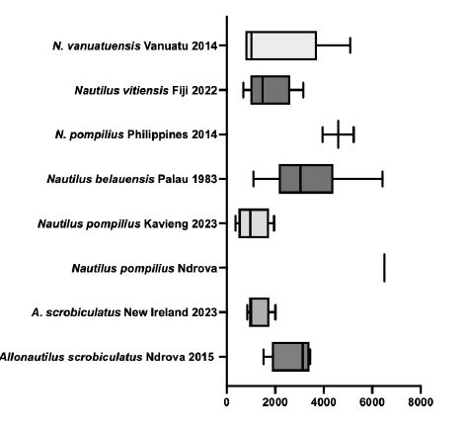
Supplemental Figure 5. Mean and range of daily horizontal movement in various species and populations The graph is plotted in meters of horizonal movement (X axis). Data not available for Osprey Reef AU. The single point for the Nautilus pompilius from Ndrova refers to the day in which it undertook mid-water swimming.
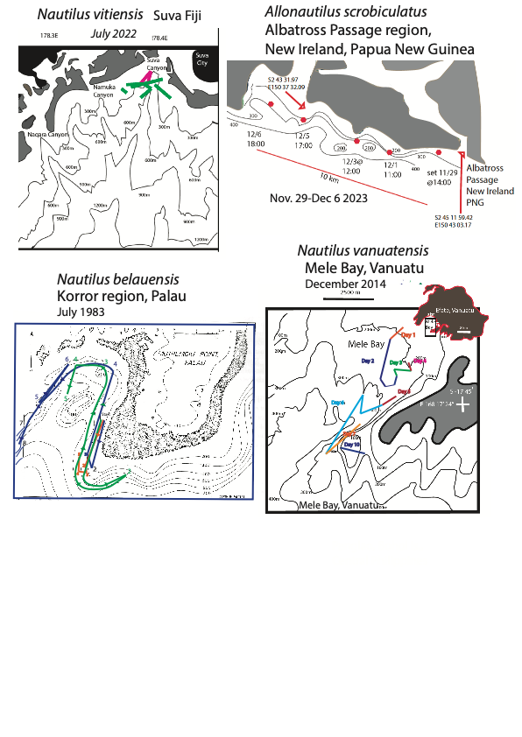Supplemental Figure 6. Horizonal movement maps. Upper left: Map of tracking site in Fiji, Suva Harbor region, with tracking of Nautilus vitiensis in 2022, showing the restriction of animal movement to the upper parts of the Suva submarine canyon, a region of high productivity; Lower Left: Palau tracking of Nautilus belauensis, 1983; Upper Right: Albatross Passage region, Kavieng, New Ireland, PNG, tracking of November -December 2023, Allonautilus scrobiculatus; Lower Right, Mele Bay, Vanuatu, 2014, tracking of multiple Nautilus vanuatuensis. At each site, tracked animals mostly moved along 200m contours with an onshore offshore superposition. A commonality of each site was the presence of nearby rivers dumping sediment and building submarine fan systems, as well as deep water canyons with probable upwelling. Another commonality of these figures is that most movement took place along 200m contours with shallowing at night and deeper forays during the day.
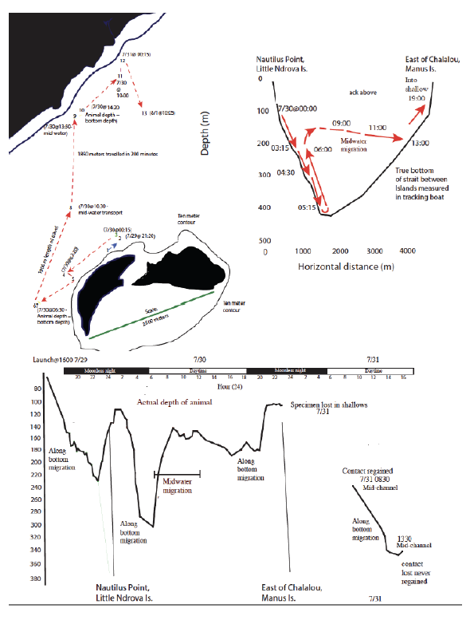
Supplemental Figure 7. First evidence of midwater, interisland migration. These data were possible because we remained over this animal day and night, remaining vertically above it in a small boat. Upper left, view of Manus Island, and to the right, Ndrova Islands (referred to as a single island on maps). The dotted red lines show the movement of a single specimen of Nautilus pompilius trapped offshore of Ndrova, on 7/29/2015 and immediately fitted with a transmitter. On the second day of tracking, this specimen ascended the Ndrova reef wall and then swam across the channel separating Ndrova from Manus in mid-water, rather than along the bottom. That track is shown in the upper right part of this figure. Lower panel shows the actual depths of this animal, determined by the transmitter depth data, and the depth of the bottom independently measured using a high-resolution depth finder in the tracking boat. Strength of signal meter in the VR100 received coupled with a directional hydrophone determined when we were directly overhead, at which time depth of animal and depth of bottom were independently logged, while geographic position was determined with a handheld, Garmin Oregon GPS, and this was further checked using the built in GPS in the VR 100 receiver. This kind of mid water, “island hopping” has never previously been observed.
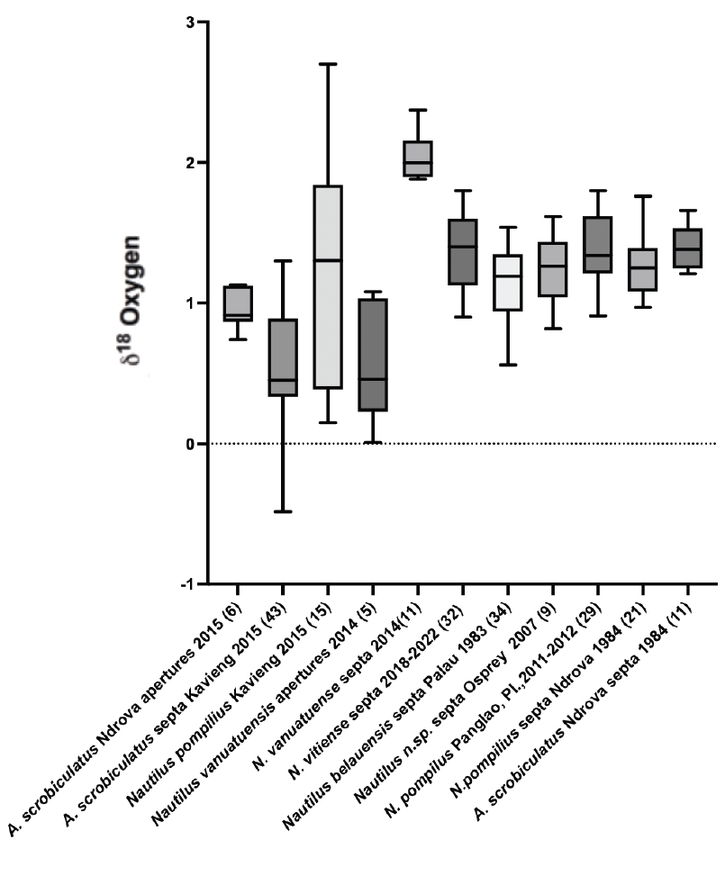
Supplemental Figure 8. Oxygen isotope results, showing mean, range, and standard deviations of carbonate analyses coming from sampled septa, from members of the various tracked populations. None of these values came from tracked animals themselves (that would kill the specimen), but from newly obtainable drift shells coming from members of the population sampled at the time of tracking. In each case the temperature of shell formation was determined using depth and temperature data sent by the two sensor transmitters at the time of tracking, as shown in Supplemental Figure 2.
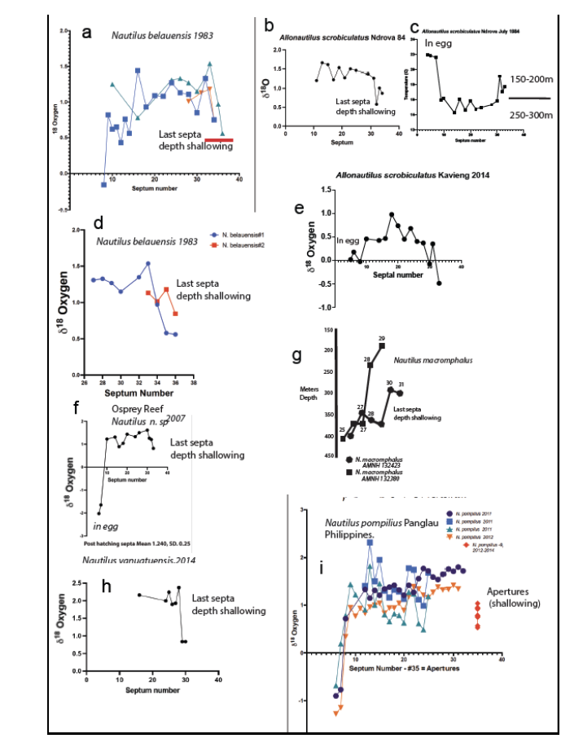
Supplemental Figure 9. New oxygen isotope results demonstrating universal shallowing during formation of last one to two septa coincident with sexual maturity. This figure also demonstrates that, during formation of post-hatching septa, there is little variation in temperature of shell formation – until the formation of the last form septa, that is, and this low degree of temperature change over ontogeny was also observed in extinct species, thus allowing us to conclude that comparing temperatures from differently sized specimens does not introduce large error. a. Nautilus belauensis, Palau, captured together in 1983, specimens UW# 837234, 837235, 837236, showing warming of last one or two septa, indicating the gradual ascent from mean depths of greater than 350m, to depths of approximately 200m or less when mature; d., Nautilus belauensis, caught during the same week in 1983, UW 837862. 837863, showing warming of last one to two septa. Based on published temperature depth profiles for Palau in 1983, juveniles grew at depths of between 300 and 400m, while tracked specimens showed mean depths of ~240-250m; b, c, Allonautilus scrobiculatus, UW 8423344, caught 1984 Ndrova, PNG, showing gradual warming of septal formation temperatures three of last four septa; e, same specimen as c, but oxygen isotope values converted to temperature, and on right, the depths at which those temperatures could be found in 1984 in Ndrova; e, oxygen isotopes drift shell specimen from Kavieng, New Ireland, collected in 2014 inshore from tracking site of 2023, showing warmer and shallower values than A. scrobiculatus analyzed from Ndrova, including significant warming (shallowing) of last three septa; f, Nautilus n. sp, Osprey Reef, specimen caught in 2007 and died in trap, with shell (UW 0734455) donated to University of Washington, showing shallowing in last three septa; g, Nautilus macromphalus, specimens AMNH 132423, 132380, from (43), habitation depth change calculated from data presented in that paper, showing the significant depth change that took place in these two specimens with onset maturity; i, multiple specimens of Nautilus pompilius captured off Panglao, Bohol Island, central Philippine Islands, 2011 and 2012 and donated to us, from site of tracking of that species. Unlike other species analyzed here, the last septa of these four mature individuals did not show significant change between last two or three septa been formed in much warmer water. However, the apertural edges of these shells were formed in warmer water than the septa.

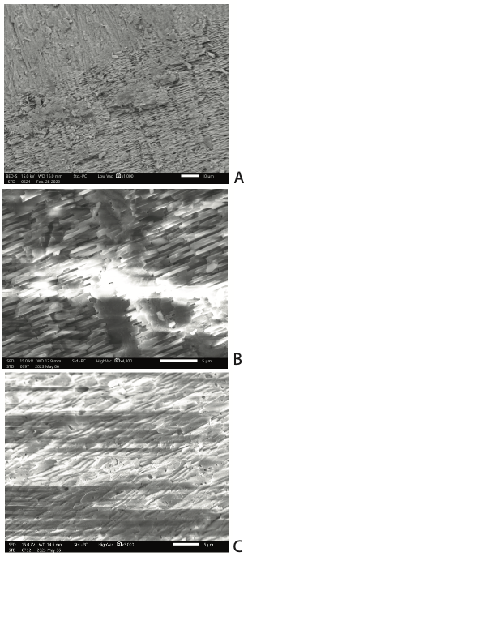

Supplemental Figure 10. Examples of scanning electron microscopy used to screen Carbonate samples for potential geochemical analyses; these photographs were not taken for publication but as working examples; they are added here based on reviewers’ comments. A. Allonautilus scrobiculatus, captured live from Ndrova (PNG), 1984. This photograph at lower power (scale bar at lower right) shows the intersection of the prismatic shell layer (above) and nacreous shell layer (below). It is the latter that is most useful in observing potential diagenesis. In this photograph (and at much higher magnification) the nacreous layer “tablets” can be seen to be clean of added material and overgrowths. B. Nacreous layer from septum of Nautilus regalis from the Cenomanian of Madagascar. This is the oldest specimen of our study. The nacreous tablets can be seen to be free of overgrowth, and thus this septum was accepted for analysis. C. Septum from Eutrephoceras suciaensis, Campanian (Late Cretaceous) of Sucia Island, Washington. This specimen under light microscopy showed yellowing and overgrowth, and the SEM shows both overgrowth and partial dissolution of the layers of nacre tablets. This specimen was rejected for analysis. Other specimens from this site, however, were accepted if they passed the observation test.

