SUPPLEMENTARY DATA

LnCaP-Luc2
(with antibody)
LnCaP-Luc2
(without antibody)
A
LnCaP-Luc2
(without antibody)
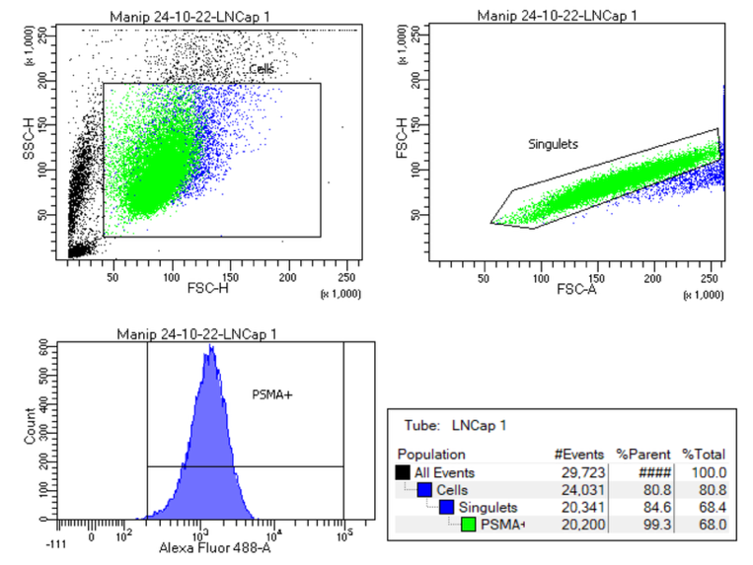
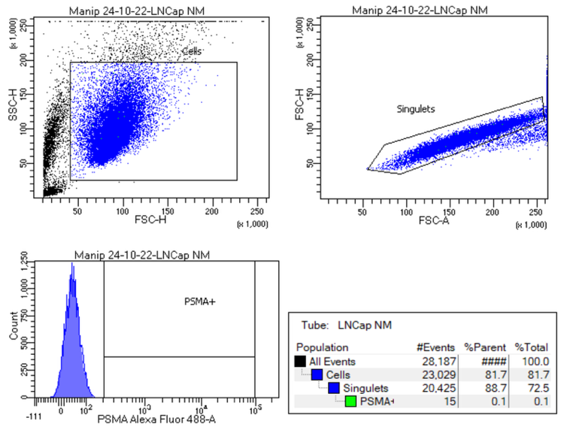
B

MDA-MB-468
(with antibody)
MDA-MB-468
(without antibody)
C
D
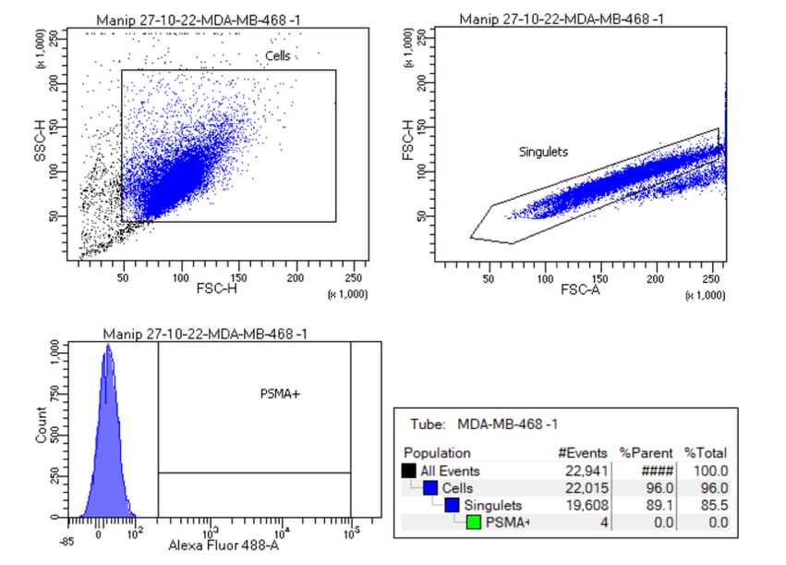
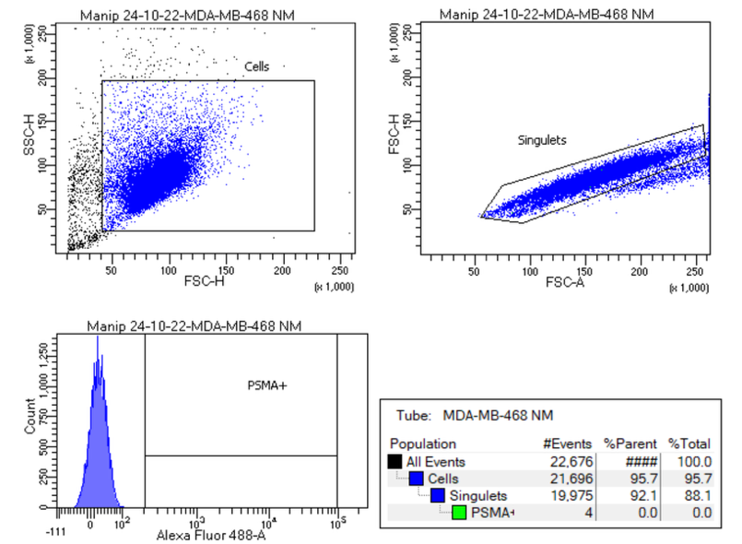

Figure S1: Gating strategy for analysis of endogenous PSMA expression
Flow cytometry analysis of PSMA expression. (A-B) The prostatic cancer cell line LnCap-Luc2 was used as positive control. (C-D) Example of MDA-MB-468 replicate showing absence of PSMA expression.
Reference of anti-PSMA antibody is (Alexa-Fluor® 488 anti-human PSMA antibody, #342505, Biolegend, San Diego, USA).

Table S1: Characterization of the 19 other syngeneic and xenograft murine models for TNBC tumor development

Models | Cell lines | Mouse Strain | Implantation site | Matrix | Cell number | Number of mice | Tumor engraftment (n, (%)) | Tumor Volume (mm³) -  25-30 days after cell inoculation
Syngeneic | 4T1 | BALB/cAnNRj | Subcutaneous | PBS | 5.10⁶ | 10 | 8 (80 %) | 680 ± 269
 |  |  |  |  | 1.10⁷ | 10 | 9 (90 %) | 802 ±401
Syngeneic | 4T1 | BALB/cAnNRj | MFP* | PBS | 5.10⁵ | 6 | 6 (100 %) | 895 ± 92
Xenograft | MDA-MB-231wt | NMRI-Foxn1nu/Fox1nu | Subcutaneous | PBS | 1.10⁷ | 10 | 8 (80 %) | 128 ± 56
Xenograft | MDA-MB-231wt | Balb/cAnNRj-Foxn1 nu/nu | MFP* | PBS/Geltrex® 1:1 | 1.10⁶ | 6 | 6 (100 %) | 190 ± 60
 |  |  |  | PBS/Matrigel® 1:1 | 5.10⁶ | 6 | 6 (100 %) | 332 ±56
Xenograft | MDA-MB-231wt  +  HUVEC | NMRI-Foxn1nu/Fox1nu | Subcutaneous | PBS | 5.10⁶/5.10⁶ | 10 | 8 (80 %) | 37 ± 16
Xenograft | MDA-MB-231wt  +  HUVEC | Balb/cAnNRj-Foxn1 nu/nu | MFP* | PBS/Geltrex® 1:1 | 1.10⁶/1.10⁶ | 6 | 5 (83 %) | 105 ± 26
Xenograft | MDA-MB-436 | NMRI-Foxn1nu/Fox1nu | Subcutaneous | PBS | 1.10⁷ | 7 | 2 (29 %) | 34 ± 6
Xenograft | MDA-MB-436 | Balb/cAnNRj-Foxn1 nu/nu | MFP* | PBS/Geltrex® 1:1 | 1.10⁶ | 6 | 5 (83 %) | 64 ± 53
 |  |  |  | PBS/Matrigel® 1:1 | 1.10⁶ | 6 | 6 (100 %) | 38 ± 60
Xenograft | MDA-MB-436  +  HUVEC | Balb/cAnNRj-Foxn1 nu/nu | MFP* | PBS/Geltrex® 1:1 | 1.10⁶ | 6 | 6 (100 %) | 55 ± 31
Xenograft | MDA-MB-468 | NMRI-Foxn1nu/Fox1nu | Subcutaneous | PBS | 1.10⁷ | 25 | 25 (100 %) | 84 ± 41
Xenograft | MDA-MB-468 | Balb/cAnNRj-Foxn1 nu/nu | MFP* | PBS | 1.10⁶ | 7 | 7 (100 %) | 98 ± 35
Xenograft | MDA-MB-468  +  HUVEC | NMRI-Foxn1nu/Fox1nu | Subcutaneous | PBS | 5.10⁶/5.10⁶ | 10 | 9 (90 %) | 52 ± 14
Xenograft | MDA-MB-468  +  HUVEC | Balb/cAnNRj-Foxn1 nu/nu | MFP* | PBS | 5.10⁵/5.10⁵ | 10 | 10 (100 %) | 44 ± 29
 |  |  |  |  | 7.10⁵/3.10⁵ | 10 | 10 (100 %) | 81 ± 20
Xenograft | BT-20 | Balb/cAnNRj-Foxn1 nu/nu | MFP* | PBS/Geltrex® 1:1 | 1.10⁶ | 6 | 4 (67 %) | 51 ± 22
 | BT-20  +  HUVEC | Balb/cAnNRj-Foxn1 nu/nu | MFP* | PBS/Geltrex® 1:1 | 1.10⁶/1.10⁶ | 6 | 2 (33 %) | NCª

*MFP: Mammary fat pad; PBS: Phosphate buffer saline; HUVEC: Human umbilical vein endothelial cells. TNBC: Triple-negative breast cancer.
a: Not Calculated, 1/6 mouse has developed a tumor at this stage

Characterization of the 19 other syngeneic and xenograft models for TNBC tumor

For syngeneic models, when injected subcutaneously in PBS, 4T1 cells showed a high tumor engraftment: 80 % and 90 % for 5.10⁶ and 1.10⁷ cells, respectively. Female BALB/c mice inoculated with 1.10⁴ 4T1 cells in the MFP developed tumors of 1,132 ± 89 mm³ at 25-30 days post-inoculation (n=12), compared to mice inoculated under the same conditions with 5.10⁵ 4T1 cells, which developed tumors of 895 ± 46 mm³ (n=6) at the same stage with 100% tumor engraftment (Fig. 1A-B). Inoculation into the MFP allowed a reduction in the number of injected cells without affecting tumor engraftment or tumor growth in this case.

For xenograft models, subcutaneous tumors showed 80% and 100 % engraftment up to 30 days p.i, with mean tumor volumes of 128 ± 56 mm³ and 84 ± 41 mm³ for MDA-MB-231wild-type (called MDA-MB-231wt) and MDA-MB-468, respectively (Figure S2A-B). Interestingly, injection of 1 million MDA-MB-468 cells into the MFP with PBS resulted in similar outcomes, with a mean tumor volume of 98 ± 35 mm³ at the same time p.i., consistent with the subcutaneous model. Nonetheless, it was observed a poor neovascularization and a hypoxia (HIF-1α) on subcutaneous models (data not shown).

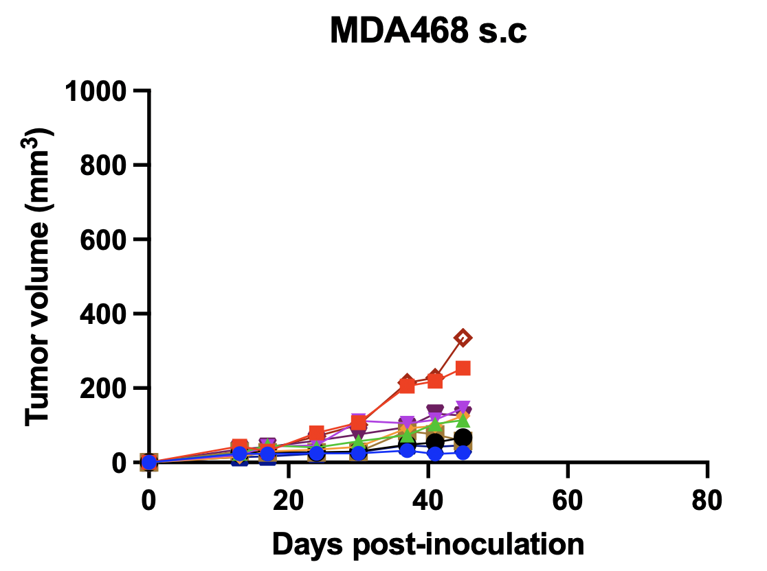
MDA-MB-468, 1.10⁶,
PBS, s.c
B
MDA-MB-231wt, 1.10⁶,
PBS, s.c
A

Figure S2: Characterization of tumors growth of MDA-MB-231wt and MDA-MB-468 mouse models
(A-B) Tumors volume after inoculation in xenograft models (n=10 per group).
The groups are described as follows: Cell line, number of cells, solution of inoculation, site of inoculation. Mice were sacrificed at different time points. Black arrows correspond to the different stages of sacrifice.
PBS: Phosphate buffer saline. S.c: subcutaneous

MDA-MB-436 cells inoculated subcutaneously with PBS achieved only 25 % tumor engraftment. (Table S1). MDA-MB-436 tumor, inoculated with 50 % Matrigel®, exhibited mean volumes of 38 ± 60 mm³, at 25 days post-inoculation (100 % tumor engraftment) (Figure. S3A). The cell line has shown slower growth rate than MDA-MB-231wt and MDA-MB-468 but no difference was observed for neovascularization or PSMA expression (Figure. S3B).

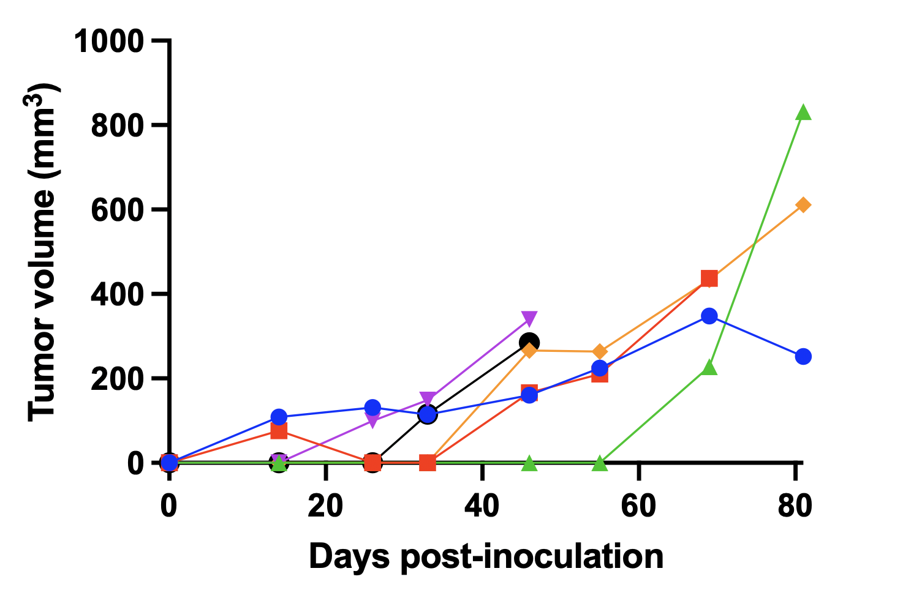
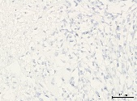
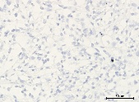
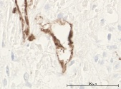
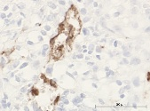
MDA-MB-436
1.10⁶, Matrigel®, MFP
(n=6)
PSMA
CD31
Ki-67
H&E
MDA-MB-436
1.10⁶, Matrigel®, MFP
(n=6)
A
B

Figure S3: Characterization of MDA-MB-436 TNBC xenograft mouse model and absence of PSMA expression
(A) Tumors volume of MDA-MB-436 cells inoculated models (n=6 per group). (B) Histological analyses of the MDA-MB-436 xenograft model. Tumor sections were stained with hematoxylin-eosin (H&E) or immunostained for Ki-67, PSMA and CD31. A zoom was performed on a central and peripheral area of each tumor for Ki-67, PSMA and CD31 staining. The groups are described as follows: Cell line, number of cells, solution of inoculation, site of inoculation. Mice were sacrificed at different time points. Each curve represents one individual tumor.
Black arrows correspond to the different stages of sacrifice. PBS: Phosphate buffer saline. MFP: Mammary fat pad. TNBC: Triple-negative breast cancer.

The BT-20 model inoculated with Geltrex® showed the poorest growth with only 2 tumors that were big enough to be recoverable (47.2 mm³ and 77.9 mm³) out of 6 inoculated mice (Figure S4).

BT-20, 1.10⁶, Geltrex®, MFP, (n=6)
A
B
H&E
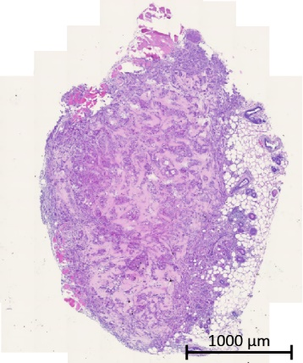
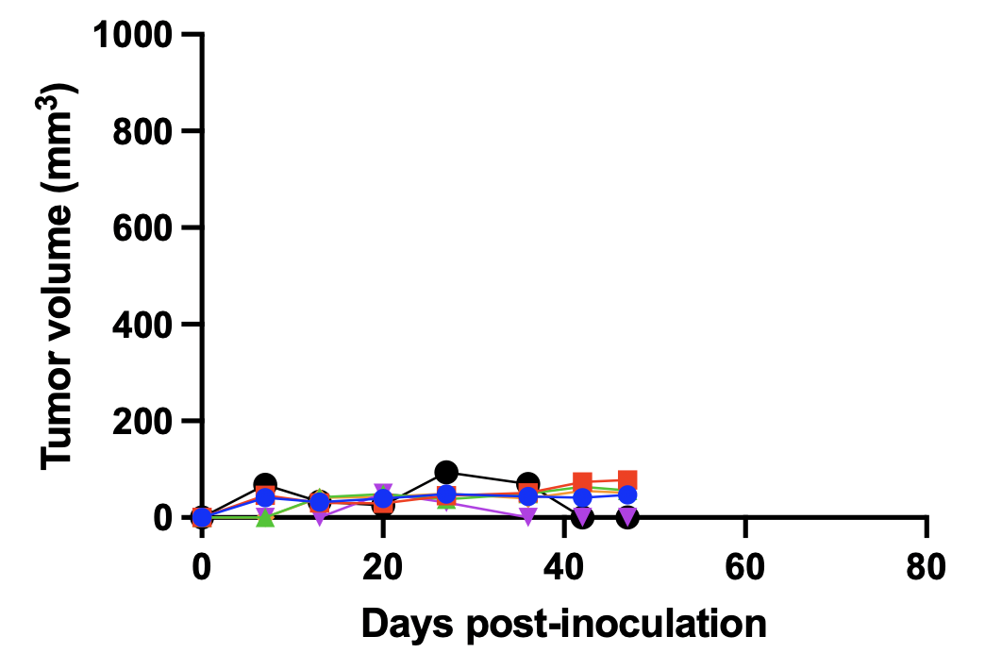

Figure S4: Characterization of BT-20 with Geltrex® mouse model
(A) Tumor volume after inoculation of BT-20 cell line. (B) Histological analyses of the TNBC model. Tumor sections were stained with hematoxylin-eosin (H&E) The experimental groups are described as follows: Cell line, number of cells, solution of inoculation, site of inoculation.
TNBC: Triple-negative breast cancer, MFP: Mammary fat pad.

MDA-MB-231wt/HUVEC and MDA-MB-468/HUVEC with PBS subcutaneous models were characterized by tumor volumes of 37 ± 16 mm³ (n=10, 80 % tumor engraftment) and 52 ± 14 mm³ (n=10, 90 % tumor engraftment), respectively, up to 25 days p.i. Despite evidence of neovascularization, histological analyses revealed no PSMA expression. Tumor volume of MDA-MB-468/HUVEC MFP models produced after inoculating 5.10⁵/5.10⁵ or 7.10⁵/3.10⁵ cells 44 ± 29 mm³ (n=10) and 81 ± 20 mm³(n=10), respectively, up to 25 days p.i with both 100 % tumor engraftment in both cases. However, there was no PSMA expression in IHC analysis (data not shown).
Tumor growth rate of inoculated MDA-MB-436 or co-inoculated MDA-MB-436/HUVEC MFP models grow in Geltrex® were 63 ± 53 mm³ (n=6, 83 % tumor engraftment) and 55 ± 31 mm³ (n=6, 83 % tumor engraftment), respectively, after 27 days p.i, (Fig. S5A, B).

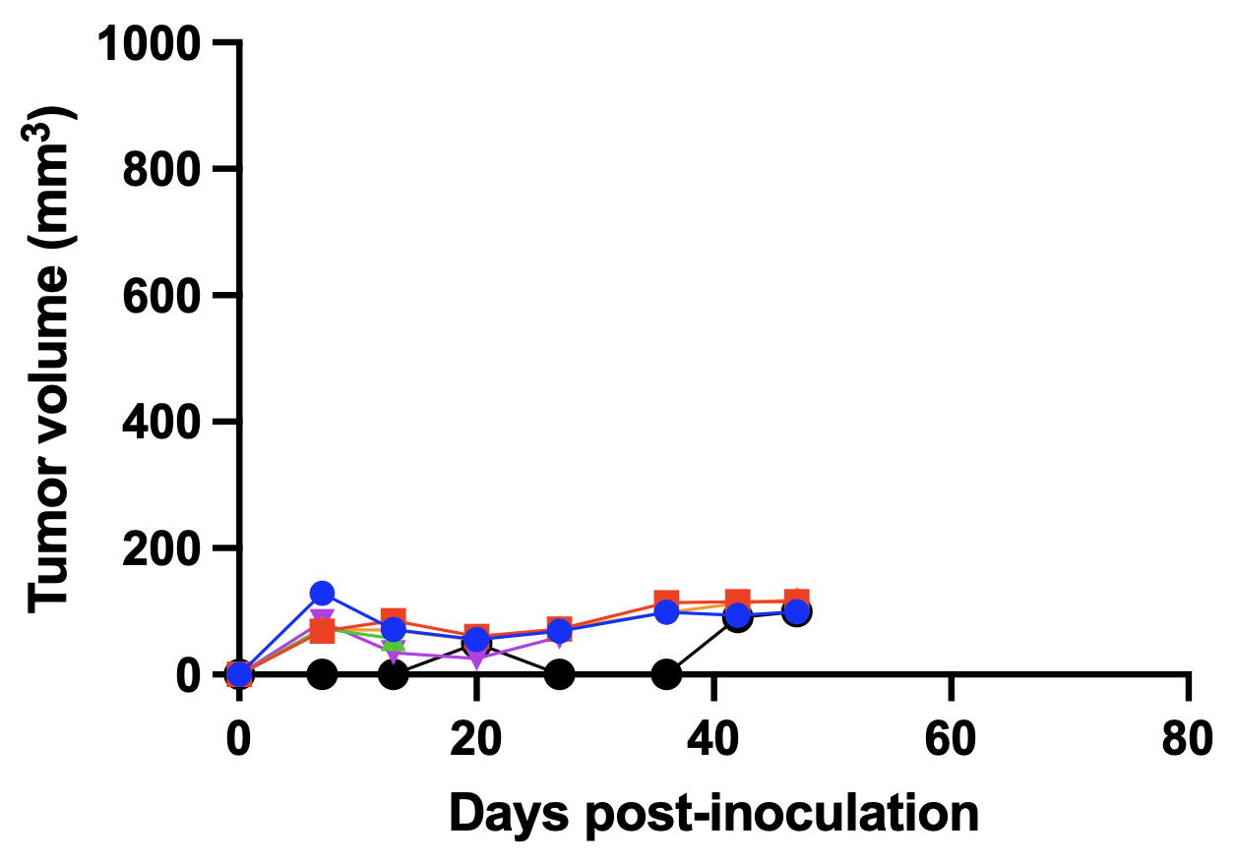
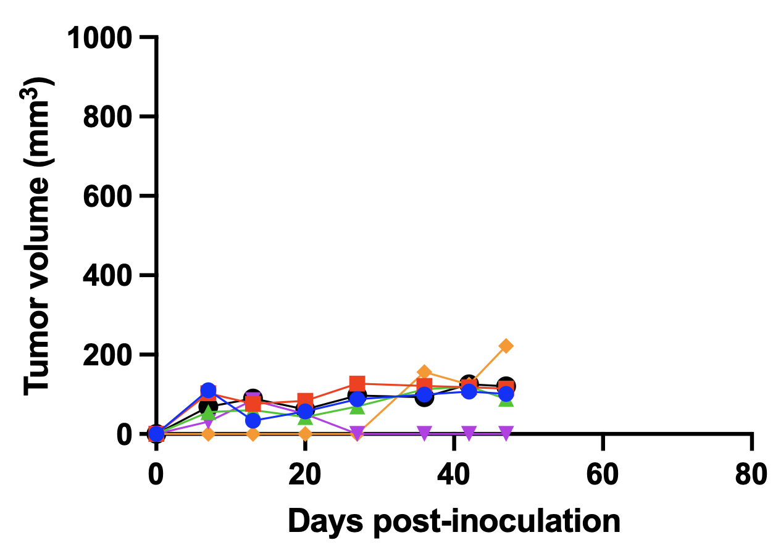
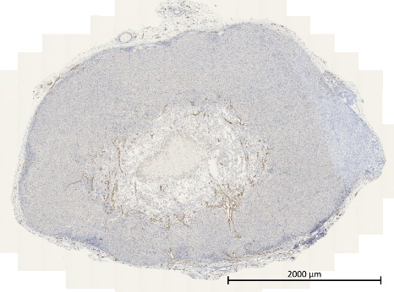
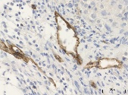
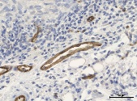
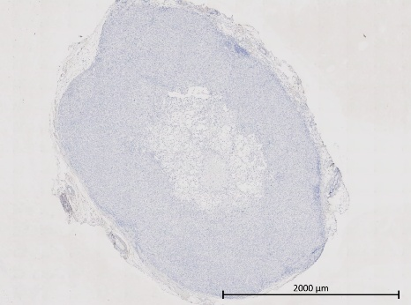
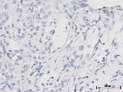
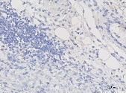
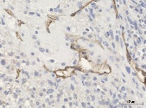
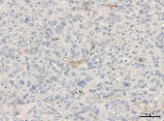
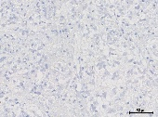
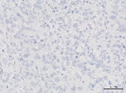
MDA-MB-436/HUVEC
5.10⁵/5.10⁵, Geltrex®, MFP
(n=6)
MDA-MB-436
1.10⁶, Geltrex®, MFP
(n=6)
A
B
CD31
Ki-67
PSMA
H&E
MDA-MB-436
1.10⁶, Geltrex®, MFP
(n=6)
C
MDA-MB-436/HUVEC
5.10⁵/5.10⁵, Geltrex®, MFP
(n=6)

Figure S5: Characterization of MDA-MB-436 mono- or co-inoculated TNBC/endothelial cells xenograft mouse model and absence of PSMA expression
(A-B) Tumors volume after inoculation in xenograft of MDA-MB-436 mono- or co-inoculated TNBC/HUVEC models (n=6 per group). (D) Histological analyses of the TNBC xenograft model. Tumor sections were stained with hematoxylin-eosin (H&E) or immunostained for Ki-67, PSMA and CD31. A zoom was performed on a central and peripheral area of each tumor for Ki-67, PSMA and CD31 staining. The groups are described as follows: Cell line, number of cells, solution of inoculation, site of inoculation. Each curve represents one individual tumor.
PBS: Phosphate buffer saline. MFP: Mammary fat pad. TNBC: Triple negative breast cancer.

Primary antibody
+
-
anti-Ki-67 antibody (1/100, Abcam # ab15580)
anti-PSMA antibody (1/100, Cell Signaling Technology #12815)
anti-CD31 antibody (1/2000, Abcam # ab182981)
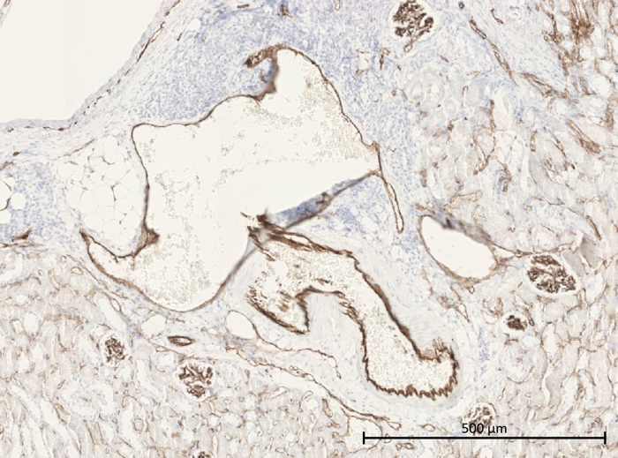
Figure S6: Antibody control
Secondary antibody from goat, anti-rabbit IgG was applied with or without primary antibody to exclude unspecific binding. Nuclei were stained with hematoxylin. Positive controls were: 4T1 tumor for Ki-67, mouse kidney for CD31 (endothelial cells of vascularization) and PSMA (epithelial cells of proximal tubules).

ADDITTIONAL DISCUSSION

Aiming a better tumoral development, researchers often use Matrigel®, a solubilized basement membrane extract derived from Engelbreth-Holm-Swarm (EHS) mouse sarcoma, rich in extracellular matrix proteins and various growth factors. As a result of poor tumoral development of human TBNC xenograft inoculated with PBS, 2 matrices were tested, Matrigel® (Corning® Matrigel® Matrix High Concentration) and Geltrex (Gibco™ Geltrex™ Reduced). Differences in tumor engraftment and growth rates between these matrices likely reflect the growth factor content [1].
Another option was co-inoculation TNBC cells with endothelial cells. Indeed, pre-clinical studies have already demonstrated in vitro that PSMA expression on the endothelial cells (HUVEC cells in these cases) is induced by factors secreted by cancer cell lines, notably MDA-MB-231[3–5]. Moreover, one of them, Nguyen et al., have shown in vivo that co-inoculation of kidney cancer cell line SK-RC-13 and HUVEC into NOD SCID mice has enabled human neovascularization PSMA expression. Here, primary HUVEC cells were co-inoculated with TNBC cell lines, including MDA-MB-231wt, and with PBS or matrices. No PSMA expression was detected. This could be explained by a premature death in vivo of the primary HUVEC. This could be checked by IHC using anti-human CD31 antibody but as it was not observed PSMA expression on early stage (15-30 days p.i), research has not been carried out.

ADDITTIONAL REFERENCES

1. Quintana E, Shackleton M, Sabel MS, Fullen DR, Johnson TM, Morrison SJ. Efficient tumour formation by single human melanoma cells. Nature. 2008;456:593–8.
2. Heesch A, Florea A, Maurer J, Habib P, Werth LS, Hansen T, et al. The prostate-specific membrane antigen holds potential as a vascular target for endogenous radiotherapy with [177Lu]Lu-PSMA-I&T for triple-negative breast cancer. Breast Cancer Res. 2024;26:30.
3. Berkman. Detection of prostate-specific membrane antigen on HUVECs in response to breast tumor-conditioned medium. Int J Oncol [Internet]. 2011 [cited 2023 Sep 5];38. Available from: http://www.spandidos-publications.com/ijo/38/5/1349
4. Nguyen DP, Xiong PL, Liu H, Pan S, Leconet W, Navarro V, et al. Induction of PSMA and Internalization of an Anti-PSMA mAb in the Vascular Compartment. Molecular Cancer Research. 2016;14:1045–53.
5. Morgenroth A, Tinkir E, Vogg ATJ, Sankaranarayanan RA, Baazaoui F, Mottaghy FM. Targeting of prostate-specific membrane antigen for radio-ligand therapy of triple-negative breast cancer. Breast Cancer Res. 2019;21:116.

