Supplementary Information S1
Kinetic, Equilibrium, and Thermodynamic Study of Methylene Blue Adsorption on Orange Peel Biochar Prepared by Microwave-Assisted Pyrolysis

Jhonny Correa-Abrilª, Elvia V. Cabreraª, Nilo Robles^{a,b}, J. L. López Teránª, and Ullrich Stahl^{a,*}

ª Universidad Central del Ecuador, Facultad de Ingeniería Química, Grupo de Investigación en Alimentos, Compuestos Orgánicos, Materiales, Microbiología aplicada, y Energía - ACMME. Enrique Ritter s/n y Bolivia, Quito, Ecuador.
^{b} Instituto de Investigación Geológico y Energético - IIGE, Quito EC-170518, Ecuador.
* Correspondence: ustahl@uce.edu.ec

Highlights:
• Pristine biochar from orange peel waste is an effective adsorbent for Methylene Blue.
• pH control is critical: constant pH 4 yields a q_{max} of 25.57 mg g⁻¹, more than double that of the unregulated system (11.24 mg g⁻¹).
• High Methylene Blue removal (83 %) occurs at pH 4, despite electrostatic repulsion with the positively charged biochar surface (pH_{pzc} = 11.20).
• The adsorption process is spontaneous, endothermic (ΔH° > 0), and dominated by physisorption mechanisms like hydrogen bonding and π-π interactions.
• The Elovich kinetic model provides the best fit (R² > 0.99), confirming a complex adsorption process on a heterogeneous surface.

- Figures:
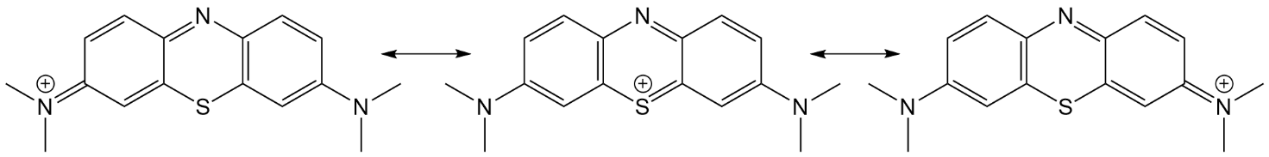
Figure S1. Resonance structures of the MB cation.

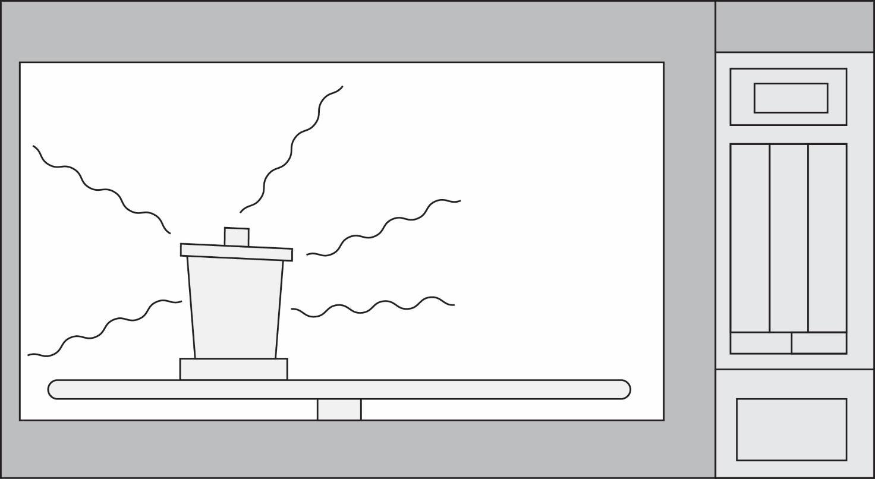
Figure S2. The schematic diagram of the microwave-assisted pyrolysis apparatus

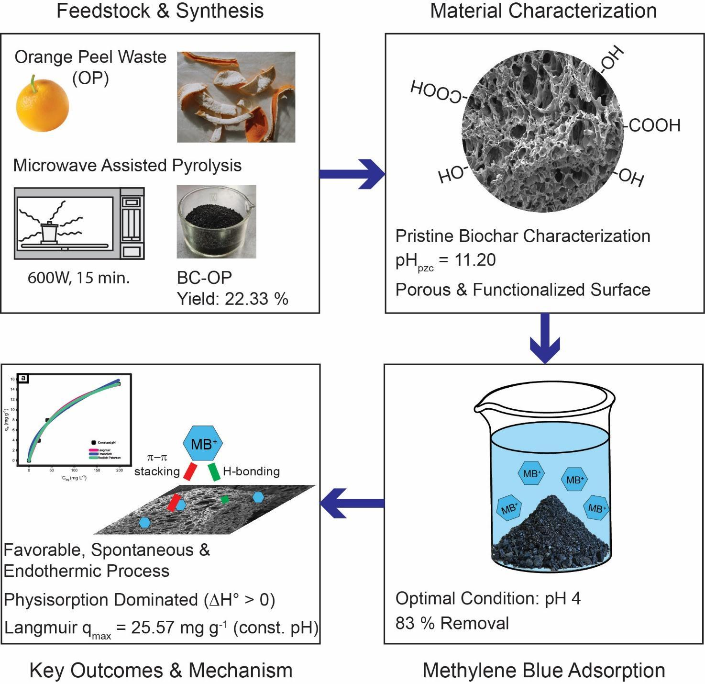
Figure S3. Schematic of the synthesis process of BC-OP via MAP, characterization, and adsorption study of MB on BC-OP.)

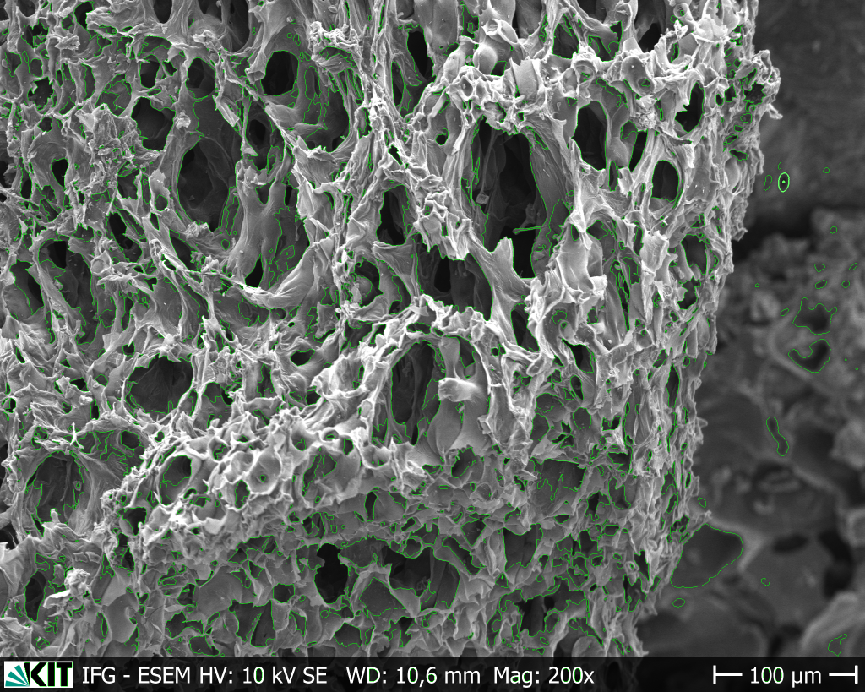
Figure S4. Pore size distribution evaluation of BC-OP with PoreVision software¹.

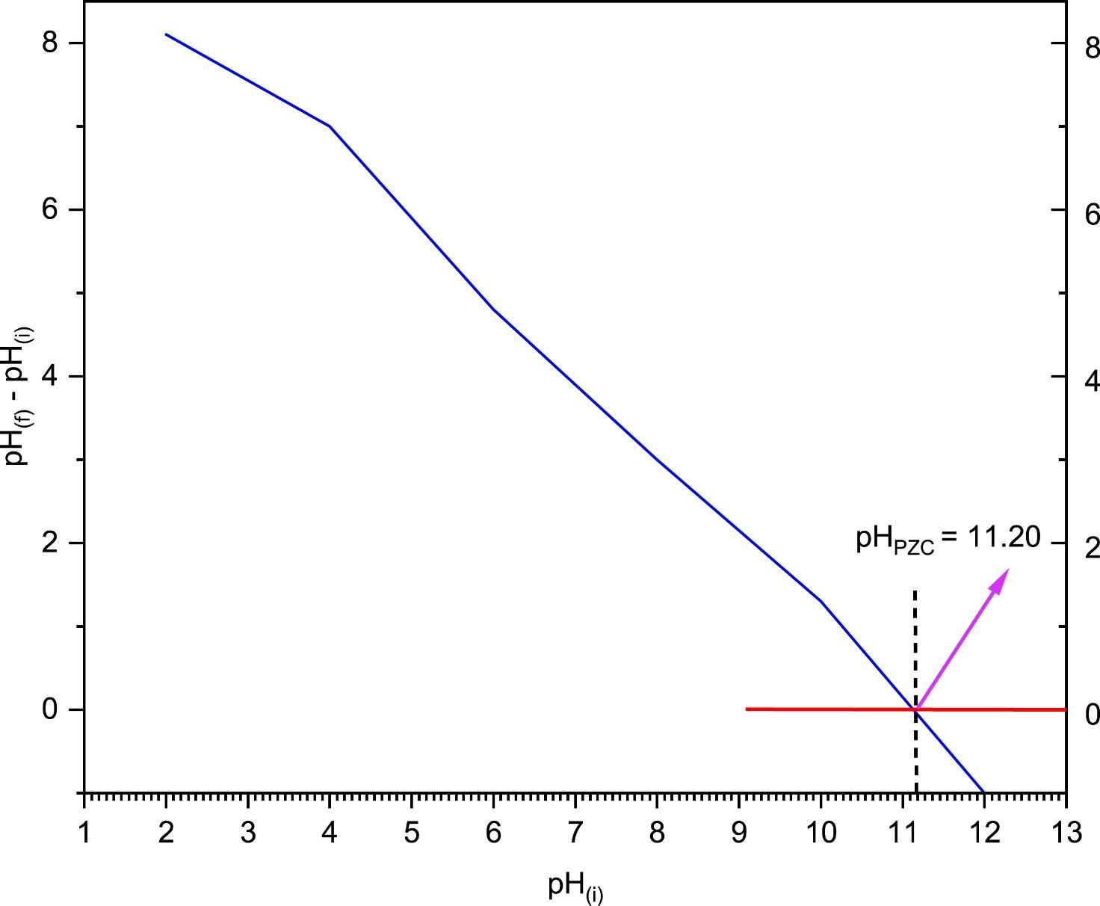
Figure S5. Determination of the pH_{pzc} value for BC-OP.
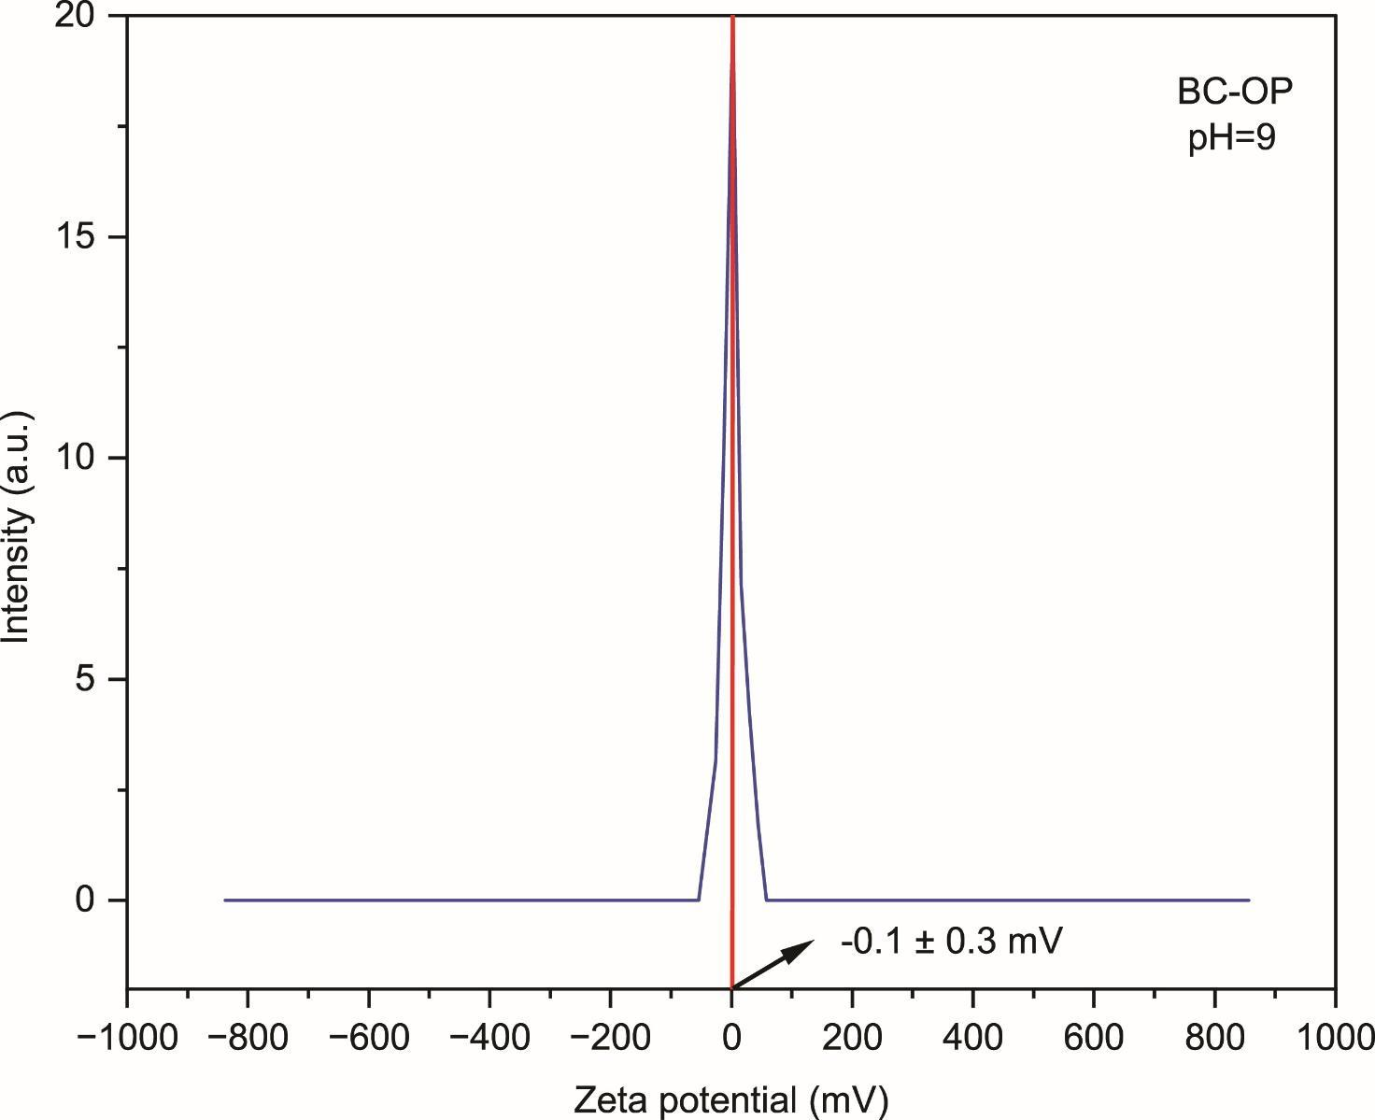
Figure S6. Determination of ZP at pH 9.
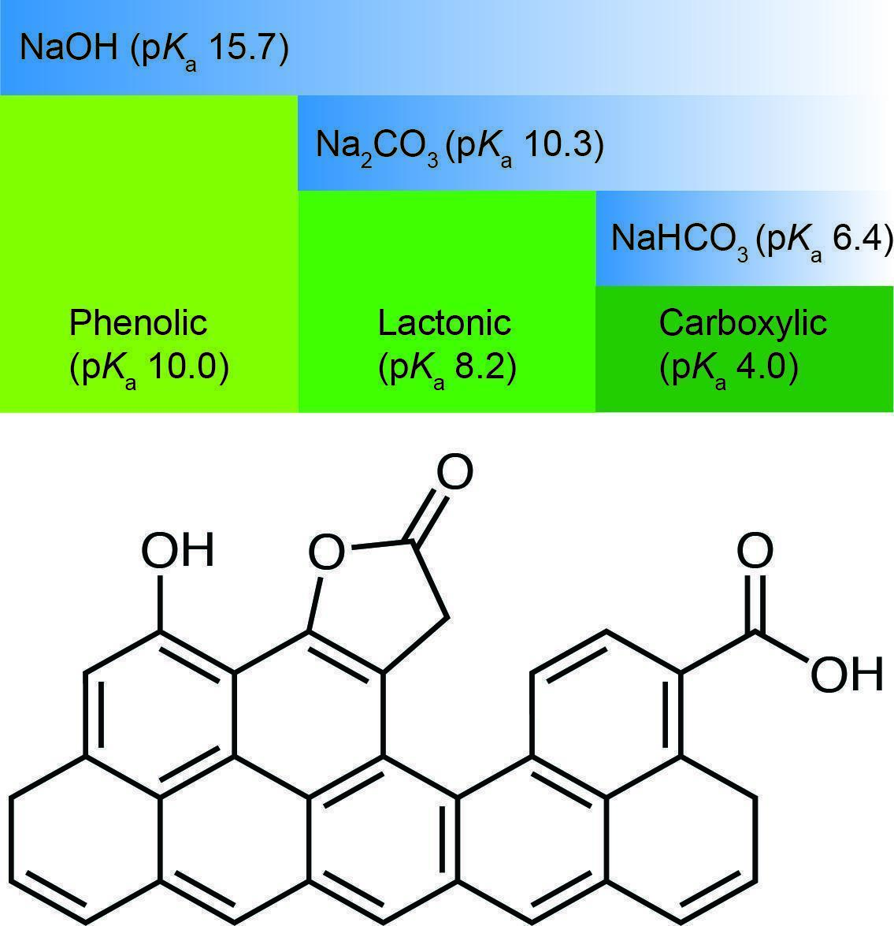
Figure S7. Schematic illustrating the Boehm titration principle of selective neutralization of oxygen functional groups according to their acidity using multiple bases ².

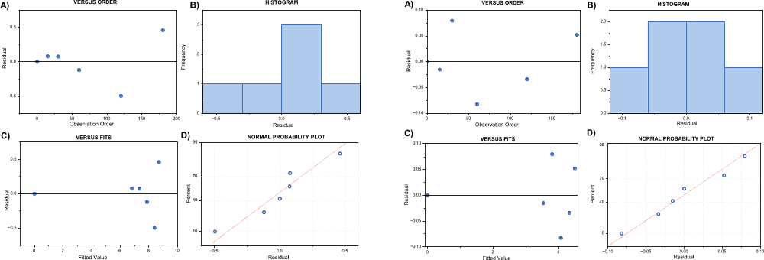
Figure S8. Residual plots of the kinetic adsorption model of MB on BC-OP under controlled (constant pH 4) and unregulated conditions.
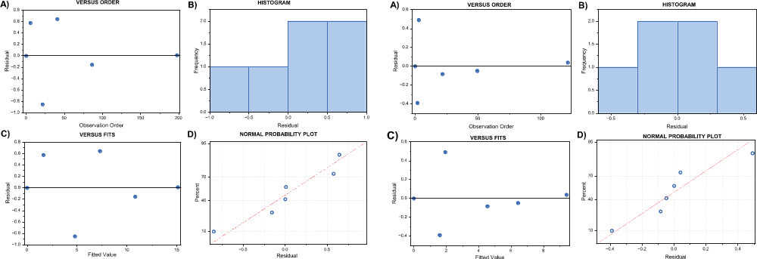
Figure S9. Residual plots of the adsorption isotherm of MB on BC-OP under controlled (constant pH 4) and unregulated conditions.
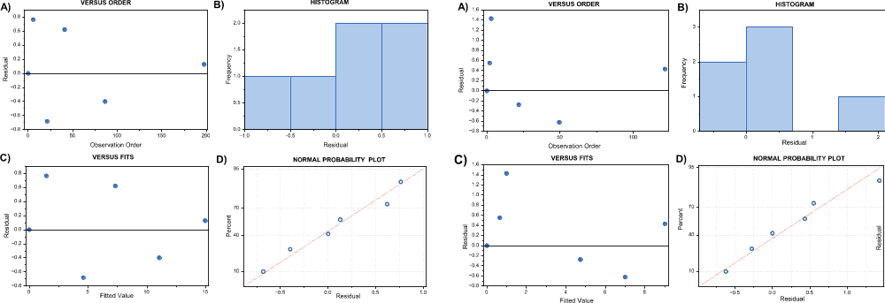
Figure S10. Residual plots of the adsorption isotherm of MB on BC-OP at 293 K under controlled (constant pH 4) and unregulated conditions.

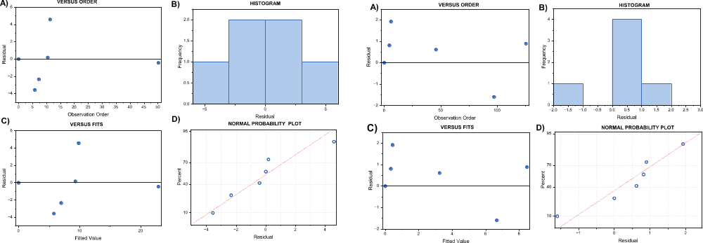
Figure S11. Residual plots of the adsorption isotherm of MB on BC-OP at 308 K under controlled (constant pH 4) and unregulated conditions.

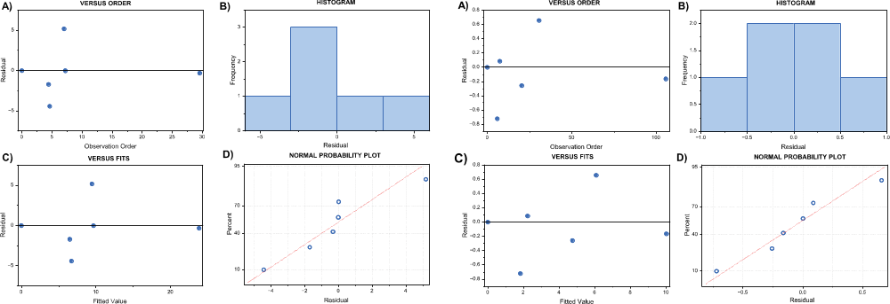
Figure S12. Residual plots of the adsorption isotherm of MB on BC-OP at 323 K under controlled (constant pH 4) and unregulated conditions.

- TABLES
Table S1. Production yield of BC-OP
Yield MAP (%)
# | OP  (g) | BC-OP  (g) | Yield  (%)
1 | 40.002 | 8.948 | 22.369
2 | 40.162 | 9.043 | 22.516
3 | 42.618 | 9.520 | 22.338
4 | 42.108 | 9.168 | 21.773
5 | 43.004 | 9.272 | 22.561
6 | 40.747 | 8.921 | 22.894
7 | 41.415 | 9.324 | 22.514
8 | 42.354 | 8.944 | 22.317
9 | 42.285 | 9.402 | 22.235
10 | 40.347 | 9.004 | 22.316
11 | 40.471 | 8.751 | 22.223
12 | 40.137 | 8.796 | 21.915
 |  | Average | 22.331
 |  | SD | 2.931

Table S2. Electrical conductivity of BC-OP.
EC (mS cm⁻¹)
1 | 4.40
2 | 4.42
3 | 4.32
Average | 4.38
SD | 0.05

Table S3. Effect of pH on the removal of MB in BC-OP.
Effect of solution pH
pH | %R | SD
2 | 61.643 | 3.544
4 | 82.703 | 3.872
6 | 70.223 | 4.444
8 | 71.091 | 0.223
10 | 72.798 | 4.712

Table S4. Effect of adsorbent dosage on the removal of MB in BC-OP under controlled (constant pH 4) and unregulated conditions.
DOSAGE
CONSTANT | Adsorbent dosage  (g 100 mL⁻¹) | Removal MB  (%) | SD | q_{e}  (mg g⁻¹) | SD
CONSTANT | 0.5 | 94.730 | 1.248 | 9.429 | 0.118
CONSTANT | 1.0 | 98.185 | 0.671 | 4.790 | 0.038
CONSTANT | 1.5 | 99.563 | 0.670 | 3.317 | 0.022
CONSTANT | 2.0 | 99.564 | 0.747 | 2.398 | 0.011
CONSTANT | 3.0 | 99.563 | 0.363 | 1.638 | 0.016
UN REGULATED | Adsorbent dosage  (g 100 mL⁻¹) | Removal MB  (%) | SD | q_{e}  (mg g⁻¹) | SD
UN REGULATED | 0.5 | 62.035 | 0.465 | 8.728 | 0.020
UN REGULATED | 1.0 | 66.281 | 1.285 | 4.155 | 0.030
UN REGULATED | 1.5 | 70.510 | 0.834 | 2.842 | 0.014
UN REGULATED | 2.0 | 82.226 | 0.643 | 2.277 | 0.007
UN REGULATED | 3.0 | 83.113 | 2.312 | 1.525 | 0.018

Table S5. Effect of contact time on the removal of MB in BC-OP under controlled (constant pH 4) and unregulated conditions.
KINETICS
CONSTANT | Time  (min) | q_{t}  (mg g⁻¹) | SD
CONSTANT | 15 | 6.908 | 0.055
CONSTANT | 30 | 7.430 | 0.470
CONSTANT | 60 | 7.760 | 0.001
CONSTANT | 120 | 7.911 | 0.001
CONSTANT | 180 | 9.173 | 0.000
UN REGULATED | Time  (min) | q_{t}  (mg g⁻¹) | SD
UN REGULATED | 15 | 3.523 | 0.172
UN REGULATED | 30 | 3.884 | 0.201
UN REGULATED | 60 | 3.989 | 0.000
UN REGULATED | 120 | 4.304 | 0.000
UN REGULATED | 180 | 4.546 | 0.113

Table S6. Study of the effect of the initial adsorbate concentration at 293 K on the removal of MB in BC-OP under controlled (constant pH 4) and unregulated conditions.

INITIAL CONCENTRATION AT 293 K
CONSTANT | C₀  (mg L⁻¹) | C_{e}  (mg L⁻¹) | q_{e}  (mg g⁻¹) | SD
CONSTANT | 50 | 5.621 | 2.214 | 0.022
CONSTANT | 100 | 21.363 | 3.924 | 0.320
CONSTANT | 200 | 40.901 | 7.939 | 0.095
CONSTANT | 300 | 86.227 | 10.667 | 0.038
CONSTANT | 500 | 197.604 | 15.089 | 0.688
UN REGULATED | C₀  (mg L⁻¹) | C_{e}  (mg L⁻¹) | q_{e}  (mg g⁻¹) | SD
UN REGULATED | 50 | 1.842 | 1.203 | 0.015
UN REGULATED | 100 | 2.910 | 2.425 | 0.001
UN REGULATED | 200 | 21.721 | 4.453 | 0.055
UN REGULATED | 300 | 49.397 | 6.378 | 0.000
UN REGULATED | 500 | 121.534 | 9.052 | 0.000
Table S7. Study of the effect of the initial adsorbate concentration at 308 K on the removal of MB in BC-OP under controlled (constant pH 4) and unregulated conditions.
INITIAL CONCENTRATION AT 308 K
CONSTANT | C₀  (mg L⁻¹) | C_{e}  (mg L⁻¹) | q_{e}  (mg g⁻¹) | SD
CONSTANT | 50 | 5.769 | 2.207 | 0.038
CONSTANT | 100 | 7.243 | 4.629 | 0.022
CONSTANT | 200 | 10.457 | 9.458 | 0.030
CONSTANT | 300 | 11.281 | 14.407 | 0.094
CONSTANT | 500 | 50.138 | 22.448 | 2.294
UN REGULATED | C₀  (mg L⁻¹) | C_{e}  (mg L⁻¹) | q_{e}  (mg g⁻¹) | SD
UN REGULATED | 50 | 4.464 | 1.137 | 0.015
UN REGULATED | 100 | 5.933 | 2.349 | 0.026
UN REGULATED | 200 | 45.789 | 3.851 | 0.403
UN REGULATED | 300 | 57.107 | 6.067 | 0.067
UN REGULATED | 500 | 125.369 | 9.356 | 0.159

Table S8. Study of the effect of the initial adsorbate concentration at 323 K on the removal of MB in BC-OP under controlled (constant pH 4) and unregulated conditions.

INITIAL CONCENTRATION AT 323 K
CONSTANT | C₀  (mg L⁻¹) | C_{e}  (mg L⁻¹) | q_{e}  (mg g⁻¹) | SD
CONSTANT | 50 | 4.606 | 2.265 | 0.040
CONSTANT | 100 | 4.427 | 4.769 | 0.029
CONSTANT | 200 | 7.180 | 9.622 | 0.150
CONSTANT | 300 | 6.996 | 14.621 | 0.057
CONSTANT | 500 | 29.528 | 23.477 | 0.568
UN REGULATED | C₀  (mg L⁻¹) | C_{e}  (mg L⁻¹) | q_{e}  (mg g⁻¹) | SD
UN REGULATED | 50 | 5.875 | 1.102 | 0.001
UN REGULATED | 100 | 7.428 | 2.312 | 0.002
UN REGULATED | 200 | 20.333 | 4.487 | 0.001
UN REGULATED | 300 | 30.596 | 6.728 | 0.000
UN REGULATED | 500 | 105.684 | 9.848 | 0.003

References
1. Olevsky, L. M., Jacques, M. G. & Hixon, K. R. PoreVision: A Program for Enhancing Efficiency and Accuracy in SEM Pore Analyses of Gels and Other Porous Materials. Gels 11, 132 (2025).
2. Sen, T. K. Adsorptive Removal of Dye (Methylene Blue) Organic Pollutant from Water by Pine Tree Leaf Biomass Adsorbent. Processes, 11(7), 1877 (2023).

