Supporting Information
Bridging photocatalysis and artificial intelligence to maximize CH₄ and CO production from CO₂ reduction using synthesized g-C₃N₄/TNTAs photocatalysts
Md. Arif Hossen^{1*}, Meherunnesa Prima², Azrina Abd Aziz^{3,4}, Nadeem A Khan⁵, Yunus Ahmed^{2*}
¹ Institute of River, Harbor and Environmental Science (IRHES), Chittagong University of Engineering & Technology, Chattogram-4349, Bangladesh.
² Department of Chemistry, Chittagong University of Engineering & Technology, Chattogram-4349, Bangladesh.
³ Faculty of Civil Engineering Technology, Universiti Malaysia Pahang Al-Sultan Abdullah, 26300 Gambang, Pahang, Malaysia.
⁴ Center for Advanced Intelligent Materials, Universiti Malaysia Pahang Al-Sultan Abdullah, 26300 Gambang, Pahang, Malaysia.
⁵ Civil Engineering Department, College of Engineering, King Khalid University, Abha, 61421, Saudi Arabia

*Corresponding author: arifhossen0101@cuet.ac.bd; yunus.acctiu@gmail.com

Text-S1. Materials and chemical specifications
The chemical reagents employed for the synthesis of photocatalysts were of analytical grade and purchased from Sigma-Aldrich Chemical Company. TiO₂ nanotube arrays (TNTAs) film was fabricated on the Titanium (Ti) substrate which had thickness of 0.25 mm (99.97%). Graphite sheet of 2 mm thickness was employed as counter electrode during anodization. Ethylene glycol (EG, 99.5%) and ammonium fluoride (NH₄F, 98.0%) were used to prepare the electrolyte solution. A laboratory DC power supply (GW Instek, GPS- 3030DD), was placed to conduct experiments. Programmable muffle furnace (Wise Therm ®, version 1.3.1) was used for the annealing and ultrasonic cleaner (JAC-1020 P) has been used for sonication. The chemicals used for the synthesis of g-C3N4 nanosheets were melamine (99.9%, Merck). During the experiment ultrapure water (Milli-Q ®, 18.2 MΩ. cm at 25°C) was utilized for all experimental purpose.

Text-S2. Synthesis procedure of TNTAs
The two-step anodic oxidation method was utilized to fabricate the TNTAs photocatalysts. The working electrode was titanium (Ti) foil, and the counter electrode was graphite, with a gap of 1.5 cm between them. To be used as a substrate during the anodization process, readily accessible Ti foil (purity 99.8%) with a 0.25 mm thickness was acquired from Sigma-Aldrich company and shaped to the appropriate size (25 mm × 20 mm). Ti foils were cleaned for 15 min in each of the following solutions in an ultrasonic bath: acetone, ethanol, and deionized water. Ethylene glycol based organic solvent was employed as electrolyte during anodization with 2.5 vol.% H₂O and optimized percentage (0.4 wt.%) of NH₄F (Hossen et al., 2024). During the synthesis of TNTAs different anodization voltage of 40V and 1h anodization time were applied. Two-step anodization involved first anodizing the TNT layers for 30 min, and then rinsing the as-formed layers ultrasonically in DI water for 20 min to remove the first layer. Before undergoing additional analysis, the anodized samples were subsequently cleaned with DI water, dried at room temperature, and annealed for 2 h at 500 °C.
Text-S3. Characterization
In this study, Field Emission Scanning Electron Microscopy (FESEM) of JEOL brand (JSM7800F) was utilized to investigate the fabricated photocatalysts samples. The X-ray diffraction (XRD) patterns were collected using PANALYTICAL brand X’PERT3 POWDER model machine with Cu Kα radiation operated at accelerating voltage of 15 to 52 kV and emission current of 5 to 60 mA. The operations were performed in the range of 2θ range between 10⁰ to 80⁰ with 0.02⁰ step size and 1s step time. The Ultraviolet-visible Diffuse Reflectance Spectroscopy (UV-Vis DRS) of PerkinElmer brand and LAMBDA 1050 model was employed in this study to measure visible light absorption spectrum of prepared samples, which operates in the range of 200-900 nm. The Photoluminescence (PL) spectra of synthesized samples were recorded in this experiment utilizing F900 EDINBURGH instruments.

Text-S4. Description of machine learning models
S4.1 Gradient Boosting
A Gradient boosting is a widely utilized machine learning model that employs an ensemble method of decision trees known as boosting. The core concept of boosting involves the sequential addition of new decision trees by calculating the residuals of the entire ensemble model. This process continues until the model achieves the highest accuracy. Additionally, these models can be customized by adjusting the structure, such as the loss function and three addition method (Natekin and Knoll, 2013). The fundamental algorithm for gradient boosting used in this study can be generalized by the following equation.
$$f\left(x\right)= \sum_{k=1}^{K}{f^{k}\left(x\right)}$$ | (1)
Where $f\left(x\right)$ and $f^{k}\left(x\right)$ indicate the entire ensemble model and k-th independent decision tree. N indicates the number of decision trees.

S4.2 HistGradientBoosting (HGB)
The Histogram-based gradient boosting is an advanced method that enhances the speed and performance of Gradient Boosting models (Xia et al., 2023). This technique efficiently combines decision trees on large datasets by dividing input features into specified intervals. As a result, unlike traditional gradient boosting methods, the models can quickly find the optimal split. Additionally, histogram-based gradient boosting can handle missing values by using one of the partitions for training, eliminating the need to preprocess the input data for missing values before applying the model.
S4.3 Extreme Gradient Boosting (XGBoost)
XGBoost, short for Extreme Gradient Boosting, is an advanced gradient boosting algorithm that assigns weights to the learning errors of weak models and sequentially incorporates them into the next model to create a prediction model (Chen and Guestrin, 2016). XGBoost models support parallel processing, resulting in faster computing speed than traditional Gradient Boosting models. Additionally, XGBoost models utilize a technique to prevent overfitting by training the tree using a regularized loss function defined by the following mathematical equation.
$$L^{t}= \sum_{i=1}^{n}{l\left(y_{i},{\hat{y_{i}}}^{t-1}+f_{t}(x_{i})\right)}+Ω\left(f_{t}\right)$$ | (2)
$$Ω\left(f_{t}\right)= γT+\frac{1}{2}λ{\left\|w\right\| }^{2}$$ | (3)
Where $L^{t}$ and $f^{t}\left(x\right)$ indicate the loss function and decision tree at the t-th iteration. The l is a convex loss function. The $y_{i}, \hat{y_{i}}$ and $x_{i}$ indicate the true value, predicted value and input data at i-th data instance. The $Ω$ is regulation term calculated with the number of leaves (T) in the decision tree and the Euclidean distance of each leaf $({\left\|w\right\| }^{2}$).
S4.4 Light Gradient Boosting Machine (LGBM)
Light Gradient Boosting Machine (LGBM) is an enhanced version of the Gradient Boosting model. It achieves this by including two techniques that effectively decrease the computational workload (Ke et al., 2017). LGBM utilizes Gradient-based one-side sampling (GOSS) and exclusive feature bundling (EFB) methods. The GOSS methodology decreases the sample size of a dataset. The fundamental premise of GOSS is that cases with substantial gradients exert a considerable influence on predictions, and the model is inadequately trained for such instances. The GOSS algorithm curates the training data set by selectively including examples that exhibit significant gradients. Hence, cases exhibiting negligible gradients can be disregarded, thereby minimizing their contribution to the training process and reducing the dataset's sample count. The EFB is a data analysis technique that aims to reduce the dimensionality of a dataset by minimizing the number of input features. The EFB employs a technique of consolidating variables with a strong correlation into a single category under the assumption that data with many dimensions is sparsely populated. Reducing the number of samples and features in the dataset using these two approaches significantly reduces the time it takes to compute the model. Furthermore, this model found a maximum limit to the decrease in performance due to the decrease in sample size and number of features (Ke et al., 2017). Therefore, while using the LGBM model, the issue of decreased prediction accuracy should not be overlooked. In addition, the LGBM model utilizes a leaf-wise approach during the tree partitioning process. Compared to the level-wise technique, which considers the tree's balance, the leaf-wise tree development in LGBM selects the best possible node to split, reducing prediction error.
The LGBM technique employs a weighted summation to amalgamate predictions from individual trees within the ensemble. During the training iteration, these weights are established by evaluating the loss function’s gradients. The subsequent equation can be employed to predict the target variable using LGBM:
𝑦̂ =∑𝛼𝑖 ℎ𝑖(𝑥) | (4)
Where 𝑦̂ forecasts the goal value, the weight assigned to the 𝑖^{th} tree is denoted by 𝛼𝑖, and the forecast made by the 𝑖^{th} tree for the input attributes 𝑥 is represented by ℎ𝑖(𝑥). The LGBM can handle massive datasets and excels at capturing intricate non-linear connections between features and the target variable. Through gradient-based optimization, it constructs a set of trees that collectively yield accurate predictions, thus enhancing the performance of the loss function.
S4.5 CatBoost
CatBoost (CB) is a machine learning technique that uses Gradient-boosted decision trees to predict continuous variables. The CatBoost model is widely recognized for its efficacy, precision, and capacity to handle categorical data (Prokhorenkova et al., 2018). For the CB model to function, it is necessary to initially design a set of relatively weak decision trees. Subsequently, these trees are amalgamated to construct a robust model. The method employed to link the trees is gradient boosting. Gradient boosting addresses the mistakes created by the previous trees by incorporating additional trees into the model. Equation (5) presents the mathematical expression utilised by CatBoost to predict continuous values:
$y=f\left(x\right)= \sum_{i=1}^{n}{αi hi\left(x\right)}$ | (5)
Here, 𝑦 represents the predicted value while 𝑥 denotes the input features. The resultant function 𝑓(𝑥) is a linear amalgamation of fundamental functions, ℎ𝑖(𝑥). The coefficients 𝛼𝑖 as certain of the significance of individual base functions within this linear amalgamation. The model coefficients are calculated using the gradient descent method. In the CB model, the loss function must be minimised. The loss function quantifies the difference between predicted and observed values. The CB model can effectively address a wide range of regression problems. It is especially effective at addressing issues that pertain to categorical attributes.
S4.6 Bagging
Bootstrap aggregation, also known as Bagging, integrates the concepts of bootstrap and aggregation (Breiman, 1996). The Bagging model generates multiple datasets with slight variations in noise and distribution by randomly sampling from the original training data. Each dataset is used to train a model independently, and the models are then combined into an ensemble model. This approach reduces the risk of models making predictions based solely on specific noise patterns in the original data. Additionally, the out-of-bagging data not included in the bootstrap process can be used to validate individual models during the model aggregation process. This validation helps the Bagging model achieve high generalization performance.
S4.7 Decision Tree
Decision trees (DT) is a model that uses a series of logical rules organized into a tree-like structure. Each test typically involves comparing data to a threshold value or specific category. This model makes predictions by segmenting the data into smaller groups using a series of decision rules arranged along a tree structure. Therefore, the order and placement of rules are crucial for the predictive accuracy of decision tree models (Geurts et al., 2009). Compared to complex artificial intelligence algorithms like artificial neural networks and convolutional neural networks, DTs have a simple structure and prediction technique. This simplicity allows the DT model to offer interpretability of predictions. Recently, many studies have focused on enhancing the performance of decision trees by improving their simple structure. As a result, studies have frequently emphasized using a combination of multiple independent DT rather than a single DT as a model (Opitz and Maclin, 1999).
S4.8 Random Forest
Random Forest (RF) is a model that utilizes the bagging technique among ensembles of independent decision trees (Breiman, 2001). In the bagging approach for regression, multiple decision trees are created by randomly sampling data from the original dataset. The final prediction is then generated by averaging the predictions of the individual trees. Random forests offer performance benefits by reducing variance while maintaining the bias of the models, which is a key advantage of the bagging model. Additionally, random forests randomly select input features for each decision tree from the pool of all input features. This variance in the input variables used in individual decision trees reduces the correlation between the trees. An analysis has shown that ensemble models with low-correlation trees reduce generalization errors and improve prediction performance (Breiman, 2001).

S4.9 Extra Trees
Extra Trees (ET), also known as highly randomized trees, are models that utilize an ensemble algorithm with significant randomness incorporated into the decision tree growth process (Geurts et al., 2006). The fundamental concept behind ET model is to introduce robust randomization in the selection of input features and cut points when splitting the nodes of the DT model. Due to this model's high level of randomness, the DT model may not provide an optimal cutting point, resulting in suboptimal predictive performance as a standalone model. However, when combined with multiple decision tree models, Extra Trees can effectively explore the data and enhance predictive performance. Furthermore, the model's randomness allows it to utilize all the data in the training process, reducing prediction bias. Additionally, the time required to build the model is reduced since it does not compute the optimal split.
S4.10 AdaBoost
The AdaBoost model can be utilized for both regression and classification scenarios. It is an ensemble learning technique that iteratively improves weak classifiers by learning from their errors. AdaBoost uses sequential ensembling instead of the parallel ensembling used in the RandomForest model. Combining numerous weak classifiers can achieve a strong classifier with high accuracy. However, it's important to note that while AdaBoost is an adaptive classifier, it can lead to overfitting. It is sensitive to outliers and noisy data but shows great promise in enhancing the performance of decision trees in binary classification problems. In our analysis, hyperparameter optimization and tuning were done using grid search to identify the best loss function. The key hyperparameters considered were the learning rate (ranging from 0.1 to 5) and the number of boosted trees (n_estimators) from 20 to 500.

Text-S5. Procedure for Tauc plot
The band gap energy (E_{g}) of FeWO₄ can be calculated from the diffuse reflectance spectroscopy (DRS) data using Tauc plots. To determine the values of the direct/indirect bands gap energy (E_{g}), the reflectance was recalculated into the dependence of Kubelka–Munk function (Kubelka, 1931) (F(R∞)) on the absorption energy using the Equation F(R∞) = (1 - R∞)²/(2·R∞), where R∞ is the diffuse reflectance (R∞ = R_{sample}/R_{standard}) from a semi-infinite layer.
$${\left(F\left(R\right)⋅hν\right)}^{\left\{\frac{1}{2}\right\}}= A\left(hν- E_{g}\right)$$
Where F(R) is the Kubelka-Munk function, related to the reflectance, h\nu is the photon energy, A is a constant, E_{g} is the band gap energy.
The band gap energies were calculated using the Tauc’s relation. This relationship is between the absorbance and the photon energy (hν). By plotting ${\left(hν\right)}^{n}$ against $hν,$ and extrapolating the linear portion of the curve to the x-axis, the band gap energy can be determined (Feng et al., 2015). In the case of an indirect band gap material, the Tauc equation is utilized for this purpose as follows-
$${\left(hν\right)}^{n}= A\left(hν- E_{g}\right)$$
In this relation, is the absorption coefficient, $hν$ is the photon energy, A is a constant, E_{g} is the band gap energy and n = 2 for direct band gap energy for these nanomaterials.

The absorption coefficient (α) is estimated by the following relation:
$$= \frac{-1}{t}lnT$$
Where, T is the transmittance value and t is the thickness of the substance that is placed under UV-Vis irradiation.

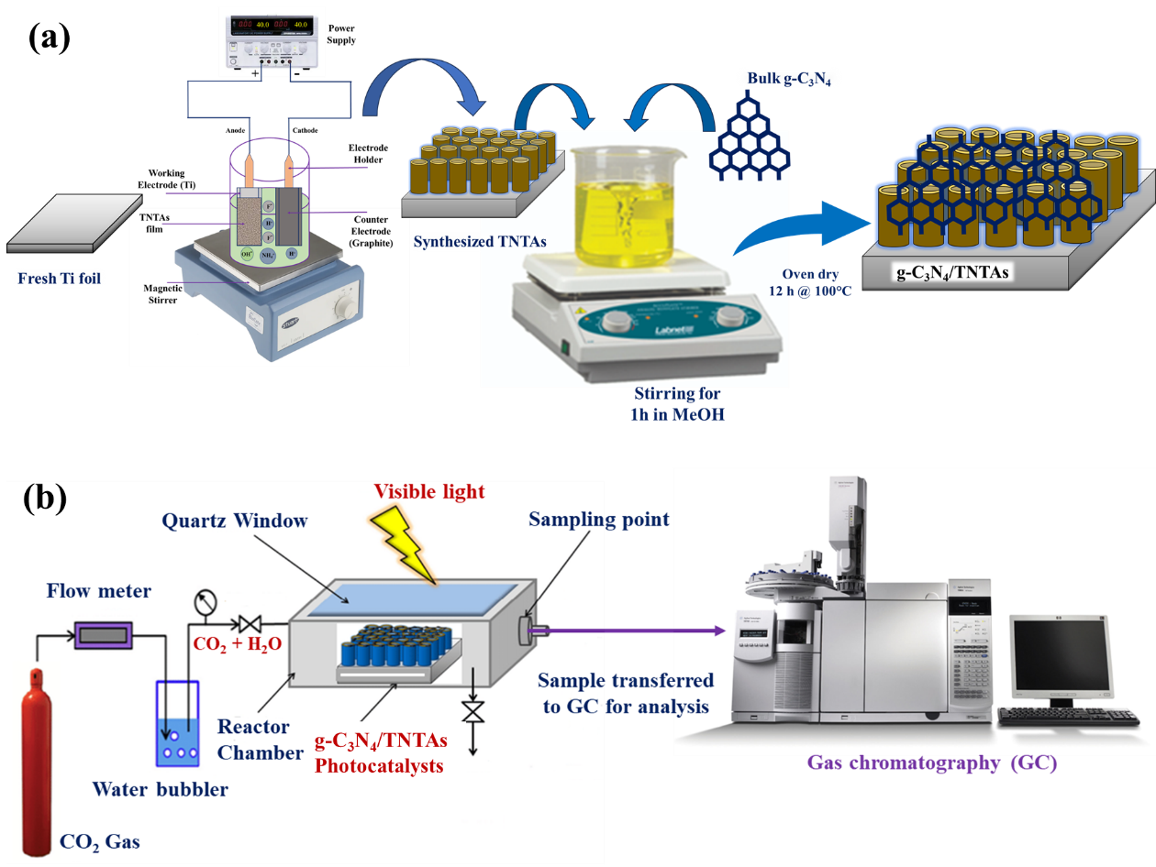
Fig. S1. Experimental framework (a) Synthesis process of g-C₃N₄/TNTAs and (b) Photocatalytic CO₂ conversion setup.

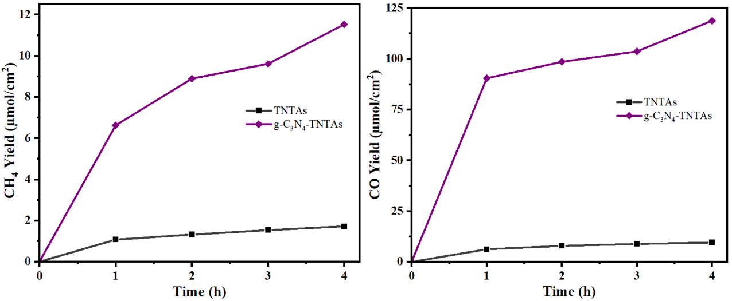
Fig. S2. Hourly production of CH₄ and CO under identical experimental conditions.

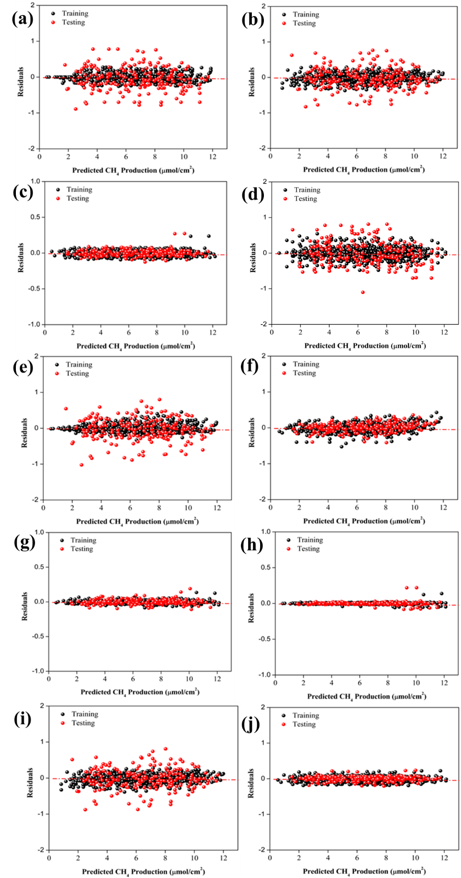

Fig. S3. The residual plot representing the relationship between the experimental and anticipated CH₄ production for (a) AB, (b) BG, (c) CB, (d) DT, (e) ET, (f) GB, (g) HGB, (h) LGBM, (i) RF, and (j) XGB models.

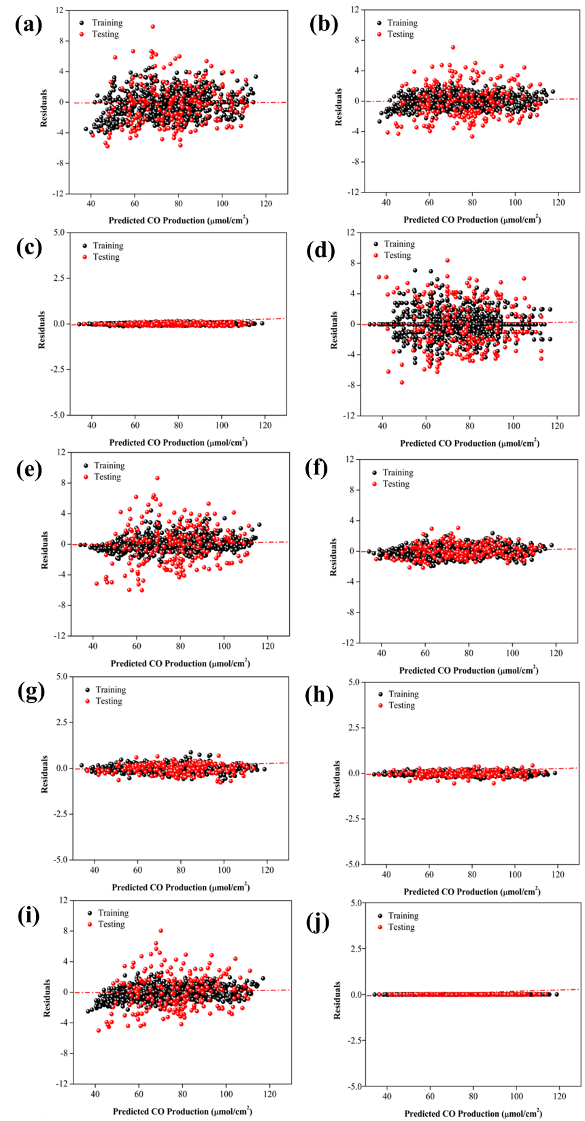
Fig. S4. The residual plot representing the relationship between the experimental and anticipated CO production for (a) AB, (b) BG, (c) CB, (d) DT, (e) ET, (f) GB, (g) HGB, (h) LGBM, (i) RF, and (j) XGB models.
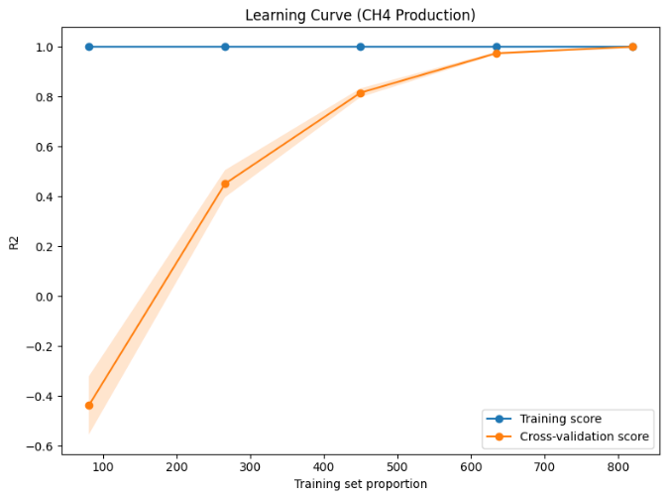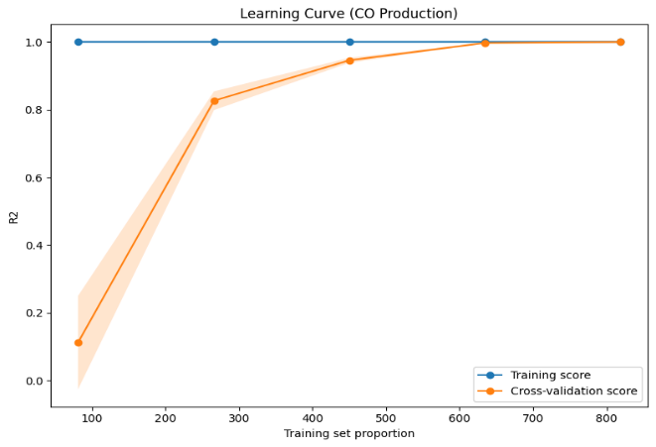
(a)
(b)
Fig. S5. Learning curves of the CatBoost model for (a) CH₄ and (b) CO production

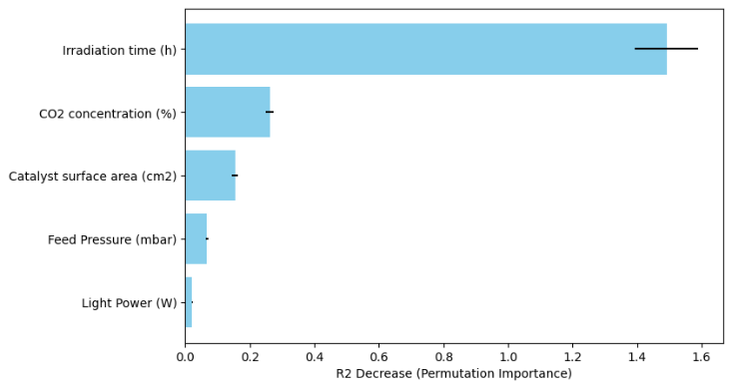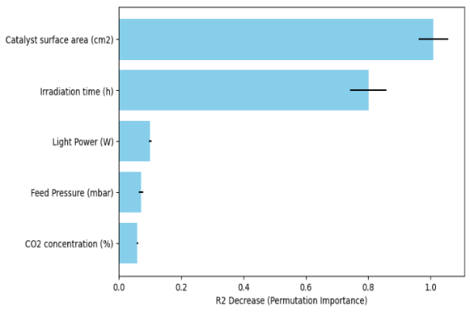
(a)
(b)
Fig S6: The bars represent each feature's model-agnostic permutation importance (a) CH₄ and (b) CO production.

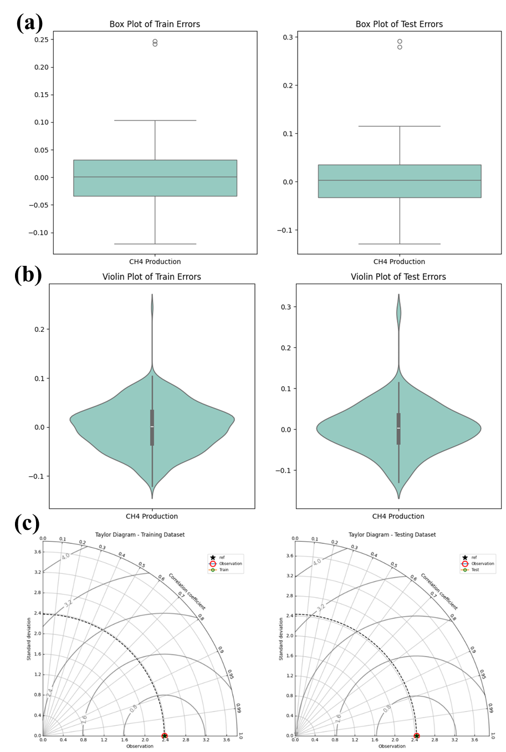
Fig. S7. (a) Box plot, (b) violin plot, and (c) Taylor diagram illustrating the performance of the CB model for CH₄ production prediction on both training and testing datasets.

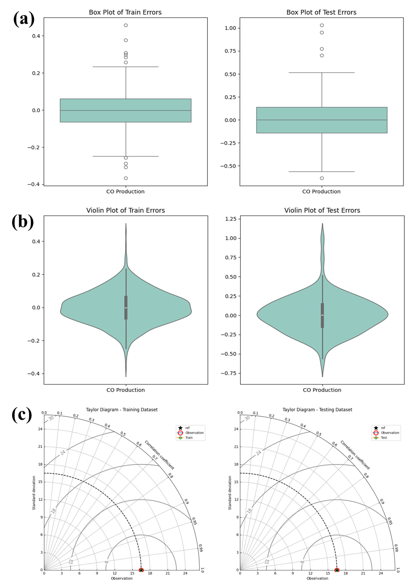
Fig. S8. (a) Box plot, (b) violin plot, and (c) Taylor diagram illustrating the performance of the CB model for CO production prediction on both training and testing datasets.

Fig. S9. Pareto visualization plots illustrating the non-dominated operating points that balance CO production against competing experimental parameters.

Fig. S10. Pareto visualization plots illustrating the non-dominated operating points that balance CH₄ production against competing experimental parameters.

Table S1. Hyper-parameters’ optimal values for the CH₄ production model

AdaBoost | n_estimators = 40, max_samples = 0.5, max_features = 1, bootstrap = False
Bagging | n_estimators = 70, max_sample = 0.8996, max_feature = 1
CatBoost | max_depth = 3, iterations = 93, 12-leaf_reg = 1.3357, learning_rate = 0.18795
Decision Tree | max_depth = 19, max_feature = 1, min_samples_split = 4, min_samples_leaf = 1
Extra Trees | max_features = 0.8367, min_samples_split = 2, min_samples_leaf = 1, n_estimators = 100, max_depth = 10
Gradient Boosting | max_feature = 0.90436, n_estimators = 99, max_depth = 3, min_samples_split = 2, min_samples_leaf = 10
HistGradientBoosting | 12_regularization = 01, learning_rate = 0.1251, max_bins = 4, max_depth = 10, max_iter = 65, min_samples_leaf = 9, min_leaf_nodes = 9,
LightGBM | n_estimators = 50, num_leaves = 5, colsample_bytree = 0.5, learning_rate = 0.299
RandomForest | max_depth = 10, max_features = 0.91703, min_samples_leaf = 1, min_samples_split = 2, n_estimators = 100
XGBoost | colsample_bytree = 0.53, max_depth = 7, min_child_weight =3, subsample = 0.9769, n_estimators = 50, colsample_bytree = 0.5308, learning_rate = 0.299

Table S2. Hyper-parameters’ optimal values for the CO production model

AdaBoost | learning_rate = 0.98, n_estimators = 299
Bagging | n_estimators = 70, max_sample = 1, n_estimator = 100
CatBoost | depth = 5, 12_leaf_reg = 1, iterations = 100, learning_rate = 0.2
Decision Tree | max_depth = 9, iterations = 100, max_features = 1.0, min_samples_split = 2, min_samples_leaf = 1
Extra Trees | max_features = 0.8898, min_samples_split = 2, min_samples_leaf = 1, n_estimators = 100, max_depth = 10
Gradient Boosting | max_feature = 0.9749, n_estimators = 97, max_depth = 4, min_samples_split = 9, min_samples_leaf = 1
HistGradientBoosting | 12_regularization = 1.5769, learning_rate = 0.299, max_bins = 9, max_depth = 6, max_iter = 100, min_samples_leaf = 5, min_leaf_nodes = 10
LightGBM | colsample_bytree = 0.5, n_estimators = 50, min_child_sample = 2, learning_rate = 0.299
RandomForest | max_depth = 10, max_features = 0.7958, min_samples_leaf = 1, min_samples_split = 2, n_estimators = 100
XGBoost | colsample_bytree = 1, max_depth = 5, min_child_weight =2, subsample = 0.6538, n_estimators = 50, colsample_bytree = 0.5308, learning_rate = 0.2575

Table S3. Scores of performance indicators of different ML algorithms for CH₄ production.

Model |  | R² Score | MSE | RMSE | MAE | MedAE
AB | Training | 0.9172 | 0.4685 | 0.6845 | 0.5747 | 0.5463
AB | Testing | 0.9181 | 0.4830 | 0.6950 | 0.5878 | 0.5289
BG | Training | 0.9877 | 0.0131 | 0.1143 | 0.0871 | 0.0698
BG | Testing | 0.9743 | 0.0926 | 0.3043 | 0.2338 | 0.1826
CB | Training | 0.9887 | 0.0075 | 0.0865 | 0.0667 | 0.0552
CB | Testing | 0.9883 | 0.0085 | 0.0919 | 0.0695 | 0.0528
DT | Training | 0.9784 | 0.0093 | 0.0964 | 0.0525 | 0.0000
DT | Testing | 0.9659 | 0.1422 | 0.3771 | 0.3000 | 0.2400
ET | Training | 0.9864 | 0.0202 | 0.1420 | 0.1117 | 0.0900
ET | Testing | 0.9835 | 0.0974 | 0.3121 | 0.2432 | 0.1928
GB | Training | 0.9883 | 0.0095 | 0.0973 | 0.0762 | 0.0634
GB | Testing | 0.9855 | 0.0266 | 0.1632 | 0.1297 | 0.1132
HGB | Training | 0.9823 | 0.0437 | 0.2091 | 0.1646 | 0.1331
HGB | Testing | 0.9805 | 0.0562 | 0.2371 | 0.1885 | 0.1621
LGBM | Training | 0.9772 | 0.1289 | 0.3591 | 0.2731 | 0.2136
LGBM | Testing | 0.9748 | 0.1485 | 0.3854 | 0.3039 | 0.2368
RF | Training | 0.9769 | 0.0178 | 0.1334 | 0.1033 | 0.0829
RF | Testing | 0.9743 | 0.0925 | 0.3041 | 0.2342 | 0.1743
XGB | Training | 0.9786 | 0.0080 | 0.0894 | 0.0701 | 0.0591
XGB | Testing | 0.9783 | 0.0100 | 0.1000 | 0.0774 | 0.0628

Table S4. Scores of performance indicators of different ML algorithms for CO production.

Model |  | R² Score | MSE | RMSE | MAE | MedAE
AB | Training | 0.9838 | 0.0511 | 0.2260 | 0.0382 | 0.0000
AB | Testing | 0.9730 | 7.3205 | 2.7056 | 2.3749 | 2.0000
BG | Training | 0.9874 | 0.7005 | 0.8370 | 0.6985 | 0.6502
BG | Testing | 0.9610 | 5.1561 | 2.2707 | 1.9108 | 1.8095
CB | Training | 0.9885 | 0.0114 | 0.1066 | 0.0846 | 0.0707
CB | Testing | 0.9874 | 0.0358 | 0.1891 | 0.1484 | 0.1187
DT | Training | 0.9789 | 5.7348 | 2.3947 | 1.8967 | 1.6667
DT | Testing | 0.9573 | 11.5951 | 3.4052 | 2.7667 | 2.4889
ET | Training | 0.9777 | 0.6329 | 0.7955 | 0.5972 | 0.4460
ET | Testing | 0.9646 | 6.9009 | 2.6270 | 2.0876 | 1.6299
GB | Training | 0.9844 | 0.4408 | 0.6640 | 0.5311 | 0.4678
GB | Testing | 0.9830 | 1.8929 | 1.3758 | 1.0939 | 0.9340
HGB | Training | 0.9817 | 0.3476 | 0.5896 | 0.4769 | 0.4060
HGB | Testing | 0.9779 | 0.5784 | 0.7605 | 0.6191 | 0.5194
LGBM | Training | 0.9724 | 7.5221 | 2.7426 | 2.1519 | 1.7248
LGBM | Testing | 0.9694 | 8.3051 | 2.8819 | 2.2994 | 1.8144
RF | Training | 0.9755 | 1.2182 | 1.1037 | 0.8797 | 0.7614
RF | Testing | 0.9675 | 6.1082 | 2.4715 | 2.0409 | 1.8768
XGB | Training | 0.9792 | 0.2283 | 0.4778 | 0.3762 | 0.3243
XGB | Testing | 0.9784 | 0.4380 | 0.6618 | 0.5151 | 0.4335

Table S5. Nested cross-validation check to prevent potential leakage.

Metrices | CH₄ Production | CO Production
Outer R² (individual 5folds) | 0.98179, 0.98234, 0.98127, 0.98182, 0.98275 | 0.98093, 0.99143, 0.98139, 0.98191, 0.98198
Outer RMSE (individual folds) | 0.0348, 0.0629, 0.0644, 0.0293, 0.0394 | 0.1403, 0.3951, 0.3292, 0.1559, 0.0671
Outer R² (mean ± 95% CI) | 0.9816 [0.9804, 0.9818] | 0.9818 [0.9726, 0.9826]
Outer RMSE (mean ± 95% CI) | 0.0462 [0.0318, 0.0605] | 0.2175 [0.0964, 0.3387]
Permutation R² mean | −0.3670 (std: 0.0626) | −0.3743 (std: 0.0502)

Table S6. Feature importances for the CH₄ prediction models
AdaBoost
  Catalyst surface area (cm²) | 0.073597
  CO₂ concentration (%) | 0.131272
  Feed Pressure (mbar) | 0.029622
  Light Power (W) | 0.002973
  Irradiation time (h) | 0.762536
Bagging
  Catalyst surface area (cm²) | 0.073352
  CO₂ concentration (%) | 0.129315
  Feed Pressure (mbar) | 0.028696
  Light Power (W) | 0.003806
  Irradiation time (h) | 0.76483
CatBoost
  Catalyst surface area (cm²) | 0.076549
  CO² concentration (%) | 0.131066
  Feed Pressure (mbar) | 0.032125
  Light Power (W) | 0.009791
  Irradiation time (h) | 0.75047
Decision Tree
  Catalyst surface area (cm²) | 0.073137
  CO₂ concentration (%) | 0.131911
  Feed Pressure (mbar) | 0.03008
  Light Power (W) | 0.004018
  Irradiation time (h) | 0.760854
Extra Trees
  Catalyst surface area (cm²) | 0.073276
  CO₂ concentration (%) | 0.129496
  Feed Pressure (mbar) | 0.027916
  Light Power (W) | 0.002899
  Irradiation time (h) | 0.766414
Gradient Boosting
  Catalyst surface area (cm²) | 0.076237
  CO₂ concentration (%) | 0.129338
  Feed Pressure (mbar) | 0.03147
  Light Power (W) | 0.009239
  Irradiation time (h) | 0.753715
HistGradientBoosting
  Catalyst surface area (cm²) | 0.076735
  CO₂ concentration (%) | 0.129554
  Feed Pressure (mbar) | 0.03139
  Light Power (W) | 0.009558
  Irradiation time (h) | 0.752764
LightGBM
  Catalyst surface area (cm²) | 0.076687
  CO₂ concentration (%) | 0.131597
  Feed Pressure (mbar) | 0.032048
  Light Power (W) | 0.009603
  Irradiation time (h) | 0.750065
Random Forest
  Catalyst surface area (cm²) | 0.073311
  CO₂ concentration (%) | 0.128801
  Feed Pressure (mbar) | 0.028834
  Light Power (W) | 0.003668
  Irradiation time (h) | 0.765386
XGBoost
  Catalyst surface area (cm²) | 0.076519
  CO₂ concentration (%) | 0.131744
  Feed Pressure (mbar) | 0.032
  Light Power (W) | 0.009994
  Irradiation time (h) | 0.749743

Table S7. Feature importances for the CO prediction models
AdaBoost
  Catalyst surface area (cm²) | 0.514424
  CO₂ concentration (%) | 0.017333
  Feed Pressure (mbar) | 0.024867
  Light Power (W) | 0.038006
  Irradiation time (h) | 0.40537
Bagging
  Catalyst surface area (cm²) | 0.50671
  CO₂ concentration (%) | 0.022381
  Feed Pressure (mbar) | 0.028662
  Light Power (W) | 0.041815
  Irradiation time (h) | 0.400432
CatBoost
  Catalyst surface area (cm²) | 0.494921
  CO₂ concentration (%) | 0.028567
  Feed Pressure (mbar) | 0.035109
  Light Power (W) | 0.048761
  Irradiation time (h) | 0.392642
Decision Tree
  Catalyst surface area (cm²) | 0.510419
  CO₂ concentration (%) | 0.018273
  Feed Pressure (mbar) | 0.026789
  Light Power (W) | 0.037514
  Irradiation time (h) | 0.407006
Extra Trees
  Catalyst surface area (cm²) | 0.510385
  CO₂ concentration (%) | 0.019322
  Feed Pressure (mbar) | 0.025387
  Light Power (W) | 0.040678
  Irradiation time (h) | 0.404228
Gradient Boosting
  Catalyst surface area (cm²) | 0.496623
  CO₂ concentration (%) | 0.028609
  Feed Pressure (mbar) | 0.032016
  Light Power (W) | 0.048135
  Irradiation time (h) | 0.394617
HistGradientBoosting
  Catalyst surface area (cm²) | 0.494762
  CO₂ concentration (%) | 0.028688
  Feed Pressure (mbar) | 0.035157
  Light Power (W) | 0.048632
  Irradiation time (h) | 0.392761
LightGBM
  Catalyst surface area (cm²) | 0.495054
  CO₂ concentration (%) | 0.028457
  Feed Pressure (mbar) | 0.035197
  Light Power (W) | 0.048718
  Irradiation time (h) | 0.392574
Random Forest
  Catalyst surface area (cm²) | 0.508429
  CO₂ concentration (%) | 0.021509
  Feed Pressure (mbar) | 0.026526
  Light Power (W) | 0.042103
  Irradiation time (h) | 0.401433
XGBoost
  Catalyst surface area (cm²) | 0.495007
  CO₂ concentration (%) | 0.02853
  Feed Pressure (mbar) | 0.035213
  Light Power (W) | 0.048767
  Irradiation time (h) | 0.392482

Table S8. Withheld test metrics for CH₄ and CO predictions using the CB model on 205 out-of-sample samples.
Metric | CH₄ production | CO production
R² | 0.9827 | 0.9903
RMSE | 0.0427 | 0.0567
MAE | 0.0272 | 0.0438
MedAE | 0.0182 | 0.0372

Table S9. Summary of model-predicted uncertainties for CH₄ and CO yields under withheld test conditions.
Parameter | Highest Value  (µmol g⁻¹) | Weighted Mean | Weighted Std | Percent Uncertainty (%)
CO | 118.7500 | 101.2933 | 3.3611 | ±3.32%
CH₄ | 12.1200 | 10.0367 | 0.8108 | ±8.08%
References
Breiman, L., 1996. Bagging predictors. Machine Learning 24(2), 123-140. https://doi.org/10.1007/BF00058655.
Breiman, L., 2001. Random Forests. Machine Learning 45(1), 5-32. https://doi.org/10.1023/A:1010933404324.
Chen, T., Guestrin, C., 2016. XGBoost: A scalable tree boosting system, Proceedings of the 22nd acm sigkdd international conference on knowledge discovery and data mining. pp. 785-794.
Feng, Y., Lin, S., Huang, S., Shrestha, S., Conibeer, G., 2015. Can Tauc plot extrapolation be used for direct-band-gap semiconductor nanocrystals? Journal of Applied Physics 117(12). https://doi.org/10.1063/1.4916090.
Geurts, P., Ernst, D., Wehenkel, L., 2006. Extremely randomized trees. Machine Learning 63(1), 3-42. https://doi.org/10.1007/s10994-006-6226-1.
Geurts, P., Irrthum, A., Wehenkel, L., 2009. Supervised learning with decision tree-based methods in computational and systems biology. Molecular Biosystems 5(12), 1593-1605.
Hossen, M. A., Abd Aziz, A., Ikreedeegh, R. R., Muhammad, A. D., Yaacof, N., Leong, K. H., & Wu, L. (2024). Optimization of anodizing parameters for the morphological properties of TiO2 nanotubes based on response surface methodology. Next Materials, 2, 100061.
Ke, G., Meng, Q., Finley, T., Wang, T., Chen, W., Ma, W., Ye, Q., Liu, T.-Y., 2017. LightGBM: a highly efficient gradient boosting decision tree, Proceedings of the 31st International Conference on Neural Information Processing Systems. Curran Associates Inc., Long Beach, California, USA, pp. 3149–3157.
Kubelka, P., 1931. Ein beitrag zur optik der farbanstriche. Z. tech. Phys 12, 593-601.
Prokhorenkova, L., Gusev, G., Vorobev, A., Dorogush, A.V., Gulin, A., 2018. CatBoost: unbiased boosting with categorical features. Advances in neural information processing systems 31.
Natekin, A., Knoll, A., 2013. Gradient boosting machines, a tutorial. Frontiers in Neurorobotics 7. https://doi.org/10.3389/fnbot.2013.00021.
Xia, L., Zheng, P., Li, J., Huang, X., Gao, R.X., 2023. Histogram-based Gradient boosting tree: A federated learning approach for collaborative fault diagnosis. IEEE/ASME Transactions on Mechatronics, 1-12. https://doi.org/10.1109/TMECH.2023.3331712.

