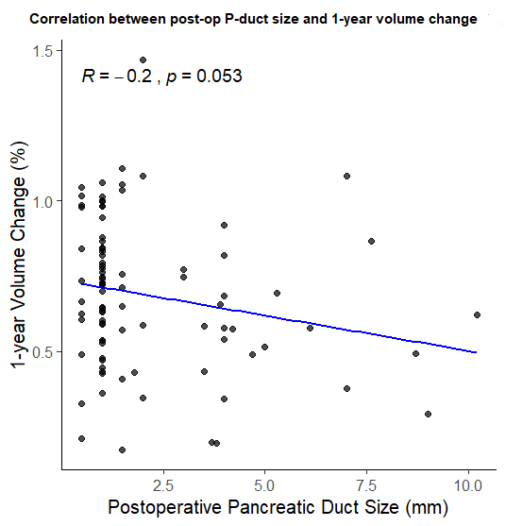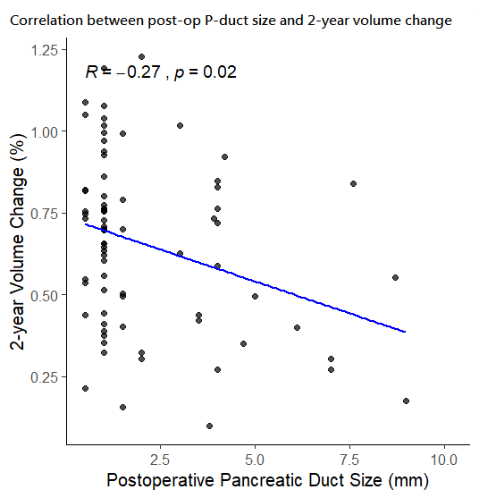
Supplementary Figure 1. Correlation between postoperative pancreatic duct diameter and remnant pancreatic volume change. Spearman's correlation analysis demonstrated a negative correlation at 1 year (ρ = −0.20, p = 0.053) and 2 years (ρ = −0.27, p = 0.02), indicating that larger postoperative duct diameters were associated with greater pancreatic atrophy.

 | 3M | 1Y | 2Y
DP | 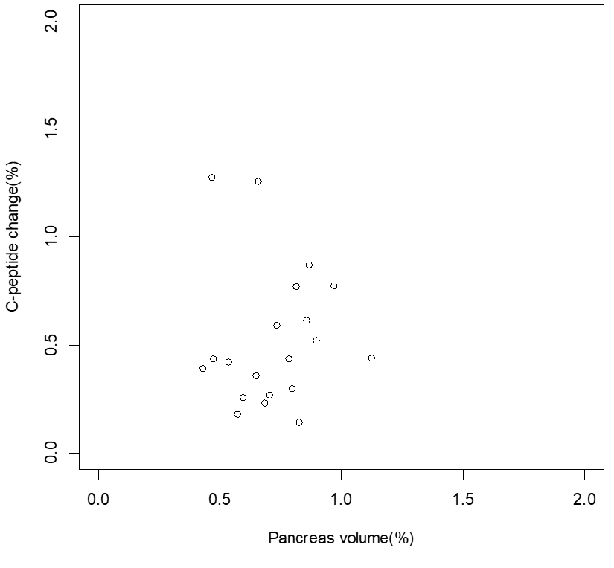 | 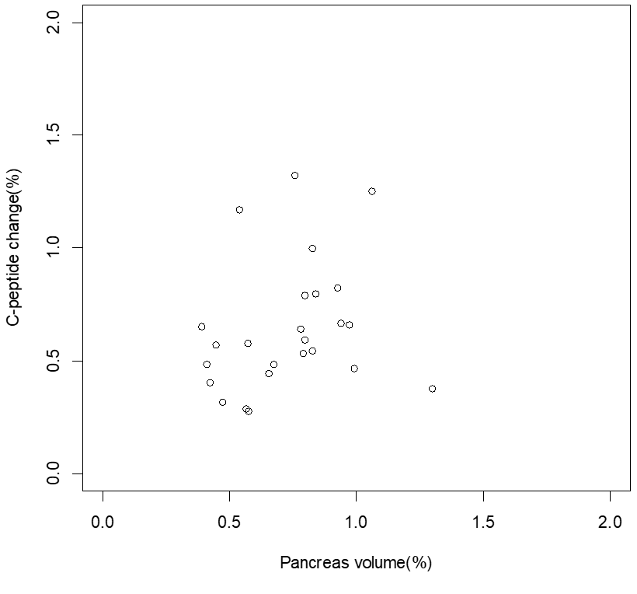 | 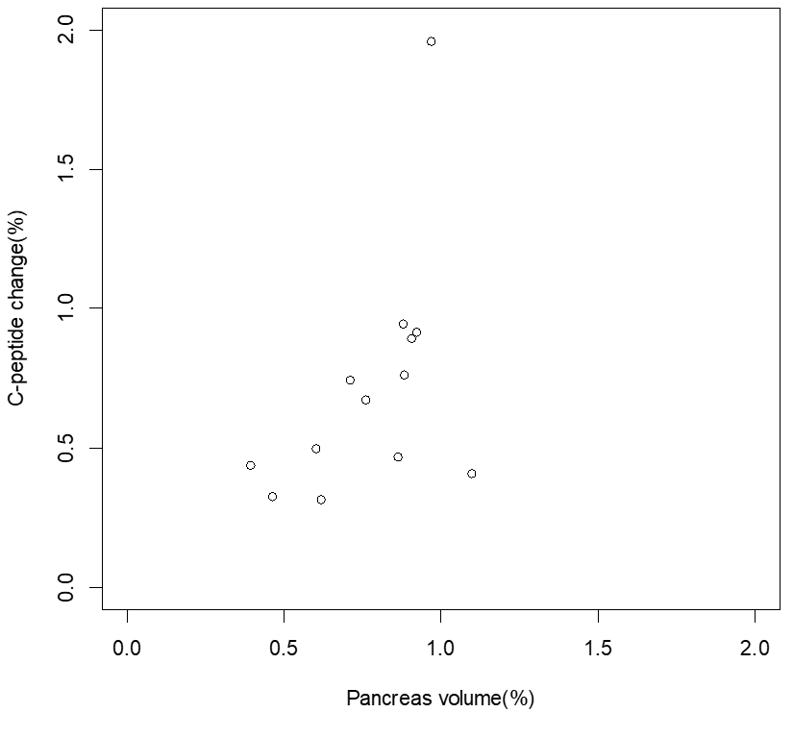
 | ơ =0.238  p= 0.32 | ơ =0.327  p= 0.11 | ơ =0.566  p= 0.05*
PD | 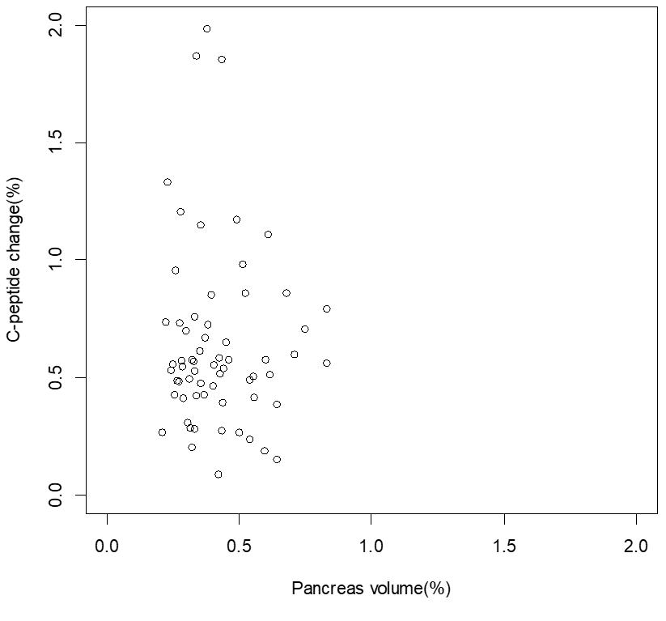 | 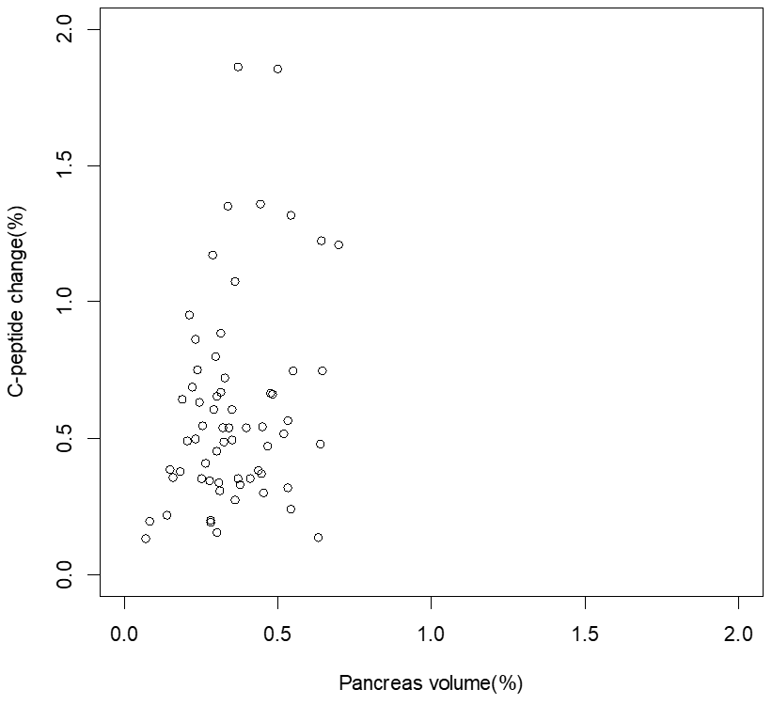 | 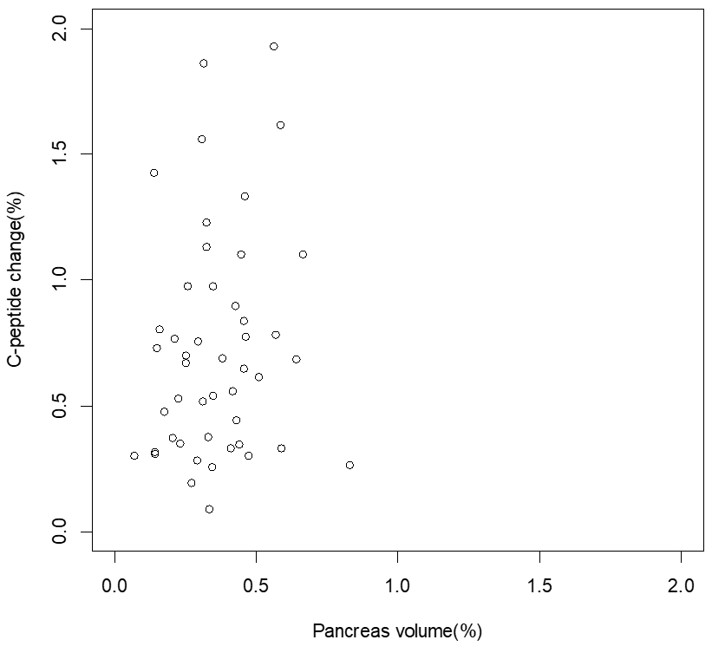
 | ơ =-0.005  p = 0.97 | ơ = 0.149  p = 0.33 | ơ =0.157  p= 0.29
Supplementary Figure 2. Relationship between change of C-peptide level (%) and pancreas volume (%) at different time points. Spearman’s correlation showed no significant correlation between C-peptide level and residual volume at postoperative 3 months, 1year and 2years.

