Supplementary Materials

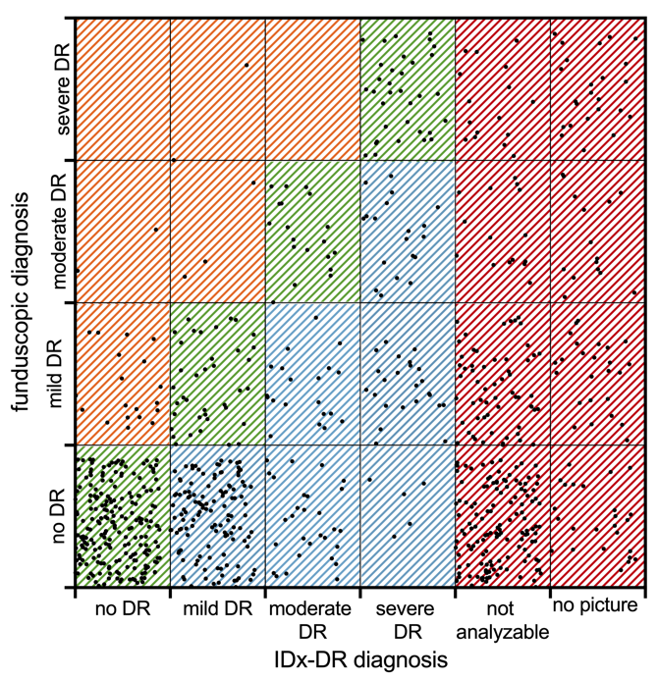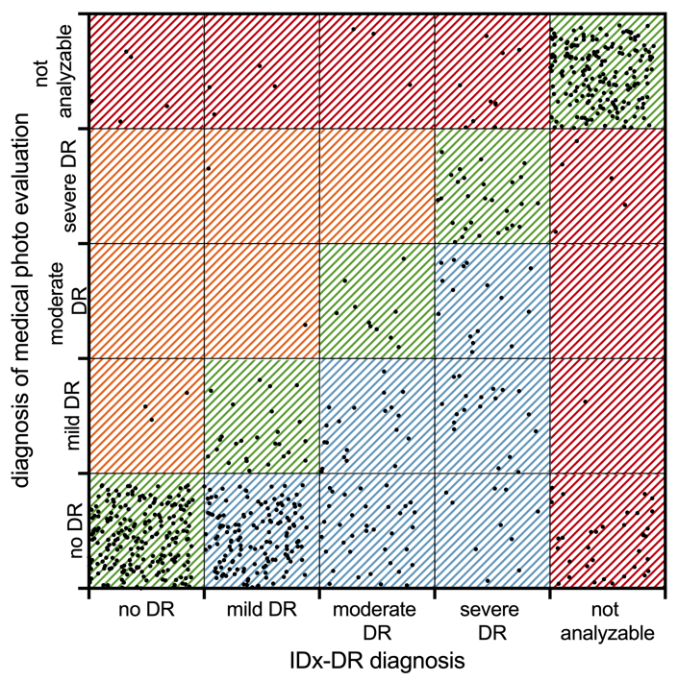
(a) | (b)
Supplementary Figure 1. (a) Scatterplot comparing IDx-DR diagnosis to gold standard Ophthalmic diagnosis using dilated funduscopy. (b) Scatterplot comparing IDx-DR diagnosis to Ophthalmic diagnosis using fundus images (the same ones as used by the IDx-DR algorithm).

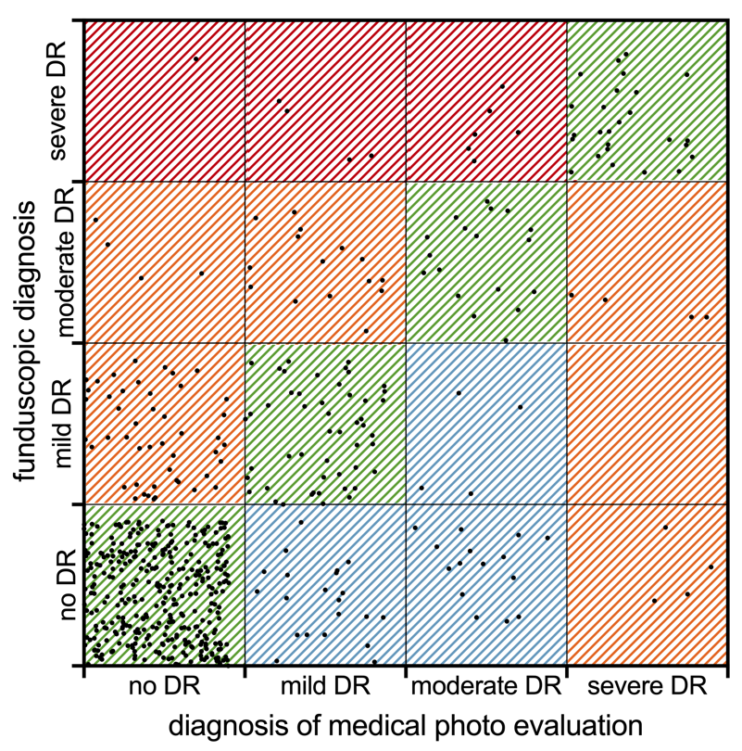

Supplementary Figure 2. Scatterplot comparing Ophthalmic diagnosis using fundus images (the same ones as used by the IDx-DR algorithm) to gold standard Ophthalmic diagnosis using dilated funduscopy.

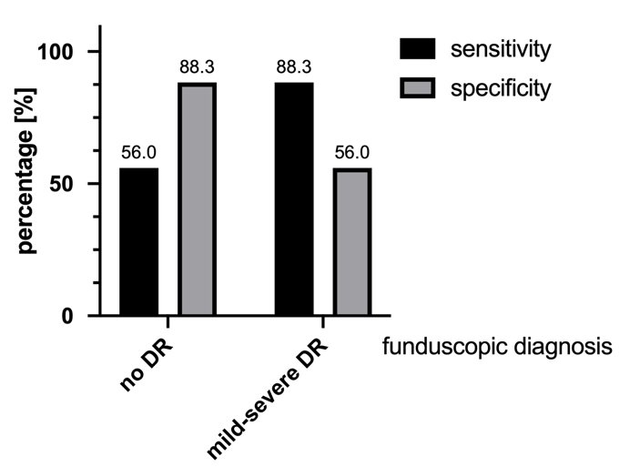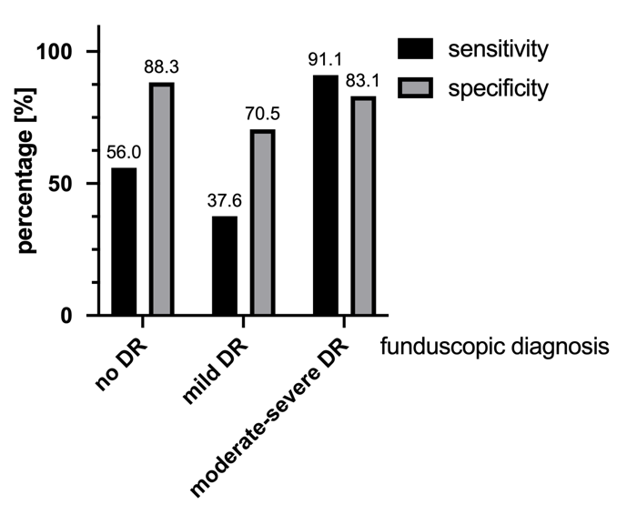
(a) | (b)
Supplementary Figure 3. (a) Sensitivity and specificity of diagnosed IDx-DR results based on funduscopic diagnosis (gold standard) when mild-severe DR is grouped. (b) Sensitivity and specificity of diagnosed IDx-DR results in based on funduscopic diagnosis (gold standard) when moderate-severe DR is grouped.

